

Project Proposal:
Skincare Recommendation System
Recommending skincare products based on skin type and skin conditions

March 27, 2021

Taniya Adhikari

Table of Contents
1 Introduction 2
1.1 Background 2
1.2 Problem Statement 2
1.3 Scope 3
1.4 Document Overview 3
2 Preliminary Requirement 3
2.1 Technical Approach 3
2.2 Data 4
2.3 Requirement Development 4
2.4 Model Deployment 5
2.5 Testing and Evaluation 5
3 Expected Results 5
4 Execution and Management of Approach 6
4.1 Project Plan Overview 6
4.2 Milestones 6
4.3 Phases 6
4.4 Activities 7
4.5 Tasks 7
4.6 Schedule 8
4.7 Project Risks 8
5 Appendix 8
6 References 9

INTRODUCTION

Background
For the longest time beauty and personal care industry has been ruled by the legacy brands or the brands that are easily available on the store. However, in recent years industry had shifted towards ecommerce. Due to this there has been a rapid growth in the industry which led to increase in newer brands with more variety in skincare products. We are introduced with different types of skincare products from all over the world and countries like Korea, Japan, and India. In 2021, beauty and personal care market grew from 483B to $511B worldwide, with average annual growth rate of 4.75%. With the shopping style shifting from offline to online, this is expected to grow even more as new brands pop up every year. There are ten thousand plus beauty products out there and new products add on daily basis which makes it hard for consumers to choose. Thus, social media plays a big role for cosmetics marketing and beauty blogs recommendation also contributes to cosmetics sales by recommending products to consumers. The purpose of this project is to build a tool to find top skincare products for specific skin conditions and suggest products to the user.

Problem Statement
The problem with a vast variety of skincare products is that consumers are burdened with a challenge of choosing from numerous products, which is often time consuming and difficult to select the right product for their skin concerns. So, a good starting point will be analysing reviews and find top rated products for specific user preferences. In this project, I am interested in developing a system that matches products based on users’ preferences in this case user budget and skin concerns to recommendations using online reviews.

Scope
The scope of this project is vast and include many parts. I will be focusing on online reviews of the products and its customer satisfaction.
Within Scope:
- Develop a model capable of recommending products based on user preferences.
- Analyse reviews to make sure that the recommended products have higher customer satisfaction with user skin concerns.
- Model should use online reviews data, to find right products for user.
- The project should apply predictive analytics techniques.

Document Overview
In this document, I will be describing preliminary requirements for the project, technical approach, data information, analysis, requirements, model deployment and evaluation. It also includes expected results, project plan and risks.

PRELIMINARY REQUIREMENTS

Technical Approach
For this project, I will be following CRISP-DM model for technical approach. I already roughly defined the project and its business problem and scope. To recommend products, I need list of products and its effectiveness. Some of the issues I am dealing with is lack of data about products and its effectiveness for skin concerns. I can barely find product data relevant to skin problems. Thus, I need customer reviews as my main data to find product effectiveness. To get product reviews I need to scrap data from the websites using keywords. Keywords will be skin concerns. This will be all text data; thus, it will require lot of pre-processing and cleaning. Once done with data preparation, I will be exploring unsupervised techniques to find a best solution to match preferences to the reviews. Next, I will be evaluating the model by using some metrics and further I will discuss the plan to use the model. All these steps are iterative, thus I will figure out if I need to add more data as I move forward with the project, whether I need to adjust business problem or modelling techniques.

Data
The only known data is online reviews of the products in dermstore.com. I plan to use this website to scrap data. Since, there is no API for this type of data, I must use tools such as BeautifulSoup or Scrapy in python to get the data. Along with online reviews, I would also need to scrap list of products on the website so I can use it to retrieve reviews.

Requirement Development
Requirement 1: Team shall use appropriate software.
This project is required to use combination of Python and R software for this project. I will need clustering techniques for NLP. I will also need Anaconda to use both Python and R.
Requirement 2: The data should come from credible resources.
The most important thing in this project is finding the right data. I have already researched ways to scrap data for customer reviews from websites such as dermstore.com or amazon.com.
Requirement 3: The methods will be based on predictive analytics principals.
The methods for this kind of project requires unsupervised learning. The target variable is unknown in this.
Requirement 4: Team is required to meet the deadlines.
It is important to meet the milestones deadlines to finish this project in time. Time management is important to this project.

Model Deployment
This project’s focus is to build a model that can interact with end users. I do plan to develop a framework for conceptual modelling using a flow diagram before I proceed with data modelling. The goal for this model is to recommend products to the user based on their preference, thus model deployment would be to use this to build simple recommendation app. It can further be used by websites or blogs to recommend products to the consumers. For this Project, I plan to present the recommendation tool as my final deliverable.

Testing and Evaluation
I will be doing two forms of testing and evaluation, one to check similarity measure of clusters and other would be feature level sentiment analysis. For unsupervised learning, the techniques are slightly different and usually it is difficult to evaluate unsupervised learning. I will be using metrics such as, adjusted rand index or Fowlkes mallows score for similarity measure. Furthermore, to make sure that recommended product meets the user preferences, I will be adding sentiment analysis to find the products with highest customer satisfaction.

EXPECTED RESULTS
The project is expected to have following results and deliverables:
- The detailed narrative of methods used to find the products based on user preferences.
- The detailed narrative of model selection techniques for unsupervised learning.
- The detailed narrative of sentiment analysis of reviews.

EXECUTION AND MANAGEMENT APPROACH

Project Plan Overview
The Project plan is divided into five milestones and four project phases with estimated dates. Tasks and activities are identified, and a project schedule is developed with estimated timeline and work effort.

Milestones

Milestone | Description | Delivery Date
Team Information/ Communication Plan | Submit Team Information and Project plan with detail schedule, activities, and phases. | 03/21/21
Data Selection and Proposal Due | Identify problem statement and select appropriate dataset for the problem. Create and submit a project proposal and project requirements. | 03/28/21
Preliminary Analysis | Finish preliminary analysis on the data and submit initial results with the draft of the final paper. | 04/18/21
Project Presentation & Status | Submit the detailed presentation slides with the critical results of the projects. Include all the challenges and future scope of the project. | 05/16/21
Final Project & Presentation | Submit final project paper which includes background, abstract, business problem and well as summary of the final results and conclusion. | 06/05/21

Phases

Phase | Description© | Sequence
Initiation | This will be the combination of milestone 1 and 2 activities. Identification of team will be done in this phase. Collaboration with potential reviewers for peer review. | Phase # 1
Planning | Development of a project plan and schedule, Formulating the business problem and selection of quality dataset for the project will be done. I will be identifying the potential use of predictive analytics and create a project proposal. | Phase # 2
Execution | Kick-Off draft final project submission. Clean and perform EDA on the dataset. Select appropriate model so we can make data-driven decision. Perform evaluation and testing of the model. Deployment of the model. | Phase # 3
Closure | Summarize the results and draw conclusions. Submit the final paper and presentation | Phase # 4

Activities

Phase | Activity | Description© | Sequence
Initiation | Team Identification | Project will be done independently. Collaboration with classmates | Activity 1
Initiation | Initial Set-up for Project | Creating Folder and threads in MS Teams. | Activity 2
Planning | Project Plan | Development and submission of Project plan and schedule. | Activity 3
Planning | Requirements | Creating initial requirements for project, identify business problem and select data | Activity 4
Execution | Preliminary Data Preparation | Conduct initial data cleaning and exploratory data analysis | Activity 5
Execution | Preliminary Modelling | Select modelling and conduct initial evaluation. Submit Analysis | Activity 6
Execution | Intermediate Analysis | Make updates to data preparation step and EDA. Make updates to modelling. | Activity 7
Execution | Test and Evaluation | Conduct final EDA, model selection and evaluation. | Activity 8
Execution | Release | Deploy model and summarize and draw final conclusions. Develop Technical report. | Activity 9
Closure | Final Submission | Make any necessary updates to project report and do final submission | Activity 10

Tasks

Phase | Activity | Task | Sequence
Initiation | Team Identification | Identify Team member/s  Collaborate with classmates for Peer Review | Task 1  Task 2
Initiation | Initial Set-up for Project | Create discussion thread  Create folder in Teams | Task 3  Task 4
Planning | Project Plan | Create Project Plan  Create a Project Schedule | Task 5  Task 6
Planning | Requirements | Identify a business problem and scope  Conduct initial research  Identify data sources  Select dataset  Develop preliminary requirements  Develop Proposal Plan | Task 7  Task 8  Task 9  Task 10  Task 11  Task 12
Execution | Preliminary Data Preparation | Initiate and Conduct Peer Review 1  Preliminary Data Preparation  Preliminary Exploratory Data Analysis  Initiate and Conduct Peer Review 2 | Task 13  Task 14  Task 15  Task 16
Execution | Preliminary Modelling | Preliminary Model Selection  Preliminary Test, and Evaluation  Summarize preliminary results and conclusions  Develop preliminary Project Draft | Task 17  Task 18  Task 19  Task 20
Execution  Execution | Intermediate Analysis  Intermediate Analysis | Initiate and Conduct Peer Review 3  Intermediate Data Preparation and EDA  Intermediate Model Selection  Intermediate Test, and Evaluation  Draw intermediate results and conclusions  Develop Presentation Slides | Task 21  Task 22  Task 23  Task 24  Task 25  Task 26
Execution | Test and Evaluation | Initiate and Conduct peer review 4  Final data preparation and EDA  Final Model Selection  Final Test and Evaluation | Task 27  Task 28  Task 29  Task 30
Execution | Release | Initiate and Conduct peer review 5  Deployment of the Model  Develop preliminary project presentation  Develop preliminary executive summary  Develop preliminary technical report | Task 31  Task 32  Task 33  Task 34  Task 35
Closure | Final Submission | Update project presentation  Update executive summary  Update technical report  Submit Final Presentation and Paper  Initiate and Conduct peer review 6 | Task 36  Task 37  Task 38  Task 39  Task 40

Schedule
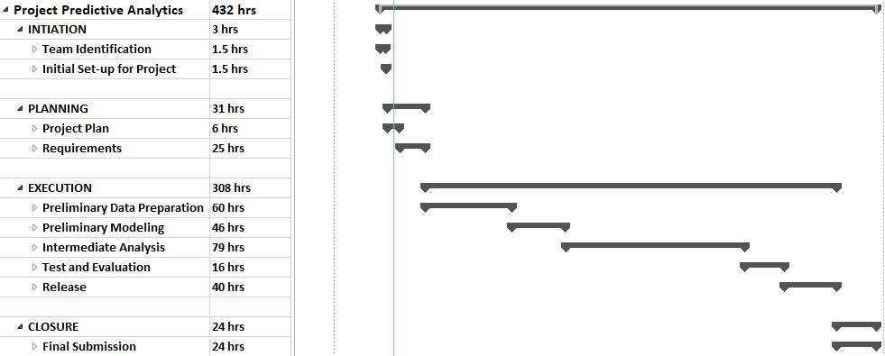

Project Risks
- This project requires unsupervised learning. There is always uncertainty with unsupervised learning because target variable is unknown. This is my first attempt to do unsupervised learning in full scale, so my expertise is limited in this analysis. Thus, this will require thorough research and study to finish this project, which will result in extra labour resources and time.
- The data has limitations. Skincare data is not easily available and skincare products are growing so it is hard to find datasets. To do this analysis, I will have to scrap large data through website. This will also require additional time and effort.

APPENDIX
Following files are added in the folder:
- Detailed Project Schedule.pdf
- Summarized Project Schedule.pdf

REFERENCES
- Dermstore: Skin Care website for beauty products online. (n.d.). Retrieved March 28, 2021, from https://www.dermstore.com/
- Roberts, R. (2021, March 08). 2021 beauty industry trends & Cosmetics Marketing: Statistics and strategies for your ecommerce growth. Retrieved March 28, 2021, from https://commonthreadco.com/blogs/coachs-corner/beauty-industry-cosmetics-marketing-ecommerce#:~:text=How%20big%20is%20the%20beauty,exceed%20%24716B%20by%202025.
- Sabanoglu, T. (2021, February 16). Cosmetic industry growth. Retrieved March 28, 2021, from https://www.statista.com/statistics/297070/growth-rate-of-the-global-cosmetics-market/

