Exercise 3.2: Graph Analysis

DSC 550

Taniya Adhikari

12/26/2020

Graphs purpose is to present data in the most condensed and clear way and to do that understanding the data and the type of graph that goes with that data is important. I ranked Bar Graph as the most effective because bar graph is easiest for the categorical data, and. It allows easy comparison between the values of each category. It can literally represent any values that can be categorize, such as total, mean, count, or median. Since for this analysis I was interested in Income vs. Race and race is categorical, bar graph was the easiest to show median income for each race category.

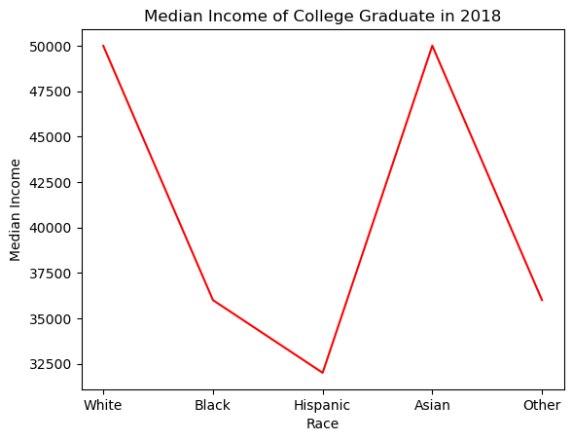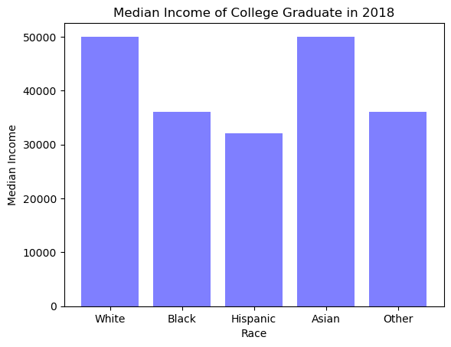  
Although, line graph can show the same analysis (median income of each race in 2018). It is not as versatile as bar graph and not as visually appealing as bar graph, because line chart basically connects each data point, it appears as if they belong to the same category. Bar graphs have separated bars for each category which makes it clearer compared to line chart. Perhaps, line chart is more useful, in the trend analysis, if I were comparing growth of income over the years then line chart would have been more useful. One thing I did liked about line chart it shows much dramatic difference between the categories compared to bar graph.

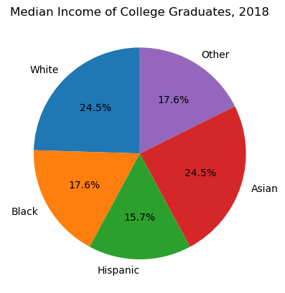

I ranked pie chart last because, for this analysis I was focusing on median income analysis of each race. Pie chart represents whole, and it helps us see each categories proportion from the total. Pie chart for median income looks like the above graph. Since, I wanted to show the comparison, pie chart is not effective here, because it is showing percentage of each category by summing up all medians, which is not needed when comparing median incomes of each category. However, pie charts are also versatile and can be useful in other analysis. If I were interested in the percentage each category holds from the total wealth of the College Graduates, or If I were interested in percentage of poverty level in each category then pie chart would have been effective. Below is the example of these scenarios.

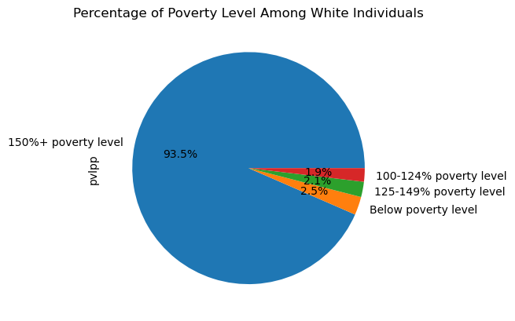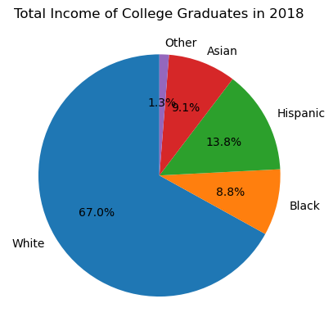

As I mentioned above, it is important to understand data variables and data types to apply visuals effectively. Not all the plots can apply to same type of analysis and variables. Graphs help us tell the story.