Political Campaigning with Voter Persuasion Model: Obama’s Campaign Case Study

Taniya Adhikari

# Overview

This case study describes the application of predictive analytics in Obama’s campaign. It explains how President Barack Obama’s campaign team applied persuasion model to find persuadable voters in the swing states. In 2012, the campaign team hired 50 analytics experts to build models that can be deployed to persuade voters to side with President Obama. States that are either red or blue are considered a sure thing or a lost cause depending on the political view, however, swing states are usually where most political campaigns are targeted. The Obama campaign used predictive analytics to micro target voters and drove millions of per-voter campaign decisions, and increased persuasive impact. There are usually two types of voters, one where voter will vote for a particular candidate regardless of the campaign, and one where voter was not going to vote for the candidate but got influenced by the campaign to vote otherwise. This is where predictive analytics are applied to target these persuadable voters.

# Business Understanding

Presidential campaigns occur every four years and months before election day which leads to one of the most powerful job in the world. Campaigns are usually conducted to influence voters to vote for the candidates and increase voter turnout. However, if the voter was going to vote anyway than increasing the voter turnout through campaign is a waste of resources. In fact, in some cases this can easily backfire and affect negatively where voter switches to a different guy. In 2021, Obama’s campaign was facing a similar problem. The team needed a model that not only identifies voters for Obama but also distinguishes between voters who will vote for Obama anyway and voters who are also at risk of being negatively affected by the campaign and switching to another guy (Mitt Romney). The team wants to know which voter will be positively influenced by political campaign efforts.

# Data Understanding

For this project, factors that predict whether a voter is persuadable or not are identified. There were certain behaviors that seemed to identify nonpartisan voters. For example, history of supporting both party candidates and registered as a republican but had a history of voting democrat candidate. There were more than 80 fields, including demographics, voting history and magazine subscriptions were employed in the modeling.

# Data Preparation

For this problem, a test was conducted across thousands of voters. Voters were divided into groups. Some groups received campaign contact through door knocks, fliers, phone calls and some groups received no contact at all. All groups were later polled to see how they were supporting Obama in a booth. The collected data was later applied to influence millions of people. There were other data sources as well, the most known one was DNC’s database, which had records regarding voter’s response to door knocks as a welcoming or door-slamming during presidential elections. All this data was later used into build uplifting models.

# Modeling and Modeling Interpretation

Persuasion modeling or uplift modeling was developed for this problem. A response uplift model was built using the data from the test conducted where individual’s response was collected. Everyone was categorized into one of the four conceptual segments.

The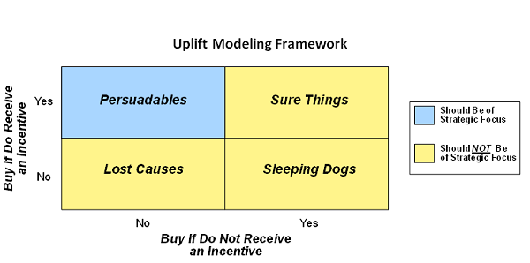 results from the model targeted campaigns towards persuadable individuals.

# Deployment

Modeling team built multiple models for each swing state. Then the models were employed to predict the potential to persuade for millions of people in swing states. The model gave insights on which individuals are most likely to be won over to Obama’s side, and which group of people they should entirely avoid contacting. Persuasion models also helped identified individuals who are nonpartisan voters.

# Summary and Conclusions

To predict which voter can positively persuaded by political campaign was the goal of this project. Thus, persuasion model was applied to predict the likelihood. The results from this model helped volunteers for Obama’s campaign to target right individuals. The model results also identified individuals with different interests, and further microtargeted these individuals. The model not only identified which individuals are persuadable, but it also identified which type of campaign effort will work on them. For example, door knocks may work for some voters, while fliers work on others. Persuasion modeling worked. This method was shown to convince more voters to choose Obama than traditional campaign targeting.