Exercise 15: Introduction to Machine Learning

Taniya Adhikari"

11/1/2020

Importing the dataset

library(tinytex)  
library(knitr)  
binary_df <- read.csv("data/binary-classifier-data.csv")  
trinary_df <- read.csv("data/trinary-classifier-data.csv")  
binary_df$label <- as.factor(binary_df$label)  
trinary_df$label <- as.factor(trinary_df$label)

Plot the data from each dataset using a scatter plot.

library(ggplot2)  
ggplot(data = binary_df, aes(x = x, y = y, color = label)) +   
 geom_point() +   
 ggtitle("Scatter Plot Binary Data")

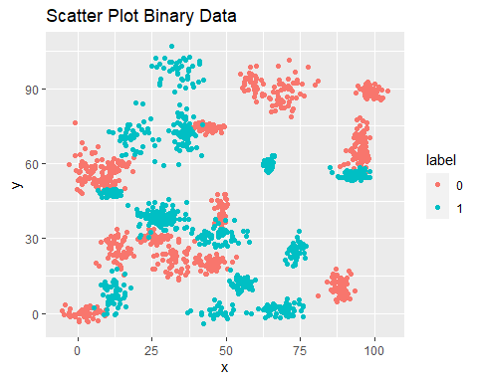

ggplot(data = trinary_df, aes(x = x, y = y, color = label)) +   
 geom_point() +   
 ggtitle("Scatter Plot Trinary Data")

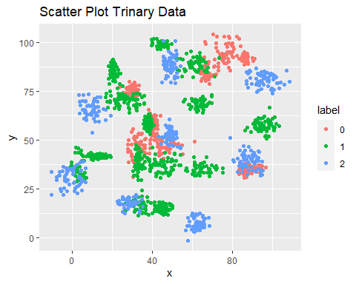

Fit a k nearest neighbors model for each dataset for k=3, k=5, k=10, k=15, k=20, and k=25. Compute the accuracy of the resulting models for each value of k. Plot the results in a graph where the x-axis is the different values of k and the y-axis is the accuracy of the model.

Binary Dataset KNN Algorithm with k = 25.

library(class)  
library(FNN)  
  
knn.binary <- sample(1:nrow(binary_df),size=nrow(binary_df)*0.7,replace = FALSE)  
  
## the normalization function is created  
nor <-function(x) { (x -min(x))/(max(x)-min(x)) }  
  
## Run normalization for predictor variables.  
binary_norm <- as.data.frame(lapply(binary_df[,c(2,3)], nor))  
  
train.binary <- binary_norm[knn.binary,] # 70% training data  
test.binary <- binary_norm[-knn.binary,] # remaining 30% test data  
  
## knn.dist calculates distance between two points. default method is euclidean.   
kdist_binary <- knn.dist(binary_norm)  
  
  
## the creating dataframes for "credibility"  
train.binarylabels <- binary_df[knn.binary,1]  
test.binarylabels <-binary_df[-knn.binary,1]  
  
## knn function  
model.binary = knn(train=train.binary, test=test.binary, cl=train.binarylabels, kdist_binary, k=25)  
  
## create confusion matrix  
tab_binary <- table(model.binary,test.binarylabels)  
  
## this function divides the correct predictions by total number of predictions that tell us how accurate the model is and multiplied by 100.  
accuracy <- function(x){sum(diag(x)/(sum(rowSums(x)))) * 100}  
accuracy(tab_binary)

## [1] 96.44444

## Knn Model PLot  
test.binary$predicted <- model.binary  
ggplot(data = test.binary, aes(x = x, y = y, color = predicted)) +   
 geom_point() +   
 ggtitle("KNN Model: Binary Predicted Values")

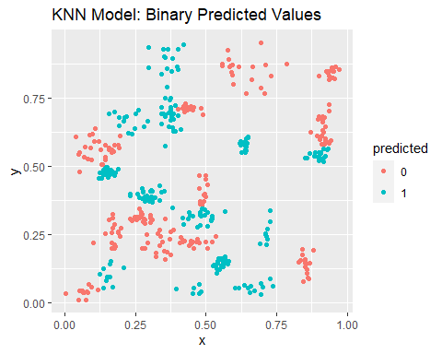

The above Scatter Plot shows the predicted values for the binary test data set, with 96.4444444%.

Accuracy of the binary data knn model.

|  |  |  |
| --- | --- | --- |
| k.v1 | accuracy.1 | error.1 |
| 3 | 97.33333 | 0.0266667 |
| 5 | 97.55556 | 0.0244444 |
| 10 | 97.11111 | 0.0288889 |
| 15 | 97.11111 | 0.0288889 |
| 20 | 97.33333 | 0.0266667 |
| 25 | 96.88889 | 0.0311111 |

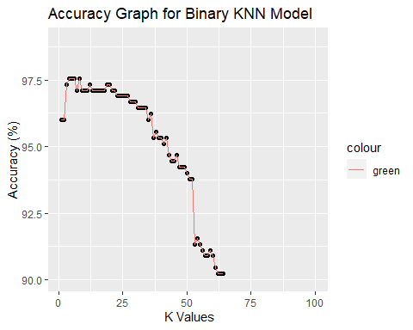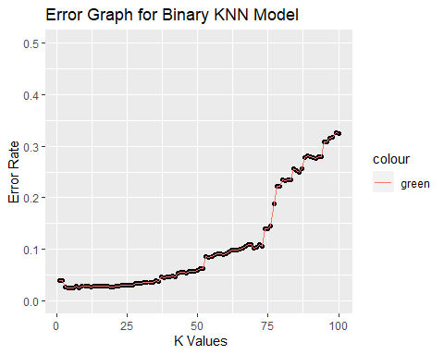

Trinary Dataset KNN Model with k = 25.

Same code from above is applied to the trinary dataset.

## [1] 87.47346

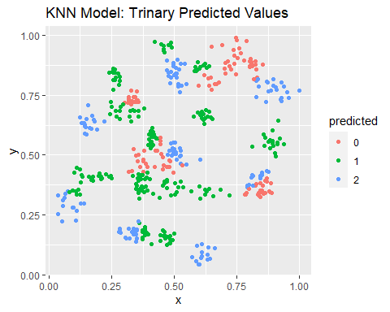

The above Scatter Plot shows the predicted values for the trinary test data set, with 87.4734607%.

Accuracy of the trinary data knn model.

|  |  |  |
| --- | --- | --- |
| k.v2 | accuracy.2 | error.2 |
| 3 | 88.95966 | 0.1104034 |
| 5 | 88.11040 | 0.1188960 |
| 10 | 88.32272 | 0.1167728 |
| 15 | 87.26115 | 0.1273885 |
| 20 | 88.11040 | 0.1188960 |
| 25 | 87.04883 | 0.1295117 |

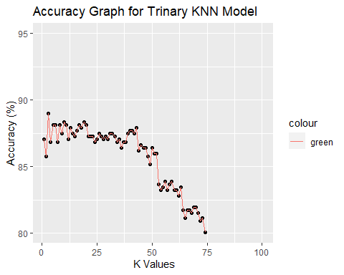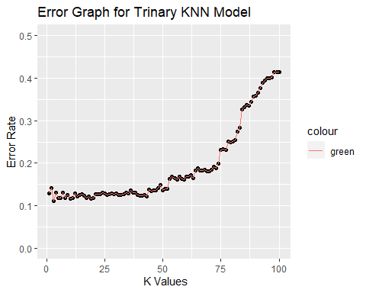

Looking back at the plots of the data, do you think a linear classifier would work well on these datasets?

No, a linear model is not a good fit for this because the data is non-linear. Linear classification works best for problems with many variables. Our data only has two variables and is dispersed into multiple clusters all over indicating it’s non-linear. Linear classifier simply won’t work because it uses linear functions.

**Referrences**

1. <https://www.edureka.co/blog/knn-algorithm-in-r/>
2. <https://rstudio-pubs-static.s3.amazonaws.com/506235_848f078b245f4fe885cea65f1528ad79.html#fitting-a-knn-model>
3. <https://en.wikipedia.org/wiki/Linear_classifier>
4. <https://towardsdatascience.com/k-nearest-neighbors-algorithm-with-examples-in-r-simply-explained-knn-1f2c88da405c>