Exercise 16: Clustering

Taniya Adhikari"

11/1/2020

Importing the dataset

library(tinytex)  
library(knitr)  
df1 <- read.csv("data/clustering-data.csv")  
summary(df1)

## x y   
## Min. : 0.0 Min. :134.0   
## 1st Qu.: 56.0 1st Qu.:141.0   
## Median : 82.0 Median :154.0   
## Mean :109.6 Mean :175.7   
## 3rd Qu.:180.0 3rd Qu.:218.0   
## Max. :249.0 Max. :236.0

# second dataset to check the fit for data  
df2 <- df1  
df3 <- df1  
library(VIM)  
aggr(df1)

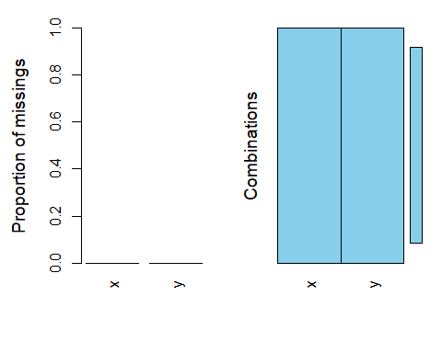

Looks like the data has no missing value.

Plot the dataset using a scatter plot.

library(ggplot2)  
ggplot(data = df1, aes(x = x, y = y)) +   
 geom_point(size=0.8) +   
 ggtitle("Scatter Plot Clustering Data")

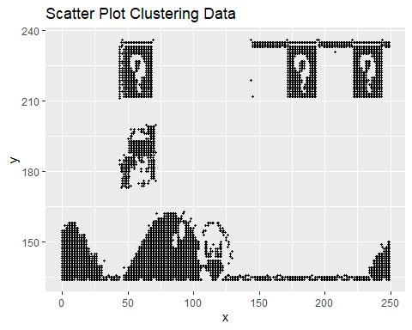

After looking at the scatterplot it looks like the clustering data represent Mario game plot.

Fit the dataset using the k-means algorithm from k=2 to k=12. Create a scatter plot of the resultant clusters for each value of k.

library(class)  
  
k <- 2:12  
for(i in k){  
 # k-means model  
 clusters1 = kmeans(df1, i)  
   
 # save the cluster in the dataset  
 df1$cluster <- as.factor(clusters1$cluster)  
  
 title <- paste("K-Means Plot: k = ", i)  
 # scatter plot  
 plot <- ggplot(data = df1, aes(x = x, y = y, colour=cluster)) +   
 geom_point(size=.8) +   
 ggtitle(title)  
   
 print(plot)  
  
}

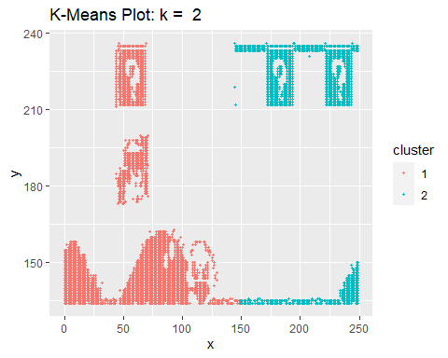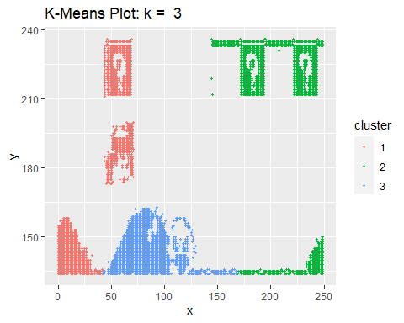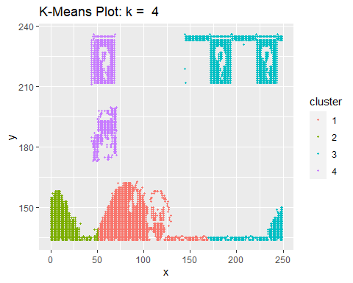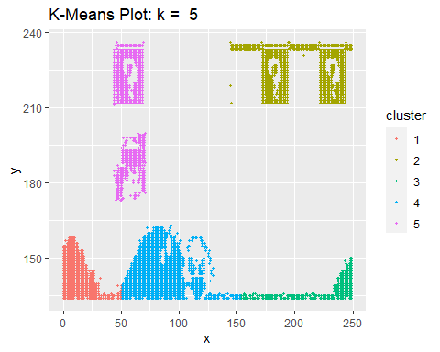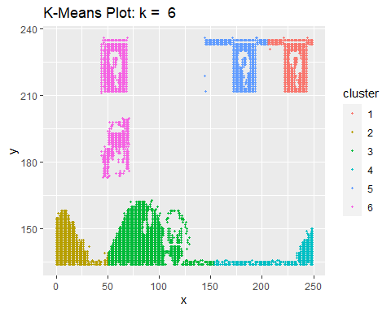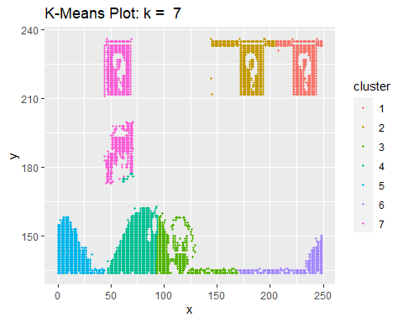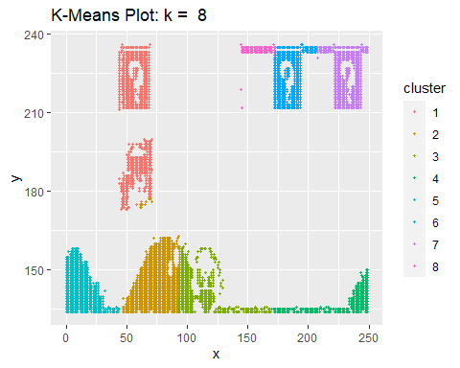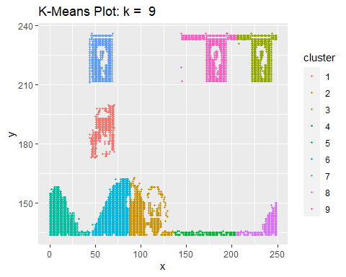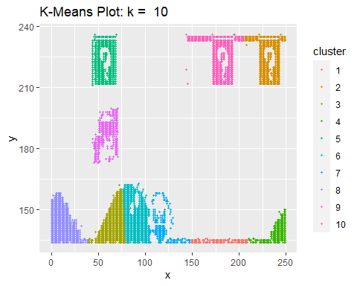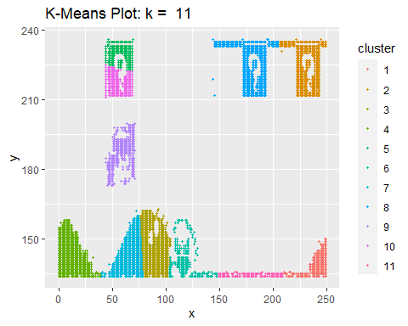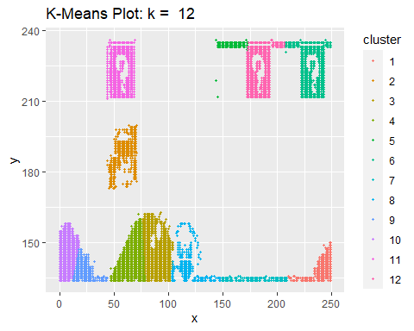

Calculate this average distance from the center of each cluster for each value of k and plot it as a line chart where k is the x-axis and the average distance is the y-axis.

library(class)  
library(FNN)  
  
k <- 1:25  
average.v <- NULL  
k.v <- NULL  
  
for(i in k){  
 # k-means model  
 clusters2 = kmeans(df2, i)  
   
 # save the cluster in the dataset  
 df2$cluster <- as.factor(clusters2$cluster)  
   
 df2$x_center <- clusters2$centers[df2$cluster, "x"]  
   
 df2$y_center <- clusters2$centers[df2$cluster, "y"]  
 head(df2)  
   
 df2$total_dist <- sqrt((df2$x-df2$x_center)**2 + (df2$y-df2$y_center)**2)  
   
 avg <- mean(df2$total_dist)  
 k.v[i] <- i  
 average.v[i] <- avg  
  
}  
avg_df <- data.frame(k.v, average.v)  
point <- avg_df[avg_df["average.v"] < 20]  
elbow.point <-point[[1]][1]  
#plotting the average distance  
ggplot(data=avg_df, aes(x = k.v, y = average.v)) +   
 geom_point() + geom_line(aes(colour="blue")) + geom_vline(xintercept = elbow.point, linetype =2) + xlab(" K Values") + ylab("Average Distance") +   
 ggtitle("Average distance Metric")

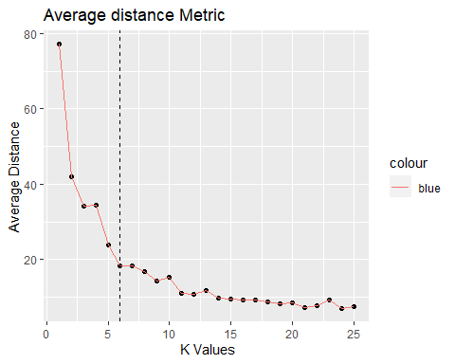

One way of determining the “right” number of clusters is to look at the graph of k versus average distance and finding the “elbow point”. Looking at the graph you generated in the previous example, what is the elbow point for this dataset?

Since each time I ran the code, I was getting different results for the elbow point so it was little harder to predict the value. I did run it enough to notice that elbow point was falling somewhere below average distance of 20. So I selected the first point after the average distance = 20. In this graph my estimated elbow point is 6.

There are several different method to check the fit of the model. One of them is Elbow method which uses within-cluster sum of square (WSS). Below I graphed the WSS and estimated elbow point which is similar to the average distance elbow point.

library(factoextra)  
library(NbClust)  
  
  
# Elbow method  
fviz_nbclust(df3, kmeans, method = "wss", k.max=25) +  
 geom_vline(xintercept = elbow.point, linetype = 2) + # add line for better visualisation  
 labs(subtitle = "Elbow method") # add subtitle

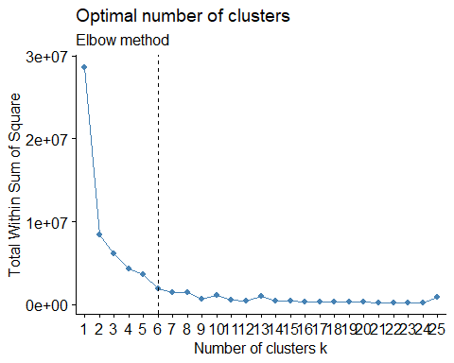

**Referrences**

1. <https://www.statsandr.com/blog/clustering-analysis-k-means-and-hierarchical-clustering-by-hand-and-in-r/>
2. <http://www.nbertagnolli.com/jekyll/update/2015/12/10/Elbow.html>
3. <https://www.edureka.co/blog/k-means-clustering/>
4. <https://www.datacamp.com/community/tutorials/k-means-clustering-r>