ADHWAITH K P
S5 AIML
ROLL NO : 3
29/07/2024

EXPERIMENT NO:1(a)

AIM: Create a n x n dimensional numpy array and find the pattern

Program
import numpy as np
from collections import defaultdict
def frepeat(arr):
m,n=arr.shape
subpattern =[]
pattern_count = defaultdict(int)
reapeating_patterns = defaultdict(int)
for i in range (n):
for j in range (n):
if arr[i][j] in arr[i]:
pattern_count[arr[i][j]] +=1
def extract(row,length):
subpatterns = []
for i in range (len(row)-length+1):
subpatterns.append(tuple(row[i:i+length]))
return subpatterns
for rows in arr:
for length in range (2,n+2):
subpatterns= extract(rows,length)
for subpattern in subpatterns:
pattern_count[subpattern] +=1
for col in arr.T:
for length in range (2,m+2):
subpatterns = extract(col,length)
for subpattern in subpatterns:
pattern_count[subpattern] +=1
repeating_patterns = {k:v for k,v in pattern_count.items() if v>1}
for pattern, count in repeating_patterns.items():
print(f"pattern {pattern} appears {count}")
return reapeating_patterns
m = int(input('enter the number of rows '))
n = int(input('enter the number of column'))
matrix = np.empty((n,n),dtype=int)
for i in range (0,m):
for j in range (0,n):
matrix[i,j]=int(input())
print(matrix)
patterns = frepeat(matrix)
for pattern, count in patterns.items():
print(f"pattern {pattern} appears {count}")
Output
enter the number of rows 5
enter the number of column 5
1
2
3
4
5
2
3
4
6
8
3
4
6
7
2
4
1
0
8
1
5
4
5
2
0
[[1 2 3 4 5]
[2 3 4 6 8]
[3 4 6 7 2]
[4 1 0 8 1]
[5 4 5 2 0]]
pattern 1 appears 3
pattern 2 appears 4
pattern 3 appears 3
pattern 4 appears 5
pattern 5 appears 3
pattern 6 appears 2
pattern 8 appears 2
pattern 0 appears 2
pattern (1, 2) appears 2
pattern (2, 3) appears 4
pattern (3, 4) appears 6
pattern (4, 5) appears 3
pattern (1, 2, 3) appears 2
pattern (2, 3, 4) appears 4
pattern (3, 4, 5) appears 2
pattern (1, 2, 3, 4) appears 2
pattern (2, 3, 4, 5) appears 2
pattern (1, 2, 3, 4, 5) appears 2
pattern (4, 6) appears 4
pattern (3, 4, 6) appears 3
pattern (6, 7) appears 2
pattern (4, 6, 7) appears 2
pattern (4, 1) appears 2
pattern (1, 0) appears 2
pattern (8, 2) appears 2

ADHWAITH K P
S5 AIML
ROLL NO : 3
29/07/2024
EXPERIMENT NO:1(b)

AIM: Create a python dataframe using pandas and find the unique rows

Program
import pandas as pd
def get_matrix_from_user():
n = int(input("enter number of rows"))
m = int(input("enter number of columns"))
matrix = []
print (f"enter elements of {n}x{m} matrix")
for i in range(n):
while True:
try:
row = list(map(int, input(f"row{i+1}:").split()))
if len(row)!=m:
raise ValueError ("number of elements equal to n")
matrix.append(row)
break
except ValueError as e:
print(f"invalid input.enter again")
return pd.DataFrame(matrix)

def find_unique_rows(df):
all_elements = df.values.flatten()
element_counts = pd.Series(all_elements).value_counts()
unique_rows_mask = df.applymap(lambda x:element_counts[x]==1).all(axis=1)
unique_rows_df = df[unique_rows_mask]
return unique_rows_df

if __name__ == "__main__":
df = get_matrix_from_user()
print("\n original dataframe:")
print(df)
unique_rows_df = find_unique_rows(df)
print("\n unique rows:")
print(unique_rows_df)

Output
enter number of rows :3
enter number of columns :3
enter elements of 3x3 matrix
row1:1 2 3
row2:2 3 4
row3:5 6 7

original dataframe:
0 1 2
0 1 2 3
1 2 3 4
2 5 6 7

unique rows:
0 1 2
2 5 6 7

Output

Enter your data with one feature and one target variable in CSV format.like:(Feature,Target)
finish with an empty line:
1,3
2,5
3,8
5,12
8,16
9,20
10,25
Enter a value to predict (for the feature): 4
Prediction for feature value 4.0: 9.5258358662614
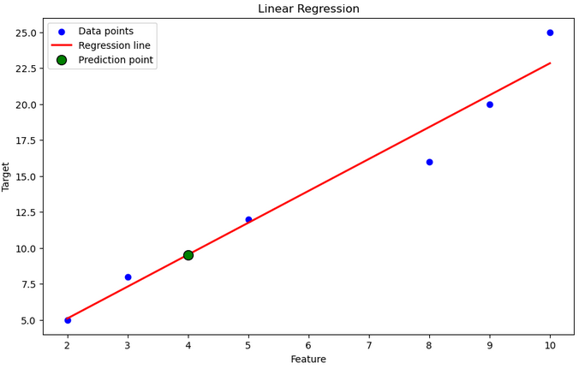

ADHWAITH K P
S5 AIML
ROLL NO : 3
29/07/2024

EXPERIMENT NO:1(c)

AIM: Perform linear regression using scikit – learn and plot the data

Program

import pandas as pd
import matplotlib.pyplot as plt
from io import StringIO
from sklearn.linear_model import LinearRegression

def main():
print("Enter your data with one feature and one target variable in CSV format.like:(Feature,Target)\n finish with an empty line:")
user_input = ""
while True:
line = input()
if line == "":
break
user_input += line + "\n"
data = StringIO(user_input)
df = pd.read_csv(data)
if df.shape[1] != 2:
print("The data must have exactly 2 columns (1 feature and 1 target).")
return
X = df.iloc[:, [0]].values
y = df.iloc[:, 1].values

model = LinearRegression()
model.fit(X, y)
try:
predict_value = float(input("\nEnter a value to predict (for the feature): "))
prediction = model.predict(np.array([[predict_value]]))
print(f"Prediction for feature value {predict_value}: {prediction[0]}")
except ValueError:
print("Invalid input for prediction. Please enter a numeric value.")
plt.figure(figsize=(10, 6))
# Plot the original data points
plt.scatter(X, y, color='blue', label='Data points')

# Plot the regression line
# Generate a range of values for plotting the line
X_range = np.linspace(X.min(), X.max(), 100).reshape(-1, 1)
y_pred = model.predict(X_range)
plt.plot(X_range, y_pred, color='red', linewidth=2, label='Regression line')

plt.scatter([predict_value], prediction, color='green', s=100, edgecolor='black', zorder=5, label='Prediction point')

plt.xlabel('Feature')
plt.ylabel('Target')
plt.title('Linear Regression')
plt.legend()
plt.show()

main()

ADHWAITH K P
S5 AIML
ROLL NO : 3
29/07/2024

EXPERIMENT NO:1(d)

AIM: Plot iris data set using matplotlib

Program

import matplotlib.pyplot as plt
from sklearn.datasets import load_iris
import pandas as pd

iris=load_iris()
data=iris.data
target=iris.target
target_names=iris.target_names
feature_names=iris.feature_names

df=pd.DataFrame(data,columns=feature_names)
df['species']=target
plt.figure(figsize=(12,8))

plt.subplot(2,2,1)
for species in range(len(target_names)):
subset=df[df['species']==species]
plt.scatter(subset[feature_names[0]],subset[feature_names[1]],label=target_names[species])
plt.xlabel(feature_names[0])
plt.ylabel(feature_names[1])
plt.title('Sepal Length vs Sepal Width')
plt.legend()

plt.subplot(2,2,2)
for species in range(len(target_names)):
subset=df[df['species']==species]
plt.scatter(subset[feature_names[0]],subset[feature_names[2]],label=target_names[species])
plt.xlabel(feature_names[0])
plt.ylabel(feature_names[2])
plt.title('Sepal Length vs Petal Length')
plt.legend()

plt.subplot(2,2,3)
for species in range(len(target_names)):
subset=df[df['species']==species]
plt.scatter(subset[feature_names[1]],subset[feature_names[2]],label=target_names[species])
plt.xlabel(feature_names[1])
plt.ylabel(feature_names[2])
plt.title('Sepal Width vs Petal Length')
plt.legend()

plt.subplot(2,2,4)
for species in range(len(target_names)):
subset=df[df['species']==species]
plt.scatter(subset[feature_names[2]],subset[feature_names[3]],label=target_names[species])
plt.xlabel(feature_names[2])
plt.ylabel(feature_names[3])
plt.title('Petal Length vs Petal Width')
plt.legend()

plt.tight_layout()
plt.show()

Output

