ADHWAITH K P
S5 AIML
ROLL NO : 3
01/09/2024

EXPERIMENT NO:4

Program 1

import pandas as pd
import numpy as np

train_data_m = pd.read_csv("/home/cs-ai-03/adhwaith/LAB/cycle3/Buy_Computer.csv")
train_data_m = train_data_m.drop(columns=['id'])

def calc_total_entropy(train_data, label, class_list):
total_row = train_data.shape[0]
total_entr = 0

for c in class_list:
total_class_count = train_data[train_data[label] == c].shape[0]
total_class_entr = - (total_class_count/total_row)*np.log2(total_class_count/total_row)
total_entr += total_class_entr

return total_entr

def calc_entropy(feature_value_data, label, class_list):
class_count = feature_value_data.shape[0]
entropy = 0

for c in class_list:
label_class_count = feature_value_data[feature_value_data[label] == c].shape[0]
entropy_class = 0
if label_class_count != 0:
probability_class = label_class_count/class_count
entropy_class = - probability_class * np.log2(probability_class)
entropy += entropy_class
return entropy

def calc_info_gain(feature_name, train_data, label, class_list):
feature_value_list = train_data[feature_name].unique()
total_row = train_data.shape[0]
feature_info = 0.0

for feature_value in feature_value_list:
feature_value_data = train_data[train_data[feature_name] == feature_value]
feature_value_count = feature_value_data.shape[0]
feature_value_entropy = calc_entropy(feature_value_data, label, class_list)
feature_value_probability = feature_value_count/total_row
feature_info += feature_value_probability * feature_value_entropy

return calc_total_entropy(train_data, label, class_list) - feature_info

def find_most_informative_feature(train_data, label, class_list):
feature_list = train_data.columns.drop(label)
max_info_gain = -1
max_info_feature = None

for feature in feature_list:
feature_info_gain = calc_info_gain(feature, train_data, label, class_list)
if max_info_gain < feature_info_gain:
max_info_gain = feature_info_gain
max_info_feature = feature

return max_info_feature

def generate_sub_tree(feature_name, train_data, label, class_list):
feature_value_count_dict = train_data[feature_name].value_counts(sort=False)
tree = {}
for feature_value, count in feature_value_count_dict.items():
feature_value_data = train_data[train_data[feature_name] == feature_value]
assigned_to_node = False
for c in class_list:
class_count = feature_value_data[feature_value_data[label] == c].shape[0]

if class_count == count:
tree[feature_value] = c
train_data = train_data[train_data[feature_name] != feature_value]
assigned_to_node = True
if not assigned_to_node:
tree[feature_value] = "?"

return tree, train_data

def make_tree(root, prev_feature_value, train_data, label, class_list):
if train_data.shape[0] != 0:
max_info_feature = find_most_informative_feature(train_data, label, class_list)
tree, train_data = generate_sub_tree(max_info_feature, train_data, label, class_list)
next_root = None

if prev_feature_value is not None:
root[prev_feature_value] = dict()
root[prev_feature_value][max_info_feature] = tree
next_root = root[prev_feature_value][max_info_feature]
else:
root[max_info_feature] = tree
next_root = root[max_info_feature]

for node, branch in list(next_root.items()):
if branch == "?":
feature_value_data = train_data[train_data[max_info_feature] == node]
make_tree(next_root, node, feature_value_data, label, class_list)

def id3(train_data_m, label):
train_data = train_data_m.copy()
tree = {}
class_list = train_data[label].unique()
make_tree(tree, None, train_data, label, class_list)
return tree

tree = id3(train_data_m, 'Buy_Computer')

def print_tree(tree, indent=""):
if isinstance(tree, dict):
for key, value in tree.items():
print(f"{indent}|---{key}:")
print_tree(value, indent + " ")
else:
print(f"{indent}{tree}")

def predict(tree, instance):
if not isinstance(tree, dict):
return tree
else:
root_node = next(iter(tree))
feature_value = instance[root_node]
if feature_value in tree[root_node]:
return predict(tree[root_node][feature_value], instance)
else:
return None

def evaluate(tree, test_data_m, label):
correct_predict = 0
wrong_predict = 0
for index, row in test_data_m.iterrows():
result = predict(tree, test_data_m.iloc[index])
if result == test_data_m[label].iloc[index]:
correct_predict += 1
else:
wrong_predict += 1
accuracy = correct_predict / (correct_predict + wrong_predict)
return accuracy

def predict_class(tree, instance):
return predict(tree, instance)

def get_user_input(features):
user_input = {}
for feature in features:
user_input[feature] = input(f"Enter value for {feature}: ")
return pd.Series(user_input)

test_data_m = pd.read_csv("/home/cs-ai-03/juhaina/Buy_Computer.csv")
test_data_m = test_data_m.drop(columns=['id'])

accuracy = evaluate(tree, test_data_m, 'Buy_Computer')
print(f"Accuracy: {accuracy}")

print("\nDecision Tree:")
print_tree(tree)

features = ['age', 'income', 'student', 'credit_rating']
user_instance = get_user_input(features)

predicted_class = predict_class(tree, user_instance)
print(f"\nTest Instance:\n{user_instance}")
print(f"Predicted Class: {predicted_class}")

def find_closest_instance(user_instance, dataset, features):
for index, row in dataset.iterrows():
if all(row[feature] == user_instance[feature] for feature in features):
return row
return None

closest_instance = find_closest_instance(user_instance, test_data_m, features)
if closest_instance is not None:
actual_class = closest_instance['Buy_Computer']
print(f"Actual Class: {actual_class}")

OUTPUT 1

Accuracy: 1.0

Decision Tree:
|---age:
|---youth:
|---student:
|---no:
no
|---yes:
yes
|---middle_age:
yes
|---senior:
|---credit_rating:
|---fair:
yes
|---excellent:
no
Enter value for age: youth
Enter value for income: medium
Enter value for student: yes
Enter value for credit_rating: fair

Test Instance:
age youth
income medium
student yes
credit_rating fair
dtype: object
Predicted Class: yes

OUTPUT 2

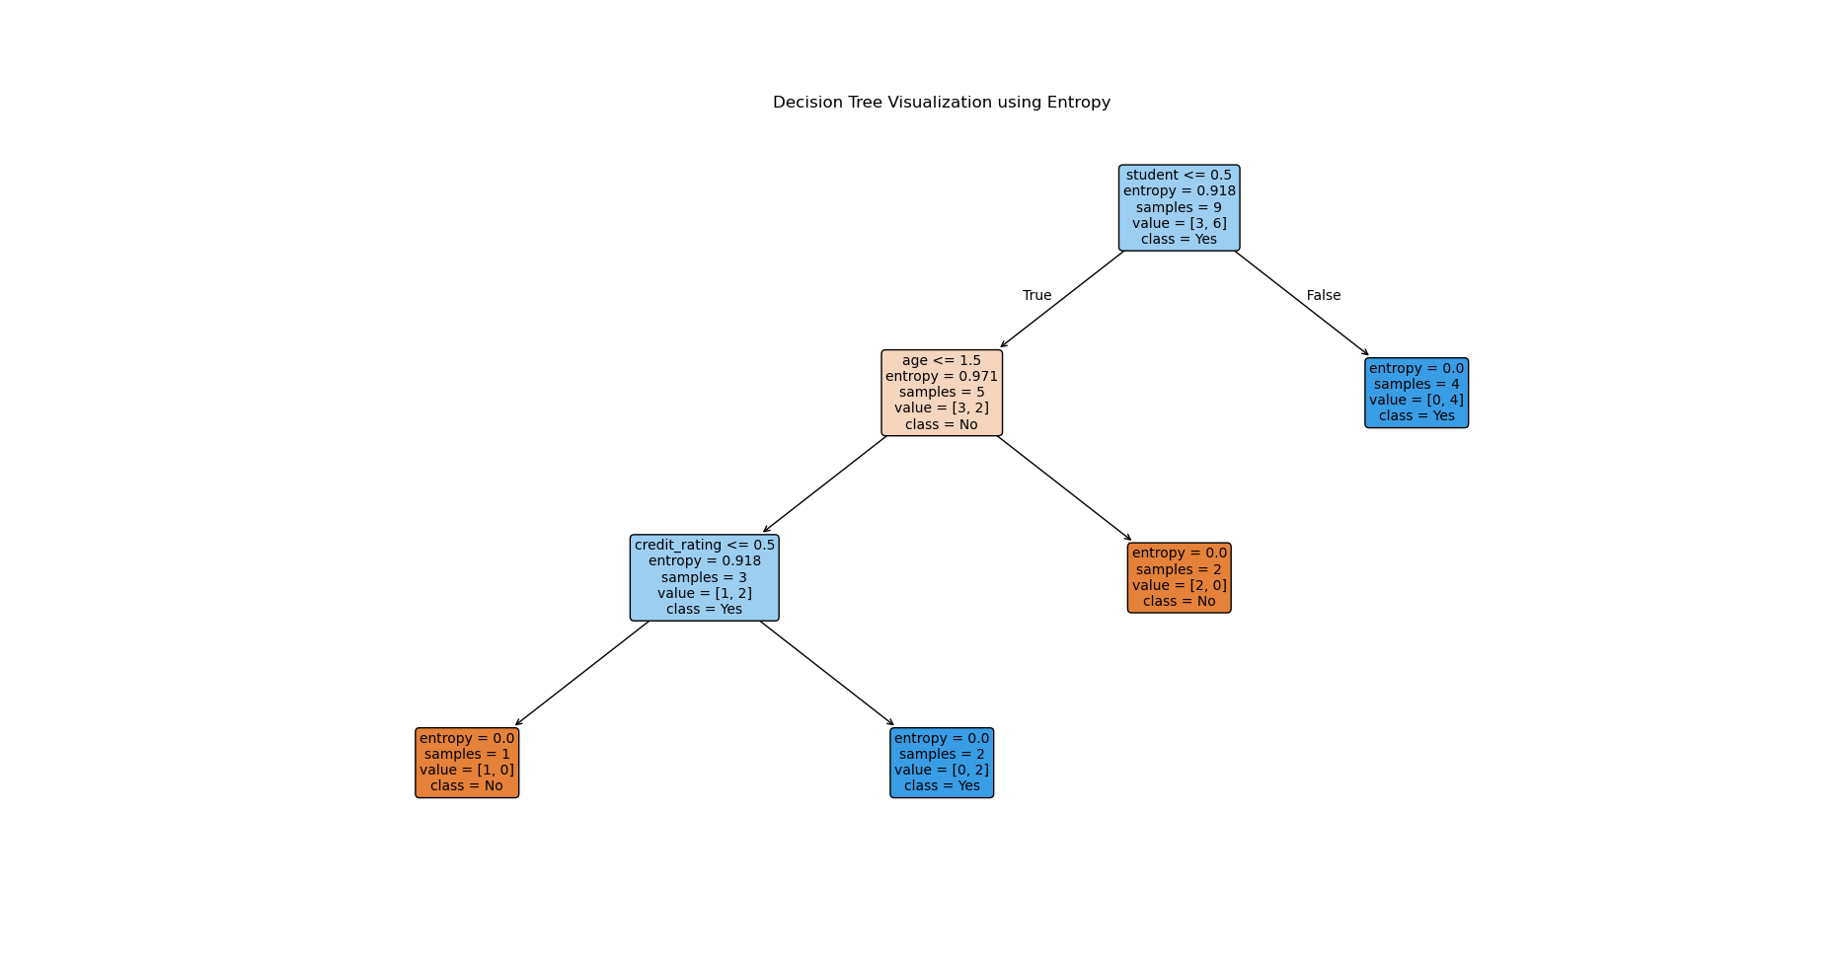

Program 2
import pandas as pd
from sklearn.model_selection import train_test_split
from sklearn.tree import DecisionTreeClassifier, plot_tree
import matplotlib.pyplot as plt
from sklearn.preprocessing import LabelEncoder

data = pd.read_csv("/home/cs-ai-03/adhwaith/LAB/cycle3/Buy_Computer.csv")
data = data.drop(columns=['id'])

label_encoders = {}
for column in data.columns:
if data[column].dtype == 'object':
le = LabelEncoder()
data[column] = le.fit_transform(data[column])
label_encoders[column] = le

X = data.drop(columns=['Buy_Computer'])
y = data['Buy_Computer']

X_train, X_test, y_train, y_test = train_test_split(X, y, test_size=0.3, random_state=42)

clf = DecisionTreeClassifier(criterion='entropy')
clf.fit(X_train, y_train)

plt.figure(figsize=(20, 10))
plot_tree(clf,
feature_names=X.columns.tolist(),
class_names=['No', 'Yes'],
filled=True,
rounded=True,
fontsize=10)
plt.title('Decision Tree Visualization using Entropy')
plt.show()

def get_user_input(features, label_encoders):
user_input = {}
for feature in features:
value = input(f"Enter value for {feature}: ")
if feature in label_encoders:
user_input[feature] = label_encoders[feature].transform([value])[0]
else:
user_input[feature] = value
return pd.DataFrame([user_input], columns=features)

features = X.columns.tolist()
user_instance = get_user_input(features, label_encoders)
predicted_class = clf.predict(user_instance)
class_names = ['No', 'Yes']
predicted_class_label = class_names[predicted_class[0]]
print(f"Predicted Class: {predicted_class_label}")

