Source

<http://www.elasticsearch.org/guide/en/elasticsearch/reference/current/docs-bulk.html>

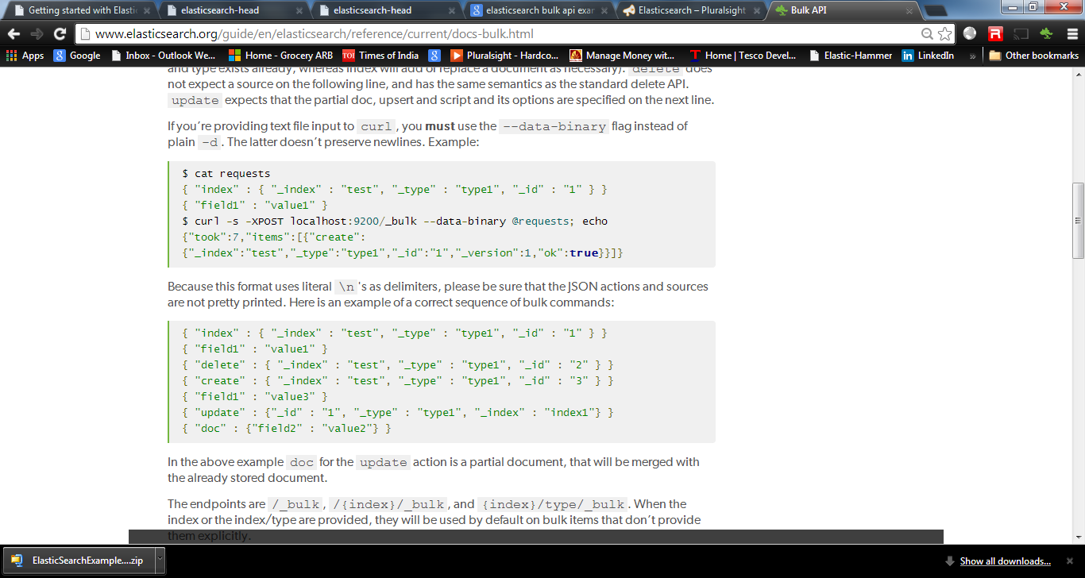

Testing on local machine

------------------

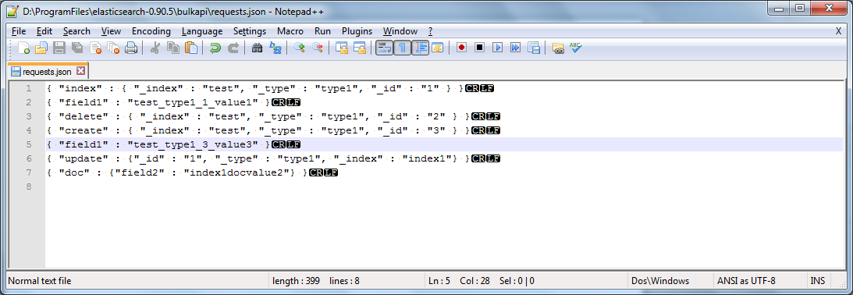

{ "index" : { "_index" : "test", "_type" : "type1", "_id" : "1" } }

{ "field1" : "test_type1_1_value1" }

{ "delete" : { "_index" : "test", "_type" : "type1", "_id" : "2" } }

{ "create" : { "_index" : "test", "_type" : "type1", "_id" : "3" } }

{ "field1" : "test_type1_3_value3" }

{ "update" : {"_id" : "1", "_type" : "type1", "_index" : "index1"} }

{ "doc" : {"field2" : "index1docvalue2"} }

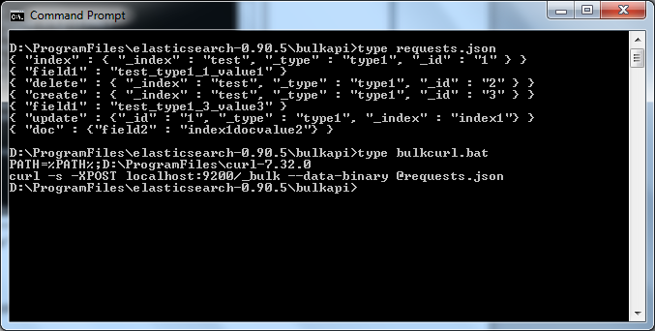

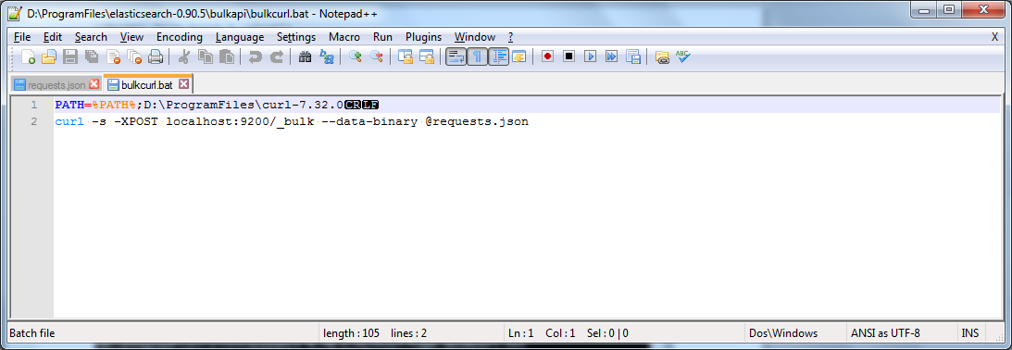

PATH=%PATH%;D:\ProgramFiles\curl-7.32.0

curl -s -XPOST localhost:9200/_bulk --data-binary @requests.json

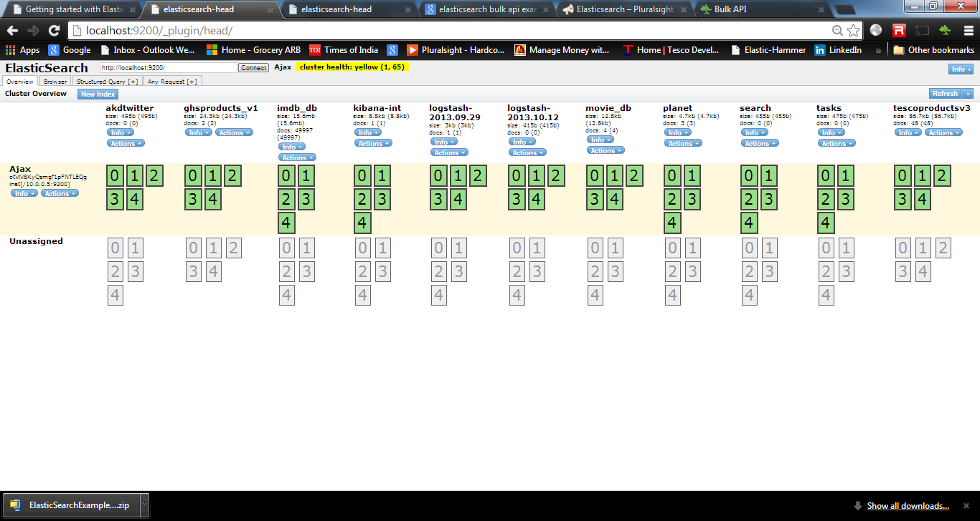

Check that we do not indexs – test or index1

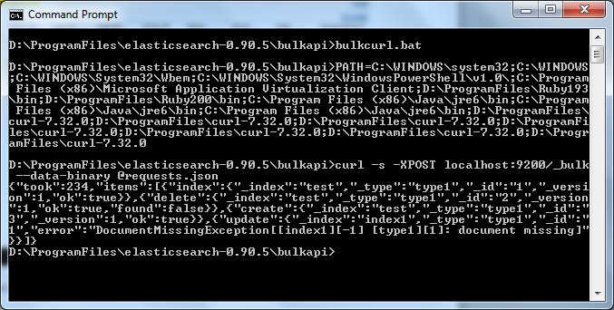

Note : Two new indexs are created

