Blockchain-Based Money Laundering Detection and Monitoring System

Abstract
Money laundering is a significant financial crime in which illegally gained funds are passed through a series of transactions to disguise their origin. Conventional financial monitoring systems usually rely on centralized databases and specific rules, resulting in issues connected to transparency, data integrity, tracking of transactions, and sharing of information between organizations. This project suggests developing a Blockchain-Based Money Laundering Detection and Monitoring System that would utilize such technologies as blockchain, smart contracts, rule-based Anti-Money Laundering checks, data storage, and transaction monitoring
The proposed system would offer dashboards for users, donors, receivers, and administrators, as well as monitoring functions. The transactions would be initiated through a web or mobile interface and would be processed through smart contracts. Before recording the transaction, an AML checking algorithm would assess if the transaction meets any of the suspicious criteria, thus initiating a transaction freeze. Then, either the system or the administrators would review the transaction and decide whether to allow it or not. The transaction metadata would be available for auditing on the blockchain, while more relevant information could be stored in a centralized database.
The proposed system would offer transparency in financial transactions, the ability to store tamper-proof data, increase visibility, and improve accountability in financial operations. In the future, the system could be expanded to include such features as machine-learning-based anomaly detection and monitoring.

Keywords: Blockchain, Money Laundering, Anti-Money Laundering, AML, Smart Contracts, Suspicious Transaction Detection, Financial Monitoring, Ethereum, Transaction Analysis, Cybersecurity.

Introduction

With the growth of digital payments, online banking, cryptocurrency platforms, electronic fund transfers, and financial applications, money can be transferred quickly between individuals and organizations. These technologies make financial services more accessible and convenient, but the speed and volume of digital transactions can also make it difficult to identify funds connected with illegal activities. Financial systems therefore need reliable methods to validate transactions, monitor unusual activity, and maintain records that can be examined when concerns arise.
Money laundering is the process of concealing the illegal origin of money or other assets so that they appear to come from legitimate sources. It may involve several transfers, the use of multiple accounts, or transactions between different parties to make the source and movement of funds harder to trace. Such activity can support other crimes and weaken trust in financial institutions. Detecting suspicious transactions is challenging because an individual transaction may appear normal when viewed alone, while a wider sequence of activity may require additional investigation.
Anti-Money Laundering (AML) systems are used by financial institutions and other regulated organizations to identify, assess, and report potentially suspicious financial activity. These systems may apply transaction rules, customer information, risk indicators, and monitoring procedures to decide which activities require further review. Effective monitoring should support timely identification of unusual transactions while allowing legitimate financial activity to continue. A transaction flagged by a rule is not, by itself, proof of a crime; it is an indication that further assessment may be needed.
Many conventional AML solutions depend on centralized databases, predefined rules, transaction records, user information, and monitoring tools. Centralized systems can be useful, but their effectiveness may depend on the reliability of the database, the access controls in place, and the ability of authorized participants to verify the history of a transaction. Where records are managed separately, sharing consistent information and maintaining a trusted audit trail can also become difficult.

However, centralized systems can create several challenges:

- Dependence on a central authority
- Possibility of database manipulation
- Limited transparency
- Difficulty in sharing trusted transaction information
- Manual investigation of suspicious transactions
- Large numbers of transactions requiring monitoring
- Difficulty maintaining an immutable transaction history

a large number of transactions to review, and challenges maintaining an audit trail.
Blockchain offers a distributed digital ledger, where entries are made in a tamper-evident manner and smart contracts can enforce rules and verify transactions.

This paper proposes a solution that utilizes both blockchain and smart contracts to monitor financial transactions, detect suspicious activity and maintain an audit trail.

Problem Statement

The main problem addressed by this project is:
= How can blockchain and smart-contract technology be used to monitor financial transactions, identify potentially suspicious transactions, and maintain a secure and tamper-resistant transaction history?

The system focuses on detecting and preventing suspicious financial activity, rather than enabling money laundering.

Objectives

The following are the objectives of this project:

- To develop a blockchain based financial transaction monitoring system.

- To implement an AML (anti-money laundering) checking procedure.

- To identify transactions that do not comply with a given set of rules.

- To record authorized financial transactions to the blockchain.

- To identify and report suspicious transactions for review.

- To provide a secure record of financial transactions.

- To maintain a verifiable transaction trail.

- To provide varying levels of access to the system.

- To improve transparency and accountability.

- To create a framework for future artificial intelligence (AI) based suspicious-transaction detection.

Proposed System

The proposed system can be divided into 5 modules:

5.1 User Module
The user module handles user registration, login and profile management.
It also lets users make transactions and view transaction details/history.

5.2 Donor Module
The donor module represents a person or an entity that makes a donation or transfers funds to a receiver.
It allows a registered user to enter the details of a receiver, specify the amount of the transaction and any additional notes. The user can view the status of a transaction.

5.3 Receiver Module
The receiver module is similar to the user module, but it is used to view and manage incoming transactions. It also allows the receiver to view the status and details of a transaction.

5.4 Monitoring Module
The monitoring module is used to view and review transactions, including reviewing transactions for suspicious activity, viewing transaction history and details and reviewing suspicious transactions.

5.5 Admin Module
The admin module is used to manage users and donors, review and manage transactions, view and manage AML monitoring rules, and view and manage system logs and permissions.

System Architecture

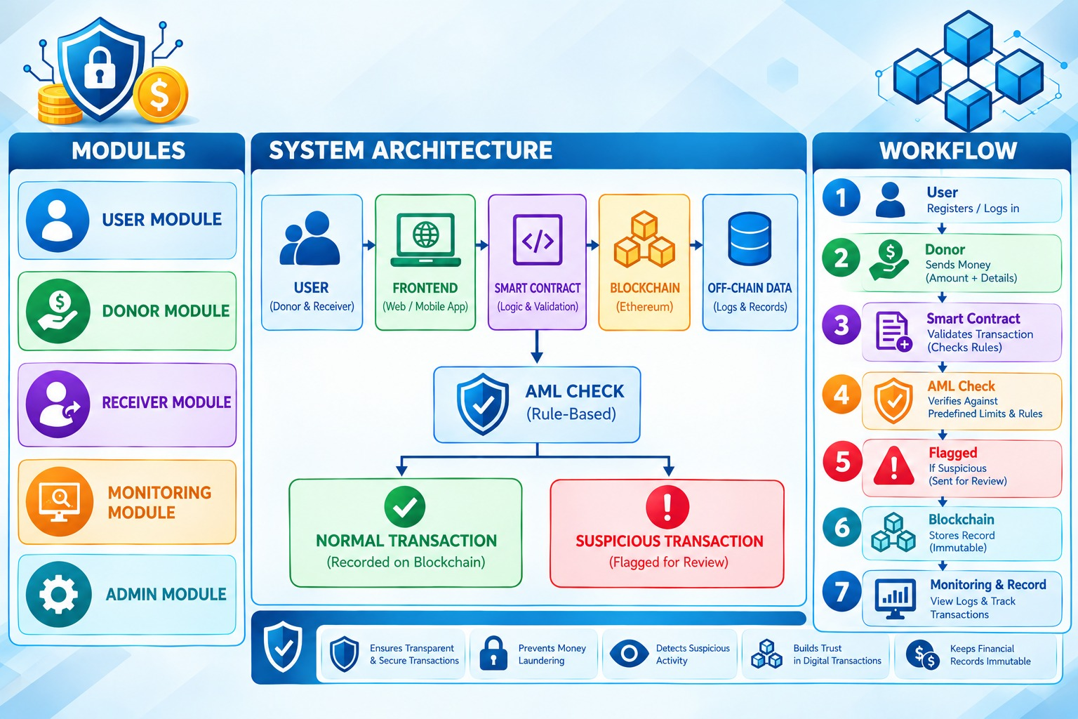

Transaction Workflow
The complete workflow of the proposed system is:
Step 1 – User Registration
The user registers with the system and provides the required information.

Step 2 – Login
The user authenticates using their credentials.

Step 3 – Transaction Initiation
The donor enters:
- Receiver ID
- Transaction amount
- Transaction purpose/details
- Other required information

Step 4 – Smart Contract Validation
- The smart contract checks whether:
- The sender is authorized.
- The receiver is valid.
- Required transaction information is present.
- Transaction conditions are satisfied.

Step 5 – AML Check
- The transaction is passed to the AML checking mechanism
- The system checks predefined conditions such as
- Transaction amount
- Transaction frequency
- Repeated transactions
- Unusual transaction patterns
- Account-related restrictions
- Configured risk rules

Step 6 – Decision
The transaction is classified into:
Normal Transaction
or
Suspicious Transaction

Step 7 – Blockchain Recording
A valid transaction is recorded on the blockchain.

Step 8 – Suspicious Transaction Alert
If a transaction satisfies suspicious-activity rules, it is flagged and sent to the monitoring/admin module for review.

Step 9 – Monitoring
- Authorized personnel can view:
- Transaction details
- Transaction status
- Transaction history
- Suspicious alerts
- Blockchain records

AML Detection Mechanism
The AML component is the main detection component of the system.
A simple rule-based risk score can be represented as:
$$R=w_{1}A+w_{2}F+w_{3}P+w_{4}H$$

where:
- $A$= amount-related risk
- $F$= transaction-frequency risk
- $P$= transaction-pattern risk
- $H$= historical risk
- $w_{1},w_{2},w_{3},w_{4}$= corresponding weights
A threshold can then be defined:
$$Decision=\left\{\begin{matrix}Normal, & R<T \\ Suspicious, & R≥T\end{matrix}\right.$$
where T represents the configured risk threshold.
This is a conceptual model; actual thresholds should be determined through testing and appropriate financial/compliance requirements.

Example AML Rules
The system can contain configurable rules such as:
Rule | Condition | Action
R1 | Amount exceeds configured threshold | Flag
R2 | Multiple rapid transactions | Review
R3 | Unusual transaction frequency | Flag
R4 | Repeated unusual patterns | Review
R5 | Account violates configured restriction | Reject/Review
R6 | High calculated risk score | Flag
These rules should be treated as configurable detection policies, rather than universal definitions of money laundering.
Smart Contract
The smart contract acts as the transaction validation and blockchain interaction layer.
Main functions
registerUser()
createTransaction()
validateTransaction()
performAMLCheck()
recordTransaction()
flagTransaction()
getTransaction()
getTransactionHistory()

Pseudocode Algorithm

BEGIN

INPUT senderDetails, receiverDetails, transactionData

IF userLogin() == FALSE THEN
DISPLAY "Login Failed"
STOP
END IF

IF validateSender(senderDetails) == FALSE OR
validateReceiver(receiverDetails) == FALSE OR
validateTransaction(transactionData) == FALSE THEN

transactionStatus = "REJECTED"
storeLogs(transactionStatus)
DISPLAY transactionStatus
STOP

END IF

suspicious = performAMLCheck(transactionData)

IF suspicious == TRUE THEN

transactionStatus = "SUSPICIOUS"
generateAlert(transactionData)
sendToMonitoringModule(transactionData)

ELSE

transactionStatus = "NORMAL"
recordOnBlockchain(transactionData)

END IF

storeLogs(transactionStatus)
DISPLAY transactionStatus

END

Blockchain Component
The blockchain maintains important transaction information in a tamper-evident ledger.
A transaction record can contain:
Transaction ID
Sender ID
Receiver ID
Amount
Timestamp
Transaction Status
Risk Status
Blockchain Hash
The blockchain provides:
Immutability
Once a transaction is recorded, unauthorized modification becomes difficult.
Transparency
Authorized participants can verify transaction records.
Traceability
Transaction history can be followed through blockchain records.
Accountability
Each transaction is associated with a recorded transaction event.

Off-Chain Storage
Not every piece of information should be stored directly on the blockchain.
Off-chain storage can contain:
- User profile information
- Detailed logs
- Supporting documents
- Monitoring records
- Investigation notes
- Additional transaction information
The blockchain can store references or hashes associated with these records.
This approach can reduce blockchain storage requirements.

Security Mechanisms
The system should implement multiple security mechanisms.

Authentication
Users must authenticate before accessing the system.

Authorization
Different users receive different permissions.

Encryption
Sensitive information should be encrypted during storage and transmission.

Hashing
Transaction and supporting records can use cryptographic hashing to detect modification.

Smart Contract Security
Smart contracts should be tested and audited to reduce vulnerabilities.

Audit Logging
Important actions should be recorded for later investigation.

Monitoring Dashboard
The monitoring module can provide an administrator dashboard containing:
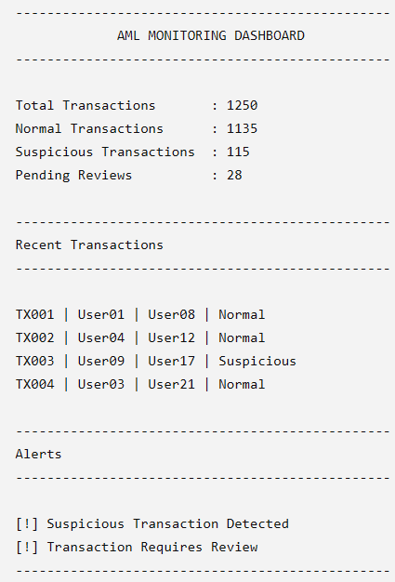
Performance Evaluation
Test Case | Transaction Scenario | AML System Response | Expected Result
1 | A customer transfers ₹2,000 to another registered customer. | Transaction passes the predefined AML checks. | Normal transaction
2 | A customer attempts a transaction that exceeds the configured transaction limit. | The system flags the transaction for further review. | Suspicious transaction
3 | A blacklisted customer attempts to initiate a transaction. | The smart contract rejects the transaction. | Transaction rejected
4 | An unauthorized user attempts to perform a restricted operation. | The smart contract denies access. | Access denied
5 | An authorized transaction is successfully completed. | Transaction details are recorded on the blockchain. | Transaction recorded successfully
6 | An administrator reviews a flagged transaction. | The monitoring module displays the relevant transaction details and status. | Transaction available for review

Literature Survey
Tadaskar et al. (2022) explored blockchain-based transaction monitoring using predefined rules and transaction histories to identify suspicious activities. Their approach supports transparent transaction tracking, but rule-based methods may struggle to detect complex money laundering patterns.
Pocher et al. (2023) investigated machine-learning and graph-based techniques for detecting anomalous cryptocurrency transactions. These methods can identify unusual transaction relationships, although their performance depends on suitable datasets and computational resources.
Kayikci and Khoshgoftaar (2024) reviewed the integration of blockchain and machine learning for financial security. Their work highlighted the potential of blockchain for maintaining reliable transaction records and machine learning for identifying suspicious patterns.
The TMAS approach (2024) used transaction graphs and heuristic methods to identify potentially suspicious financial activities. However, processing large transaction networks can require considerable computational resources.
Liu et al. (2025) reviewed rule-based, machine-learning, and deep-learning techniques for anti-money laundering. The study highlighted challenges involving data availability, privacy, and the detection of complex laundering activities.
Research Gap
Existing AML approaches can involve complex algorithms, large datasets, and significant computational resources. Therefore, this project proposes a simpler blockchain-based system that applies predefined rules to verify transactions, identify suspicious activities, restrict unauthorized operations, and maintain transparent and verifiable transaction records. The system aims to demonstrate how blockchain and smart contracts can support transaction monitoring and improve the traceability of financial activities.

Expected Results
The proposed system is expected to provide:
- Automated transaction validation.
- Faster identification of rule-based suspicious transactions.
- Tamper-evident transaction records.
- Better transaction traceability.
- Controlled access to financial information.
- Centralized monitoring through the dashboard.
- Improved auditability of transaction activities.
Important: These are expected/project objectives, not measured experimental results. Actual percentages should only be added after testing the implemented system.

Conclusion
The Blockchain-Based Money Laundering Detection and Monitoring System provides a secure architecture for monitoring financial transactions and identifying potentially suspicious activities. The system combines user and transaction modules with smart contracts, blockchain technology, predefined Anti-Money Laundering (AML) rules, off-chain storage, and an administrative monitoring dashboard. By integrating these components, the proposed system aims to improve transaction monitoring, data integrity, transparency, and accountability in financial operations.
The system workflow begins with user registration and transaction initiation. The smart contract validates the transaction details and checks whether the transaction satisfies the required conditions. Subsequently, the AML module evaluates the transaction using predefined rules, such as transaction amount, transaction frequency, unusual transaction patterns, and account-related restrictions. Transactions classified as normal can be recorded on the blockchain, while potentially suspicious transactions are flagged and forwarded to the monitoring module for further investigation. This approach supports the systematic identification of transactions that require additional attention.
Blockchain technology provides a tamper-evident transaction history that can support auditing and transaction traceability. Smart contracts help automate transaction validation and the application of predefined rules, reducing the need for manual intervention in routine checks. In addition, off-chain storage can be used to maintain detailed user information, supporting documents, and investigation records without storing all sensitive information directly on the blockchain. The administrative dashboard further supports the monitoring process by allowing authorized personnel to review transaction details, examine suspicious alerts, and access relevant records.
However, the effectiveness of the proposed system depends on the accuracy of its AML rules, the quality of the available transaction data, and the security of its implementation. A rule-based approach may not identify every sophisticated money laundering technique, particularly when suspicious activities involve complex transaction networks or patterns that are not covered by the configured rules. Furthermore, blockchain technology improves record integrity and traceability but does not independently guarantee that every recorded transaction is legitimate. Suspicious transactions therefore require appropriate investigation and review by authorized personnel.
Future enhancements could include integrating machine learning algorithms to identify previously unknown suspicious patterns, graph-based analysis to examine relationships between transactions and accounts, and real-time analytics to improve monitoring efficiency. Additional improvements could involve stronger identity verification, role-based access control, enhanced privacy protection, comprehensive security testing, and evaluation using suitable transaction datasets. These enhancements could help improve the system's detection capabilities, scalability, and practical applicability.
In conclusion, the proposed Blockchain-Based Money Laundering Detection and Monitoring System demonstrates how blockchain technology and smart contracts can be combined with rule-based AML mechanisms to support secure and transparent financial transaction monitoring. Although further testing and development are required before practical financial deployment, the system provides a foundation for developing more reliable, traceable, and adaptable AML monitoring solutions.

References
- Tadaskar, S., Golhar, B., Rathod, R., and Kadam, S. (2022). “Blockchain Technology and Money Laundering.” International Journal of Novel Research and Development, 7(12), c179–c184. Available: https://ijnrd.org/viewpaperforall.php?paper=IJNRD2212221
- Pocher, N., Zichichi, M., Merizzi, F., Shafiq, M. Z., et al. (2023). “Detecting Anomalous Cryptocurrency Transactions: An AML/CFT Application of Machine Learning-Based Forensics.” Electronic Markets, 33, Article 37. DOI: 10.1007/s12525-023-00654-3.
- Kayikci, S., and Khoshgoftaar, T. M. (2024). “Blockchain Meets Machine Learning: A Survey.” Journal of Big Data, 11, Article 9. DOI: 10.1186/s40537-023-00852-y.
- Huang, S., et al. (2024). “TMAS: A Transaction Misbehavior Analysis Scheme for Blockchain.” Blockchain: Research and Applications, 5(3), Article 100197. DOI: 10.1016/j.bcra.2024.100197.
- “Blockchain Solutions with Consensus Algorithms and Immediate Finality: Toward Panopticon-Style Monitoring to Enhance Anti-Money Laundering.” (2024). Electronic Commerce Research and Applications, 65, Article 101386. Available: https://www.sciencedirect.com/science/article/pii/S1567422324000310
- Liu, L., Li, X., Lan, T., Cheng, Y., Chen, W., Li, Z., Cao, S., Han, W., Zhang, X., and Chai, H. (2025). “A Survey on Anti-Money Laundering Techniques in Blockchain Systems.” Strategic Study of CAE, 27(2), 287–303. DOI: 10.15302/J-SSCAE-2024.11.025.
- Asiri, A., and Somasundaram, K. (2025). “Graph Convolution Network for Fraud Detection in Bitcoin Transactions.” Scientific Reports, 15, Article 11076. DOI: 10.1038/s41598-025-95672-w. Publisher article
- Ferretti, S., D’Angelo, G., and Ghini, V. (2025). “Enhancing Anti-Money Laundering Frameworks: An Application of Graph Neural Networks in Cryptocurrency Transaction Classification.” IEEE Access, 13, 50201–50215. DOI: 10.1109/ACCESS.2025.3552240. Publication record
- Liang, Y., Wu, W., Liang, R., Chen, Y., Lei, K., Zhong, G., Zhang, J., Gan, Q., and Huang, J. (2025). “A Plug-and-Play Data-Driven Approach for Anti-Money Laundering in Bitcoin.” Expert Systems with Applications, 266, Article 126072. DOI: 10.1016/j.eswa.2024.126072. Publisher article
- “Bitcoin Money Laundering Detection via Subgraph Contrastive Learning.” (2024). Entropy, 26(3), Article 211. DOI: 10.3390/e26030211. Full-text article

