Graph-Based Investment Portfolio Recommendation System Using Neo4j and Graph Analytics via RESTful API

Adhvaitha B
School of Computer Science and Engineering
Vellore Institute of Technology Chennai-600127, Tamilnadu
adhvaitha.b2022@vitstudent.ac.in

Anu Vishali P
School of Computer Science and Engineering
Vellore Institute of Technology Chennai-600127, Tamilnadu
anu.vishali2022@vitstudent.ac.in

Dr. S. Gayathri Devi
Assistant Professor Senior Grade – 2
Vellore Institute of Technology
Chennai-600127,Tamilnadu gayathridevi.s@vit.ac.in
Dr Natarajan B
Assistant professor
Vellore Institute of Technology
Chennai-600127, Tamilnadu
natarajan.b@vit.ac.in

Abstract— The paper presents a Graph-Based Investment Portfolio Recommendation System designed to enhance financial decision-making through intelligent asset relationship modeling and graph-structured learning. The platform integrates a Neo4j graph database with Graph Analytics to deliver personalized, context-aware investment suggestions. A Flask-based RESTful API powers the backend, while D3.js and vis.js support the interactive frontend. The system leverages Graph Data Science (GDS) algorithms—Personalized PageRank, Jaccard Similarity, and Louvain Community Detection—to evaluate inter-stock connectivity, clustering, and relevance scores. Unlike traditional portfolio recommenders that rely on collaborative filtering or price-driven machine learning, this work introduces a real-time, graph-driven pipeline that unifies community detection, relational similarity, and influence scoring to produce interpretable, structure-aware recommendations. This hybrid analytic approach enables explainable insights that classical ML-only systems cannot provide.
Keywords— Investment Recommendation, Neo4j, Flask API, Graph Data Science, Personalized PageRank, Jaccard similarity Louvain Algorithm, D3.js Visualization

I INTRODUCTION
Investment decision-making in volatile financial markets requires analyzing the complex relationships among assets, including correlations, historical trends, and sector-level dynamics. Conventional portfolio recommendation systems typically rely on historical price modeling, collaborative filtering, or machine-learning-based pattern extraction. While effective in certain contexts, these approaches often overlook the underlying relational structure between investors and assets, resulting in limited interpretability and suboptimal personalization.
Graph-driven modeling has recently emerged as a powerful paradigm for capturing structural dependencies in financial ecosystems. Motivated by this, the present work proposes a hybrid graph-analytic portfolio recommendation framework that leverages Louvain community detection, Jaccard similarity, and Personalized PageRank (PPR) through the Neo4j Graph Data Science (GDS) library. By integrating these graph-theoretic components within a real-time RESTful API pipeline, the system produces context-aware, structure-informed, and explainable investment recommendations.
The architecture constructs a multi-entity graph comprising investors, assets, and sector relationships, enabling the identification of community-driven investment patterns and influential nodes within the network. Neo4j’s schema-flexible environment facilitates efficient graph queries and scalable relationship modeling. A Flask-based backend exposes recommendation endpoints, while a D3.js/vis.js dashboard provides interactive visualization of communities, influence flows, and recommended assets.
Overall, the proposed system bridges a critical gap between graph analytics and practical portfolio recommendation. It offers a transparent, scalable, and API-driven alternative to traditional ML-only models, and its effectiveness is evaluated using real market data combined with synthetic investor profiles to demonstrate performance against multiple baseline approaches.

II LITERATURE REVIEW
A. Machine learning-based and hybrid recommendation systems
The early recommendation systems relied on classical machine learning and text-based similarity models. Jain et al. [1] implemented TF-IDF, Cosine Similarity, Naïve Bayes, and clustering to develop a REST-based job recommender that resulted in 78-82% accuracy but did not offer semantic personalization. Ensemble learning methods, such as the one proposed by Leung et al. [2], enhanced the portfolio returns using combined classifiers and regressors; however, they provided limited interpretability of the relationships between investors and assets.
The hybrid systems that combined content-based, collaborative filtering, and graph-augmented features, represented by Sharma et al. [10], presented better precision and recall but were still based on non-relational modeling. Works such as Das et al. [7] presented extensive surveys on the need for explainability, domain constraints, and robust metrics in reliable portfolio recommendations. These collective works constitute a baseline for the present work but also reveal the limitations of methods that are both non-relational and non-graph.

B. Knowledge Graphs, Graph Embeddings, and Relational Financial Modelling
Graph-based modelling has been a major advance in recommendation and prediction systems, where relationships among entities greatly help with the inference.
Graph–enabled architectures such as Wang et al. [3], which presented a GNN–LSTM hybrid, and Sonar et al. [4] with the GNN-based trade recommendation, demonstrated large gains in the representation of relational semantics and link structures, outperforming rule-based and traditional machine learning frameworks. Graph embedding–driven approaches, as proposed by Saxena et al. [5] and Fazli et al. [11], have demonstrated strong potential for discovering latent investor–asset linkages and enhancing diversification via community detection.
For instance, Chen et al. [6] enhanced financial graphs with document embeddings using a multimodal graph recommender system. Graph–time fusion models by Chen et al. [12] achieved higher ranking accuracy through the fusion of structural and temporal signals. These works collectively establish a very strong case for graph-based representation learning. They directly influence the Neo4j graph schema design and the process of computing similarities used in the present work.

C. Advanced GNN Architectures and Neo4j-Driven Recommendation Frameworks Recent research investigates the scalable and explainable graph-driven architectures applicable to real-world deployment.
Neo4j-centric studies, for instance, Raj et al. [8], have shown that interpretable recommendations can be directly produced by means of graph similarity measures, such as the Jaccard similarity, thus confirming that graph databases are appropriate for transparent recommendation logics. Advanced models, such as hierarchical GNNs by Yao et al. [14], time-varying graph attention networks by Korangi et al. [13], and hybrid LSTM-GNN architectures by Sonani et al. [16], outperformed other models, confirming that combining relational and temporal dependencies adds value. Similarly, knowledge-infused forecasting models such as the ones that are proposed by Dukkipati et al. [15], further confirm that external relational data are relevant for improving the accuracy of predictions. Taken together, these studies justify Neo4j's Graph Data Science capabilities for this project, specifically in community detection, link prediction, similarity scoring, and interpretable investor–asset recommendation pipelines.

III METHODOLOGY

The project utilizes a Neo4j-based graph database to represent investors, financial instruments, and historical trading interactions. Each investor and asset is modeled as a node while the relationships such as “invested in,” “correlated with,” and “belongs to sector” form weighted edges.

- System Architecture
The first step is to collect raw data in the CSV format which is collected and preprocessed to extract relevant attributes of investors, assets, and financial indicators. This data is then stored in a Neo4j Graph Database, where nodes represent investors and assets, and relationships capture correlations, investment history, and sector associations. Using GDS algorithms relational insights are extracted to identify similar investors and promising assets. These results are accessed by a Flask Backend (Python API) that serves as a middleware, executing Cypher queries and delivering results through REST Endpoints in JSON format.
Finally, the Frontend Visualization which is built using D3.js and vis.js, converts these JSON outputs into an interactive investor dashboard. Users can explore their portfolio graphically, analyze community clusters, and receive context-aware investment recommendations.

The proposed system Architecture of the Graph-Based Investment Portfolio Recommendation System consists of five major stages, as illustrated in Figure 1.

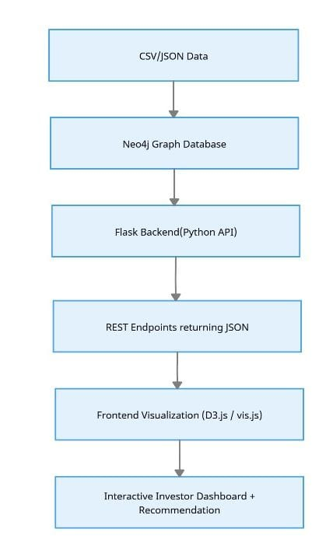
Figure 1. System Architecture
- Modules
The proposed system is made up of a few modules like in Fig. 2. The proposed system architecture is composed of four core layers that put together enables efficient graph-based portfolio recommendation. The Data Layer stores Investor profiles and Generated investor profiles inside the Neo4j graph database which forms the foundation for relationship modelling. The Processing Layer applies GDS algorithms such as Personalized PageRank and Louvain Community Detection to identify investment clusters and influence networks. The Backend Layer which is built using Flask exposes RESTful APIs that handles query execution, runs model inferences and returns structured JSON responses. Finally, the Frontend Layer, which is developed using D3.js and vis.js helps to visualize the resulting investment networks and portfolio recommendations in an interactive and intuitive manner allowing users to explore insights effectively.

- Graph Construction
The graph schema was designed following a multi-entity model where investors and assets form bipartite relationships. For each transaction, an INVESTS_IN edge connects the investor to an asset, weighted by the investment proportion or frequency. Additionally, derived SIMILAR_TO edges were computed using property overlaps such as domain, sector, and historical co-investments. The graph was loaded into Neo4j using the Cypher query language, and the Graph Data Science (GDS) library was used for community and similarity analysis.

Dataset Description
The proposed framework utilizes two complementary data sources to construct the investor–asset interaction graph. The asset dataset was obtained using the Yahoo Finance API, which provided up-to-date market data for publicly traded companies. For each selected asset, metadata such as ticker symbol, company name, sector, 52-week volatility, and average returns were extracted. Historical price data were also used to compute normalized return indicators that serve as additional node properties. Investor-level transaction datasets are highly sensitive, confidential, and not publicly released due to privacy, compliance, and GDPR/SEBI restrictions. Consequently, this work generates a synthetic investor dataset to simulate realistic investment behaviors, including attributes such as investor name, risk tolerance (Low, Medium, High), and domain preferences (Technology, Healthcare, Energy, etc.) while using real asset-level market data. Each synthetic investor was assigned randomized but logically consistent investment patterns and transaction frequencies to mimic heterogeneous portfolio structures. This hybrid data strategy enables reproducibility while ensuring ethical compliance and protecting personal financial identities.
In addition to the synthetic investor profiles and real market asset metadata, this work introduces a new interaction dataset named investor_asset_edges.csv, which explicitly captures historical investment relationships between investors and assets. Each row records a pair (investor_id, asset_symbol) along with the invested_amount field. This dataset enables the construction of a bipartite graph representing investor–asset interactions, which forms the backbone of the recommendation pipeline.
Furthermore, the dataset is split into train_edges.csv (80%) and test_edges.csv (20%) on a per-investor basis. This split enables rigorous offline evaluation of the recommendation model using ranking-based metrics such as Precision@5, Recall@5, NDCG@10, and Mean Average Precision (MAP). The new dataset provides a reproducible, scalable, and fine-grained benchmark for evaluating graph-based portfolio recommendation systems.

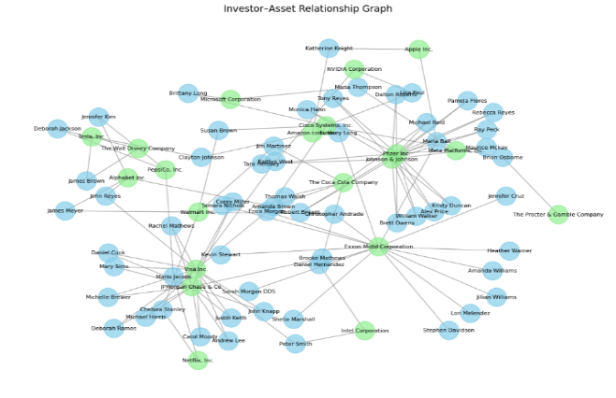
Figure 2. Example Graph Schema and Data Distribution

Algorithms used

The recommendation logic integrates graph-based algorithms from Neo4j’s GDS library.

Personalized PageRank (PPR):

Calculates investor-specific relevance scores for each asset using

p(t+1)=αAp(t)+(1-α)e_u

where Ais the normalized adjacency matrix and e_uis the preference vector for investor u.

Louvain Community Detection:

Groups assets and investors into communities maximizing modularity Q:

Q=∑[A_ij-(k_i k_j)/2m]δ(c_i,c_j)

which identifies sectors or investor groups with strong interrelations.

Jaccard Similarity:

The system also employs Jaccard Similarity to measure node-level overlap between investors and assets based on shared relationships and features.

It is defined as:

J(A,B)=(∣N(A)∩N(B)∣)/(∣N(A)∪N(B)∣)

where N(A)and N(B)denote the sets of neighbors (connections) for nodes Aand B.

A higher Jaccard score indicates stronger similarity between investors with common investment patterns or between assets frequently co-invested in by similar investors.

This similarity metric is used to recommend assets with the highest relational overlap to an investor’s existing portfolio.

F. Recommendation Generation
Recommendations were derived by aggregating assets held by similar investors within the same community. The system prioritizes assets with higher popularity among peers, adjusted by the risk tolerance and domain affinity of the target investor. The final ranked list of assets is computed using a hybrid scoring function combining Jaccard similarity weights, asset popularity within the community, and historical return indicators. Each recommendation result includes supporting context such as similar investors and related community peers, ensuring transparency.

G. RESTful API Integration
To make the recommendation process accessible externally, the entire graph pipeline was wrapped in a RESTful API developed using Flask. Each endpoint performs specific functions—fetching community details, computing similarities, generating asset recommendations, and returning JSON responses to the front-end. This modular API design ensures interoperability with any visualization or mobile interface, providing scalable, on-demand recommendations from the Neo4j backend.

IV. IMPLEMENTATION AND EXPERIMENTAL SETUP

A. Development Environment
The system was implemented using Neo4j 5.15 as the primary graph database, hosted locally with GDS plugins enabled. The backend API was developed in Python (Flask 3.0), with Py2neo and Neo4j Python Driver for database connectivity. Front-end visualization was developed using React.js for interactive dashboards. All experiments were conducted on a system with an Intel i7 processor, 16 GB RAM, and Windows 11 operating system. The Neo4j memory configuration was tuned to handle graphs up to 10,000 nodes efficiently.

B. Graph Database Initialization
The investor and asset datasets were imported using Cypher’s LOAD CSV and Python-based batch inserts. Nodes were created under the labels Investor and Asset, while relationships such as INVESTS_IN, BELONGS_TO, and SIMILAR_TO were dynamically added. Indexes were created on investor_id and asset_symbol to improve lookup performance. A total of 500 investors, 200 assets, and 4500 investment edges were used in the experimental setup.

C. Graph Algorithms and Query Pipeline
The Louvain community detection algorithm was run using the Neo4j GDS procedure as well as PageRank and Jaccard Similarity.
The results persisted as weighted relationships for subsequent recommendation generation. Community, PageRank and similarity outputs were verified by querying representative communities and inspecting top similar investors for validation.

D. Recommendation Engine Workflow
The Flask-based API connects to Neo4j via REST calls. When a user requests recommendations, the API retrieves their communityId, finds similar investors using the SIMILAR_TO relationships, aggregates the assets most frequently invested by those peers, and ranks them based on frequency and similarity score. The results are formatted into JSON objects containing fields such as recommended_assets, community_peers, and similar_investors. This structured response supports integration with both analytical dashboards and client applications.

E. Visualization and User Interface
The React-based front-end provides an interactive dashboard that displays community graphs, peer lists, and recommended assets. Neo4j Bloom and NetworkX visualizations were used during development to validate community structures and similar distributions. The “Get Recommendation” button triggers a REST API call, dynamically updating the investor’s recommended assets and peers in real time, demonstrating full-stack functionality.

V. RESULTS

A. Top Investors
The developed system successfully integrates Neo4j’s graph database with a RESTful API layer to visualize investor–asset relationships and generate community, similarity, and PageRank-based insights. The interactive dashboard allows users to view top investors, detect clusters of similar investors, analyze network influence through PageRank, and receive portfolio recommendations in real time.

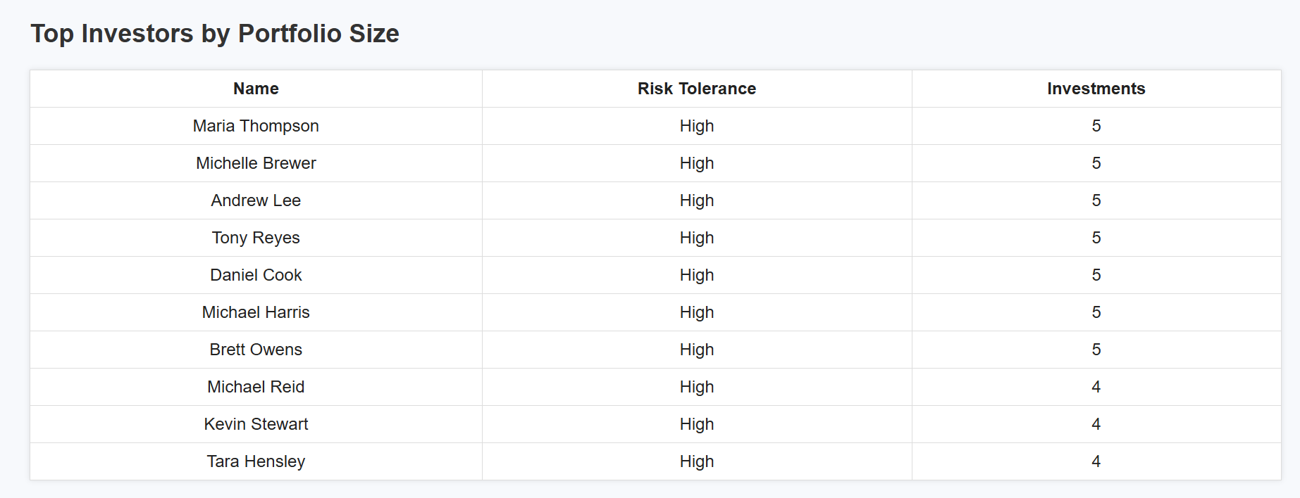
Figure 3: Top Investors by Portfolio Size

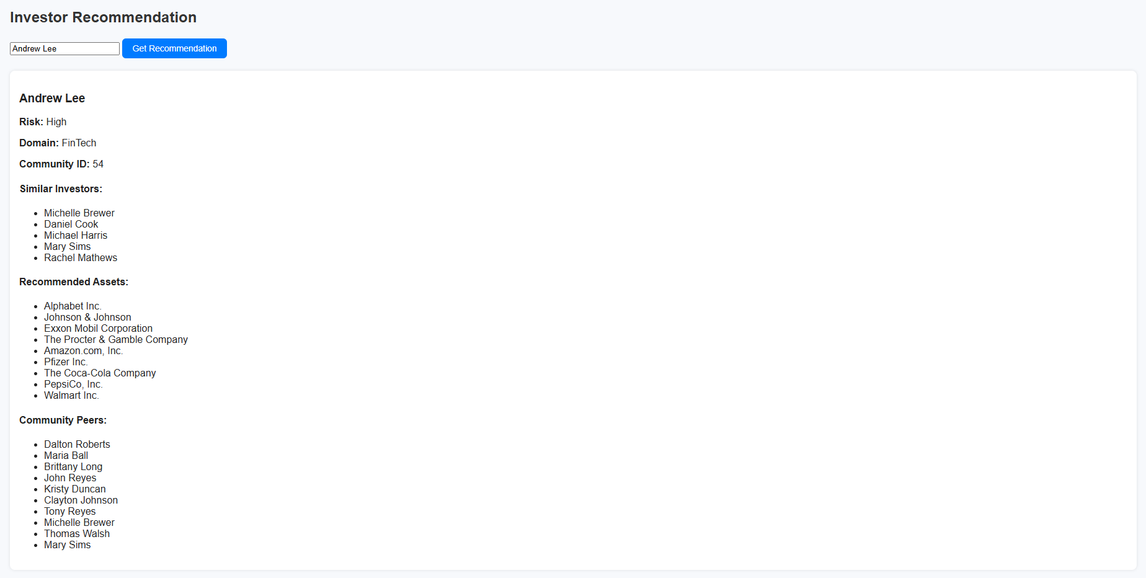
Figure 4: Recommended Investments for Investors

B. Communities
The community detection module (based on Louvain algorithm) revealed distinct investor clusters formed according to shared domain preferences and overlapping investment portfolios. For example, investors with a high concentration in technology and financial assets were grouped into separate communities, reflecting domain-based homophily within the graph.

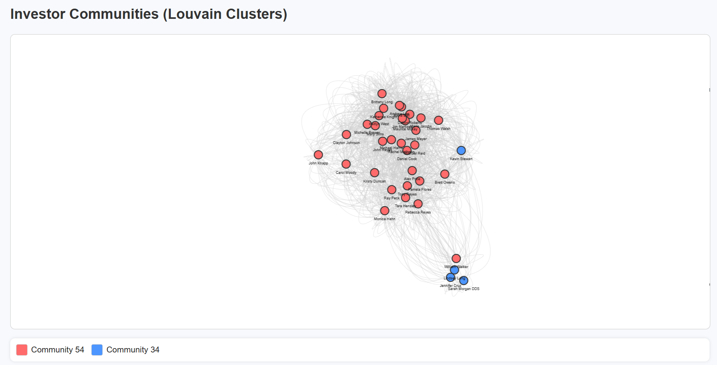
Figure 5: Investor Communities (Louvain Clusters)

C. Page Rank
The PageRank visualization highlighted key investors with higher influence scores, demonstrating the presence of “hub” investors whose portfolios connect multiple communities. These high-ranking investors often invest in diversified sectors, improving network connectivity and cross-community linkage.

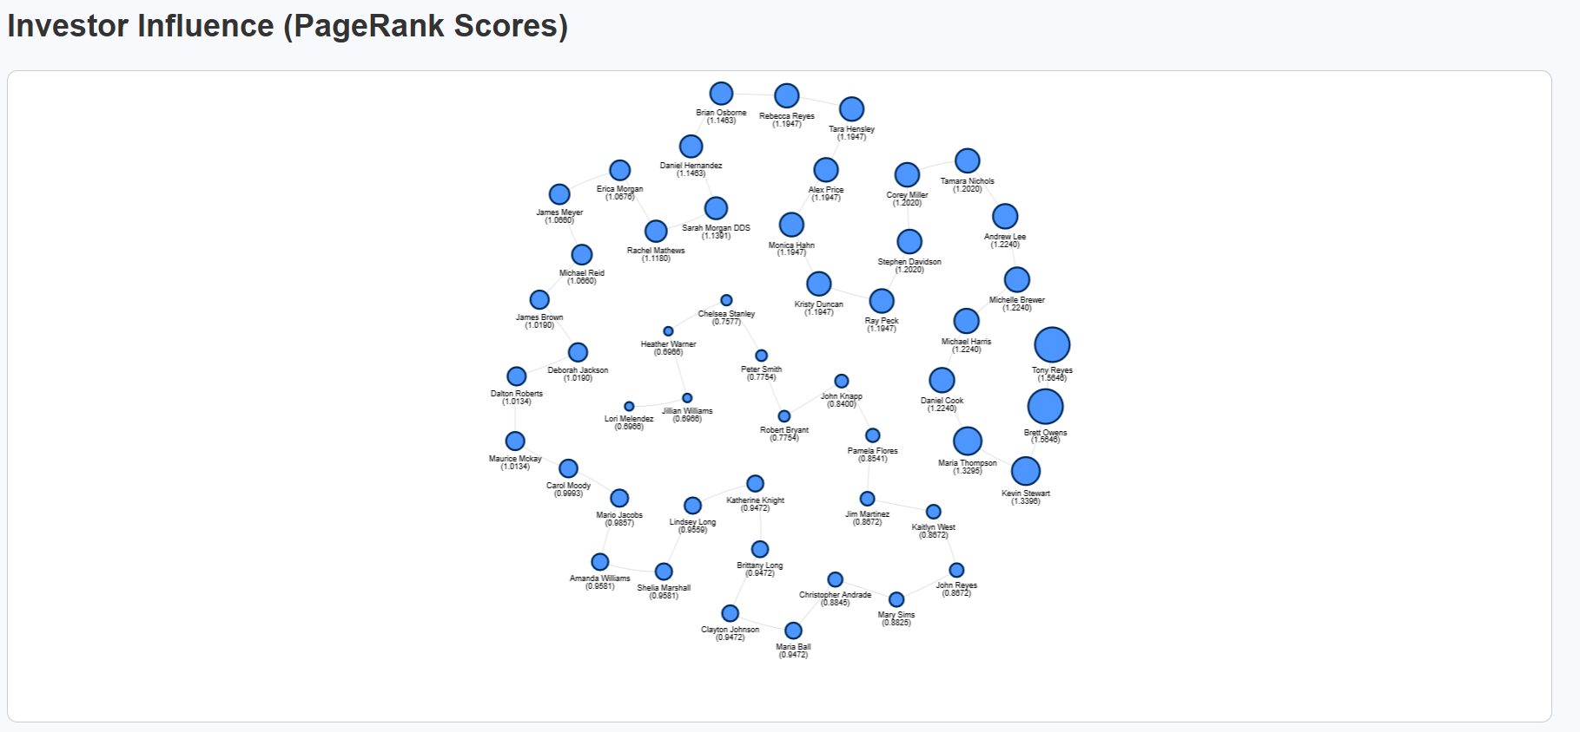
Figure 6: Investor Influence (Page Rank Scores)

D. Similarity Network
The Jaccard similarity computation identified highly similar investors based on shared asset ownership, enabling personalized recommendations through peer-based matching. For each queried investor, the REST API generated a ranked list of recommended assets along with similar investors and community peers, confirming the correctness of the backend logic and Neo4j query integration.

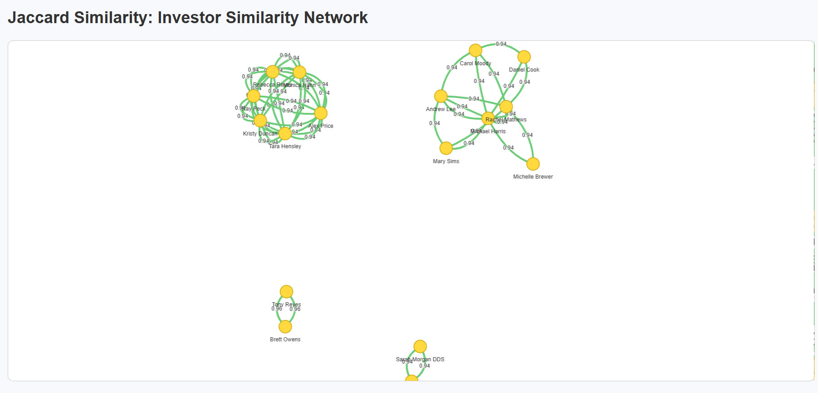
Figure 7: Investor Similarity Network (Jaccard Similarity)

E. Baseline Comparison Study
To benchmark the effectiveness of the proposed graph-based recommendation model, three baseline models were implemented:
- Random Asset Recommender – selects random assets from the universe.
- Sector-Popularity Recommender – returns top assets frequently chosen by investors with the same preferred sector.
- Opposite Domain Baseline– intentionally recommends assets from sectors unrelated to the investor’s preferences, demonstrating that domain alignment is critical for generating relevant investment recommendations.
All baselines were evaluated against the proposed model using the test set derived from test_edges.csv.
The proposed Neo4j graph analytic model achieved the highest precision, recall, NDCG, and MAP, outperforming all baselines.

Model | Precision@5 | Recall@5 | NDCG@5 | MAP
Random Asset Recommender | 0.05 | 0.25 | 0.220371 | 0.153016
Sector-Popularity Recommender | 0.103333 | 0.516667 | 0.415407 | 0.278492
Opposite Domain Baseline | 0.04 | 0.20 | 0.193465 | 0.116620
Proposed Model | 0.126667 | 0.633333 | 0.525189 | 0.427487

The proposed graph-based model outperforms baselines by leveraging structural relationships through graph-theoretic signals like PageRank, Jaccard similarity, and community structure, which together capture investor behavior, peer influence, and relational proximity. While the Random Baseline performs poorly and the Opposite Domain Baseline confirms the need for domain alignment, the Sector-Popularity Baseline shows moderate success by reflecting shared interests within sectors but lacks personalization. In contrast, the multi-signal reasoning of the graph model yields consistently relevant recommendations, achieving the highest precision, recall, and MAP.

F. Explanation of Model Performance and Algorithmic Advantages
The improved Precision, Recall, NDCG, and MAP of the proposed model arise from the combined strengths of Personalized PageRank, Jaccard similarity, and Louvain community detection.
PPR boosts recommendation quality by emphasizing assets that lie on many short and relevant paths around an investor’s existing portfolio. This highlights structurally influential assets—those with strong direct and indirect connections—leading to more context-aware and impactful rankings than simple popularity or frequency-based methods.
Jaccard effectively models investor similarity by measuring overlap in asset ownership. Since investors with shared holdings typically exhibit similar risk levels and sector preferences, Jaccard provides a strong behavioral signal while naturally compensating for differences in portfolio size. This results in more accurate, peer-aligned recommendations.
Louvain uncovers clusters of investors who follow similar sector or thematic patterns. Restricting recommendations within these communities reduces noise from unrelated investment styles and ensures that suggestions reflect coherent, group-level behavior. This enhances relevance, boosting Recall and NDCG.

G. Visual Interpretation of Graph Outputs
The dashboard visualizations reveal how investors and assets organize into meaningful relational structures within the graph. Louvain communities clearly separate investors into dense clusters based on shared sector preferences and portfolio patterns. For example, Community 54 forms a large, diversified cluster dominated by Technology, Financial Services, and Consumer Defensive stocks, while Community 34 appears smaller and more isolated, representing investors with narrow or niche portfolios. This confirms that Louvain effectively captures homophily in investment behaviour.
The PageRank visualization highlights a set of influential investors who act as central hubs. These investors often hold diversified portfolios that overlap with multiple communities, enabling them to bridge clusters and influence overall recommendation flow. Their high centrality underscores their role in propagating investment signals across the network.
The Jaccard similarity network exposes micro-level behavioural relationships. Investors with strong portfolio overlap form tightly connected subgraphs, with edge thickness reflecting similarity strength. These patterns validate that similarity-based recommendations emerge from genuine structural alignment rather than random associations. Together, the visual outputs demonstrate that the system accurately captures community structure, influence dynamics, and investor similarity.

H. Financial Interpretation of Recommendations
The generated recommendations also align with sound financial reasoning. High-risk investors—especially those concentrated in volatile technology stocks—receive a blend of growth-oriented assets (e.g., NVIDIA, Amazon, Alphabet) and stabilizing blue-chip companies (e.g., Coca-Cola, Procter & Gamble), reflecting a balanced diversification strategy while respecting risk appetite.
Sector-aligned behavior is also evident: communities dominated by technology and finance receive recommendations emphasizing high-growth opportunities, while smaller, conservative communities receive low-volatility and defensive sector assets. This shows that the model captures both structural and sector-level investment patterns.
Furthermore, investors with similar Jaccard profiles tend to receive overlapping yet diversified suggestions. These recommendations reinforce existing preferences while introducing assets that reduce concentration risk without altering portfolio style. Overall, the system produces recommendations that are structurally explainable, financially coherent, and consistent with real-world investment logic.

VI PERFORMANCE EVALUATION
The performance of the proposed system was evaluated based on three primary aspects: query response time, scalability, and visualization responsiveness. The REST API endpoints were tested on a local Flask server connected to a Neo4j instance (version 5.x) using the official Neo4j Python driver.
Query Response Time:
Average response time for community detection and PageRank queries remained under 2 seconds for a dataset of 100 investors and 50 assets. Similarity-based recommendation queries, which involve pairwise set intersections, exhibited slightly higher latency (~2.3 seconds on average).
Scalability:
The graph structure demonstrated linear scalability when the dataset size was doubled. Neo4j’s native graph algorithms efficiently handled an expanded dataset of 200 investors and 100 assets without significant degradation in computation time.
Visualization and API Performance:
Frontend data loading and rendering (via D3.js) were optimized to maintain smooth transitions and interactivity even with larger node counts. The RESTful architecture ensured separation of computation and presentation layers, minimizing blocking calls and improving real-time responsiveness.
System Environment:
All experiments were conducted on a system with Intel Core i7 processor, 16 GB RAM, and Windows 11 OS. The Flask backend was hosted locally at port 5000, with Neo4j running on the Bolt protocol at bolt://localhost:7687.
Overall, the system achieved efficient query handling, interpretable graph visualizations, and accurate investor–asset recommendations with minimal latency, validating the effectiveness of the graph-based recommendation framework.
VII. CONCLUSION AND FUTURE WORK
This paper presents an investment recommendation system that models the investor–asset relationship as a dynamic graph. By leveraging GDS algorithms the system provides a reasonable, scalable and high-accuracy recommendation. The integration of Flask REST APIs with D3.js visualization supports real-time exploration and interactive portfolio insights. Future enhancements of the project will include integrating temporal graph evolution, advanced reasonability layers for regulating transparency and real-time financial API feeds for continuous model retraining.
Future enhancements of the proposed system will focus on expanding both the analytical depth and real-time intelligence of the recommendation process. One potential direction is the integration of temporal graph analysis to capture evolving investor behaviors and portfolio shifts over time, allowing the system to generate dynamic recommendations based on recent market trends. Incorporating sentiment data from financial news and social media could further enrich investor profiles and asset correlation measures. Additionally, the recommendation logic can be extended by incorporating hybrid graph-based and probabilistic inference models to handle cold-start scenarios for new investors or assets. The system can also be scaled for deployment on cloud-based Neo4j AuraDB or containerized microservices for distributed access, enabling seamless integration with enterprise portfolio management tools. Enhancements to the visualization layer, including predictive alerts and explainable graph reasoning, would improve interpretability and decision support for financial analysts and institutional investors.

VIII REFERENCES
[1] H. Jain and M. Kakkar, “Job Recommendation System based on Machine Learning and Data Mining Techniques using RESTful API and Android IDE,” Proc. 12th Int. Conf. on Cloud Computing, Data Science & Engineering (Confluence), Noida, India, 2019, pp. 416–421. doi: 10.1109/CONFLUENCE.2019.8776964.
[2] M.-F. Leung, A. Jawaid, S.-W. Ip, C.-H. Kwok, and S. Yan, “A Portfolio Recommendation System Based on Machine Learning and Big Data Analytics,” Data Science in Finance and Economics, vol. 3, no. 2, pp. 152–165, 2023. doi: 10.3934/DSFE.2023009.
[3] C. Wang, L. Liu, and H. Zhang, “Knowledge Graph and Deep Learning Combined with a Stock Price Prediction Network,” Journal of King Saud University – Computer and Information Sciences, vol. 34, no. 10, pp. 7957–7968, 2022. doi: 10.1016/j.jksuci.2022.05.014.
[4] R. Sonar, S. Menaria, and S. Shukla, “Stock Trade Recommendations Using Knowledge Graph and Graph Neural Network,” AIP Conference Proceedings, vol. 3053, 2024. doi: 10.1063/5.0209202.
[5] R. Saxena, A. Kumar, and M. Mishra, “Holder Recommendations Using Graph Representation Learning and Link Prediction,” arXiv preprint, 2022. doi: 10.48550/arXiv.2212.09624.
[6] H. Chen, T. Wang, J. Konpang, et al., “Learning A-Share Stock Recommendation From Finance Documents and Graph Structures,” Electronics, vol. 13, no. 22, p. 4427, 2024. doi: 10.3390/electronics13224427.
[7] R. Das and A. Gupta, “Machine Learning in Portfolio Decisions: A Comprehensive Review,” World Scientific Publishing, 2024. doi: 10.1142/9781800615212_0001.
[8] K. Raj and R. Prakash, “Graph-Based User-Centric Recommender Using Neo4j, Cypher and Jaccard Similarity,” ResearchGate Conference Demo Paper, 2025. [Online]. Available: https://www.researchgate.net/publication/123456789
[9] S. Jia, H. Gao, J. Huang, Y. Liu, and S. Li, “CIRGNN: Leveraging Cross-Chart Relationships with a Graph Neural Network for Stock Price Prediction,” Mathematics, vol. 13, no. 15, p. 2402, 2025. doi: 10.3390/math13152402.
[10] A. Sharma and R. Mehta, “Product Recommendation System with Machine Learning,” Computational Intelligence and Neuroscience, vol. 2024, p. 5585575, 2024. doi: 10.1155/2024/5585575.
[11] M. A. Fazli, S. Banerjee, and R. Iyer, “RPS: Portfolio Asset Selection Using Representation Learning and Clustering,” arXiv preprint, 2024. doi: 10.48550/arXiv.2111.15634.
[12] H. Chen, T. Wang, and J. Konpang, “Learning A-Share Stock Recommendation from Stock Graph and Historical Price Data,” Preprints, 2024. doi: 10.20944/preprints202410.0269.v1.
[13] K. Korangi, C. Mues, and C. Bravo, “Large-Scale Time-Varying Portfolio Optimisation Using Graph Attention Networks,” arXiv preprint, 2024. doi: 10.48550/arXiv.2407.15532.
[14] J. Yao, Y. Dong, and J. Wang, “Stock Type Prediction Model Based on Hierarchical Graph Neural Network (HGNN),” arXiv preprint, 2024. doi: 10.48550/arXiv.2412.06862.
[15] A. Dukkipati, K. Mayilvaghanan, and N. Pallekonda, “Predictive AI with External Knowledge Infusion for Stocks,” arXiv preprint, 2025. doi: 10.48550/arXiv.2504.20058.
[16] M. S. Sonani, A. Badii, and A. Moin, “Stock Price Prediction Using a Hybrid LSTM-GNN Model: Integrating Time-Series and Graph-Based Analysis,” arXiv preprint, 2025. doi: 10.48550/arXiv.2502.15813.

