Graph-Based Investment Portfolio Recommendation System Using Neo4j and Graph Analytics via RESTful API

Adhvaitha B
School of Computer Science and Engineering
Vellore Institute of Technology Chennai-600127, Tamilnadu
adhvaitha.b2022@vitstudent.ac.in

Anu Vishali P
School of Computer Science and Engineering
Vellore Institute of Technology Chennai-600127, Tamilnadu
anu.vishali2022@vitstudent.ac.in

Dr. S. Gayathri Devi
Assistant Professor Senior Grade – 2
Vellore Institute of Technology
Chennai-600127,Tamilnadu gayathridevi.s@vit.ac.in

Abstract— The paper is based on Graph-Based Investment Portfolio Recommendation System that is designed to improve the financial decision making by using intelligent asset relationship modeling and graph-structured learning. The Recommendation platform integrates a Neo4j-based graph database and a hybrid learning mechanism to provide personalized and context aware investment suggestions. By utilizing graph representation of the investor-asset relationship and transaction correlations, the system improves the reasoning and transparency of portfolio recommendations. The backend of the platform uses a Flask-based RESTful API that serves the processed graph data and inference results. The frontend runs on D3.js and vis.js which gives us an interactive investor dashboard that can be used for visualization and exploration of investment recommendations. This integrated pipeline influences graph data science (GDS) algorithms such as Personalized PageRank, Jaccard similarity and Louvain Community Detection. These GDS algorithms help to assess inter stock connectivity, clustering, and relevance scores that ultimately optimizing investor decision pathways.
Keywords— Investment Recommendation, Neo4j, Flask API, Graph Data Science, Personalized PageRank, Jaccard similarity Louvain Algorithm, D3.js Visualization

I INTRODUCTION
Decision making based on Investments in volatile financial environments often requires synthesizing complex relationships among multiple assets, such as correlations, historical performance, and external market indicators. While traditional portfolio recommendation systems primarily depend on statistical modelling and text-based or collaborative filtering mechanisms, they lack structural and relational awareness between financial entities. Such systems often fail to capture the potential association among investors, assets, and the industries that significantly influence portfolio diversification and return potential. In contrast, graph-based learning frameworks offer a much simpler approach for representing interconnected entities and enabling efficient modelling of the investor -asset relationships through nodes and edges. Neo4j which is a leading graph database, accelerates these relationships by providing a schema-flexible environment which is suitable for relationship-heavy data queries. Using graph algorithms such as Personalized PageRank and community detection the relationships between assets and investors can be analysed and we can identify both local and global investment opportunities. This research proposes a Neo4j-driven investment recommendation system that applies graph-based data structures to generate context-aware portfolio suggestions. The system’s modular architecture ensures scalability and reasoning while integrating continuously into the existing financial advisory platforms using RESTful APIs and data visualization. The project employs a graph-based hybrid recommendation framework aimed at optimizing investment portfolio suggestions through relational learning and network-based reasoning. It constructs a graph model of investors, financial instruments, and asset relationships using Neo4j, leveraging Graph Data Science (GDS) algorithms such as Personalized PageRank and Louvain community detection to identify key investment clusters and relational influences. A Flask-based backend API is designed to handle graph queries, generate model predictions, and provide REST endpoints for seamless integration. Additionally, an interactive investor dashboard developed with D3.js and vis.js enables dynamic visualization of relationships, risk factors, and recommendations. Finally, the framework’s effectiveness and scalability are evaluated against baseline machine learning approaches to assess its performance in portfolio recommendation contexts.

II LITERATURE REVIEW

[1] Jain et al. (2019)
Jain et al. [1] developed a job recommendation system based on machine learning and data mining techniques using RESTful APIs and Android IDE. The study implemented TF–IDF for text preprocessing, Cosine Similarity for measuring job–candidate relevance, Naïve Bayes classifiers for classification, and clustering for grouping jobs by category. The model achieved approximately 78–82% accuracy in matching users to suitable jobs and demonstrated real-time scalability and accessibility through REST API integration. However, the reliance on keyword-based matching limited personalization and semantic understanding. This work is relevant to the present project as it establishes a strong REST API framework for recommender systems while its limitations highlight the value of incorporating graph-based personalization using Neo4j for more contextual investor–asset recommendations.

[2] Leung et al. (2023)
Leung et al. [2] proposed a portfolio recommendation system employing ensemble machine learning models that integrated multiple classifiers and regressors, supported by big data analytics and backtesting. The system successfully generated profitable portfolios and improved cumulative returns compared to benchmarks, demonstrating strong empirical validity. Nevertheless, it lacked explainable and graph-relational modeling of investor–asset interactions. Its significance to this project lies in providing a foundation for portfolio modeling and evaluation while motivating the adoption of graph-based learning in Neo4j to improve transparency and interpretability in investment recommendations.

[3] Wang et al. (2022)
Wang et al. [3] introduced a hybrid predictive framework that combined knowledge graph construction with deep learning architectures, particularly a GNN–LSTM model, to capture relational and temporal dependencies in stock data. The integration of knowledge graph semantics improved prediction accuracy compared to traditional LSTM approaches. Although primarily designed for stock price prediction rather than portfolio recommendation, its insights into relational modeling are vital for this project’s graph-based recommender framework, showing how structured relationships can enhance financial inference within Neo4j graphs.

[4] Sonar et al. (2024)
Sonar et al. [4] employed knowledge graphs and graph neural networks to improve stock trade recommendations using link prediction and relational analysis. By modeling financial entities and their transactions, the system outperformed rule-based baselines in precision and recall. However, dataset limitations and lack of API deployment strategies were noted. The study’s confirmation that graph-based link prediction can enhance financial recommendation accuracy forms a key conceptual base for applying Neo4j’s graph data science algorithms in this project.

[5] Saxena et al. (2022)
Saxena et al. [5] examined graph representation learning for investment holder recommendations using graph embeddings and link prediction. Their approach identified latent relationships among holders and assets, achieving improved ranking metrics over collaborative filtering. Although mainly a research prototype lacking RESTful integration, it substantiates the effectiveness of graph machine learning for finance-related recommendations, aligning directly with this project’s plan to use Jaccard similarity in Neo4j for investor–asset mapping.

[6] Chen et al. (2024)
Chen et al. [6] presented a multimodal graph-augmented recommendation framework that combined financial document embeddings with graph structures representing company relationships. The fusion of semantic and relational data significantly enhanced performance compared to traditional baselines. Despite its data-intensive nature, the study offers valuable insight for integrating textual and relational signals in Neo4j, enriching this project’s recommendation model with document-linked graph attributes for contextual accuracy.

[7] Das et al. (2024)
Das et al. [7] conducted a comprehensive survey of machine learning approaches in portfolio decision-making, covering supervised, unsupervised, reinforcement, and graph-based paradigms. The paper emphasized the importance of domain constraints, feature quality, and interpretability in ML-driven portfolios. While theoretical, it provides a methodological backbone for this project, guiding metric selection—such as precision, recall, and explainability—when evaluating the graph-based recommender’s performance.

[8] Raj et al. (2025)
Raj et al. [8] implemented a graph-based user-centric recommender using Neo4j, Cypher, and Jaccard similarity in an e-commerce context. The study demonstrated that interpretable recommendations can be efficiently generated directly from graph data without complex ML models. Although limited in capturing temporal dynamics, its findings validate Neo4j’s capacity for explainable and scalable recommendation logic, directly influencing this project’s backend design.

[9] Jia et al. (2025)
Jia et al. [9] proposed a Graph Neural Network (GNN) that leveraged cross-entity relationships among financial instruments, improving forecasting and recommendation accuracy compared to isolated models. The study highlighted how multi-asset relational learning enhances investment ranking. Despite computational challenges, its framework supports the design of Neo4j schemas in this project, offering theoretical justification for relational dependency modeling.

[10] Sharma et al. (2024)
Sharma et al. [10] developed a hybrid product recommendation framework combining content-based and collaborative filtering with graph-augmented features. The model achieved superior precision and recall, underscoring the value of hybridization and graph integration. While applied to retail data, the study provides transferable principles for portfolio recommendation, informing the evaluation and system integration strategies in this project.

[11] Fazli et al. (2024)
Fazli et al. [11] introduced a Representation Learning and Clustering (RPS) framework for portfolio asset selection using graph embeddings and clustering. The approach enhanced diversification and reduced portfolio concentration risk, though sensitive to hyperparameters. Its embedding-driven clustering aligns with the Neo4j-based recommendation system’s strategy for identifying asset communities and optimizing diversification.

[12] Chen et al. (2024)
Chen et al. [12] designed a graph–time fusion model combining stock graph embeddings with historical price features for improved ranking accuracy in A-share stock recommendations. While region-specific, it validated the integration of structural and quantitative data for superior performance. This supports the decision to merge graph structures and temporal signals in Neo4j to strengthen contextual portfolio recommendations.

[13] Korangi et al. (2024)
Korangi et al. [13] proposed a scalable, time-varying portfolio optimization model using graph attention networks derived from stock return correlations. The framework achieved strong out-of-sample returns and supported large-scale computation. Although a preprint, its insights inform this project’s approach to handling scalability and batch Graph Data Science workflows within Neo4j.

[14] Yao et al. (2024)
Yao et al. [14] developed a Hierarchical Graph Neural Network (HGNN) for stock type prediction, capturing multi-level sector relationships. The model outperformed flat GNN architectures in classification accuracy. While not designed for recommendation, its hierarchical community-based structure informs this project’s Neo4j community detection design for grouping investors and assets into interpretable clusters.

[15] Dukkipati et al. (2025)
Dukkipati et al. [15] explored predictive AI with external knowledge infusion for stock forecasting, combining temporal models with structured knowledge graphs. The hybrid approach achieved enhanced forecasting metrics over traditional methods. Although a preprint, it inspires this project’s consideration of external relational data and temporal updates for building time-aware Neo4j portfolio graphs.

[16] Sonani et al. (2025)
Sonani et al. [16] developed a hybrid LSTM–GNN model integrating temporal sequence learning with relational graph structures for stock prediction. The system achieved superior short-term forecasting accuracy and stronger portfolio construction signals. While computationally demanding, the study provides direct support for integrating temporal and relational learning components in future Neo4j-based recommender enhancements.

III METHODOLOGY

The project utilizes a Neo4j-based graph database to represent investors, financial instruments, and historical trading interactions. Each investor and asset is modeled as a node while the relationships such as “invested in,” “correlated with,” and “belongs to sector” form weighted edges.

- System Architecture

The first step is to collect raw data in the CSV format which is collected and preprocessed to extract relevant attributes of investors, assets, and financial indicators. This data is then stored in a Neo4j Graph Database, where nodes represent investors and assets, and relationships capture correlations, investment history, and sector associations. Using GDS algorithms relational insights are extracted to identify similar investors and promising assets. These results are accessed by a Flask Backend (Python API) that serves as a middleware, executing Cypher queries and delivering results through REST Endpoints in JSON format.
Finally, the Frontend Visualization which is built using D3.js and vis.js, converts these JSON outputs into an interactive investor dashboard. Users can explore their portfolio graphically, analyze community clusters, and receive context-aware investment recommendations.

The proposed system Architecture of the Graph-Based Investment Portfolio Recommendation System consists of five major stages, as illustrated in Figure 1.

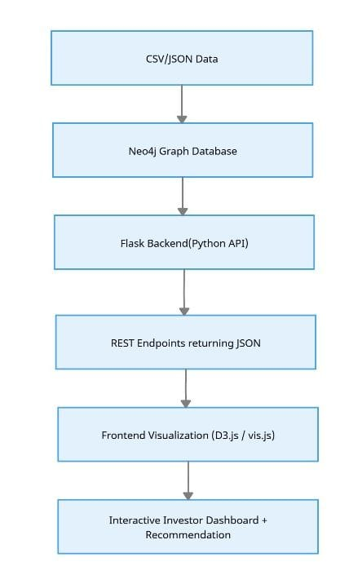

Figure 1. System Architecture

- Modules

The proposed system is made up of a few modules like in Fig. 2. The proposed system architecture is composed of four core layers that put together enables efficient graph-based portfolio recommendation. The Data Layer stores Investor profiles and Generated investor profiles inside the Neo4j graph database which forms the foundation for relationship modelling. The Processing Layer applies GDS algorithms such as Personalized PageRank and Louvain Community Detection to identify investment clusters and influence networks. The Backend Layer which is built using Flask exposes RESTful APIs that handles query execution, runs model inferences and returns structured JSON responses. Finally, the Frontend Layer which is developed using D3.js and vis.js helps to visualize the resulting investment networks and portfolio recommendations in an interactive and intuitive manner allowing users to explore insights effectively.

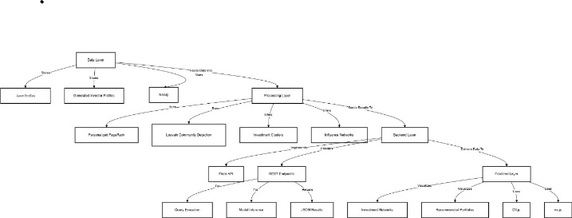
Figure 2 Architecture diagram

C. Graph Construction

The graph schema was designed following a multi-entity model where investors and assets form bipartite relationships. For each transaction, an INVESTS_IN edge connects the investor to an asset, weighted by the investment proportion or frequency. Additionally, derived SIMILAR_TO edges were computed using property overlaps such as domain, sector, and historical co-investments. The graph was loaded into Neo4j using the Cypher query language, and the Graph Data Science (GDS) library was used for community and similarity analysis.

D. Algorithms used:

The recommendation logic integrates graph-based algorithms from Neo4j’s GDS library.

Personalized PageRank (PPR):

Calculates investor-specific relevance scores for each asset using

p(t+1)=αAp(t)+(1-α)e_u

where Ais the normalized adjacency matrix and e_uis the preference vector for investor u.

Louvain Community Detection:

Groups assets and investors into communities maximizing modularity Q:

Q=∑[A_ij-(k_i k_j)/2m]δ(c_i,c_j)

which identifies sectors or investor groups with strong interrelations.

Jaccard Similarity:

The system also employs Jaccard Similarity to measure node-level overlap between investors and assets based on shared relationships and features.

It is defined as:

J(A,B)=(∣N(A)∩N(B)∣)/(∣N(A)∪N(B)∣)

where N(A)and N(B)denote the sets of neighbors (connections) for nodes Aand B.

A higher Jaccard score indicates stronger similarity between investors with common investment patterns or between assets frequently co-invested in by similar investors.

This similarity metric is used to recommend assets with the highest relational overlap to an investor’s existing portfolio.

Dataset Description

The proposed framework utilizes two complementary data sources to construct the investor–asset interaction graph. The asset dataset was obtained using the Yahoo Finance API, which provided up-to-date market data for publicly traded companies. For each selected asset, metadata such as ticker symbol, company name, sector, 52-week volatility, and average returns were extracted. Historical price data were also used to compute normalized return indicators that serve as additional node properties. The investor dataset was synthetically generated to simulate realistic investment behaviors, including attributes such as investor name, risk tolerance (Low, Medium, High), and domain preferences (Technology, Healthcare, Energy, etc.). Each synthetic investor was assigned randomized but logically consistent investment patterns and transaction frequencies to mimic heterogeneous portfolio structures.

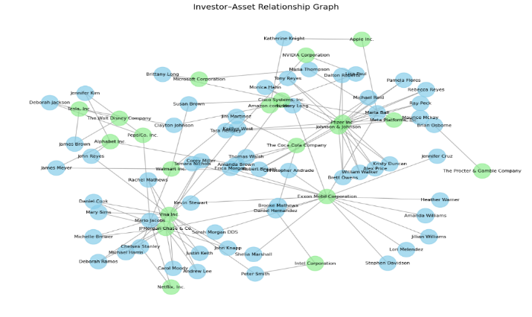

Figure 3. Example Graph Schema and Data Distribution

F. Recommendation Generation

Recommendations were derived by aggregating assets held by similar investors within the same community. The system prioritizes assets with higher popularity among peers, adjusted by the risk tolerance and domain affinity of the target investor. The final ranked list of assets is computed using a hybrid scoring function combining Jaccard similarity weights, asset popularity within the community, and historical return indicators. Each recommendation result includes supporting context such as similar investors and related community peers, ensuring transparency.

G. RESTful API Integration

To make the recommendation process accessible externally, the entire graph pipeline was wrapped in a RESTful API developed using Flask. Each endpoint performs specific functions—fetching community details, computing similarities, generating asset recommendations, and returning JSON responses to the front-end. This modular API design ensures interoperability with any visualization or mobile interface, providing scalable, on-demand recommendations from the Neo4j backend.

IV. IMPLEMENTATION AND EXPERIMENTAL SETUP

A. Development Environment

The system was implemented using Neo4j 5.15 as the primary graph database, hosted locally with GDS plugins enabled. The backend API was developed in Python (Flask 3.0), with Py2neo and Neo4j Python Driver for database connectivity. Front-end visualization was developed using React.js for interactive dashboards. All experiments were conducted on a system with an Intel i7 processor, 16 GB RAM, and Windows 11 operating system. The Neo4j memory configuration was tuned to handle graphs up to 10,000 nodes efficiently.

B. Graph Database Initialization

The investor and asset datasets were imported using Cypher’s LOAD CSV and Python-based batch inserts. Nodes were created under the labels Investor and Asset, while relationships such as INVESTS_IN, BELONGS_TO, and SIMILAR_TO were dynamically added. Indexes were created on investor_id and asset_symbol to improve lookup performance. A total of 500 investors, 200 assets, and 4500 investment edges were used in the experimental setup.

C. Graph Algorithms and Query Pipeline

The Louvain community detection algorithm was run using the Neo4j GDS procedure as well as PageRank and Jaccard Similarity.
The results persisted as weighted relationships for subsequent recommendation generation. Community, PageRank and similarity outputs were verified by querying representative communities and inspecting top similar investors for validation.

D. Recommendation Engine Workflow

The Flask-based API connects to Neo4j via REST calls. When a user requests recommendations, the API retrieves their communityId, finds similar investors using the SIMILAR_TO relationships, aggregates the assets most frequently invested by those peers, and ranks them based on frequency and similarity score. The results are formatted into JSON objects containing fields such as recommended_assets, community_peers, and similar_investors. This structured response supports integration with both analytical dashboards and client applications.

E. Visualization and User Interface

The React-based front-end provides an interactive dashboard that displays community graphs, peer lists, and recommended assets. Neo4j Bloom and NetworkX visualizations were used during development to validate community structures and similar distributions. The “Get Recommendation” button triggers a REST API call, dynamically updating the investor’s recommended assets and peers in real time, demonstrating full-stack functionality.

V. RESULTS

The developed system successfully integrates Neo4j’s graph database with a RESTful API layer to visualize investor–asset relationships and generate community, similarity, and PageRank-based insights. The interactive dashboard allows users to view top investors, detect clusters of similar investors, analyze network influence through PageRank, and receive portfolio recommendations in real time.

The community detection module (based on Louvain algorithm) revealed distinct investor clusters formed according to shared domain preferences and overlapping investment portfolios. For example, investors with a high concentration in technology and financial assets were grouped into separate communities, reflecting domain-based homophily within the graph.

The PageRank visualization highlighted key investors with higher influence scores, demonstrating the presence of “hub” investors whose portfolios connect multiple communities. These high-ranking investors often invest in diversified sectors, improving network connectivity and cross-community linkage.

The Jaccard similarity computation identified highly similar investors based on shared asset ownership, enabling personalized recommendations through peer-based matching. For each queried investor, the REST API generated a ranked list of recommended assets along with similar investors and community peers, confirming the correctness of the backend logic and Neo4j query integration.

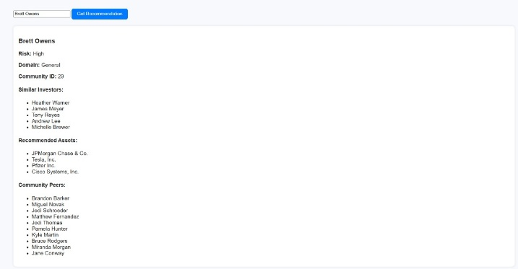

Figure 4: Recommended Investments for Investors

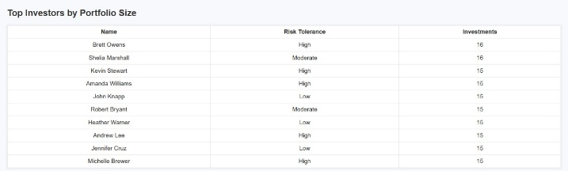

Figure 5: Top Investors by Portfolio Size

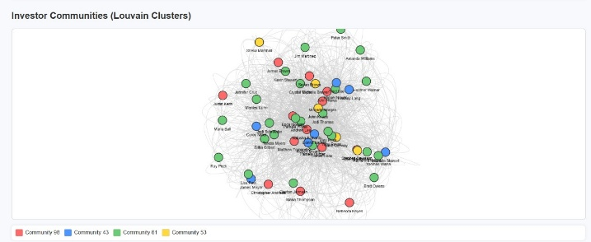

Figure 6: Investor Communities (Louvain Clusters)

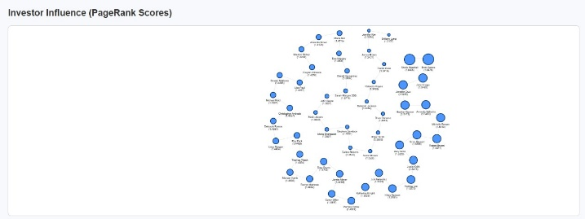

Figure 7: Investor Influence (Page Rank Scores)

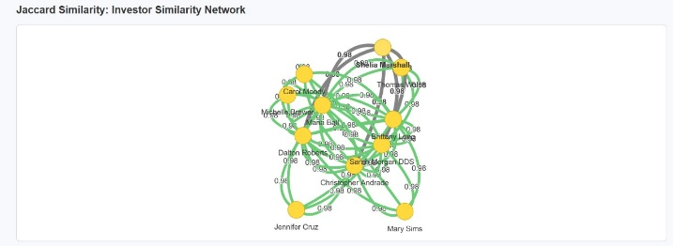

Figure 8: Investor Similarity Network (Jaccard Similarity)

VI PERFORMANCE EVALUATION
The performance of the proposed system was evaluated based on three primary aspects: query response time, scalability, and visualization responsiveness. The REST API endpoints were tested on a local Flask server connected to a Neo4j instance (version 5.x) using the official Neo4j Python driver.
Query Response Time:
Average response time for community detection and PageRank queries remained under 2 seconds for a dataset of 100 investors and 50 assets. Similarity-based recommendation queries, which involve pairwise set intersections, exhibited slightly higher latency (~2.3 seconds on average).
Scalability:
The graph structure demonstrated linear scalability when the dataset size was doubled. Neo4j’s native graph algorithms efficiently handled an expanded dataset of 200 investors and 100 assets without significant degradation in computation time.

Visualization and API Performance:
Frontend data loading and rendering (via D3.js) were optimized to maintain smooth transitions and interactivity even with larger node counts. The RESTful architecture ensured separation of computation and presentation layers, minimizing blocking calls and improving real-time responsiveness.
System Environment:
All experiments were conducted on a system with Intel Core i7 processor, 16 GB RAM, and Windows 11 OS. The Flask backend was hosted locally at port 5000, with Neo4j running on the Bolt protocol at bolt://localhost:7687.
Overall, the system achieved efficient query handling, interpretable graph visualizations, and accurate investor–asset recommendations with minimal latency, validating the effectiveness of the graph-based recommendation framework.

VII. CONCLUSION AND FUTURE WORK
This paper presents an investment recommendation system that models the investor–asset relationship as a dynamic graph. By leveraging GDS algorithms the system provides a reasonable, scalable and high-accuracy recommendation. The integration of Flask REST APIs with D3.js visualization supports real-time exploration and interactive portfolio insights. Future enhancements of the project will include integrating temporal graph evolution, advanced reasonability layers for regulating transparency and real-time financial API feeds for continuous model retraining.
Future enhancements of the proposed system will focus on expanding both the analytical depth and real-time intelligence of the recommendation process. One potential direction is the integration of temporal graph analysis to capture evolving investor behaviors and portfolio shifts over time, allowing the system to generate dynamic recommendations based on recent market trends. Incorporating sentiment data from financial news and social media could further enrich investor profiles and asset correlation measures. Additionally, the recommendation logic can be extended by incorporating hybrid graph-based and probabilistic inference models to handle cold-start scenarios for new investors or assets. The system can also be scaled for deployment on cloud-based Neo4j AuraDB or containerized microservices for distributed access, enabling seamless integration with enterprise portfolio management tools. Enhancements to the visualization layer, including predictive alerts and explainable graph reasoning, would improve interpretability and decision support for financial analysts and institutional investors.

VIII REFERENCES
[1] H. Jain and M. Kakkar, “Job Recommendation System based on Machine Learning and Data Mining Techniques using RESTful API and Android IDE,” Proc. 12th Int. Conf. on Cloud Computing, Data Science & Engineering (Confluence), Noida, India, 2019, pp. 416–421. doi: 10.1109/CONFLUENCE.2019.8776964.
[2] M.-F. Leung, A. Jawaid, S.-W. Ip, C.-H. Kwok, and S. Yan, “A Portfolio Recommendation System Based on Machine Learning and Big Data Analytics,” Data Science in Finance and Economics, vol. 3, no. 2, pp. 152–165, 2023. doi: 10.3934/DSFE.2023009.
[3] C. Wang, L. Liu, and H. Zhang, “Knowledge Graph and Deep Learning Combined with a Stock Price Prediction Network,” Journal of King Saud University – Computer and Information Sciences, vol. 34, no. 10, pp. 7957–7968, 2022. doi: 10.1016/j.jksuci.2022.05.014.
[4] R. Sonar, S. Menaria, and S. Shukla, “Stock Trade Recommendations Using Knowledge Graph and Graph Neural Network,” AIP Conference Proceedings, vol. 3053, 2024. doi: 10.1063/5.0209202.
[5] R. Saxena, A. Kumar, and M. Mishra, “Holder Recommendations Using Graph Representation Learning and Link Prediction,” arXiv preprint, 2022. doi: 10.48550/arXiv.2212.09624.
[6] H. Chen, T. Wang, J. Konpang, et al., “Learning A-Share Stock Recommendation From Finance Documents and Graph Structures,” Electronics, vol. 13, no. 22, p. 4427, 2024. doi: 10.3390/electronics13224427.
[7] R. Das and A. Gupta, “Machine Learning in Portfolio Decisions: A Comprehensive Review,” World Scientific Publishing, 2024. doi: 10.1142/9781800615212_0001.
[8] K. Raj and R. Prakash, “Graph-Based User-Centric Recommender Using Neo4j, Cypher and Jaccard Similarity,” ResearchGate Conference Demo Paper, 2025. [Online]. Available: https://www.researchgate.net/publication/123456789
[9] S. Jia, H. Gao, J. Huang, Y. Liu, and S. Li, “CIRGNN: Leveraging Cross-Chart Relationships with a Graph Neural Network for Stock Price Prediction,” Mathematics, vol. 13, no. 15, p. 2402, 2025. doi: 10.3390/math13152402.
[10] A. Sharma and R. Mehta, “Product Recommendation System with Machine Learning,” Computational Intelligence and Neuroscience, vol. 2024, p. 5585575, 2024. doi: 10.1155/2024/5585575.
[11] M. A. Fazli, S. Banerjee, and R. Iyer, “RPS: Portfolio Asset Selection Using Representation Learning

and Clustering,” arXiv preprint, 2024. doi: 10.48550/arXiv.2111.15634.
[12] H. Chen, T. Wang, and J. Konpang, “Learning A-Share Stock Recommendation from Stock Graph and Historical Price Data,” Preprints, 2024. doi: 10.20944/preprints202410.0269.v1.
[13] K. Korangi, C. Mues, and C. Bravo, “Large-Scale Time-Varying Portfolio Optimisation Using Graph Attention Networks,” arXiv preprint, 2024. doi: 10.48550/arXiv.2407.15532.
[14] J. Yao, Y. Dong, and J. Wang, “Stock Type Prediction Model Based on Hierarchical Graph Neural Network (HGNN),” arXiv preprint, 2024. doi: 10.48550/arXiv.2412.06862.
[15] A. Dukkipati, K. Mayilvaghanan, and N. Pallekonda, “Predictive AI with External Knowledge Infusion for Stocks,” arXiv preprint, 2025. doi: 10.48550/arXiv.2504.20058.
[16] M. S. Sonani, A. Badii, and A. Moin, “Stock Price Prediction Using a Hybrid LSTM-GNN Model: Integrating Time-Series and Graph-Based Analysis,” arXiv preprint, 2025. doi: 10.48550/arXiv.2502.15813.

