Do Global Forest Datasets Accurately Map Mangroves in Mumbai?

Abstract
Mangroves are essential specialised trees that provide carbon storage, shoreline stabilization, and natural flood protection, especially in densely populated cities like Mumbai. However, reported estimates of mangrove extent show differences depending on the datasets and classification methods used. The purpose of this study is to evaluate the differences between Hansen Global Forest Change(GFC) and Global Mangrove Watch(GMW), so that it can be determined whether these datasets accurately represent mangroves in Mumbai. This analysis was limited to the 20N 070E region which includes Mumbai’s mangroves. The methodology began by reprojecting the dataset images to EPSG:32643 coordinate system, with GMW being used as the baseline mangrove mask. Within this mask, Hansen’s first and last year of detection data were analyzed to assess spatial agreement, and persistence. Results show that 92% of GMW mangroves were detected as forest at least once in GFC; however, no pixels were classified as persistent forest and rather only temporary forest, with pixels having a median detection duration near zero years. This result is scientifically suspicious and suggests the unstable forest signals within mangrove regions likely caused by tidal effects, phenology, or canopy structure. These findings suggest that Hansen can detect mangroves, but with unstable short lasting signals. Datasets such as GMW, which incorporate radar data and greater coastal parameters, are more suitable for extent mapping and for identifying mangrove zones.

Keywords: mangroves; Mumbai; Global Mangrove Watch; Hansen GFC; raster alignment; remote sensing
Introduction
Mangroves are specialised trees and shrubs that grow in saline water in intertidal zones. They are characterized by: high carbon dioxide retention capabilities, strong, stilt-like roots that help them survive in muddy and changing water levels, making them one of the most essential coastal ecosystems around the world.

They are extremely effective carbon sinks, storing around 1000 tonnes of carbon per hectare, far greater than terrestrial forests. Moreover, they act as natural coastal defenders against various climate events and calamities¹. In fact, a 100 meter belt of mangroves can reduce wave height by 13-66% through their dense root network’s ability to dissipate wave energy and trap sediments protecting against storm surges and flood risks². Apart from this, they aid in trapping sediments, which stabilize shorelines and reduce erosion.

For densely populated coastal cities such as Mumbai, these features are extremely critical- their functions are approximately valued at ₹1700 crore annually, and the Thane creek mangrove belt alone stores around 238,000 tonnes of carbon^{3,4}. Apart from the ecological aspects, these mangroves also protect fishing communities' livelihoods, by promoting biodiversity and providing nursing grounds for fish and other marine life⁵. Overall, all the aforementioned functions of mangroves make them indispensable for the environment, especially in the case of Mumbai itself.

Mumbai, one of India’s most densely populated cities contains one of the largest urban mangrove covers in the world. These are spread all around the periphery of Mumbai, with the majority of mangroves being concentrated in Thane creek, Mahim, Versova, and Gorai⁸. The reported total cover varies due to varying mapping methods, but recent studies show Greater Mumbai’s mangrove cover is around 50-70km², while the Mumbai suburban district contributes around 64km² of mangroves⁶. The Thane Creek Sanctuary is the largest protected mangrove region in the area, with a reported site area of around 65km² according to one source, and 90km² according to another. This disagreement may be an effect of how boundaries are defined (such as the inclusion/disclusion of areas enclosed within mangroves)⁶.

However, despite their importance, Mumbai’s mangroves have faced continuous threats of destruction, fragmentation, or thinning from many different angles. Due to the rapid urbanization persistent in Mumbai, projects such as the coastal road, other industrial development projects, and even illegal encroachment, mangrove loss and fragmentation have been inevitably proliferating. Moreover, recurring issues as a result of weak regulatory enforcement including untreated sewage discharge and illegal waste dumping have degraded the water and land where mangroves usually thrive, hence posing a threat to their health. Rapid climate change, sea level rise, and increased frequency of extreme rainfall, alter the habitat of mangroves irreparably, further worsening this crisis.

Numerous studies have attempted to quantify the exact changes of mangrove cover in Mumbai, but most have varying results based on spatial extent, time frame, as well as resolution of imaging. Some studies which employ satellite imagery (Landsat or Sentinel data) have reported local increases or even doubling of mangrove cover in parts of Thane Creek from 79.14km² in 1990 to 154.5km² in 2017 attributed to the deposition of sediment that has allowed mangroves to spread closer to the center of the creek^{7,8}. In contrast, some other studies report marginal declines or near stability in total mangrove cover over multiple decades, with the total mangrove area in Mumbai being 50.52km² in 2004, and 48.7km² in 2013⁹. These contrasting findings are likely not only due to differing scales at which the change is analyzed, which may capture local regional expansion instead of net regional change, but rather the datasets and classification methods employed.
This study focuses on a comparison of mangrove datasets in Mumbai using two major global datasets: Hansen Global Forest Change (GFC) and Global Mangrove Watch (GMW). The scope of this paper is limited to evaluating spatial agreement, temporal detection behavior, and classification stability of areas within Mumbai’s coastal regions. Additionally, the research does not attempt to quantify actual area loss, or to model future scenarios, but rather focuses on how dataset choice can influence interpretation of both extent and persistence in these surrounding regions.
One potential limitation of this study is that it’s constrained to Mumbai and its surrounding coastal mangrove ecosystems. When selecting the co-ordinates for the analysis we used: (20N 070E - Hansen, 20N 070E- GMW), which covered the majority of mangroves found surrounding Mumbai’s urban area. Hence, due to the small area being considered in this study, the findings provide meaningful insights into datasets within this coastal context, however they can’t be directly generalized to other regions with mangroves globally, due to differing canopy structures, sediment characteristics, tidal cycles or climatic conditions. Moreover, Mumbai itself is a unique coastal ecosystem considering its one of the only metropolitan cities surrounded by mangroves. Therefore, its ecology would differ as compared to other such ecosystems.
Additionally, the comparative analysis is only limited to two widely used datasets: Hansen Global Forest Change (GFC) and Global Mangrove Watch (GMW). Although these are among the most commonly referenced datasets for most use cases due to their multi-dataset integration methodology, other high-resolution or region-specific datasets were not included in this paper such as ESA World cover¹⁰, or the Jaxa ALOS PALSAR dataset¹¹. As a result, the conclusions only reflect discrepancies and consistencies between these two datasets, which don’t span all available mangrove or forest monitoring datasets.
Dataset | Description | Strengths | Limitations
Hansen Global Forest Change¹² | -Not mangrove-specific  -30m resolution using NASA/USGS Data Landsat(Optical Imagery)  -Defines trees as vegetation with canopy cover above 10%(What this paper uses)  -Uses decision tree classification to classify trees | -Annual dataset -High-resolution forest loss data | -Optical imagery means that clouds can affect readings, as well as tidal changes.  -Confuses mangroves with other forests due to decision tree classification
Global Mangrove Watch¹³ | -Mangrove-specific  -10m resolution using ALOS PALSAR, ESA World cover, Landsat(Radar and Optical imagery)  -Classifies mangroves based on intertidal forests in coastal regions  -Uses object based classification as well as radar texture | -High reported accuracy in published validation(94.0% accuracy)¹³ due to object based classification and radar and optical (cloud/tidal effects don't affect data) | -Not strictly yearly based dataset
Table 1. Comparison of datasets used in this study (Hansen Global Forest Change vs Global Mangrove Watch). Summary of key dataset characteristics relevant to mangrove mapping and comparison, including whether the product is mangrove-specific, spatial resolution, sensor type (optical vs radar+optical), classification approach, and expected limitations in coastal/intertidal environments.

Methods

Study Area
The study is focused on the mangrove ecosystems within the Mumbai region in India. The analysis was restricted to the tile corresponding to 20N, 70E in the Hansen dataset. This tile encompasses the majority of the mangrove cover surrounding Mumbai, including Thane Creek, Mahim, Versova, and Gorai. All spatial analyses were conducted at pixel level within this defined region.

Hansen Global Forest Change (GFC)
GFC is a general forest temporal dataset derived mainly from Landsat optical imagery with a 30m resolution, which maps tree cover and annual loss/gain using canopy cover and height thresholds¹². Since it doesn't explicitly separate mangroves from other first or wetland vegetation, it is more susceptible to the effects of cloud cover, mixed coastal pixels, and flooding, leading to the omission or misclassification of mangroves.

In this dataset, forest is taken as vegetation with more than 10% canopy cover. The following layers appear within the dataset:

- Tree cover baseline (treecover2000)
- Loss year
- First year of forest detection
- Last year of forest detection

Global Mangrove Watch (GMW)
The GMW dataset gives spatially explicit binary classification of mangrove extent. GMW is a mangrove-specific spatial dataset that integrates radar data (ALOS PALSAR) with optical imagery and coastal habitat masks, allowing it to more accurately detect mangroves in waterlogged, intertidal environments¹³. Due to their unique techniques of collecting data, including differences in sensor type (only optical vs radar+optical), classification thresholds, spatial resolution, and ecological constraints, there are often discrepancies between the two.

In this study, the GMW was the baseline mask used to define the spatial extent within which all other detection analysis was performed. Unlike GMW, the Hansen dataset does not distinguish mangroves from other forest types. It detects tree cover based on spectral classification and canopy thresholds.

Raster Preprocessing and Spatial Alignment
All raster preprocessing was performed using Python, primarily with the rasterio, numpy, and pyproj libraries^{14, 15, 16, 17}.

One of the major issues with using the different datasets is the fact that they are using different coordinate reference systems (CRS). This makes it difficult to conduct a direct comparison between the two datasets. Thus, we first projected both datasets onto a common projected coordinate system: EPSG:32643 (UTM Zone 43N).

This projection was selected because it is appropriate for western India and allows accurate area calculations in meters. Reprojection was performed using nearest-neighbor resampling to preserve categorical integrity of forest and mangrove classifications.

Subsequently, we aligned the two grids to allow for a pixel level comparison. The GMW raster was resampled to match the Hansen grid so that each pixel represented the same geographic area across datasets.

Then the pixel area was calculated for both datasets using the relation: Pixel area (m²) = |pixel width × pixel height|. Which leads to area, in hectares, as Area (ha) = (pixel count × pixel area in m²) / 10,000. All statistics in the Results section come from this calculation.

A mask, that selected where mangroves were detected, was created for GFC and two values extracted: First year of forest detection and Last year of forest detection. These values encode the first and last years in which Hansen classified the pixel as forest. From this we created three classifications: Never forest, Temporary forest & Persistent forest. Basically, where pixels were never detected as mangroves, where they were for some years but not all and where they were always detected. This classification allowed assessment of forest stability within mangrove areas. From this forest detection duration was calculated as the difference between last year and first year of detection. A histogram of detection duration was generated to evaluate persistence patterns, and a spatial duration map was created to identify geographic clustering of stable versus unstable forest detection.

To quantify agreement between datasets, the following spatial comparisons were computed:
- Mangrove pixels detected as forest in Hansen
- Mangrove pixels not detected as forest in Hansen
- Hansen forest pixels outside GMW mangrove areas

These are summarized both visually and numerically in the Results section.

Results
After reprojection and grid alignment to the Hansen 30m resolution grid (EPSG:32643), the total mangrove area within the study region was calculated as 1508.85 hectares based on the Global Mangrove Watch (GMW) mask. All subsequent forest detection analysis was restricted to these mangrove-classified pixels.

These results show that the total GMW mangrove area in the study region is approximately 1508.85 ha, with around 92% of mangrove areas having at least one year of forest detection in Hansen, while about 8% never show a forest signal. Furthermore, the spatial visualizations show clear areas where Hansen detects forest outside GMW mangroves and vice-versa. Put together, these findings suggest that Hansen can generally detect mangroves, but not without flaws in detection potentially caused by sparse canopies, young/degraded mangroves, tidal flooding, and sensor limitation (low resolution).
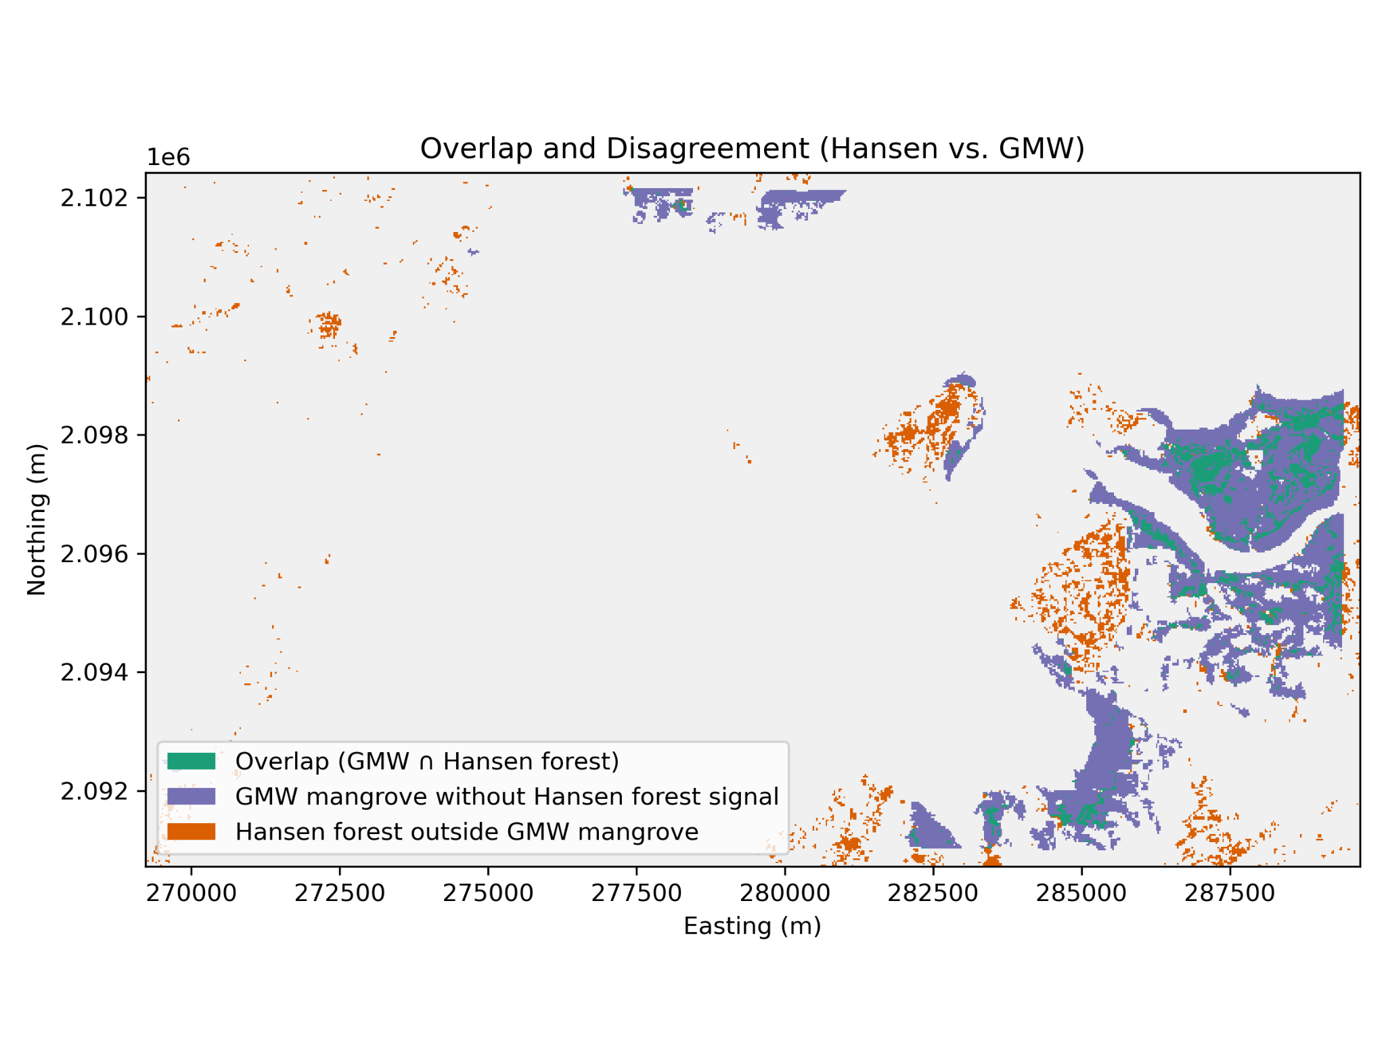
Figure 1. Overlap and disagreement between Hansen forest signal and GMW mangroves (aligned grid). Map comparing the Hansen-derived forest signal with the Global Mangrove Watch (GMW) mangrove mask after reprojection and grid alignment (EPSG:32643). Green indicates overlap pixels classified as mangrove by GMW and forest by Hansen under the chosen forest definition (canopy-cover threshold stated in Methods). Purple indicates GMW mangrove pixels not detected as forest in Hansen (mangrove-only). Orange indicates Hansen forest pixels outside the GMW mangrove mask (forest-only). Axes are in projected meters and represent the aligned analysis grid.
For each mangrove pixel, the first and last years of Hansen forest detection were extracted. The spatial distribution of first detection years shows earlier forest signals concentrated in inland mangrove regions, while later detections are more spatially fragmented. The last detection map reveals patchy and discontinuous forest signals across mangrove areas, suggesting instability in classification over time.
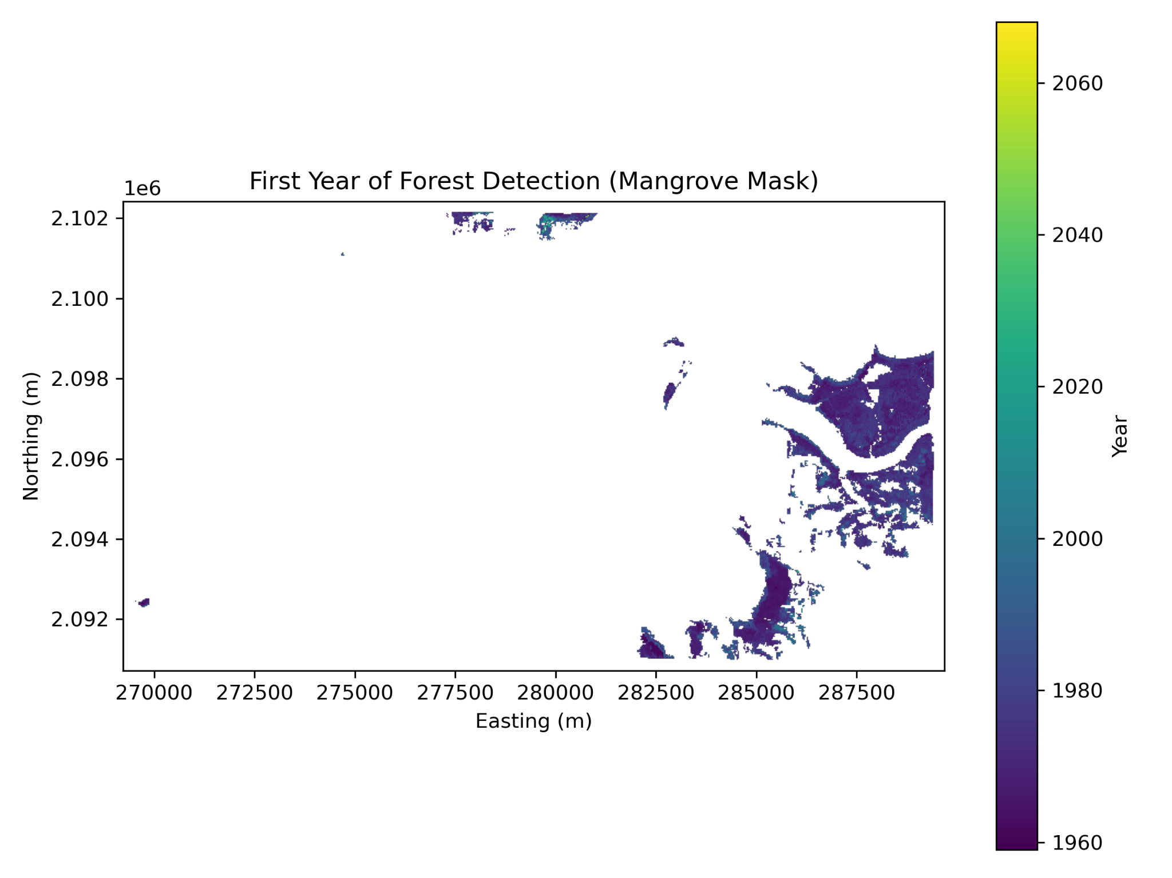
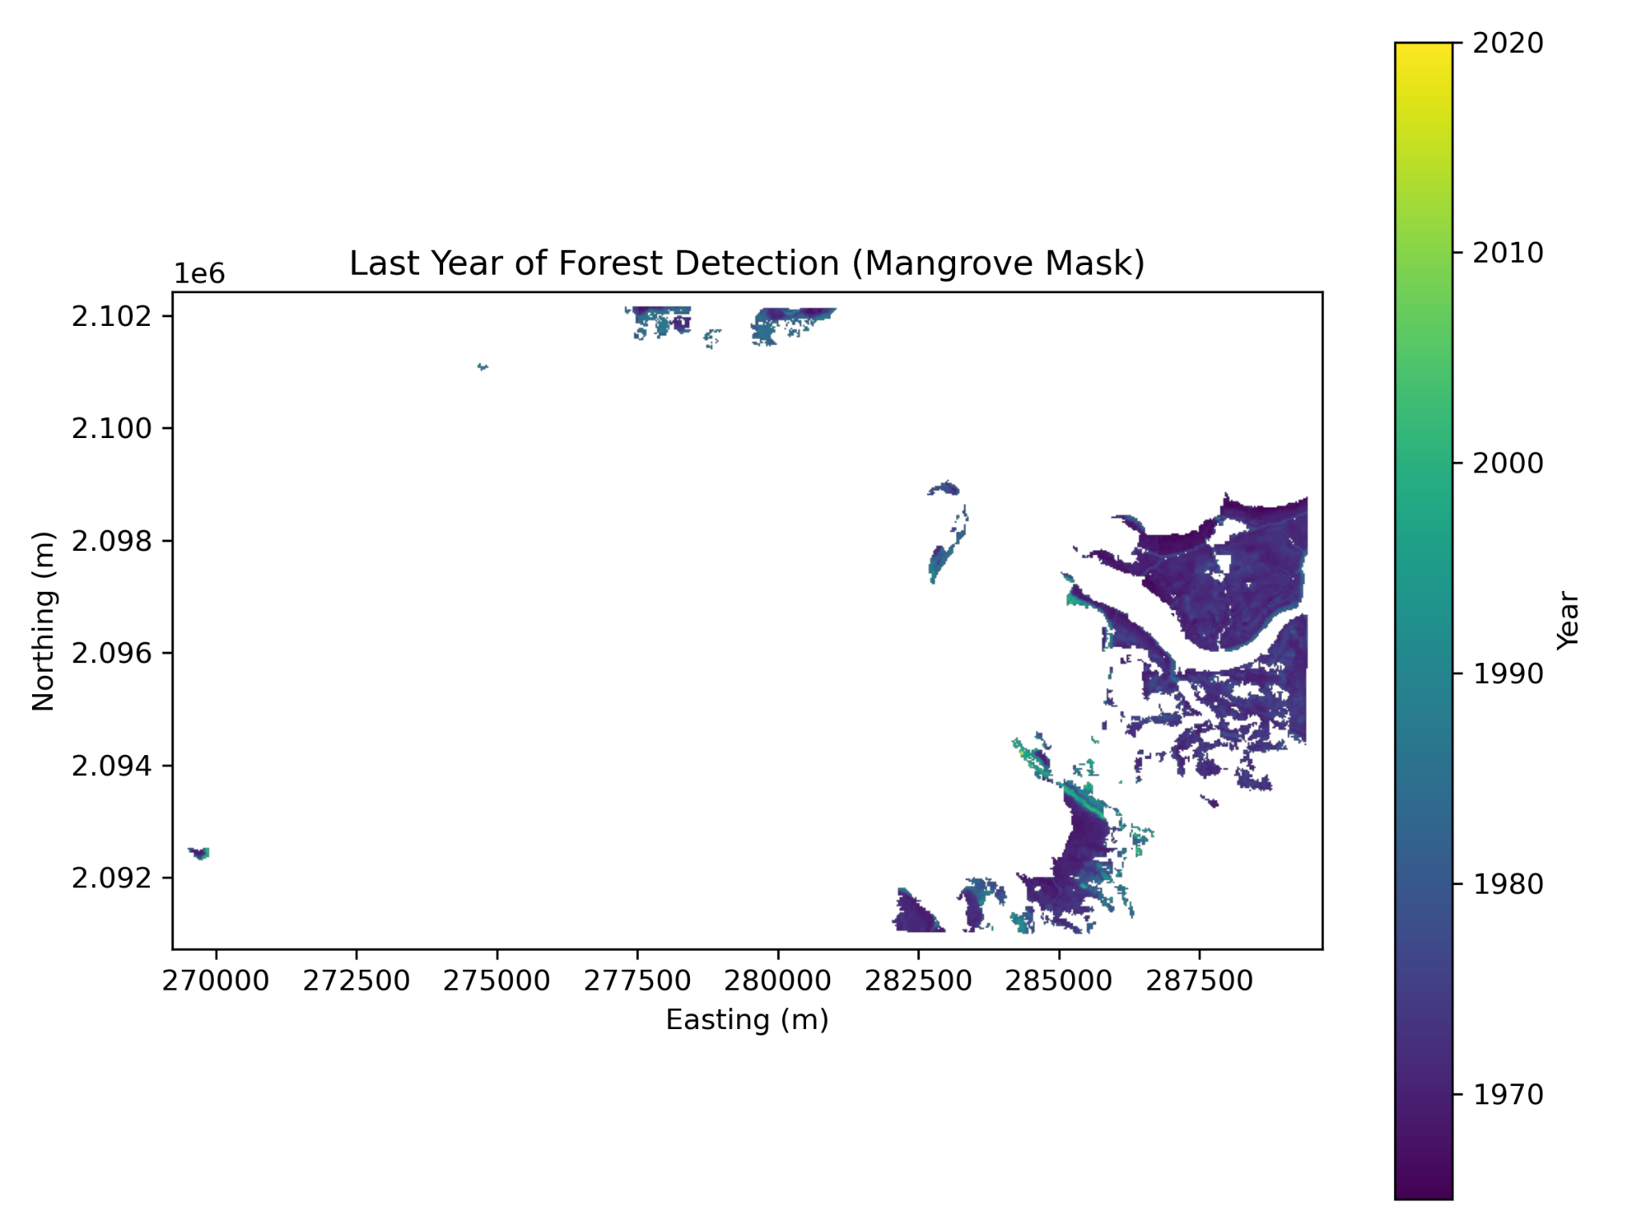Figure 2. Spatial distribution of first and last year of Hansen forest detection within GMW mangroves. Two maps showing (top) the first year and (bottom) the last year that Hansen classifies a pixel as forest, restricted to pixels inside the GMW mangrove mask. Values are decoded to calendar years using the encoding described in Methods. Spatial patterns indicate where forest detection appears earlier versus later, and where forest detection persists longer into the record.
Histograms of first and last detection years further demonstrate that forest detection does not occur uniformly across the mangrove system.
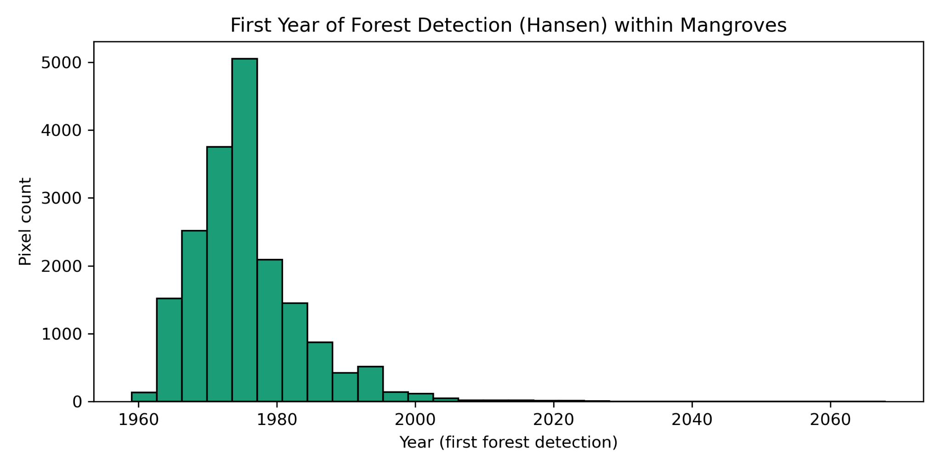
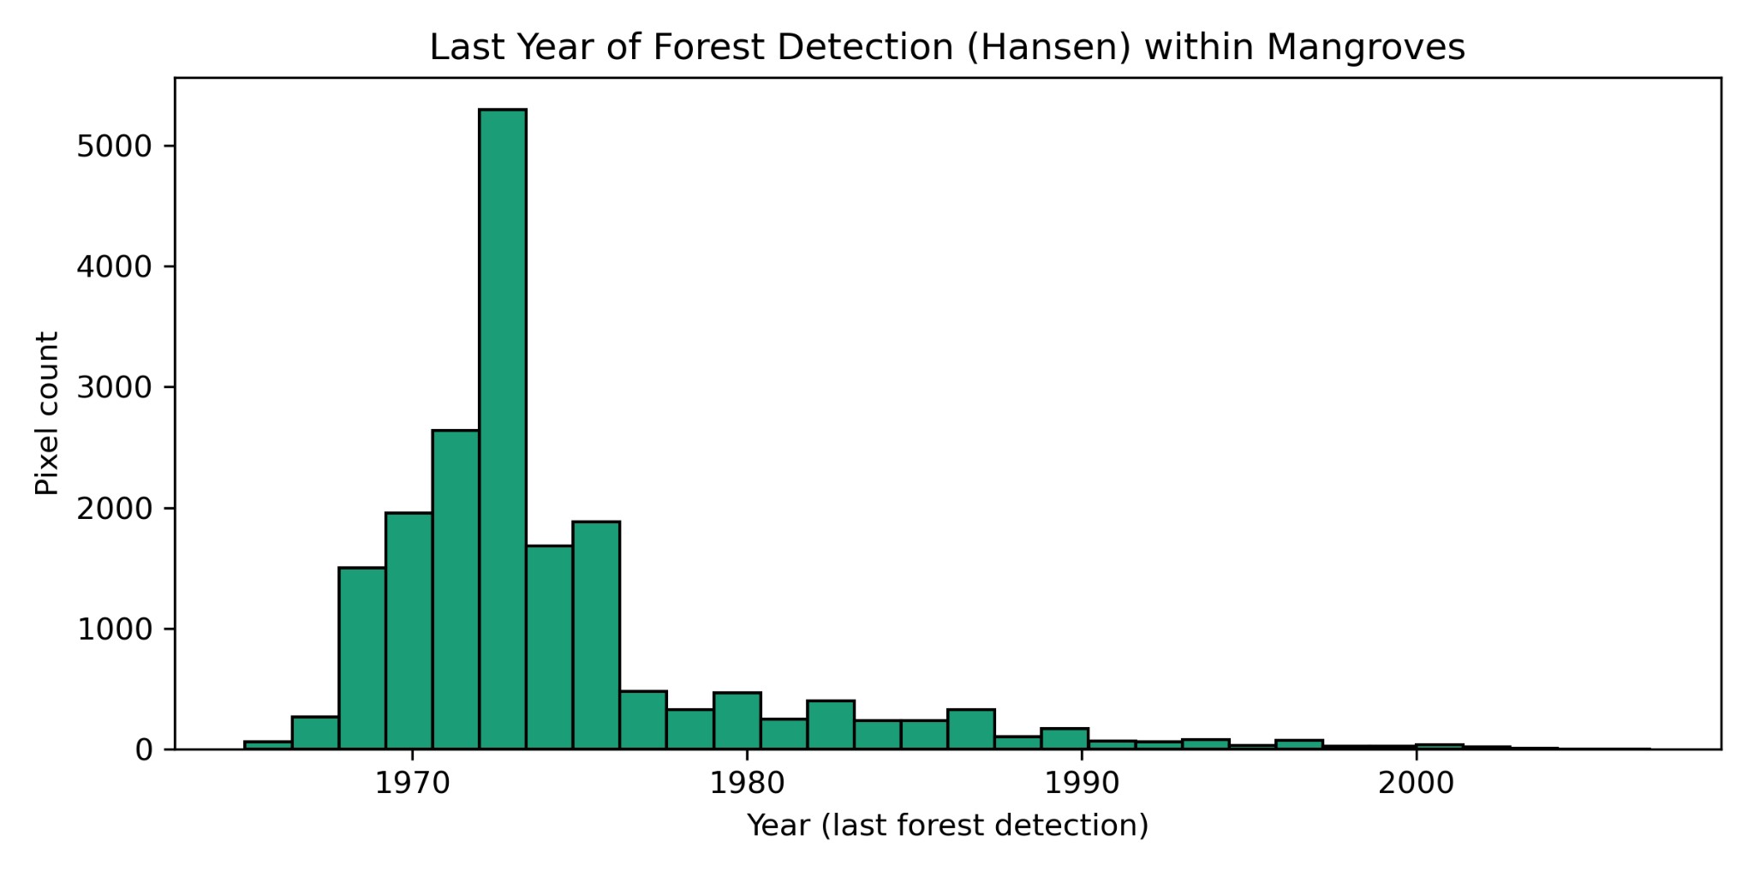
Figure 3. Histograms of first-year and last-year Hansen forest detections within GMW mangroves. Distributions of (top) first detection year and (bottom) last detection year for mangrove pixels with valid detections. These histograms summarize whether forest detection begins and ends uniformly across the mangrove system or is concentrated in specific time ranges. Bin counts represent pixel counts on the aligned grid.
In terms of the classification of mangroves, results show approximately 1393.22 ha (92.34%) of mangroves are classified as “temporary forest” in the Hansen dataset based on the first > 0 and last<latest criterion (Forest signals appear at some point but disappear before the latest year). On the other hand, approximately 115.63 ha (7.66%) are classified as “never forest” (first == 0) in the Hansen dataset.
However, persistent forest (first>0 and last==latest) is found to be 0 ha, conveying that all persistent forest pixels are being classified as temporary forest. This outcome is extremely suspicious considering that mangroves have long lifespans and don’t simply remain in a constant cycle of dying out as the data is suggesting.
Due to the suspicious and unstable nature of these results, this data doesn’t imply that mangroves are disappearing, but rather suggests that Hansen’s forest classification is unstable when applied to Mumbai’s mangrove ecosystems.
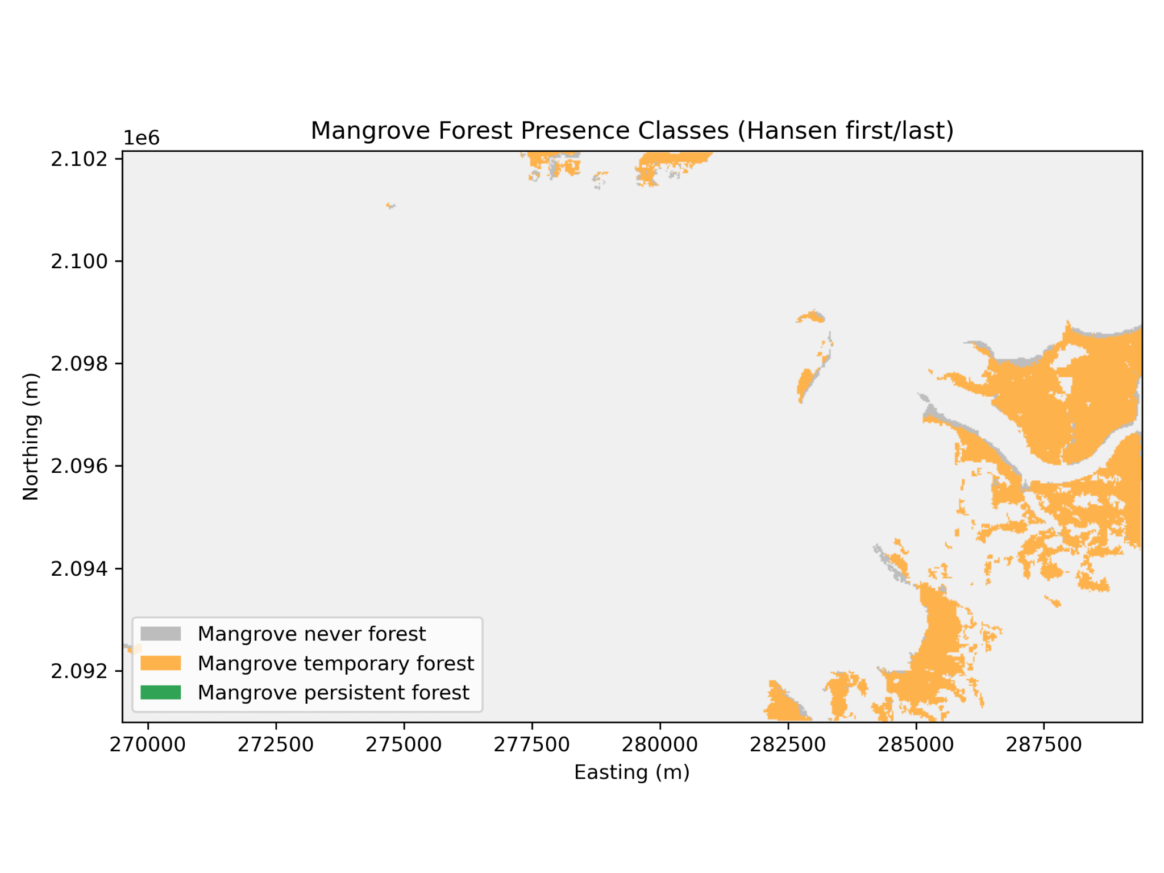
Figure 4. Mangrove forest presence classes derived from Hansen first/last detection (within the GMW mask). Categorical map classifying GMW mangrove pixels into: never forest (no Hansen detection), temporary forest (detected at least once but not present through the latest year), and persistent forest (detected and still present in the latest year). Class definitions follow the first/last criteria stated in Methods and are applied only inside the GMW mangrove extent.
The duration analysis discussed in the methodology section showed:
- A median duration near zero years
- A distribution dominated by short detection intervals
- Numerous pixels exhibiting near-zero or minimal persistence
The spatial duration map confirms that most mangrove pixels show short-lived forest detection signals rather than long-term stability.
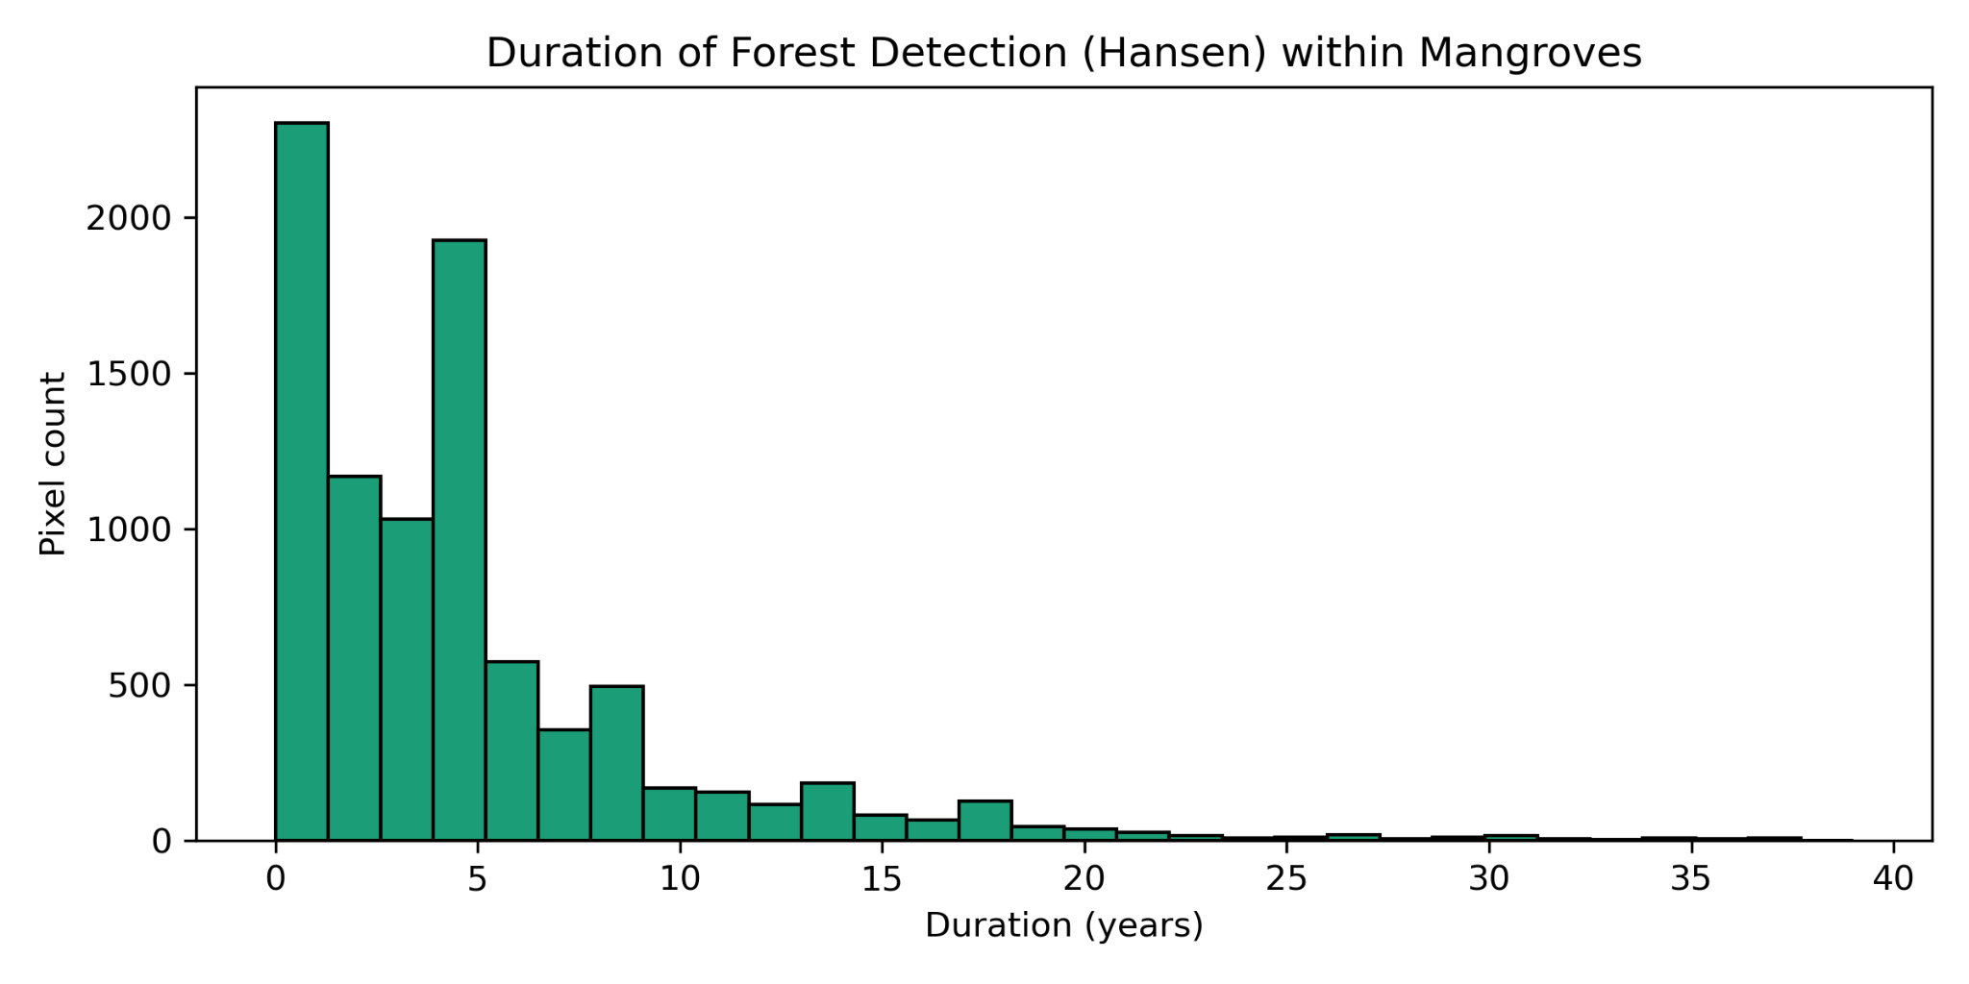
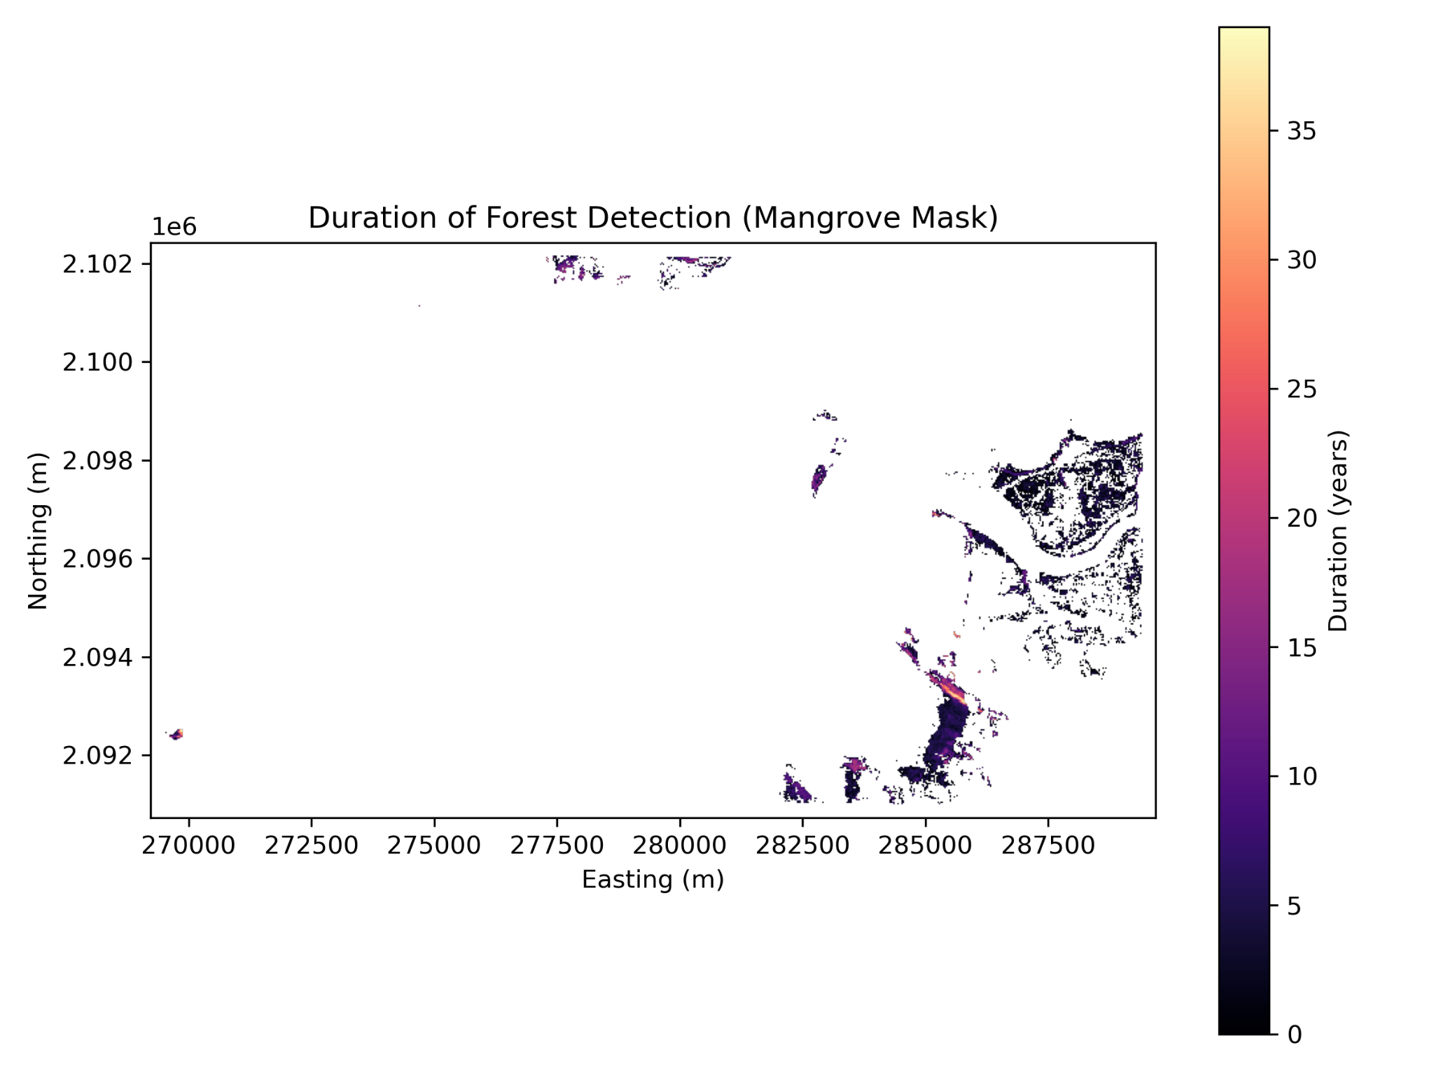

Figure 5. Duration of Hansen forest detection within mangroves (histogram and spatial map). (Top) Histogram of detection duration computed as (last detection year − first detection year) for mangrove pixels with valid detections. (Bottom) Spatial map of the same duration metric within the GMW mangrove mask. Short durations indicate unstable or intermittent forest classification, while longer durations indicate more persistent Hansen forest detection. Duration is reported in years using the decoding described in Methods.
As Figure 5 shows, the median duration of forest pixel seen in Hansen is near-zero, with very few pixels exceeding a duration of more than 10 years. This suggests that short-lived forest signals dominate duration maps and there is a scarcity of >5 years pixels, again reinforcing the suspicious nature of 0% persistent forest.
The duration spatial map further indicates that mangrove pixels aren’t persistent in the Hansen dataset and regularly flicker in and out of its classification of forest. Apart from the reasons stated previously, this can be attributed to tidal effects, phenology, canopy structure, and sensor noise. These results indicate that Hansen forest classification within mangroves is temporally unstable.
Discussion
Although over 92% of mangrove pixels exhibit forest detection at least once, the near absence of persistent forest classification suggests that Hansen’s forest definition does not consistently capture mangrove ecosystems over time.
This instability appears to reflect classification variability rather than large-scale mangrove loss, as cumulative loss within the mangrove mask was minimal over the study period.
Disagreement between Hansen and GMW is expected because the datasets are designed for different purposes and are built from different sensors and classification assumptions. Hansen Global Forest Change is a general-purpose forest monitoring product derived primarily from Landsat optical imagery and canopy cover thresholds. In contrast, GMW is designed specifically for mangroves and integrates radar (ALOS PALSAR) with optical imagery and coastal habitat constraints to improve detection in intertidal environments.
Several factors can plausibly explain why mangrove pixels may flicker in and out of Hansen’s forest classification:
First, mangroves occur in intertidal zones where the observed surface reflectance changes substantially with the tidal stage. Even if vegetation is unchanged, the mixture of water, mudflat, and canopy within a pixel can vary across images, causing unstable classification at 30 m resolution.
Second, mangrove canopy structure is often heterogeneous and can be sparse or low in height compared to many inland forests. Pixels with canopy cover near a fixed threshold (e.g., 10%) may move above or below the detection boundary due to seasonal effects, partial inundation, atmospheric conditions, or mixed-pixel effects.
Third, optical imagery is sensitive to cloud cover and haze, which can reduce usable observations and increase uncertainty in coastal regions. Radar-based inputs in GMW are less affected by cloud cover and can better discriminate against vegetated surfaces in wet environments, contributing to higher classification stability.
These factors jointly suggest that Hansen’s “forest persistence” signal may reflect classification variability as much as ecological change when applied to mangroves.
A critical interpretation point is that “temporary forest” in this analysis does not necessarily represent real ecological loss of mangroves. Instead, it indicates that Hansen does not detect forest consistently at that pixel across time. Therefore, the observed dominance of temporary classifications should be interpreted as a limitation of applying a general forest product to a coastal wetland ecosystem, not as evidence that Mumbai’s mangroves are repeatedly disappearing and returning.
This distinction is important because Hansen products are frequently used in environmental monitoring workflows and policy discussions. If mangroves are frequently mischaracterized as non-persistent forest, conclusions about mangrove degradation or stability derived from Hansen alone may be biased.
Mangroves are increasingly treated as natural infrastructure due to their role in coastal protection and flood risk reduction. For cities such as Mumbai, mangrove mapping supports environmental impact assessment, coastal regulation compliance, and resilience planning. The results here imply that dataset choice can strongly influence interpretation of mangrove persistence and change.
Specifically, Hansen-derived forest stability metrics may underrepresent mangrove persistence in intertidal environments and may not be appropriate as a standalone tool for monitoring mangrove stability. GMW-style mangrove-specific products, which incorporate radar and coastal constraints, are likely more suitable for baseline extent mapping and for identifying mangrove zones for planning purposes.
This study has several limitations.
First, it focuses on a single geographic region (Mumbai) and a limited spatial tile. Results may not directly generalize to mangroves with different canopy structures, sediment regimes, tidal ranges, or climatic conditions.
Second, this analysis compares only two widely used datasets. Additional datasets (e.g., ESA WorldCover mangrove classes or regionally validated mangrove maps) could provide further context.
Third, interpretation depends on correct decoding of Hansen temporal layers (first/last year). While the workflow standardizes projections and aligns grids for fair comparison, temporal encoding and nodata conventions require careful handling. Any remaining ambiguity in first/last encoding would affect persistence and duration estimates.
Finally, this study does not include field validation. Instead, it focuses on internal consistency and comparative behavior between datasets.
Overall, the results suggest that Hansen Global Forest Change can detect mangrove vegetation in Mumbai intermittently, but does not provide stable forest persistence signals within mangrove environments. The disagreement between Hansen and GMW is systematic and likely driven by sensor modality differences, intertidal mixed-pixel effects, and threshold-based classification limitations. These findings support the broader conclusion that ecosystem-specific datasets are necessary for reliable mangrove monitoring and that applying generic forest persistence metrics to mangroves requires caution.
Acknowledgments
I would like to thank my mentor for guidance on project design, methodology, and paper editing. I also thank the developers and maintainers of the Global Mangrove Watch and Hansen Global Forest Change datasets for making their data publicly available. This work used open-source Python tools including Rasterio, NumPy, Pandas, Matplotlib, and related geospatial libraries for data processing and visualization.
References
- UN Environment Programme. Mangrove forests. https://www.unep.org/topics/ocean-seas-and-coasts/blue-ecosystems/mangrove-forests, 2023.
- A. McIvor, I. Möller, T. Spencer, M. Spalding. Reduction of wind and swell waves by mangroves. https://elaw.org/resource/reduction-of-wind-and-swell-waves-by-mangroves, 2023.
- V. Chandrashekhar. Mumbai residents show “will to pay” for mangrove conservation. https://timesofindia.indiatimes.com/india/mumbai-residents-show-will-to-pay-for-mangrove-conservation/articleshow/119779108.cms, 2025.
- S. Rebello. Mumbai: Thane mangroves act as carbon sink. https://www.hindustantimes.com/mumbai/mumbai-thane-mangroves-act-as-carbon-sink/story-s5r3st85ustmlXt0LvWS6M.html, 2015.
- Food and Agriculture Organization of the United Nations. The world’s mangroves 1980–2005. https://www.fao.org/4/a1427e/a1427e00.htm, 2007.
- Ministry of Environment, Forest and Climate Change (MoEFCC). Forest survey of India: State of forest report 2017. https://www.gktoday.in/state-of-the-forest-report-2017/, 2017.
- A. A. S., G. L., M. K. R., R. C., S. John, S. G., J. Thomas. Multi-decadal changes of mangrove forest and its response to the tidal dynamics of Thane Creek, Mumbai. Journal of Sea Research. Vol. 180, pg. 102162, 2022, https://doi.org/10.1016/j.seares.2021.102162.
- NASA Earth Observatory. Monitoring Mumbai’s mangroves. https://science.nasa.gov/earth/earth-observatory/monitoring-mumbais-mangroves-91333/, 2017.
- A. Abhyankar, T. Sahoo, B. Seth, P. Mohapatra, S. Palai, P. Bhargava, S. Chaurasiya, S. Isasare. Mapping and change detection of mangroves around Mumbai using remote sensing and geographic information systems (GIS). Journal of Civil Engineering, Science and Technology. Vol. 12, 2021, https://www.researchgate.net/publication/356756294_MAPPING_AND_CHANGE_DETECTION_OF_MANGROVES_AROUND_MUMBAI_USING_REMOTE_SENSING_AND_GEOGRAPHIC_INFORMATION_SYSTEMS_GIS.
- ESA WorldCover. WorldCover. 2021, https://esa-worldcover.org/en.
- Japan Aerospace Exploration Agency (JAXA). ALOS-2 / PALSAR-2. 2014, https://www.eorc.jaxa.jp/ALOS-2/en/about/palsar2.htm.
- M. C. Hansen, P. V. Potapov, R. Moore, M. Hancher, S. A. Turubanova, A. Tyukavina, D. Thau, S. V. Stehman, S. J. Goetz, T. R. Loveland, A. Kommareddy, A. Egorov, L. Chini, C. O. Justice, J. R. G. Townshend. High-resolution global maps of 21st-century forest cover change. Science. Vol. 342, pg. 850-853, 2013, https://doi.org/10.1126/science.1244693.
- P. Bunting, A. Rosenqvist, R. M. Lucas, L. M. Rebelo, L. Hilarides, N. Thomas, A. Hardy, T. Itoh, M. Shimada, C. M. Finlayson. The global mangrove watch - A new 2010 global baseline of mangrove extent. Remote Sensing. Vol. 10, pg. 1669, 2018, https://doi.org/10.3390/rs10101669.
- C. R. Harris, K. J. Millman, S. J. van der Walt, et al. Array programming with NumPy. Nature. Vol. 585, pg. 357–362, 2020, https://doi.org/10.1038/s41586-020-2649-2.
- S. Gillies. Rasterio: Geospatial raster I/O for Python. https://rasterio.readthedocs.io, 2013.
- PROJ contributors. PROJ coordinate transformation software library. https://proj.org, 2023.
- J. D. Hunter. Matplotlib: A 2D graphics environment. Computing in Science & Engineering. Vol. 9, pg. 90–95, 2007, https://doi.org/10.1109/MCSE.2007.55.

