Keywords: tonal stability; key ambiguity; Tonnetz; Krumhansl–Schmuckler algorithm; Key Ambiguity Index; computational musicology; MIDI; harmonic motion

Introduction

Problem Statement
Understanding tonal stability and harmonic centroids is essential for both traditional music theory and computational music analysis ((Krumhansl, C.L.; Cuddy, L.L. A Theory of Tonal Hierarchies in Music. Music Perception. pg. 51–96, 2010.)), ((Balzano, G.J. The Pitch Set as a Level of Description for Studying Musical Pitch Perception. Music, Mind, and Brain: The Neuropsychology of Music. pg. 321–351, 1982.)). While Classical music generally adheres to a stable key with predictable harmonic progressions, Jazz and Stravinsky's compositions often exhibit rapid key changes and more complex tonal structures ((Temperley, D.; Marvin, E.W. Pitch-Class Distribution and the Identification of Key. Music Perception. Vol. 25, No. 3, pg. 193–212, 2008.)). Existing methods, such as the Krumhansl–Schmuckler (KS) key-finding algorithm, capture certain aspects of tonality but do not fully account for harmonic ambiguities or dynamic shifts in tonal centroids ((Krumhansl, C.L.; Kessler, E.J. Tonal Hierarchies and Rare Intervals in Music Cognition. Canadian Journal of Psychology. Vol. 41, No. 4, pg. 379–396, 1987.)), ((Vuvan, D.T.; Prince, J.B.; Schmuckler, M.A. Tonal Hierarchy Representations in Auditory Imagery. Memory & Cognition. Vol. 39, No. 3, pg. 477–490, 2011.)). This study proposes a comprehensive analytical framework capable of quantifying both tonal stability and harmonic modulation across musical genres.

Exact Premise and Importance
Compositions that traverse multiple key areas are expected to exhibit reduced tonal stability and more frequent shifts in tonal centers ((Krumhansl, C.L.; Cuddy, L.L. A Theory of Tonal Hierarchies in Music. Music Perception. pg. 51–96, 2010.)), ((Temperley, D.; Marvin, E.W. Pitch-Class Distribution and the Identification of Key. Music Perception. Vol. 25, No. 3, pg. 193–212, 2008.)). We introduce the Key Ambiguity Index (KAI), which integrates the rolling variance of key strength, derived from the Krumhansl–Schmuckler method, with the cumulative path length in Tonnetz space. Application of KAI to excerpts from Classical, Jazz, and Stravinsky repertoires is expected to reveal higher tonal ambiguity in Jazz and Stravinsky pieces relative to Classical works ((Vuvan, D.T.; Prince, J.B.; Schmuckler, M.A. Tonal Hierarchy Representations in Auditory Imagery. Memory & Cognition. Vol. 39, No. 3, pg. 477–490, 2011.)). This measure facilitates quantitative comparisons of tonal dynamics across genres, highlighting stylistic distinctions in harmonic behavior.

Objectives
- Compute rolling KS key-strength time series and Tonnetz-derived tonal centroids for MIDI excerpts across multiple genres.
- Define the Key Ambiguity Index (KAI) by combining variance in key strength with tonal centroid motion.
- Analyze and compare KAI distributions across Classical, Jazz, Stravinsky, Pop, and Rock music.
- Statistically evaluate differences in tonal stability and harmonic motion across genres to test whether Jazz and Stravinsky excerpts exhibit greater tonal ambiguity than Classical excerpts.
The study of the ``stickiness'' of tonal centers and the movement of harmony has long been an important aspect of computational musicology. As we experience the music of the classical repertoire, we are accustomed to hearing tonic centers that remain stable and predictable in terms of harmony, but in the realm of Jazz and much 20th-century music, as exemplified by the works of Igor Stravinsky, we experience quick tonal changes and unusual pitch-class relationships. Several techniques have been applied to the study of the stability of tonality in both symbolic music representations and in the sound itself, including the study of pitch-class distributions, the use of chroma features ((Muller, M.; Ewert, S. Chroma Toolbox: MATLAB Implementations for Extracting Variants of Chroma-Based Audio Features. Proceedings of the 12th International Society for Music Information Retrieval Conference (ISMIR). pg. 215–220, 2011.)), and the application of the Krumhansl–Schmuckler (KS) algorithm for key finding ((Krumhansl, C.L.; Schmuckler, M.A. Key-finding in music. 1986.)). The Tonnetz, or geometric representation of pitch classes and their relationships, has also proven to be an important tool in the study of the proximity of chords, the centroids of keys, and the path of harmony through multidimensional space ((Tymoczko, D. A Geometry of Music: Harmony and Counterpoint in the Extended Common Practice. Oxford University Press. 2011.)). By combining the KS key finding algorithm with the centroids derived from the Tonnetz, we are able to gain an understanding of the way in which the tonal centers shift and the way in which the harmony moves through multidimensional space.
In this study, we seek to determine whether Jazz and Stravinsky excerpts exhibit less tonal stability and greater harmonic variation than those in the Classical repertoire. Our method relies on the analysis of MIDI data, which fixes pitch and time while removing any variability in performance. We calculate six-dimensional Tonnetz-derived tonal centroids and rolling KS key strength time series for each excerpt, examining the evolution of tonal centers and harmonic movement in six dimensions. Additionally, we introduce a small jitter in the calculation of the KS time series, which reduces the effect of quantized onset times in the MIDI data. Finally, we smooth the Tonnetz-derived centroids and KS time series using a Gaussian filter, reducing frame-to-frame variation in tonal centers and revealing harmonic movement ((Muller, M. Fundamentals of Music Processing: Audio, Analysis, Algorithms, Applications. Springer. 2015.)).
We also propose a novel Key Ambiguity Index (KAI) given by the sum of the z-score normalized key strength variance and the Tonnetz-derived path length per minute. The KAI distributions are computed from snippets of Classical, Jazz, Stravinsky, Pop, and Rock pieces. To compare the statistics of each genre, we will use Kruskal–Wallis tests with Dunn's post-hoc tests and false discovery rate correction, examining the differences in tonal stability and harmonic movement across each group. We will also verify the robustness of our results by examining the impact of some of our parameter choices, such as frame sizes and smoothing, on centroid movement. KAI combines rolling KS key strength with Gaussian smoothing of Tonnetz-driven harmonic movement to derive a numeric measure of tonal uncertainty, enabling a quantitative comparison of tonal and harmonic characteristics unique to each genre. We anticipate that Jazz and Stravinsky pieces will demonstrate lower average key strength and longer Tonnetz movement than Classical pieces, reflecting greater tonal ambiguity and harmonic movement.
We borrowed samples from Classical, Jazz, Stravinsky, Pop, and Rock to create the KAI distributions. To evaluate how well each genre performs, we apply Kruskal–Wallis tests with Dunn's post-hoc analyses and false discovery rate corrections, examining the differences in tonal stability and harmonic motion across the genres. We also evaluate the robustness of the findings by examining the impact of some parameter settings, such as the size of the frames and the amount of smoothing, on the centroid motion. The KAI algorithm combines rolling KS key strength with Gaussian smoothing of the Tonnetz-informed harmonic motion to create a numerical measure of tonal ambiguity, allowing us to compare tonal and harmonic characteristics that are genre-specific. We anticipate that the Jazz and Stravinsky music would exhibit lower key strength and longer Tonnetz motion than the Classical music, indicating higher ambiguity in the tones and richer harmonic content. The Key Ambiguity Index (KAI) is proposed as a single figure combining KS key strength variance with Tonnetz path length per minute, which aims to provide a comprehensive measure of tonal ambiguity. In the analytical part, the average HCDF curves are calculated and visualized for each genre, the distribution of KAI is calculated over all genres, and violin plots are used to display the distribution of tonal ambiguity with harmonic motion. The statistical analysis employs the Kruskal–Wallis test and Dunn post-test with FDR correction to compare the genres, with robustness checks involving the adjustment of the frame size and the addition of jitter. The analytical part presents the key findings: the Jazz and Stravinsky excerpts exhibit higher tonal ambiguity and multidimensional harmonic motion than the Classical music pieces. The discussion part interprets the observed patterns with reference to the position of the tonal centroids, key strength, and harmonic fluidity. Finally, the paper concludes by highlighting the key contributions, emphasizing the reproducibility and flexibility of the computational framework, and suggesting future directions involving performance-based or audio-based approaches.

Motivation
The understanding of the construction of music and the movement of harmony is an important goal in both music theory and computational musicology. Conventional analysis involves listening and studying the score, but quantitative analysis brings an objective and replicable quality in assessing tonal stability and harmony complexity. By using pitch class distributions, chroma features, and tonal centroids derived from the Tonnetz ((Muller, M.; Ewert, S. Chroma Toolbox: MATLAB Implementations for Extracting Variants of Chroma-Based Audio Features. Proceedings of the 12th International Society for Music Information Retrieval Conference (ISMIR). pg. 215–220, 2011.)), ((Tymoczko, D. A Geometry of Music: Harmony and Counterpoint in the Extended Common Practice. Oxford University Press. 2011.)), we can use algorithms that identify patterns in musical sequences that are characteristic of different musical styles. Moreover, we can use the Tonnetz and other tools to create musical sequences that are useful in analysis and composition. This allows us to examine tonal ambiguity, harmony, and style using a quantitative and replicable approach.
In building upon these computer-related concepts, this research explores tonal movement and harmonic indeterminacy across different music genres. In integrating tonal movement based on Tonnetz theory with rolling key strength values based on Krumhansl and Schmuckler theory, this research creates an evolving picture of how tonal stability is maintained or wavers over time. This framework enables quantification of not only tonal movement but also instances of tonal interpretation that become ambiguous or uncertain. When this framework is used to analyze music from Classical, Pop, Rock, Jazz, and Stravinsky music genres, unique stylistic characteristics emerge. The results suggest that music genres with more developed chromaticism and longer harmony progressions also have more tonal freedom and key ambiguity than music genres with more tonal center stability. Overall, these results demonstrate how computer-related research supports traditional music theory by providing quantification of music stylistic differences.

Background

Tonal Perception and Tonal Stability
Tonal perception denotes the cognitive ability of listeners to infer the key or tonal center of a musical composition, thereby distinguishing between notes perceived as stable and those that are less resolved. This hierarchical structure is consistent across transpositions but exhibits systematic differences between major and minor modes; minor keys are further complicated by the presence of multiple forms (natural, harmonic, and melodic) ((Krumhansl, C.L.; Cuddy, L.L. A Theory of Tonal Hierarchies in Music. Music Perception. pg. 51–96, 2010.)), ((Krumhansl, C.L.; Kessler, E.J. Tracing the Dynamic Changes in Perceived Tonal Organization in a Spatial Representation of Musical Keys. Psychological Review. Vol. 89, No. 4, pg. 334–368, 1982.)), ((Vuvan, D.T.; Prince, J.B.; Schmuckler, M.A. Tonal Hierarchy Representations in Auditory Imagery. Memory & Cognition. Vol. 39, No. 3, pg. 477–490, 2011.)).
Quantifying tonal stability is essential, as it informs multiple aspects of music cognition—including expectancy formation, memory, and the computational identification of tonal centers—underpinning algorithmic models in musicology ((Krumhansl, C.L.; Kessler, E.J. Tonal Hierarchies and Rare Intervals in Music Cognition. Canadian Journal of Psychology. Vol. 41, No. 4, pg. 379–396, 1987.)), ((Krumhansl, C.L.; Cuddy, L.L. A Theory of Tonal Hierarchies in Music. Music Perception. pg. 51–96, 2010.)). Empirical studies using probe-tone experiments have consistently shown that listeners' ratings of how well a note fits a given context correspond closely to these hierarchical structures, validating the psychological reality of tonal stability across musical genres ((Krumhansl, C.L.; Cuddy, L.L. A Theory of Tonal Hierarchies in Music. Music Perception. pg. 51–96, 2010.)), ((Vuvan, D.T.; Prince, J.B.; Schmuckler, M.A. Tonal Hierarchy Representations in Auditory Imagery. Memory & Cognition. Vol. 39, No. 3, pg. 477–490, 2011.)).
In short, tonal perception and the hierarchy of pitch stability form the foundational framework for studying how humans experience and process music, and provide a key reference point for computational models such as the Krumhansl–Schmuckler key-finding algorithm ((Krumhansl, C.L.; Cuddy, L.L. A Theory of Tonal Hierarchies in Music. Music Perception. pg. 51–96, 2010.)), ((Vuvan, D.T.; Prince, J.B.; Schmuckler, M.A. Tonal Hierarchy Representations in Auditory Imagery. Memory & Cognition. Vol. 39, No. 3, pg. 477–490, 2011.)).

Background on the Krumhansl--Schmuckler Key-Finding Algorithm
Understanding the tonal structure of music is a central goal in both music theory and music cognition. In Western tonal music, pitches are organized around a central reference tone called the tonic, forming a tonal hierarchy. This hierarchy assigns greater psychological ``stability'' to some tones over others: the tonic is the most stable, followed by other diatonic notes, and finally non-diatonic notes ((Krumhansl, C.L.; Kessler, E.J. Tonal Hierarchies and Rare Intervals in Music Cognition. Canadian Journal of Psychology. Vol. 41, No. 4, pg. 379–396, 1987.)), ((Schmuckler, M.A. Tonality and Contour in Melodic Processing. Psychological Research. Vol. 85, No. 1, pg. 96–116, 2021.)). These hierarchical relationships have been verified experimentally using the probe-tone procedure, where listeners rate the ``goodness-of-fit'' of a single tone following a tonal context. The resulting ratings closely match theoretical predictions of tonal importance, confirming that listeners perceive certain tones as cognitively central within a key ((Krumhansl, C.L. Cognitive Foundations of Musical Pitch. Oxford University Press. 1990.)), ((Schmuckler, M.A.; Tomovski, R. Pitch and Pitch Structures. Journal of Experimental Psychology: Human Perception and Performance. Vol. 31, No. 1, pg. 1–17, 2005.)).
The Krumhansl–Schmuckler (KS) key-finding algorithm ((Krumhansl, C.L.; Schmuckler, M.A. Key-finding in music. 1986.)), ((Schmuckler, M.A.; Tomovski, R. Pitch and Pitch Structures. Journal of Experimental Psychology: Human Perception and Performance. Vol. 31, No. 1, pg. 1–17, 2005.)) provides a computational framework for identifying the tonal center of a musical passage. The algorithm operates by representing musical material as pitch-class vectors and correlating them with experimentally derived key profiles, enabling the inference of both static and time-varying tonal centers.
The KS algorithm abstracts tonal information from surface pitch patterns by summing durations of pitch occurrences while ignoring temporal order, mirroring perceptual processes. It is flexible, capable of analyzing both short passages and entire pieces to identify static or time-varying tonal centers. Empirical validation confirms that its predictions closely align with listeners' perceptions of tonality, including tonal stability, perceived key motion, and memory effects such as false recall of implied notes ((Krumhansl, C.L. Cognitive Foundations of Musical Pitch. Oxford University Press. 1990.)), ((Schmuckler, M.A.; Tomovski, R. Pitch and Pitch Structures. Journal of Experimental Psychology: Human Perception and Performance. Vol. 31, No. 1, pg. 1–17, 2005.)), ((Vuvan, D.T.; Prince, J.B.; Schmuckler, M.A. Tonal Hierarchy Representations in Auditory Imagery. Memory & Cognition. Vol. 39, No. 3, pg. 477–490, 2011.)).
Beyond music theory, the KS algorithm serves as a model of pattern recognition in perception, demonstrating how humans abstract global structures from complex, time-varying stimuli—a principle relevant not only to music but to general cognitive processing ((Schmuckler, M.A. Tonality and Contour in Melodic Processing. Psychological Research. Vol. 85, No. 1, pg. 96–116, 2021.)).

Chroma Feature Extraction
Chroma features provide a compact representation of tonal content by mapping all pitches of a musical signal into 12 pitch classes (C–B), effectively ignoring octave information while preserving harmonic relationships ((Shah, J.; Vaidya, M.; Patel, M. Leveraging Chroma Feature for Classification of Western Music. Proceedings of the International Conference on Emerging Trends in Engineering and Technology. 2021.)), ((Ellis, D.P.W. MATLAB Implementations for Chroma Feature Extraction. Web resource, Columbia University LabROSA. 2008.)). This octave invariance reflects the perceptual property that pitches separated by octaves share similar tonal ``color,'' making chroma features well-suited for capturing harmonic and melodic structure.
In practice, chroma features are represented as 12-dimensional vectors, where each element corresponds to the energy of a pitch class within a short time frame. Over time, these vectors form a chromagram, a time–pitch representation that summarizes tonal activity and progression. The chromagram can be interpreted as a frequency spectrum folded into a single octave, enabling comparisons across pieces that differ in register or instrumentation ((Ellis, D.P.W. MATLAB Implementations for Chroma Feature Extraction. Web resource, Columbia University LabROSA. 2008.)).
Within this study, chroma features serve as the foundational representation for computing Tonnetz centroids. By adding pitch-class distributions in an octave-invariant form, they enable consistent analysis of harmonic relationships and support downstream tasks such as key estimation and the measurement of tonal motion through HCDF.

Harmonic Change Detection Function
Harmonic Change Detection (HCD) identifies chord boundaries and harmonic transitions in music, supporting tasks such as Automatic Chord Recognition. The Harmonic Change Detection Function (HCDF), introduced by ((Harte, C.; Sandler, M.; Gasser, M. Detecting Harmonic Change in Musical Audio. Proceedings of the 1st ACM Workshop on Audio and Music Computing Multimedia. pg. 21–26, 2006.)), detects harmonic changes by representing each time frame in a tonal space and measuring the distance between consecutive frames; peaks in the HCDF indicate potential chord changes.
Early approaches, such as ((Hainsworth, S.W.; Macleod, M.D. Particle Filtering Methods for Music Transcription. Proceedings of the International Computer Music Conference (ICMC). 2004.)), applied band-wise analysis of audio signals to capture harmonic transitions, highlighting the importance of frequency-specific processing. Later refinements focused on optimizing distance metrics and representations to improve detection accuracy ((Degani, A.; Dalai, M.; Leonardi, R.; Migliorati, P. Harmonic Change Detection in Musical Audio for Automatic Chord Recognition. IEEE Transactions on Audio, Speech, and Language Processing. 2011.)).
In symbolic music, HCDF has been adapted to work with MIDI or MusicXML data using tonal interval representations, such as Tonal Interval Vectors (TIV), often combined with chord reduction techniques to focus on structurally essential notes ((Ramoneda Franco, P. Chord Reduction and Harmonic Analysis for Symbolic Music. Proceedings of the Sound and Music Computing Conference (SMC). 2020.)), ((Macedo, J. Tonal Interval Vectors for Harmonic Change Detection in Symbolic Music. Proceedings of the International Society for Music Information Retrieval Conference (ISMIR). 2022.)). These symbolic methods avoid the confounding effects of timbre and performance, providing a clearer measure of harmonic change.

Tonnetz and Geometric Representation of Harmony
In computational musicology, the Tonnetz is a geometric framework used to map chords and keys into a spatial representation, allowing harmonic relationships to be visualized and analyzed systematically ((Cannas, S.; Andreatta, M. A Symbolic Perspective on the Generalized Tonnetz. Journal of Mathematics and Music. Vol. 12, No. 3, pg. 169–186, 2018.)), ((Krumhansl, C.L.; Cuddy, L.L. A Theory of Tonal Hierarchies in Music. Music Perception. pg. 51–96, 2010.)). Each vertex in a Tonnetz typically represents a pitch or chord, and edges connect pitches or chords that are closely related in terms of voice leading, such as major and minor triads ((Cannas, S.; Andreatta, M. A Symbolic Perspective on the Generalized Tonnetz. Journal of Mathematics and Music. Vol. 12, No. 3, pg. 169–186, 2018.)). By translating musical structures into geometric space, the Tonnetz enables researchers to study harmonic progressions in terms of ``distance,'' where short paths correspond to small, parsimonious changes in harmony, and longer paths correspond to larger tonal shifts ((Krumhansl, C.L.; Cuddy, L.L. A Theory of Tonal Hierarchies in Music. Music Perception. pg. 51–96, 2010.)), ((Cannas, S.; Andreatta, M. A Symbolic Perspective on the Generalized Tonnetz. Journal of Mathematics and Music. Vol. 12, No. 3, pg. 169–186, 2018.)).
This representation is particularly useful for analyzing harmonic movement because it formalizes concepts like voice leading and chordal transformations into measurable operations. The neo-Riemannian transformations—Parallel (P), Leading-tone exchange (L), and Relative (R)—allow minimal movement between chords, and these operations are naturally represented as edges in the Tonnetz or its dual, the Chicken-wire torus ((Cannas, S.; Andreatta, M. A Symbolic Perspective on the Generalized Tonnetz. Journal of Mathematics and Music. Vol. 12, No. 3, pg. 169–186, 2018.)). Similarly, the generalization to seventh chords provides a more complete framework for analyzing four-part harmony, as each vertex represents a seventh chord and edges indicate parsimonious transformations between them ((Cannas, S.; Andreatta, M. A Symbolic Perspective on the Generalized Tonnetz. Journal of Mathematics and Music. Vol. 12, No. 3, pg. 169–186, 2018.)).
By using geometric representations like the Tonnetz, researchers can quantify harmonic relationships, track key ambiguity, and measure tonal stability across compositions. The concept of distance in this space corresponds directly to harmonic change, making it possible to computationally analyze patterns in voice leading and chord progression across genres ((Krumhansl, C.L.; Cuddy, L.L. A Theory of Tonal Hierarchies in Music. Music Perception. pg. 51–96, 2010.)), ((Cannas, S.; Andreatta, M. A Symbolic Perspective on the Generalized Tonnetz. Journal of Mathematics and Music. Vol. 12, No. 3, pg. 169–186, 2018.)).

Measuring Tonal Motion: Distance-Based Methods
While the Tonnetz formalizes relational geometry, distance-based methods quantify the magnitude of harmonic motion, together providing complementary perspectives on tonal structure. They provide a quantitative approach to track harmonic movement in music by representing chords, keys, or pitch collections as points in a geometric space and calculating the distance between them ((Krumhansl, C.L.; Cuddy, L.L. A Theory of Tonal Hierarchies in Music. Music Perception. pg. 51–96, 2010.)), ((Cannas, S.; Andreatta, M. A Symbolic Perspective on the Generalized Tonnetz. Journal of Mathematics and Music. Vol. 12, No. 3, pg. 169–186, 2018.)). In this framework, the distance between two points corresponds to the amount of harmonic change: shorter distances indicate closely related chords or smooth voice leading, while longer distances reflect larger tonal shifts or modulations ((Krumhansl, C.L.; Cuddy, L.L. A Theory of Tonal Hierarchies in Music. Music Perception. pg. 51–96, 2010.)).
One commonly used approach is Euclidean distance, where chords or tonal centroids are mapped into a multidimensional vector space. The centroid of a chord or passage can be computed as the weighted average of its pitch classes, capturing its tonal ``center of gravity'' in the space ((Cannas, S.; Andreatta, M. A Symbolic Perspective on the Generalized Tonnetz. Journal of Mathematics and Music. Vol. 12, No. 3, pg. 169–186, 2018.)). For two-dimensional tonal centroids $(a_1, a_2)$ and $(b_1, b_2)$, the Euclidean distance is:
\[
d = \sqrt{(b_1 - a_1)^2 + (b_2 - a_2)^2}
\]
Extending this to the six-dimensional tonal centroids used in this study, the 6D Euclidean distance between $(a_0, \ldots, a_5)$ and $(b_0, \ldots, b_5)$ is:
\[
d = \sqrt{(b_0 - a_0)^2 + (b_1 - a_1)^2 + \cdots + (b_5 - a_5)^2} = \sqrt{\sum_{d=0}^{5}(b_d - a_d)^2}
\]
By measuring the movement of centroids over time, researchers can quantify tonal motion, providing insight into the stability or instability of harmonic progressions. This concept links directly to the HCDF, which computes the distances between successive centroids to measure how far the music moves harmonically over time. For example, in classical tonal music, distances between successive centroids tend to be small, reflecting smooth voice leading and tonal stability, while in Jazz or contemporary music, larger distances may indicate more chromaticism or ambiguity ((Krumhansl, C.L.; Cuddy, L.L. A Theory of Tonal Hierarchies in Music. Music Perception. pg. 51–96, 2010.)), ((Cannas, S.; Andreatta, M. A Symbolic Perspective on the Generalized Tonnetz. Journal of Mathematics and Music. Vol. 12, No. 3, pg. 169–186, 2018.)).

The Gap in Current Methods
The Krumhansl–Schmuckler (KS) algorithm is widely used to quantify tonal stability and key strength, effectively identifying which key a musical passage gravitates toward ((Krumhansl, C.L.; Cuddy, L.L. A Theory of Tonal Hierarchies in Music. Music Perception. pg. 51–96, 2010.)). Similarly, distance-based methods such as the HCDF track the movement of chords or pitch-class centroids over time, capturing harmonic motion and transitions in a piece ((Krumhansl, C.L.; Cuddy, L.L. A Theory of Tonal Hierarchies in Music. Music Perception. pg. 51–96, 2010.)). Meanwhile, geometric representations of harmony such as the Tonnetz and its chord-based generalizations provide a spatial model of relationships between chords, mapping transformations like neo-Riemannian P, L, and R operations and allowing the analysis of parsimonious voice leading ((Cannas, S.; Andreatta, M. A Symbolic Perspective on the Generalized Tonnetz. Journal of Mathematics and Music. Vol. 12, No. 3, pg. 169–186, 2018.)).
While each of these methods offers a unique perspective—key strength, motion, or relational structure—they remain limited in scope. Critically, none of them simultaneously accounts for both tonal ambiguity and harmonic motion. The KS algorithm identifies key stability but does not provide insight into transitions or ambiguity between multiple possible tonal centers. HCDF and centroid-based methods quantify movement, yet they do not capture the relational geometry or proximity of chords in a meaningful musical space. Tonnetz-based models describe harmonic relationships but are not inherently designed to measure the dynamic interplay of tonal uncertainty across a musical sequence.
This gap motivates the development of a unified metric that simultaneously accounts for tonal ambiguity and harmonic motion, providing a more comprehensive representation of musical progression. The Key Ambiguity Index (KAI) exemplifies such a metric, explicitly integrating tonal uncertainty—derived from key profile probabilities—with harmonic movement, quantified through centroid or Tonnetz-based distances. By combining these complementary measures, the KAI bridges tonal stability, motion, and relational structure, enabling a holistic analysis of key ambiguity and harmonic trajectories across compositions.

Methods
In order to examine tonal stability and harmonic movement for different music genres, we utilized a corpus analysis approach using computer software. The MIDI files were preprocessed by using fixed-size sliding windows to transform each MIDI file into chroma vectors. The chroma vectors were used to compute six-dimensional centroids of Tonnetz ((Harte, C.; Sandler, M.; Gasser, M. Detecting Harmonic Change in Musical Audio. Proceedings of the 1st ACM Workshop on Audio and Music Computing Multimedia. pg. 21–26, 2006.)). The Euclidean distances were used to compute the frame-wise distances between successive centroids and generate the Harmonic Change Detection Function (HCDF). The HCDF was used to quantify tonal movement.
The rolling key strength time series were estimated using the Krumhansl–Schmuckler algorithm ((Krumhansl, C.L. Cognitive Foundations of Musical Pitch. Oxford University Press. 1990.)) on the flattened streams. In order to allow for some flexibility in the onset times of the notes and counteract the effects of the quantization in the MIDI data, some random jitter is introduced during the KS calculation. Tonnetz and KS time series are smoothed using a series of Gaussian filters.
We also created a composite Key Ambiguity Index (KAI), achieved by adding the z-scored variance of KS key strength to the total Tonnetz path length per minute. The frame-by-frame calculation of the KAI integrates the variability in key strength with the multidimensional motion of harmony, producing a continuous excerpt-level measurement of tonal ambiguity.
The analytical pipeline is illustrated through the following line graphs:
- Average Tonal Motion (HCDF) per Genre
Normalized HCDF curves (resampled to 300 points) are averaged within each genre, with standard error bands indicating within-genre variability (Figure 1).
- 6D Distance (KS vs Chroma) by Genre
Frame-wise Euclidean distances between KS key centroids and chroma-derived tonal centroids are averaged per genre, quantifying harmonic divergence over time (Figure 2).
- Frame-wise Key Ambiguity Index (KAI) by Genre
The normalized KAI over 300 resampled frames is plotted for each genre, capturing composite tonal uncertainty based on key-strength variance and Tonnetz motion (Figure 3).
- 6D Distance Example
KS versus chroma centroid distance is shown for a representative excerpt from a selected genre (Classical Music), illustrating within-piece harmonic deviation (Figure 4).
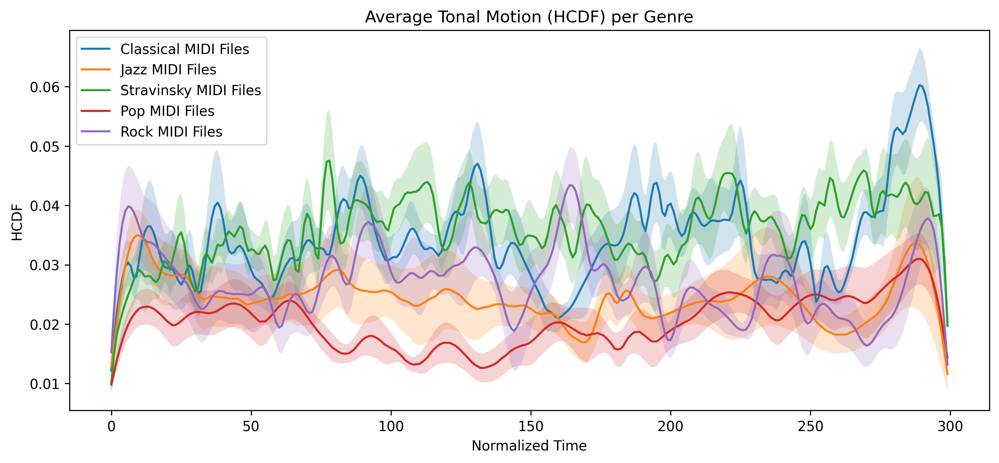
Figure 1: Average Tonal Motion (HCDF) per Genre. Normalized HCDF curves (resampled to 300 points) are averaged within each genre, with standard error bands indicating within-genre variability.

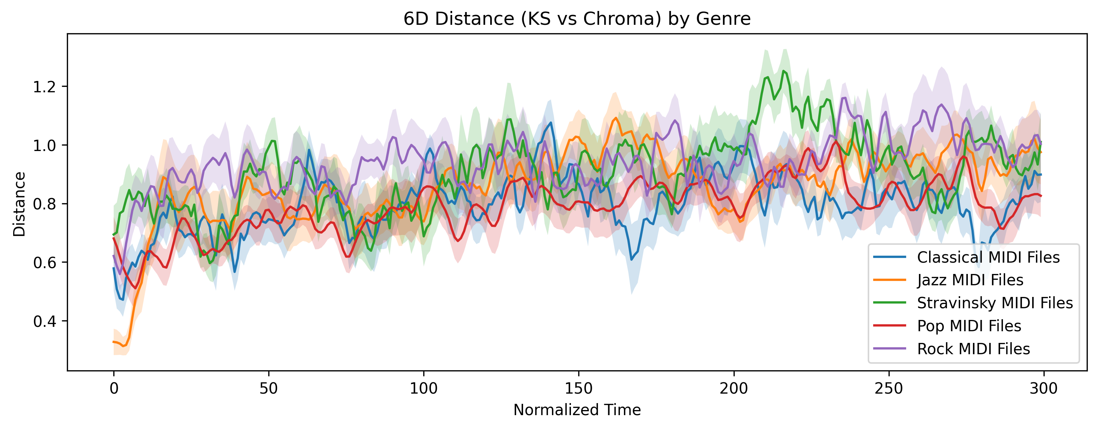
Figure 2: 6D Distance (KS vs Chroma) by Genre. Frame-wise Euclidean distances between KS key centroids and chroma-derived tonal centroids are averaged per genre, quantifying harmonic divergence over time.

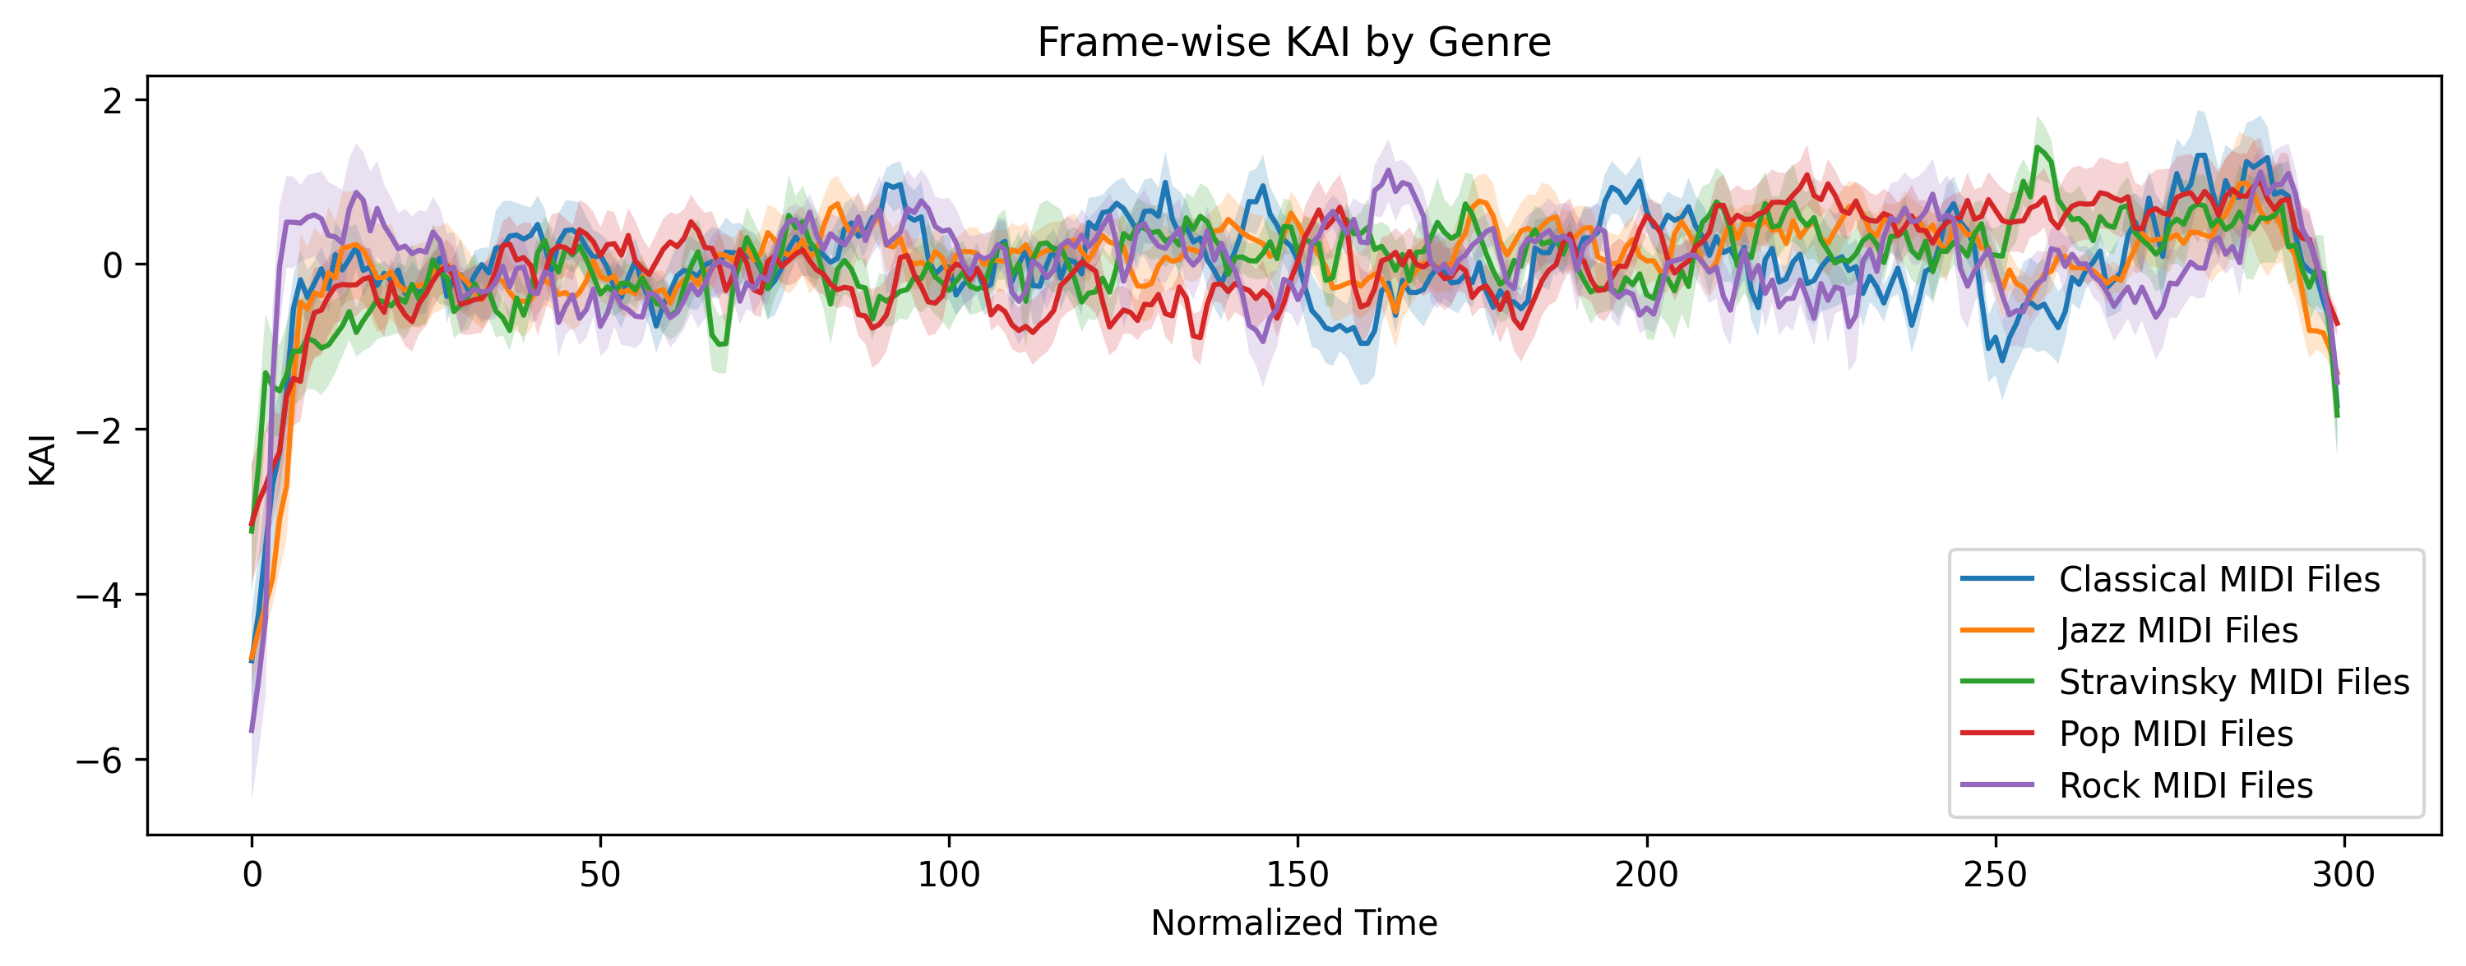
Figure 3: Frame-wise Key Ambiguity Index (KAI) by Genre. The normalized KAI over 300 resampled frames is plotted for each genre, capturing composite tonal uncertainty based on key-strength variance and Tonnetz motion.

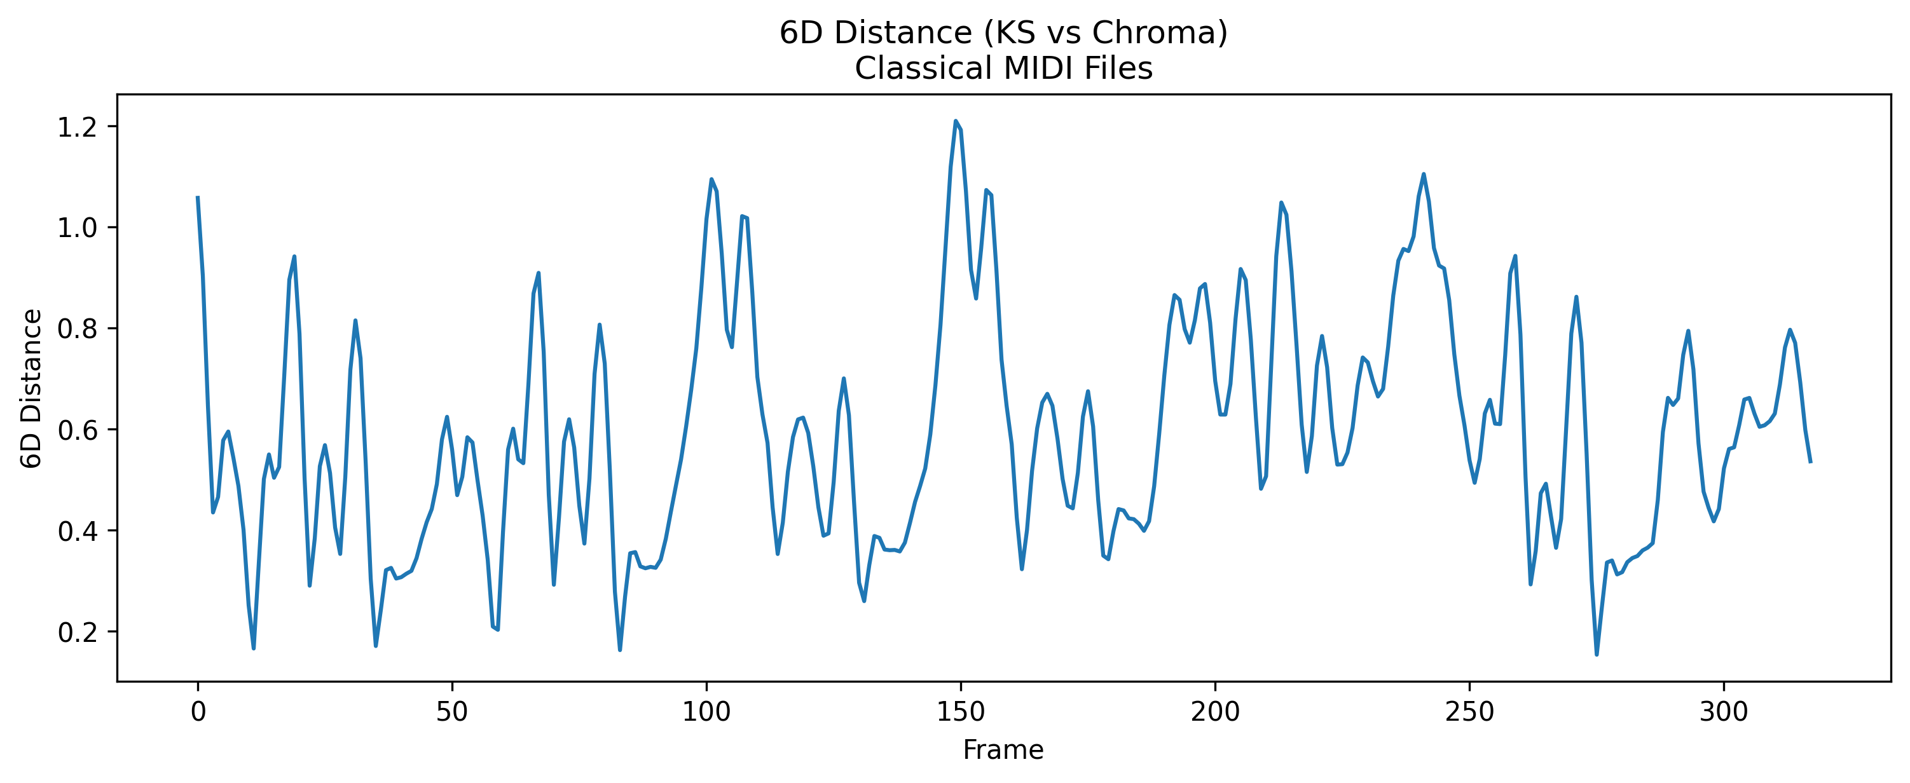
Figure 4: 6D Distance Example (Single File). KS versus chroma centroid distance is shown for a representative excerpt from a selected genre (Classical Music), illustrating within-piece harmonic deviation.

Time-based analyses serve two complementary purposes. First, within-piece temporal graphs reveal the evolution of tonal motion and key ambiguity across individual compositions. Second, by normalizing all curves to a fixed length, cross-genre comparisons of averaged tonal trajectories become feasible, with standard error bands providing statistically meaningful indication of variability within each genre.

Results
The distributions of tonal motion, harmonic deviation, and key ambiguity across genres were assessed using violin plots for all excerpts.
- HCDF Distribution by Genre
The violin plot in Figure 5 presents the distribution of frame-wise HCDF values for each genre. This visualization captures the variability of tonal motion across excerpts, complementing the averaged line graph presented in the Methodology section.
- 6D Distance Distribution by Genre
Figure 6 illustrates the distribution of frame-wise Euclidean distances between KS key centroids and chroma-derived tonal centroids across all excerpts within each genre. This metric reflects the range of harmonic divergence present in the dataset.
- Key Ambiguity Index (KAI) by Genre
The violin plot in Figure 7 shows the distribution of the composite KAI metric, calculated as the sum of the z-scored variance of KS key strength and normalized Tonnetz motion per minute. These distributions provide the basis for nonparametric statistical analyses, including Kruskal–Wallis tests and Dunn post-hoc comparisons.
- 6D Distance Distribution (Single File)
Figure 8 presents frame-wise KS versus chroma centroid distances for a representative excerpt from a single genre (Classical Music), illustrating within-piece variation in harmonic deviation. This complements the line graph example in the Methodology section.
- Frame-wise KAI Distribution by Genre
The violin plot in Figure 9 illustrates the distribution of frame-wise KAI values aggregated across all excerpts for each genre. This visualization captures the temporal evolution of tonal uncertainty at the frame level, showing how tonal ambiguity fluctuates within pieces and across genres.
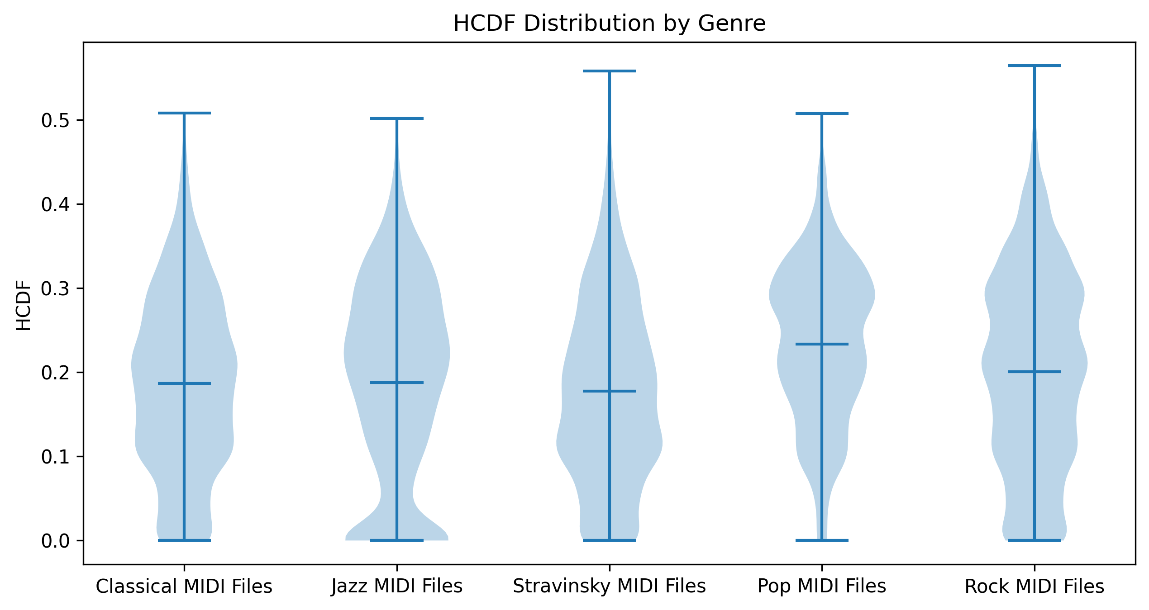
Figure 5: HCDF Distribution by Genre. The violin plot presents the distribution of frame-wise HCDF values for each genre, capturing the variability of tonal motion across excerpts.

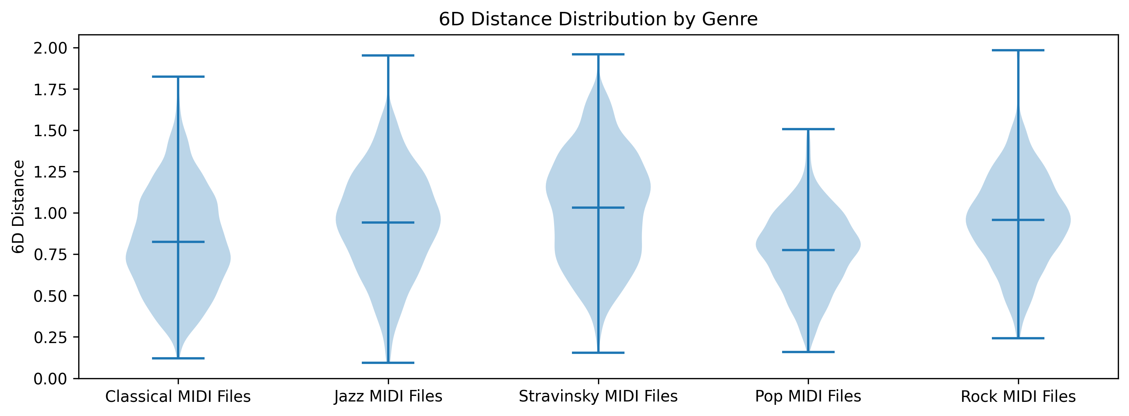
Figure 6: 6D Distance Distribution by Genre. Distribution of frame-wise Euclidean distances between KS key centroids and chroma-derived tonal centroids across all excerpts within each genre.

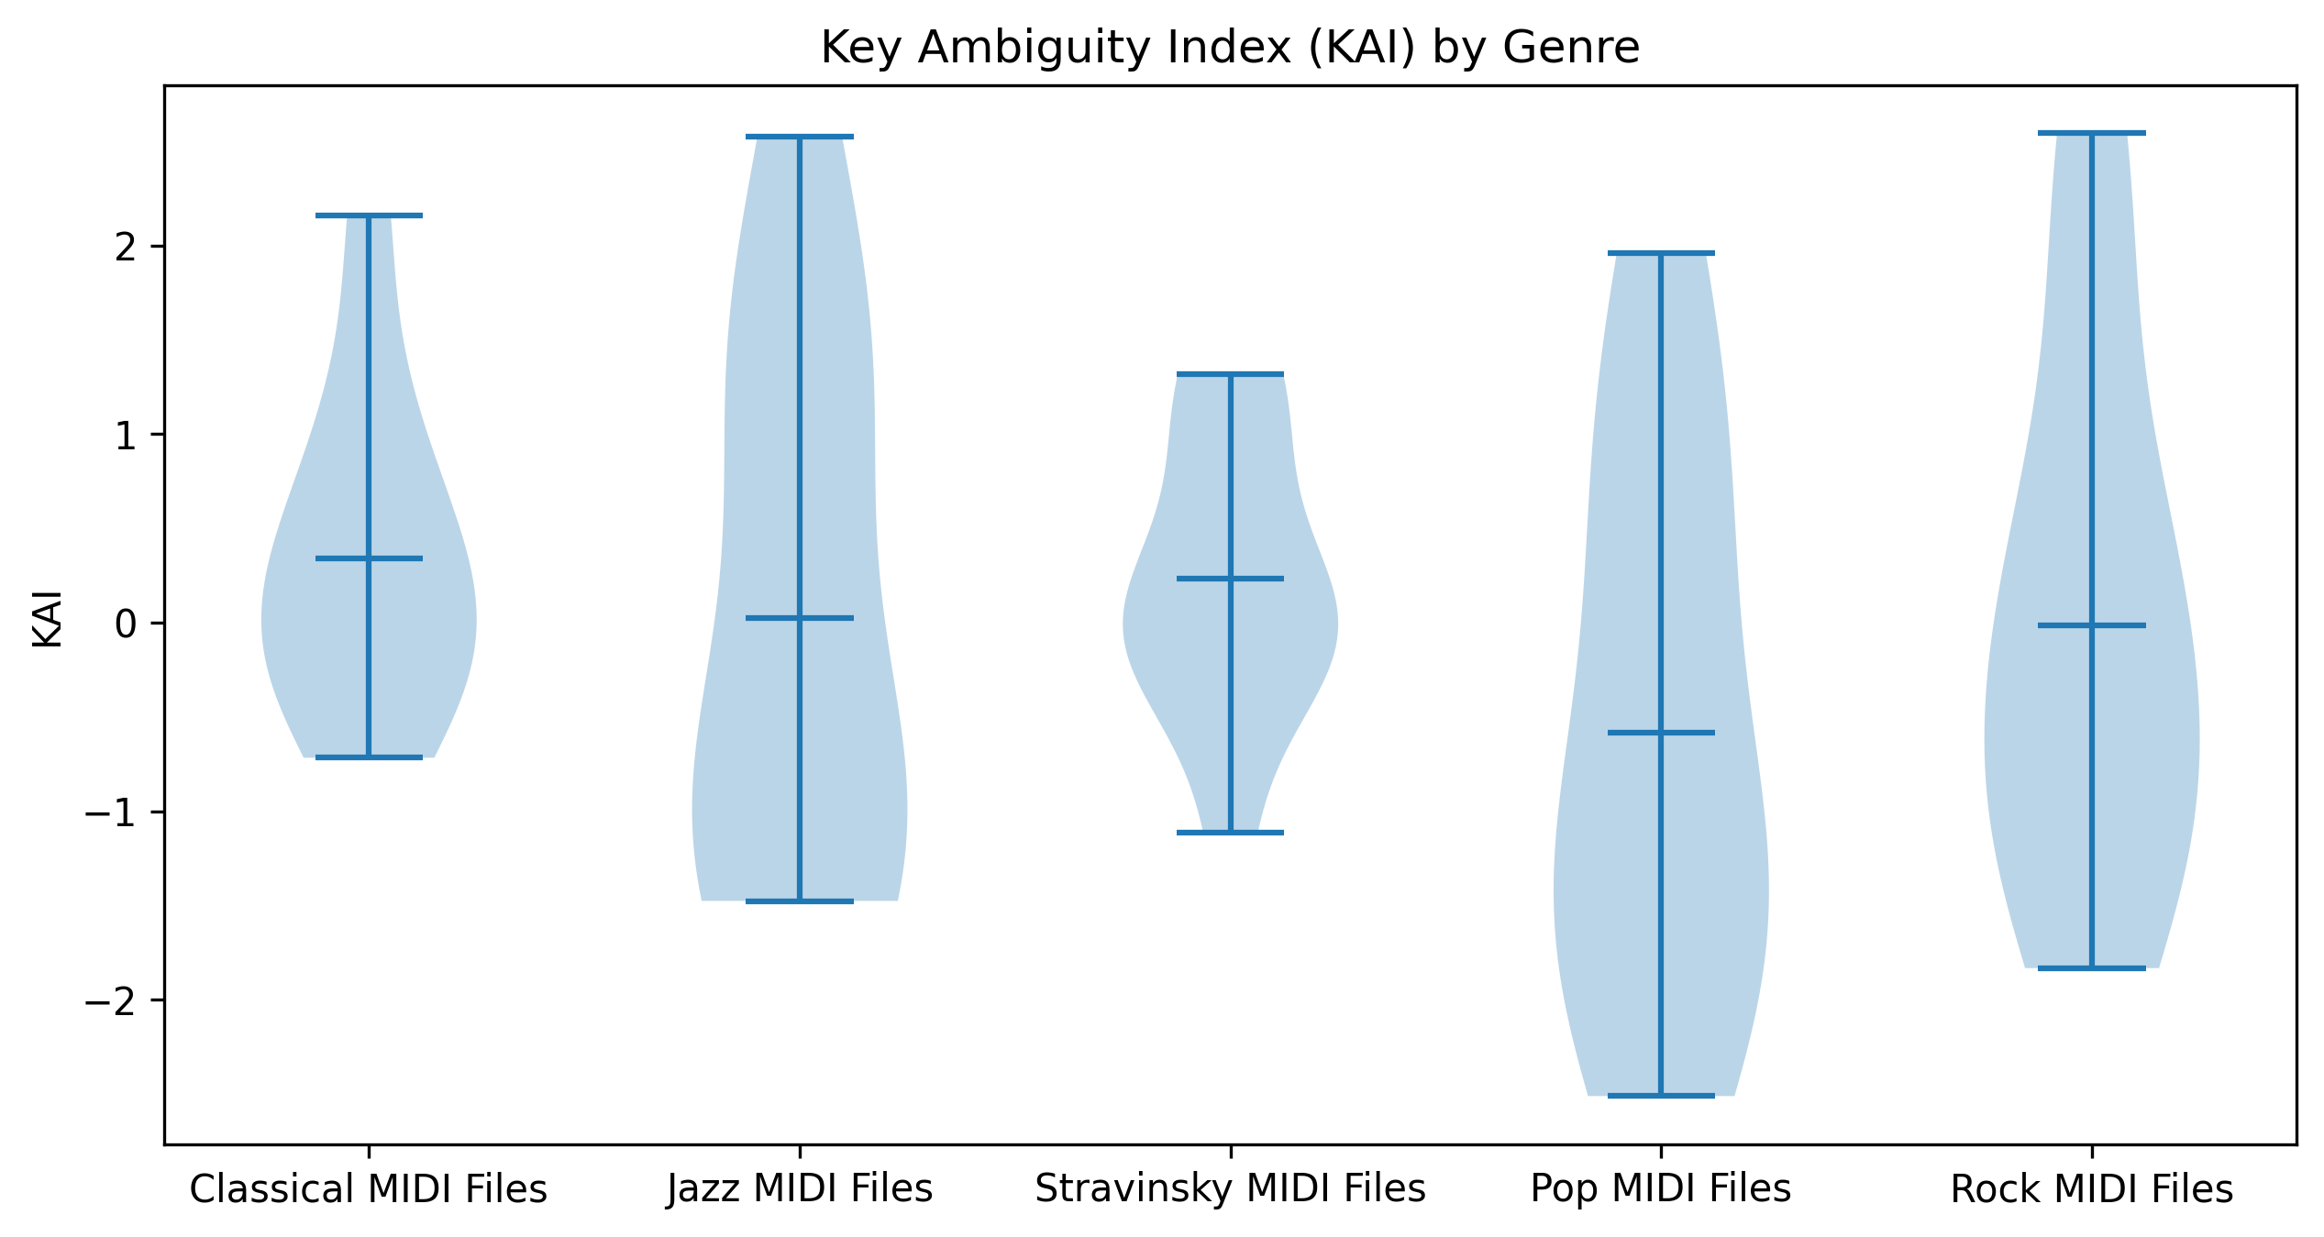
Figure 7: Key Ambiguity Index (KAI) by Genre. Distribution of the composite KAI metric, calculated as the sum of the z-scored variance of KS key strength and normalized Tonnetz motion per minute.

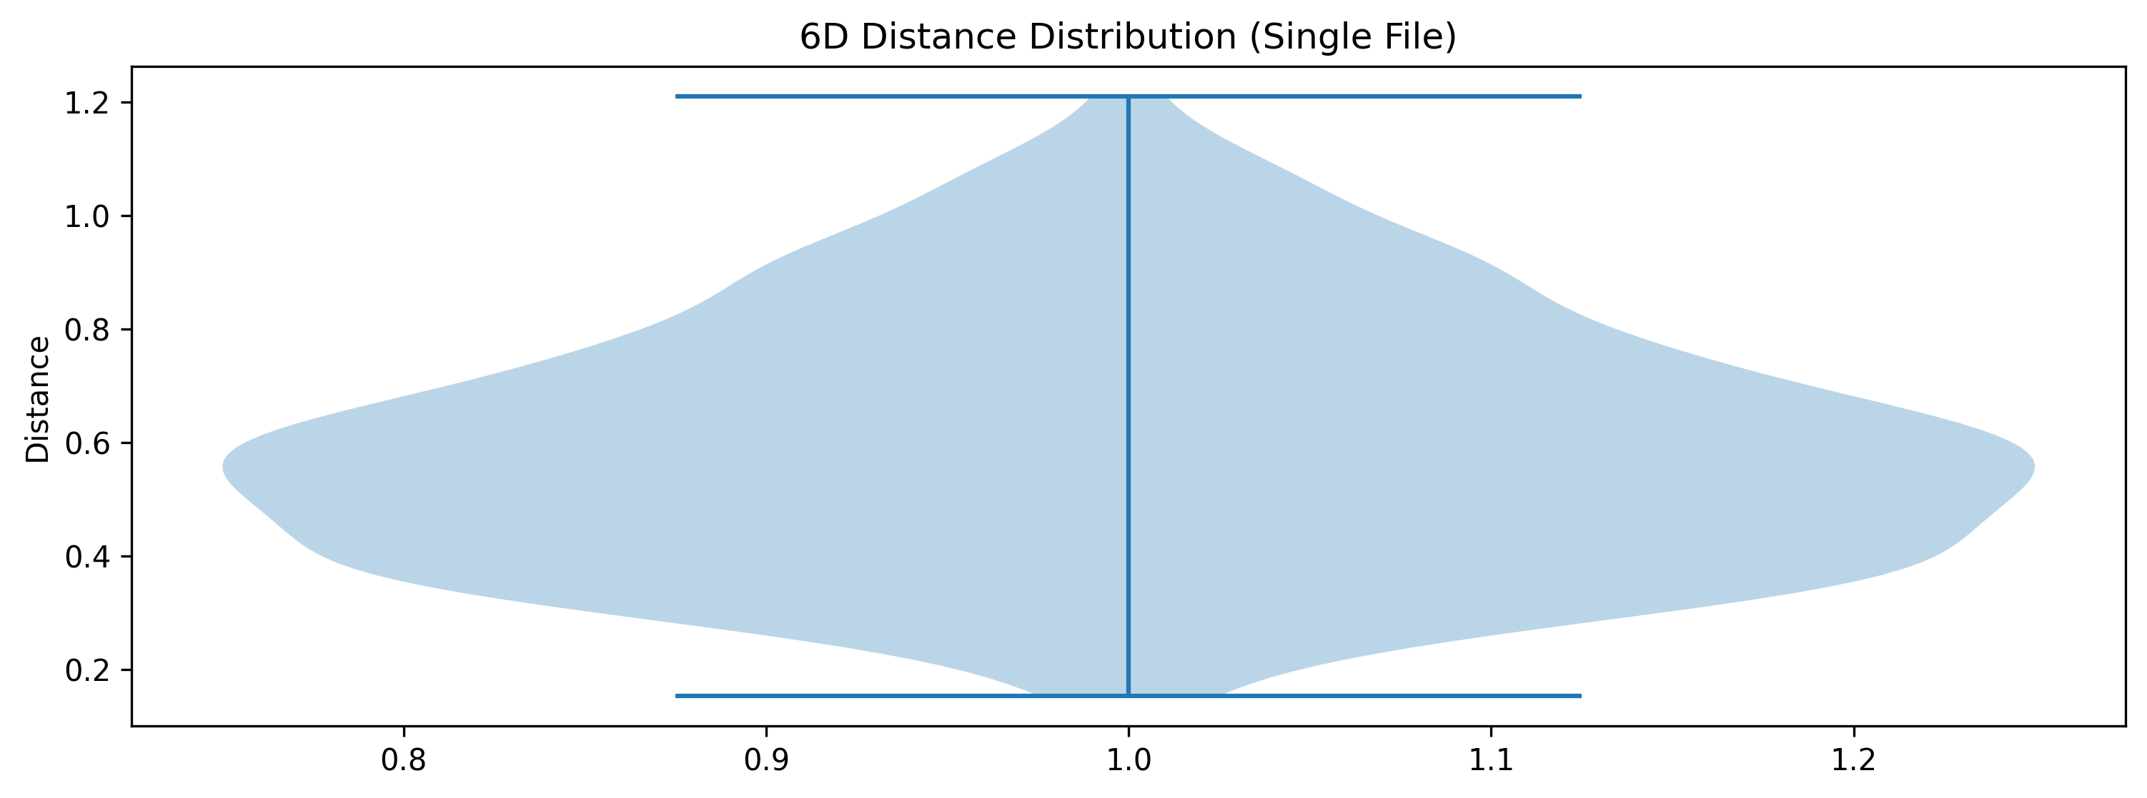
Figure 8: 6D Distance Distribution (Single File). Frame-wise KS versus chroma centroid distances for a representative excerpt from a single genre (Classical Music), illustrating within-piece variation in harmonic deviation.

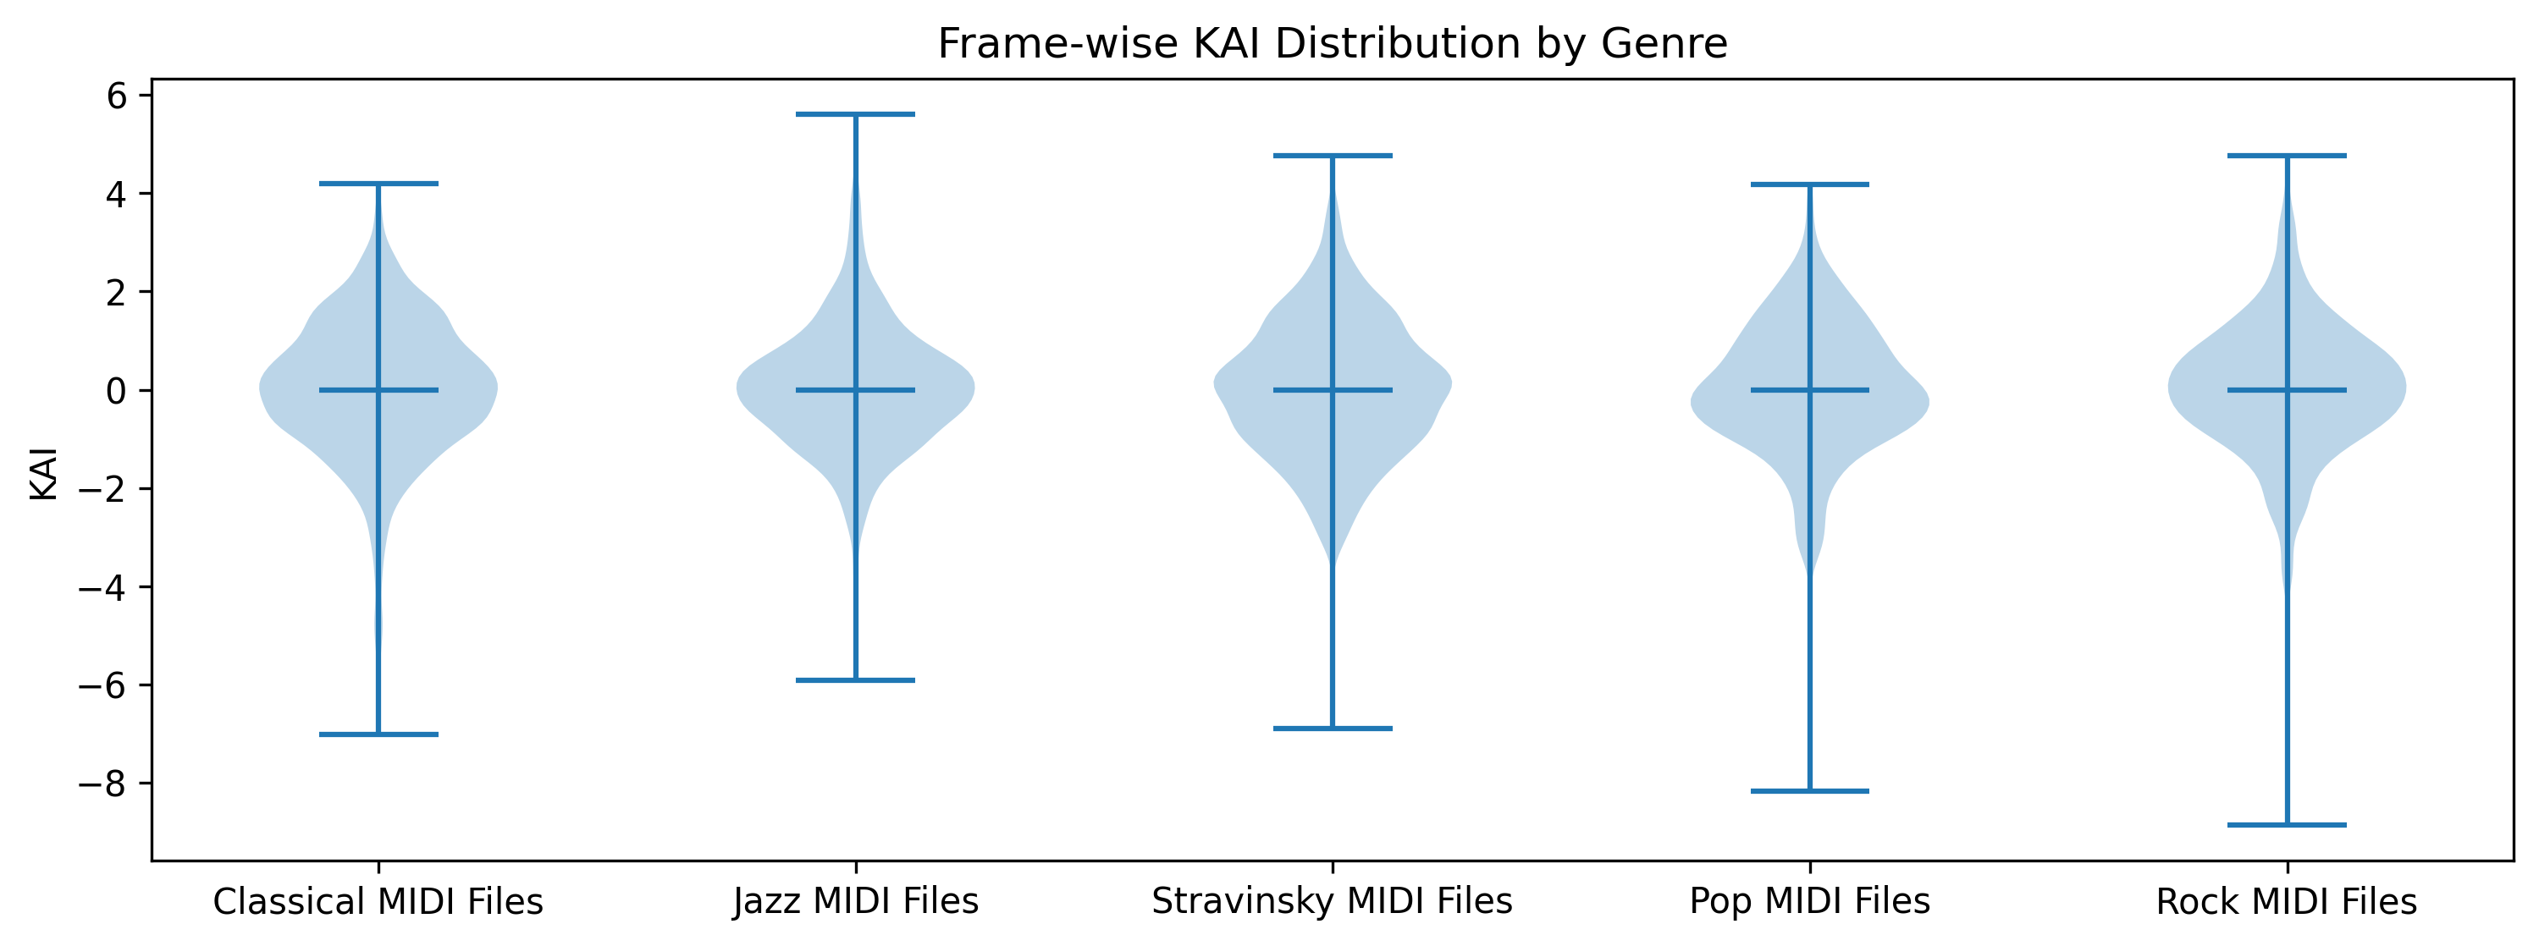
Figure 9: Frame-wise KAI Distribution by Genre. Distribution of frame-wise KAI values aggregated across all excerpts for each genre, capturing the temporal evolution of tonal uncertainty at the frame level.

The combination of these violin plots with the corresponding time-based line graphs provides a comprehensive view of both the within-piece and cross-genre variability of tonal motion, harmonic deviation, and key ambiguity in the dataset.

Discussion
The three violin plots reveal systematic genre-based differentiation in tonal motion, harmonic divergence, and composite tonal uncertainty. Considered jointly, the distributions indicate comparatively lower key stability and greater tonal mobility in Jazz and Stravinsky excerpts relative to Classical repertoire.

HCDF: Frame-wise Tonal Motion
The HCDF Distribution by Genre plot demonstrates clear contrasts in centroid-to-centroid tonal displacement. Classical excerpts exhibit a compact distribution centered at lower HCDF values with limited upper-tail extension. This configuration suggests smooth local tonal transitions and strong short-range continuity; large harmonic displacements occur infrequently and appear structurally constrained.
Pop shows slightly elevated but similarly concentrated values, consistent with stable harmonic cycles punctuated by controlled shifts. Rock presents broader dispersion and moderately heavier tails, indicating more frequent medium-scale tonal movement while retaining an overarching tonal reference framework.
In contrast, Jazz and Stravinsky display the widest and most vertically extended HCDF distributions. The breadth of these distributions indicates sustained tonal mobility rather than isolated modulatory events. Within-genre variability is therefore substantially greater in Jazz and Stravinsky than in Classical repertoire, reflecting more fluid harmonic trajectories. Upper-tail elongation indicates recurrent high-magnitude centroid shifts, reflecting sustained tonal mobility. Variance is therefore not merely a statistical artifact but a direct reflection of stylistic harmonic freedom and the density of large-scale voice-leading events.

6D Distance: Key--Surface Divergence
The 6D Distance Distribution by Genre further differentiates repertoires by quantifying divergence between KS-derived key centroids and chroma-derived tonal centroids. Classical excerpts cluster at lower 6D distances with concentrated density, indicating strong alignment between surface pitch content and inferred key structure. Local deviations remain proximate to a stable tonal center.
Pop mirrors this compact profile, reinforcing tonal centricity, whereas Rock exhibits moderate expansion, suggesting partial attenuation of key alignment.
Jazz and Stravinsky demonstrate higher median values and substantially broader spreads. Their distributions extend further upward, indicating more frequent and larger discrepancies between instantaneous chroma configurations and key profiles. Differentiation is observable not only in central tendency but also in dispersion and tail behavior, suggesting systematic harmonic divergence rather than sporadic deviation.
The 6D distance measures the Euclidean separation between KS-derived key centroids and chroma-based tonal centroids, effectively quantifying the alignment of surface pitch content with underlying key structure. Classical and Pop excerpts cluster at low 6D distances with concentrated densities, confirming strong tonal centricity and minimal divergence from expected key profiles. Rock exhibits moderate expansion, suggesting partial attenuation of key alignment, while Jazz and Stravinsky show substantially higher medians and broader distributions. The elongated upper tails indicate frequent, pronounced discrepancies between instantaneous chroma configurations and inferred keys, capturing systematic harmonic divergence rather than isolated anomalies. These trends complement HCDF observations, reinforcing the conclusion that Jazz and Stravinsky navigate extended harmonic trajectories and depart from classical key predictability.

KAI: Composite Tonal Uncertainty
The Key Ambiguity Index (KAI) provides a unified measure of tonal uncertainty by integrating statistical key strength and geometric harmonic motion. Unlike prior approaches, KAI combines Krumhansl–Schmuckler (KS) key profiles, which quantify probabilistic key strength, with Tonnetz-derived chordal trajectories, capturing relational harmonic movement. This dual approach allows KAI to track both the magnitude of tonal ambiguity and the pattern of motion through tonal space—features that existing methods alone cannot resolve.
Frame-wise KAI distributions reveal clear stylistic patterns. Classical and Pop music concentrate at low ambiguity values with narrow tails, reflecting stable tonal centers and constrained harmonic motion. Rock shows broader distributions with more pronounced upper tails, consistent with recurrent tonal fluctuations. Jazz and Stravinsky exhibit the highest KAI values, with extended upper tails indicating frequent high-ambiguity states and complex harmonic navigation. Notably, median ambiguity overlaps across genres, suggesting that stylistic distinctions emerge primarily in extreme tonal states rather than in central tendencies.
By capturing both tonal uncertainty and harmonic motion, KAI provides a meaningful metric for comparing genres, analyzing compositional strategies, and exploring perceptual effects of tonal ambiguity. It offers a new framework for studying music where traditional measures of key strength or motion alone would be insufficient.

Integrated Interpretation
Across all three metrics, a coherent pattern emerges:
- Classical repertoire maintains low within-genre variability and strong tonal centricity.
- Pop and Rock occupy intermediate positions, reflecting moderate dispersion and partial weakening of key alignment.
- Jazz and Stravinsky consistently demonstrate the greatest spread, heavier upper tails, and elevated divergence from stable key anchoring.
Collectively, these results indicate that Jazz and Stravinsky excerpts traverse longer Tonnetz trajectories, sustain higher frame-wise motion, and operate under greater tonal ambiguity relative to Classical works. Importantly, these findings underscore that stylistic differentiation is driven less by mean values than by distributional variance and tail behavior, highlighting the critical role of extreme tonal states in defining harmonic identity and perception.

Conclusion
This study presented a computational framework for quantifying tonal stability and key ambiguity across musical genres using the Krumhansl–Schmuckler key-finding algorithm and Tonnetz-derived tonal centroids. By introducing the Key Ambiguity Index (KAI), which combines variance in key strength with normalized Tonnetz path length, we provided a composite metric for capturing tonal uncertainty. Our analysis of MIDI corpora spanning Classical, Pop, Rock, Jazz, and Stravinsky repertoire revealed systematic stylistic differences, with Jazz and Stravinsky exhibiting greater tonal mobility and higher ambiguity states compared to Classical works. These findings demonstrate the effectiveness of combining KS key analysis with Tonnetz-based metrics for quantitative musicological research and suggest promising directions for future work on performance-based or audio-based extensions of this framework.

Acknowledgments
The author thanks the supervisors and reviewers who provided feedback on this work. Data sourced from the MAESTRO dataset (CC BY-NC-SA), WJazzD, and JAZZVAR corpora.

References
[1] Krumhansl, C.L. Cognitive Foundations of Musical Pitch. Oxford University Press. 1990.
[2] Cohn, R. Introduction to Neo-Riemannian Theory: A Survey and a Historical Perspective. Journal of Music Theory. Vol. 42, No. 2, pg. 167–180, 1998.
[3] Harte, C.; Sandler, M.; Gasser, M. Detecting Harmonic Change in Musical Audio. Proceedings of the 1st ACM Workshop on Audio and Music Computing Multimedia. pg. 21–26, 2006.
[4] Temperley, D. What's Key for Key? The Krumhansl-Schmuckler Key-Finding Algorithm Reconsidered. Music Perception. Vol. 17, No. 1, pg. 65–100, 1999.
[5] Lewin, D. Generalized Musical Intervals and Transformations. Yale University Press. 1987.
[6] Tymoczko, D. The Geometry of Musical Chords. Science. Vol. 313, No. 5783, pg. 72–74, 2006.
[7] Muller, M.; Ewert, S. Chroma Toolbox: MATLAB Implementations for Extracting Variants of Chroma-Based Audio Features. Proceedings of the 12th International Society for Music Information Retrieval Conference (ISMIR). pg. 215–220, 2011.
[8] Lerdahl, F. Tonal Pitch Space. Music Perception. Vol. 5, No. 3, pg. 315–349, 1988.
[9] Tymoczko, D. A Geometry of Music: Harmony and Counterpoint in the Extended Common Practice. Oxford University Press. 2011.
[10] Muller, M. Fundamentals of Music Processing: Audio, Analysis, Algorithms, Applications. Springer. 2015.
[11] Krumhansl, C.L.; Cuddy, L.L. A Theory of Tonal Hierarchies in Music. Music Perception. pg. 51–96, 2010.
[12] Krumhansl, C.L.; Kessler, E.J. Tracing the Dynamic Changes in Perceived Tonal Organization in a Spatial Representation of Musical Keys. Psychological Review. Vol. 89, No. 4, pg. 334–368, 1982.
[13] Krumhansl, C.L.; Kessler, E.J. Tonal Hierarchies and Rare Intervals in Music Cognition. Canadian Journal of Psychology. Vol. 41, No. 4, pg. 379–396, 1987.
[14] Vuvan, D.T.; Prince, J.B.; Schmuckler, M.A. Tonal Hierarchy Representations in Auditory Imagery. Memory & Cognition. Vol. 39, No. 3, pg. 477–490, 2011.
[15] Schmuckler, M.A. Tonality and Contour in Melodic Processing. Psychological Research. Vol. 85, No. 1, pg. 96–116, 2021.
[16] Krumhansl, C.L.; Schmuckler, M.A. Key-finding in music. 1986.
[17] Schmuckler, M.A.; Tomovski, R. Pitch and Pitch Structures. Journal of Experimental Psychology: Human Perception and Performance. Vol. 31, No. 1, pg. 1–17, 2005.
[18] Shah, J.; Vaidya, M.; Patel, M. Leveraging Chroma Feature for Classification of Western Music. Proceedings of the International Conference on Emerging Trends in Engineering and Technology. 2021.
[19] Ellis, D.P.W. MATLAB Implementations for Chroma Feature Extraction. Web resource, Columbia University LabROSA. 2008.
[20] Hainsworth, S.W.; Macleod, M.D. Particle Filtering Methods for Music Transcription. Proceedings of the International Computer Music Conference (ICMC). 2004.
[21] Degani, A.; Dalai, M.; Leonardi, R.; Migliorati, P. Harmonic Change Detection in Musical Audio for Automatic Chord Recognition. IEEE Transactions on Audio, Speech, and Language Processing. 2011.
[22] Ramoneda Franco, P. Chord Reduction and Harmonic Analysis for Symbolic Music. Proceedings of the Sound and Music Computing Conference (SMC). 2020.
[23] Macedo, J. Tonal Interval Vectors for Harmonic Change Detection in Symbolic Music. Proceedings of the International Society for Music Information Retrieval Conference (ISMIR). 2022.
[24] Balzano, G.J. The Pitch Set as a Level of Description for Studying Musical Pitch Perception. Music, Mind, and Brain: The Neuropsychology of Music. pg. 321–351, 1982.
[25] Temperley, D.; Marvin, E.W. Pitch-Class Distribution and the Identification of Key. Music Perception. Vol. 25, No. 3, pg. 193–212, 2008.
[26] Cannas, S.; Andreatta, M. A Symbolic Perspective on the Generalized Tonnetz. Journal of Mathematics and Music. Vol. 12, No. 3, pg. 169–186, 2018.

