VisionAI: Real-Time Multimodal Navigation Assistance for Blind and Low-Vision People
First Author, Second Author, and Third Author
Aspiring Scholars Directed Research Program
Fremont, CA, USA
zaria.shahabdeen@students.asdrp.org

Abstract—Independent travel is a cornerstone of autonomy, yet the mobility aids that most blind and low-vision (BLV) people rely on, the long cane and the guide dog, have changed little in decades and convey little semantic information about the surrounding scene. Mainstream pedestrian navigation apps, in turn, were not designed for non-visual use and offer only coarse turn-by-turn guidance. We present VisionAI, a work-in-progress wearable system that pairs consumer-grade smart glasses (camera and audio output) with a smartphone app to deliver continuous, hands-free auditory guidance. VisionAI couples Google Maps routing with a multimodal large language model (MLLM) and a real-time vision pipeline that describe the scene, track salient objects across frames, and surface obstacle and hazard alerts as the user walks. Beyond the system itself, we argue that current evaluation practice for MLLM-driven navigation aids cannot express the failures that matter in mobility, because published benchmarks score single-turn descriptions that the user asked for and therefore have no notion of a warning that arrives late or an utterance the system volunteered unbidden. We define an operational evaluation framework that adds these temporal and proactive measures, stating each as a unit, a ground truth, and a measurement procedure. We then instantiate the subset that does not require a human trial, through a simulation study of the on-device reflex that compares it against four alternative decision criteria drawn from the literature over 24,000 synthetic scenes. The shipped rule lowers false alarms by a factor of 2.9 against the strongest alternative, warns at 3.8 meters, and is invariant to camera pitch, while missing more hazards than two ungated criteria that alarm fifteen times as often. We are explicit that this study validates one decision layer against the framework rather than validating the framework itself, and we set out the staged participatory trials that would close that gap.
Index Terms—accessibility, assistive technology, blind and low vision, multimodal large language models, obstacle detection, pedestrian navigation, smart glasses, wearable computing

Introduction
Globally, an estimated 43.3 million people are blind and a further 295 million live with moderate-to-severe vision impairment, figures projected to reach roughly 61 million and 474 million by 2050 as populations age [1]. Independent mobility is closely tied to employment, social participation, and wellbeing [6], yet the aids most widely used today each leave a gap. The long cane reliably detects ground-level obstacles and drop-offs within arm’s reach but conveys nothing about head-height hazards, the identity of objects, or the layout of a space; guide dogs add judgment and obstacle avoidance but are costly and scarce. Mainstream wayfinding apps provide routing while assuming a user who can glance at a screen and visually resolve the last few meters, producing guidance that is too coarse and too visual for confident non-visual travel [2], [3]. Semantic understanding of the immediate environment, what is ahead and where, therefore still rests largely with the traveler [6].
Multimodal large language models (MLLMs) appear to narrow this gap by generating fluent descriptions of images, and consumer tools such as Be My AI and Seeing AI have made on-demand scene description widely accessible [5], [8]. These tools, however, are photo-based and question-driven: the user captures a frame and asks about it. Continuous, hands-free navigation through dynamic outdoor environments imposes much harder constraints, including low latency, temporal consistency across frames, prioritization of safety-relevant information, and graceful behavior under uncertainty. In a safety-critical setting, the well-documented tendency of MLLMs to hallucinate, repeat, or describe with misplaced confidence is not a cosmetic flaw but a potential hazard, and recent studies show that a single spatial inaccuracy in an otherwise fluent description can be dangerous for a BLV traveler [10], [11].
VisionAI is our attempt to explore this space. It pairs consumer-grade smart glasses, providing a forward-facing camera and audio output, with an Android application that integrates three components: a real-time vision pipeline that detects and tracks salient objects and renders them as concise spoken alerts; turn-by-turn navigation that augments Google Maps routing with audio-first instructions; and an audio feedback layer that fuses environmental description and navigation into a single hands-free stream. The design goal is for the guidance to feel supportive rather than overwhelming, surfacing what matters when it matters.
Our purpose here, however, is less to advocate for one system than to use it as a concrete case for a question we believe the community must confront: how should MLLM-driven navigation aids be evaluated before they are placed in the hands of BLV travelers? Accuracy benchmarks designed for static visual question answering [9] do not capture the costs that matter on a sidewalk, a late warning, a confident description of an object that is not there, or an alarm that erodes trust. We make three contributions. First, a two-tier architecture that separates an on-device safety reflex, budgeted under 100 milliseconds, from cloud MLLM guidance, with the separation forced by measured latency rather than chosen for elegance. Second, a simulation study of the reflex decision layer that compares it against published alternative criteria on identical scenes and reports its operating envelope, its sensitivity to tuning, and its blind spots. Third, an operational evaluation framework, given as metrics with units, ground truth, and measurement procedures, together with an account of why several of them lie outside what current benchmarks can measure.

Related Work
Assistive navigation for BLV people spans several distinct technical traditions. The white cane and the guide dog remain the dominant primary aids and are highly effective at detection, but neither conveys head-height hazards, the affordances of nearby objects, or the semantic layout of an unfamiliar space, a gap that has motivated work on richer technology-mediated description for mobility [6]. A substantial line of research instead pursues accurate localization: NavCog delivers smartphone turn-by-turn navigation for BLV users [2], and NavCog3 achieves fine-grained localization using Bluetooth Low Energy beacons, signaling semantic features and points of interest such as doorways and shops, and was evaluated with BLV participants in large-scale real-world environments [3]. Audio augmented reality takes a third approach, building a mental map through spatialized sound; Microsoft Soundscape calls out roads, intersections, and landmarks and places audio beacons at destinations, running ambiently in the background [4]. These systems excel at where to go, but they depend on instrumented environments or detailed maps and use no camera, so they cannot interpret the open-ended visual scene or detect dynamic, unmapped hazards in the user’s immediate path.
A complementary tradition uses cameras to describe the scene itself. Hoogsteen et al. show that useful description for mobility is more than object listing and must be selective and task-relevant [6]; Jain et al. move perception into the infrastructure, offloading sensing to fixed street cameras at intersections [7]; and the VizWiz line established the broader challenge of answering real visual questions captured by blind users [9]. On-demand interpretation has meanwhile matured from human assistance to AI: Aira connects users to trained remote agents, Be My Eyes connects them to sighted volunteers and, more recently, to a GPT-4-based assistant [5], and Seeing AI offers app-based recognition of text, scenes, and objects. Penuela et al. surface both the appeal and the failure modes of such applications in practice [8]. Critically for our work, a growing body of evaluation research questions whether current vision-language models are ready for mobility: they struggle to produce consistently precise directional and depth information [10], and BLV users weight properties such as sufficiency, conciseness, and freedom from non-actionable content differently from generic image-captioning metrics [11]. This work demonstrates the value of visual scene understanding but generally treats it as a standalone capability rather than fusing it with active turn-by-turn routing.
Several commercial products now place a camera on the face. OrCam MyEye reads text and recognizes faces and objects, much of it offline, but processes one item at a time on request and is positioned for deliberate reading rather than real-time navigation; Envision Glasses are purpose-built for BLV users and provide hands-free OCR and on-command scene description; and Ray-Ban Meta smart glasses have made camera-equipped eyewear affordable and unobtrusive at around US$300, with Be My Eyes integration for description and live assistance, though their AI is command-based and tuned for a general consumer audience [5]. Across these products the dominant interaction model is a user-initiated query about a captured moment, and navigation, when present, is not deeply fused with continuous environmental description.

Differentiation: Positioning VisionAI
Taken together, prior art divides along two axes that VisionAI aims to join. Systems are strong at either navigation (NavCog3 [3], Soundscape [4]) or scene description (Be My AI [5], Seeing AI, OrCam), but rarely both at once; and their interaction is either continuous-but-blind-to-vision (audio-AR) or vision-aware-but-command-driven (MLLM apps and smart glasses). We position VisionAI against this landscape along four dimensions.
Fusion of navigation and scene understanding. VisionAI treats turn-by-turn routing and continuous environmental description as a single, prioritized audio stream rather than two apps the user must switch between. Routing answers where to go while the perception loop answers what is around me right now, with a shared arbitration layer deciding what to speak and when.
Continuous, proactive perception versus command-triggered snapshots. Where OrCam, Ray-Ban Meta, and Be My AI largely answer questions about a frame the user has chosen to capture, VisionAI runs a persistent loop with frame-to-frame object tracking, surfacing safety-relevant changes proactively (for example, "bicycle approaching from the right") without requiring the user to ask. This shifts the burden of vigilance from the user to the system.
Consumer-grade, infrastructure-free hardware. Unlike beacon-based localization, which requires instrumenting the environment [3], or premium dedicated devices that can cost several thousand dollars, VisionAI targets affordable off-the-shelf smart glasses paired with a user's existing Android phone. The aim is to lower both the financial and the deployment barrier, trading bespoke accuracy for everyday availability.
Safety-first evaluation as a first-class goal. The recent LVLM-for-BLV literature shows that fluent description is necessary but not sufficient: models still produce spatial errors and hallucinations that may be tolerable for casual use yet dangerous in mobility, and there is no shared way to measure this for navigation aids [10], [11]. A core part of our contribution is therefore not a system feature but a proposed evaluation framework, separating safety metrics (inaccurate-prediction rate, false-alarm rate, time-to-warning) from response-quality metrics (instruction correctness, hallucination rate, repetition rate), together with a participatory trial protocol. VisionAI thus targets a measurement gap as much as a system gap.
- Positioning of VisionAI relative to representative prior systems. "Partial" indicates limited or command-only support.
System | Turn-by-turn nav | Scene description | Continuous / proactive | Infra-free | Consumer-grade HW
White cane / guide dog | No | No | Yes | Yes | —
NavCog3 [3] | Yes | Partial | Yes | No | Yes
Soundscape [4] | Partial | No | Yes | Yes | Yes
Be My AI / Seeing AI [5] | No | Yes | No | Yes | Yes
OrCam / Envision | No | Yes | Partial | Yes | Yes
Ray-Ban Meta + Be My Eyes [5] | No | Yes | Partial | Yes | Yes
VisionAI | Yes | Yes | Yes | Yes | Yes

We state plainly what VisionAI is and is not. Its novelty lies in integration, interaction design, and an explicit evaluation-and-validation agenda, not in a new detection or localization algorithm; it reuses established mapping and MLLM components. Several of the design intentions above, particularly the claim that proactive, fused guidance reduces cognitive load without overwhelming the user, remain hypotheses to be tested with BLV participants. Surfacing and pressure-testing exactly these open questions is a central aim of this paper.

An Operational Evaluation Framework
A framework that names metrics without defining how to measure them cannot be audited, so we state each one as a unit, a source of ground truth, and a procedure. Table II does this and also records how far prior evaluation reaches for each metric.
Prior evaluation of vision-language assistance for BLV people is strong on the axes it was built for and structurally silent on others. VizWiz established answer correctness for real visual questions captured by blind users [9]. Kim et al. show that current large vision-language models produce unreliable directional and depth information when asked to guide BLV travelers [10]. An et al. show that BLV users weight sufficiency, conciseness, and freedom from non-actionable content differently from generic captioning metrics [11]. Between them these three span correctness, spatial precision, and human preference, which is most of the space in which the quality of a description can be judged.
All three, however, score a single turn that the user initiated, against a frame the user chose to submit. That shared setup has a consequence for mobility. No metric whose unit is time can be expressed, because nothing in the protocol records when a response arrived relative to the hazard it describes. No metric whose unit is an unsolicited utterance can be expressed either, because a system that speaks only when asked can neither raise a false alarm nor repeat itself. Time to warning, false alarm rate, and repetition rate therefore fall outside these benchmarks, not because the benchmarks are deficient but because a continuously acting aid is a different object of study from a question answering system. Our framework is the attempt to close that specific difference, and the study in Section VI measures five of its seven metrics on our own reflex layer.
- The proposed evaluation framework. Each metric is given operationally, with the reach of prior evaluation recorded in the final column.
Metric | Unit | Ground truth and measurement procedure | Reach of prior evaluation
Time to warning | Seconds, or meters of clearance | Interval from the first spoken alert to contact with the hazard, taken from logged position traces or simulated trajectories | Out of reach. A single asked question carries no timing relative to a hazard
False alarm rate | Percent of hazard-free scenes, or alerts per minute | Share of scenes or minutes carrying an urgent alert while nothing lay in the walking path, labeled from scene geometry | Out of reach. A system that speaks only when asked cannot alarm unbidden
Inaccurate prediction rate | Percent of hazards | Share of in-path hazards that produced no alert before contact | Partial. [10] scores spatial and depth error on static scenes, with no missed event in time
Repetition rate | Utterances per obstacle event | Count of spoken alerts attributable to one continuous encounter with one obstacle | Out of reach. One submitted item yields one utterance by construction
Instruction correctness | Percent of instructions | Agreement between the spoken action and a ground truth safe action for that moment, annotated per event | Partial. [9] scores answers and [10] scores directions, neither as an action that must be timely
Hallucination rate | Percent of utterances | Utterances asserting an object or relation absent from the frame, annotated against that frame | Reached by [10] and [11]. Deferred here because it requires real model outputs on real scenes
Trust and cognitive load | Ordinal ratings and interview codes | Structured interviews and repeated-use diaries with BLV participants | Partial. [11] measures preference among descriptions, not trust built through repeated use

Methods

Platform and software architecture
The application was implemented in Kotlin for the Android platform because Kotlin provides strong interoperability with Android APIs and supports modern language features, including null safety, expressive asynchronous programming, and maintainable application architecture. The software architecture follows a modular design in which the user interface, navigation state management, data repositories, and external service integrations are separated into distinct components. This organization was selected to improve maintainability, support systematic testing, and facilitate future extension of the system for additional accessibility functions.

Localization and routing
During operation, the app acquires the user's location and device orientation through the Android location and sensor APIs and uses these signals to estimate the user's current position, heading, and motion state. Navigation begins when the user specifies a destination, either through direct entry or voice input. The app then queries a routing service to obtain a route represented as a polyline and a sequence of turn-by-turn instructions. Google Maps Platform Places and Directions services were selected for this purpose because they provide widely adopted, well-documented geocoding and routing functionality for pedestrian navigation, thereby reducing the need to implement routing infrastructure from scratch. The route geometry is decoded locally within the application and compared with the user's live positional data to determine the next maneuver, the distance to the next turn, and whether the user has deviated from the planned path.

Vision-based obstacle detection
The system also includes a vision-based obstacle detection pipeline to generate immediate safety alerts. Live camera frames are captured using CameraX, which was chosen because it offers lifecycle-aware camera access and simplifies integration with Android's camera permissions and device compatibility model. These frames are processed using ML Kit object detection, which was selected because it enables on-device, low-latency detection of objects in real time without requiring a continuous cloud connection, an important requirement for accessibility applications in which reliability and responsiveness are critical. To minimize false positives caused by transient visual noise, the app applies an edge-triggered decision rule that requires repeated detections before an obstacle is declared, and it uses tracking information from ML Kit to identify objects that are growing in apparent size, a looming cue related to the classical time-to-contact analysis of visual approach [12]. When an obstacle is judged to be relevant to the user's path, the application issues an urgent verbal warning and a directional cue, enabling the user to respond rapidly without waiting for a full navigation update.

Spoken interaction and contextual assistance
For interaction, VisionAI uses Android's Text-to-Speech API to deliver spoken guidance and haptic feedback to reinforce navigation events. Text-to-Speech was selected because spoken instructions are a natural and effective modality for blind and low-vision users, and the Android interface provides direct control over timing, interruption, and speech rate in a manner well suited to real-time assistive systems. Voice input is supported through the Android speech-recognition interface. In addition, the app integrates the Gemini API to generate short, context-aware natural-language assistance from camera and navigation context. This functionality was incorporated to support richer situational explanations beyond the deterministic navigation logic, while the on-device reflex layer remains responsible for safety-critical obstacle alerts. This design reflects a safety-oriented architecture in which low-latency, on-device perception and guidance are prioritized over potentially slower cloud-based inference for urgent events.

Concurrency and data flow
Asynchronous processing is handled through Kotlin coroutines and Flow, which were selected because they simplify concurrent programming in Android applications by expressing background work in a readable, structured manner while preserving responsiveness and thread safety. The view model and repository layers use these abstractions to propagate updates from location, sensor, vision, and routing components to the user interface and audio-feedback modules. This design reduces the likelihood of race conditions and facilitates the coordination of multiple concurrent streams of information, which is essential in a real-time assistive system.

Operational workflow
The resulting workflow proceeds as follows: the application requests the required permissions for location, microphone, and camera; the user specifies a destination; a route is computed and loaded into the navigation state; the user's live position and heading are continuously monitored; and the app delivers spoken turn instructions, obstacle warnings, and optional contextual assistance as movement progresses. When the user reaches the destination or cancels navigation, the application terminates the active guidance session and clears transient state. This workflow was designed to minimize cognitive load and ensure that assistance is provided in a timely and multimodal manner, consistent with established principles of accessibility-oriented interaction design.

Results

Architecture, latency, and simulation setup
VisionAI has not yet been evaluated with blind and low-vision participants. We report two kinds of preliminary result, engineering measurements from the Android prototype and a simulation study in which we ported the shipped decision rules and threshold values of the safety reflex out of the application source and ran synthetic walking scenarios through them.
The governing measurement is latency. In bench testing the cloud MLLM loop took 1.5 to 3 seconds from frame capture to spoken output, during which a pedestrian at 1.4 m/s [13] covers 2.1 to 4.2 meters, far too long for a collision warning. This produced the two-tier design of Fig. 1, in which an on-device reflex layer delivers a spoken stop warning and haptic pulse within a 100-millisecond budget while the MLLM tier supplies richer directional guidance and never sits on the critical path. Against the shipped 1.5-second throttle, the same latency bounds the cloud tier to 20 to 40 guidance updates per minute, each describing a scene the walker has already left behind. An earlier prototype used MiDaS depth estimation [14], but it cost roughly 200 milliseconds per frame and caused thermal throttling.
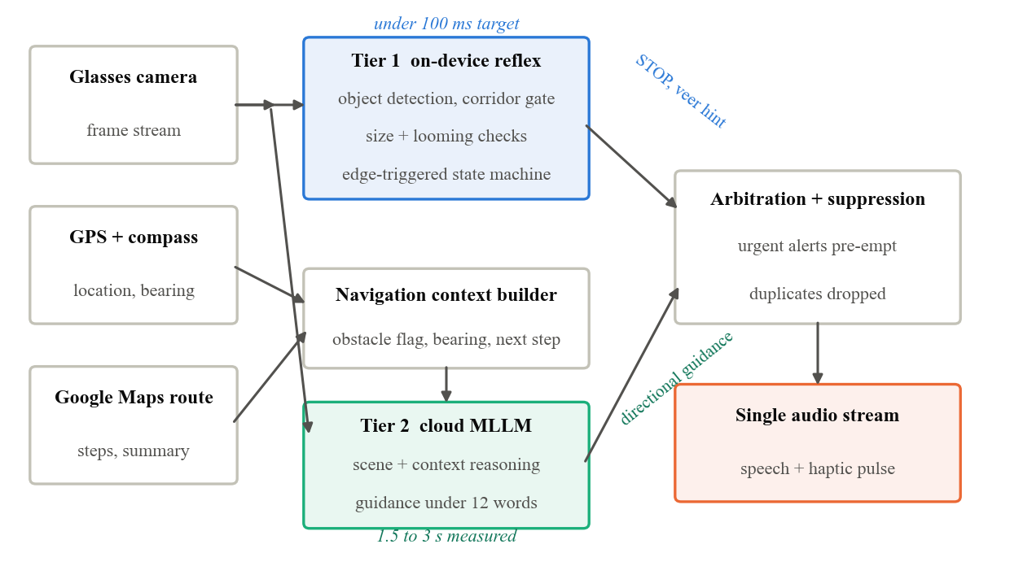
- VisionAI runtime architecture. The on-device reflex tier and the cloud MLLM tier feed one arbitration layer and one hands-free audio stream.
Because the neural detector runs only on Android hardware, the simulation exercises the decision layer above it rather than the detector itself. A simulated camera with a 60-degree vertical and 46-degree horizontal field of view processes 10 frames per second at 1.4 m/s, and obstacles are boxes whose apparent size follows pinhole projection with 10 percent multiplicative noise and positional jitter imitating detector instability. The rules under test are the shipped ones, listed in full in the repository of Section VI-F.

Time to warning
Fig. 2 shows the distance at which the reflex first raises an alert as a function of obstacle height. Under the size gates alone a standing person is flagged 4.3 meters away, about 3.1 seconds before contact, while a one-meter trash bin is flagged at 2.5 meters and a 0.9-meter bollard at only 2.3 meters. The looming cue, which triggers on estimated time to contact [12], corrects this for the objects that need it, lifting both the bin and the bollard to a full two seconds of warning and roughly doubling warning distance for obstacles under half a meter tall.
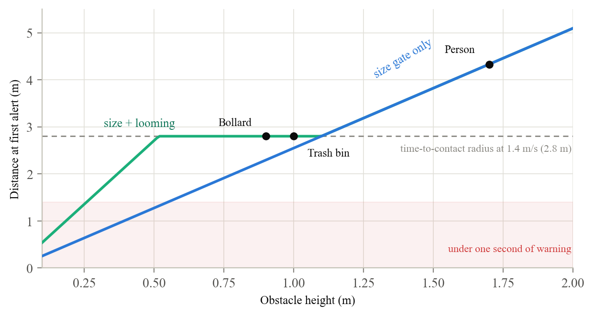
- Simulated distance at first alert versus obstacle height under the shipped thresholds. The looming cue extends warnings for mid-sized and small obstacles out to the time-to-contact radius.
Sweeping walking speed exposes an unplanned property. Size-gated warning time falls as speed rises, from 5.4 seconds at 0.8 m/s to 2.2 seconds at 2.0 m/s, but warning time on the looming path is pinned at 2.0 seconds at every speed because time to contact is itself the trigger. A low curb spanning the walkway remains a blind spot, rejected by the background width gate before its apparent size reaches the near threshold.

Comparison against alternative decision rules
A comparison against our own earlier prototype cannot establish that the shipped rule is a good choice, so we evaluated it against four alternative criteria run through the same scenes with the same noise. R1 applies the optical time-to-contact criterion alone [12], with no spatial gate. R2 applies a fixed apparent-size threshold alone at 0.34 of frame height. R3 is the ground-contact bottom-edge heuristic, also the rule in our first prototype. R4 models an idealized monocular relative-depth estimator of the kind we removed [14], representing both the scale ambiguity of relative depth and the ground-plane confusion produced by a downward tilt. R5 is the shipped conjunction of corridor gate, background-width rejection, size gates, looming, and two-frame confirmation. These are reimplementations of published criteria under our stated assumptions, not of any specific product.
Each rule saw 16,000 hazard-free and 8,000 hazard scenes sampled separately, and every rule received the identical trailing 0.9 seconds of observations. A scene counts as a hazard when an object lies in the walking path within 2.5 meters.
Fig. 3 reports four measures. The shipped rule raises a false alarm on 2.0 percent of hazard-free scenes, 2.9 times fewer than the strongest alternative, R3 at 5.7 percent, and roughly fifteen times fewer than the two ungated criteria, R2 at 26.2 percent and R1 at 31.0 percent. It also gives more warning than three of the four, first alerting 3.76 meters out against 3.12 for R3, 2.85 for R4, and 2.33 for R2.
We state the result that does not favor our design. The shipped rule misses more hazards than R1 and R2, 47.4 percent against 24.5 and 22.4 percent on the same deliberately harsh per-frame metric. The cause is the spatial gate, since R1 and R2 alert on anything that looms anywhere in the frame, including objects that will pass safely to one side, which is why they catch more true hazards and equally why they cry wolf fifteen times as often. We treat that trade as settled by deployment, since an alert that fires on safe passers-by is abandoned within a block.
The remaining comparison concerns stability, and it is exact rather than statistical. R1, R2, and R5 read only apparent size, so perturbing camera pitch by eight degrees while holding the detector realization fixed cannot change their decisions, and their measured flip rate is zero. R3 changes its decision on 14.3 percent of scenes and R4 on 23.5 percent, because both reason about where the ground meets the frame. For a camera worn on the face or carried in a walking hand, pitch varies continuously, so this is our clearest evidence for preferring apparent size to ground geometry.
Miss rates are high for every rule partly because a hazard 0.8 meters ahead and 0.45 meters to one side falls outside the simulated 46-degree horizontal field of view, a limit of the camera model rather than of any decision rule.
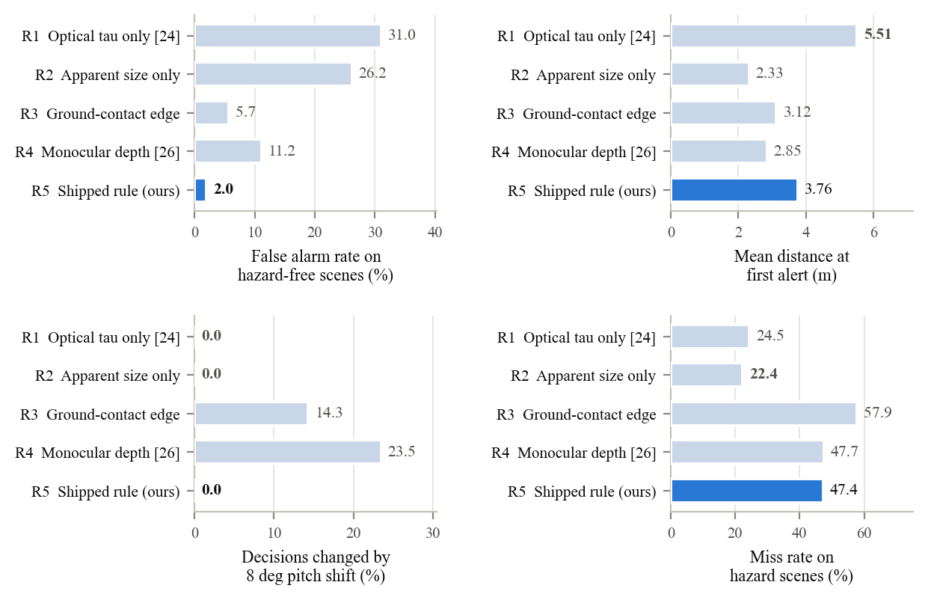
- Four measures over 16,000 hazard-free and 8,000 hazard scenes for five decision rules. The shipped rule attains the lowest false-alarm rate and complete pitch invariance and warns farther than three of the four alternatives, while missing more hazards than the two criteria that apply no spatial gate.

Repetition and instruction correctness
Fig. 4 traces a simulated walk in which a pedestrian approaches a bollard from 8 meters, stops half a meter away, backs off, and approaches again. The reflex speaks exactly twice, once per approach, with the first warning at 2.7 meters. It stays quiet while the pedestrian stands in front of the obstacle and re-arms only after 1.2 seconds of clear path. A naive level-triggered policy on the same frames would have spoken 81 times.
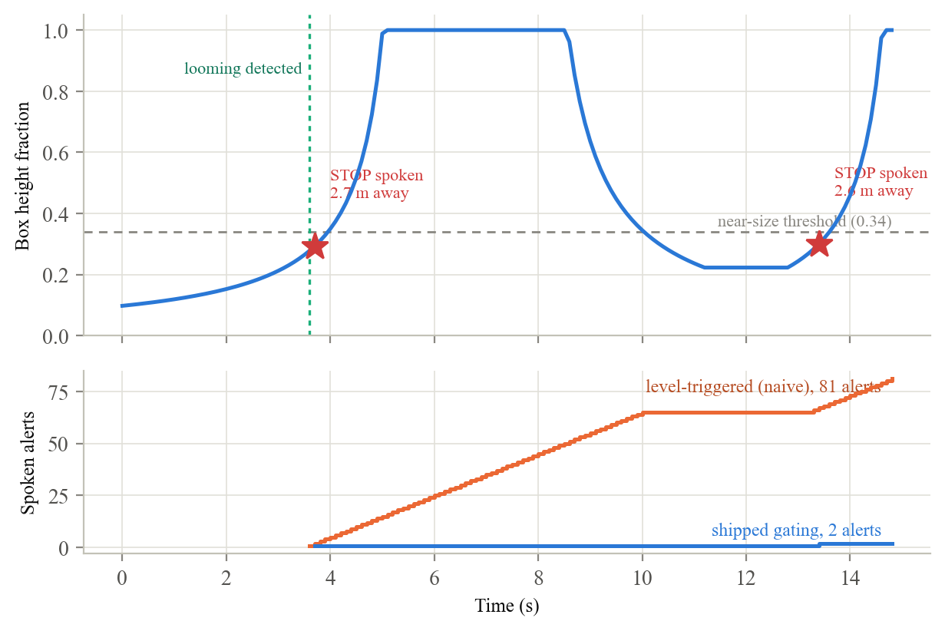
- A simulated double approach toward a 0.9 m bollard. The shipped gating speaks twice while a naive level-triggered policy would speak 81 times.
A separate stress test isolates the entry requirement. With the detector emitting spurious danger frames on a clear path, a single-frame policy speaks 11 to 16 times per minute even with the cooldown in place, while the shipped two-frame requirement cuts this to 1.3 per minute at 5 percent flicker and 9.7 at 20 percent.
When the reflex fires, the system also computes a veer hint locally from box geometry so the avoidance direction does not wait on the cloud. The hint is spoken only when the obstacle is clearly off center and the opposite side is substantially open, so the system stays silent in about 71 percent of the configuration space. Over 30,000 noisy scenes it speaks a correct hint in 82 percent of scenes where the opposite side is genuinely open and recommends an unsafe side in 0.18 percent overall. Whether that conservatism suits BLV travelers only the trials of Section VII can answer.

What simulation cannot show
Read carefully, this study validates the decision layer of one system against the framework of Section IV, and it does not validate the framework itself. Three limits follow. The system under test, the simulator, and the framework were built by the same authors, so agreement among them is weaker evidence than independent replication. The scenes are synthetic and the perception layer idealized, so every warning distance and error rate is a claim about decision logic given a detection, not about whether the detector fires at all under real lighting, motion blur, and hardware variation. And hallucination rate and trust are not instantiated here at all, the first because it requires real model outputs and the second because it requires people.
Two prototype failures are worth recording for other builders. The MLLM streams cumulative text as it generates, and speaking every chunk flooded the Android text-to-speech engine with interruption requests until it silenced itself; the prototype now accumulates the full response and speaks once per analysis. The speech helper also marked itself busy when the engine rejected an utterance, stalling guidance indefinitely, and now checks the return code and recovers.
The latency and speech findings are measured directly. Camera geometry, frame rate, and walking speed are stated assumptions, flicker rates and hazard definitions are modeling choices, and the absolute error rates should be read as comparative indicators rather than field predictions. These results are evidence that the decision layer behaves as designed, not evidence of field safety.

Reproducibility
The application source and every script used in this section are available at [16]. The simulation code depends only on NumPy and Matplotlib and lives under paper/simulation, where three scripts regenerate all thirteen figures and three result files in under ten seconds. Every random seed is fixed, so a clean checkout reproduces our outputs byte for byte, which we verified by file comparison. The thresholds under test are the same constants the shipped application uses, and the repository records which source file each one comes from, so the study cannot drift from the app. Adding a further comparator to Section VI-C requires one function and one list entry, which we hope makes these results as easy to contest as to repeat.

Future Work
Our immediate priority is to move from bench and simulation results to evidence gathered with the people the system is meant to serve. We plan this in stages so that each stage establishes the safety case for the next.
On-device technical validation. Before anyone outside the team uses the system, we will run a structured device test plan on real streets with sighted researchers, covering single-alert behavior on approach, correct re-arming, false-alarm checks on open sidewalks and with the camera pitched down, veer hint correctness, and speech reliability under rapid updates. Thresholds will be tuned one parameter at a time from logged field data, and the same walks will test the simulation's predictions directly, for example the 2.8-meter first-alert distance in Fig. 2. A wider corridor and a wider-angle lens will be evaluated against the close-range off-axis misses of Section VI-C, and ground-plane analysis against the curb blind spot of Section VI-B.
Controlled trials with BLV participants. Working with our partner eye-care foundation, we will recruit blind and low-vision volunteers for trials on a controlled indoor course and a closed outdoor course. Every session will follow a protocol approved by an institutional review board, with informed consent, an orientation and mobility professional present, a sighted researcher shadowing, and freedom to stop at any time. The system will be used alongside each participant's primary aid, never in place of it, and sessions will collect the metrics defined in Section IV together with structured interviews on trust, cognitive load, and preferred verbosity.
Real-world routes. Once controlled trials show acceptable safety metrics, we will extend testing to busy sidewalks, signalized crossings, and transit areas, pairing quantitative logging with diary-style feedback gathered over several weeks, since trust in an assistive system develops through repeated use rather than in a single session [8].
Reducing dependence on the cloud. The latency and reliability of the cloud MLLM remain the weakest part of the design, and Section VI-A quantifies the prize, since an on-device model at half-second latency would double the guidance rate while cutting scene staleness to under a meter. We are planning a hybrid tier in which a small on-device model [15] handles routine guidance with the cloud model as fallback, first in shadow mode so quality can be compared on identical frames before any user hears it.
Hardware and system maturation. Finally, we plan to move the camera to the glasses form factor of Section I, profile battery and thermal behavior over realistic walks, surface explicit errors when the cloud model fails, and consolidate the prototype's parallel processing paths. The framework and trial protocol set out here are the standard we intend to hold this system to, and we will report against them whether or not the results favor the design.

References
- GBD 2019 Blindness and Vision Impairment Collaborators, "Trends in prevalence of blindness and distance and near vision impairment over 30 years: An analysis for the Global Burden of Disease Study," Lancet Glob. Health, vol. 9, no. 2, pp. e144–e160, 2021.
- D. Ahmetovic, C. Gleason, K. M. Kitani, H. Takagi, and C. Asakawa, "NavCog: Turn-by-turn smartphone navigation assistant for people with visual impairments or blindness," in Proc. 13th Int. Web All Conf. (W4A), New York, NY, USA, 2016.
- D. Sato, U. Oh, K. Naito, H. Takagi, K. M. Kitani, and C. Asakawa, "NavCog3: An evaluation of a smartphone-based blind indoor navigation assistant with semantic features in a large-scale environment," in Proc. 19th Int. ACM SIGACCESS Conf. Comput. Accessibility (ASSETS), 2017, pp. 270–279.
- Microsoft, "Microsoft Soundscape: 3D audio for ambient awareness and navigation," 2018. [Online]. Available: https://www.microsoft.com/en-us/research/product/soundscape/
- Be My Eyes, "Be My Eyes — See the world together (Be My AI)," 2015. [Online]. Available: https://www.bemyeyes.com/
- K. M. P. Hoogsteen, S. Szpiro, G. Kreiman, and E. Peli, "Beyond the cane: Describing urban scenes to blind people for mobility tasks," ACM Trans. Accessible Comput., vol. 15, no. 3, art. 20, pp. 1–29, 2022.
- G. Jain et al., "Towards street camera-based outdoor navigation for blind pedestrians," in Proc. 25th Int. ACM SIGACCESS Conf. Comput. Accessibility (ASSETS), 2023, art. 77.
- R. E. Gonzalez Penuela, J. Collins, C. Bennett, and S. Azenkot, "Investigating use cases of AI-powered scene description applications for blind and low vision people," in Proc. CHI Conf. Human Factors Comput. Syst. (CHI), 2024, art. 901.
- D. Gurari et al., "VizWiz Grand Challenge: Answering visual questions from blind people," in Proc. IEEE Conf. Comput. Vis. Pattern Recognit. (CVPR), 2018, pp. 3608–3617.
- E. Kim, N. M. An, W. J. Kang, S. Kim, J. Thorne, and H. Shim, "Are large vision-language models ready to guide blind and low-vision individuals?," 2025, arXiv:2510.00766.
- N. M. An, E. Kim, W. J. Kang, S. Kim, J. Thorne, and H. Shim, "How blind and low-vision individuals prefer large vision-language model-generated scene descriptions," 2025, arXiv:2502.14883.
- D. N. Lee, "A theory of visual control of braking based on information about time-to-collision," Perception, vol. 5, no. 4, pp. 437–459, 1976.
- R. W. Bohannon, "Comfortable and maximum walking speed of adults aged 20–79 years: Reference values and determinants," Age Ageing, vol. 26, no. 1, pp. 15–19, 1997.
- R. Ranftl, K. Lasinger, D. Hafner, K. Schindler, and V. Koltun, "Towards robust monocular depth estimation: Mixing datasets for zero-shot cross-dataset transfer," IEEE Trans. Pattern Anal. Mach. Intell., vol. 44, no. 3, pp. 1623–1637, 2022.
- Android Developers, "Gemini Nano with Android AICore," Google, 2024. [Online]. Available: https://developer.android.com/ai/gemini-nano
- VisionAI project, “Application source and simulation scripts,” 2026. [Online]. Available: https://github.com/adhvayjagadeesh/GuideGlass

