VisionAI URTC Revision Draft
This document contains replacement text for the internal review comments. Each block is marked with where it goes. Nothing here changes Figures 1, 2, or 4, and the new figure replaces the existing Figure 3, so the figure count does not increase.
1 Abstract, closing passage
Placement. Replaces the text from "Beyond the system itself" to the end of the abstract. Addresses the comments on paper framing, on owning the contribution, and on aligning claims with what the study shows.
Beyond the system itself, we argue that current evaluation practice for MLLM-driven navigation aids cannot express the failures that matter in mobility, because published benchmarks score single-turn descriptions that the user asked for and therefore have no notion of a warning that arrives late or an utterance the system volunteered unbidden. We define an operational evaluation framework that adds these temporal and proactive measures, stating each as a unit, a ground truth, and a measurement procedure. We then instantiate the subset that does not require a human trial, through a simulation study of the on-device reflex that compares it against four alternative decision criteria drawn from the literature over 24,000 synthetic scenes. The shipped rule lowers false alarms by a factor of 2.9 against the strongest alternative, warns at 3.8 meters, and is invariant to camera pitch, while missing more hazards than two ungated criteria that alarm fifteen times as often. We are explicit that this study validates one decision layer against the framework rather than validating the framework itself, and we set out the staged participatory trials that would close that gap.
2 Introduction, contributions paragraph
Placement. Replaces the sentence beginning "We make three contributions" and the list that follows. Foregrounds the two contributions identified in review while keeping the framework, now stated as something delivered rather than proposed.
We make three contributions. First, a two-tier architecture that separates an on-device safety reflex, budgeted under 100 milliseconds, from cloud MLLM guidance, with the separation forced by measured latency rather than chosen for elegance. Second, a simulation study of the reflex decision layer that compares it against published alternative criteria on identical scenes and reports its operating envelope, its sensitivity to tuning, and its blind spots. Third, an operational evaluation framework, given as metrics with units, ground truth, and measurement procedures, together with an account of why several of them lie outside what current benchmarks can measure.
3 New section, an operational evaluation framework
Placement. New section, placed after Differentiation and before Methods. This gives the framework its own home and repairs the cross-references in Results and Future Work that currently point at Section I. It also answers how our evaluation compares to prior methods.
A framework that names metrics without defining how to measure them cannot be audited, so we state each one as a unit, a source of ground truth, and a procedure. Table 2 does this and also records how far prior evaluation reaches for each metric.
Prior evaluation of vision-language assistance for BLV people is strong on the axes it was built for and structurally silent on others. VizWiz established answer correctness for real visual questions captured by blind users [11]. Kim et al. show that current large vision-language models produce unreliable directional and depth information when asked to guide BLV travelers [12]. An et al. show that BLV users weight sufficiency, conciseness, and freedom from non-actionable content differently from generic captioning metrics [13]. Between them these three span correctness, spatial precision, and human preference, which is most of the space in which the quality of a description can be judged.
All three, however, score a single turn that the user initiated, against a frame the user chose to submit. That shared setup has a consequence for mobility. No metric whose unit is time can be expressed, because nothing in the protocol records when a response arrived relative to the hazard it describes. No metric whose unit is an unsolicited utterance can be expressed either, because a system that speaks only when asked can neither raise a false alarm nor repeat itself. Time to warning, false alarm rate, and repetition rate therefore fall outside these benchmarks, not because the benchmarks are deficient but because a continuously acting aid is a different object of study from a question answering system. Our framework is the attempt to close that specific difference, and the study in Section 5 measures four of its seven metrics on our own reflex layer.
Table 2. The proposed evaluation framework. Each metric is given operationally, with the reach of prior evaluation recorded in the final column.
Metric | Unit | Ground truth and measurement procedure | Reach of prior evaluation
Time to warning | Seconds, or meters of clearance | Interval from the first spoken alert to contact with the hazard, taken from logged position traces or simulated trajectories | Out of reach. A single asked question carries no timing relative to a hazard
False alarm rate | Percent of hazard-free scenes, or alerts per minute | Share of scenes or minutes carrying an urgent alert while nothing lay in the walking path, labeled from scene geometry | Out of reach. A system that speaks only when asked cannot alarm unbidden
Inaccurate prediction rate | Percent of hazards | Share of in-path hazards that produced no alert before contact | Partial. [12] scores spatial and depth error on static scenes, with no missed event in time
Repetition rate | Utterances per obstacle event | Count of spoken alerts attributable to one continuous encounter with one obstacle | Out of reach. One submitted item yields one utterance by construction
Instruction correctness | Percent of instructions | Agreement between the spoken action and a ground truth safe action for that moment, annotated per event | Partial. [11] scores answers and [12] scores directions, neither as an action that must be timely
Hallucination rate | Percent of utterances | Utterances asserting an object or relation absent from the frame, annotated against that frame | Reached by [12] and [13]. Deferred here because it requires real model outputs on real scenes
Trust and cognitive load | Ordinal ratings and interview codes | Structured interviews and repeated-use diaries with BLV participants | Partial. [13] measures preference among descriptions, not trust built through repeated use

4 Results, replacing the subsection on false alarms and misses
Placement. Replaces the whole of Results Section C, including its figure. Retitle the subsection to Comparison against alternative decision rules. The new figure replaces the existing Figure 3, so the figure count is unchanged.
A comparison against our own earlier prototype cannot establish that the shipped rule is a good choice, so we evaluated it against four alternative criteria, all run through the same scenes with the same noise. R1 applies the optical time-to-contact criterion alone [24], alerting when the tracked expansion of a box implies contact within two seconds, with no spatial gate. R2 applies a fixed apparent-size threshold alone, at the same 0.34 of frame height the shipped rule uses. R3 is the ground-contact bottom-edge heuristic, alerting when a box within a centre band reaches the lowest fifth of the frame, which was also the rule in our first prototype. R4 models an idealised monocular relative-depth estimator of the kind we removed [26], alerting when estimated depth in the central region falls below 2.5 meters, with both the scale ambiguity inherent to relative depth and the ground-plane confusion produced by a downward tilt represented. R5 is the shipped conjunction of corridor gate, background-width rejection, size gates, looming, and two-frame confirmation. These are reimplementations of published criteria under the assumptions stated in Section 5-A, not of any specific product, and we make no claim about how any deployed system performs.
Each rule saw 16,000 hazard-free and 8,000 hazard scenes, sampled separately so that both rates are estimated on adequate support, and every rule received the identical trailing 0.9 seconds of observations so that none was advantaged by information the others lacked. A scene counts as a hazard when an object lies in the walking path within 2.5 meters.
Figure 3 reports four measures. The shipped rule raises a false alarm on 2.0 percent of hazard-free scenes, 2.9 times fewer than the strongest alternative, R3 at 5.7 percent, and roughly fifteen times fewer than the two ungated criteria, R2 at 26.2 percent and R1 at 31.0 percent. It also gives more warning than three of the four, first alerting 3.76 meters out against 3.12 for R3, 2.85 for R4, and 2.33 for R2.
We state the result that does not favour our design. The shipped rule misses more hazards than R1 and R2, 47.4 percent against 24.5 and 22.4 percent on the same deliberately harsh per-frame metric. The cause is the spatial gate. R1 and R2 alert on anything that looms or grows large anywhere in the frame, including objects that will pass safely to one side, which is why they catch more true hazards and equally why they cry wolf fifteen times as often. We treat that trade as settled by the deployment context rather than by the ratio, since an alert that fires on safe passers-by is abandoned by its user within a block, and the reflex is a backstop beneath a second guidance tier rather than the system's only source of information.
The remaining comparison concerns stability, and it is exact rather than statistical. R1, R2, and R5 read only apparent size, so perturbing camera pitch by eight degrees in either direction while holding the detector realisation fixed cannot change their decisions, and their measured flip rate is zero. R3 changes its decision on 14.3 percent of scenes and R4 on 23.5 percent, because both reason about where the ground meets the frame. For a camera worn on the face or carried in a walking hand, pitch varies continuously, so this is the clearest evidence we have for preferring apparent size to ground geometry, and it quantifies after the fact why the depth-based prototype was abandoned.
One caveat applies to every rule. Miss rates are high throughout partly because a hazard 0.8 meters ahead and 0.45 meters to one side falls outside the simulated 46-degree horizontal field of view, where no rule can see it. That limitation belongs to the camera model rather than to any decision rule, and Section 6 describes the wider-angle lens and wider corridor we intend to test against it.
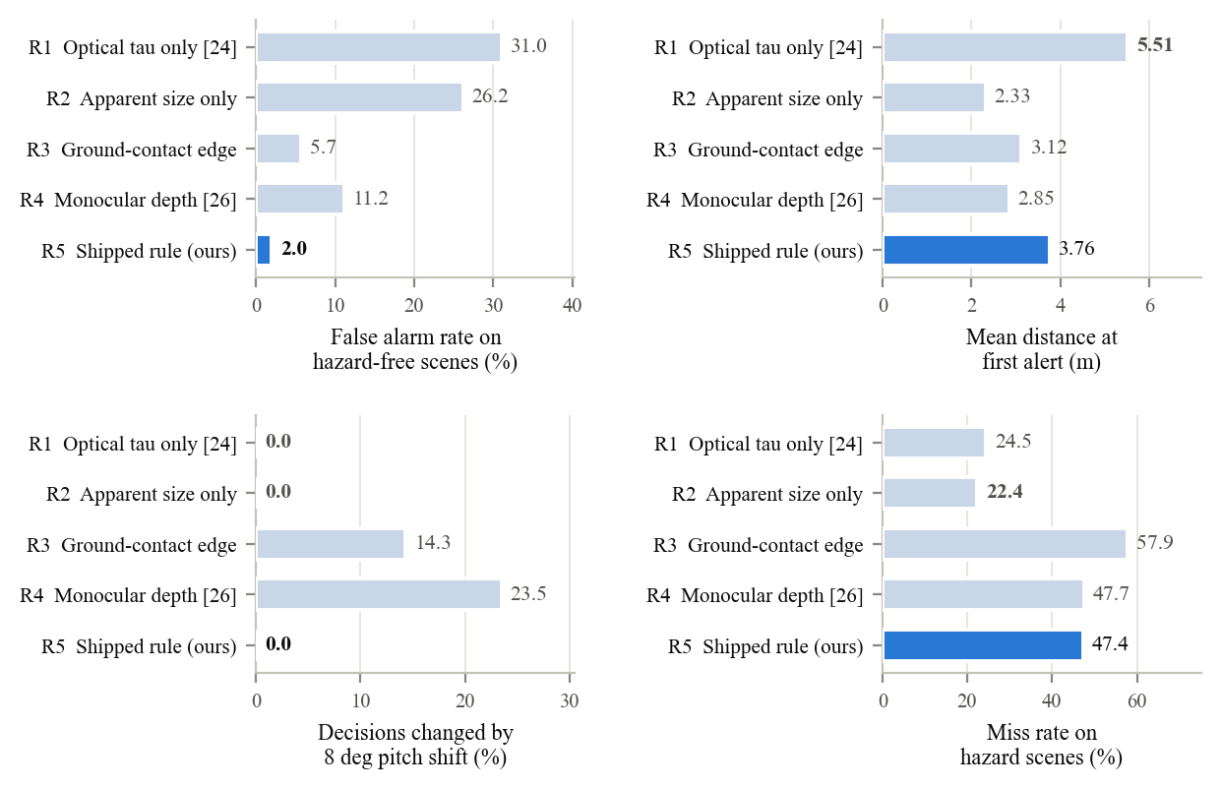
Figure 3. Four measures over 16,000 hazard-free and 8,000 hazard scenes for five decision rules. The shipped rule attains the lowest false-alarm rate and complete pitch invariance and warns farther than three of the four alternatives, while missing more hazards than the two criteria that apply no spatial gate.
5 Results, replacing the opening of the subsection on what simulation cannot show
Placement. Replaces the first paragraph of Results Section E. Addresses the comment on aligning claims with what the simulation establishes.
Read carefully, this study validates the decision layer of one system against the framework of Section 4, and it does not validate the framework itself. Three limits follow, and we would rather state them than have a reader find them. The system under test, the simulator, and the framework were built by the same authors, so agreement among them is weaker evidence than an independent replication would be. The scenes are synthetic and the perception layer is idealised, so every warning distance, alert count, and error rate is a claim about decision logic given a detection, not about whether the detector fires at all under real lighting, motion blur, and hardware variation. And the two framework metrics that bear most directly on MLLM guidance, hallucination rate and trust, are not instantiated here at all, the first because it requires real model outputs on real scenes and the second because it requires people. That boundary is what this subsection contributes. It marks where simulation stops being able to certify an aid of this kind, and where the participatory trials of Section 6 have to take over.
6 Future Work, closing sentence
Placement. Replaces the final sentence of the paper. Addresses the comment on owning the contribution.
The framework and the trial protocol set out here are the standard we intend to hold this system to, and we will report against them whether or not the results favour the design.
7 Review comments not addressed in this draft
Two comments call for edits to the live document rather than replacement prose. The first asks that the Methods section be shortened and that a screenshot of the running application be added with a brief explanation, which needs a screenshot from a device and a decision about whether it sits beside the architecture figure or replaces it. The second asks that citations to production systems be dropped to save space, which affects references 5, 7, 14, 15, and 16 and the sentences in Related Work and Differentiation that lean on them. Cutting the Methods paragraphs on Kotlin, coroutines, CameraX, and text-to-speech together with those references frees roughly 500 words, which is enough to carry the new section and table added above.

