4 Results
VisionAI is a work in progress and has not yet been evaluated with blind and low vision participants. We therefore report two kinds of preliminary results. The first kind is engineering findings from building and bench testing the Android prototype. The second kind is a simulation study in which we ported the exact decision rules and shipped threshold values of the safety reflex out of the application source and ran synthetic walking scenarios through them. The section moves from the architecture and its measured latency, through the simulation method, to the warning behavior, alert discipline, error rates, threshold sensitivity, and instruction correctness of the reflex tier, then to the cadence limits of the cloud tier, and closes by mapping every measured quantity onto the evaluation framework this paper proposes and by stating the limits of what simulation can claim. Throughout, we state which numbers are measured on the prototype and which come from simulation.
4.1 Two tier architecture and latency
In our testing, the cloud MLLM guidance loop took roughly 1.5 to 3 seconds from frame capture to spoken output. A pedestrian walking at a typical pace of 1.4 m/s covers 2.1 to 4.2 meters in that window, which is far too long for collision warnings. This measurement produced the central architectural decision of the prototype, a two tier design in which a fully on-device reflex layer watches the walking corridor and delivers an immediate spoken stop warning and a haptic pulse within a target budget of 100 milliseconds, while the MLLM tier supplies richer directional guidance and is never on the critical path for urgent alerts. Figure 1 shows the runtime architecture and Figure 2 compares the latency of the two tiers.
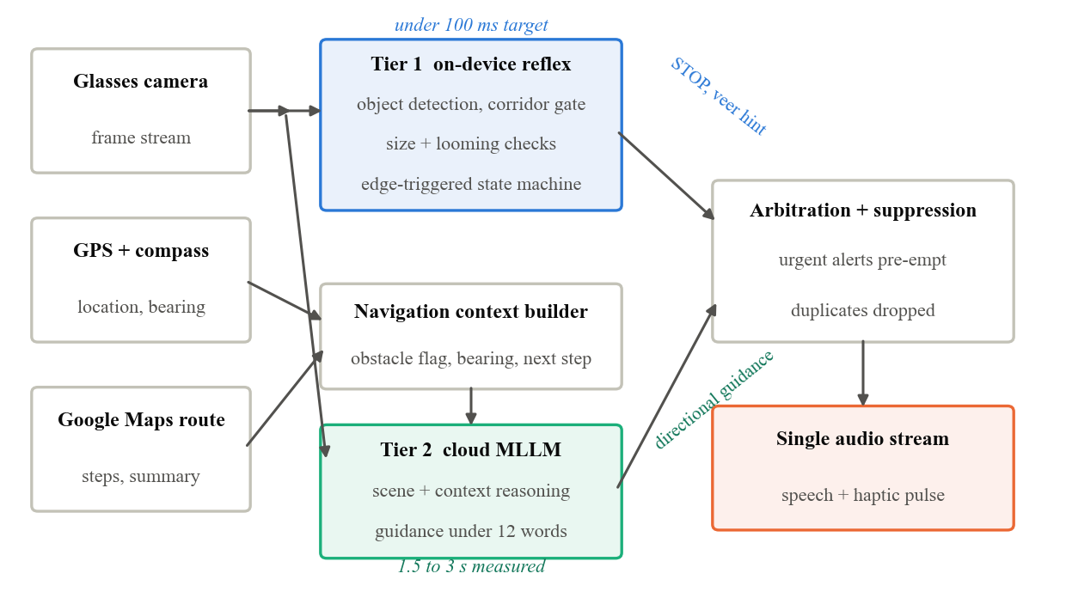
Figure 1. VisionAI runtime architecture. The on-device reflex tier and the cloud MLLM tier feed one arbitration layer and one hands-free audio stream.
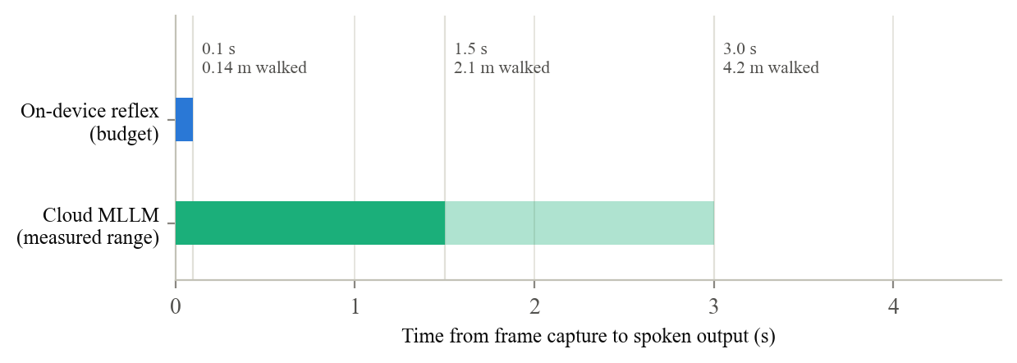
Figure 2. Latency of the two guidance tiers, annotated with the distance a pedestrian walks at 1.4 m/s before speech begins.
An earlier version of the prototype also attempted monocular depth estimation on the phone with the MiDaS model. It required about 200 milliseconds per frame, occupied a dedicated high priority thread, and caused thermal throttling, and because it produces only relative depth a flat wall ten meters away could look identical to a vehicle two meters away when both filled the frame. We replaced it with object detection combined with the size and motion cues analyzed below.
4.2 Simulation methodology
The neural detector runs only on Android hardware, so we did not simulate the detector itself. Instead we extracted the decision layer that sits on top of it, using the same constants the application ships with. Table 2 lists those parameters together with the effect each produces in the analyses that follow. The simulated camera has a 60 degree vertical and 46 degree horizontal field of view, processes 10 frames per second, and moves at a walking speed of 1.4 m/s unless a scenario varies it. Obstacles are modeled as boxes whose apparent size follows pinhole projection, with 10 percent multiplicative noise on box dimensions and positional jitter on box centers to imitate detector instability. Where an analysis needs an approaching walker, the decision logic receives the full 0.9 second frame history its looming detector expects. The simulation therefore validates the decision logic and its thresholds, not the underlying detector, and we return to this limitation in Section 4.11.
Table 2. Shipped reflex parameters exercised by the simulation and the effect each produces. Figure numbers refer to this section.
Parameter | Shipped value | Effect observed in simulation
Walking corridor | 0.32 to 0.68 of frame width | Confines alerts to the walking path. Widening it is the strongest lever on misses (Figure 9).
Background width gate | 0.90 of frame width | Rejects walls and ground spans. Creates the curb and close wall blind spots (Figures 3 and 5).
Near height gate | 0.34 of frame height | Sets the size only warning line in Figures 3 and 5. Mostly trades false alarms, not misses (Figure 9).
Near area gate | 0.12 of frame area | Catches wide low objects the height gate misses.
Looming window and limit | 0.9 s window, 2.0 s time to contact | Lifts warnings to 2.8 m and makes warning time speed invariant (Figures 3 and 4).
Entry requirement | 2 consecutive frames | Cuts spurious alerts by roughly an order of magnitude (Figure 7).
Clear requirement | 4 consecutive frames | Prevents flicker from re-arming the alert during an encounter.
Alert cooldown | 3.5 s | Two alerts instead of 81 in the double approach of Figure 6.
Re-arm delay | 1.2 s of clear path | Allows a second warning on a genuine second approach.

4.3 Warning distance and time to warning
Figure 3 shows the distance at which the reflex first raises an alert as a function of obstacle height. Under the size gates alone, a standing person is flagged 4.3 meters away, about 3.1 seconds before contact, while a one meter trash bin is flagged at 2.5 meters and a 0.9 meter bollard at only 2.3 meters, about 1.6 seconds before contact. The looming cue changes this picture for exactly the objects that need it. Because a steady approach at walking speed brings the time to contact below two seconds at 2.8 meters, the looming path lifts the warning distance for the bin and the bollard to 2.8 meters, a full two seconds of warning, and roughly doubles the warning distance for obstacles under half a meter tall. The simulation also confirms a known blind spot. A low curb spanning the walkway is rejected by the background width gate before its apparent size ever reaches the near threshold, so it never triggers the reflex at any distance. This matches the limitation recorded during development and motivates the ground plane work in Section 5.
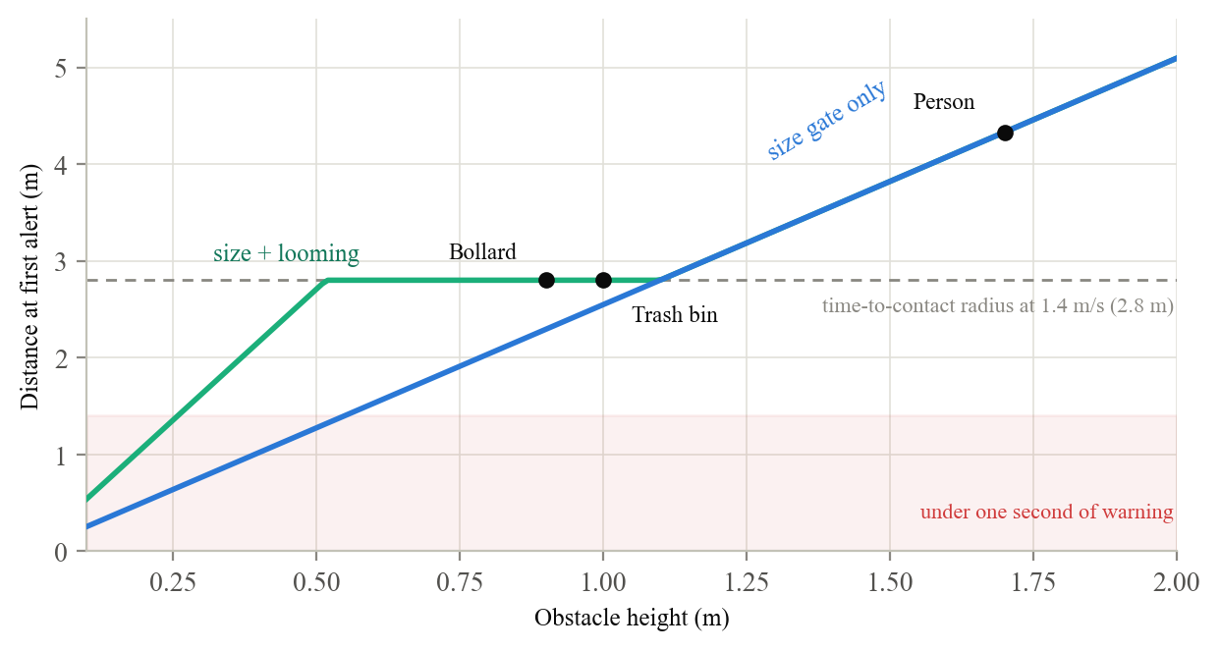
Figure 3. Simulated distance at first alert versus obstacle height under the shipped thresholds. The looming cue extends warnings for mid sized and small obstacles out to the time-to-contact radius.
Figure 4 extends the warning analysis across walking speeds, and it exposes a property we had not designed for explicitly. For obstacles caught by the size gates alone, warning time falls as speed rises, since the alert distance is fixed while the walker covers it faster. A person is flagged 5.4 seconds ahead at a slow 0.8 m/s but only 2.2 seconds ahead at a brisk 2.0 m/s. For obstacles caught by the looming path the relationship inverts. Because time to contact is itself the trigger, the warning time is pinned at 2.0 seconds at every speed, so a faster walker is simply warned farther away. The reflex therefore degrades gracefully for exactly the users who stress it most, a property worth preserving when the thresholds are retuned in the field.
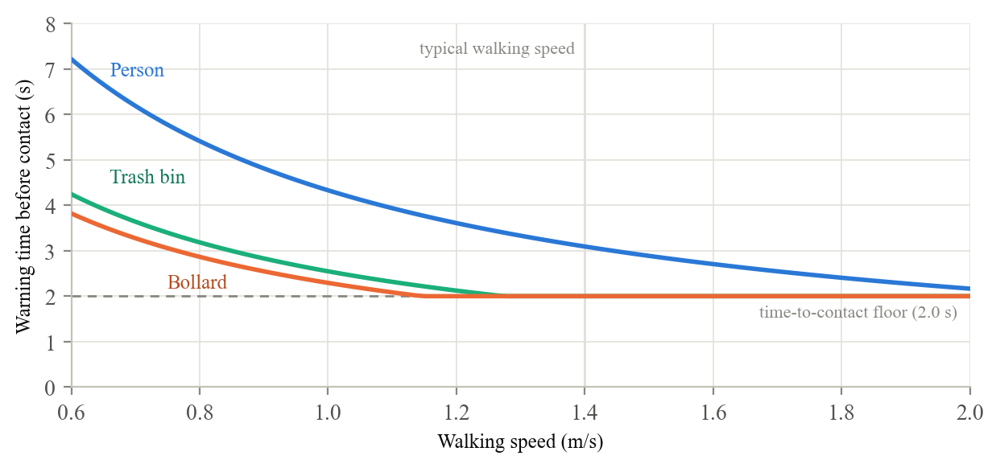
Figure 4. Warning time before contact as a function of walking speed. Size gated warnings shrink with speed while the time-to-contact trigger holds a constant 2.0 second floor.
4.4 The detection envelope
Figure 5 aggregates the whole reflex into a single operating picture, the probability that an approaching walker receives an alert as a function of obstacle distance and height under detector noise. Three structures are visible. The diagonal boundary is the near size gate, along which detection probability transitions smoothly because box jitter blurs the threshold. The vertical band ending at 2.8 meters is the looming path, which fills in full detection for any object taller than about half a meter regardless of the size gate. And the pale wedge at the upper left is the background rejection gate discarding objects so close that they span most of the frame, the same trade that produces the wall and curb blind spots. This figure is, in effect, the specification that the field tests of Section 5 must confirm or correct.
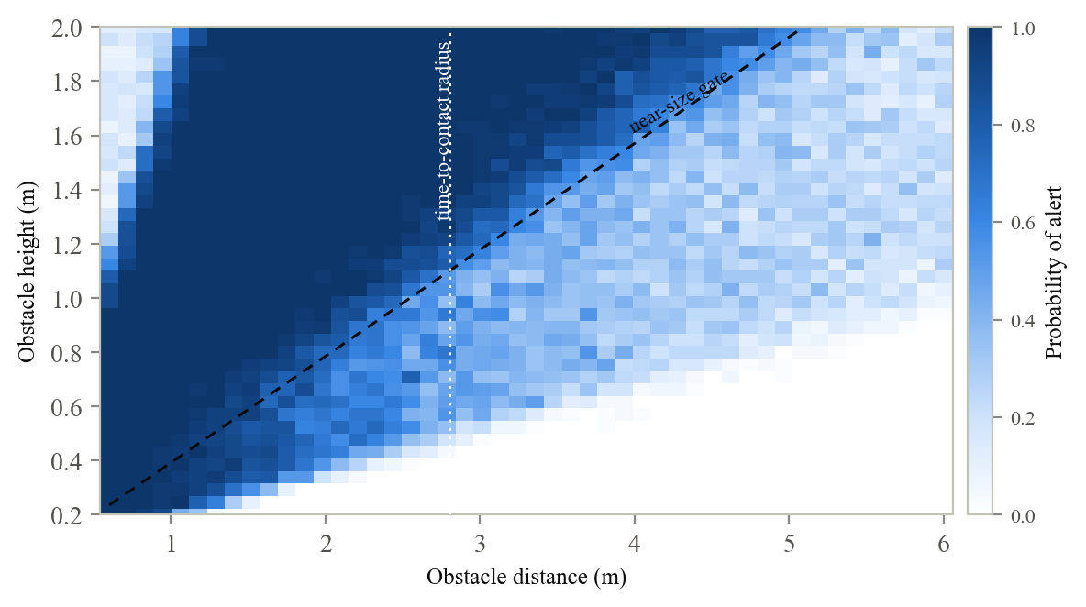
Figure 5. Simulated probability of an alert over obstacle distance and height, with 50 noisy trials per cell. Dashed lines mark the analytic gate boundaries.
4.5 Alert discipline and flicker robustness
Figure 6 traces a simulated walk in which a pedestrian approaches a bollard from 8 meters, stops half a meter away, backs off, and approaches again. The reflex speaks exactly twice, once per approach, with the first warning at 2.7 meters. It stays quiet while the pedestrian stands in front of the obstacle, and it re-arms only after the path has been clear for 1.2 seconds, so the second approach produces a second warning. A naive level triggered policy evaluated on the same frames would have spoken 81 times. This behavior was the direct fix for the repeated stop announcements we observed in early bench testing.
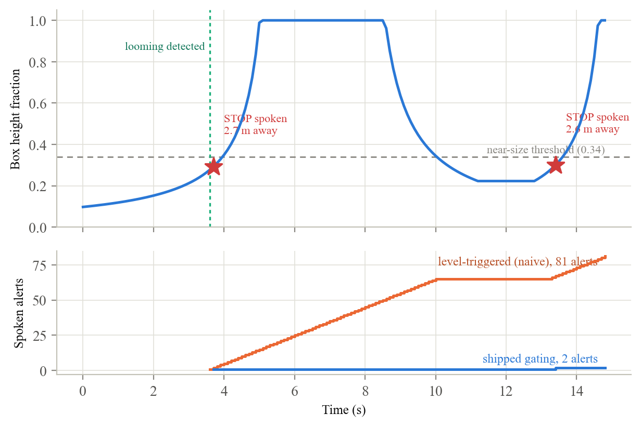
Figure 6. A simulated double approach toward a 0.9 m bollard. The shipped gating speaks twice while a naive level triggered policy would speak 81 times.
Figure 7 isolates the entry requirement with a stress test in which the detector emits spurious danger frames at a fixed flicker rate while the path is actually clear. A single frame policy would speak 11 to 16 times per minute even with the 3.5 second cooldown in place. The shipped two frame requirement cuts this to 1.3 spurious alerts per minute at 5 percent flicker and 9.7 at 20 percent, and a third frame would cut the worst case to 3.2 per minute at a cost of only 0.1 seconds of added warning delay. This gives the field tuning plan in Section 5 a concrete decision rule. If the flicker rate observed in logs exceeds roughly 10 percent, raising the entry requirement to three frames is the cheapest available trade.
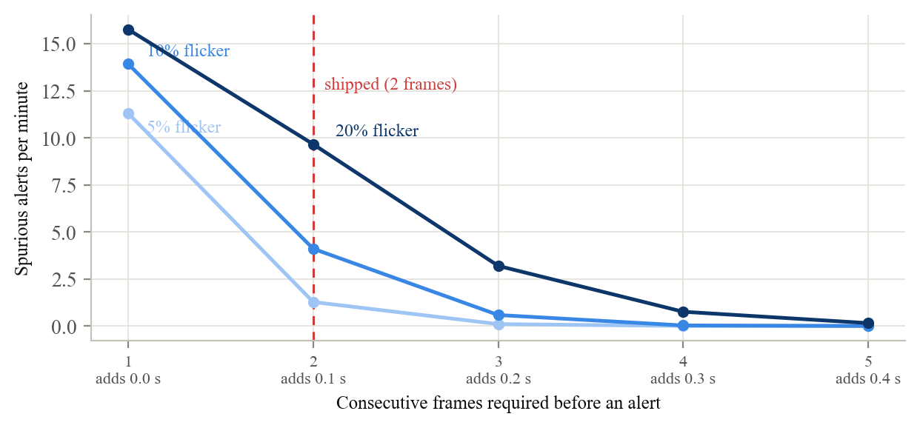
Figure 7. Spurious alerts per minute on a clear path versus the number of consecutive danger frames required, for three detector flicker rates. Each added frame delays a true alert by 0.1 seconds.
4.6 False alarms, misses, and threshold sensitivity
We compared the shipped decision rule against the rule used in the first prototype, which flagged danger whenever an object's bottom edge fell in the lowest 20 percent of the frame. Each of 40,000 synthetic scenes draws an obstacle size, lateral position, and distance, a hand-held camera pitch between 10 degrees up and 30 degrees down, and per frame box jitter, and a quarter of the scenes contain only a distant wall or fence. A scene counts as a hazard when the object lies in the walking path within 2.5 meters. Figure 8 summarizes the outcome. With its two frame confirmation, the shipped rule raises a false alarm in 2.0 percent of non hazard scenes versus 5.7 percent for the legacy rule, and it also misses fewer hazards, 49.1 percent versus 57.1 percent on this deliberately harsh per frame metric. Dropping the confirmation requirement lowers the miss rate to 40.7 percent but more than triples the false alarm rate to 7.3 percent, and the shipped design accepts that trade because false alarms erode the trust the system depends on.
The per frame miss numbers overstate misses in practice, because in a continuous approach the alert usually fires at the time to contact radius, as in Figure 6, and stays latched while the obstacle remains ahead. The clearest advantage of the shipped rule is stability. Apparent size does not depend on camera pitch, so the shipped decision never changes when the pitch is perturbed by 8 degrees in either direction, whereas the legacy bottom edge rule flips its decision in 14.2 percent of scenes under the same perturbation. For a camera carried in a walking user's hand or worn on their face, that pitch invariance separates a usable alert from noise. The misses that remain concentrate where the design predicts them, in obstacles under half a meter tall, which account for about one in six missed hazards, and in close range objects sitting off the camera axis beyond the 46 degree field of view.
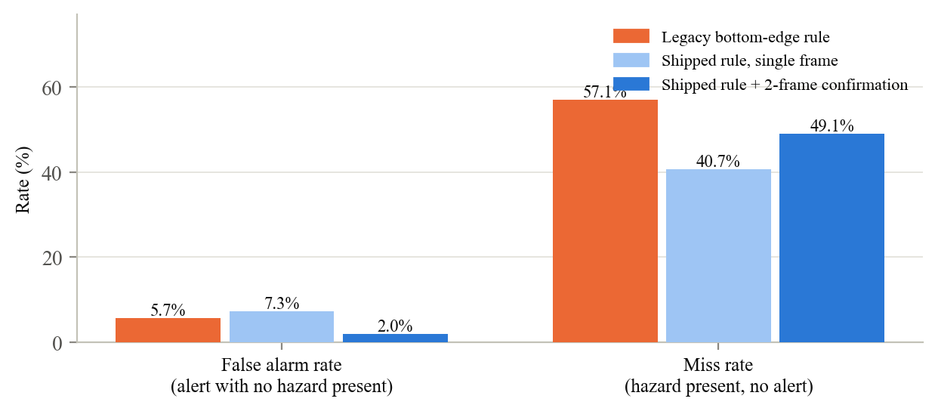
Figure 8. Per frame error rates over 40,000 simulated scenes with randomized camera pitch and box jitter, for the legacy bottom edge rule and the shipped decision rule.
Figure 9 asks how sensitive this operating point is to the two most consequential tuning knobs, sweeping each while holding everything else fixed and evaluating with stratified sampling of hazard and non hazard scenes. The two knobs behave very differently. Raising the near height gate from 0.22 to 0.46 of the frame cuts false alarms from 4.3 to 1.3 percent while moving misses by only six points, from 44.6 to 50.6 percent, because close range detection is dominated by the looming path rather than the size gate. The corridor width behaves in the opposite way. Widening it from the shipped 0.36 to 0.52 of the frame cuts misses from about 48 to 35 percent at a cost of roughly half a percentage point of false alarms, because it recovers exactly the close range off axis hazards identified above. This is the single clearest tuning recommendation the simulation produces, and validating a wider corridor on real sidewalks is now an explicit goal of the field plan in Section 5.
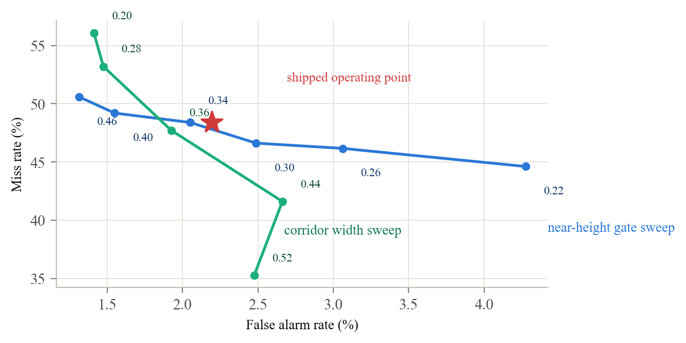
Figure 9. False alarm and miss rates as the near height gate and the corridor width are swept around the shipped operating point, with stratified sampling. Labels give the parameter value at each point.
4.7 Local avoidance hints and instruction correctness
When the reflex fires, the system also computes a veer hint locally from box geometry, so the avoidance direction does not wait 1.5 to 3 seconds for the cloud. Figure 10 maps every combination of obstacle position and opposite side occupancy to the decision the shipped rule makes. The hint is spoken only when the obstacle is clearly off center and the opposite side of the frame is substantially open. Across the configuration space the system stays silent in about 71 percent of cases, including whenever the obstacle is dead ahead or both sides are comparably occupied.
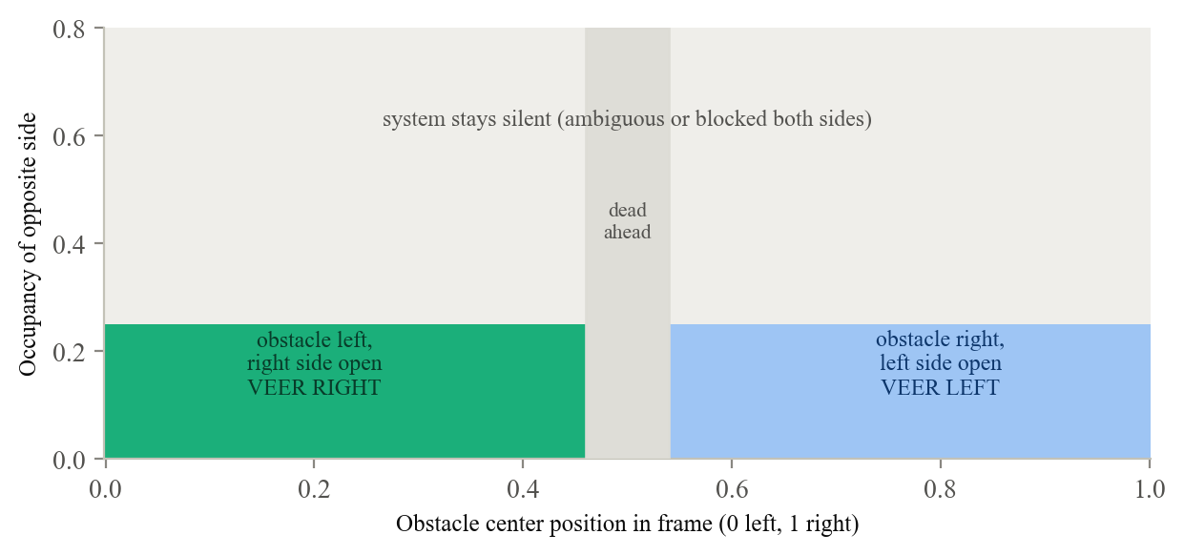
Figure 10. Veer hint decision regions under the shipped rule. The system stays silent in about 71 percent of the configuration space, preferring no direction over a possibly wrong one.
Figure 11 evaluates the same rule as an instruction correctness measurement of the kind our proposed framework calls for, across 30,000 scenes with a hazard ahead and randomized side clutter, where the rule observes noisy versions of the true occupancies. When the opposite side is genuinely open, the rule speaks a correct hint in 82 percent of scenes and stays conservatively silent in the rest. Under moderate clutter it speaks correctly a third of the time and otherwise holds its silence, and under heavy clutter it is silent essentially always, which is the correct behavior because no safe veer exists. Across all scenes the rule recommends an unsafe or wrong side in 0.18 percent of cases, all of them boundary cases created by measurement noise, so it speaks a helpful hint roughly 200 times for every harmful one. The asymmetry is the point. The rule purchases that safety margin by refusing to speak in roughly a third of the scenes where a hint might have helped, and whether that trade feels right to BLV travelers is a question only the trials in Section 5 can answer.
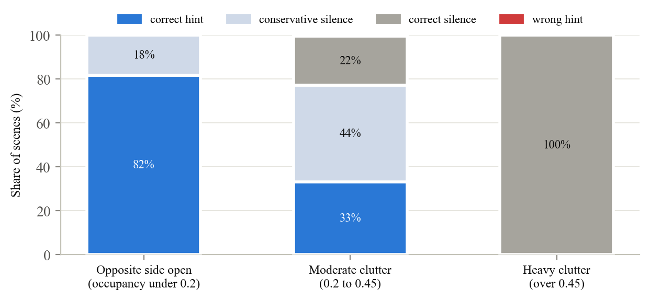
Figure 11. Outcome of the veer hint rule over 30,000 noisy scenes, grouped by how cluttered the escape side is. Wrong hints occur in 0.18 percent of scenes overall.
4.8 Tier 2 guidance cadence and staleness
The reflex tier bounds worst case harm, but the quality of everyday guidance depends on how often the MLLM tier can speak and how stale its words are when they arrive. Both quantities follow directly from the shipped request throttle of 1.5 seconds and the model latency, because a new request is not issued while one is in flight. Figure 12 shows both. At the measured 1.5 to 3 second latency the system can deliver at most 20 to 40 guidance updates per minute, and each utterance describes a scene the walker left 2.1 to 4.2 meters behind. A hypothetical on-device model with half second latency would sit at the throttle cap of 40 updates per minute while cutting staleness to 0.7 meters. This is the quantitative case for the hybrid on-device tier planned in Section 5. We treat these as design envelope numbers rather than measurements, since real update rates also depend on movement gating and obstacle events.
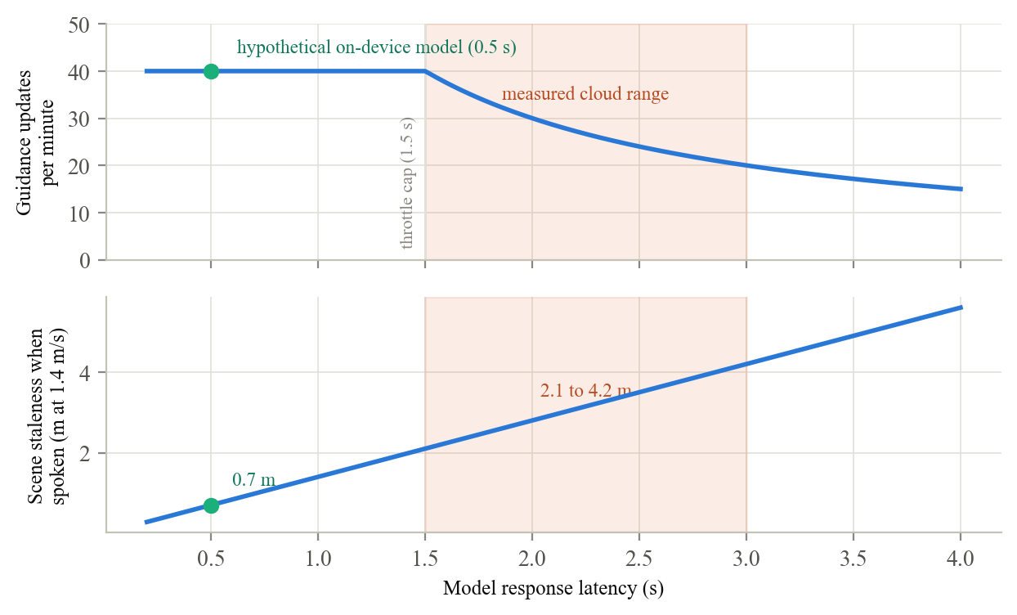
Figure 12. Guidance updates per minute and scene staleness as a function of model response latency, given the shipped 1.5 second request throttle. The shaded band is the measured cloud latency range.
4.9 Speech pipeline findings
Two failures found during bench testing are worth recording for other builders. First, the MLLM streams cumulative text as it generates, and speaking every chunk flooded the Android text-to-speech engine with interruption requests until it silenced itself entirely. The prototype now accumulates the full response and speaks once per analysis. Second, the speech helper originally marked itself busy even when the engine rejected an utterance, which could stall all guidance indefinitely. It now checks the return code and recovers. The model is also constrained to responses under twelve words so that guidance remains actionable while walking.
4.10 Reading the results through the proposed evaluation framework
The central claim of this paper is that MLLM navigation aids need a shared evaluation framework, and this section can be read as a first in silico instantiation of it. Time to warning is instantiated by Figures 3 through 5, which turn a threshold file into a concrete promise, two seconds of warning for mid sized obstacles at any walking speed. False alarm rate is instantiated by Figures 7 through 9, which show it is governed by different knobs than the miss rate and can be traded deliberately. Repetition rate is instantiated by Figure 6, where a policy choice changes 81 spoken alerts into 2. Instruction correctness is instantiated by Figure 11, where the local hint recommends an unsafe side in fewer than 0.2 percent of scenes. Two framework metrics cannot be instantiated in simulation at all. Hallucination rate is a property of the MLLM tier and requires real model outputs on real scenes, and trust requires people. That boundary is itself a finding. It marks where simulation stops being able to certify a system like this and where the participatory trials of Section 5 must take over.
4.11 Limits of these results
We state the limits plainly. The latency figures and the speech findings are measured prototype behavior, while every warning distance, alert count, and error rate is a simulation of the decision layer under an idealized perception model. Real world performance also depends on whether the neural detector boxes the obstacle at all, which the simulation does not capture, and on lighting, motion blur, and hardware variation. The camera geometry, frame rate, and walking speed are stated assumptions rather than measurements, the flicker rates, jitter magnitudes, and hazard definitions are modeling choices, and the absolute error rates in Section 4.6 should be read as comparative indicators rather than field predictions. Several recent changes, including the looming detector and the speech recovery logic, have been verified through code review and compilation but not yet on real sidewalks. These results should therefore be read as evidence that the decision layer behaves as designed, not as evidence of field safety, and Section 5 describes how we intend to close that gap.
5 Future Work
Our immediate priority is to move from bench and simulation results to evidence gathered with the people the system is meant to serve. We plan this in stages so that each stage establishes the safety case for the next.
On-device technical validation. Before anyone outside the team uses the system, we will run a structured device test plan on real streets with sighted researchers. This covers single alert behavior when approaching a pole or wall, correct re-arming after an obstacle clears, false alarm checks on open sidewalks and with the camera pitched toward the ground, veer hint correctness when one side is clearly open, and speech reliability under rapid guidance updates. Detection thresholds such as the near size ratio and the alert cooldown will be tuned one parameter at a time from logged field data. The same walks will test the simulation's predictions directly, for example the 2.8 meter first alert distance for mid sized obstacles in Figure 3, the two alert trace in Figure 6, and the flicker rule from Section 4.5, which tells us to raise the entry requirement to three frames if logged flicker exceeds roughly 10 percent. A wider walking corridor and a wider angle lens will be evaluated against the close range off axis misses identified in Section 4.6, and ground plane analysis will be explored for the curb blind spot identified in Section 4.3.
Controlled trials with BLV participants. Working with our partner eye care foundation, we will then recruit blind and low vision volunteers for trials on a controlled indoor course and a closed outdoor course. Every session will follow a protocol approved by an institutional review board, with informed consent, an orientation and mobility professional present, a sighted researcher shadowing the participant, and the freedom to stop at any time. The system will be used alongside each participant's primary aid, never in place of it. During these sessions we will collect the safety and response quality metrics proposed in Section 1, including false alarm rate, time to warning, instruction correctness against a ground truth action, hallucination rate, and repetition rate, together with structured interviews on trust, cognitive load, and preferred phrasing and verbosity.
Real world routes. Once the controlled trials show acceptable safety metrics, we will extend testing to the settings where the system will actually be used, including busy sidewalks, signalized crossings, and transit areas. These sessions will pair quantitative logging with diary style feedback gathered over several weeks, since trust in an assistive system develops through repeated use rather than in a single session.
Reducing dependence on the cloud. The latency and reliability of the cloud MLLM remain the weakest part of the design, and Section 4.8 quantifies the prize. An on-device model at half second latency would double the guidance rate while cutting scene staleness from several meters to under one. We are planning a hybrid tier in which a small on-device model handles routine scene guidance and the cloud model serves as a fallback. We will first run the on-device model in shadow mode, logging its outputs alongside the cloud model without speaking them, so that quality can be compared on identical frames before any user hears its guidance. On-device speech recognition for spoken destination commands is a further candidate.
Hardware and system maturation. Finally, we plan to move the camera from the handheld phone to the glasses form factor described in Section 1, profile battery and thermal behavior over walks of realistic length, surface explicit errors when the cloud model fails rather than failing silently, and consolidate the prototype's parallel processing paths into a single well tested pipeline. We hope workshop feedback will sharpen both the trial protocol and the evaluation framework before these studies begin.

