Design Principles & Patterns

Exercise 1: Implementing the Singleton Pattern

Code
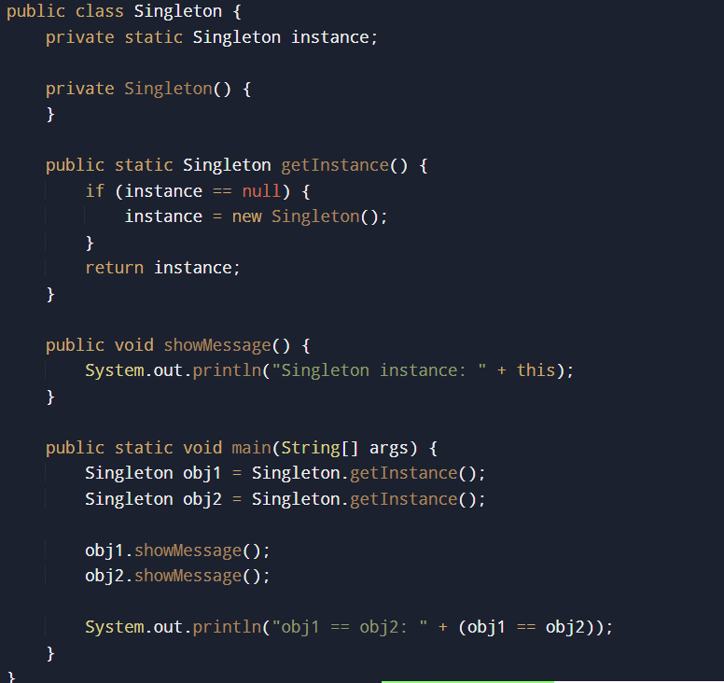

Output

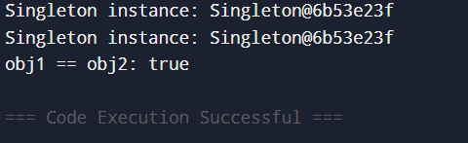

Exercise 2: Implementing the Factory Method Pattern

Code
interface Shape {
void draw();
}
class Circle implements Shape {
public void draw() {
System.out.println("Drawing a Circle");
}
}
class Square implements Shape {
public void draw() {
System.out.println("Drawing a Square");
}
}
class Rectangle implements Shape {
public void draw() {
System.out.println("Drawing a Rectangle");
}
}
class ShapeFactory {
public Shape getShape(String shapeType) {
if (shapeType == null) {
return null;
}
if (shapeType.equalsIgnoreCase("CIRCLE")) {
return new Circle();
} else if (shapeType.equalsIgnoreCase("SQUARE")) {
return new Square();
} else if (shapeType.equalsIgnoreCase("RECTANGLE")) {
return new Rectangle();
}
return null;
}
}
public class FactoryPatternDemo {
public static void main(String[] args) {
ShapeFactory shapeFactory = new ShapeFactory();
Shape shape1 = shapeFactory.getShape("CIRCLE");
shape1.draw();
Shape shape2 = shapeFactory.getShape("SQUARE");
shape2.draw();
Shape shape3 = shapeFactory.getShape("RECTANGLE");
shape3.draw();
}
}

Output
Drawing a Circle
Drawing a Square
Drawing a Rectangle

