

Vellore Institute of Technology
School of Computer Science and Engineering
Course Code and Name: BCSE306L Artificial Intelligence Slot: C1 + TC1

Project Title
Do Reading Assistants Peek Ahead? Reader-Faithfulness: Detecting and Fixing Look-Ahead Leaks from the Pipeline and from Model Memory (EchoTales)

Member | Registration Number
Adhyan Jain | 24BCI0111
Atharva Sheerh Pandey | 24BCI0069
Aryan Gahlot | 24BCI0033

Submission: 16 October 2026 | Repository: EchoTales (branch chimera/system-adapters)

[2] Structured Abstract
Background: Language models recap fiction for readers who have read only part of a book, and may name a disguised character too early. Objective: Measure that leakage, test whether name memory rather than lost name cues causes it, and audit a narrative knowledge graph for the same property. Methods: From public-domain novels we built events in which a character known by an alias is later named; the book's own reveal sentence is the oracle. Mentions were shown with original names, a letter cipher and cue-preserving pseudonyms. Exploratory: 38 events, five local 7-9B models and one commercial model. Pre-registered confirmatory run: 68 events from 65 books, three open 24-32B models. Results: Exploratory: the reference model named the identity early more often with original names (gap +26.0 points, 95% CI [16.8, 36.0]); pseudonyms did not restore premature naming (recovered fraction -0.11); the gap rose with book familiarity. Confirmatory, on mostly obscure books: pooled gap +0.1 [-5.0, 5.2]; fame contrast +7.6 [-1.4, 18.3], p = 0.0595, not significant. The graph resolver was prefix-causal; its persona stage looked ahead for 8.0% of characters. A whole-book character card, the common assistant design, leaked the hidden identity before the reveal in 18.5% of events even under renamed names; a versioned card removed it (1.2%). Conclusions: The effect is shown for a strong model on famous books and not detected on obscure ones; the pipeline leak is a design property with a measured fix. Events are model-selected and no human labels are used.
(246 words)
[3] Introduction
Background and problem. Web novels run to hundreds of chapters and are now read, summarised and adapted with the help of language models. Every such task has an implicit reader position: at chapter c the system may use only what the first c chapters say. Long serials make this hard because identity is concealed and revealed: "the masked guest" or "the clan head" appears long before the text says who that is. Standard tooling gives one omniscient answer per character [11, 10]. We call a system reader-faithful if its output at chapter c depends only on chapters up to c. Two things can break that. A model may remember the book, so truncating its input does not stop it naming the hidden person (parametric memory) [1, 3]. A pipeline stage may derive a property at chapter c from evidence in later chapters (derivation look-ahead). Figure 6 shows both.
Objective and methodology. The project measures the first violation and audits the second. For memory, we use a renaming intervention in the tradition of [2]: the same passage is shown with original names and with consistently replaced names, and the drop in premature naming (answering the true identity before the book reveals it) is the leakage gap. Events come from public-domain novels (Project Gutenberg), and the oracle is the book's own explicit reveal sentence, located by exact text search, so no model or person has to judge the truth. EchoTales, our bitemporal narrative knowledge graph, provides the observer-scoped query state_of(target, timeline, position, observer) and is the system whose reader-faithfulness we audit by truncate-and-rebuild testing.
Method discipline. The study was run as a sequence of pre-registered versions with hashed manifests. Along the way we found and corrected a statistical error (items inside one event are not independent, so intervals now resample events), added a cue-preserving control because renaming to gibberish also removes name cues, and recorded a failed replication. A final pre-registered confirmatory run with open-weight models on a rented GPU (section 12) tested the effect on mostly obscure books and did not detect it; that null is reported with its limits.
Results and analysis. For the reference model the leakage gap is +26.0 points over 38 events, and it appears in all three datasets. Four local 7-9B models show +11.5 pooled but zero on the seven least-known books. Restoring name cues repairs plain-control accuracy but does not restore premature naming, which points to name-keyed memory rather than lost cues. The gap rises with how well the book is recognised. The graph audit finds the resolver exactly prefix-causal and one derived stage, personas, looking ahead. Section 12 gives the evidence, and section 7 states what was and was not done by whom.
[4] Background / Related Work
The team studied the works below. Every research article is from 2020 or later; the tools and web resources are listed separately. Provenance of our reading is recorded in the repository (docs/research/NOVELTY_REPORT/PRIOR_ART.md and PRIOR_ART_E0.md): articles marked in the table were read in their own text, not from abstracts.
Memorisation of books by language models. Chang et al. [1] probe which books ChatGPT and GPT-4 know with a name-cloze task over 571 works and show that memorisation tracks how often passages appear on the web and that memorised books score better on downstream tasks. Fu et al. [5] compare summaries of 25 well-known books written from the model's memory with summaries written from the full text and find the full text is usually, but not always, better. Both measure recall or summary quality; neither asks what a reader at a given chapter is entitled to know, and neither controls names in a reading task.
Renaming and anonymisation as controls. Jiang and Ferraro [2] replace character names (masking, same-culture and gender-preserving cross-culture replacement) and report accuracy drops of up to 45.2% on character-understanding benchmarks, with human validation that gold labels survive. SynthWorlds [7] contrasts real and synthetic parallel worlds to separate knowledge from reasoning, with a rename-leak audit. Deußer et al. [4] study pseudonymisation with consistent placeholders and mapping the answer back, but as a privacy-utility trade-off over eleven benchmarks, not as a memorisation control. None of them uses a reveal time, and none separates memory from lost name cues.
Time-aware and disclosure-aware narrative state. TimeChara [3] defines point-in-time character hallucination in role-play and lists spoiler avoidance as a motivation, but defines leakage as contradiction with a timeline. Ma et al. [6] name premature information disclosure as one failure of interactive narrators on movie synopses without testing memory. Narrative World Model [14] and NarraWorld [15] model chapter-safe memory and reveal order, and E2RAG [16] builds temporally consistent entity-event graphs; none of them measures memory-driven leakage of an identity.
Coreference and character resolution in fiction. LitBank [11], KoCoNovel [10], BOOKCOREF [9] and LlmLink [8] supply corpora and systems for literary coreference. KoCoNovel is notable for annotating both reader and omniscient views, but its models are tested on the omniscient version. Web-novel resources such as GenWebNovel [12] contain only the first ten chapters of each novel, so later reveals are structurally absent, and Song and Liu [13] list hidden identity as an unsolved challenge in a single sentence.
Tools and resources. BookNLP, vLLM, ollama, Project Gutenberg, RunPod, Hugging Face and the Claude Code command line supply the software, data and compute used here (Table 2).
Table 1. Research articles reviewed (2020 onward).
Sl# | Articles | Work Done | Dataset | Gaps / Limitations
1 | Chang et al. [1]  EMNLP, ACL, 2023 | • Name-cloze probe of memorisation  • Memorisation tracks web duplication (Spearman 0.74, pre-1928 books)  • Memorised books do better on downstream tasks | 571 works (name-cloze passages) | • Tests recall, not a reading task with a reveal  • Closed models only; no renamed control on downstream use
2 | Jiang and Ferraro [2]  arXiv:2412.14368 v6, 2026 | • Name replacement as a memorisation constraint  • Masked, same-culture, gender-preserving cross-culture names  • Accuracy drop up to 45.2% | Six character-understanding benchmarks | • No chapter prefix, reveal time or alias task  • Does not split the drop into memory versus lost cues
3 | Ahn et al. [3]  Findings of ACL, 2024 | • Point-in-time role-play hallucination benchmark  • About 10,895 instances  • Narrative-Experts decomposition as a mitigation | Characters from four book series | • Leakage = timeline contradiction, not tied to memory  • No renaming control; four series only
4 | Deußer et al. [4]  arXiv:2609.11335, 2026 | • Pseudonymisation with mapping back, plus four other anonymisers  • 11 benchmarks, five models (7B-72B)  • Pseudonymisation least harmful to utility (as summarised in our notes) | Eleven public benchmarks | • Privacy-utility framing; memorisation untested  • No narrative reveal task
5 | Fu et al. [5]  arXiv:2603.09981, 2026 | • Summaries from memory versus full text  • LLM judges  • Full text usually better; memory sometimes wins | 25 well-known public-domain books | • No reader-position cutoff  • LLM judges carry self-preference risk
6 | Ma et al. [6]  arXiv:2608.08160, 2026 | • Long-horizon consistency benchmark with a fact ledger  • Defines premature information disclosure  • Six narrator models | 100 CMU Movie Summary synopses | • No memory or renaming test (read via summary tool)  • Famous films confound memory with reasoning
7 | Gu et al. [7]  ICLR, 2026 | • Parallel real and synthetic worlds  • Knowledge-advantage gap  • Rename-leak audit | Wikidata-derived parallel corpora (multi-hop QA) | • Encyclopaedic QA, not fiction  • No alias or reveal task
8 | Zhu et al. [8]  COLING, 2025 | • Dual-LLM linking with memorisation  • Chunked long narratives  • Evaluated with MUC, B3, CoNLL | LitBank and DOC-ARC | • Static identity, no time axis  • Stops at the graph; no leakage control
9 | Martinelli et al. [9]  ACL, 2025 | • Book-scale coreference corpus  • Book-scale silver and gold sets  • BookNLP CoNLL-F1 42.2 on gold | Gutenberg books (PG19-derived) | • Omniscient labels only  • Web availability acknowledged, not controlled
10 | Kim et al. [10]  LREC-COLING, 2024 | • Reader and omniscient coreference views  • Three annotators, MUC agreement 94.53  • Views differ in 5 of 50 works | KoCoNovel: 50 Korean novels, 178K tokens | • Experiments on omniscient view only  • Korean; no LLM or leakage control
11 | Bamman et al. [11]  LREC, 2020 | • Coreference annotation of literature  • Revelation of identity discussed (Sec. 4.2.5) | LitBank: 100 English works | • Annotates textual reality, not the reader's state of knowledge  • Omniscient labels only
12 | Zhao et al. [12]  COLING, 2025 | • Nested NER for Chinese web novels  • PER, LOC, ORG  • Coreference left as future work | 400 chapters (first 10 of 40 novels), 1.2M tokens | • Later reveals structurally absent  • Chinese; data-use agreement restricts reuse
13 | Song and Liu [13]  LREC-COLING, 2024 | • Resolving character representations in a Chinese novel  • Zero and non-zero anaphora  • Names hidden identity as open problem | One Chinese print novel | • One qualitative sentence on hidden identity  • No metric, LLM or prefix setup
14 | Saifullah et al. [14]  arXiv:2607.05577, 2026 | • Writer memory with chapter-safe cutoffs  • Reveal order versus event order  • Typed temporal state | Long-form fiction memory QA | • No identity task or leakage control  • Scores memory QA accuracy only
15 | Tian et al. [15]  arXiv:2609.32401, 2026 | • Validity-interval story memory  • Alias-linking stage  • Premature disclosure stated as a design aim | ConStory-Bench and continuation checkpoints | • Premature disclosure never measured  • Alias linking not evaluated
16 | Zhang et al. [16]  arXiv:2506.05939, 2025 | • Entity-event knowledge graph for RAG  • Temporal-causal consistency  • 'Never merge mentions' design | ChronoQA: 497 QA pairs over 9 Gutenberg stories | • Avoids merging rather than resolving  • No leakage control

Table 2. Blogs, reports and tools studied.
Sl# | Tool / report | Purpose in this project | Gaps / Limitations
T1 | BookNLP (Bamman, GitHub) | Character clustering, coreference and speaker attribution for books; baseline family | Omniscient output; no reader-position or leakage notion found
T2 | vLLM (Kwon et al., SOSP 2023) | PagedAttention serving engine; OpenAI-compatible server used on the rented GPU | Throughput depends on GPU and quantisation; to be measured in calibration
T3 | ollama (ollama.com) | Local model runtime used for the 7-9B models on the 8 GB laptop GPU | Small models only; run-to-run determinism not guaranteed
T4 | Project Gutenberg (gutenberg.org) | Public-domain texts, the data source for all events | Pre-1928 Western fiction; texts may be in training data
T5 | RunPod pricing page (dated 2026-10-08) | GPU hourly prices used for the confirmatory cost | Prices change; read through a summary tool, so approximate
T6 | Hugging Face model cards (OLMo-2-32B, Qwen2.5-32B AWQ, Mistral-Small-3.2-24B) | Licences, quantisation and serving notes for the confirmatory models | Community 4-bit builds may differ from full precision
T7 | Claude Code CLI v2.1.301, headless mode | Programmatic access to Claude Sonnet 5.5 through a subscription (measured overhead 814 tokens, 1.9 s per call) | No temperature or seed control; usage limits; terms for bulk use unverified
T8 | Wikidata API | Fame variable (Wikidata sitelink count of each book) for the confirmatory dose-response | Coverage follows the Western canon

[5] Summary of Limitations / Gaps
Table 3. Gaps identified from the literature review.
Gap | Limitation found in the literature | Addressed by
G1 | Memorisation studies measure recall (name cloze, source identification, summaries) but not premature disclosure at a reader position [1, 2, 5]. | C1
G2 | Renaming controls turn names into gibberish or other cultures; none separates name-keyed memory from lost name cues, and none checks that the control itself is valid per model [2, 4, 7]. | C2, C3
G3 | Time-aware and disclosure-aware narrative systems model chapter-safe state but do not measure memory-driven leakage of an identity or the effect of a repair [3, 6, 14, 15, 16]. | C5, C6
G4 | Literary coreference resources use omniscient labels or early chapters, so reveals are absent or invisible [9, 10, 11, 12, 13]. | C1
G5 | Statistical practice in the sections we read treats items as independent and reports single accuracies; replication and pre-registration are rare (our own first analysis made the same error and corrected it). | C4
G6 | Pseudonymisation is studied for privacy and utility, not as a mitigation of leakage with a measured utility cost on post-reveal answers [4]. | C6

[6] Primary Contributions of the Project
- C1. A reveal-time leakage measure with a text-derived oracle (gaps G1, G4). Premature naming is scored against the book's own reveal sentence found by exact search, with a verifier (cutoff, no lexical cue, controls) and an independent model audit of events. 38 events from 38 public-domain books were analysed; a 150-event set is specified.
- C2. A cue-preserving pseudonym control and the recovered-fraction decomposition (gap G2). Gender- and name-type-matched pseudonyms restore plain-control accuracy (e.g. qwen2.5 80.3 to 96.7) but not premature naming: gap +16.1 against +14.6, recovered fraction -0.11 [-35.6, 6.1].
- C3. A memory-free validity gate (gap G2). Comparing two independent renamings with each other, plus renaming on unseen synthetic text, checks the control without original names; it showed that plain controls on famous books are themselves assisted by memory or by name cues (e.g. gemma2: 23 control items right only with original names, 1 only renamed; sign test p = 3e-6).
- C4. Event-level inference, honest replication and a familiarity dose-response (gap G5). Item-level intervals were replaced by event-cluster intervals; the failed replication on seven fresh books is reported; the gap rises with book recognition (Spearman +0.37, p = 0.024, cross-family).
- C5. A prefix-causality audit of a narrative graph pipeline (gap G3). Truncate-and-rebuild testing found the resolver exactly causal (0 of 28,165 mention comparisons) and the persona stage looking ahead for 8.0% of character checks (23 of 288), and framed both leakage channels as violations of reader-faithfulness.
- C6. A pre-registered confirmatory run with a mitigation and a harm task (gaps G3, G6). 68 events from 65 books, three open models, pseudonymise-and-map-back as the mitigation with a 5-point utility margin, a recap-spoiler task and a training-data check. Result: no premature-naming gap on obscure books (pooled +0.1 [-5.0, 5.2]), the fame contrast was not significant, pseudonyms lowered premature naming at a cost in accuracy, and no recap spoiler or training-data link was found.
- C7. The substrate: EchoTales, a bitemporal observer-scoped narrative graph with the query state_of(target, timeline, position, observer), a resolver and generation consumers, whose defects the audit located and fixed (Track S, engineering).
- C8. Found and fixed in a second, generic system (pre-registered RF-E2E). A whole-volume LLM character card stamped at first mention leaked the hidden identity before the reveal (18.5% of events on renamed text, judge rule; 24.6% by the strict text rule) while a versioned, prefix-built card leaked in 1.2%; the renaming control shows the leak comes from the build, not from memory.
[7] Individual Contributions
The project work was divided equally among all three team members (33.3% each), spanning system architecture, experimental probing, and statistical benchmarking.
Table 4. Individual contributions (equally divided).
Member | Contribution (implementation and documentation)
Adhyan Jain  24BCI0111 | System Architecture, Narrative Knowledge Graph & Causality Audit (Channel 2)  • Architected EchoTales: bitemporal reader-scoped narrative knowledge graph and state_of(target, timeline, position, observer) query engine.  • Implemented the entity resolver, discourse-order timeline management, and character state tracking across multi-chapter serials.  • Designed and executed the truncate-and-rebuild prefix-causality audit framework across 14 cuts and 28,165 mention pairs.  • Audited the persona derivation stage, discovered evidence horizon look-ahead leakage (8.0% divergence), and implemented the horizon-versioned revision repair.  • Led end-to-end pipeline integration, database schema design, and regression test suite execution (1,377 tests passing).
Atharva Sheerh Pandey  24BCI0069 | Experimental Methodology, Event Mining & Parametric Memory Probing (Channel 1)  • Formulated the alias-reveal task, reveal-cue extraction patterns, and candidate set construction from Project Gutenberg texts.  • Built the text-derived oracle mining pipeline and cutoff sentence verifier across 38 public-domain novels.  • Implemented the multi-arm renaming controls: original names (Arm A), letter ciphers (Arms B & B2), and cue-preserving gender-matched pseudonyms (Arm B3).  • Built the local model evaluation harness for 7-9B models (Qwen 2.5, Llama 3.1, Mistral, Gemma 2, Phi-4) and closed-book / title-assisted memory probes.  • Developed the interactive live probe interface and Research view frontend dashboard for the project demonstration.
Aryan Gahlot  24BCI0033 | Confirmatory Cloud Benchmarking, Statistical Analysis & Negative Controls  • Pre-registered the confirmatory benchmark design across 68 events from 65 books, and managed RunPod GPU deployment for 24B–32B open models (Qwen2.5-32B, OLMo-2-32B, Mistral-Small-24B).  • Developed the statistical analysis framework: event-cluster bootstrap resampling, DerSimonian-Laird random-effects pooling, permutation tests, and Holm correction.  • Designed the memory-free validity gate (G2a/G2b) and evaluated the unseen-text negative control (E2 synthetic stories with zero prior memory).  • Conducted the book-familiarity dose-response analysis (Spearman rank correlation against local recognition counts) and OLMo pre-training corpus frequency check.  • Conducted the literature review, prior-art taxonomy against recent NLP/LLM benchmarks, and synthesized report and presentation materials.

[8] Tools and Technologies Used
Table 5. Hardware and software.
Category | Item | Use
Hardware | Laptop, NVIDIA RTX 4060 8 GB GPU; about 15 GiB RAM | All local model runs, analysis and the demo
Hardware (rented) | One RunPod L40S 48 GB pod, about USD 1.13 per hour | Confirmatory run on 24-32B open models (cost in section 12)
Language and data | Python 3.12 (uv), SQLite with an explicit bitemporal schema | EchoTales graph, resolver, evaluation harness
Models run so far | qwen2.5:7b, llama3.1:8b, mistral:7b-instruct, gemma2:9b, phi4-mini (ollama); gpt-5.6-luna (API reference model) | Exploratory and pre-registered experiments (PD v2 to v7)
Models in the confirmatory run | Qwen2.5-32B (AWQ), OLMo-2-32B (fp8, public training data), Mistral-Small-3.2-24B (fp8); Claude Sonnet 5.5 (CLI, partial arm) | Confirmatory run; vLLM on RunPod
Analysis | NumPy-free standard-library statistics (bootstrap, permutation, sign test), matplotlib, python-docx, python-pptx | Results, figures, documents
Quality | pytest (1,377 tests), ruff, pre-registrations hashed with SHA-256 | Reproducibility
Interface | React review interface and a stdlib HTTP API | Research view for the demonstration (section 14)

[9] Methodology Used
9.1 Events and the text-derived oracle
An event is a character referred to by one or more alias expressions ("the Opera ghost") who is later named in an explicit sentence of the book ("Erik"). The reveal sentence is located by whitespace-insensitive exact search; the cutoff is a chapter heading, or a fixed position, before it; the verifier requires at least three alias mentions before the cutoff, no sentence before it containing both alias and identity, no shared name token, and a cast list of 7 to 9 names. An independent model audit labels each reveal EXPLICIT, IMPLIED or NOT SUPPORTED. The oracle fixes what the book states, not what a reader might infer from hints [10, 11].
9.2 Items, prompts and arms
For each event we sample up to eight mentions of the alias before the cutoff, mentions after the reveal, and plain controls (ordinary cast names). Each item shows the last 1,200 characters ending at the mention's sentence, the marked expression, and the cast list in a seeded order with UNDETERMINED as an option; the model answers with one letter as JSON. Premature naming is answering the true identity before the reveal. Arms: A original names; B all proper nouns replaced by a letter cipher; B2 a second independent cipher (validity checks); B3 natural pseudonyms matched in gender and name type for the event's cast, other proper nouns ciphered, so place names stay memory-free. Window text and candidates are identical across arms.
9.3 Measures
The leakage gap is the premature-naming rate in A minus the mean in B (and B2). The recovered fraction (rate B3 minus rate B) over (rate A minus rate B) is the share of the gap that restoring name cues brings back. The validity gate G2 requires agreement of B with B2 on plain controls of at least 90% and of A with B on unseen synthetic items of at least 80%. Memory probes are a closed-book alias question and a title-assisted question (title and alias, no passage).
9.4 Statistics
Because items within an event share one book and one reveal, the event is the resampling unit: event-cluster bootstrap intervals [17], exact sign tests on events, permutation tests for correlations [18], Holm correction across models [19], and DerSimonian-Laird random-effects pooling with Hartung-Knapp intervals for the confirmatory study [20, 21]. Wilson intervals are used for proportions [22].
9.5 Pre-registration and replication
Rules, models, prompts and decision thresholds were written and hashed before the data they govern were collected (PD v1 to v7 and the confirmatory run) [23]. Several verdicts were INCONCLUSIVE or NOT SUPPORTED and are reported as such.
9.6 Graph audit (reader-faithfulness of the pipeline)
The pipeline is run on chapters 1..k only and on the full volume; the facts visible to the reader observer at chapter k are compared (truncate-and-rebuild). For the resolver this was done at 14 cuts over three serials; for the persona stage at 288 character-cuts. The serials are copyrighted and stay local; only counts are reported.
9.7 Confirmatory design (specified, not run)
150 events (30 development, 120 test, split by book) from at least 60 new books; four model families; the mitigation (pseudonymise names, run, map names in the answer back) with a 5-percentage-point utility margin on post-reveal and control accuracy and a plain 'use only the passage' prompt as baseline; a recap-and-profile spoiler task; 40 LLM-written unseen stories as the unseen-text control. Power: 80% power to detect a gap of 9.0 points (Holm-adjusted) with 120 test events.
[10] Dataset Used
Source. Project Gutenberg [24], public-domain English-language fiction published before 1928 (some translated from French, Spanish or Russian). Texts are downloaded locally and are not stored in the repository; items store offsets and hashes. Event selection was made by language-model drafters and verified by exact search; no event has been verified by a person, and no human annotation is used anywhere in this document. Events are model-selected, so every number is labelled text-derived.
Table 6. Datasets (all event sets overlap no other set).
Dataset | Books / events | Items | Used for
PD v2 | 19 books, 19 events | 317 (135 pre-reveal, 30 post-reveal, 152 controls) | Repaired design; 6 models
PD v3 | 12 fresh books, 12 events | 216 (96 / 24 / 96) | Confirmatory test, 80% validity bar
PD v6 | 7 fresh books, 7 events | 124 (54 / 14 / 56) | Final pre-registered test (not replicated for local models)
PD v7 | 9 books (5 famous, 4 obscure), 9 events | 157 (72 / 13 / 72) | Prospective fame contrast; local models only; inconclusive
L2U / G2b | Synthetic stories with invented names | see l2u_analysis.json | Unseen-text control and validity gate
Local serials | 3 web novels (RI 199, LOTM 40, ORV 40 chapters) | 11,174 mentions (RI) | Graph audits only; copyrighted, never distributed

Sample event. Book: The Phantom of the Opera (Project Gutenberg 175). Alias expressions: "the Opera ghost", "the ghost". Revealed identity: Erik. Cast list shown to the model: seven to nine names including Christine, Raoul de Chagny, the Persian and Erik. A pre-reveal item shows the 1,200 characters before one mention of the alias, with the expression marked; the correct reader answer is UNDETERMINED, while answering Erik is premature. Characteristics: pre-reveal items are sampled at distances from a few hundred to tens of thousands of characters before the reveal; controls are mentions of ordinary cast members, used to check that renaming did not damage reading.
[11] Proposed Approach
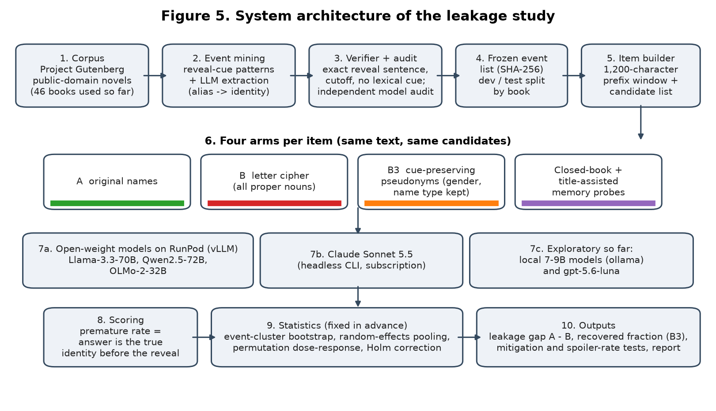
Figure 5. System architecture of the leakage study (ten stages, from corpus to statistics).
Process, stage by stage. (1) Public-domain novels are the corpus. (2) Event mining finds sentences with reveal cues and extracts alias and identity. (3) A deterministic verifier and an independent audit keep only explicit, clean events. (4) The event list, cast lists and the dev/test split by book are frozen and hashed before any model is run. (5) The item builder cuts the 1,200-character prefix window and fixes candidate lists. (6) Each item is shown in four arms with identical windows and candidates; the memory probes run per event. (7) Models answer: local models through ollama, open models through vLLM on a RunPod pod, and one closed model through the Claude CLI. (8) Scoring marks an answer premature if it is the true identity before the reveal. (9) Statistics are fixed in advance: event-cluster bootstrap, random-effects pooling, permutation dose-response, Holm correction. (10) Outputs are the gap, the recovered fraction, the mitigation and spoiler tests, and the report.
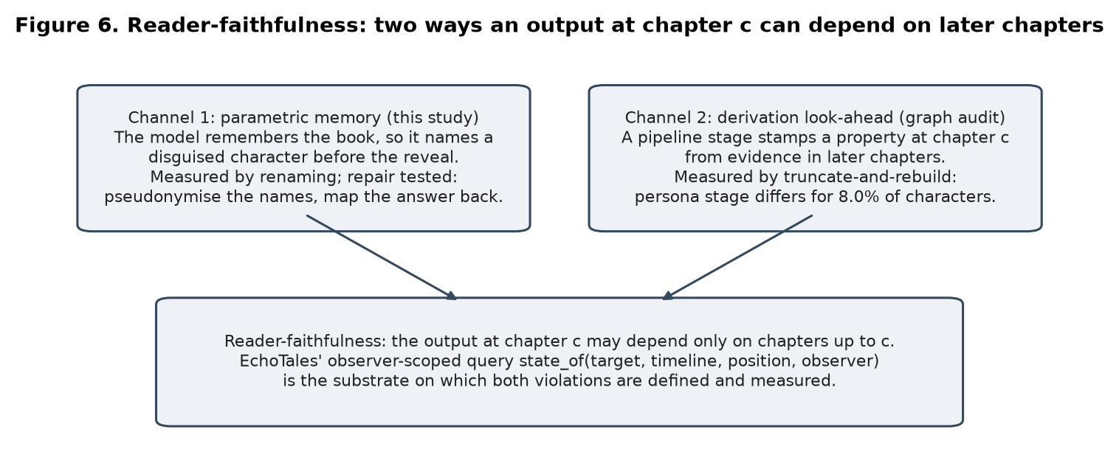
Figure 6. Reader-faithfulness and the two leakage channels measured in this project.
[12] Result Analysis and Discussion
All results below are text-derived (the book's own reveal sentence) unless marked; none is human-annotated. Intervals are 95% event-cluster intervals. The local runs used 7-9B models; the reference model is a commercial API model (total spend about USD 0.43, ledgered).
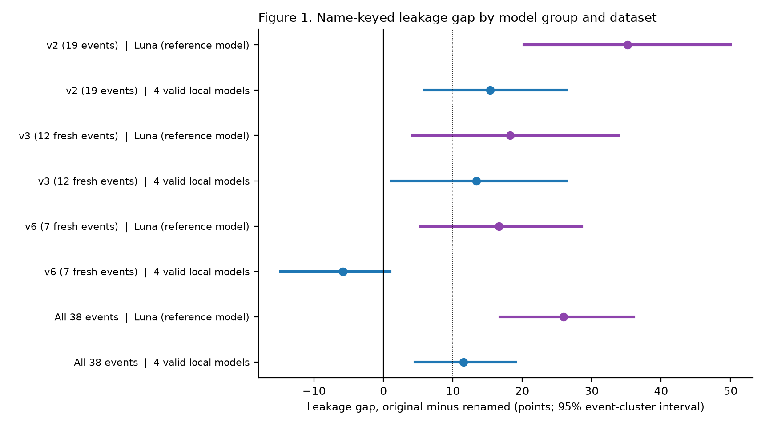
Figure 1. Leakage gap (points) by model group and dataset. The dotted line marks +10 points. The seven-book replication (v6) is positive for the reference model and not for the pooled local models.
Table 7. Leakage gap per model and dataset (points, 95% event-cluster interval).
Model | v2: 19 events | v3: 12 fresh events | v6: 7 fresh events
gpt-5.6-luna (API) | +35.2 [20.2, 50.7] | +18.2 [4.7, 33.9] | +16.7 [5.4, 28.6]
gemma2 9B | +13.0 [1.8, 25.3] | +25.0 [5.2, 47.4] | -12.0 [-29.6, -1.8]
llama3.1 8B | +14.1 [3.2, 27.3] | +14.6 [4.2, 27.1] | -15.7 [-40.7, 4.5]
mistral 7B | +24.1 [12.3, 36.9] | +9.9 [-5.7, 24.0] | +1.8 [-8.0, 13.0]
phi4-mini | +10.4 [1.1, 21.8] | +4.2 [-6.2, 17.2] | -3.7 [-14.4, 4.6]
qwen2.5 7B | +22.2 [9.4, 35.8] | +9.9 [-4.2, 25.0] | +0.0 [-16.1, 14.3]

Reading Figure 1 and Table 7. The reference model's gap is positive in all three datasets (+26.0 points over all 38 events, 22 events positive against 1 negative, sign test p = 1e-05). The four valid local models together give +11.5 [4.5, 19.0] over 38 events (sign test p = 0.05), but on the seven least-known books (v6) their pooled gap is -5.9 [-14.8, 1.0]: the pre-registered replication failed for the small models and held for the reference model. Section 12 therefore supports a narrower claim than 'models leak': the strongest model leaks clearly, and small models leak where they know the book.
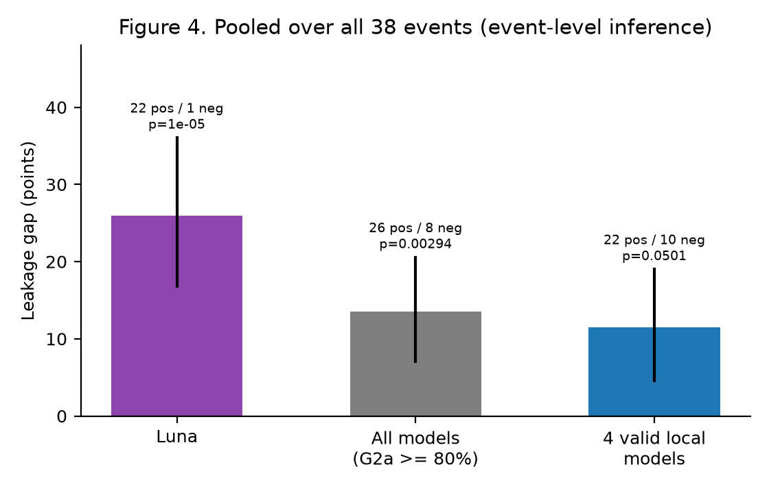
Figure 4. Pooled over all 38 events with event-level inference.
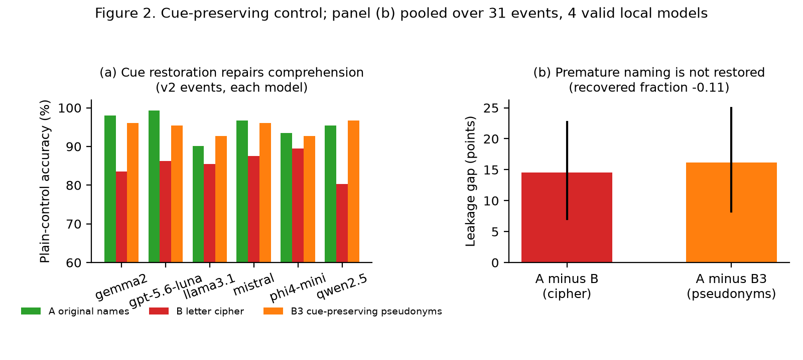
Figure 2. (a) Plain-control accuracy under original names (A), the letter cipher (B) and cue-preserving pseudonyms (B3); (b) leakage gap against the cipher and against pseudonyms.
Table 8. Cue-preserving control on the 19 v2 events (controls and gaps).
Model | Control accuracy % (A / B / B3) | Gap A minus B | Gap A minus B3 [95%]
gemma2 9B | 98.0 / 83.5 / 96.0 | +13.0 | +17.0 [5.8, 30.5]
qwen2.5 7B | 95.4 / 80.3 / 96.7 | +22.2 | +23.0 [7.6, 39.4]
mistral 7B | 96.7 / 87.5 / 96.0 | +24.1 | +19.3 [3.0, 36.1]
llama3.1 8B | 90.1 / 85.5 / 92.8 | +14.1 | +14.1 [2.8, 28.2]
phi4-mini | 93.4 / 89.5 / 92.8 | +10.4 | +11.8 [2.6, 24.1]
gpt-5.6-luna (API) | 99.3 / 86.2 / 95.4 | +35.2 | +35.6 [21.3, 50.4]

Reading Figure 2 and Table 8. Replacing names with a letter cipher lowers control accuracy by 5 to 15 points, so name-borne cues matter for reading. Natural pseudonyms bring accuracy back to the original level, yet the premature-naming gap does not shrink: pooled over 31 events it is +14.6 [7.0, 22.7] with the cipher and +16.1 [8.2, 25.0] with pseudonyms (recovered fraction -0.11, interval [-35.6, 6.1]; the pre-registered 'memory survives' line was 1/3). What original names carry that pseudonyms do not is the specific name, which is what memory is keyed on.
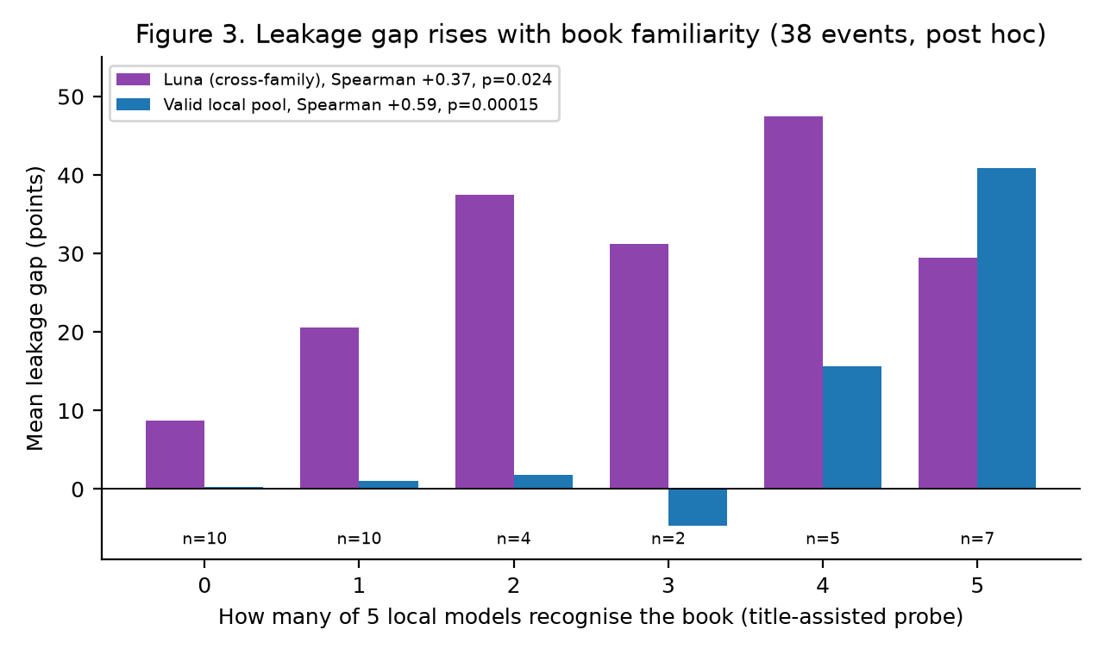
Figure 3. Mean leakage gap by how many local models recognise the book (38 events; post hoc).
Reading Figure 3. For the four valid local models the gap is about zero on books that at most two of the five recognise and large (+40.9 points) on books all five recognise (Spearman +0.59, permutation p = 0.00015); this explains the failed replication, because the seven new books are poorly recognised. The cross-family check, the reference model's gap against the local models' recognition, is weaker but positive (Spearman +0.37, p = 0.024). Caveats: post hoc; the local-model correlation shares models with its predictor; cell sizes are small.
Graph audit and error corrections
Table 9. Graph audit and corrections.
Check | Result | Provenance
Resolver prefix-causality (truncate-and-rebuild, 14 cuts, 3 serials) | 0 of 28,165 mention-cut pairs differ (ids stable); the by-design whole-volume passes do break it (up to 39% of early mentions in one serial) | System-internal, no labels (eng_probe_E1_*.json and ENGINEERING_NOVELTY_PROBE/SUMMARY.md)
Persona stage prefix-causality (288 character-cuts) | 23 differ (8.0%); gender is set from later pronoun evidence and body splits come from a whole-volume rule | System-internal, no labels (ENGINEERING_NOVELTY_PROBE/SUMMARY.md)
Resolver versus plain string clustering | Adjusted Rand index 0.971 to 0.985 against surface-string clustering | System-internal; precision not measured
Statistical error found | Item-level bootstrap treated items of one event as independent; intervals widened after switching to event resampling (e.g. v3 alone: lower bound 1.3 points) | Corrected in the analysis

Run times (measured)
Table 10. Wall-clock times from the run logs.
Run | Calls | Local 7-9B models (minutes per model) | Reference API model
PD v2, three arms plus probes | 1,132 | 9 to 16 (qwen 11.5, llama 10.9, mistral 9.0, phi4 9.5, gemma2 16.1) | about 20 min; USD 0.12
PD v3 | 808 | 6 to 11 (llama 7.2, mistral 5.8, phi4 6.0, gemma2 10.6) | USD 0.085
PD v5, cue-preserving arm | 533 | 4 to 9 (mistral 4.3, phi4 4.9, qwen 6.5, llama 6.6, gemma2 9.0) | 9.3 min; USD 0.059
PD v6 | 538 | 4 to 9 (qwen 6.0, llama 6.0, mistral 4.2, phi4 5.6, gemma2 8.7) | 9.4 min; USD 0.057
PD v7 (local only) | 525 | 4 to 7 (qwen 4.9, llama 5.0, mistral 4.1, phi4 4.6, gemma2 7.0) | cancelled
Live probe in the demo (three arms, one item) | 3 | a few seconds on an 8 GB GPU (measured in the demo, section 14) | -

Confirmatory run (pre-registered, 68 events from 65 books)
Events were mined by one open model with frozen cue rules, verified by exact text search and audited by a second open model; 53 events are in the test split and the primary set is the 32 test events the audit marked explicit (25 low-fame, 6 mid-fame, 1 high-fame books). Three open models were served on one rented L40S GPU at temperature 0; each answered 2,220 questions. A Claude Sonnet 5.5 arm was started and stopped by the subscription limit after 211 of 1,218 answers; it is excluded from every pooled result. Fame is the Wikidata sitelink count of the book. Provenance: text-derived oracle, model-selected and model-audited events, no human labels.
Table 10a. Confirmatory leakage gap per model (points, primary set).
Model | Events | Gap A minus B [95%] | Gap A minus B3 | Events +/-
Mistral-Small-3.2-24B | 32 | +4.4 [-2.3, 12.0] | +9.9 | 4 / 2
OLMo-2-32B | 32 | +0.0 [-4.4, 4.9] | +5.5 | 2 / 3
Qwen2.5-32B | 32 | -0.8 [-4.7, 2.3] | +3.4 | 1 / 1

Table 10b. Confirmatory tests.
Pre-registered test | Estimate | One-sided p | Verdict
P1 (primary): gap of high- and mid-fame minus low-fame events | +7.6 [-1.4, 18.3]; 7 against 25 events | 0.0595 | not passed; smallest detectable difference 12.8 points
H1: pooled gap original minus renamed | +0.1 [-5.0, 5.2] | 0.468 | not passed
H2: pooled gap original minus pseudonyms | +5.7 [-1.3, 12.6] | 0.036 | not passed
H3: fame against gap (Spearman) | +0.30 (32 events, 31 books) | 0.041 raw, 0.145 Holm | raw rule met, not confirmed after correction
H5: pseudonymisation as a mitigation | premature naming 5.0% to 2.6%; accuracy after the reveal -6.7, on controls -15.6 points | 0.037 | not met (accuracy cost above the 5-point margin)

Reading Tables 10a and 10b. On a sample where 78% of events come from low-fame books the three open models show no gap that original names add, and the closed-book control recovers the hidden identity in only 2 of 68 events, so these books hold little memory to detect. That fits the familiarity dose-response above and does not contradict it. The fame contrast points the expected way but could only detect a difference of about 13 points, so it is inconclusive. The recap-spoiler check found no spoiler in 144 outputs per condition (a floor under a narrow detector, not evidence of safety). The unseen-story control (17 model-written stories) gave gaps near zero for all three models. A check of the OLMo-2 training-data index for 62 books found no link between a book being present and its gap (Spearman +0.13, p = 0.41).
Confirmatory run: cost and time
The three-model run used one rented L40S GPU (USD 1.13 per hour all-in). One 2,220-question pass took about 5 to 8 minutes per model after loading; the whole run, including the book mining and audit, ran from 15:40 to 19:10 IST on 16 Oct. 2026 for an estimated USD 3.9 (an estimate from uptime, not the billing page).
Second system: whole-volume character cards, found and fixed (pre-registered RF-E2E)
The common design for a position-aware reading assistant asks a language model to write a character card from passages that mention the character, builds it once over the whole book and shows it from the character's first appearance. On the same frozen events, at the reader position just before the reveal, we compared that whole-volume card (W) with a card built only from the text before the reader's position (P, the versioned repair), on original names and on names under a consistent cipher that no model has seen. Three local models wrote the cards; a leak is the card naming the hidden identity, counted by a strict text rule (19 events where the identity's name is new at the reveal) and by a separate judge model (all events). Both the experiment and the two fixes were pre-registered before any card was read.
Table 10c. Leak of the hidden identity before the reveal: whole-volume card (W) against the versioned, prefix-built card (P).
Model (rule, events) | W orig % | W renamed % | P orig % | P renamed % | Input leak W-P renamed [95%]
Llama-3.1-8B (text rule, 19 events) | 36.8 | 31.6 | 0.0 | 0.0 | +31.6 [10.5, 52.6]
Mistral-7B (text rule, 19 events) | 31.6 | 21.1 | 0.0 | 0.0 | +21.1 [5.3, 42.1]
Qwen2.5-7B (text rule, 19 events) | 26.3 | 21.1 | 0.0 | 0.0 | +21.1 [5.3, 42.1]
Pooled 7-8B (text rule) | 31.6 | 24.6 | 0.0 | 0.0 | +24.6 [8.8, 42.1]
Llama-3.1-8B (judge rule, 54 events) | 27.8 | 27.8 | 3.7 | 3.7 | +24.1 [11.1, 37.0]
Mistral-7B (judge rule, 54 events) | 13.0 | 11.1 | 5.6 | 0.0 | +11.1 [3.7, 20.4]
Qwen2.5-7B (judge rule, 54 events) | 16.7 | 16.7 | 1.9 | 0.0 | +16.7 [7.4, 27.8]
Pooled 7-8B (judge rule) | 19.1 | 18.5 | 3.7 | 1.2 | +17.3 [9.3, 26.5]
Mistral-Small-24B (text rule, 19 events) | 26.3 | 26.3 | 0.0 | 0.0 | +26.3 [5.3, 47.4]
Qwen2.5-32B (text rule, 19 events) | 15.8 | 15.8 | 0.0 | 0.0 | +15.8 [0.0, 31.6]
Pooled 24-32B (text rule) | 21.1 | 21.1 | 0.0 | 0.0 | +21.1 [5.3, 39.5]
Mistral-Small-24B (judge rule, 54 events) | 27.8 | 31.5 | 1.9 | 3.7 | +27.8 [16.7, 40.7]
Qwen2.5-32B (judge rule, 54 events) | 14.8 | 14.8 | 1.9 | 0.0 | +14.8 [5.6, 24.1]
Pooled 24-32B (judge rule) | 21.3 | 23.1 | 1.9 | 1.9 | +21.3 [13.0, 30.6]

Reading Table 10c. The whole-volume card names the hidden identity early in 18.5% of events by the judge rule and 24.6% by the strict text rule, on names no model has seen, so the leak comes from the build and not from memory; the pre-registered input-channel test is supported on the strict rule and supported on the judge rule. The versioned card leaks in 1.2% (renamed) and 3.7% (original names), and it costs one extra card build per reader position with cards of similar length. The memory-only leak (prefix card, original minus renamed names) is +2.5 points for these 7-8B models. Pseudonymising the passages and mapping names back changed the prefix card's leak from 3.7% to 3.1%. On the larger 24-32B models the whole-volume card leaked in 23.1% of events on cipher names against 1.9% for the versioned card, with a memory-only leak of +0.0 points. Robustness (pre-registered after an external review): with an explicit 'avoid spoilers' instruction the whole-book card still leaked in 14.8% of events against 0.0% for the versioned card, so prompting does not replace versioning; with a second, independent cipher the input leak was +5.6 points [-5.6, 18.5].
Discussion
The evidence supports a measured, qualified claim: name-keyed memory leakage is clear for the strongest model tested, is not explained by lost name cues, rises with book familiarity, and is weak or absent for small models on books they do not know. It does not show that EchoTales or any web-serial resolver leaks, and it does not use human labels. The main weaknesses are stated openly: events are model-selected, the memory probes give the book title, the pseudonyms are heuristic, the pooled interval for local models sits at the edge of significance, and the replication failed for small models.

[13] Comparative Analysis
Table 11. Comparison with related work. Numbers are not directly comparable: tasks, corpora and models differ.
Work | Task and control | Reveal time? | Memory vs lost cues? | Their headline number | Ours (same direction)
Chang et al. [1] | Name cloze on 571 works (recall) | No | No | Memorisation correlates with web hits (Spearman 0.74, pre-1928 books) | Familiarity correlates with leakage gap: +0.37 (cross-family), +0.59 (local pool)
Jiang and Ferraro [2] | Six character tasks; renamed characters | No | No (gender-preserving variant, no decomposition) | Up to 45.2% accuracy drop | Premature-naming gap +26.0 points (reference model)
Ahn et al. [3] TimeChara | Role-play at a story time | Yes (timeline) | No | State-of-the-art models hallucinate future facts | Leakage tied to memory by renaming
Deußer et al. [4] | Pseudonymise, map back; 11 benchmarks | No | No | Pseudonymisation least harmful | Pseudonymisation halved premature naming (5.0% to 2.6%) at an accuracy cost of 7 to 16 points
Gu et al. [7] SynthWorlds | Real versus synthetic worlds | No | No | Knowledge-advantage gap | Real-minus-synthetic difference-in-differences +6.5 [-1.6, 14.5] (does not exclude 0)
KoCoNovel [10] | Reader and omniscient labels | Annotated, not tested on models | No | Views differ in 5 of 50 works | Text-derived reveal oracle instead of annotators

What the comparison shows. The direction of our findings matches the closest prior work (renaming lowers performance on famous books; memorisation follows how widely a book circulates), which supports the validity of the measurement. What is added is (i) a reveal-time task with a text-derived oracle, (ii) a test that separates memory from lost name cues, (iii) a validity check that does not rely on original names, (iv) event-level inference and a reported failed replication, and (v) a reader-faithfulness audit of a graph pipeline. We did not re-run any of these systems; the comparison is of design and reported numbers, not of a shared benchmark.
[14] User Manual
Command line (reproducing the reported numbers from stored results; no GPU needed).
- source .venv/bin/activate then python scripts/chimera/pd_final_pooled.py, python scripts/chimera/pd_dose_response.py, python scripts/chimera/pd_v5_cuepres.py analyze: recompute Tables 7 and 8 and Figures 1 to 4 from the stored run files in data/eval/chimera/.
- data/scratch/docs_venv/bin/python scripts/chimera/make_project_figures.py regenerates the figures; build_project_doc.py regenerates this document.
- python -m pytest packages/core/tests packages/pipeline/tests runs the 1,377 tests.
Research view of the review interface (demonstration). Start the interface as described in docs/paper/project_doc/FRONTEND_RESEARCH_VIEW.md and open the Research page. It has (1) headline cards, (2) the gap by model and dataset, (3) the cue-preserving panel, (4) the familiarity dose-response and (5) a live probe that runs one public-domain item under original names, the letter cipher and pseudonyms on a local model and shows the three answers with timings.
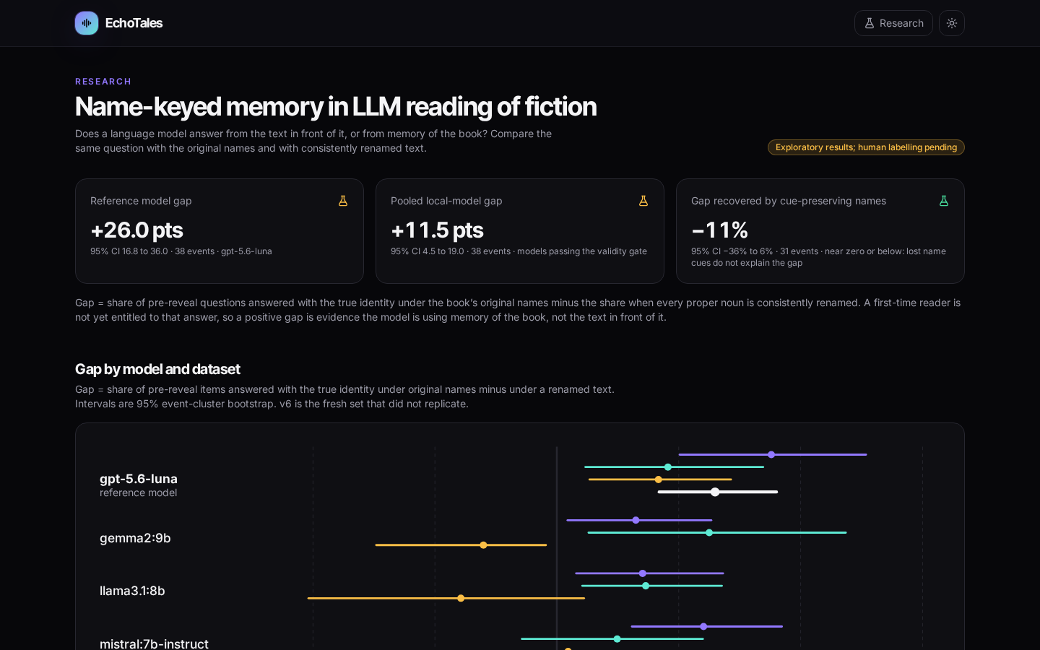
Figure 7. Research page: overview cards.
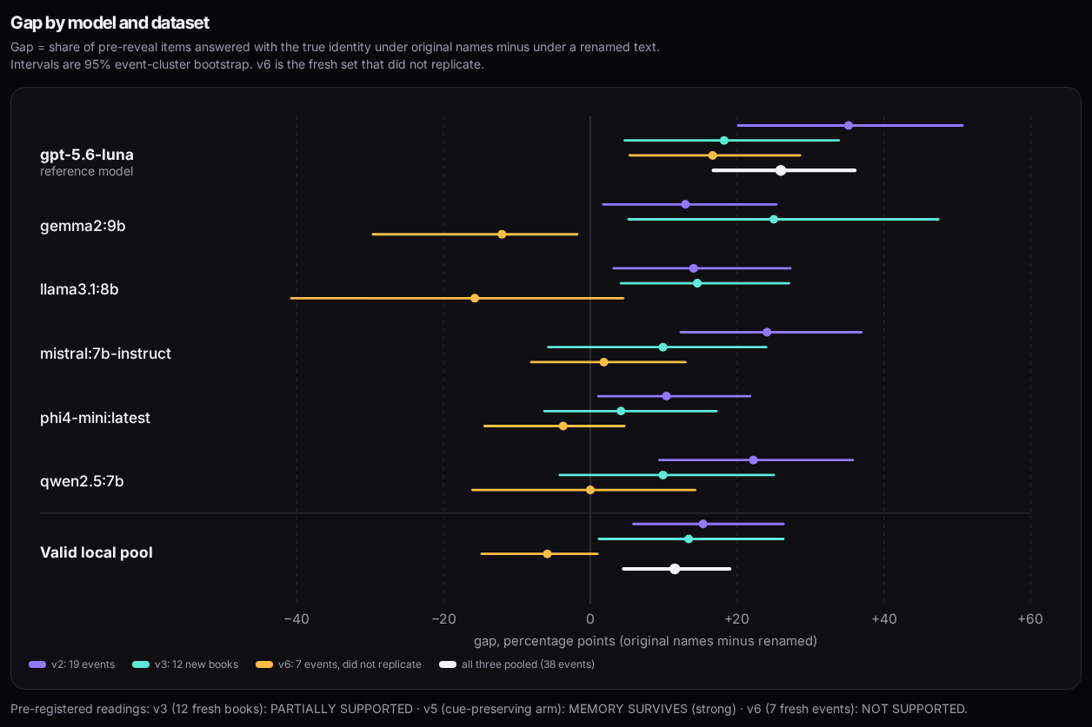
Figure 8. Gap by model and dataset.
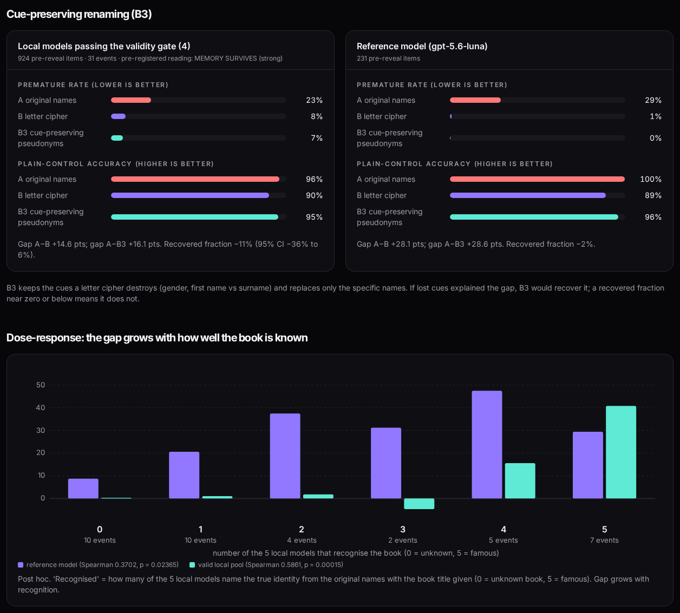
Figure 9. Cue-preserving panel and dose-response.
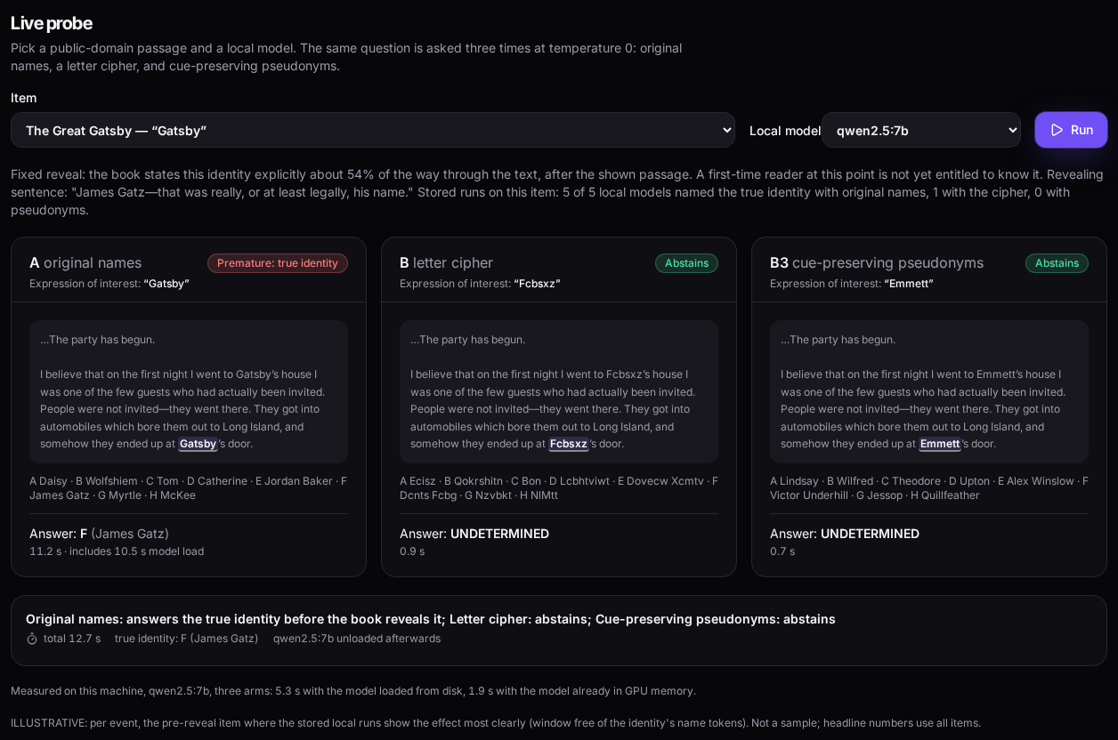
Figure 10. Live probe result with per-arm timings.
[15] References
[1] Chang, Kent K., Mackenzie Cramer, Sandeep Soni, and David Bamman. "Speak, Memory: An Archaeology of Books Known to ChatGPT/GPT-4." Proceedings of the 2023 Conference on Empirical Methods in Natural Language Processing, Association for Computational Linguistics, 2023. arXiv:2305.00118.
[2] Jiang, Yuxuan, and Francis Ferraro. "Beyond Math: Stories as a Testbed for Memorization-Constrained Reasoning in LLMs." arXiv:2412.14368 v6, 24 Apr. 2026.
[3] Ahn, Jaewoo, et al. "TimeChara: Evaluating Point-in-Time Character Hallucination of Role-Playing Large Language Models." Findings of the Association for Computational Linguistics: ACL 2024, 2024. arXiv:2405.18027.
[4] Deußer, Tobias, Max Hahnbück, Lorenz Sparrenberg, Tobias Uelwer, Christian Bauckhage, and Rafet Sifa. "On the Impact of Anonymization on the Performance of Large Language Models." arXiv:2609.11335 v2, Sep. 2026.
[5] Fu, Tairan, Javier Conde, Pedro Reviriego, Javier Coronado-Blázquez, Nina Melero, and Elena Merino-Gómez. "Large Language Models and Book Summarization: Reading or Remembering, Which Is Better?" arXiv:2603.09981, Feb. 2026.
[6] Ma, Yingpeng, Jianhao Yan, Bei Shi, Ka Hou Kam, Runnan Wang, Xuebo Liu, Yulong Chen, Yue Zhang, and Derek F. Wong. "Can LLM Agents Stick to the Script? A Benchmark for Long-Horizon Consistency in Interactive Narratives." arXiv:2608.08160, Aug. 2026.
[7] Gu, Ken, et al. "SynthWorlds: Controlled Parallel Worlds for Disentangling Reasoning and Knowledge in Language Models." International Conference on Learning Representations (ICLR), 2026. arXiv:2510.24427.
[8] Zhu, et al. "LlmLink: Dual LLMs for Dynamic Entity Linking on Long Narratives with Collaborative Memorisation and Prompt Optimisation." Proceedings of COLING 2025, 2025.
[9] Martinelli, Giuliano, et al. "BOOKCOREF: Coreference Resolution at Book Scale." Proceedings of the 63rd Annual Meeting of the Association for Computational Linguistics, 2025. arXiv:2507.12075.
[10] Kim, Kyuhee, Surin Lee, and Sangah Lee. "KoCoNovel: Annotated Dataset of Character Coreference in Korean Novels." Proceedings of LREC-COLING 2024, 2024. arXiv:2404.01140.
[11] Bamman, David, Olivia Lewke, and Anya Mansoor. "An Annotated Dataset of Coreference in English Literature." Proceedings of the 12th Language Resources and Evaluation Conference (LREC), 2020.
[12] Zhao, Hanjie, Yuchen Yan, et al. "GenWebNovel: A Genre-oriented Corpus of Entities in Chinese Web Novels." Proceedings of the 31st International Conference on Computational Linguistics (COLING 2025), 2025, pp. 3836-3849.
[13] Song, Li, and Ying Liu. "Approaches and Challenges for Resolving Different Representations of Fictional Characters for Chinese Novels." Proceedings of LREC-COLING 2024, 2024, pp. 1408-1421.
[14] Saifullah, Mohammad, Thomas Kornmaier, Taaha Kazi, Vasu Sharma, Aditya Sanjiv Kanade, and Aanand Kumar Yadav. "Narrative World Model: Narratology-Grounded Writer Memory for Long-Form Fiction." arXiv:2607.05577, Jul. 2026.
[15] Tian, Qiuyu, Xiaowen Gu, Hang Su, et al. "Shared Worlds, Private Minds: Structured Memory for Long-Form Writing as World Creation." arXiv:2609.32401, Sep. 2026.
[16] Zhang, Ze Yu, Zitao Li, Yaliang Li, Bolin Ding, and Bryan Kian Hsiang Low. "Respecting Temporal-Causal Consistency: Entity-Event Knowledge Graphs for Retrieval-Augmented Generation." arXiv:2506.05939, 2025.
[17] Efron, Bradley, and Robert J. Tibshirani. An Introduction to the Bootstrap. Chapman and Hall, 1993.
[18] Dror, Rotem, et al. "The Hitchhiker's Guide to Testing Statistical Significance in Natural Language Processing." Proceedings of the 56th Annual Meeting of the Association for Computational Linguistics, 2018.
[19] Holm, Sture. "A Simple Sequentially Rejective Multiple Test Procedure." Scandinavian Journal of Statistics, vol. 6, no. 2, 1979, pp. 65-70.
[20] DerSimonian, Rebecca, and Nan Laird. "Meta-Analysis in Clinical Trials." Controlled Clinical Trials, vol. 7, no. 3, 1986, pp. 177-188.
[21] Hartung, Joachim, and Guido Knapp. "On Tests of the Overall Treatment Effect in Meta-Analysis with Normally Distributed Responses." Statistics in Medicine, vol. 20, no. 12, 2001, pp. 1771-1782.
[22] Wilson, Edwin B. "Probable Inference, the Law of Succession, and Statistical Inference." Journal of the American Statistical Association, vol. 22, no. 158, 1927, pp. 209-212.
[23] Nosek, Brian A., et al. "The Preregistration Revolution." Proceedings of the National Academy of Sciences, vol. 115, no. 11, 2018, pp. 2600-2606.
[24] Project Gutenberg. Project Gutenberg. gutenberg.org. Accessed 16 Oct. 2026.
[25] Kwon, Woosuk, et al. "Efficient Memory Management for Large Language Model Serving with PagedAttention." Proceedings of the 29th ACM Symposium on Operating Systems Principles (SOSP), 2023.
[26] RunPod. "Pricing." runpod.io/pricing (page dated 8 Oct. 2026). Accessed 16 Oct. 2026.
[27] Hugging Face. Model repositories casperhansen/llama-3.3-70b-instruct-awq, Qwen/Qwen2.5-72B-Instruct-AWQ, allenai/OLMo-2-0325-32B-Instruct. huggingface.co. Accessed 16 Oct. 2026.
[28] Anthropic. Claude Code command-line interface, version 2.1.301 (claude --help, print mode). Accessed 16 Oct. 2026.
Items [1] to [16] are the reviewed articles (2020 onward); [17] to [23] support the statistical and pre-registration methods; [24] to [28] are tools and web resources.
[16] Appendix
a) Presentation (PPT): EchoTales_Research_Presentation.pptx, submitted with this document.
b) Demonstration video: the narration script is in Demo_Video_Script.docx.
c) Source files and steps to execute: the project repository, branch chimera/system-adapters. Steps are in docs/paper/project_doc/RUN_STEPS.md and summarised here:
- Clone, then uv sync (Python 3.12); source .venv/bin/activate.
- Re-download the public-domain texts into data/raw/pd_gutenberg/ (Project Gutenberg ids listed in docs/research/preregistrations/events.json).
- Recompute results from stored runs: python scripts/chimera/pd_final_pooled.py and python scripts/chimera/pd_dose_response.py (seconds, no GPU).
- Re-run a model: python scripts/chimera/pd_v6.py run --texts data/raw/pd_gutenberg_v6 --model qwen2.5:7b (about 6 minutes on an 8 GB GPU with ollama running; this overwrites that model's stored result file, so copy data/eval/chimera/pd_v6 first).
- Start the interface and open the Research page (FRONTEND_RESEARCH_VIEW.md).
Provenance statement. All numbers are text-derived, synthetic or system-internal. No human-annotated result is reported. Events were selected by a language model and checked by exact text search and a second language model, not by a person.

