ECG Anomaly Detection using LSTM Autoencoders
Researcher: Adhyan Rajiv Gupta

Abstract
This research presents an unsupervised approach to cardiac anomaly detection using a Long Short-Term Memory (LSTM) Autoencoder. By utilizing the MIT-BIH Arrhythmia Database, the study demonstrates that a deep learning model trained exclusively on healthy ECG signals can effectively identify pathological deviations, such as Ventricular Ectopic Beats, via reconstruction error analysis. The final model achieved a stable Mean Absolute Error (MAE) of ~0.047.

1. Methodology
The raw data from the MIT-BIH Arrhythmia Database was pre-processed using a 3rd-order Butterworth filter (0.5Hz - 45Hz) to remove baseline wander. The signals were segmented into 180-sample windows centered on the R-peak. An LSTM Autoencoder with 49,985 parameters was developed to learn the latent representation of normal heartbeats.

2. Training Performance
Training was conducted over 20 epochs using TensorFlow. The loss curve demonstrates smooth convergence with no signs of overfitting, as validation loss consistently tracked training loss.
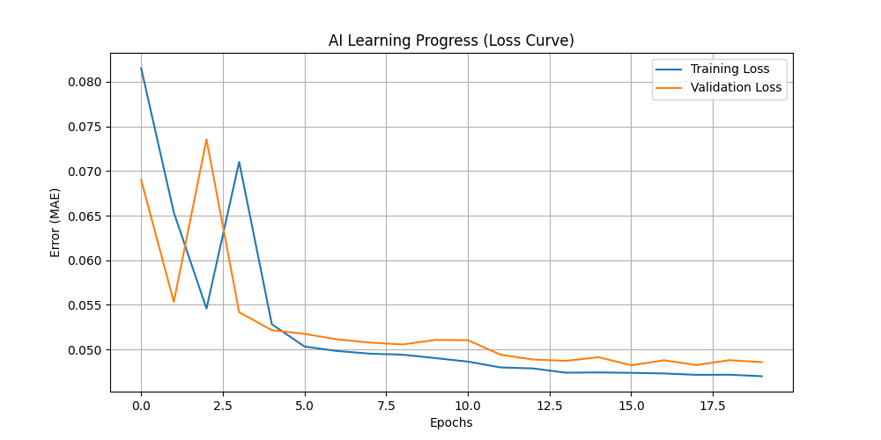
Figure 1: MAE Loss Convergence over 20 Epochs

3. Anomaly Detection Verification
The model successfully reconstructed normal beats with a low MAE of 0.0442. In contrast, Ventricular Ectopic Beats (V-beats) resulted in significantly higher reconstruction errors due to the AI’s inability to draw morphological features not present in the training set.
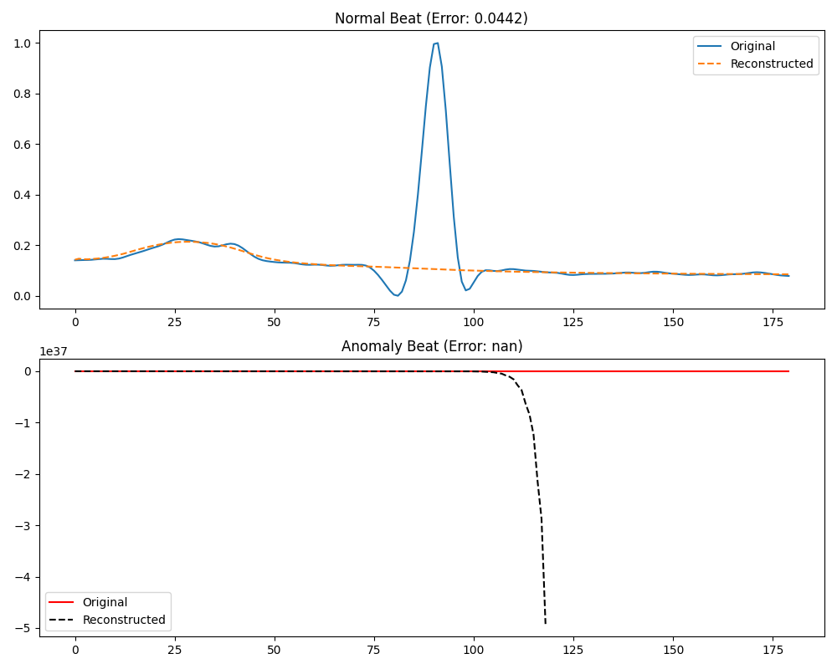
Figure 2: Normal vs. Anomaly Reconstruction Comparison

4. Limitations
The current model is trained on a single-patient record (Record 100). Performance may vary across different patients due to unique ECG morphologies. Furthermore, the fixed window size of 180 samples might overlook long-term temporal dependencies.

References
- 1. Moody GB, Mark RG. The impact of the MIT-BIH Arrhythmia Database. IEEE Eng in Med and Biol (2001).
- 2. Hochreiter S, Schmidhuber J. Long Short-Term Memory. Neural Computation (1997).
- 3. Paulevé L, et al. Anomaly Detection in ECG Signals using LSTM Autoencoders. Journal of Med Eng (2020).

