**Lab 3**

Name- Adhyyan Tripathi

Roll no -8

Sec C

Reg no -201700403

Q) Consider the following Grammar:

S -> cAd

A -> a|b|ab

**ALGORITHM:**

Step 1: Start.

Step 2: Function for start symbol, S()

Step2.1 check if first input symbol corresponds to start production.

Step2.2 if true

Step2.3 match the next symbol

Step2.4 Call function for nonterminal to scan for symbols

Step2.5 else

Error

Step 3: Function for Nonterminal A().

Step3.1Choose an A- production,

A→ X1X2……………Xk

Step3.2 for (i=J to k)

Step3.3 if (Xi is non terminal)

Call procedure Xi();

Step3.4 else if (Xi equal the current input symbol)

Advance the input to next symbol

Step3.5 else

error

Step 4: Stop.

**Screenshot:**

**For valid Strings- cad, cbd, cabd**

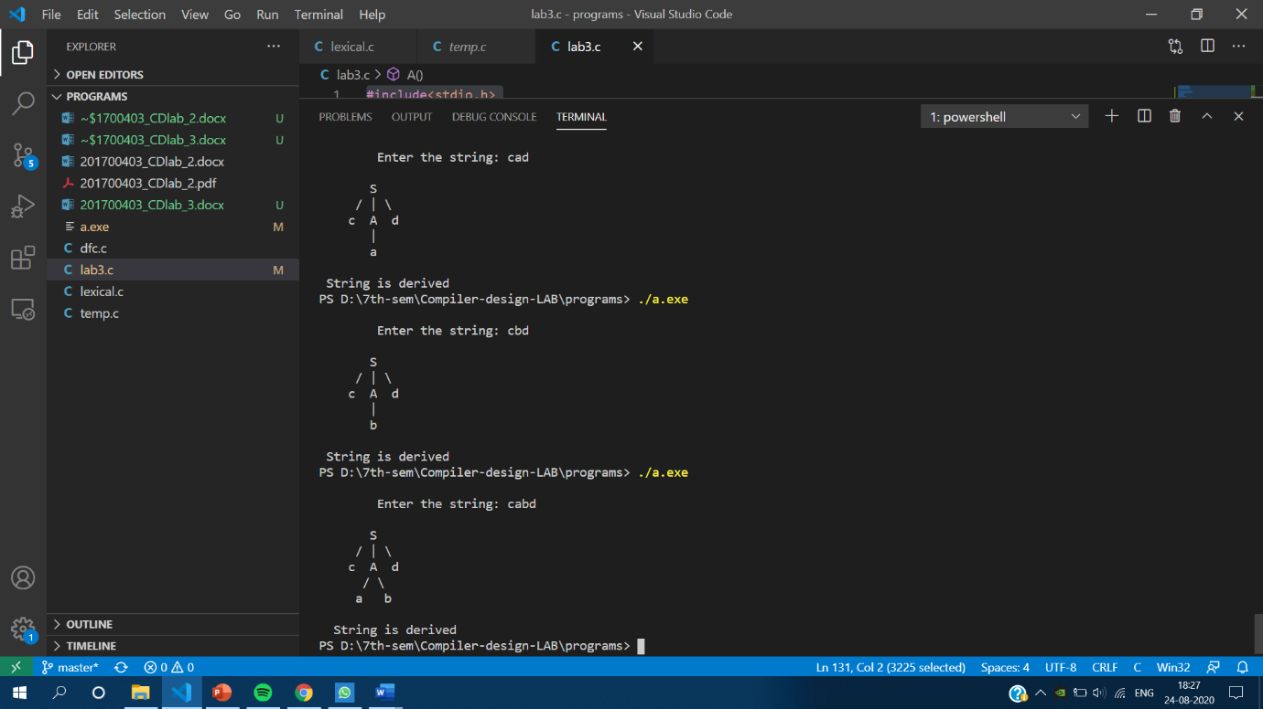

**For invalid Strings-**

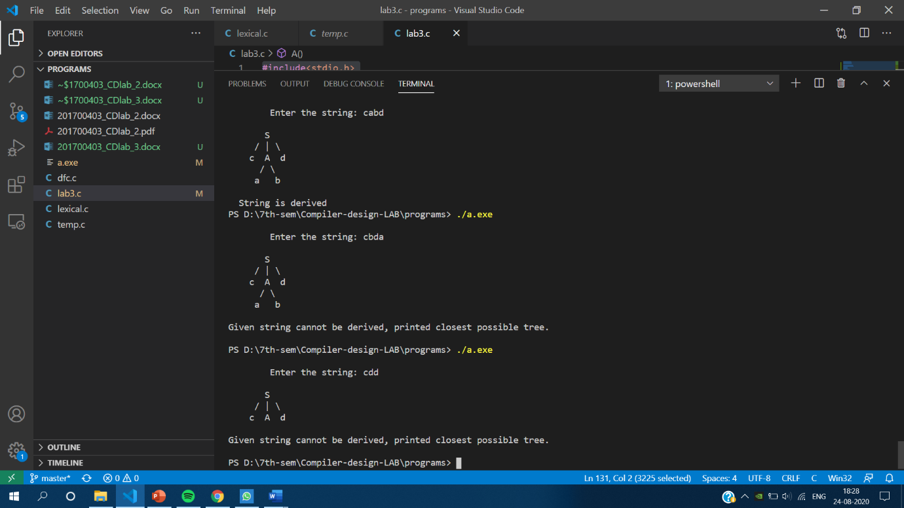

**3. Check for Valid/Invalid string in the input.**

Valid Strings are – 1) cad

2) cbd

3) cabd

Invalid Strings are – All other strings other than the above three.