**Geographic information Systems**

**Assignment No. 2**

**Name- Adhyyan Tripathi**

**Sec/Dept. – C/CSE**

**Reg. no. – 201700403**

1. **What is meant by the ecological fallacy issue in GIS? Give an example.**

**Ans -** An ecological fallacy, often called an ecological inference fallacy, is an error in the interpretation of statistical data in an ecological study, whereby inferences about the nature of specific individuals are based solely upon aggregate statistics collected for the group to which those individuals belong. This fallacy assumes that individual members of a group have the average characteristics of the group at large. Stereotypes are one form of ecological fallacy, which assumes that groups are homogeneous.

Example - If a particular group of people is measured to have a lower average IQ than the general population, it is an error to assume that all or most members of that group have a lower IQ than the general population. For any given individual from that group, there is no way to know if that person has a lower than average IQ, average IQ, or above average IQ compared to the general population.

1. **What are process models? Describe and give an example of each of the three basic types of process models.**

**Ans -** Process models attempt to describe the interaction of the objects that are depicted in the representation model. It simulates real-world processes. There are two reasons for constructing such a model. From a pragmatic point of view’ decisions need to be made and actions taken about spatial phenomena. Models help this process. From a philosophical point of view a process model may be the only way of evaluating our understanding of the complex behaviour of spatial systems. In GIS process models may be used in either role. For example, in the nuclear waste and house-hunting case studies GIS has been used to help the decision-making process. In the Zdarske Vrchy case study GIS was used to aid understanding of complex ecological and environmental processes such as the effects of acid rain on forest ecosystems, and the effects of habitat change on the endangered black grouse.

There are two approaches to process modelling - a priori and a posteriori

Three basic types of process models are –

1. Natural and scale analogue models - A natural analogue model uses actual events or real-world objects as a basis for model construction. These events or objects occur either in different places or at different times.

Example - A natural analogue model to predict the formation of avalanches in the previously unstudied area of a new ski piste might be constructed by observing how avalanches form in an area of similar character. The impact that avalanches would have on the proposed ski piste could also be examined by looking at experiences of ski piste construction in other areas. There are also scale analogue models such as topographic maps and aerial photographs, which are scaled-down and generalized replicas of reality. These are exactly the kind of analogue models that GIS might use to model the avalanche prediction problem.



1. Conceptual models - Conceptual process models are usually expressed in verbal or graphical form, and attempt to describe in words or pictures quantitative and qualitative interactions between real-world features.

Example- The most common conceptual model is a systems diagram, which uses symbols to describe the main components and linkages of the model.

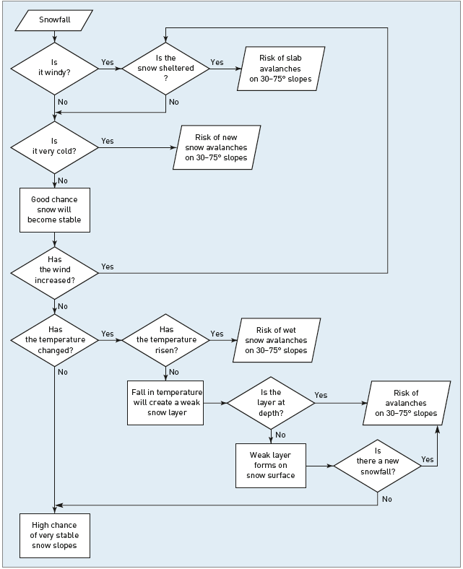

1. Mathematical models- Mathematical process models use a range of techniques including deterministic, stochastic and optimization methods. In deterministic models, there is only one possible answer for a given set of inputs.

Example- A deterministic avalanche prediction model might show a linear relationship between slope angle and size of avalanche. The steeper the slope, the smaller the avalanche which results, since snow build-up on the slope will be less. This model might be created by developing a least-squares regression equation for slope angle against avalanche size.

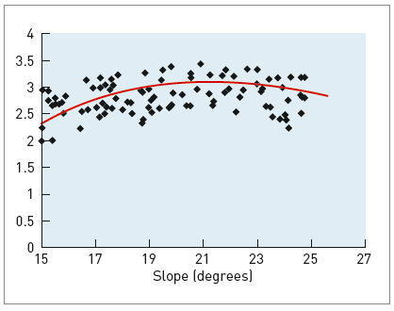

1. **Describe the multi-criteria evaluation (MCE) approach to modelling the decision making process. When have you used the MCE approach in this course?**

**Ans -** MCE techniques allow map layers to be weighted to reflect their relative importance and, unlike any other overlay in vector GIS, they do not rely on threshold values. MCE is a method for combining data according to their importance in making a given decision. At a conceptual level, MCE methods involve qualitative or quantitative weighting, scoring or ranking of criteria to reflect their importance to either a single or a multiple set of objectives. In essence, MCE techniques are numerical algorithms that define the ‘suitability’ of a particular solution on the basis of the input criteria and weights together with some mathematical or logical means of determining trade-offs when conflicts arise.

Implementation of MCE algorithm-

1. Selection of criteria.
2. Standardization of criterion scores.
3. Allocation of weights.
4. Applying the MCE algorithm.

MCE approach can be used in - Proximity to schools calculation, Property insurance calculation and Proximity to main roads.

1. **Discuss four problems with using GIS to model spatial problems.**

**Ans-** Problems with using GIS to model spatial problems are-

1. The quality of source data for model calibration.
2. The availability of real world data for model Validation.
3. The conceptual and technical problems of building multi-dimensional models.
4. The complexity of modelling reality.
5. **Why is map design an important consideration when creating maps using a GIS?**

**Ans -** Map design is an important consideration when creating maps using GIS because, map is still the most elegant and compact method of displaying spatial data. The role of the map is to communicate spatial information to the user. This information may include location, size, shape, pattern, distribution and trends in spatial objects.

**6. Briefly describe the main elements of a map?**

**Ans-** In designing a map so that it best achieves its objectives, it is necessary to consider a number of key map design elements.

These include:

- the frame of reference;

- the projection used;

- the features to be mapped;

- the level of generalization;

- annotation used; and

- symbolism employed.