**Intelligent Systems Lab**

**Lab No- 3**

Name- Adhyyan Tripathi

Roll no -8

Sec C

Reg no – 201700403

**Q1) Data Visualization.**

**Ans-** Data visualization of randomly generated dataset using makeblobs.

**2 centers-**

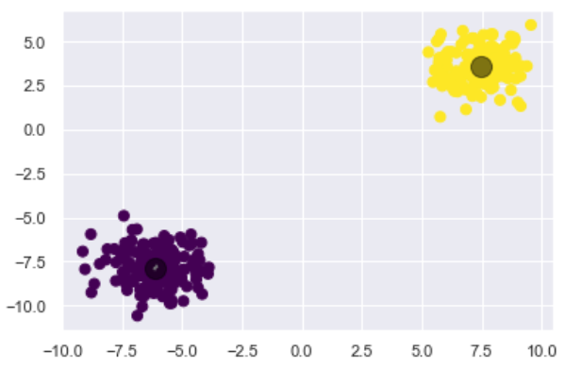

**3 centers-**

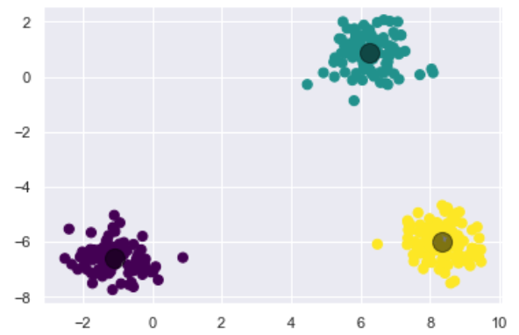

**4 centers-**

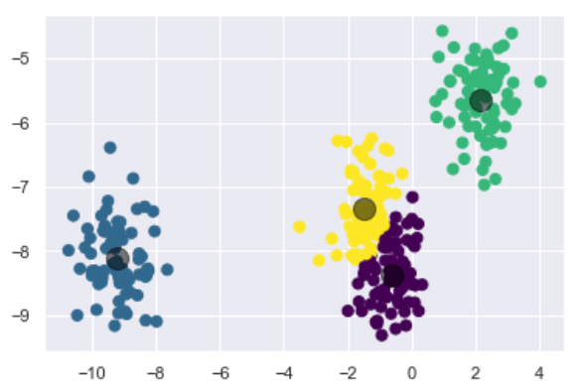

**Q2) Binary classification.**

**Ans-** For binary classification I’m generating random data with 2 clusters.

The hyperparameters that I’ll be changing in this section are- n_init, max_iter and n_clusters.

The data used once for a configuration will remain same for all the other configurations.

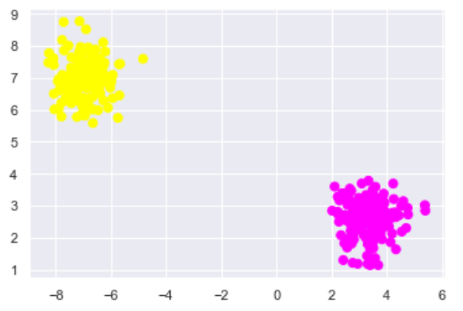

**Changing the n_clusters hyperparameter-**

**For n_clusters=1: For n_clusters=2:**

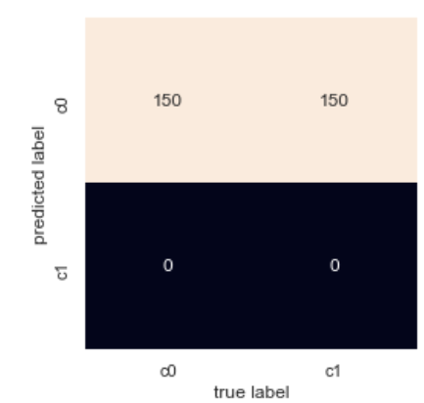 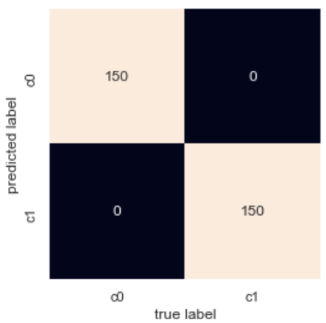

Accuracy = 0.5 Accuracy = 1

**For n_clusters=5: For n_clusters=10:**

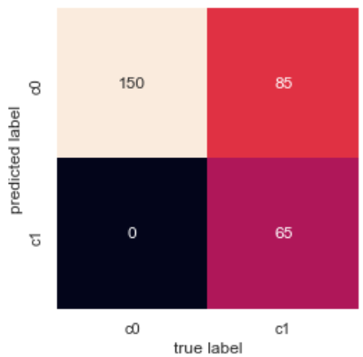 

Accuracy= 0.7166666666666667 Accuracy= 0.6766666666666666

The accuracy increases if the n_clusters value is less than the number of clusters in the dataset. When the value of n_clusters is equal to the number of clusters the accuracy is the maximum. If the n_clusters value is increased further, the accuracy starts to fall.

**Changing the max_iter and n_init hyperparameter-**

For these hyperparameters if we keep n_clusters= 2 then, the is difference is very minimal, so to make these differences clear I’ll be using n_cluster value as 10.

**For n_init=10 and max_iter=100: For n_init=10 and max_iter=100:**

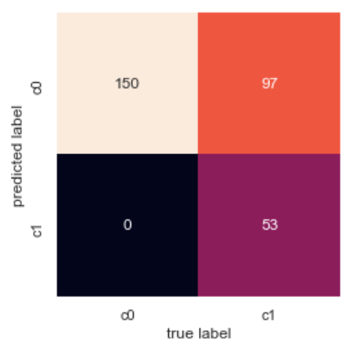

Accuracy= 0.6766666666666666 Accuracy= 0.6766666666666666

**For n_init=10 and max_iter=100: For n_init=10 and max_iter=100:**

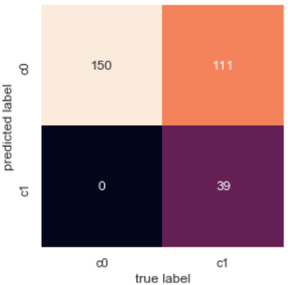 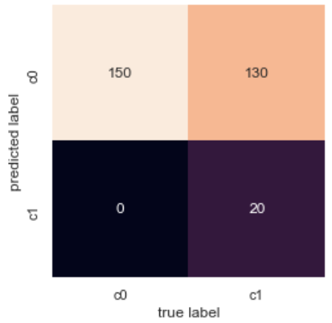

Accuracy= 0.63 Accuracy= 0.5666666666666667

The accuracy decreases as we increase either of the parameter n_init and max_iter.

**Q.3) Multiclass classification.**

**Ans-** In this section we are using handwritten digits data, to train the model.

**Q .3.1) Do they actually correspond to the digits 0–9?**

**Ans-** Yes, they correspond to the digits 0-9 except for the digit 8. The digit 8 does not looks like it should.

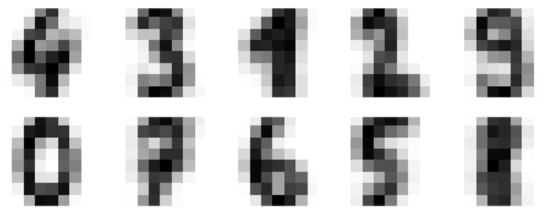

**Q.3.2) If you label each cluster with the digit that occurs most frequently**

**within it, then what is your classification accuracy with this unsupervised method?**

**Ans-** The accuracy of the model is 0.7952142459654981.

The accuracy for all the “digits” are-

Digit 0- 0.99438202247

Digit 1- 0.3021978021

Digit 2- 0.8505747126

Digit 3- 0.8516483516

Digit 4- 0.90055248618

Digit 5- 0.747252747252

Digit 6 - 0.9725274725

Digit 7 - 0.9725274725

Digit 8 - 0.5604395604

Digit 9 - 0.763736263736

**Q.3.3) What kinds of misclassifications are happening, and why?**

**Ans –** If we look for digit 1 and 8 in the confusion matrix, the model misclassifies the digit 1 as digit 8.

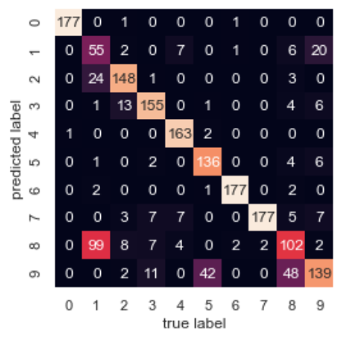

It happens so, because k-means does not work for non-spherical data. Some non-spherical data are –

K-means classifies this as

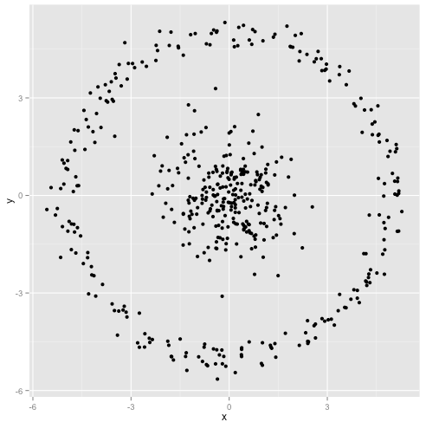 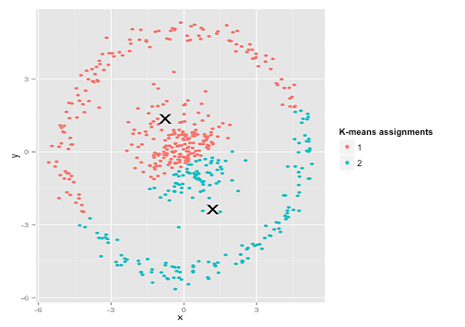

**Classifying the same digit dataset with k=5**



Other than digit 0 (1st cluster) no other cluster clearly represent any digit.

The confusion matrix for k=5 –

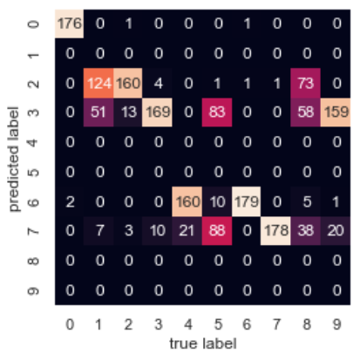

We get this result because the model is trying to group all the 10 classes into 5 classes. For example, digit 5 is predicted as digit 3 and digit 7. So, this result does not make any sense.