**Case Study:**

**How Does a Bike-Share Navigate Speedy Success?**

**Introduction**

Welcome to the Cyclistic bike-share analysis case study! In this case study, you will perform many real-world tasks of a junior data analyst. You will work for a fictional company, Cyclistic, and meet different characters and team members. In order to answer the key business questions, you will follow the steps of the data analysis process: ask, prepare, process, analyze, share, and act.

Along the way, the Case Study Roadmap tables — including guiding questions and key tasks — will help you stay on the right path. By the end of this lesson, you will have a portfolio-ready case study.

Download the packet and reference the details of this case study anytime.

**Scenario**

You are a junior data analyst working in the marketing analyst team at Cyclistic, a bike-share company in Chicago. The director of marketing believes the company’s future success depends on maximizing the number of annual memberships. Therefore, your team wants to understand how casual riders and annual members use Cyclistic bikes differently. From these insights, your team will design a new marketing strategy to convert casual riders into annual members. But first, Cyclistic executives must approve your recommendations, so they must be backed up with compelling data insights and professional data visualizations.

**Characters and teams**

* **Cyclistic:** A bike-share program that features more than 5,800 bicycles and 600 docking stations. Cyclistic sets itself apart by also offering reclining bikes, hand tricycles, and cargo bikes, making bike-share more inclusive to people with disabilities and riders who can’t use a standard two-wheeled bike. The majority of riders opt for traditional bikes; about 8% of riders use the assistive options. Cyclistic users are more likely to ride for leisure, but about 30% use them to commute to work each day.
* **Lily Moreno:** The director of marketing and your manager. Moreno is responsible for the development of campaigns and initiatives to promote the bike-share program. These may include email, social media, and other channels.
* **Cyclistic marketing analytics team:** A team of data analysts who are responsible for collecting, analyzing, and reporting data that helps guide Cyclistic marketing strategy. You joined this team six months ago and have been busy learning about Cyclistic’s mission and business goals — as well as how you, as a junior data analyst, can help Cyclistic achieve them.
* **Cyclistic executive team:** The notoriously detail-oriented executive team will decide whether to approve the recommended marketing program.

**About the company**

In 2016, Cyclistic launched a successful bike-share offering. Since then, the program has grown to a fleet of 5,824 bicycles that are geotracked and locked into a network of 692 stations across Chicago. The bikes can be unlocked from one station and returned to any other station in the system anytime. Until now, Cyclistic’s marketing strategy relied on building general awareness and appealing to broad consumer segments. One approach that helped make these things possible was the flexibility of its pricing plans: single-ride passes, full-day passes, and annual memberships. Customers who purchase single-ride or full-day passes are referred to as casual riders. Customers who purchase annual memberships are Cyclistic members. Cyclistic’s finance analysts have concluded that annual members are much more profitable than casual riders. Although the pricing flexibility helps Cyclistic attract more customers, Moreno believes that maximizing the number of annual members will be key to future growth. Rather than creating a marketing campaign that targets all-new customers, Moreno believes there is a very good chance to convert casual riders into members. She notes that casual riders are already aware of the Cyclistic program and have chosen Cyclistic for their mobility needs.

Moreno has set a clear goal: Design marketing strategies aimed at converting casual riders into annual members. In order to do that, however, the marketing analyst team needs to better understand how annual members and casual riders differ, why casual riders would buy a membership, and how digital media could affect their marketing tactics. Moreno and her team are interested in analyzing the Cyclistic historical bike trip data to identify trends.

**Ask**

Three questions will guide the future marketing program: 1. How do annual members and casual riders use Cyclistic bikes differently? 2. Why would casual riders buy Cyclistic annual memberships? 3. How can Cyclistic use digital media to influence casual riders to become members? Moreno has assigned you the first question to answer: How do annual members and casual riders use Cyclistic bikes differently? You will produce a report with the following deliverables:

1. A clear statement of the business task
2. A description of all data sources used
3. Documentation of any cleaning or manipulation of data
4. A summary of your analysis
5. Supporting visualizations and key findings
6. Your top three recommendations based on your analysis

Use the following Case Study Roadmap as a guide.

Note: Completing this case study within a week is a good goal.

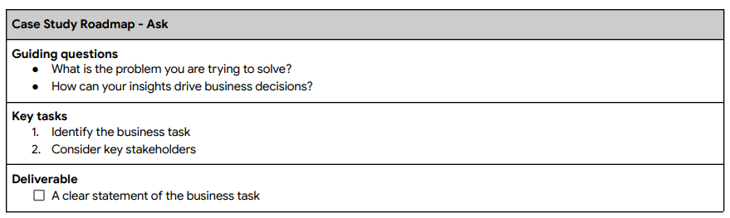

**Prepare**

You will use Cyclistic’s historical trip data to analyze and identify trends.

Download the Cycistic Trip Data here: <https://divvy-tripdata.s3.amazonaws.com/index.html> . (Note: The datasets have a different name because Cyclistic is a fictional company. For the purposes of this case study, the datasets are appropriate and will enable you to answer the business questions. The data has been made available by Motivate International Inc. under this <https://www.divvybikes.com/data-license-agreement>)

You will use Cyclistic’s historical trip data to analyze and identify trends.

(Note: The datasets have a different name because Cyclistic is a fictional company. For the purposes of this case study, the datasets are appropriate and will enable you to answer the business questions. The data has been made available by Motivate International Inc. under this license.) You can choose to work with an entire year of data, or just one quarter of a year. If you are working in Google Sheets, there are some files that might be too large to view. This is public data that you can use to explore how different customer types are using Cyclistic bikes. But note that data-privacy issues prohibit you from using riders’ personally identifiable information. This means that you won’t be able to connect pass purchases to credit card numbers to determine if casual riders live in the Cyclistic service area or if they have purchased multiple single passes.

Now, prepare your data for analysis using the following Case Study Roadmap as a guide:

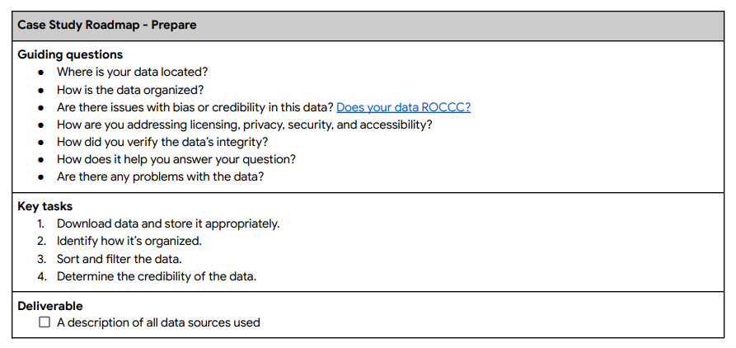

**Process**

Then, process your data for analysis using the following Case Study Roadmap as a guide:

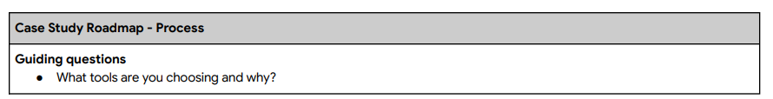

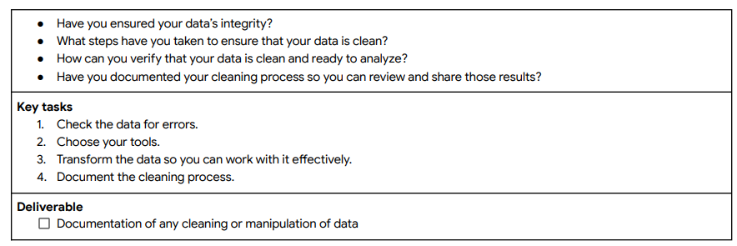

**Analyze**

Now that your data is stored appropriately and has been prepared for analysis, start putting it to work.

Use the following Case Study Roadmap as a guide:

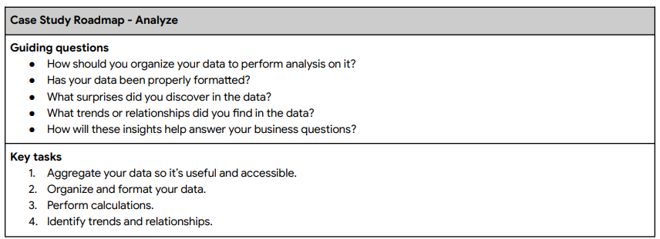



Follow these steps for using R Open R Studio and use this script to complete the following steps:

1. Import your data.
2. Make columns consistent and merge them into a single dataframe.
3. Clean up and add data to prepare for analysis.
4. Conduct descriptive analysis.
5. Export a summary file for further analysis.

**Share**

Now that you have performed your analysis and gained some insights into your data, create visualizations to share your findings. Moreno has reminded you that they should be sophisticated and polished in order to effectively communicate to the executive team.

Use the following Case Study Roadmap as a guide:

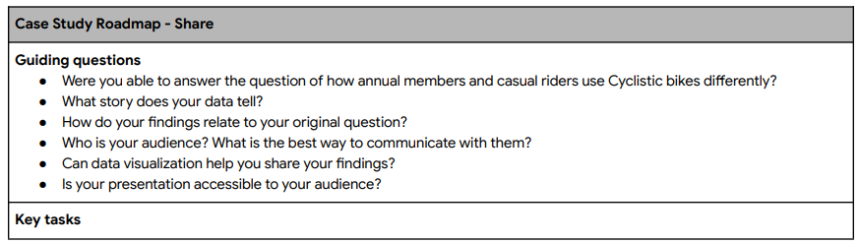

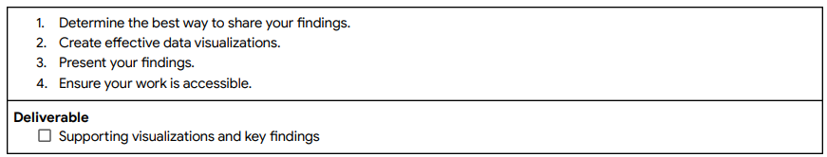

**Act**

Now that you have finished creating your visualizations, act on your findings. Prepare the deliverables Morena asked you to create, including the three top recommendations based on your analysis.

Use the following Case Study Roadmap as a guide:

