**HOSPITALITY PERFORMANCE ANALYTICS DASHBOARD**

This hospitality project is one of the resume project challenges run by Codebasics.

**Domain:**  Hospitality

**Function:** Revenue

**About the company:**

AtliQ Grands owns multiple five-star hotels across India. They have been in the hospitality industry for the past 20 years. Due to strategic moves from other competitors and ineffective decision-making in management, AtliQ Grands are losing its market share and revenue in the luxury/business hotels category. As a strategic move, the managing director of AtliQ Grands wanted to incorporate “Business and Data Intelligence” to regain their market share and revenue. However, they do not have an in-house data analytics team to provide them with these insights.  
  
Their revenue management team had decided to hire a 3rd party service provider to provide them with insights from their historical data.  
  
You are a data analyst who has been provided with sample data and a mock-up dashboard to work on the following task.

1. Create the metrics according to the metric list.
2. Create a dashboard according to the mock-up provided by stakeholders.
3. Create relevant insights that are not provided in the metric list/mock-up dashboard.

**Workflow:**

**There is a list of visual metrics provided by the stakeholders to look into.**

1. **Trends By Weeks –**  
   Revenue  
   Occupancy %  
   Avg Rating
2. **Split By City –**Revenue  
   Occupancy %  
   Avg Rating
3. **Occupancy By Day Type**
4. **Booking% by Platform**
5. **Filters –**  
   Properties  
   City  
   Status  
   Platform  
   Month  
   Week
6. **Table –**  
   Hotels property id  
   City  
   Revenue  
   Occupancy %  
   Avg rating %  
   Cancellation rate %
7. **% change vs the previous month**

**Top metrics:**

1. **RevPar**
2. **ADR**
3. **OCC%**
4. **Revenue**
5. **DSRN**

**Data Transformation and Modeling**

* **Data Transformation:** Utilized Power Query for data cleaning and transformation.
* **Data Modeling:** Established relationships among different tables in a star schema format, with fact tables at the center surrounded by dimension tables.

**Note:**

In the hotel industry, Fridays and Saturdays are considered weekends for the purpose of occupancy analysis.

**Star Schema:** All the fact tables are in the middle and surrounded with the dimension tables.

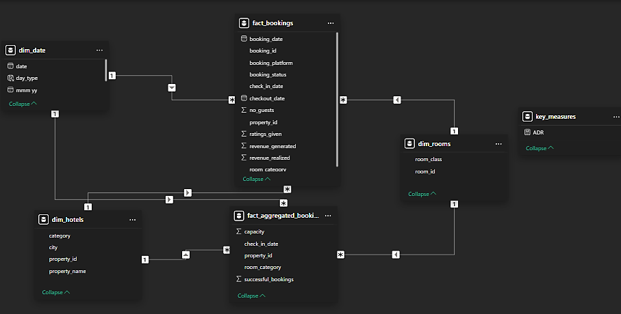

**Results:**

**This dashboard provides a comprehensive overview of our hospitality performance across key metrics, helping us track revenue, occupancy, room rates, and platform performance.**

1. **Revenue**:
   * We’ve generated total revenue of 1.69 billion, showing a slight increase of 0.2%. This indicates stable business growth, though there’s potential for further improvement.
2. **RevPar (Revenue Per Available Room)**:
   * Currently, our RevPar stands at 7,337, which is a critical indicator of how efficiently we’re filling rooms and generating revenue. This is closely aligned with our ADR (Average Daily Rate) and occupancy rates.
3. **Occupancy and ADR**:
   * Our occupancy rate is 57.79%, and our ADR is 12.7K. Occupancy increased marginally by 0.2%, and the room rates remain steady, suggesting consistency in demand. However, improving occupancy further, especially during weekdays, would drive additional revenue.
4. **Realisation Rate**:
   * The realisation rate, which stands at 70.14%, represents the percentage of revenue that is actually collected compared to potential earnings. This suggests effective revenue capture but could be enhanced by targeting cancellations (currently around 24%) and driving higher sales via direct channels.
5. **Revenue by Category**:
   * Business travelers make up the majority of our revenue at 61.62%, while luxury bookings account for 38.38%. This indicates a well-balanced customer mix, but there may be opportunities to target higher-margin luxury segments to boost profitability.
6. **Day-wise Performance**:
   * Weekends outperform weekdays significantly, with weekend RevPar at 9,721 and occupancy at 62.64%. This is higher compared to weekdays, where occupancy drops to 55.88%. We may want to explore targeted weekday promotions or offers to drive midweek bookings and improve overall utilization.
7. **Platform Performance**:
   * In terms of booking platforms, direct online bookings contribute to the highest realization percentage (70.2%), indicating that efforts to promote direct channels should continue. Conversely, platforms like makeMyTrip show a lower realization rate (69.02%), which may need further negotiation or optimization in terms of commission structures.
8. **Property-Level Insights**:
   * At a property level, hotels in Mumbai, particularly 'Atiq Exotica,' are leading in revenue generation, with 117 million. Other cities such as Hyderabad and Bangalore also show strong performance, though there are slight variations in occupancy and ADR. This detailed breakdown helps us identify top-performing properties and those that might benefit from targeted marketing or operational improvements.

In summary, the dashboard reflects overall steady growth with opportunities to increase weekday occupancy, reduce cancellations, and continue promoting direct bookings for higher revenue capture. Targeting high-performing properties and optimizing underperforming ones will be key to maximizing revenue potential in the coming periods.