Vaccume Cleaner ^{(Simulation)}
Aditya Gupta
1906082
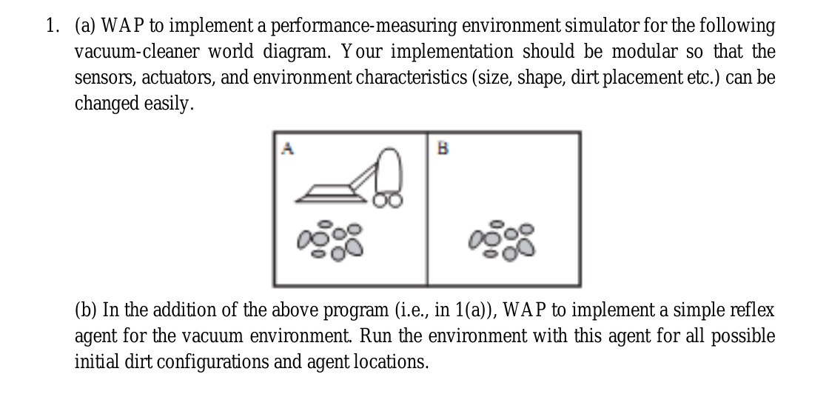
0. Running it:

> pip3 install import_ipynb

After downloading the zip q1.zip, we can run cells in `main.ipynb`, or see previous output

1. Differences from original:
As Sir told we can try different settings, so I found it interesting to try with a 2D array and:

- Size: Instead of giving size directly to a dust object, we assume the quantity of dirt matters, and like again all dirt on a Sofa belongs to that Sofa, so it has More or maybe lesser dirt than other things
- Shape: This again is specified by object itself, since we can provide different shapes for object in environment.scene
- Dirt placement: Can be easily controlled by just editting the ‘environment.scene’ file

2. Files:
- main.ipynb – Cells in this notebook can be run for the actual program
- *.ipynb – All other notebooks contain the main class codes
- environment.scene -
It is a file in which we can describe *initial* environment, example file is:
-,0,-,0,-,0,-,0,-,0,-,0
+,1,-,0,-,0,-,1,-,0,+,1
+,0,-,0,-,1,],1,+,0,+,1
+,1,-,1,],0,],1,+,0,+,0
+,1,-,1,],0,],1,+,1,+,1
+,0,-,0,+,1,+,0,+,0,+,1
;
-,Sofa
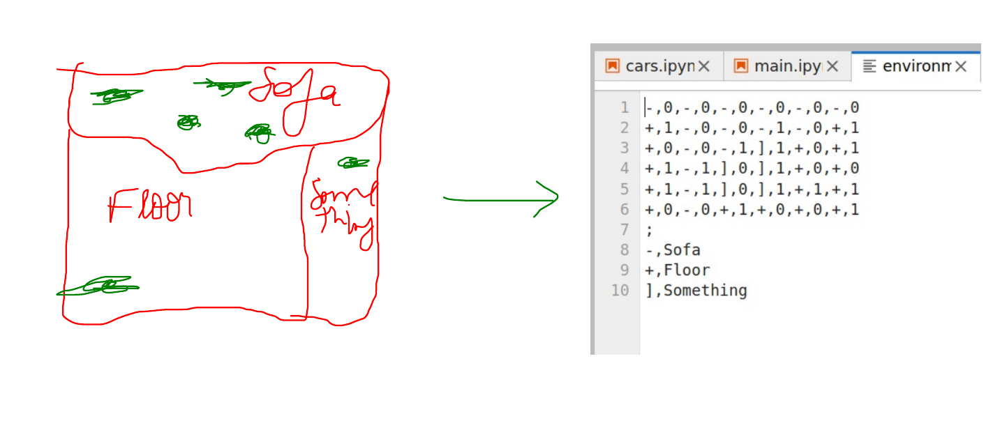
+,Floor
],Something

What this descibes is, the 0 and 1 are whether dirt or not (each coordinate represented by [object,is_dirty] pair),
‘-’, ‘+’, ‘]’ or any other symbol signifies any object, for eg. Here we see that the first row all part of a single object (a Sofa, logic is that, if a thing has dirt, it is better to prefer location on that same object so cleaning is better rather than unrelated dirt here and there)

After the ‘;’ line, we can specify alternate name for the symbols, for eg. ‘-’ is alias for Sofa. The topmost part of Sofa is all clean, little dirt just below.

3. Performance measure?
It simply always increases, but the more dirt it finds at a region, the more quickly it increases.

4. How is it modular ?
It all is based on Slide 52 diagram, i found it interesting so tried separated all those components

- Initial configuration: Very much easy to change by just editing text file ‘environment.scene’
- Sensors: More sensors can be easily added, as they are separate classes/objects.
For eg, currently using a ‘Visual’ sensor (to ‘see’ 2 units farther than current position, what locations has dust), second is a ‘PositionSensor’, which is used to tell which position (coord) is the vaccum (technically we can see all the environment but to see only relevant part, albeit a small part, this is needed by cleaner)
- Actuators: Actuators are classes, that have an ‘act()’ method, it receives a environment matrix, it should return how much coords to move... the internal logic in whatever can be changed as suited, just that it has the ‘act()’ method, we can pass to cleaner.attempt_clean
- Environment: It is also a different class, should provide a 2D array though so cleaner can find dirt, if needed it can be changed during runtime, or initially with the environment.scene file
- Not yet done, but grouping of dust based on object, so if Sofa is dirty next time prefer location on Sofa if still dirty: It allows that, and Environment class provides the support, but not needed now

5. What does your simple reflex agent do ?
Receiving a 2D array of where dirt is, returns a pair of coordinates to how much to move, for eg to move left is to return [-1,0], for right it is [1,0].
Since this is 2D, it can also move diagonally but in limit, ie. 2 unit farther at max
As for how it choses where to move, it randomly does so, chosing among the dirty coordinates

PEAS table:
Agent Type | Performance Measure | Environment | Actuators | Sensors
Vacuum Cleaner | How much dirt it found | Floor,objects | Moving,Cleaning | Visual,Position

Originality: Actually I thought of it to be simpler, at in time made it a bit more complex doing same (chosing random dirty locations), code maybe with some new additions is at my github: https://github.com/adi-g15/reflex_agents, it actually ended up complex than it should be since i was trying to add it to my simulator project too, ended up making a bit of mess, but should be cleaner now

