Automatic Taxies ^{(Simulation)}
Aditya Gupta
1906082
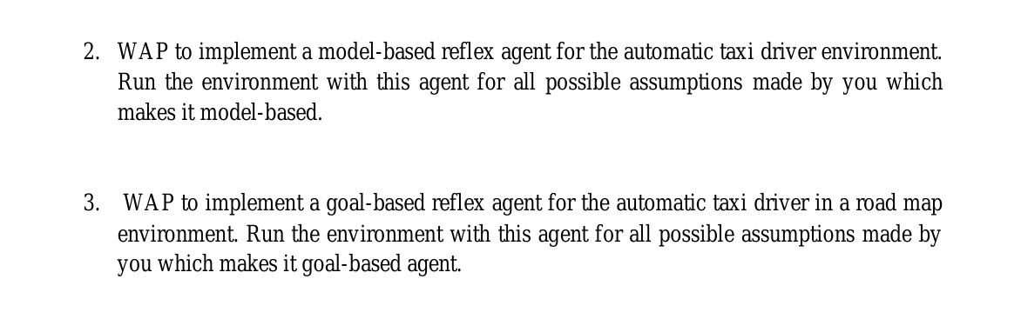
1. Running It:

> pip3 install import-ipynb

Then, can just run all cells in only main.ipynb

2. Any differences from question?
No, but they are both in same program, and hoping to be quite modular, either can be tried by just replacing a word (the agent class name)

3. Design
Design is completely based on Slide 54, and Slide 57 of the notes PPT, I tried making it quite modular.

On the highest level, we only have 3 classes
- Environment: This just stores a matrix of 20*20 (default) boxes, each box is_blocked is True or False, ie. Our taxi can go in that box or not at that moment, it takes a filename “environment.scene” to set initial state
- AutoTaxi: The automatic taxi class, it takes agent_class, environ, start_loc, end_loc.
So, we can easily pass either ModelBasedReflexAgent or GoalBasedReflexAgent, to solve both problems
- NotSoSmartCar: This is just to simulate ‘traffic’, and follows a pre-defined path, we can easily edit and pass by editing the path*.txt files

Internally, it has ModelBasedReflexAgent, GoalBasedReflexAgent reflex agents also, they have common API, both will have a .act() method that takes the percept and returns action (direction to move)

4. What is your environment ?
It is 2D matrix of True (can’t go), or False (can move into). It’s initial state can be defined in ‘environment.scene’ file.
Normal cars have a ‘path’, but automatic taxi can move in any direction.
For eg. If a NotSoSmartCar is already there, our automatic taxi MUST not collide with it, nor any other obstacle.

5. What is your Model-Based reflex agent ?
It follows Slide 55 pseudocode.
At instantiation, it receives the Taxi object, it is required to access current location of taxi, and the Environment.
Then, it provides an .act() function, which takes the current environment (it’s perception of the world), and returns direction (in form of x,y... for eg. -1,0 for Left)
State stored by it: It stores the destination, and what obstacles are present
Model: In this, i just use the state’s obstacles array as model itself, since my motive in this was just for it to not collide, and in this, obstacles define how next state depends on current
Rules: Just don’t collide

PEAS:
Agent Type | Performance Measure | Environment | Actuators | Sensors
Model-based taxi | Don’t Collide | Grid, Roads | Moving | Visual,Position

6. What is your Goal-Based reflex agent ?

It follows Slide 57 (picture in zip file)

It is the model-based reflex agent logic + Chose the best direction which will reach the Goal (destination) quicker.

What it will be like if i do action A:
For all movable directions, it first, don’t collide (following Model-based), then find what will be the distance to destination if I move in this, so we chose the direction which ends lowering distance from goal.

PEAS
Agent Type | Performance Measure | Environment | Actuators | Sensors
Goal-Based taxi | No Collision, Reaching destination on time | Grid, Roads | Moving | Visual,Position,Distance
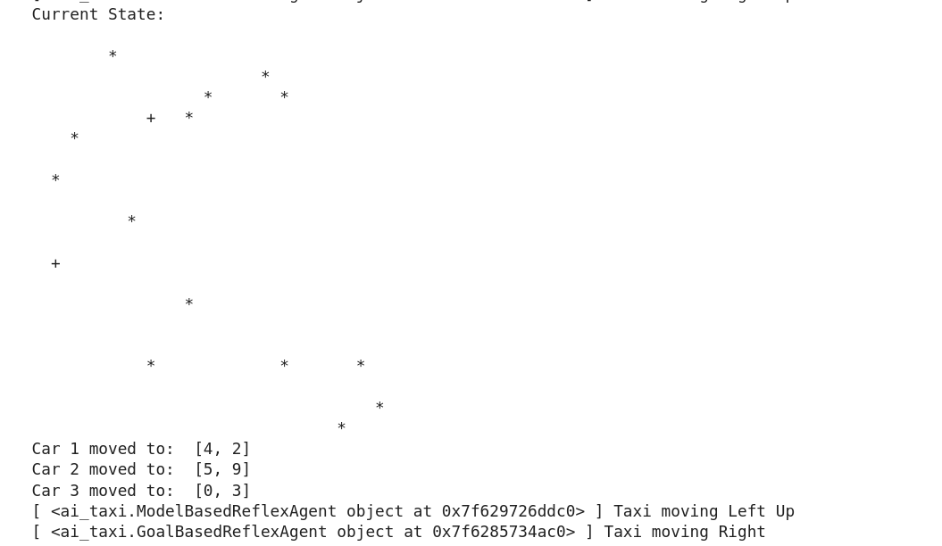
Originality – The code is also at my github- https://github.com/adi-g15/reflex_agents

