When you have acne, you can develop any (or a combination) of these breakouts on your skin:
- Whiteheads
- Blackheads
- Pimples
- Nodules, cysts, or both (deep and painful)
The following describes how each of these breakouts develops, and pictures show what they look like.
Whitehead
Whiteheads
Picking at whiteheads can lead to more whiteheads and acne scars, so dermatologists recommend that you treat whiteheads with an acne treatment instead of picking at them.
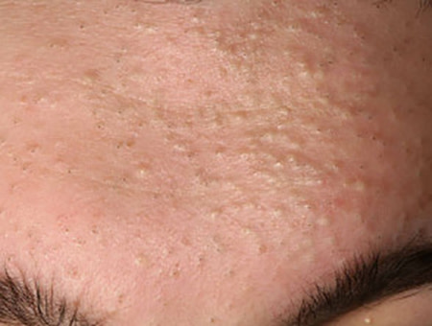
A whitehead forms when excess oil and dead skin cells build up and plug the opening of a pore. This causes a blemish that is raised and white or flesh colored.
Medical name: Closed comedo, which means “closed pore.”
Blackhead
Blackheads
Dermatologists recommend treating this type of acne with a retinoid, as squeezing a blackhead can cause an infection or permanent scar.
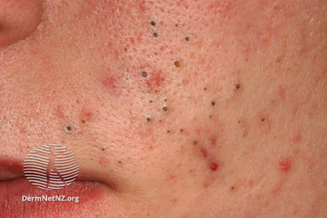
This type of acne also develops when excess oil and dead skin cells build up inside a pore. As the buildup accumulates, it widens the opening of the pore and you see a blackhead.
Why are blackheads black? Many people mistakenly believe the black speck is dirt. What you’re really seeing is a chemical reaction. When the buildup inside the pore reacts with oxygen in the air, the black color appears. This reaction is similar to what happens when a cut-up apple turns brown.
Medical name: Open comedo, which means “open pore.”
Pimple
Treatment
If you have a few pimples, you can often successfully treat these with an acne product that contains benzoyl peroxide, retinoid, or azelaic acid.
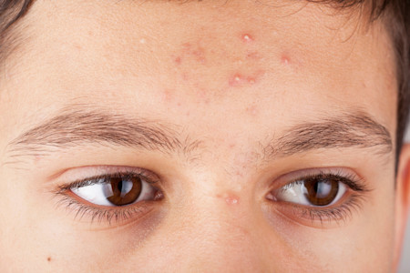
Sometimes excess oil, dead skin cells, and bacteria get trapped inside a pore. The bacteria, which are normally found on our skin, can multiple quickly in the excess oil. As the pore fills with bacteria, inflammation (swelling) develops and a pimple appears.
Medical name: If the pimple contains pus, it’s called a pustule. A pimple without pus is called a papule.
Acne nodule or cyst
Acne cyst
If you have an extremely painful acne cyst or nodule, a dermatologist can inject it with medication to reduce the pain and help it clear more quickly.
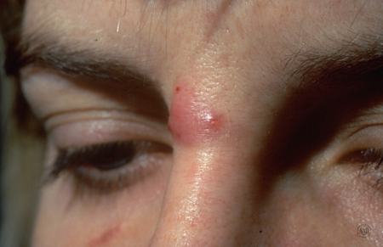
When a pore fills with enough excess oil, dead skin cells, and bacteria to cause inflammation (swelling) that goes deep into the skin, an acne nodule or cyst develops. Because these breakouts go deep into the skin, they can feel tender or painful.
The main difference between an acne nodule and an acne cyst is that a cyst contains pus. Because nodules don’t contain pus, they feel harder to the touch than do cysts.
Acne can cause more than breakouts
Some people dismiss acne as a skin condition that you’ll eventually outgrow, but it can have a profound and lasting effect on someone’s life. Many people develop one or more of the following after getting acne.
Acne scars: When an acne breakout clears, it can leave a permanent scar. Some scars cause depressions in the skin. Others are raised. It’s impossible to predict who will develop scars when the acne clears, but the following increases your risk:
- Living with acne for an extended amount of time because you don’t treat it or treatment doesn’t work
- Having one or more close blood relatives who developed acne scars
Dark spots on the skin: As an acne breakout clears, some people see a spot where the acne once was. This completely flat spot can be pink, red, purple, black, or brown, and it’s often mistaken for a permanent acne scar.
Dark spots on skin
As the acne clears, it can leave long-lasting dark spots on the skin.
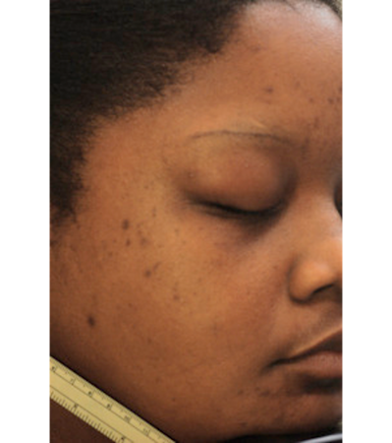
Unlike acne scars, these spots will eventually clear on their own. Clearing can take time, though. Some spots can last for a year or longer. The darker the spot, the longer it will take to clear. Treatment and the right skin care can help clear the spots more quickly and prevent new dark spots.
You’ll find out how you can treat and prevent these dark spots in skin of color at: 10 tips for clearing acne in skin of color.
The medical name for these spots is postinflammatory hyperpigmentation (PIH).
Lower self-esteem: Research shows that acne can deflate one’s self-esteem, and dermatologists see this in many patients who have acne. Lower self-esteem during the teen and early adulthood years can negatively affect one’s life.
For example, lower self-esteem can prevent someone from pursuing a desired career, speaking up in class, getting a part-time job, making friends, or dating.
Low self-esteem is also associated with anxiety and depression.
Treating acne rather than letting it run its course can prevent lowered self-esteem.
Depression: Studies reveal that teens with acne have a higher risk of developing depression, which may include thoughts of suicide, than do teens who have the occasional pimple. This is why dermatologists recommend treating acne when it begins and continuing treatment to prevent new breakouts.
While few people escape acne during their teenage years, some people are more likely to develop deep, painful pimples that leave scars. You’ll discover who is most likely to develop this type of acne at: Acne: Causes

Images
Image 1: Illustration property of the American Academy of Dermatology
Images 2 and 3: Used with permission of DermNet New Zealand Image Library.
Image 4: Getty Images
Image 5: Image used with permission of the American Academy of Dermatology National Library of Dermatologic Teaching Slides.
Image 6: J Am Acad Dermatol. 2014;70:108-14.
References
Dalgard F. Gieler U, et al. “Self-esteem and body satisfaction among late adolescents with acne: Results from a population survey.” J Am Acad Dermatol 2008;59:746-51.
Savory SA, Agim NG, et al. “Reliability assessment and validation of the postacne hyperpigmentation index (PAHPI), a new instrument to measure postinflammatory hyperpigmentation from acne vulgaris.” J Am Acad Dermatol. 2014;70:108-14.
Thiboutot DM, Dréno B, et al. “Practical management of acne for clinicians: An international consensus from the Global Alliance to Improve Outcomes in Acne.” J Am Acad Dermatol 2018;78:S1-23.
Zaenglein AL, Thiboutot DM. “Acne vulgaris.” In: Bolognia JL, et al. Dermatology. (fourth edition). Mosby Elsevier, China, 2018:588-92.
Zaenglein AL, Pathy AL, et al. “Guidelines of care for the management of acne vulgaris.” J Am Acad Dermatol. 2016;74:945-73.
Family history with acne
If one of your parents or another close blood relative had deep, painful pimples, you have a greater risk of developing this type of acne.

What causes acne?
Acne develops when pores become clogged. What type of acne you get depends on what clogs your pores. You’ll find pictures of the different types of acne, along with a description of how each type of blemish forms at: Acne: Signs and symptoms
While scientists are still trying to figure out why some people skin seems more likely to develop acne, it’s likely that hormones play a role.
Why does acne usually develop during the teenage years?
Hormones may explain why acne is so common in teenagers. During puberty, hormones called androgens increase the size of the skin’s oil glands. These glands start making more oil, which can clog pores.
Can acne start before (or after) your teen years?
Yes. People can get acne at almost any age.
Around 20% of newborns develop a type of acne called neonatal acne, which usually appears between the second and fourth weeks of life. This type of acne goes away on its own without causing scars. It also does not increase the risk of developing severe acne later in life.
Some children develop infantile acne, which begins between 3 and 6 months of age. Infantile acne can cause deep acne nodules and cysts, leading to permanent acne scars. Fortunately, infantile acne is rare.
Acne is also a growing problem for women over 25 years of age. Most of these women had acne as teens and continue to get breakouts as adults. Some of these women had teenage acne that cleared. Now years later, they are experiencing acne breakouts again. About 20% to 40% of women who have adult acne develop it for the first time as an adult.
Can nicotine cause acne?
One study found that smoking may play a role for some women with acne. In this study, the women had noticeable whiteheads and blackheads that often covered a large area of their face. Some also had a few pimples.
The researchers found that many of the women in this study smoked cigarettes. They also found that the more cigarettes a woman smoked, the more severe her acne. Some of these women developed icepick-type acne scars when the acne cleared.
Link to smoking
Most women in the study who develop noticeable whiteheads along with a few pimples smoked.
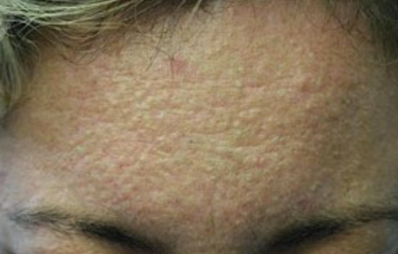
Other studies have found that smokers are more likely to have acne than non-smokers. This repeat finding suggests that smoking cigarettes may trigger acne.
Can stress cause acne?
While stress cannot cause acne, stress may worsen existing acne. Results from studies suggest that when stress intensifies, the severity of the acne increases.
Can food or anything else worsen acne?
Yes. Acne may worsen if you:
- Get too little sleep
- Eat certain foods
- Use oily makeup and skin care products
- Apply oily hair care products, such as pomade
You’ll find more about how food can affect acne at Can the right diet get rid of acne?
Are some people more likely to get acne?
Nearly everyone develops at least a few breakouts during the teenage years. It’s impossible to predict who will develop more severe acne, but you have a higher risk if one or both of your parents (or other close blood relative) had severe acne that left them with acne scars.
The good news is that you don’t have to live with acne. Today, virtually every case of acne can be treated successfully. Sometimes, this requires the help of a board-certified dermatologist.
You’ll find out how dermatologists treat acne at: Acne: Diagnosis and treatment

Images
Getty Images
References
Burgos A, Burch JM. “Acne and acneiform eruptions.” In: Fitzpatrick JE, et al. Dermatology Secrets Plus (5th edition). Elsevier. China, 2016:185-6.
Capitanio B, Sinagra JL, et al. “Underestimated clinical features of postadolescent acne.” J Am Acad Dermatol. 2010;63:782-8.
Heymann WR. “Stress2 + Hormones2 = Acne2.” Dermatology World: Insights and Inquires.” June 5, 2019. Last accessed June 14, 2019.
Thiboutot DM, Dréno B, et al. “Practical management of acne for clinicians: An international consensus from the Global Alliance to Improve Outcomes in Acne.” J Am Acad Dermatol 2018;78:S1-23.
Zaenglein AL, Graber EM, et al. “Acne vulgaris and acneiform eruptions.” In: Wolff K, Goldsmith LA, et al. Fitzpatrick’s Dermatology in General Medicine (seventh edition). McGraw Hill Medical, New York, 2008:690-703.
Zaenglein AL, Pathy AL, et al. “Guidelines of care for the management of acne vulgaris.” J Am Acad Dermatol. 2016;74:945-73.
Zaenglein AL, Thiboutot DM. “Acne vulgaris.” In: Bolognia JL, et al. Dermatology. (fourth edition). Mosby Elsevier, China, 2018:588-92.
Zeichner JA, Baldwin HE, et al. “Emerging issues in adult female acne.” J Clin Aesthet Dermatol. 2017; 10(1): 37-46.
Do you avoid eating greasy fries and burgers because you believe they’ll cause new pimples? There may be a connection, but probably not for the reason you think. Here’s what the research shows.
A low-glycemic diet may lead to fewer pimples
If you’re like most Americans, you consume plenty of high-glycemic foods and beverages. These foods and beverages raise your blood sugar quickly. Examples include white bread, corn flakes, puffed rice, potato chips, white potatoes or fries, doughnuts or other pastries, sugary drinks such as milkshakes, and white rice.
Findings from small studies suggest that following a low-glycemic diet may reduce the amount of acne you have. Low-glycemic foods include most fresh vegetables, some fresh fruits, beans, and steel-cut oats.
Here’s what researchers have found may happen when people with acne switch to a low-glycemic diet.
- USA: 2,258 patients were placed on a low-glycemic diet so that they could lose weight. This diet also reduced their acne, with 87% of patients saying they had less acne, and 91% saying they needed less acne medication.¹
- Australia: 43 males with acne (aged 15 to 25 years of age) ate either their normal diet or switched to a low-glycemic diet for 12 weeks. At the end of 12 weeks, those who followed the low-glycemic diet had significantly less acne than those who ate their normal diet.²
- Korea: 32 patients with acne (aged 20 to 27 years old) ate either their normal diet or a low-glycemic diet for 10 weeks. Those following the low-glycemic diet had significantly less acne at the end of 10 weeks than the patients who ate their normal diet.³
- Turkey: 86 patients (50 with acne) kept food logs for 7 days. Those with the most severe acne consumed a high-glycemic diet.⁴
Scientists believe that following a low-glycemic diet may reduce acne because this diet eliminates spikes in your blood sugar. When your blood sugar spikes, it causes inflammation throughout your body. These spikes also cause your body to make more sebum, an oily substance in your skin. Both inflammation and excess sebum can lead to acne.
While these findings show that following a low-glycemic diet can lead to fewer breakouts, other studies have not found a connection between a high-glycemic diet and acne. More research is needed to know for sure.
Cow's milk may lead to acne breakouts
While cow's milk (but not milkshakes) is a low-glycemic beverage, some studies suggest that drinking this type of milk may be linked to an increase in acne breakouts. In these studies, all types of cow's milk (whole, low-fat, and skim) have been linked to acne. Here’s what the researchers discovered.
Milk and acne

In one study, women who drank 2 or more glasses of skim milk per day were 44% more likely to have acne than the other women in this study.
- USA: 47,355 adult women were asked to recall what they ate during their high school years. Only cow's milk was found to be linked to acne. Women who drank 2 or more glasses of skim milk a day were 44% more likely to have acne than others.⁵
- USA: 6,094 girls, aged 9 to 15 years old, completed 2 lengthy questionnaires (given at least 1 year apart) about their diet. The girls who drank the most cow's milk (whole, low-fat, or skim) were more likely to have acne.⁶
- USA: 4,273 boys, aged 9 to 15 years old, completed 2 lengthy questionnaires (given at least 1 year apart) about their diet. The boys who drank skim milk were more likely to have acne.⁷
- Italy: 205 patients, aged 10 to 24 years old, who were seeing a dermatologist for moderate to severe acne, and 358 patients in the same age range who were seeing a dermatologist for another skin condition (and had little or no acne) were asked what they ate. The patients with acne drank significantly more cow's milk than the patients who did not have acne. There were no other differences in diet between the 2 groups of patients.⁸
- Malaysia: 88 patients, aged 18 to 30 years old, were asked to complete a food diary for 3 days. Half (44) of the patients had acne, and half (44) did not have acne. The patients who had acne consumed more cow's milk and high-glycemic foods than did the patients without acne.⁹
Why cow's milk may increase or worsen acne is still a bit of a mystery. One theory is that some of the hormones in milk cause inflammation inside the body. Inflammation can clog your pores, leading to acne. However, more research is needed to know for sure.
No evidence yogurt or cheese can increase acne breakouts
While cow's milk may increase the risk of developing acne, no studies have found that products made from milk, such as yogurt or cheese, lead to more breakouts.
What these research findings mean for you
While more research is needed to know whether certain foods can worsen acne, there is something that you can do right now if you think your diet affects your acne.
Dermatologists recommend that you pay attention to your breakouts, and ask yourself these questions:
- Does any food or beverage seem to trigger a breakout or worsen your existing acne?
- If something seems to trigger a breakout, what happens when you don’t have that food or beverage for a day, a week, or a month?
Effective acne treatment includes skin care and medication
While diet may play a role in causing your breakouts or worsening your acne, keeping your skin clear requires more than a diet change. Using acne friendly skin care and acne medication helps to prevent new breakouts.

¹ Rouhani P, Berman B, et al. “Poster 706: Acne improves with a popular, low glycemic diet from South Beach.” J Am Acad Dermatol. 2009;60(3, suppl 1):AB14.
² Smith RN, Mann NJ, et al. “The effect of a high-protein, low glycemic–load diet versus a conventional, high glycemic–load diet on biochemical parameters associated with acne vulgaris: A randomized, investigator-masked, controlled trial.” J Am Acad Dermatol. 2007;57(2):247-56.
³ Kwon HH, Yoon JY, et al. “Clinical and histological effect of a low glycaemic load diet in treatment of acne vulgaris in Korean patients: a randomized, controlled trial.” Acta Derm Venereol. 2012;92(3):241-6.
⁴ Cerman AA, Aktaş E, et al. “Dietary glycemic factors, insulin resistance, and adiponectin levels in acne vulgaris.” J Am Acad Dermatol. 2016;75(1):155-62.
⁵ Adebamowo CA, Spiegelman D, et al. “High school dietary dairy intake and teenage acne.” J Am Acad Dermatol. 2005;52(2):207-14.
⁶ Adebamowo CA, Spiegelman D, et al. “Milk consumption and acne in adolescent girls.” Dermatol Online J. 2006;12(4):1.
⁷ Adebamowo CA, Spiegelman D, et al. “Milk consumption and acne in teenaged boys.” J Am Acad Dermatol. 2008;58(5):787-93.
⁸ Di Landro A, Cazzaniga S, et al. “Family history, body mass index, selected dietary factors, menstrual history, and risk of moderate to severe acne in adolescents and young adults.” J Am Acad Dermatol. 2012 ;67(6):1129-35.
⁹ Ismail NH, Manaf ZA, et al. “High glycemic load diet, milk and ice cream consumption are related to acne vulgaris in Malaysian young adults: a case control study.” BMC Dermatol. 2012;12:13.

Images
Getty Images
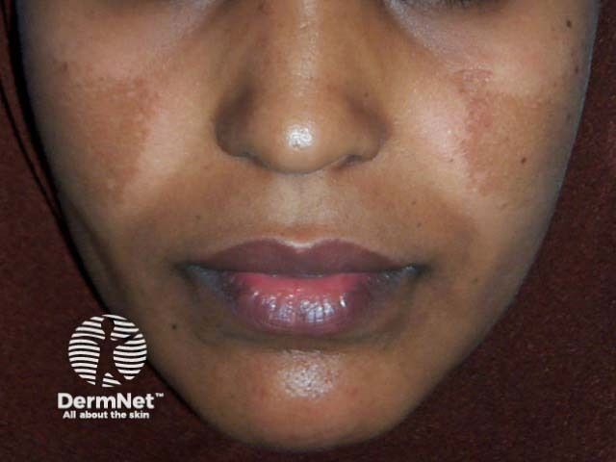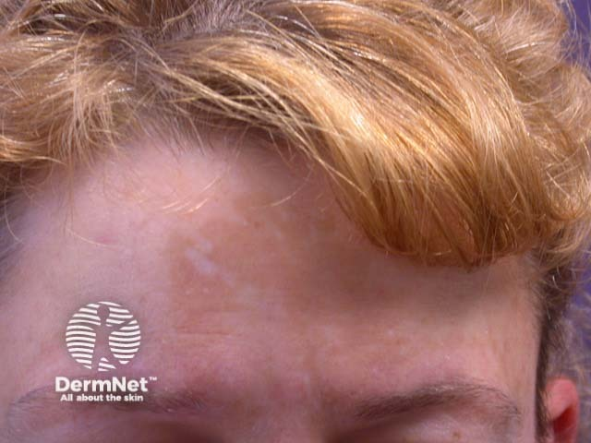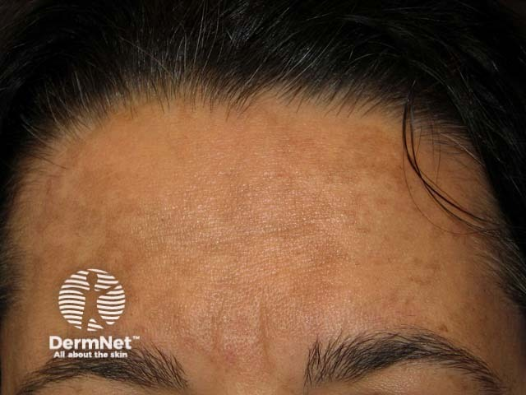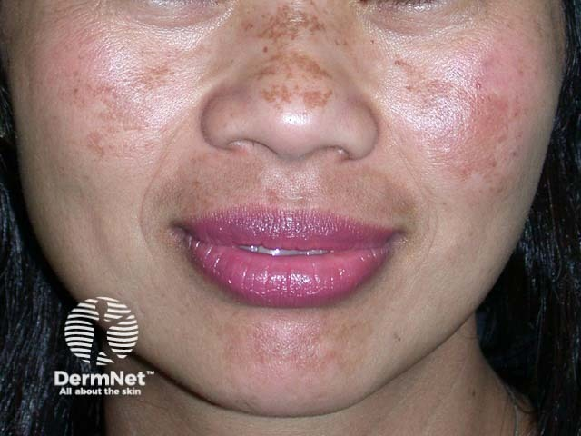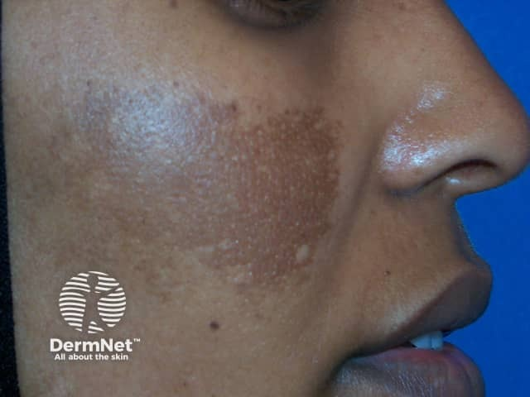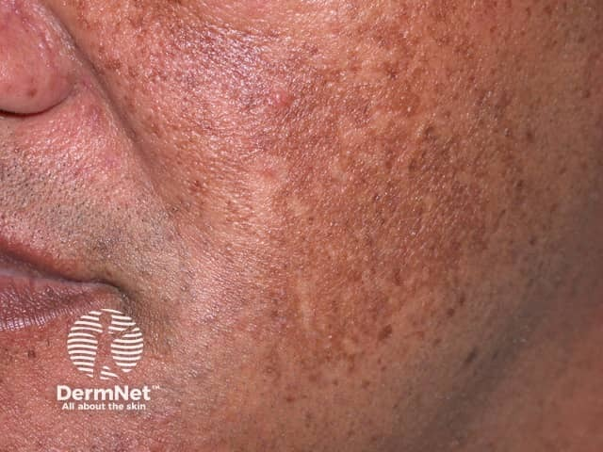
References
Adebamowo CA, Spiegelman D, et al. “High school dietary dairy intake and teenage acne.” J Am Acad Dermatol. 2005;52(2):207-14.
Adebamowo CA, Spiegelman D, et al. “Milk consumption and acne in adolescent girls.” Dermatol Online J. 2006;12(4):1.
Adebamowo CA, Spiegelman D, et al. “Milk consumption and acne in teenaged boys.” J Am Acad Dermatol. 2008;58(5):787-93.
American Academy of Dermatology. “Growing evidence suggests possible link between diet and acne.” News release issued February 2013.
Cerman AA, Aktaş E, et al. “Dietary glycemic factors, insulin resistance, and adiponectin levels in acne vulgaris.” J Am Acad Dermatol. 2016;75(1):155-62.
Ismail NH, Manaf ZA, et al. “High glycemic load diet, milk and ice cream consumption are related to acne vulgaris in Malaysian young adults: a case control study.” BMC Dermatol. 2012;12:13.
Khanna R, Shifrin N, et al. “Diet and Dermatology: Google Search Results for Acne, Psoriasis, and Eczema.” Cutis. 2018 July;102(1):44-8.
Kwon HH, Yoon JY, et al. “Clinical and histological effect of a low glycaemic load diet in treatment of acne vulgaris in Korean patients: a randomized, controlled trial.” Acta Derm Venereol. 2012;92(3):241-6.
Rouhani P, Berman B, et al. “Poster 706: Acne improves with a popular, low glycemic diet from South Beach.” J Am Acad Dermatol. 2009;60(3, suppl 1):AB14.
Smith RN, Mann NJ, et al. “The effect of a high-protein, low glycemic–load diet versus a conventional, high glycemic–load diet on biochemical parameters associated with acne vulgaris: A randomized, investigator-masked, controlled trial.” J Am Acad Dermatol. 2007;57(2):247-56.
Zaenglein AL, Pathy AL, et al. “Guidelines of care for the management of acne vulgaris.” J Am Acad Dermatol. 2016;74:945-73.

