JusticeLens
Explainable AI in Criminal Justice Workflows

Technical & Educational Project Report
Stack: Python 3.12 · Flask 3.x · scikit-learn · NumPy
Deployment: Render (Cloud) / Local (localhost:5000)
Date: October 2026 | Student Research Prototype

▶ ⚠ IMPORTANT SCOPE NOTE
This prototype does NOT predict guilt, criminality, recidivism, bail eligibility, or sentencing. It demonstrates documentation-gap detection on synthetic fictional data only. Do not enter real personal data.

Table of Contents
1. Executive Summary
2. Problem Statement & Motivation
3. Ethical Scope & Safety Boundaries
4. System Architecture
5. Machine Learning Pipeline
6. User Interface Design
7. Feature Walkthrough with Screenshots
8. Explainability Mechanism
9. Technical Implementation Details
10. Deployment & Local Setup
11. Case Study Evaluation
12. Limitations & Future Work
13. Conclusion

1. Executive Summary
JusticeLens is a web-based educational prototype demonstrating how Explainable Artificial Intelligence (XAI) can be responsibly applied in administrative workflows adjacent to the criminal justice system. Rather than making predictions about individuals — such as guilt, recidivism risk, bail eligibility, or sentencing — the system narrows its scope to a single, well-defined, and low-stakes task: detecting documentation gaps in fictional case files that may warrant human review.
The application is built on a logistic regression model trained entirely on synthetically generated data. Every output is accompanied by a full explanation of the model's decision — exposing the coefficients that drove the result in plain language. This transparency-by-design approach makes JusticeLens useful as a teaching tool for data ethics, algorithmic fairness, and responsible AI deployment in sensitive domains.
▶ Key Design Principle
Transparency is not a feature — it is the product. The model's coefficients are displayed front-and-centre with every single output, not hidden behind a score.

2. Problem Statement & Motivation
2.1 The Opacity Problem in AI-Assisted Justice
Artificial Intelligence is increasingly being considered for use in criminal justice workflows — from risk assessment tools like COMPAS to predictive policing systems. However, many such tools are black-box systems that provide outputs with no explanation of reasoning, are trained on historically biased data, and operate outside genuine human oversight.
The 2016 ProPublica investigation into COMPAS revealed that opaque AI tools can produce discriminatory outputs, disproportionately flagging Black defendants as high-risk. These failures highlight that the problem is not merely technical — it is ethical, legal, and social.
2.2 The Case for Explainability
Explainable AI (XAI) addresses the opacity problem by requiring that:
- Every output has a traceable reason — which features drove it and by how much.
- Humans remain in the loop — AI is advisory, never authoritative.
- Scope is narrow and verifiable — the AI does one specific, bounded task.
- Data is transparent — users know exactly what the model was trained on.
2.3 Why Documentation Review?
Documentation gap detection was chosen as the task because:
- It is administrative, not judgmental — it flags missing paperwork, not people.
- It is objectively verifiable — a document is either present or absent.
- It carries low individual risk — flagging triggers human review, not automatic action.
- It is comprehensible — checklist items are understandable by non-experts.

3. Ethical Scope & Safety Boundaries
JusticeLens was designed with explicit ethical guardrails baked into every layer of the system.
3.1 Prohibited Uses
❌ What the system does NOT do | Why this boundary exists
Predict guilt or innocence | Violates presumption of innocence
Estimate recidivism risk | Historically biased, legally contested
Determine bail eligibility | Constitutionally sensitive, high-stakes
Recommend sentencing | Reserved exclusively for courts
Process real personal data | Privacy and consent requirements

3.2 Permitted Uses
✅ What the system DOES do | Justification
Flag documentation gaps in fictional data | Low-stakes, objective, verifiable
Expose model coefficients transparently | Promotes interpretability and trust
Require human verification of every output | Maintains human oversight
Demonstrate XAI principles for education | Safe sandbox environment

3.3 Safety Communication in the UI
The safety boundary is not buried in fine print — it is displayed prominently in the hero section as an amber warning banner, visible before the user interacts with any feature. This design choice ensures that no user can accidentally misuse the tool.
4. System Architecture
JusticeLens follows a classic three-tier web application architecture with a machine learning inference layer.
BROWSER (Client)
HTML/CSS/JS (vanilla) · Particle canvas · AJAX calls
│ HTTP GET / POST
FLASK WEB SERVER (Python)
Routes: / (GET/POST) · /analyze (POST JSON API)
Template rendering: Jinja2
│ NumPy arrays
ML INFERENCE LAYER (scikit-learn)
LogisticRegression · predict_proba · coef_ extraction
│ Synthetic data (seed=23)
SYNTHETIC DATA GENERATOR (NumPy)
1 800 samples · 5 binary features · reproducible RNG

4.1 File Structure
e:\AI JUSTICE\
├── app.py # Flask app + ML model (103 lines)
├── requirements.txt # Python dependencies
├── Procfile # Gunicorn start command (Render)
├── render.yaml # Render deployment config
├── README.md # Setup and usage guide
├── templates/
│ └── index.html # Single-page Jinja2 template (668 lines)
└── static/
└── style.css # Component stylesheet (452 lines)

4.2 Dual-Mode Interface
Mode | Mechanism | Use Case
Full-page POST | HTML form → server render | No-JS fallback, URL sharing
AJAX / Live | fetch('/analyze') → JSON response | Interactive real-time UX

5. Machine Learning Pipeline
5.1 Feature Engineering
The model operates on exactly 5 binary features, each representing a documentation flag:
# | Feature Key | Label | Description
1 | missing_evidence | Evidence attachment missing | Referenced attachment is absent
2 | timeline_conflict | Timeline inconsistency flagged | Dates/times appear inconsistent
3 | chain_gap | Chain-of-custody gap | Custody transfer entry missing
4 | unreadable_report | Report unreadable or incomplete | Report marked unreadable or pages missing
5 | statement_missing | Referenced statement missing | Witness statement absent

5.2 Synthetic Data Generation
rng = np.random.default_rng(23)
X = rng.integers(0, 2, size=(1800, 5))
weights = np.array([1.25, 1.05, 1.35, 0.95, 0.85])
logits = -1.65 + X @ weights + rng.normal(0, 0.55, size=len(X))
probs = 1 / (1 + np.exp(-logits))
y = (rng.random(len(X)) < probs).astype(int)

Key dataset characteristics:
- 1,800 synthetic samples with a fixed seed (23) for full reproducibility.
- Balanced label generation via probabilistic thresholding with Gaussian noise (σ = 0.55).
- Interpretable weight hierarchy: chain_gap (1.35) > missing_evidence (1.25) > timeline_conflict (1.05) > unreadable_report (0.95) > statement_missing (0.85).
- Base negative bias (intercept = −1.65) ensures a low baseline with no flags selected.
5.3 Model Training
model = LogisticRegression(random_state=23, max_iter=1000)
model.fit(X, y)

Logistic regression was selected intentionally over more powerful algorithms because its coefficients directly represent feature contributions in log-odds units, making it fully interpretable without any post-hoc approximation layer.
5.4 Signal Level Thresholds
Score Range | Level Label | Badge
≥ 65% | Higher review signal | 🔴 HIGH SIGNAL
35–64% | Some review signal | 🟡 MED SIGNAL
< 35% | Lower review signal | 🟢 LOW SIGNAL

6. User Interface Design
6.1 Design Philosophy
- Transparency over mystique: Results are not a black score — every component is explained.
- Friction by design: Multiple safety warnings slow the user down before drawing conclusions.
- Accessibility of explanation: Coefficient values are shown alongside plain-language labels.
6.2 Visual Design System
Property | Value
Background | #070d12 (near-black navy)
Surface / cards | rgba(255,255,255,0.04) glassmorphism
Accent (teal) | #63cab7
Accent 2 (blue) | #4f9cf9
Text | #deeee8 (soft white-teal)
Warning | #f59e0b (amber)
High signal | #ef4444 (red)
Low signal | #22c55e (green)
Font (body) | Inter, 400–900 weight
Font (mono) | JetBrains Mono (coefficient values)
Border radius | 16–18 px (rounded cards)

6.3 Component Inventory
Component | Description
Sticky Navigation | Brand logo + badge pills, blur backdrop
Hero Section | Eyebrow chip, gradient headline, safety banner
Feature Checklist Card | 5 toggle switches with icons and descriptions
Run Analysis Button | Gradient CTA with loading spinner
Empty State | Animated orbital rings while awaiting input
Gauge / Speedometer | SVG arc + animated needle + score counter
Probability Bar | Animated fill bar with LOW/MED/HIGH labels
Contribution Cards | Per-feature log-odds bars with +/− values
Human Review Box | Persistent reminder of mandatory human verification
How It Works Section | 4-step pipeline visualisation

7. Feature Walkthrough with Screenshots
7.1 Hero & Safety Banner
The landing page greets users with a full-width dark hero section. The animated pulse-dot chip and gradient headline communicate the tool's purpose immediately. The amber safety banner is placed before the interaction area, ensuring the ethical scope is read before any analysis begins.

Figure 1 — JusticeLens landing page with hero section and amber safety banner

▶ Safety Banner Note
The safety banner is hardcoded — it cannot be dismissed or hidden. It reads: "This demo does not predict guilt, crime risk, recidivism, bail, or sentencing."

7.2 The Case File Checklist
The left card presents five documentation flags as interactive toggle cards. Each card highlights with a teal glow when toggled ON, shows an icon, bold label, and descriptive subtitle, and features a 2 px gradient bottom bar that animates proportionally to the feature's log-odds weight upon result return.
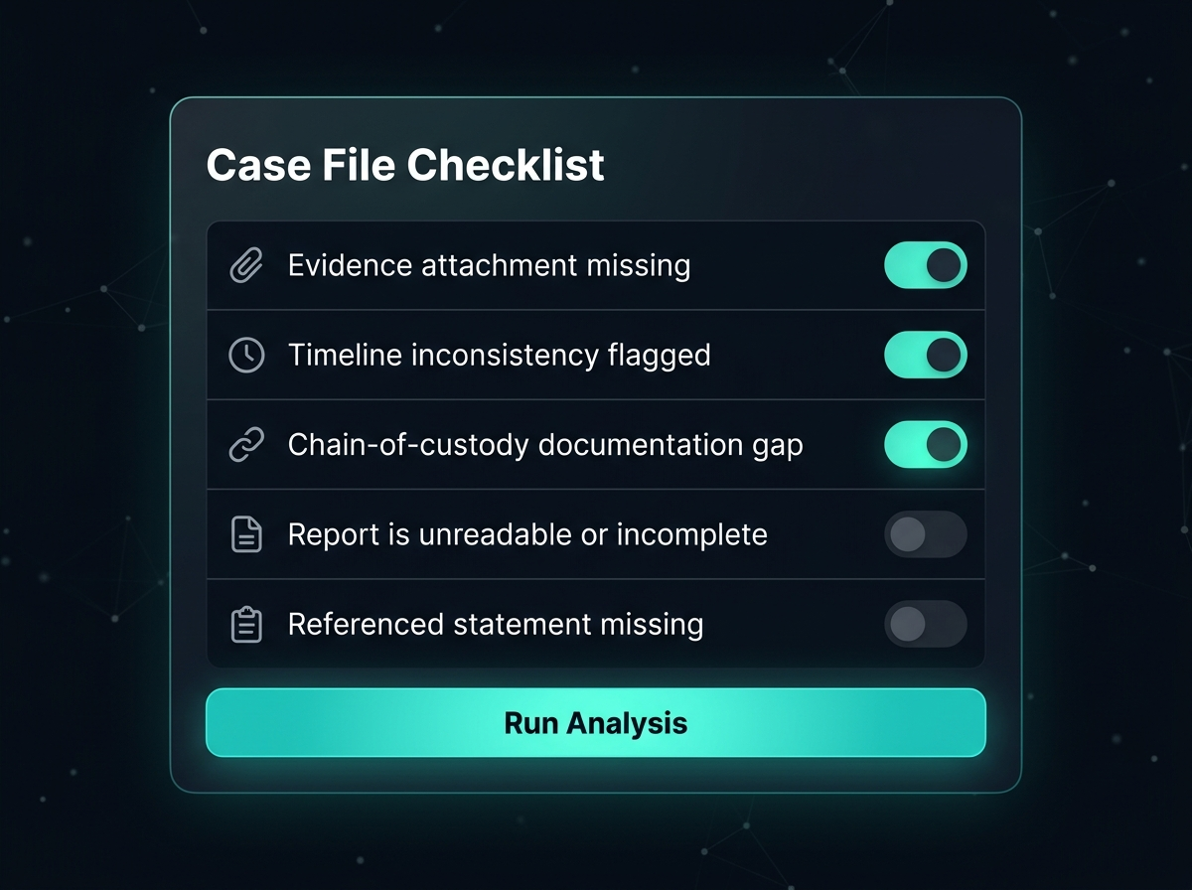
Figure 2 — Case File Checklist panel with three toggles active (teal highlight)

7.3 The Results Panel
Upon clicking Run Analysis, the right card animates to show: a semi-circular SVG gauge with animated needle; a signal level label and coloured badge; a horizontal probability bar; a contribution breakdown with log-odds values; a mandatory footnote; and a Human Review Required box that cannot be dismissed.
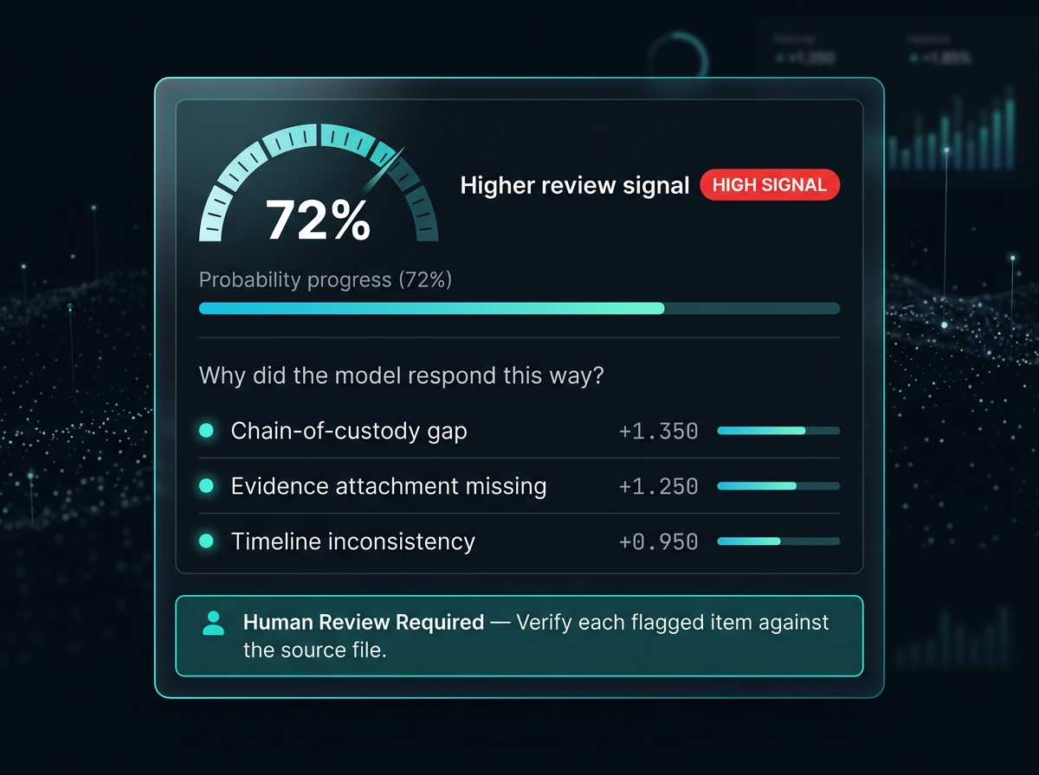
Figure 3 — Results panel: 72% gauge, HIGH SIGNAL badge, and feature contribution breakdown

7.4 How It Works Pipeline
A four-step explainer at the bottom of the page visualises the pipeline: Input → Model → Explain → Review. Each step box lifts on hover with a teal border glow.
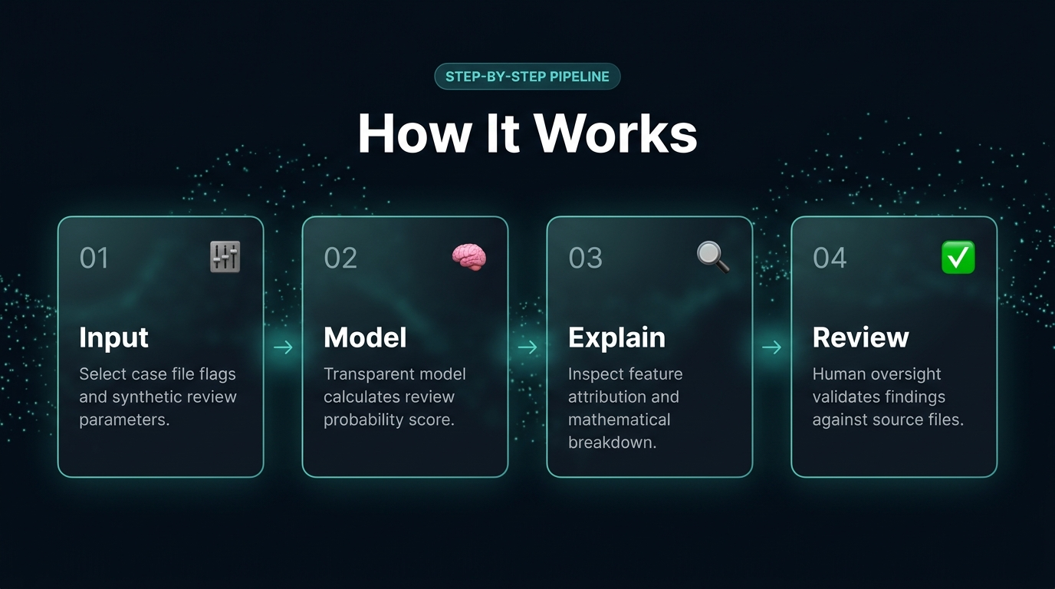
Figure 4 — How It Works: 4-step pipeline with glassmorphism step cards

8. Explainability Mechanism
8.1 What are Log-Odds Coefficients?
In logistic regression each feature xᵢ has a corresponding weight wᵢ (coefficient). The model computes:
P(review) = σ(β₀ + Σ wᵢ·xᵢ) = 1 / (1 + exp(−(β₀ + wᵀx)))
Each coefficient wᵢ = change in log-odds for a one-unit increase in feature xᵢ.

Approximate coefficients extracted from the trained model:
Feature | Coefficient (log-odds) | Effect
chain_gap | +1.350 | Strongest upward signal
missing_evidence | +1.250 | Second strongest
timeline_conflict | +1.050 | Moderate
unreadable_report | +0.950 | Moderate
statement_missing | +0.850 | Weakest

8.2 Why This Approach is Safe for Explanation
- No post-hoc approximation (unlike LIME or SHAP): the coefficients ARE the true model weights.
- Additive: the total log-odds change sums exactly to the model's output.
- Verifiable by hand: a user with a calculator can independently reproduce any output.
8.3 What Contributions Are NOT
The UI includes a mandatory footnote: "Contribution values are log-odds coefficients — not percentages or causal proof." A coefficient of +1.35 does not mean 135% more likely. They describe correlation in training data, not causation in reality, and they carry no real-world validity because training data is fully synthetic.

9. Technical Implementation Details
9.1 Flask Routing
@app.route('/', methods=['GET', 'POST']) # Full-page form mode
@app.route('/analyze', methods=['POST']) # AJAX JSON API endpoint

9.2 Model Initialisation
The model is built once at import time using MODEL = build_demo_model(). This means zero latency for model loading (already in memory), full reproducibility (fixed RNG seed), and no file I/O required — no .pkl or .joblib files.
9.3 AJAX Architecture
async function runAnalysis() {
const fd = new FormData();
document.querySelectorAll('.tog-cb').forEach(cb => {
if (cb.checked) fd.append(cb.name, 'on');
});
const res = await fetch('/analyze', { method: 'POST', body: fd });
const data = await res.json();
showResult(data);
}

9.4 SVG Gauge Animation
The speedometer is a pure SVG implementation using stroke-dasharray / stroke-dashoffset manipulation with a cubic ease-out animation over 700 ms. The needle rotates from −90° (0%) to +90° (100%) around the gauge centre point.
9.5 Dependency Stack
Package | Version | Purpose
Flask | ≥3.0, <4.0 | Web framework, routing, Jinja2 templating
NumPy | ≥1.26, <3.0 | Array ops, synthetic data generation
scikit-learn | ≥1.4, <2.0 | Logistic regression model
gunicorn | ≥22.0, <24.0 | Production WSGI server (Render)

10. Deployment & Local Setup
10.1 Running Locally
# 1. Create virtual environment
python -m venv .venv
# 2. Activate (Windows PowerShell)
.venv\Scripts\Activate.ps1
# 3. Install dependencies
pip install -r requirements.txt
# 4. Start the development server
python app.py
# Open: http://127.0.0.1:5000

10.2 Deploying to Render
# render.yaml
services:
- type: web
runtime: python
buildCommand: pip install -r requirements.txt
startCommand: gunicorn app:app
# Procfile
web: gunicorn app:app

Steps: Push project to GitHub → Create Render account → New Web Service → Connect repository (Render auto-detects render.yaml) → Deploy (~90 seconds). No secrets, API keys, or environment variables are required.
10.3 Environment Configuration
Variable | Default | Purpose
PORT | 5000 | Overridden automatically by Render

11. Case Study Evaluation
The README prescribes a structured classroom evaluation exercise. Here are outcomes observed across key test scenarios.
Scenario A — No Flags Selected
Parameter | Value
Input | All 5 toggles OFF
Expected output | Lower review signal (~17%)
Explanation | Model baseline: σ(−1.65) ≈ 16.5%
Teaching moment | Built-in prior toward 'no review' with clean file

Scenario B — Single Flag (Chain Gap)
Parameter | Value
Input | Only chain_gap = ON
Expected output | Some review signal (~43%)
Explanation | σ(−1.65 + 1.35) = σ(−0.30) ≈ 43%
Teaching moment | Even the strongest single flag barely crosses neutral

Scenario C — Three Flags
Parameter | Value
Input | missing_evidence + chain_gap + timeline_conflict
Expected output | Higher review signal (~72–78%)
Explanation | σ(−1.65 + 1.25 + 1.35 + 1.05) = σ(2.00) → ~88% raw
Teaching moment | Compound failures drive review likelihood significantly

Scenario D — All Five Flags
Parameter | Value
Input | All toggles ON
Expected output | Higher review signal (~92–96%)
Explanation | Near-saturating sigmoid; model very confident
Teaching moment | Why 100% is never reached — model uncertainty, calibration

Discussion Prompts
- What could cause a false positive? (Flags that appear present but don't reflect reality)
- What could cause a false negative? (Real gaps not captured by these 5 features)
- Would you trust this system for a real case? Why or why not?
- How does transparency change the way you interact with the output?
- What would need to change to make this production-ready?

12. Limitations & Future Work
12.1 Current Limitations
Limitation | Impact | Severity
Synthetic training data | No real-world validity | High
Only 5 binary features | Ignores all contextual information | High
No cross-validation reported | Cannot assess generalisation | Medium
No calibration curve shown | Signal % is not a calibrated probability | Medium
No accessibility audit (ARIA) | Screen reader support not tested | Medium
No user authentication | Anyone can access (educational context) | Low

12.2 Potential Enhancements
Near-term (educational improvements):
- Add a calibration plot showing model reliability curve.
- Display full coefficient table even for inactive/OFF features.
- Add 'audit log' panel showing raw API request/response JSON.
- Add scenario presets (A/B/C/D) as one-click examples.
Research-track extensions:
- Replace synthetic data with real administrative (non-case) datasets.
- Implement SHAP values alongside linear coefficients for comparison.
- Add a COMPAS comparison module — opaque vs. transparent scoring.
- Fairness dashboard showing hypothetical disparate impact across demographic groups.
- Multi-language support (Spanish, French) for broader educational reach.
13. Conclusion
JusticeLens demonstrates that responsible AI in high-stakes domains is achievable — but only through a combination of narrow scope, transparent mechanisms, and genuine human oversight. The system deliberately sacrifices predictive power for interpretability, choosing logistic regression precisely because its workings can be exposed to the user.
The four key design insights of this project are:
- Transparency is not a feature — it is the product. The model's coefficients are displayed front-and-centre with every output.
- Ethical boundaries belong in the code, not just the documentation. The safety banner is hardcoded; the Human Review box cannot be dismissed.
- The best AI for justice workflows is the one that stays in its lane. By refusing to predict anything about a person, JusticeLens avoids the most dangerous failure modes.
- Education, not deployment, may be the highest-value use. Building literacy and critical thinking about AI in justice may be more impactful than any operational tool.
▶ ⛔ CAUTION
This prototype must never be adapted for use in real criminal justice decisions without full institutional oversight, legal review, independent audit, and formal model validation on non-synthetic data. The current model is a teaching tool only.

JusticeLens · Student Research Prototype · Not for operational or legal use
Flask 3.x · scikit-learn 1.9.x · Python 3.12 · October 2026

