

CSE 3502
Information Security Management

Lab Report – 3
Access Lists
Winter Semester 2022-23
Name:Aditya Krishna
Reg No.:20BCE0456
Guided by: Prof. Lavanya K

z10th Feb, 2023
Introduction to ACL:

A series of rules known as an access control list (ACL) defines which people or systems are allowed or denied access to a certain object or system resource. Additionally, access control lists are implemented in switches and routers, where they serve as filters to govern which traffic is allowed access to the network.
A security property on each system resource identifies the access control list for that resource. Every person who has access to the system has a place on the list. The most typical rights for a file system ACL are the capacity to read a file or all the files in a directory, to write to the file or files, and, if the file is an executable file or programme, to run it.
Types of Access Lists:

1. Standard access lists
A Standard access list can use only the source IP address in an IP packet to filter the network traffic. Standard access lists are typically used permit or deny an entire system or network. They cannot be used to filter individual protocol or services such as FTP and Telnet.

2. Extended access lists
Extended access lists use the source and destination IP addresses. They can be used to filter specific protocol or service.

Step 1 : Outlining the components and their connections
Components used include:
1. 2811-type Routers: Router0 and Router1
2. Switch 2960-24TT: Switch0
3. Server-PT: Server0
4. PC-PT: PC0 and PC1
Making the topology
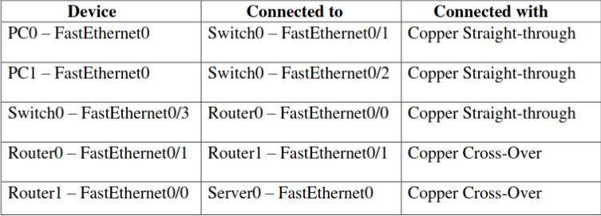
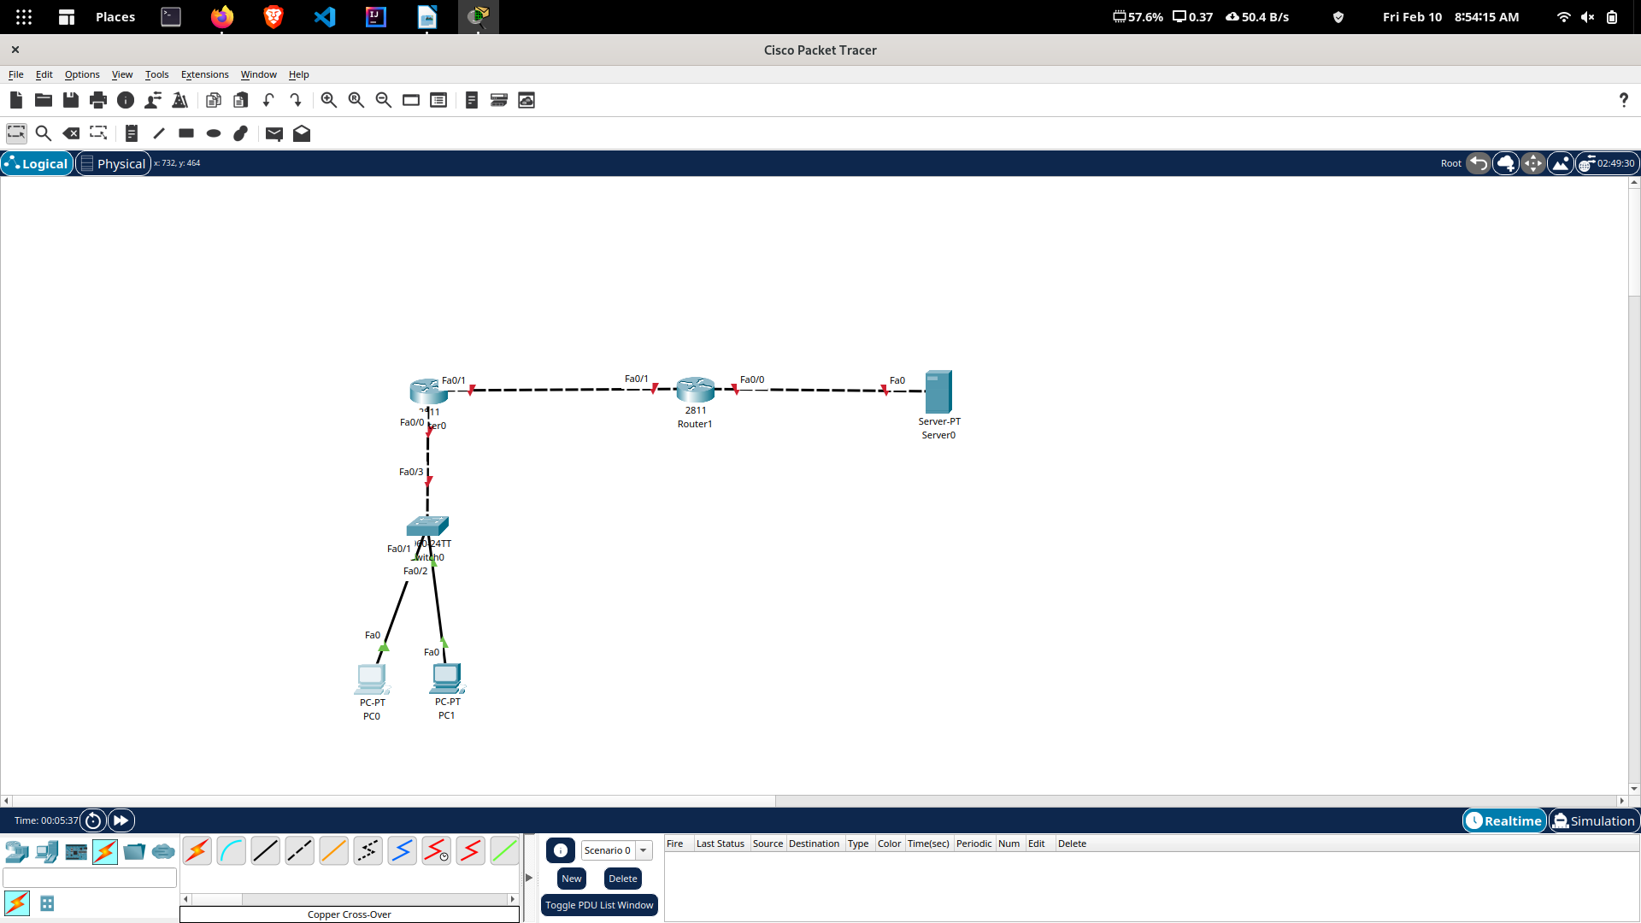
Step2 : Assigning IP Addresses
Device | Connection | IP Address
PC0 | FastEthernet0 | 10.0.0.2/8
PC1 | FastEthernet0 | 10.0.0.3/8
Router0 | FastEthernet0/0 | 10.0.0.1/8
Router0 | FastEthernet0/1 | 192.168.0.1/24
Router1 | FastEthernet0/1 | 192.168.0.2/24
Router1 | FastEthernet0/0 | 20.0.0.1/8
Server0 | FastEthernet0 | 20.0.0.2/8

Default Gateway PC0 and PC1 are set to ‘10.0.0.1’ and that of Server-PT is set to ‘192.168.0.1’.

The IP addresses can also be set using cli of the routers.

Router0( config)# int fa0/ 0
Router0( config-if)# ip add 10.0.0.1 255.0.0.0
Router0( config-if)# no shut
Router0( config-if)# exit
Router0( config)# int fa0/ 1
Router0( config-if)# ip add 192.168.0.1 255.255.255.0
Router0( config-if)# no shut
Router0( config-if)# exit
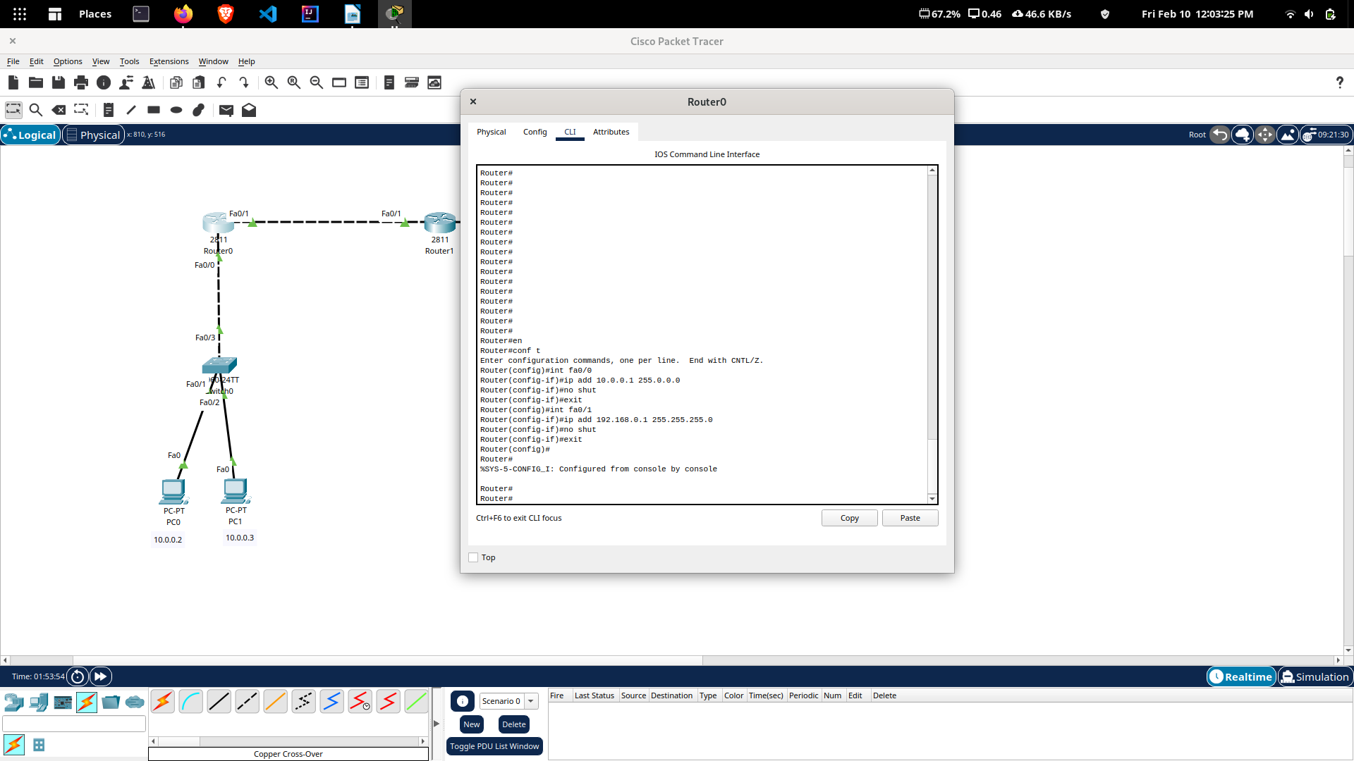

Router1( config)# int fa0/ 0
Router1( config-if)# ip add 20.0.0.1 255.0.0.0
Router1( config-if)# no shut
Router1( config-if)# exit
Router1( config)# int fa0/ 1
Router1( config-if)# ip add 192.168.0.2 255.255.255.0
Router1( config-if)# no shut
Router1( config-if)# exit

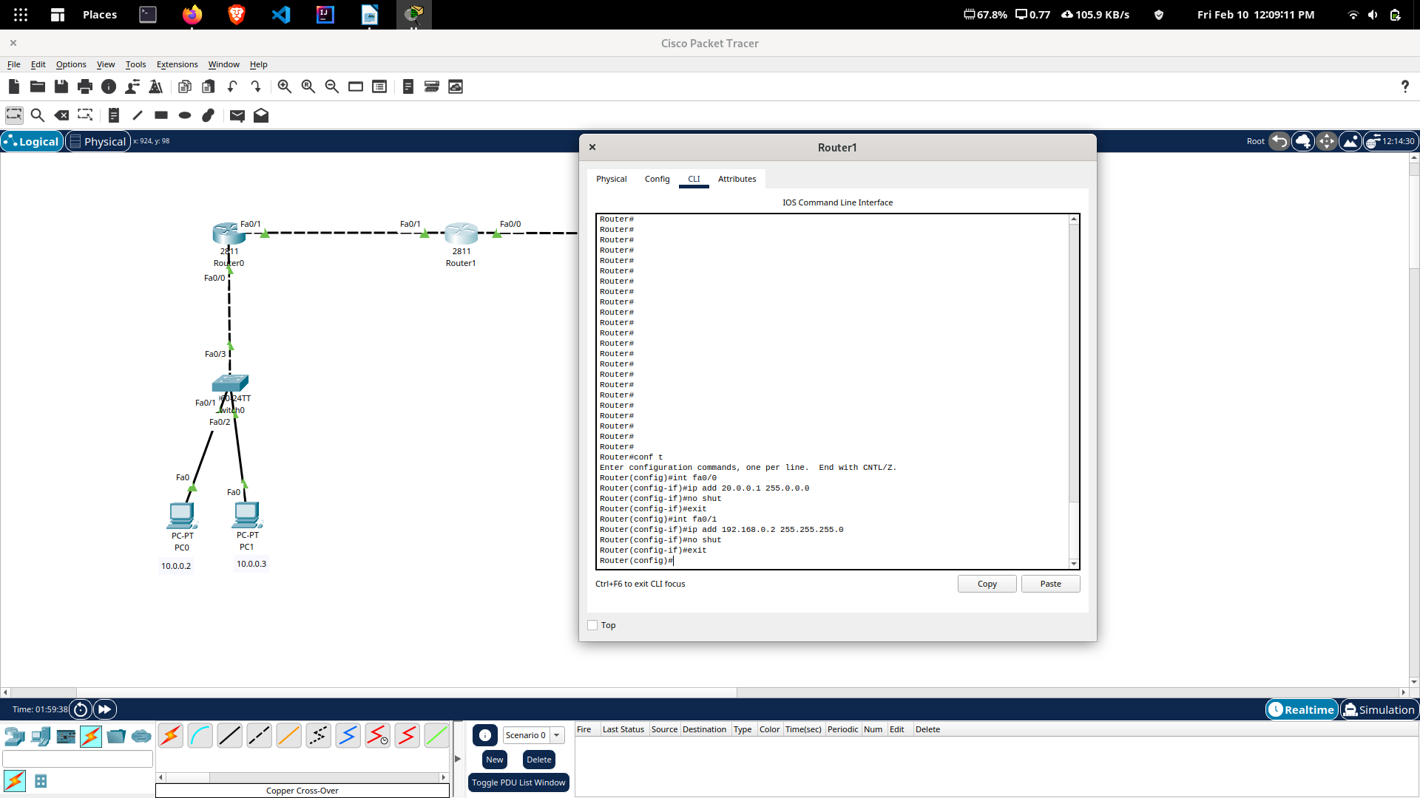

Step 3 : Setting a routing method
Once you have configured appropriate IP addresses, use a routing metho such as RIP. To do so, execute the following commands on Router0.
Router0( config)# router rip
Router0( config-router)# network 192.168.0.0
Router0( config-router)# network 10.0.0.0
Router0( config-router)# exit

Next, move on to Router1 and execute the following commands to configure
the RIP routing protocol.
Router1( config)# router rip
Router1( config-router)# network 192.168.0.0
Router1( config-router)# network 20.0.0.0
Router1( config-router)# exit

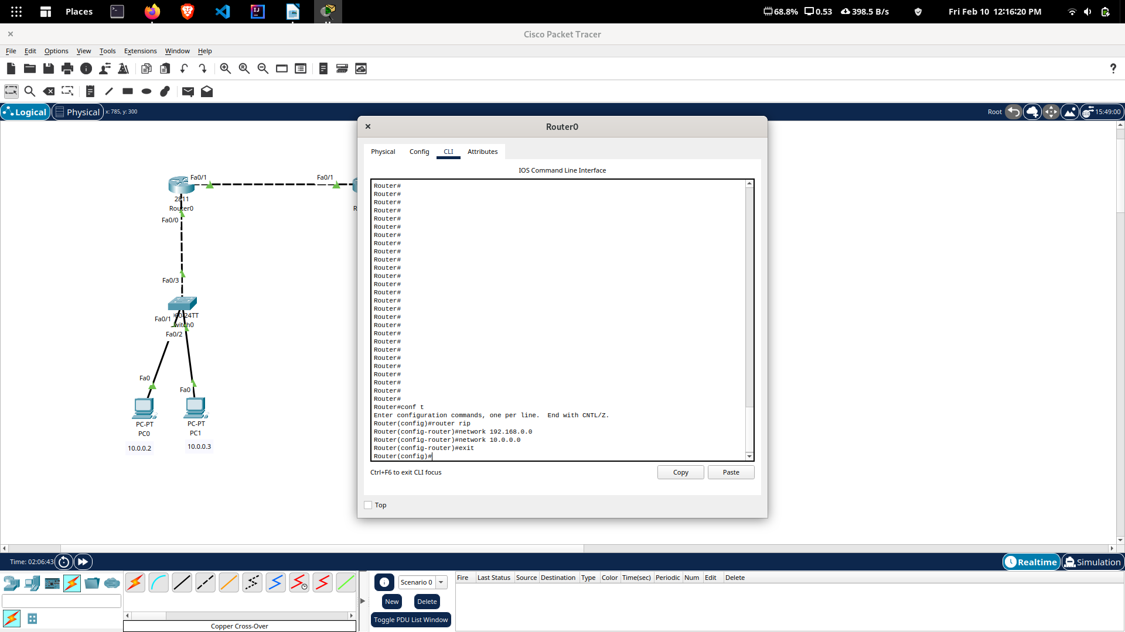

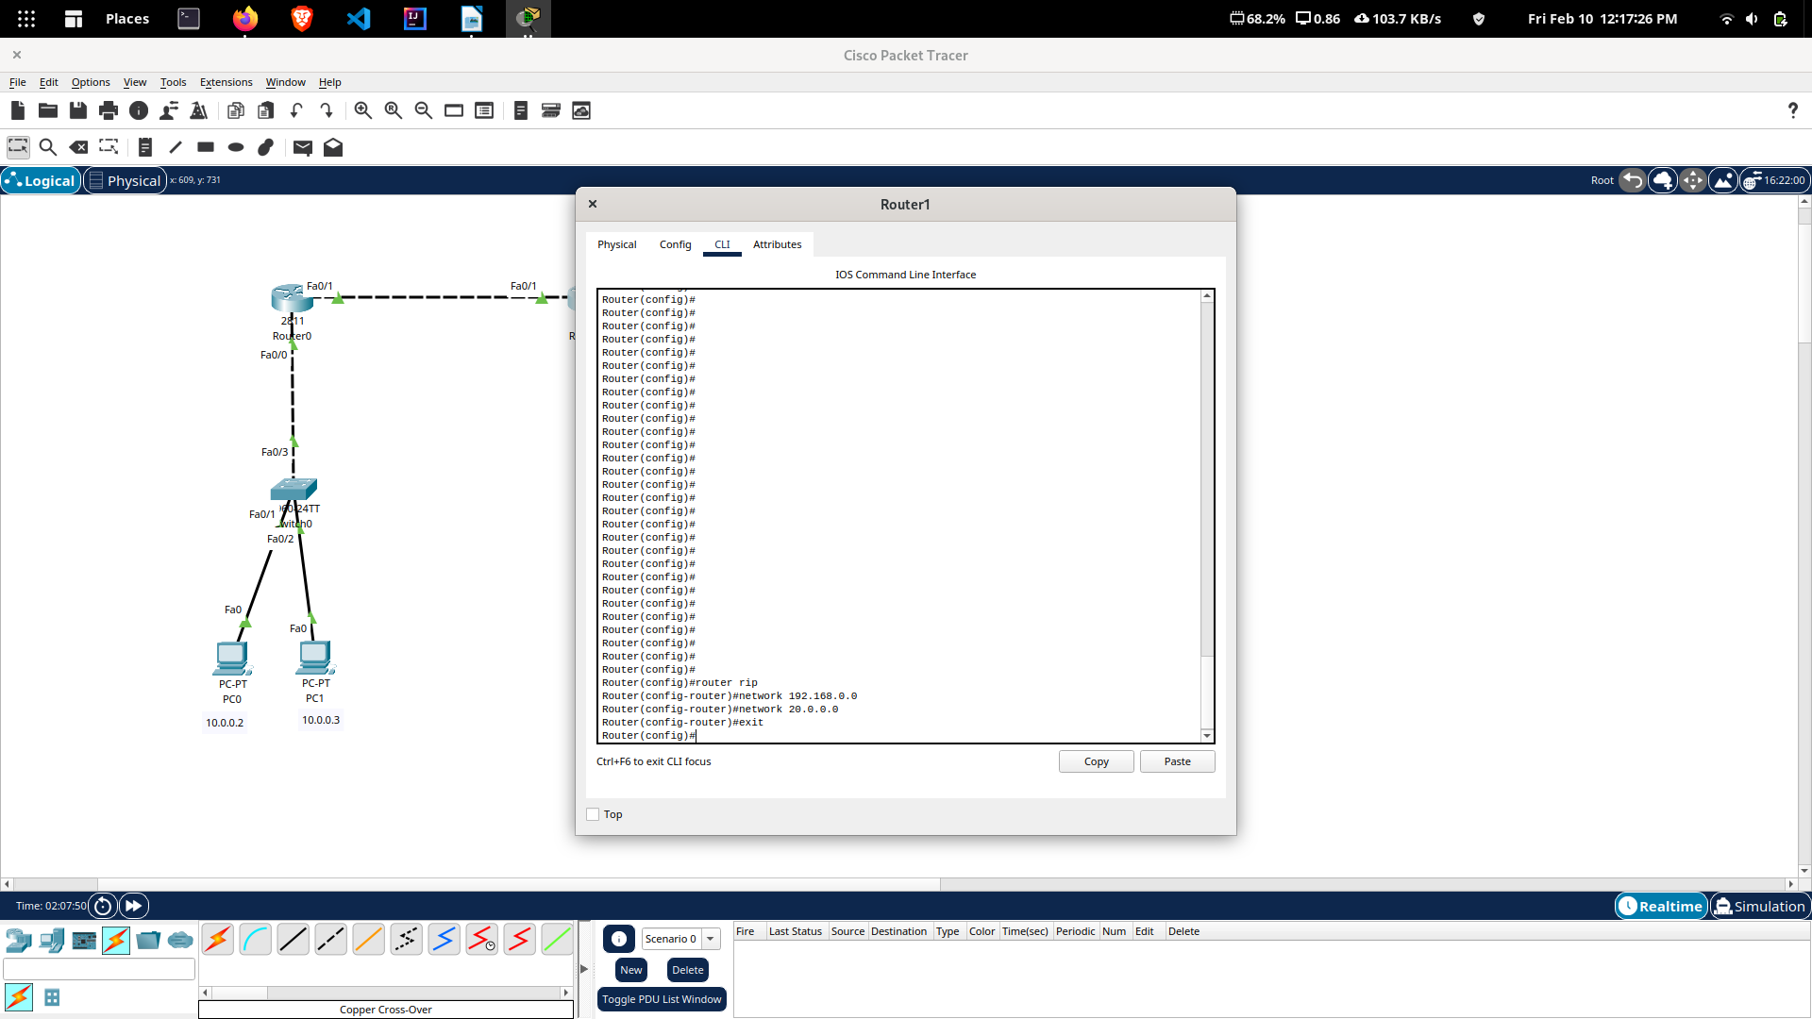

Step 4 : Configuring Standard ACL

As of now, we can ping the Server using PC0 or PC1.

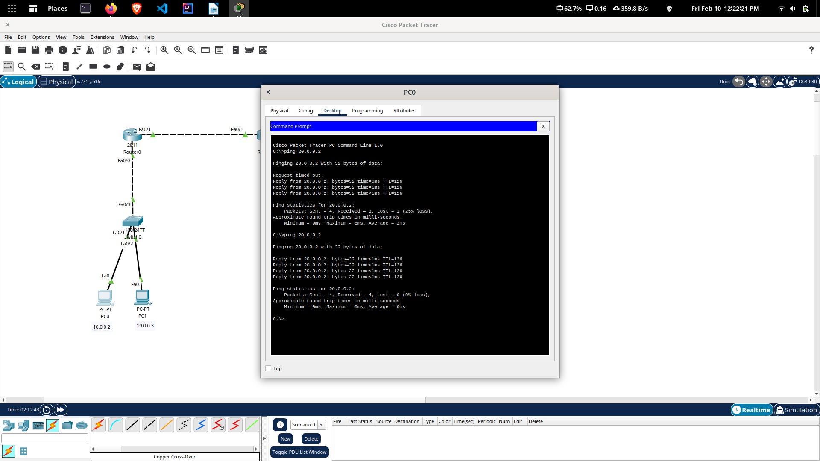

In this configuration, we will restrict host 10.0.0.2 (PC0) from accessing Router1.

It can be configured using the following CLI commands :

Router1( config)# access-list 10 deny host 10.0.0.2
Router1( config)# access-list 10 permit any
Router1( config)# int fa0/ 1
Router1( config-if)# ip access-group 10 in
Router1( config-if)# exit
Router1( config)# exit
Router1# show ip access-lists

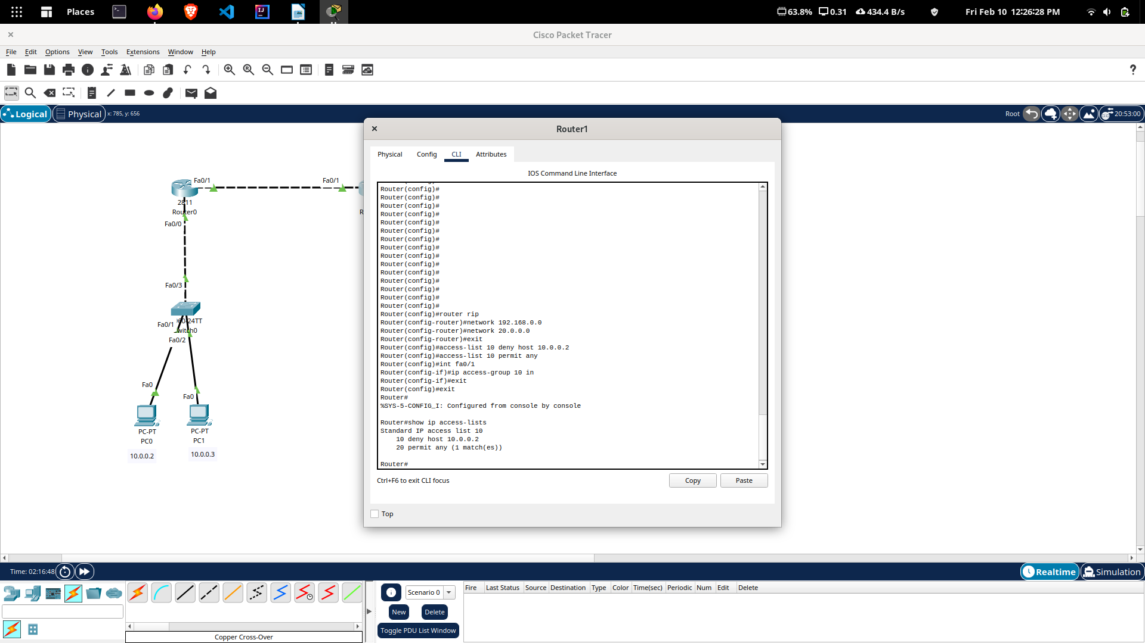
Step 5 : Verify Standard ACL Configuration
Now as we try to ping the Router1 using PC0, we can see that we can no longer
reach that network.
For testing, enter
ping 192.168.0.2, from PC0.
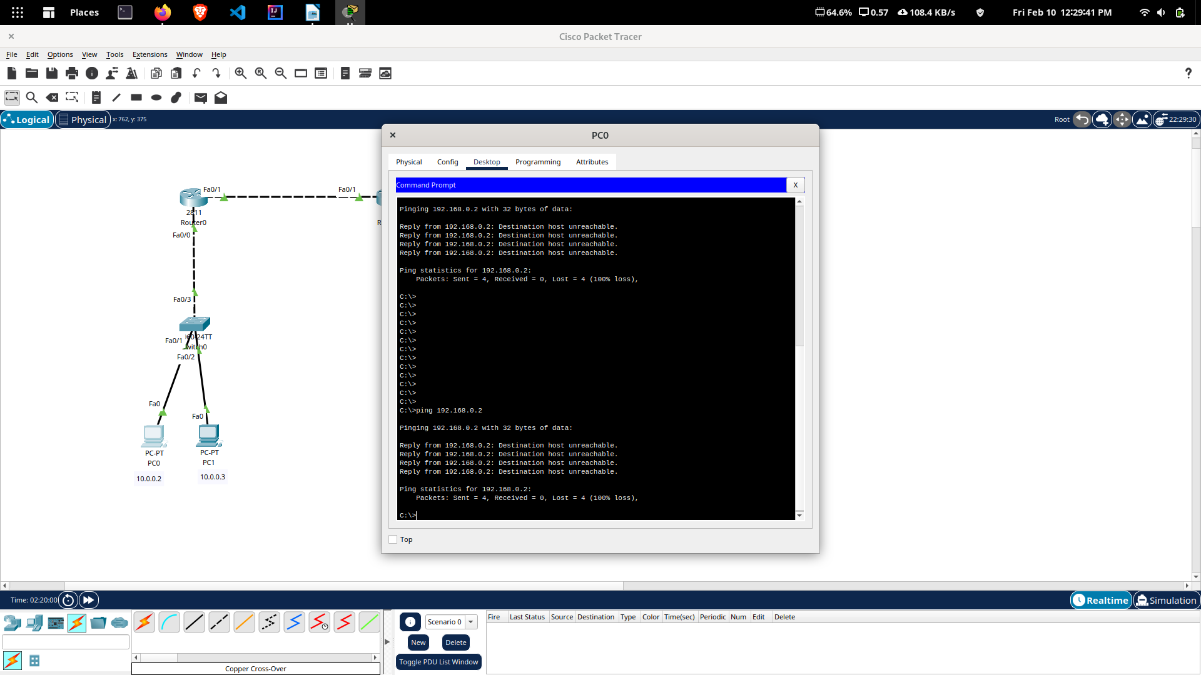
Now, after having tested the ACL configuration, we can remove the ACL
configuration so the next test could be performed. To remove the configured
ACL, execute the following command on Router1.
Router1( config)# no access-list 10 deny host 10.0.0.2
Try to ping again from PC0 to Router1, this time you should be able ping
successfully, because the applied ACL has been removed.
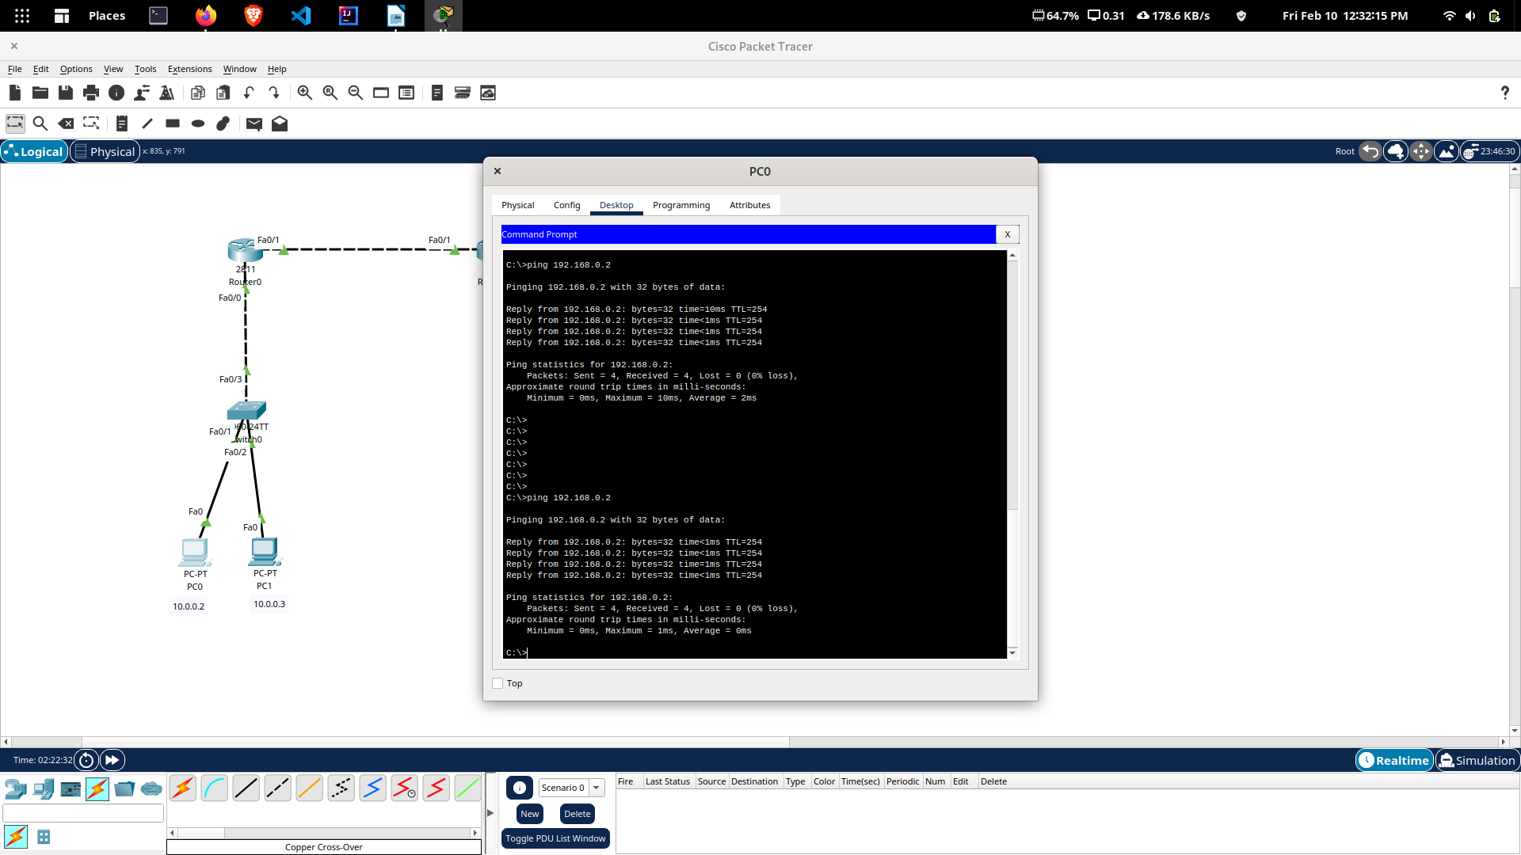
Step 6 : Configuring Extended ACL
To configure Extended ACL, we will deny the host 10.0.0.2 (PC0) from
accessing the web server (20.0.0.2).
In order to prevent host 10.0.0.2 to access the Web server (20.0.0.2), you need
to execute the following commands in the CLI of Router1.
Router1( config)# access-list 150 deny tcp host 10.0.0.2 20.0.0.2 0.0.0.0 eq
www
Router1( config)# access-list 150 permit ip any any
Router1( config)# int fa0/ 1
Router1( config-if)# ip access-group 150 in
Router1( config-if)# exit
Router1( config)# exit
Once you applied an ACL on the desired interface, execute the following
command to view the configured access lists.
Router1# show ip access-lists
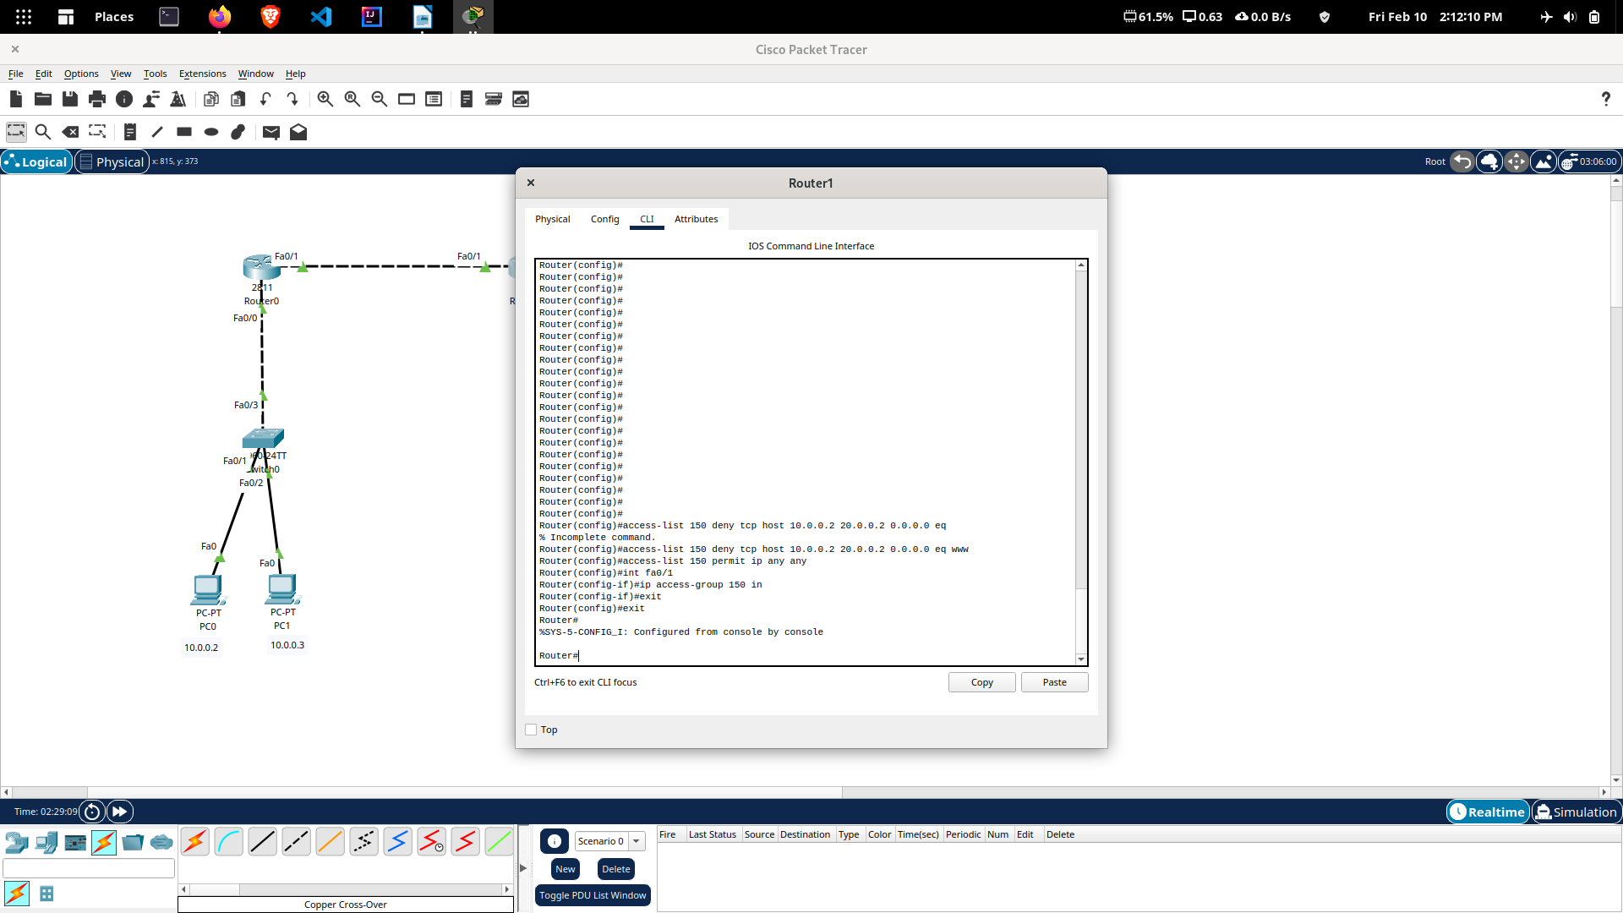
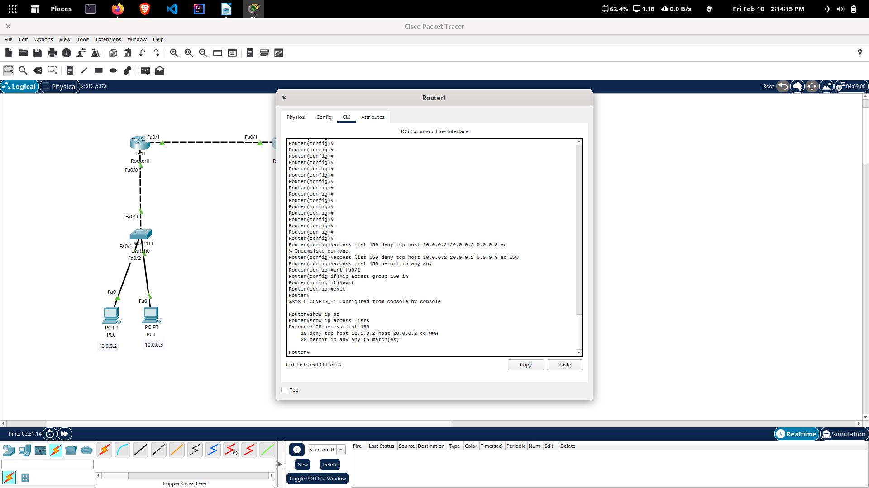
Step 7 : Verify Extended ACL Configuration
To verify your configuration, open the Web browser on PC0, type http://
20.0.0.2 and press Enter. You should not be able to access the Web server.

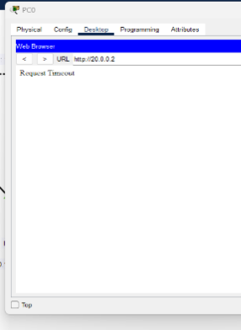

Now move on to PC1 and try to access server, this time you should be able
to access server. This is because we have not prevented PC1 to access
server.
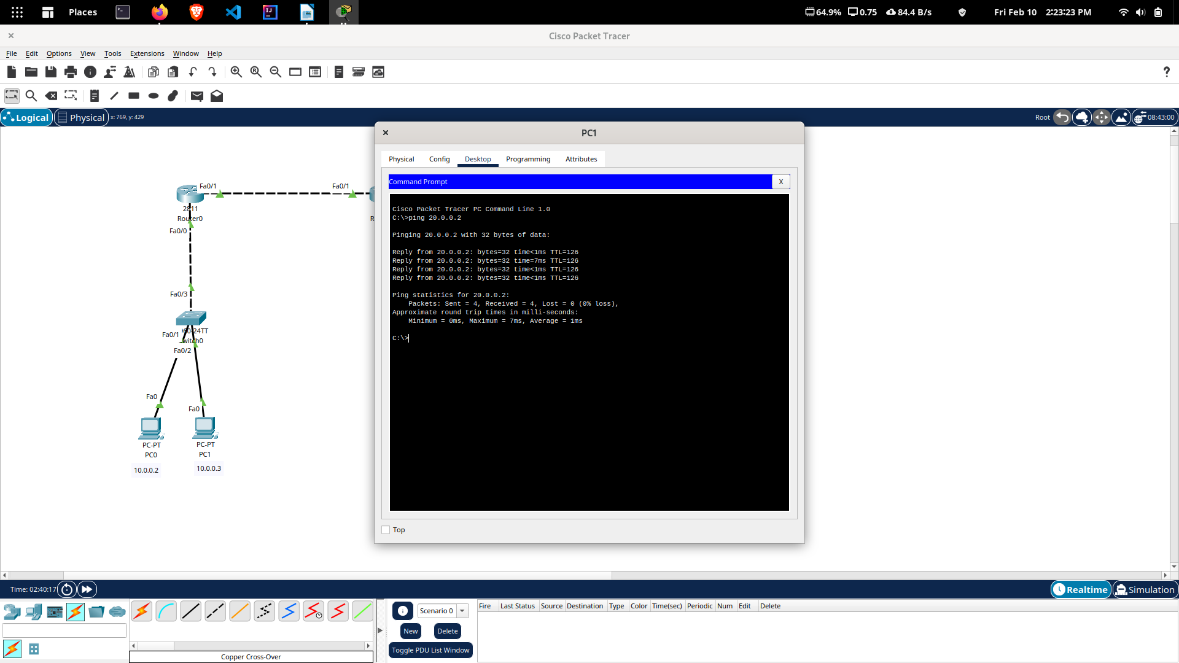
Now, you have configured and verified the Extended ACL, you can remove the
configured ACL. To do so, execute the following command on Router1.
Router1( config)# no access-list 150 deny tcp host 10.0.0.2 host 20.0.0.2 eq www

