
CSE 3502
Information Security Management
Winter Semester 2022-23
Lab Report – 4

Configuration of IOS Intrusion Prevention System (IPS)

Name:Aditya Krishna
Reg No.:20BCE0456
Guided by: Prof. Lavanya K

24th Feb, 2023

Introduction :
An IOS Intrusion Prevention System (IOS IPS) is a security technology designed to detect and prevent various types of network attacks, including network-based and application-based attacks, from penetrating and exploiting vulnerabilities in a network. It is implemented as a software module within the Cisco IOS software running on routers and switches. The IOS IPS performs real-time traffic analysis of network traffic passing through the device, compares it against predefined attack signatures, and takes action to block the traffic that matches these signatures.The IPS can operate in inline mode, where it actively blocks suspicious traffic, or in promiscuous mode, where it only monitors traffic and sends alerts to the network administrator for further analysis. By proactively identifying and blocking potential threats, an IOS IPS helps to improve the overall security posture of a network and minimize the risk of security breaches.

Objectives/AIM

• Enable IOS IPS.
• Configure logging.
• Modify an IPS signature.
• Verify IPS.

Step 0: Make the topology

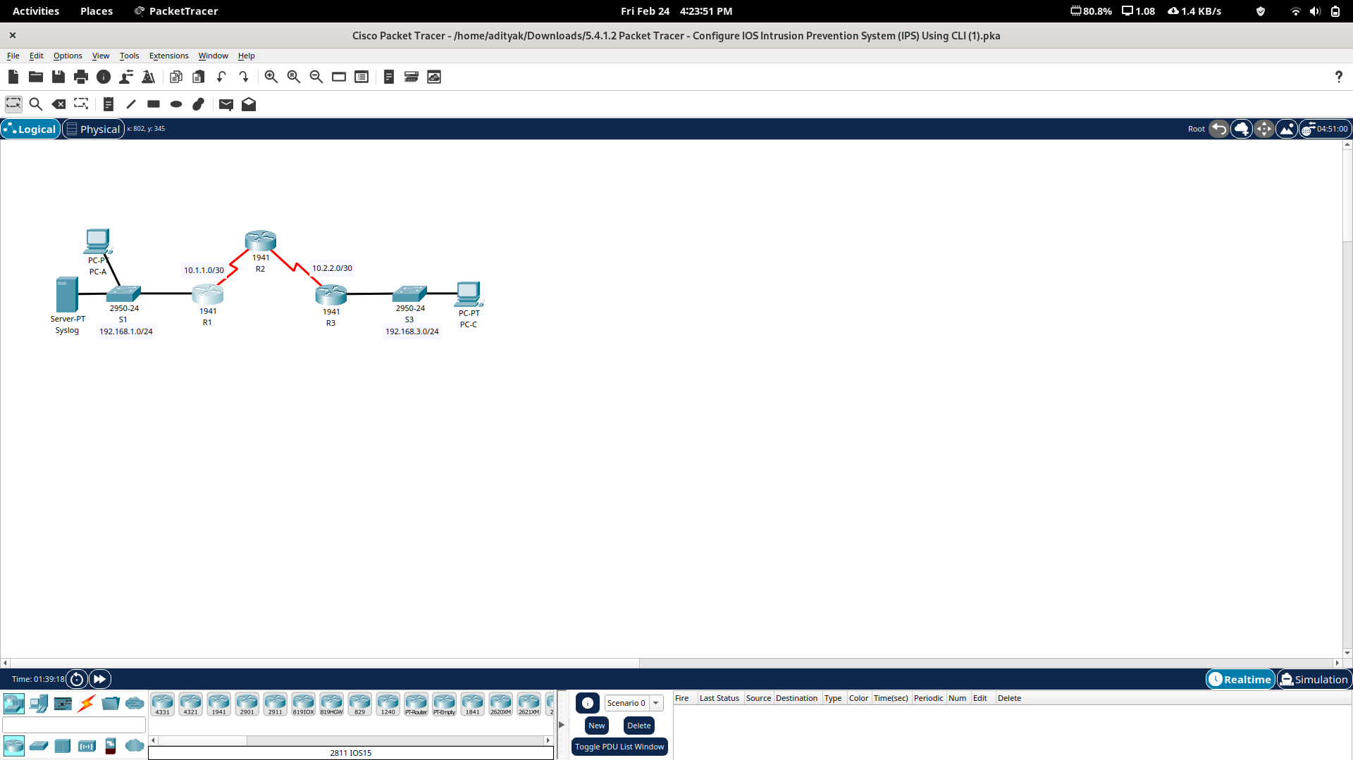

IP Addressing Table

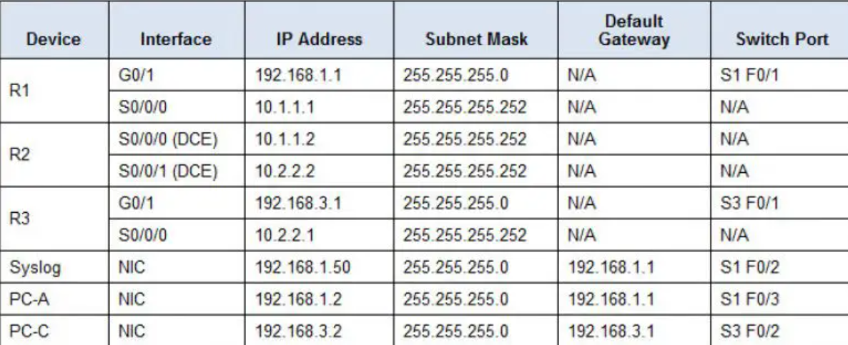
Assign IP’s respectively & enable the connections.

Part 1: Enable IOS IPS

Step 1: Enable the Security Technology package.

a. On R1, issue the show version command to view the Technology Package license information.

b.If the Security Technology package has not been enabled, use the following command to enable the package.
R1(config)# license boot module c1900 technology-package securityk9

c. Accept the end user license agreement.

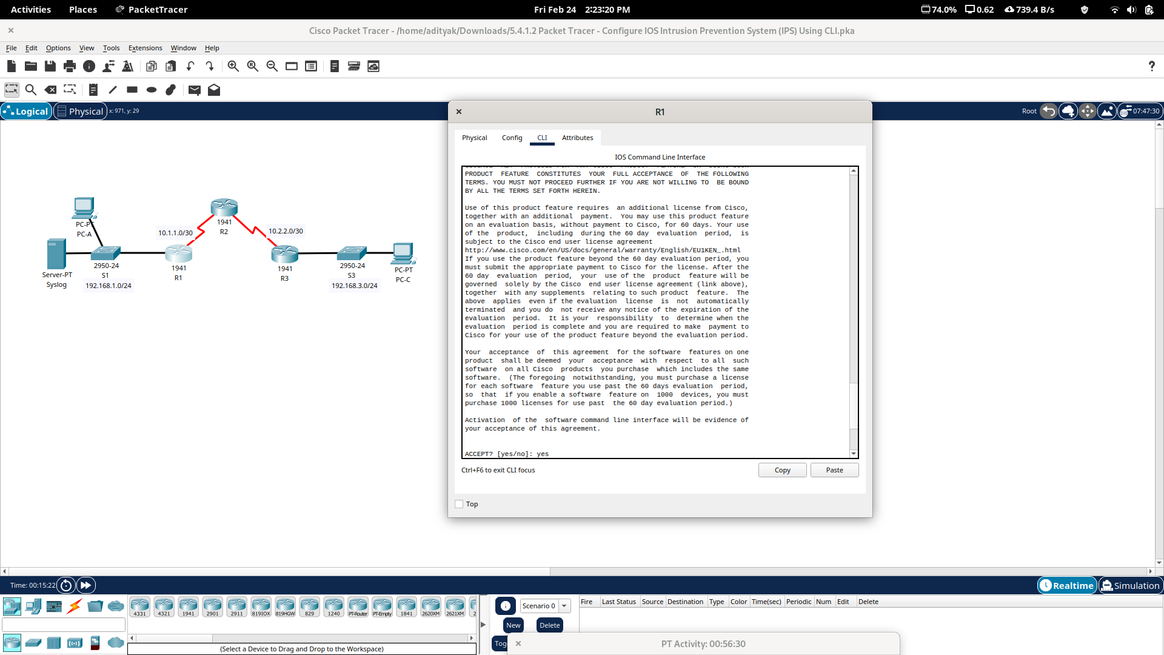
d.Save the running-config and reload the router to enable the security license.

e.Verify that the Security Technology package has been enabled by using the show version command.

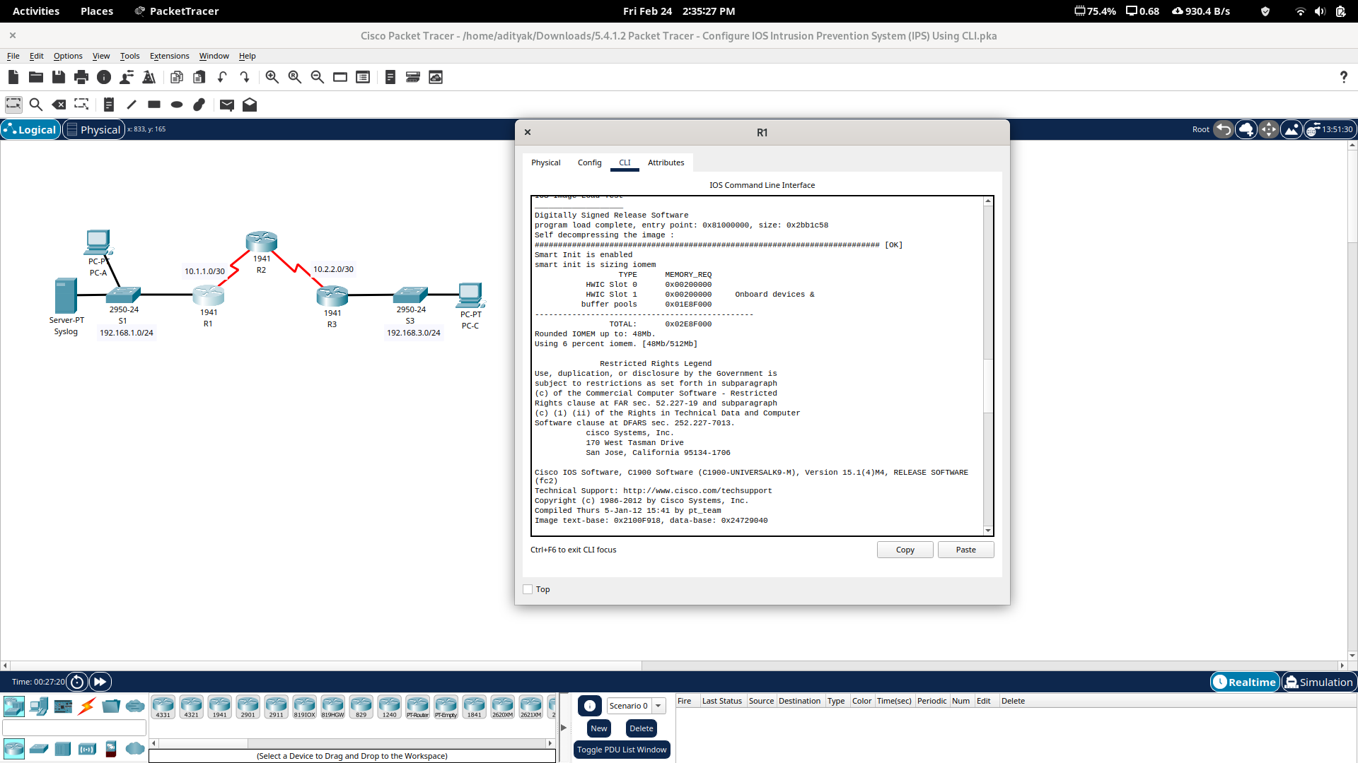

Step 2: Verify network connectivity.

a. Ping from PC-C to PC-A. The ping should be successful.

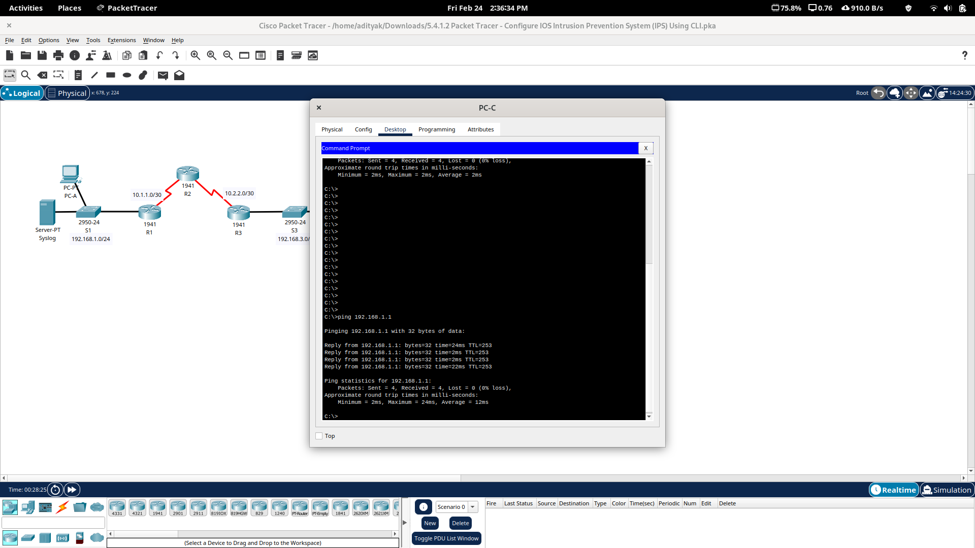

b. Ping from PC-A to PC-C. The ping should be successful.

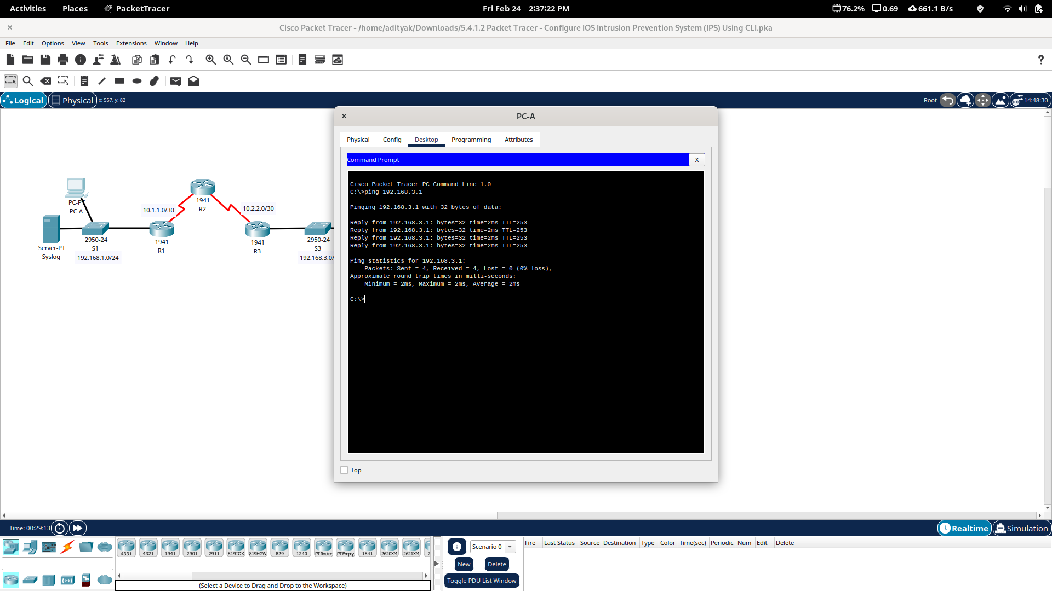
Step 3: Create an IOS IPS configuration directory in flash.

On R1, create a directory in flash using the mkdir command. Name the directory ipsdir.

R1#mkdir ipsdir
Create directory filename [ipsdir]? <ENTER>
Created dir flash:ipsdir

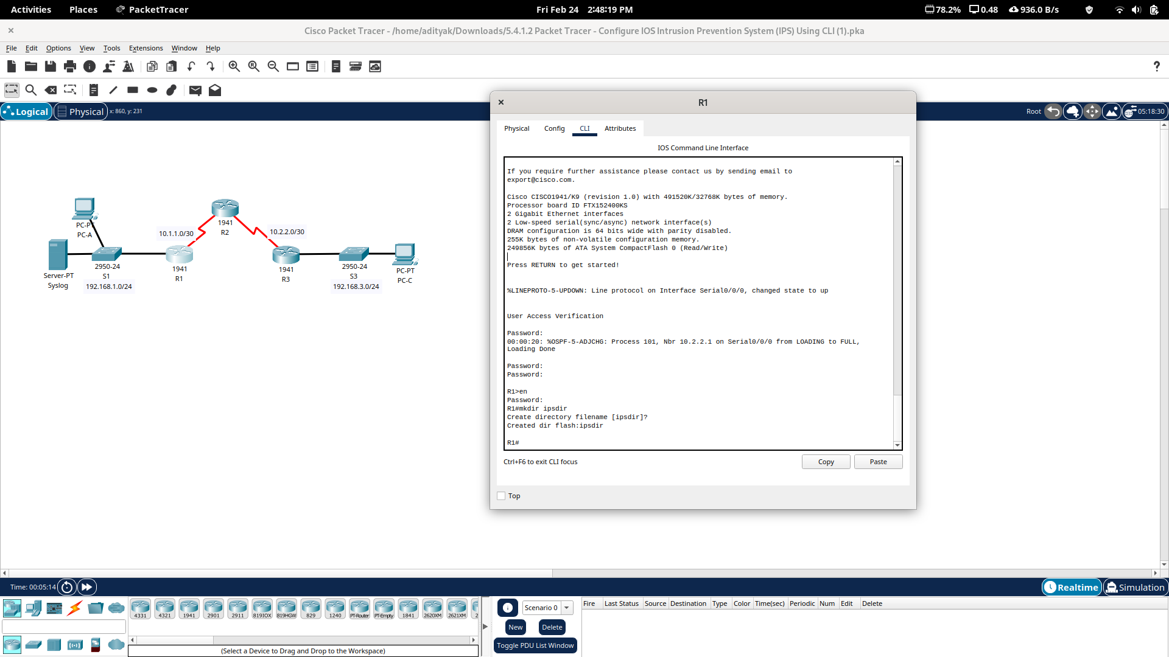

Step 4: Configure the IPS signature storage location.
On R1, configure the IPS signature storage location to be the directory you just created.
ip ips config location flash:ipsdir

Step 5: Create an IPS rule.
On R1, create an IPS rule name using the ip ips name name command in global configuration mode. Name the IPS rule iosips.
ip ips name iosips

Step 6: Enable logging.
IOS IPS supports the use of syslog to send event notification. Syslog notification is enabled by default. If logging console is enabled, IPS syslog messages display.
a.Enable syslog if it is not enabled
ip ips notify log

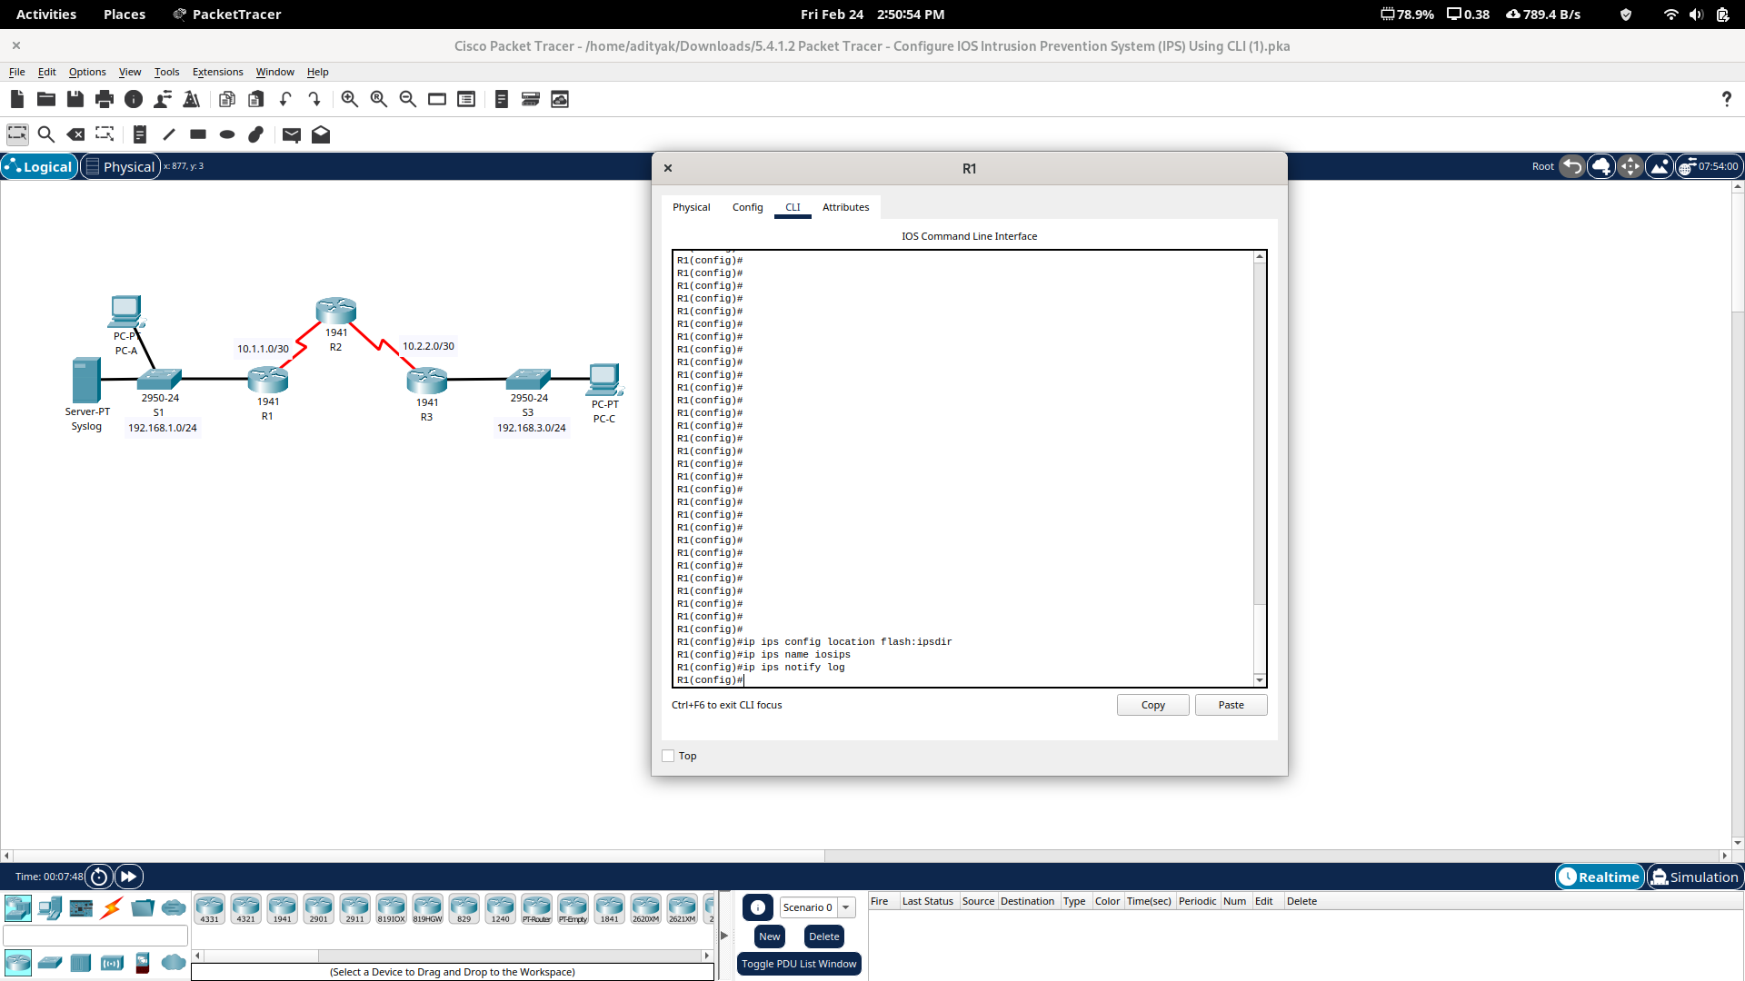
b.If necessary, use the clock set command from privileged EXEC mode to reset the clock.
R1# clock set 10:20:00 10 january 2014
c.Verify that the timestamp service for logging is enabled on the router using the show run command. Enable the timestamp service if it is not enabled.
R1(config)# service timestamps log datetime msec
d.Send log messages to the syslog server at IP address 192.168.1.50.
R1(config)# logging host 192.168.1.50
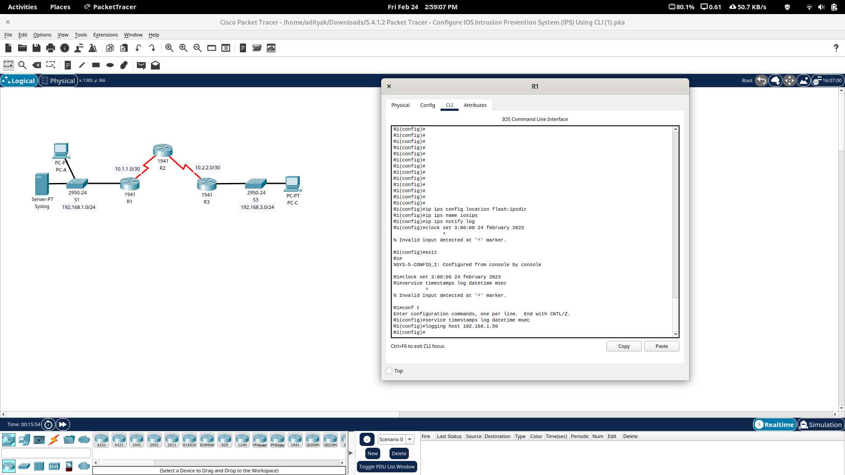

Step 7: Configure IOS IPS to use the signature categories.

Retire the all signature category with the retired true command. Unretire the IOS_IPS Basic category with the retired false command.

R1(config-ips-category)# category all
R1(config-ips-category-action)# retired true
R1(config-ips-category-action)# exit
R1(config-ips-category)# category ios_ips basic
R1(config-ips-category-action)# retired false
R1(config-ips-category-action)# exit
R1(config-ips-cateogry)# exit
Do you want to accept these changes? [confirm] <Enter>
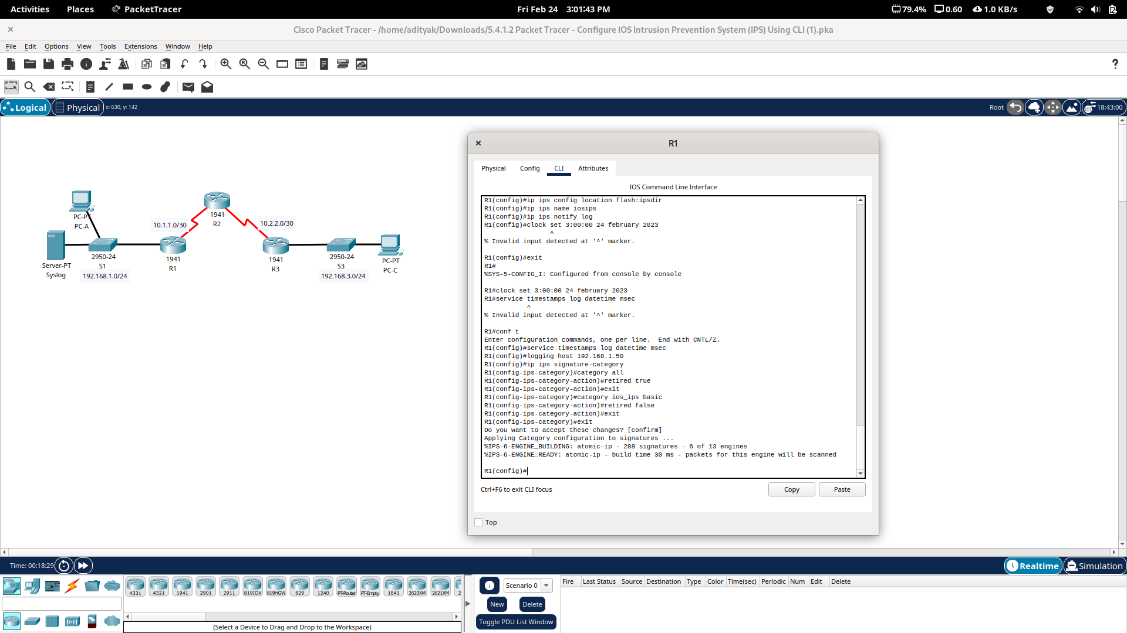

Step 8: Apply the IPS rule to an interface.
Apply the IPS rule to an interface with the ip ips name direction command in interface configuration mode. Apply the rule outbound on the G0/1 interface of R1. After you enable IPS, some log messages will be sent to the console line indicating that the IPS engines are being initialized.
R1(config)#interface g0/1
R1(config-if)#ip ips iosips out

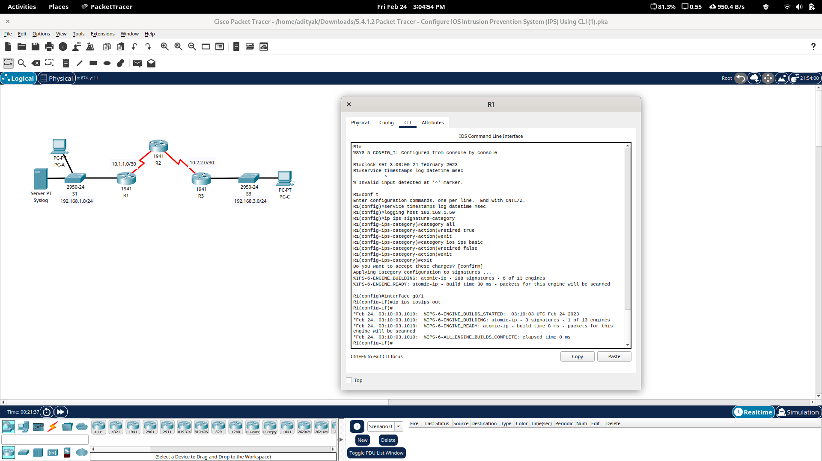

Part 2: Modify the Signature

Step 1: Change the event-action of a signature.
Un-retire the echo request signature (signature 2004, subsig ID 0), enable it, and change the signature action to alert and drop.
R1(config)# ip ips signature-definition
R1(config-sigdef)# signature 2004 0
R1(config-sigdef-sig)# status
R1(config-sigdef-sig-status)# retired false
R1(config-sigdef-sig-status)# enabled true
R1(config-sigdef-sig-status)# exit
R1(config-sigdef-sig)# engine
R1(config-sigdef-sig-engine)# event-action produce-alert
R1(config-sigdef-sig-engine)# event-action deny-packet-inline
R1(config-sigdef-sig-engine)# exit
R1(config-sigdef-sig)# exit
R1(config-sigdef)# exit
Do you want to accept these changes? [confirm] <Enter>

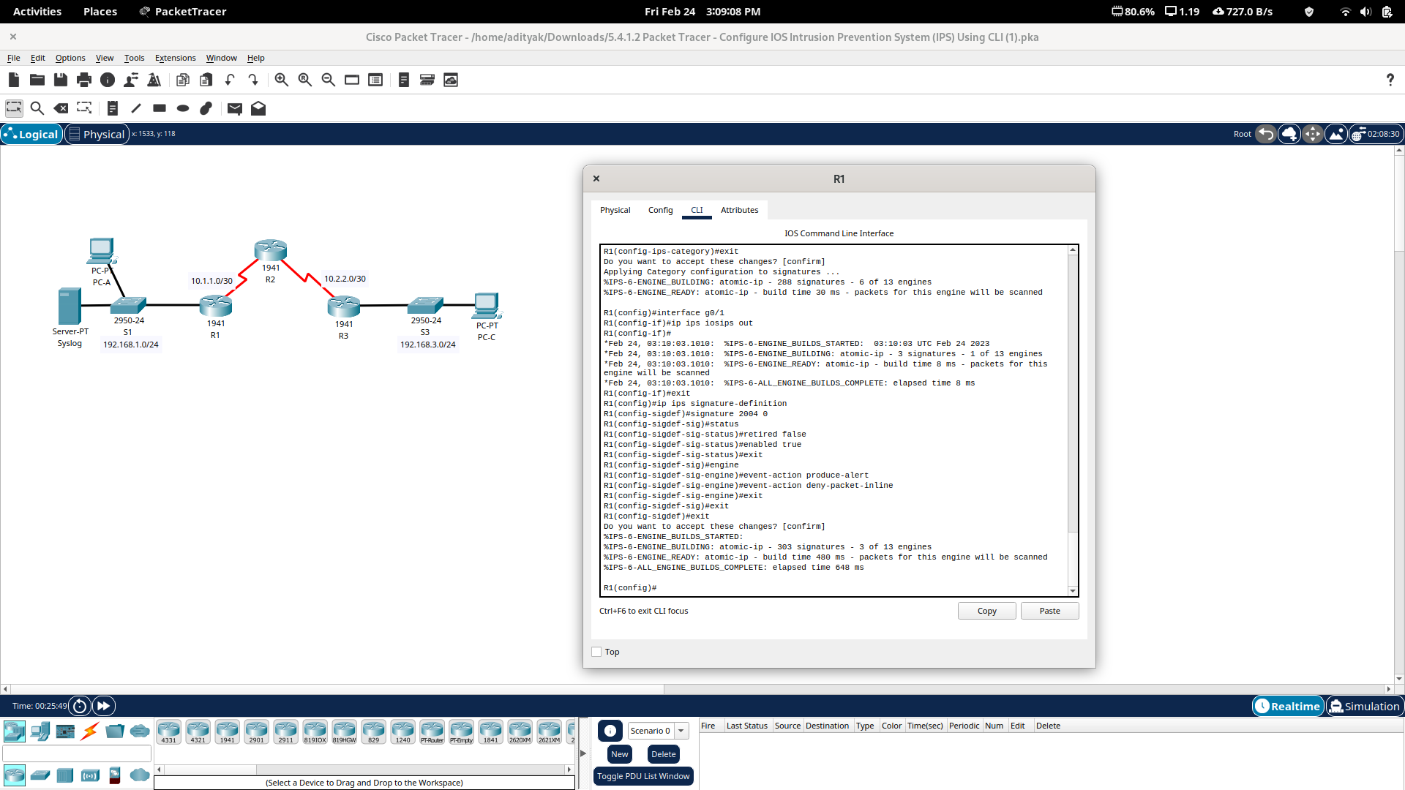

Step 2: Use show commands to verify IPS.
Use the show ip ips allcommand to view the IPS configuration status summary.

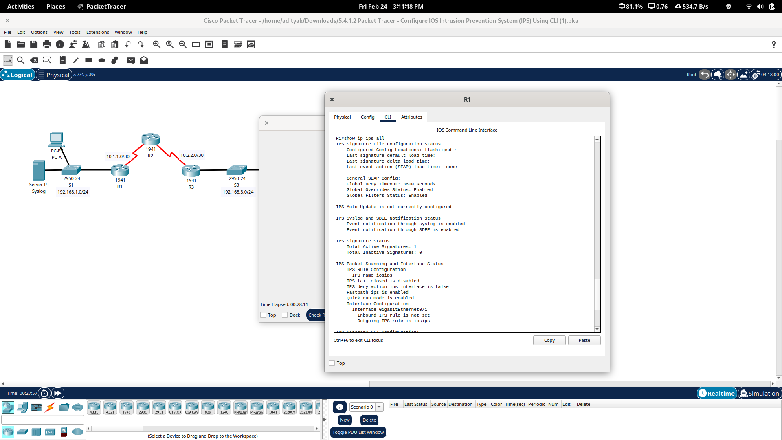

Step 3: Verify that IPS is working properly.

a.From PC-C, attempt to ping PC-A.
The pings should fail. This is because the IPS rule for event-action of an echo request was set to “denypacket-inline”.
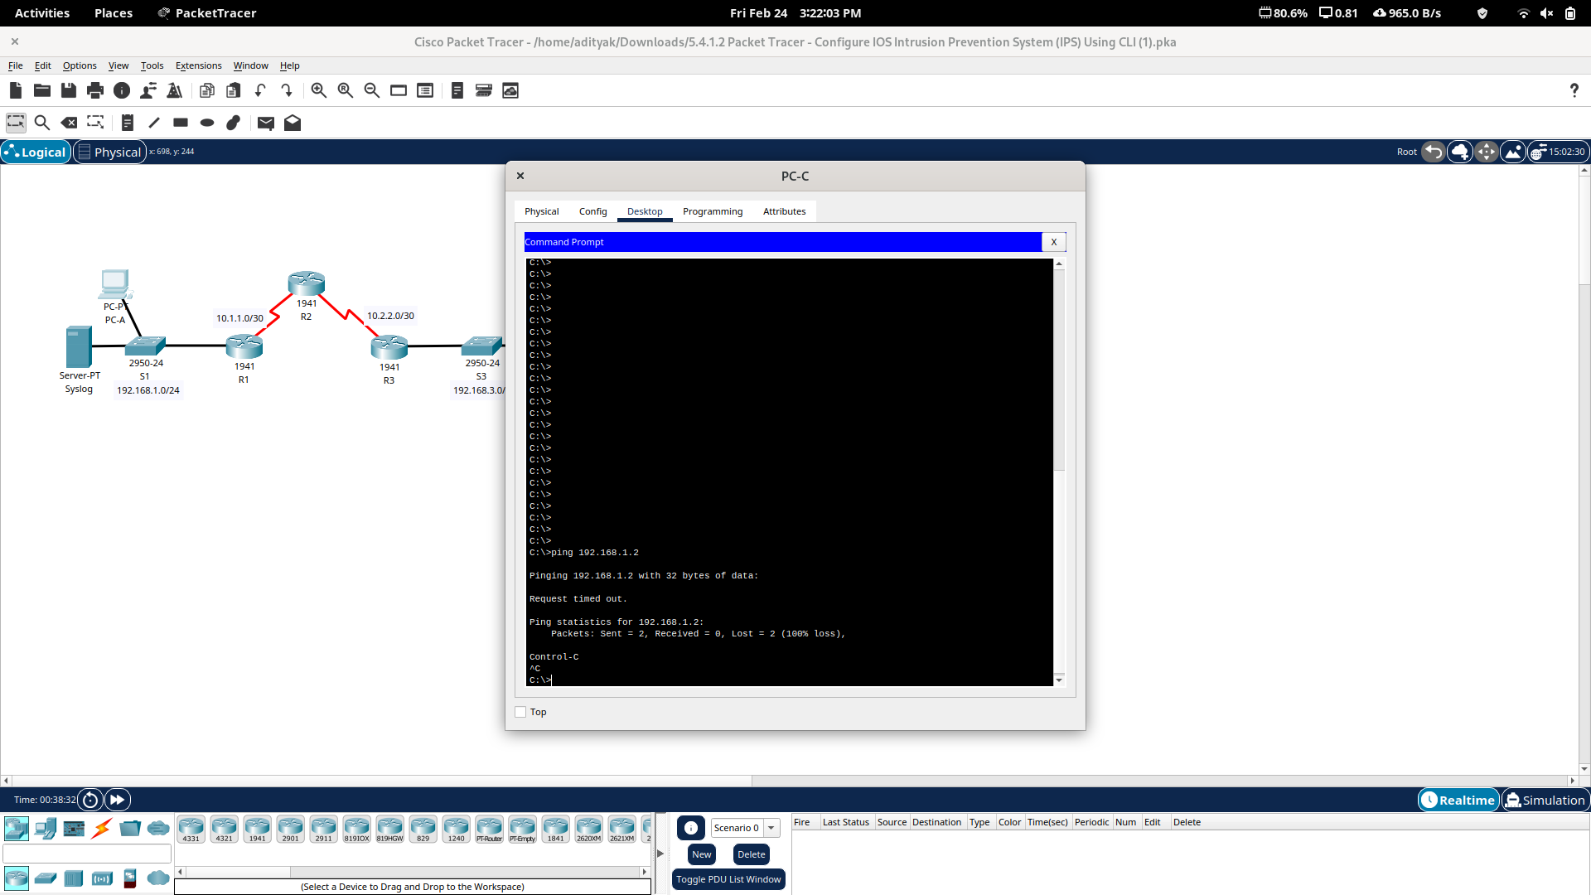
b.From PC-A, attempt to ping PC-C.
The ping should be successful. This is because the IPS rule does not cover echo reply. When PC-A pings PC-C, PC-C responds with an echo reply.
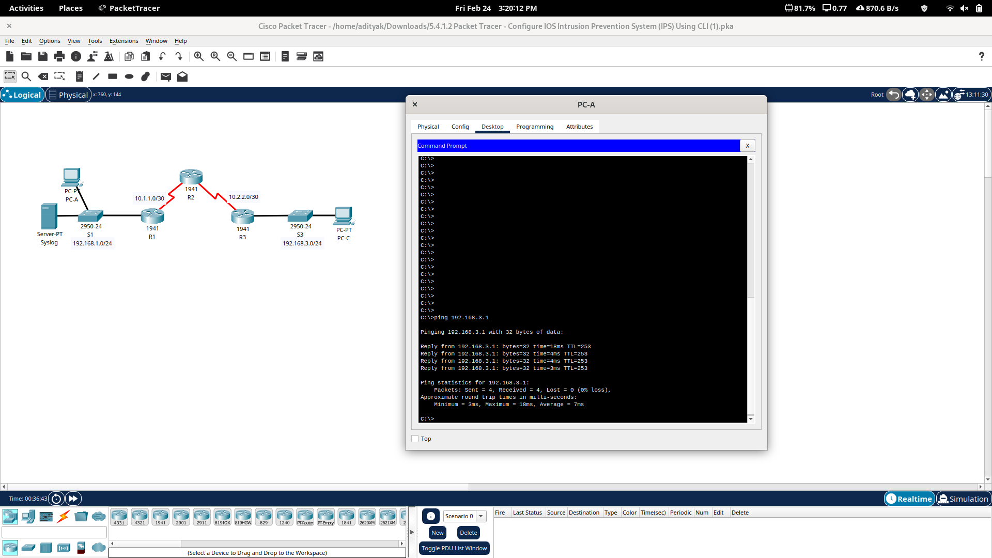

Step 4: View the syslog messages.
a. Click the Syslog server.
b. Select the Services tab.
c. In the left navigation menu, select SYSLOG to view the log file.
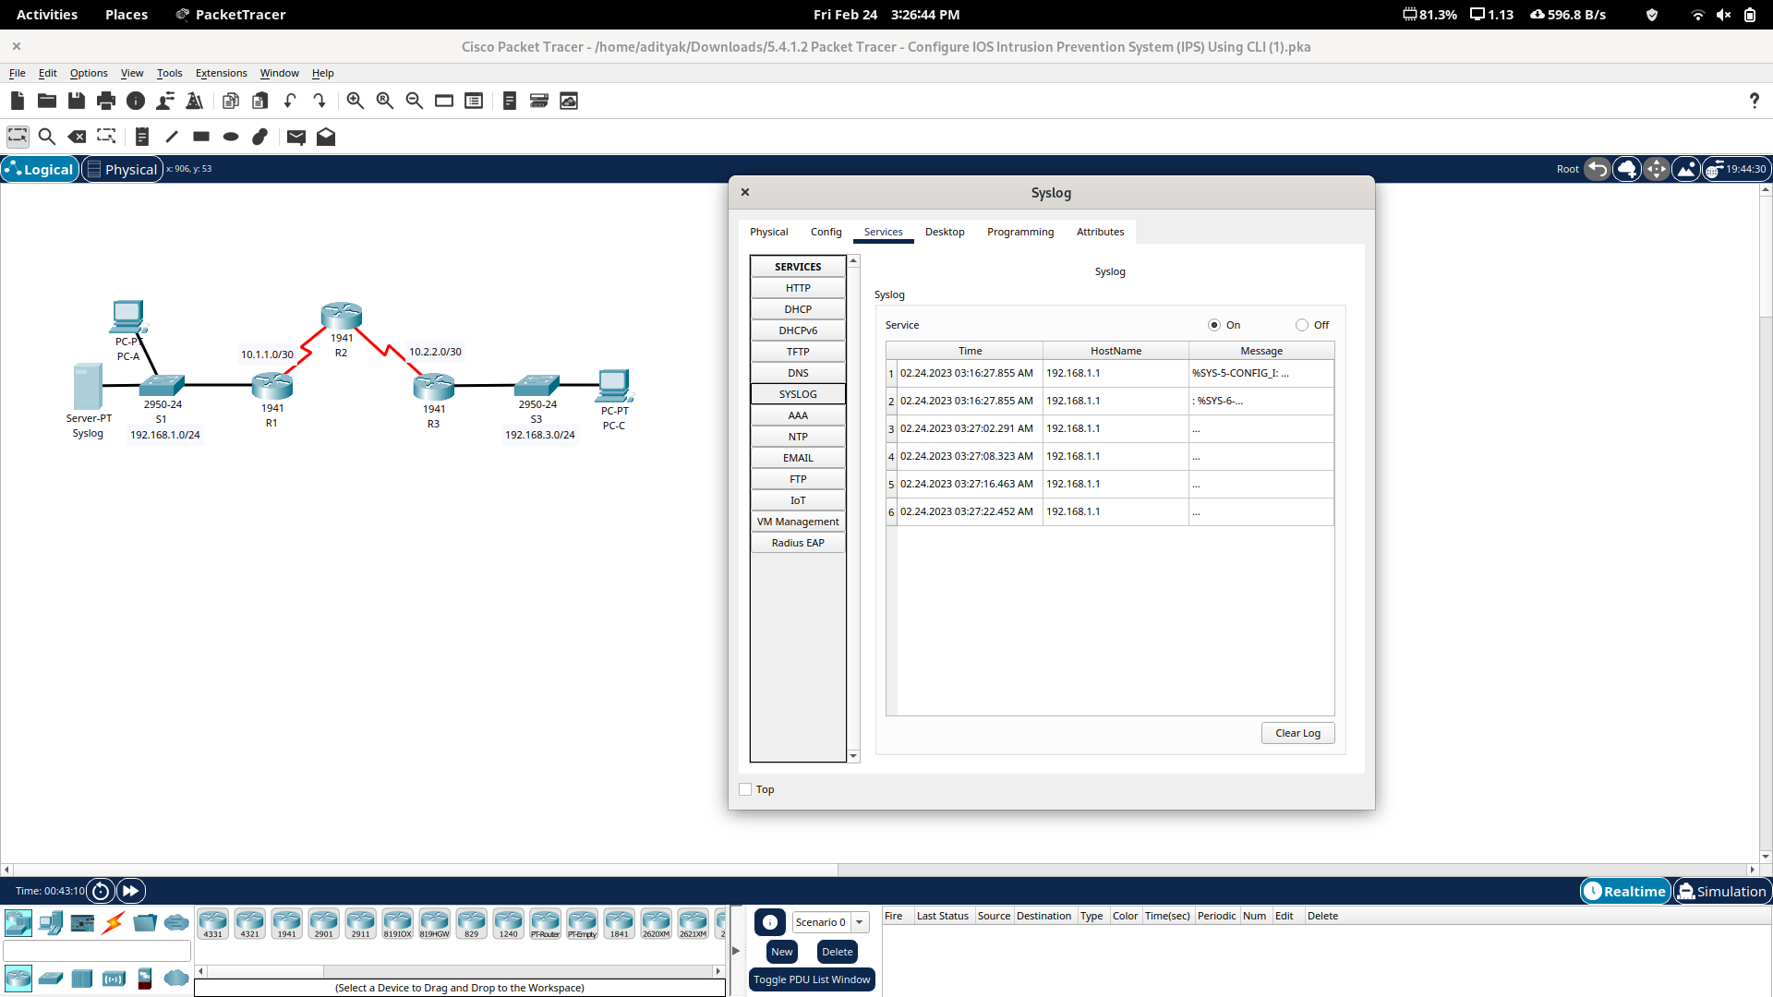

Step 5: Check results.
Your completion percentage should be 100%. Click Check Results to see feedback and verification of which required components have been completed.



