

CSE 3502
Information Security Management

Lab Report – 2
Static & Dynamic NAT Configuration

Winter Semester 2022-23

Name:Aditya Krishna
Reg No.:20BCE0456
Guided by: Prof. Lavanya K
13th Jan, 2022
Static NAT
Static NAT (Network Address Translation) is a type of NAT that maps a private IP address to a public IP address on a one-to-one basis. This means that the same private IP address is always mapped to the same public IP address. This is used when a device on a private network needs to be reached from the Internet using a specific public IP address. Static NAT is often used to provide Internet access to a server on a private network, or to allow remote access to a device on a private network. The device that needs to be reached from the Internet is assigned a public IP address, and this address is then mapped to the device's private IP address. This allows incoming traffic to be directed to the correct device on the private network.In summary, Static NAT is a type of NAT that maps a private IP address to a public IP address on a one-to-one basis, it is used when a device on a private network needs to be reached from the Internet using a specific public IP address.
Dynamic NAT
Dynamic NAT (Network Address Translation) is a type of NAT that maps a private IP address to a public IP address on a one-to-many basis. This means that different private IP addresses can be mapped to the same public IP address. This is used when a device on a private network needs to share a limited number of public IP addresses. Dynamic NAT is often used to provide Internet access to multiple devices on a private network that share a limited number of public IP addresses. When a device on the private network requests access to the Internet, the NAT router assigns it a public IP address from a pool of available addresses. This allows multiple devices on the private network to access the Internet using the same public IP address. It is important to note that dynamic NAT is less secure than static NAT because it's harder to track and block unwanted incoming traffic. In summary, Dynamic NAT is a type of NAT that maps a private IP address to a public IP address on a one-to-many basis, it is used when a device on a private network needs to share a limited number of public IP addresses. It allows multiple devices on the private network to access the Internet using the same public IP address, but it's less secure than static NAT.
Components
Devices | Description
Server | A server is a computer or system that provides resources, data,  services, or programs to other computers, known as clients, over a  network.
Router | A router is a networking device that forwards data packets between  computer networks. Routers perform the traffic directing functions  on the Internet.
Switch | A switch is a device in a computer network that connects other  devices together. Multiple data cables are plugged into a switch to  enable communication between different networked devices.
End-devices | A source or destination device in a networked system. For  example, a user's PC is an end device, and so is a server.
1. Static NAT Configuration

Topology:

Static NAT Configuration setup diagram. Here, we've used serial0/0 to link two routers. Router0 is linked to a switch, as long as a server is linked to Router1. Three further end devices (laptops) are linked to the switch.

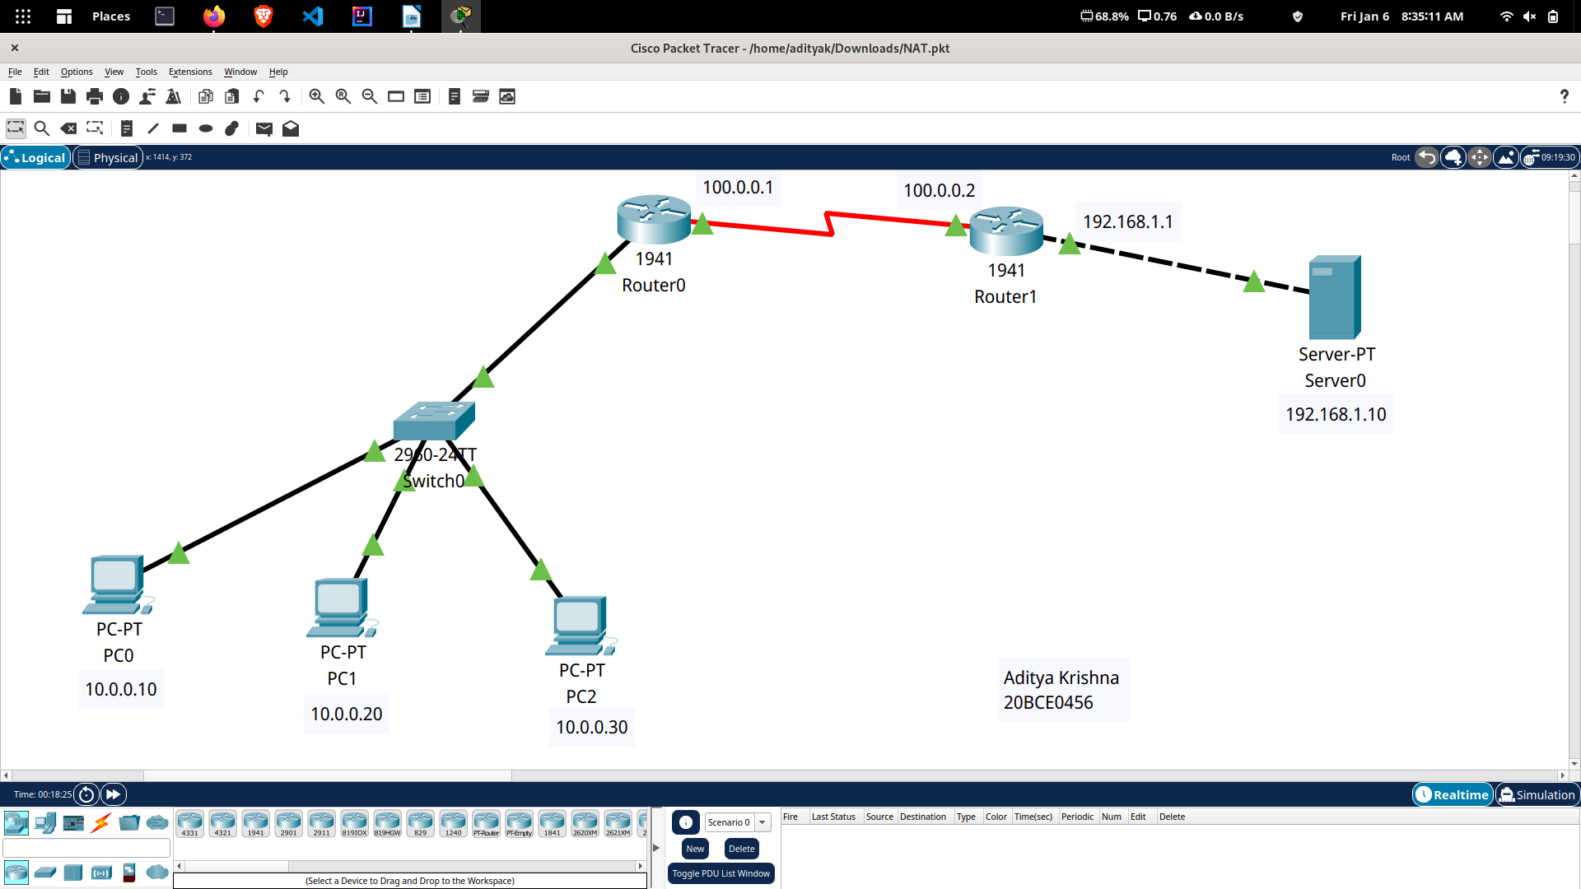

Initial IP Configuration

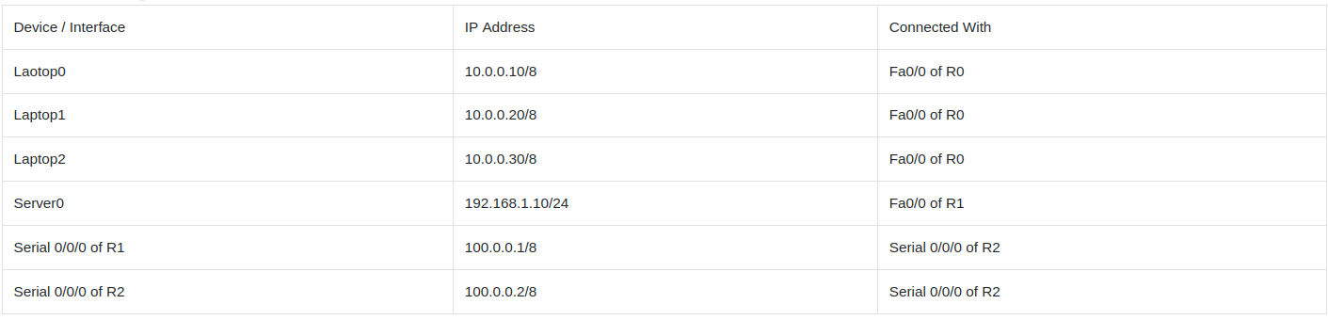

Static Nat Configuration requires three steps:

1. Define IP address mapping
2. Define inside local interface
3. Define inside global interface

Command is used to map the inside local IP address with inside global IP address is as follows :

Router(config)#ip nat inside source static [inside local ip address] [inside global IP address]

If Laptop1 is configured with IP address 10.0.0.10. To map it with 50.0.0.10 IP address we will use following command

Router(config)#ip nat inside source static 10.0.0.10 50.0.0.10

In second step we have to define which interface is connected with local the network. On both routers interface Fa0/0 is connected with the local network which need IP translation.Following command will define interface Fa0/0 as inside local.
Router(config-if)#ip nat inside

In third step we have to define which interface is connected with the global network. On both routers serial 0/0/0 interface is connected with the global network. Following command will define interface Serial0/0/0 as inside global.
Router(config-if)#ip nat outside

R1 Static NAT Configuration Commands:
R1(config)#ip nat inside source static 10.0.0.10 50.0.0.10
R1(config)#ip nat inside source static 10.0.0.20 50.0.0.20
R1(config)#ip nat inside source static 10.0.0.30 50.0.0.30
R1(config)#interface gig 0/0
R1(config-if)#ip nat inside
R1(config-if)#exit
R1(config)#interface Serial 0/1/0
R1(config-if)#ip nat outside
R1(config-if)#exit

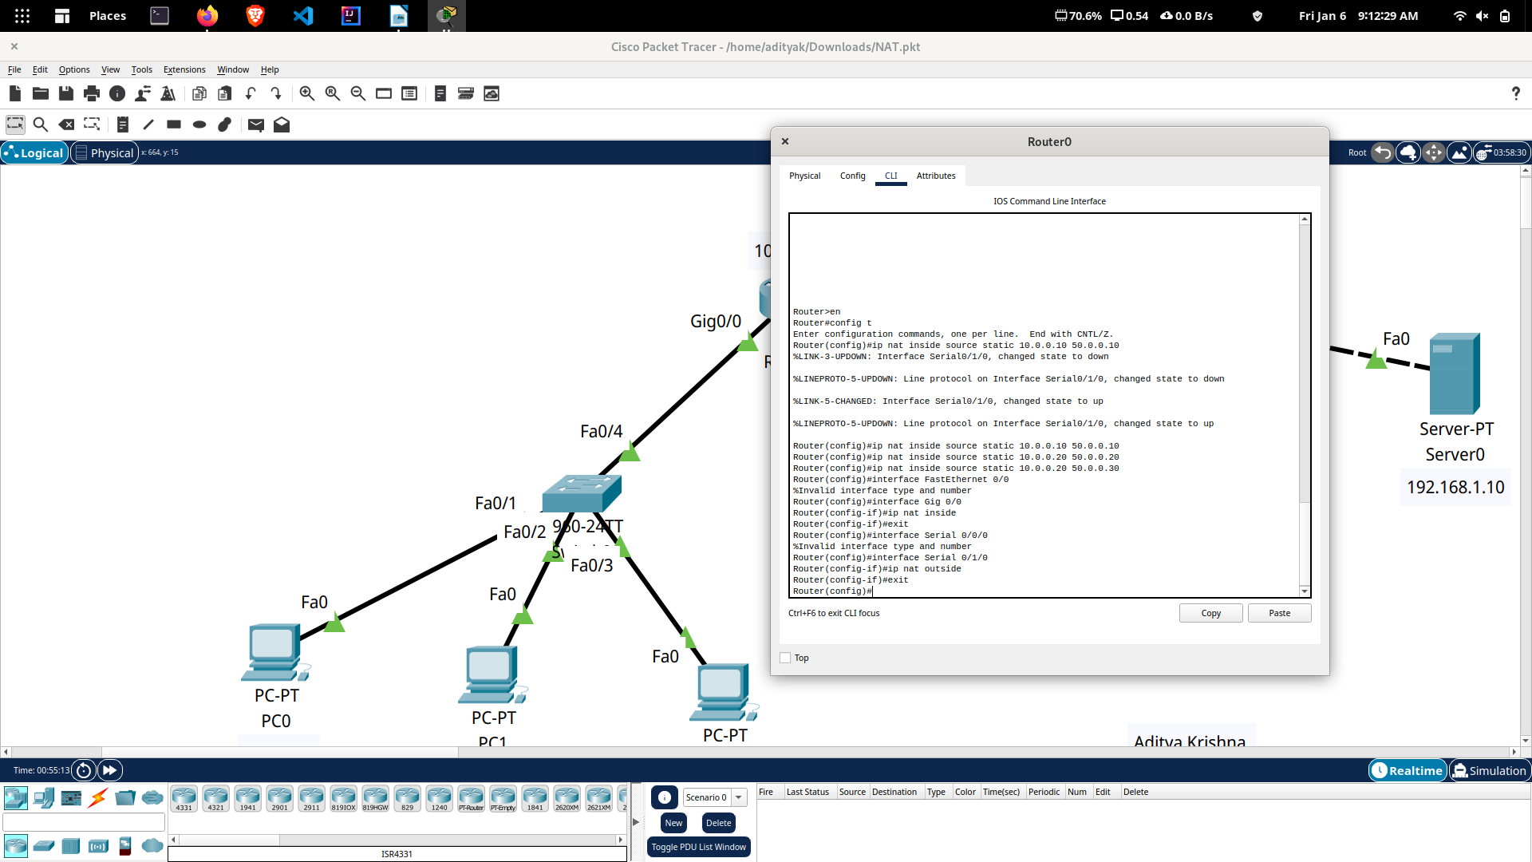

R2 Static NAT Configuration Commands:
R2(config)#ip nat inside source static 192.168.1.10 200.0.0.10
R2(config)#interface Gig 0/0
R2(config-if)#ip nat inside
R2(config-if)#exit
R2(config)#interface Serial 0/1/0
R2(config-if)#ip nat outside
R2(config-if)#exit

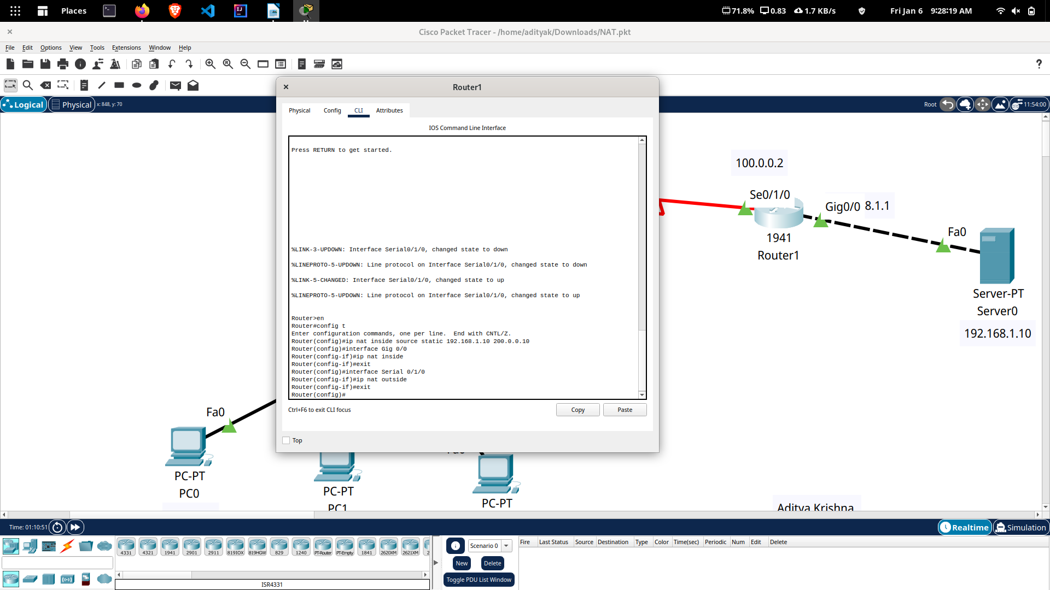

Configure static routing in R1
R1(config)#ip route 200.0.0.0 255.255.255.0 100.0.0.2

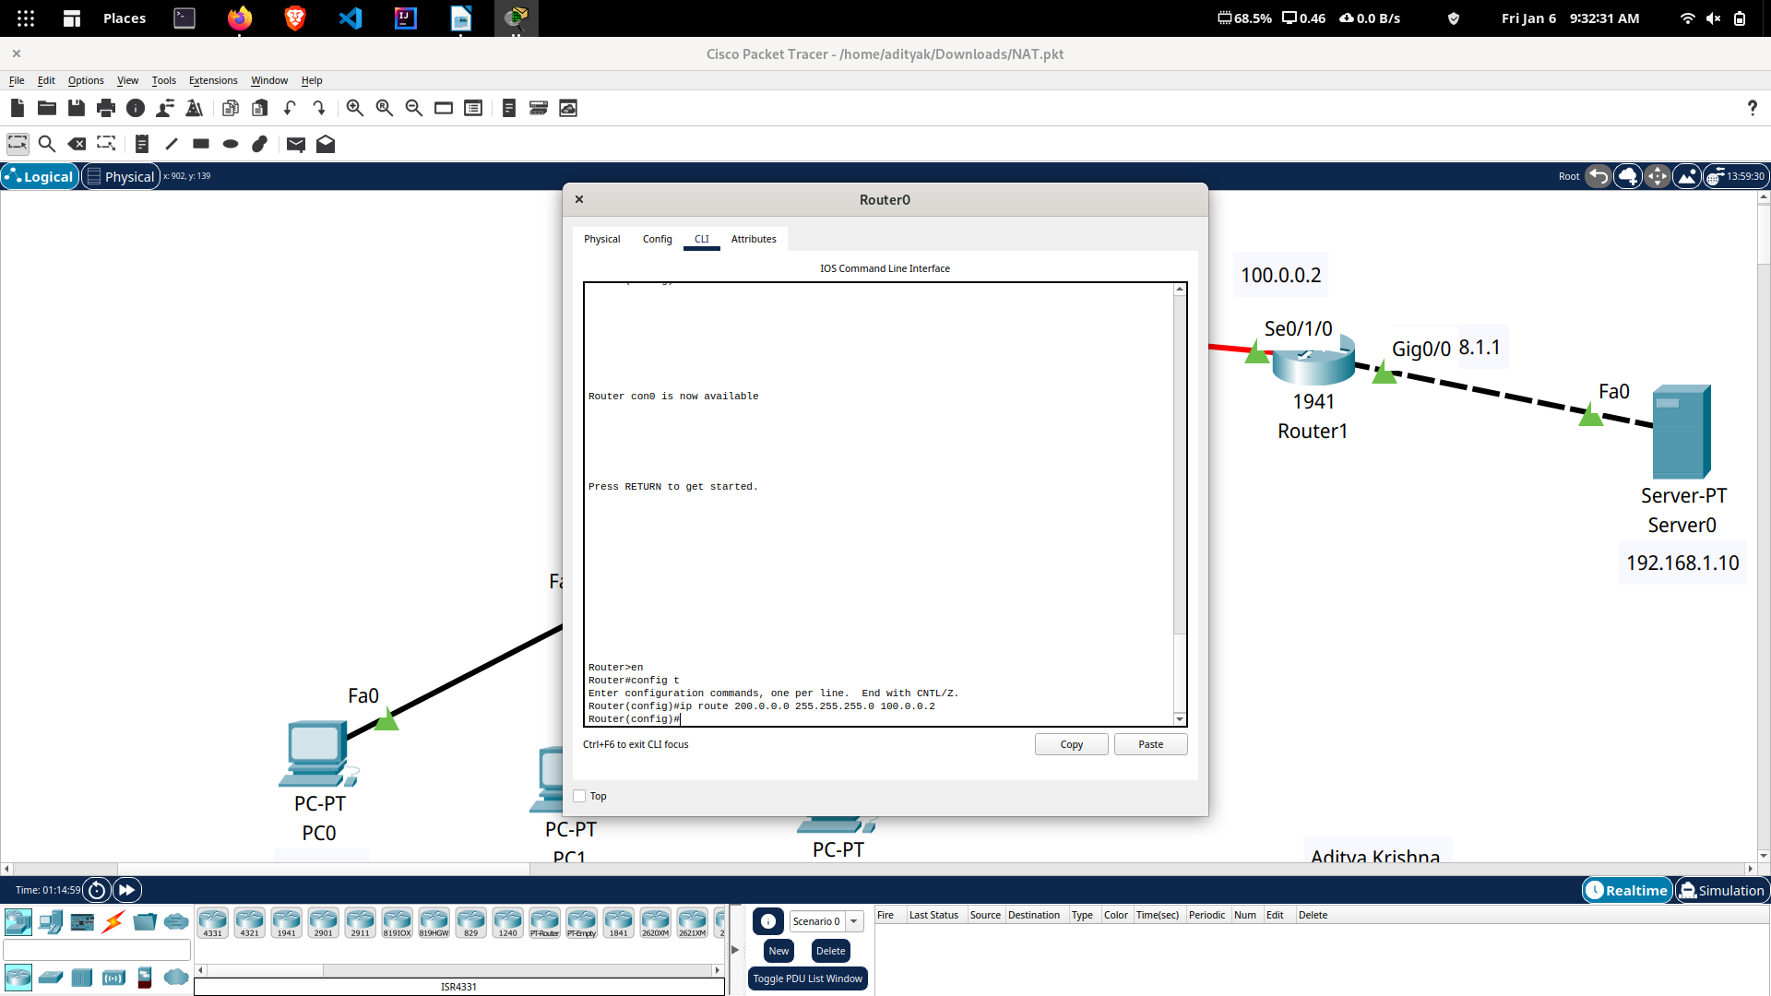

Configure static routing in R2
R2(config)#ip route 50.0.0.0 255.0.0.0 100.0.0.1
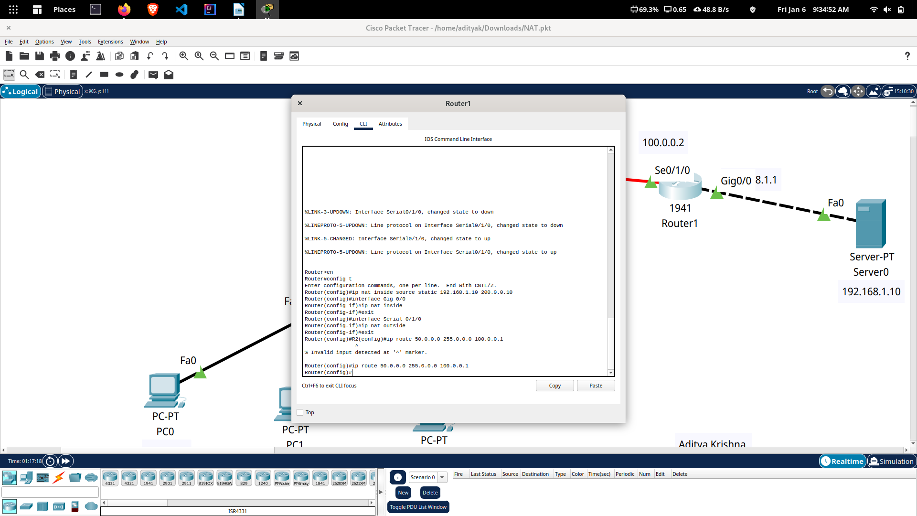
Testing Static NAT Configuration
ipconfig
This command verifies that we are testing from correct NAT device.
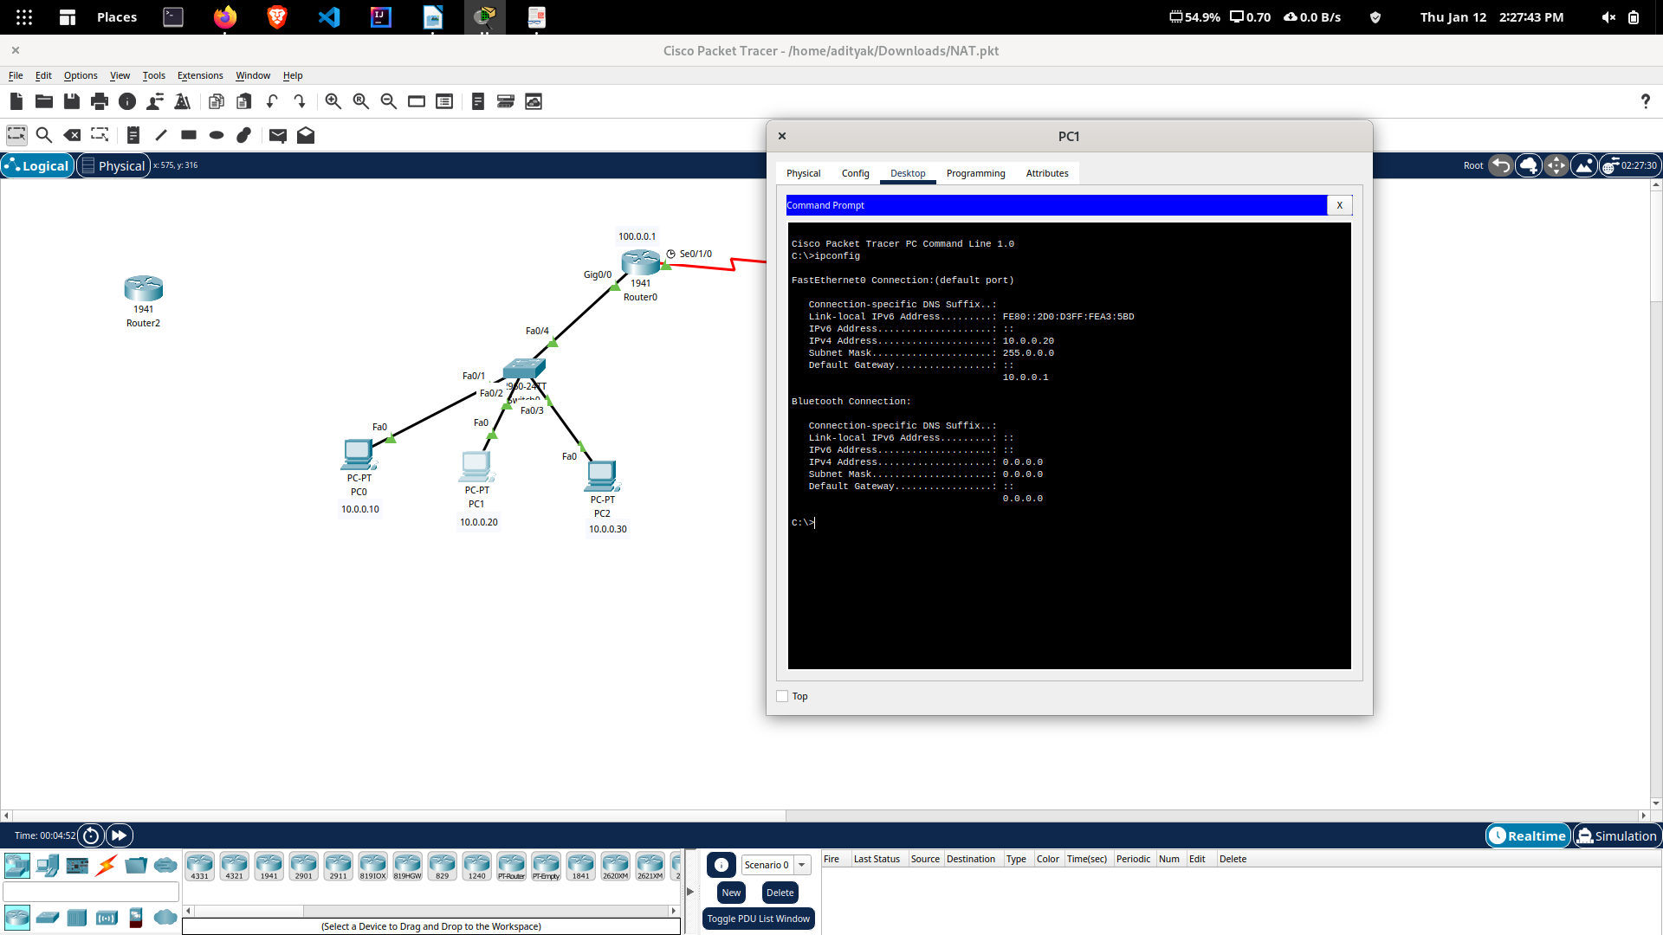
ping 100.0.0.1
This command checks whether we are able to access the remote device or not. A ping reply confirms that we are able to connect with remote device on this IP address.
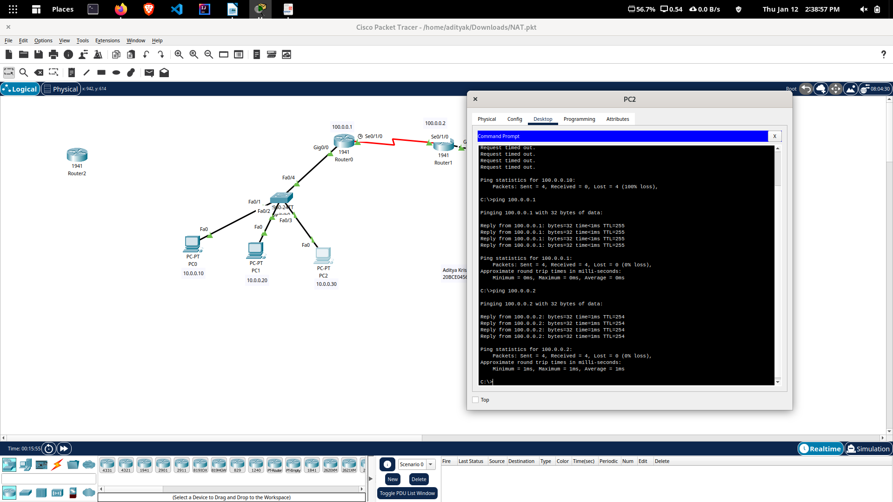
Ping 192.168.1.10
This command checks whether we are able to access the remote device on its actual IP address or not. A ping error confirms that we are not able to connect with remote device on this IP
address.
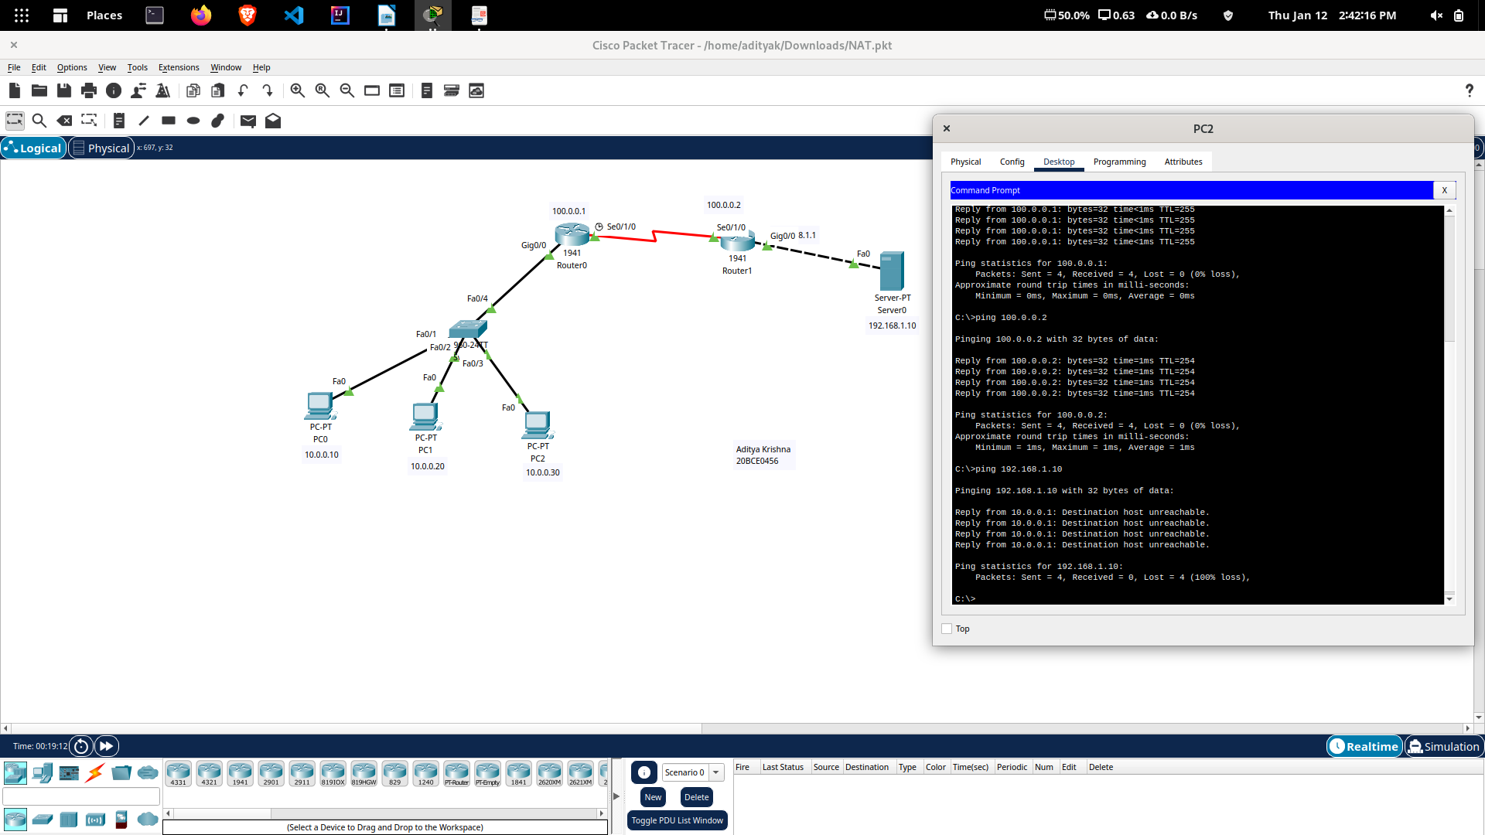

show ip nat translations
This command is used to verify that the translation does exist in the translation table.
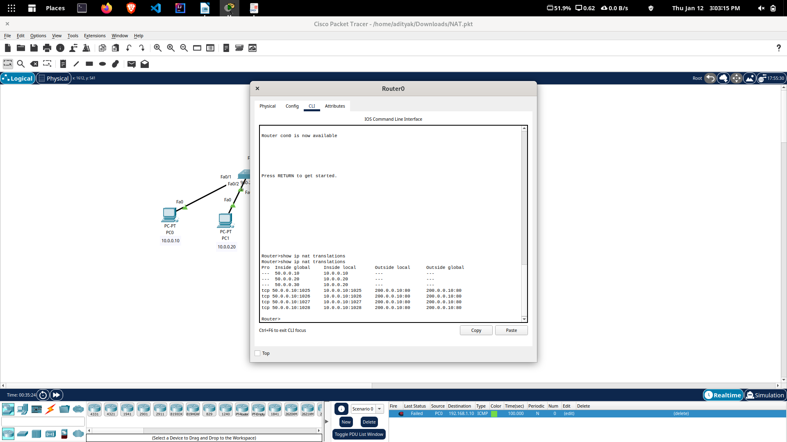
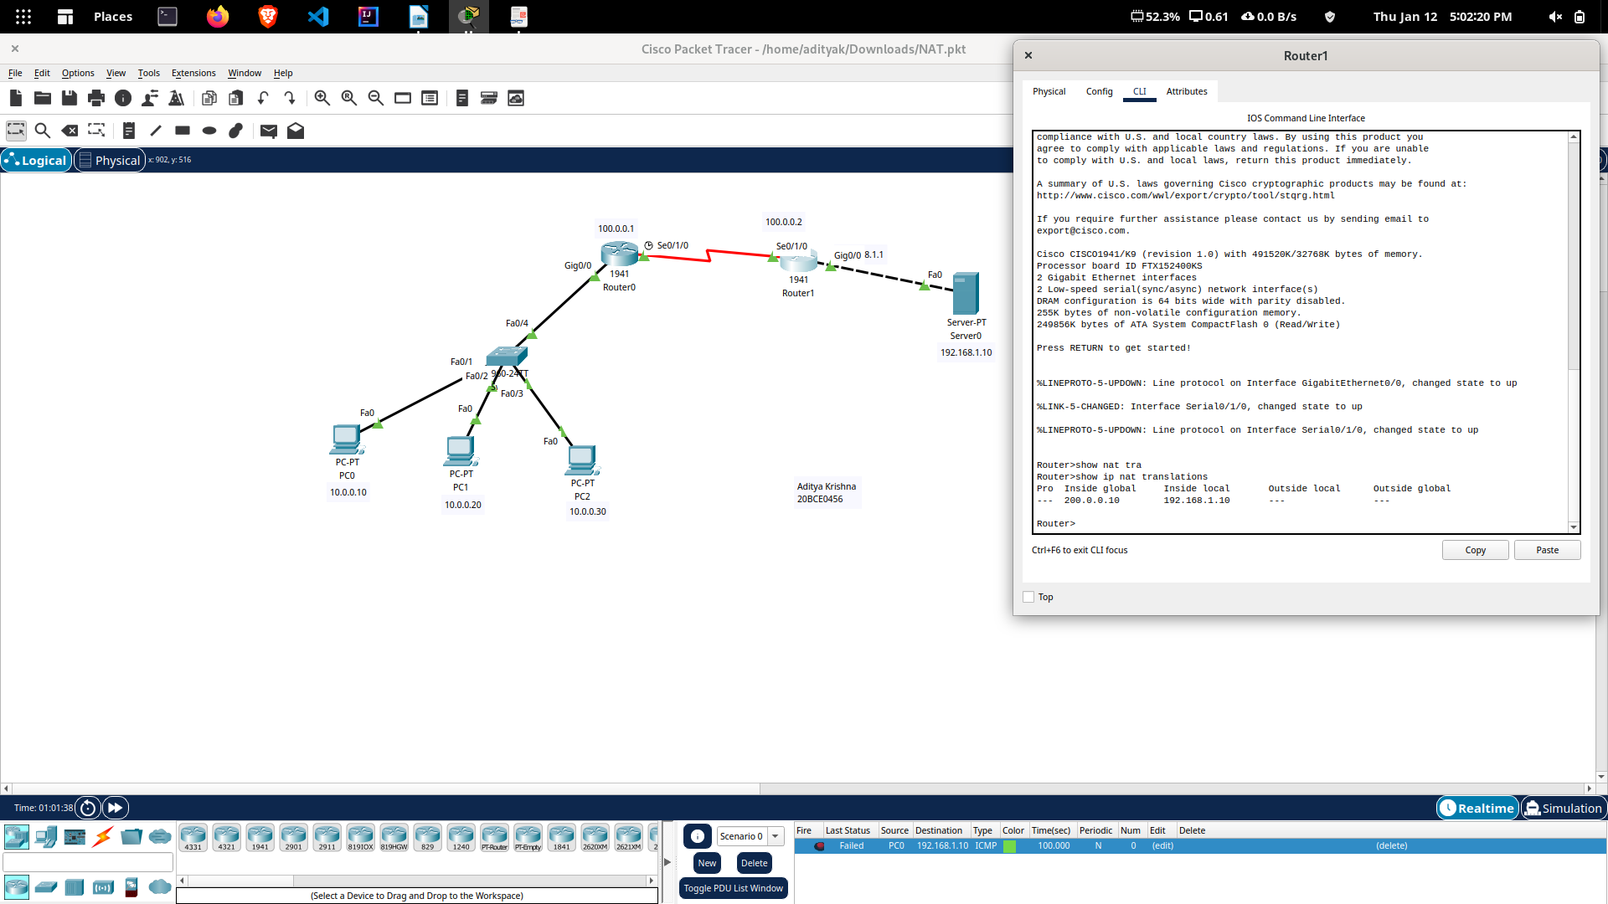
The actual IP address is not listed here because router is receiving packets after the translation. From R1’s point of view remote device’s IP address is 200.0.0.10 while from R2’s point of view end device’s IP address is 50.0.0.10. This way if NAT is enabled, we would not be able to trace the actual end device.
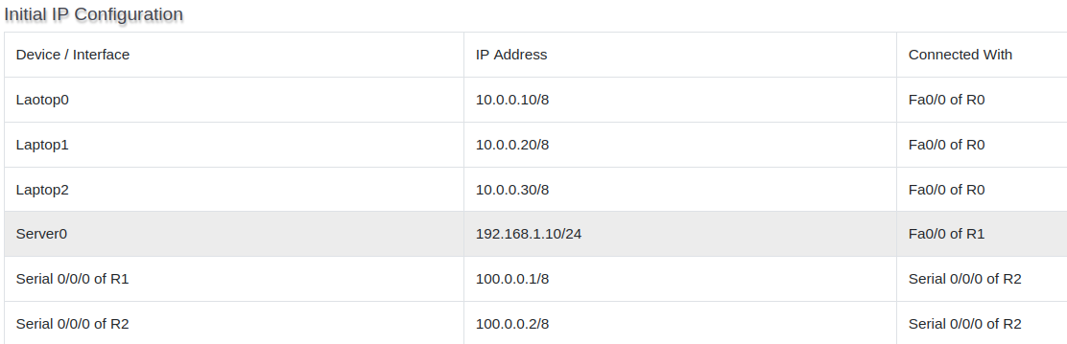
Dyanmic NAT Config

Configure Dynamic NAT
Dynamic NAT configuration requires four steps: -
- Create an access list of IP addresses which need translation
- Create a pool of all IP address which are available for translation
- Map access list with pool
- Define inside and outside interfaces

To create a standard numbered ACL following global configuration mode command is used:-
Router(config)# access-list ACL_Identifier_number permit/deny matching-parameters
We have three hosts in lab. Let’s create a standard access list which allows two hosts and denies one host.

R1(config)#access-list 1 permit 10.0.0.10 0.0.0.0
R1(config)#access-list 1 permit 10.0.0.20 0.0.0.0
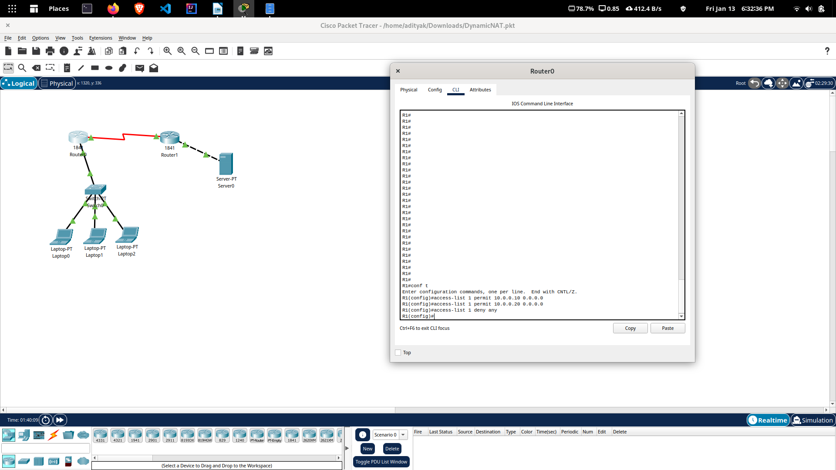
R1(config)#access-list 1 deny any

Standard ACL Configuration

R1(config)#ip nat pool ccna 50.0.0.1 50.0.0.2 netmask 255.0.0.0

Second step we created a pool named ccna. To configure a dynamic NAT with these options we will use following command.

R1(config)#ip nat inside source list 1 pool ccna

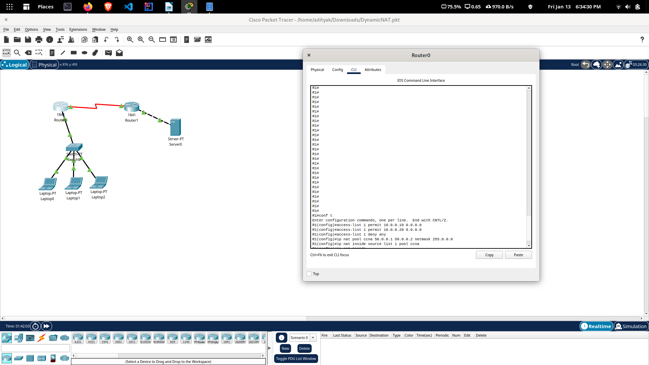

Router(config-if)#ip nat inside

Router(config-if)#ip nat outside

R1 Dynamic NAT Configuration

R1#configure terminal
Enter configuration commands, one per line. End with CNTL/Z.
R1(config)#access-list 1 permit 10.0.0.10 0.0.0.0
R1(config)#access-list 1 permit 10.0.0.20 0.0.0.0
R1(config)#access-list 1 deny any
R1(config)#ip nat pool ccna 50.0.0.1 50.0.0.2 netmask 255.0.0.0
R1(config)#ip nat inside source list 1 pool ccna
R1(config)#interface FastEthernet 0/0
R1(config-if)#ip nat inside
R1(config-if)#exit
R1(config)#interface Serial0/0/0
R1(config-if)#ip nat outside
R1(config-if)#exit
R1(config)#

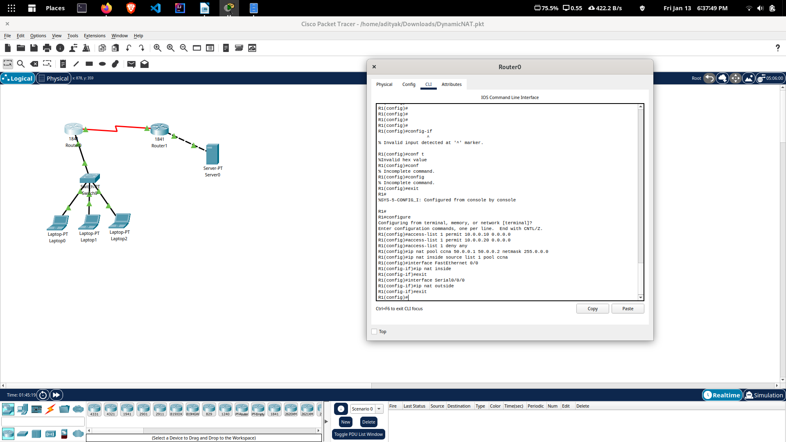

Configure static NAT on R2

R2>enable
R2#configure terminal
Enter configuration commands, one per line. End with CNTL/Z.
R2(config)#ip nat inside source static 192.168.1.10 200.0.0.10
R2(config)#interface Serial 0/0/0
R2(config-if)#ip nat outside
R2(config-if)#exit
R2(config)#interface FastEthernet 0/0
R2(config-if)#ip nat inside
R2(config-if)#exit
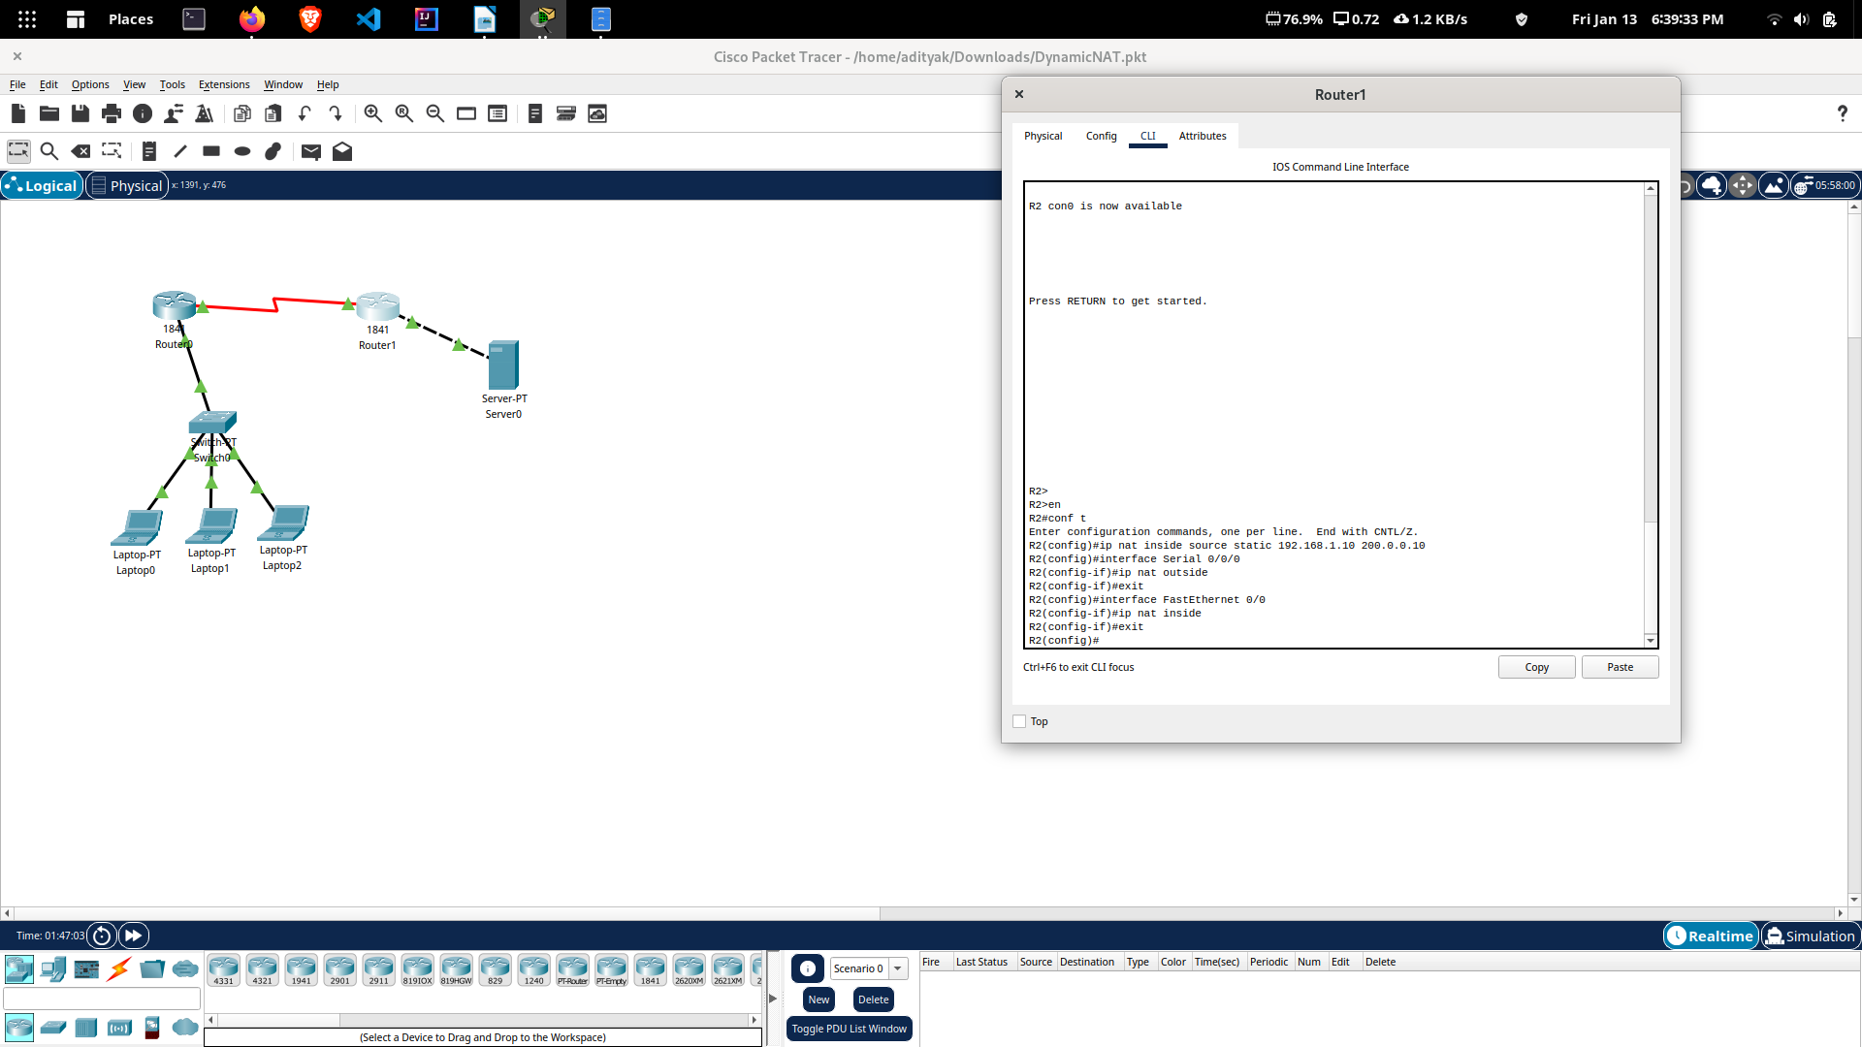
R2(config)#

Testing Dynamic NAT Configuration

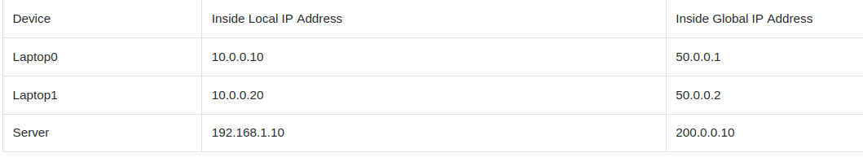

To test this setup click Laptop0 and Desktop and click Command Prompt.
- Run ipconfig command.
- Run ping 200.0.0.10 command.
- Run ping 192.168.1.10 command.

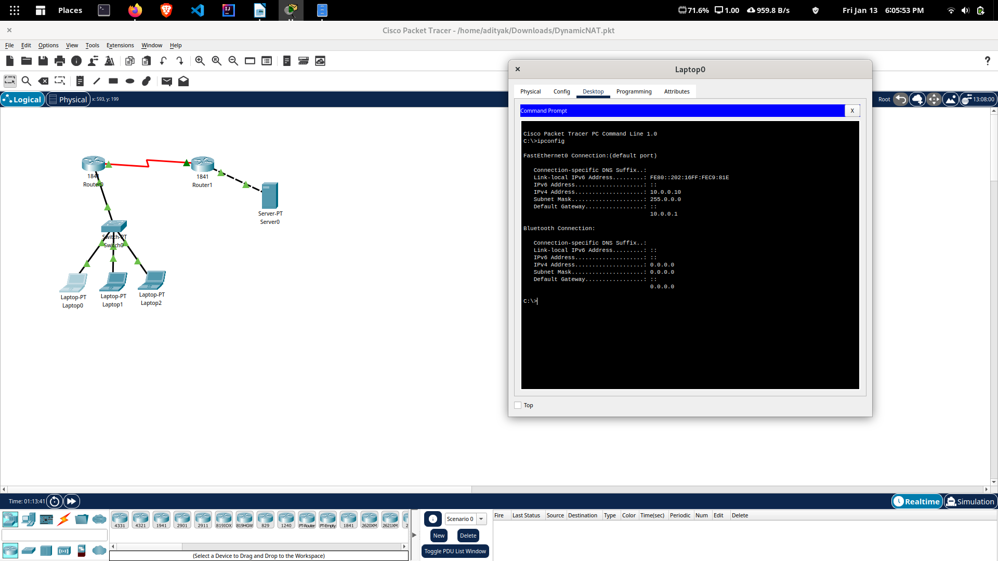

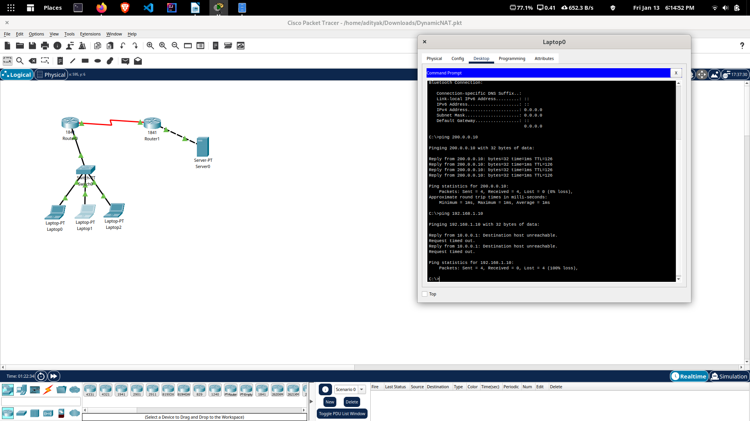
Now run ping 200.0.0.10 command from Laptop2.

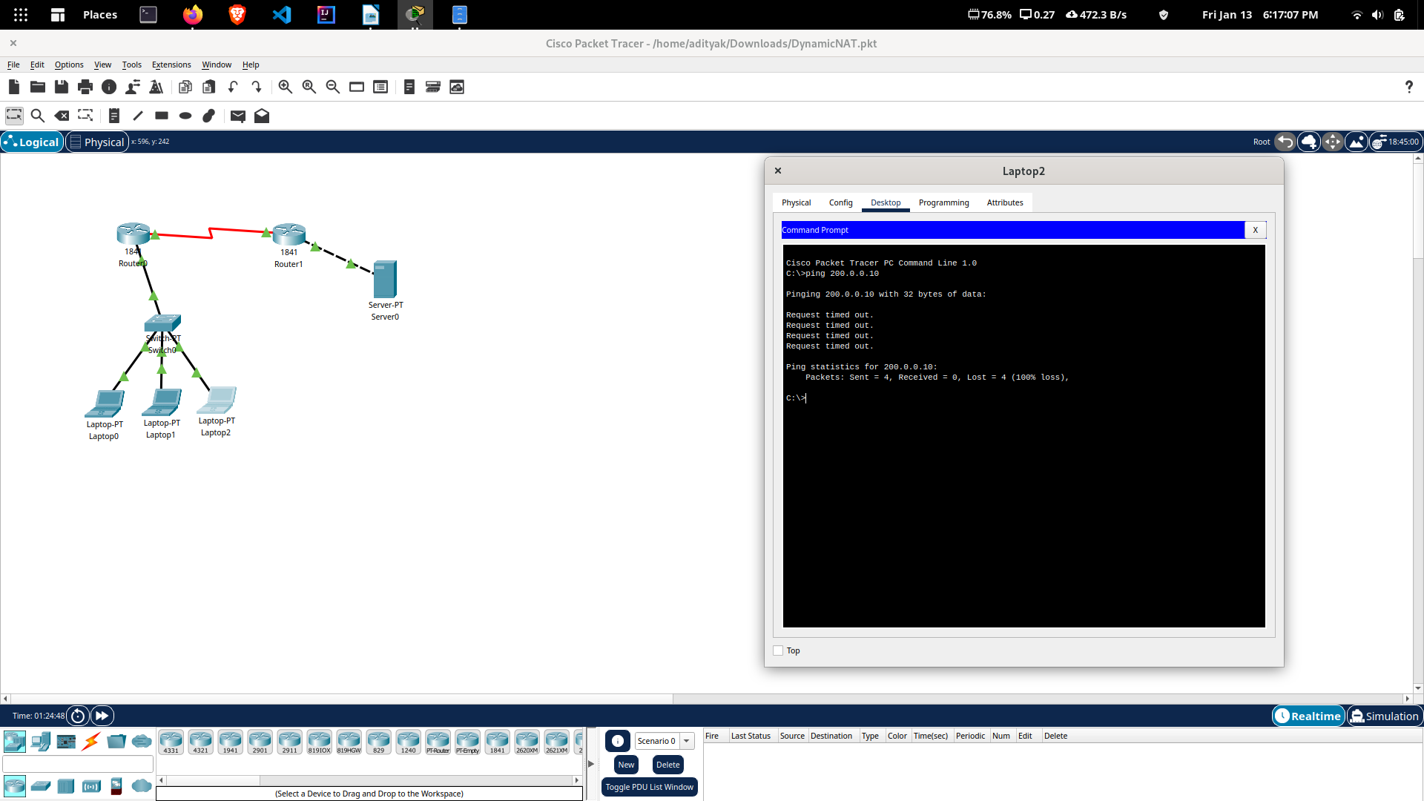
First command verifies that we are testing from correct NAT device. Second command checks whether we are able to access the remote device or not. A ping reply confirms that we are able to connect with remote device on this IP address. Third command checks whether we are able to access the remote device on its actual IP address or not. A ping error confirms that we are not able to connect with remote device on this IP address.
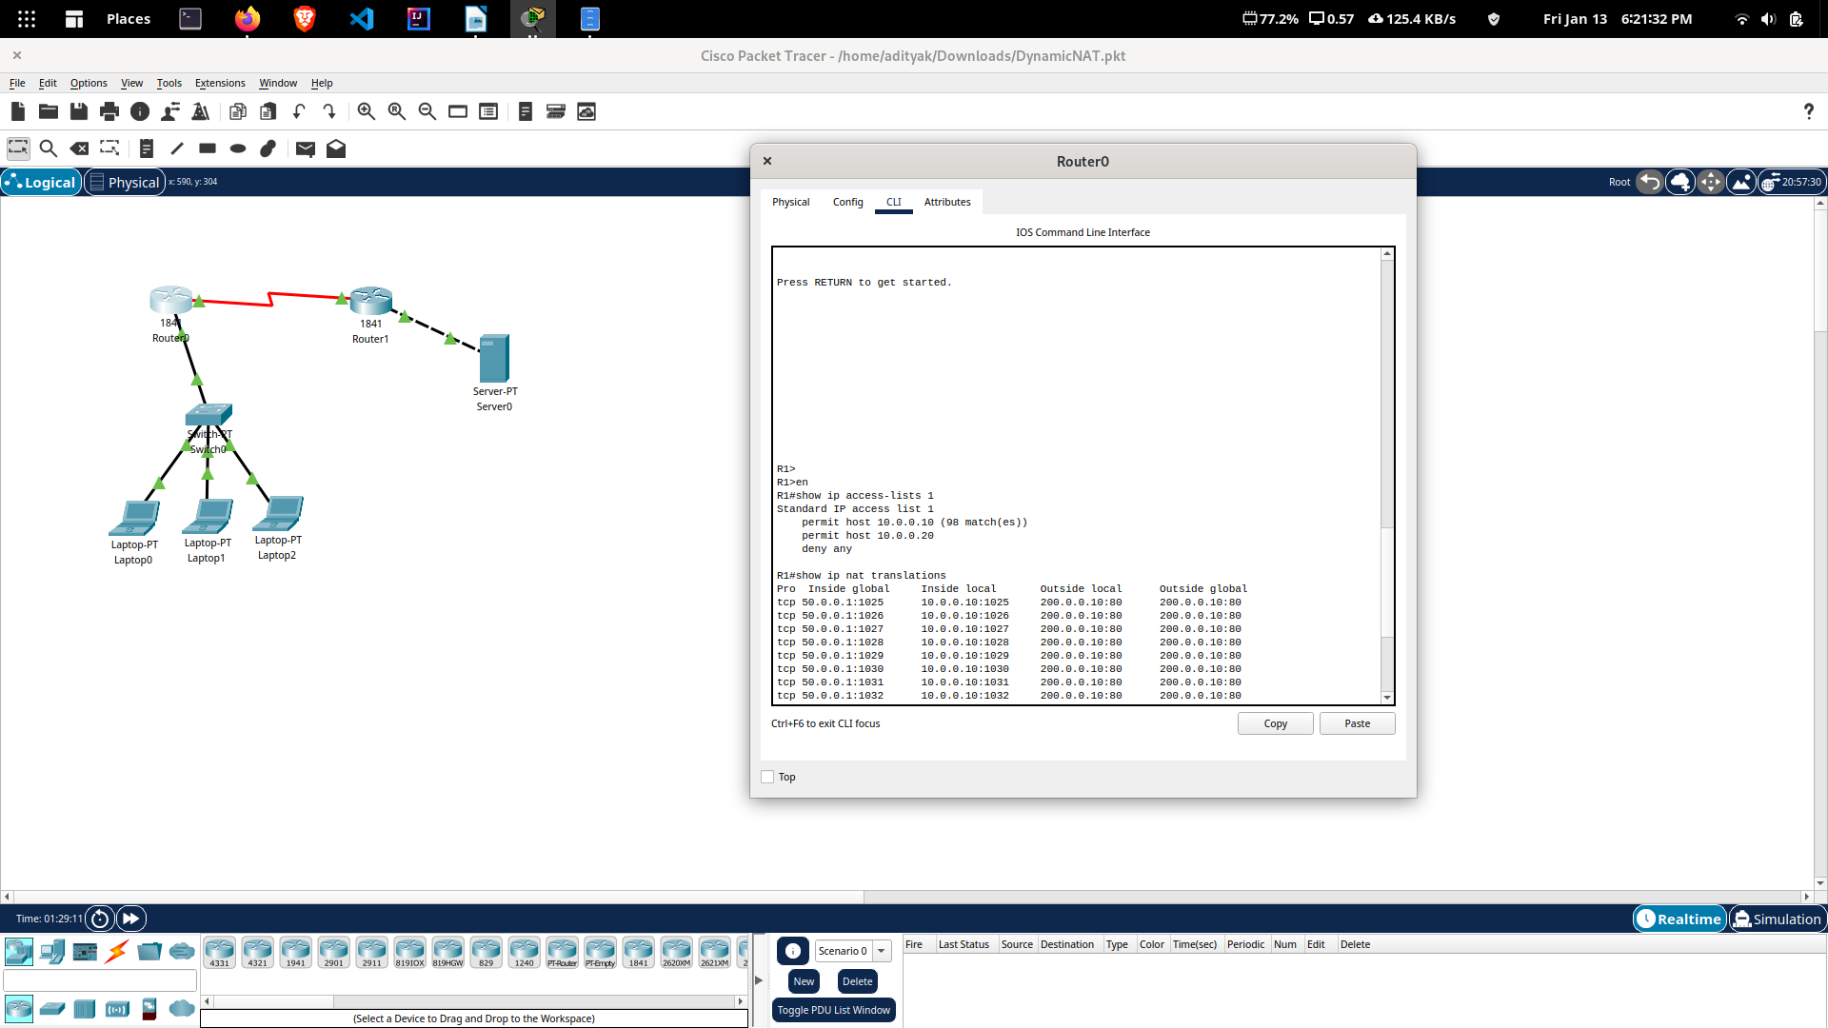
We can also verify this translation on router with show ip nat translation command.

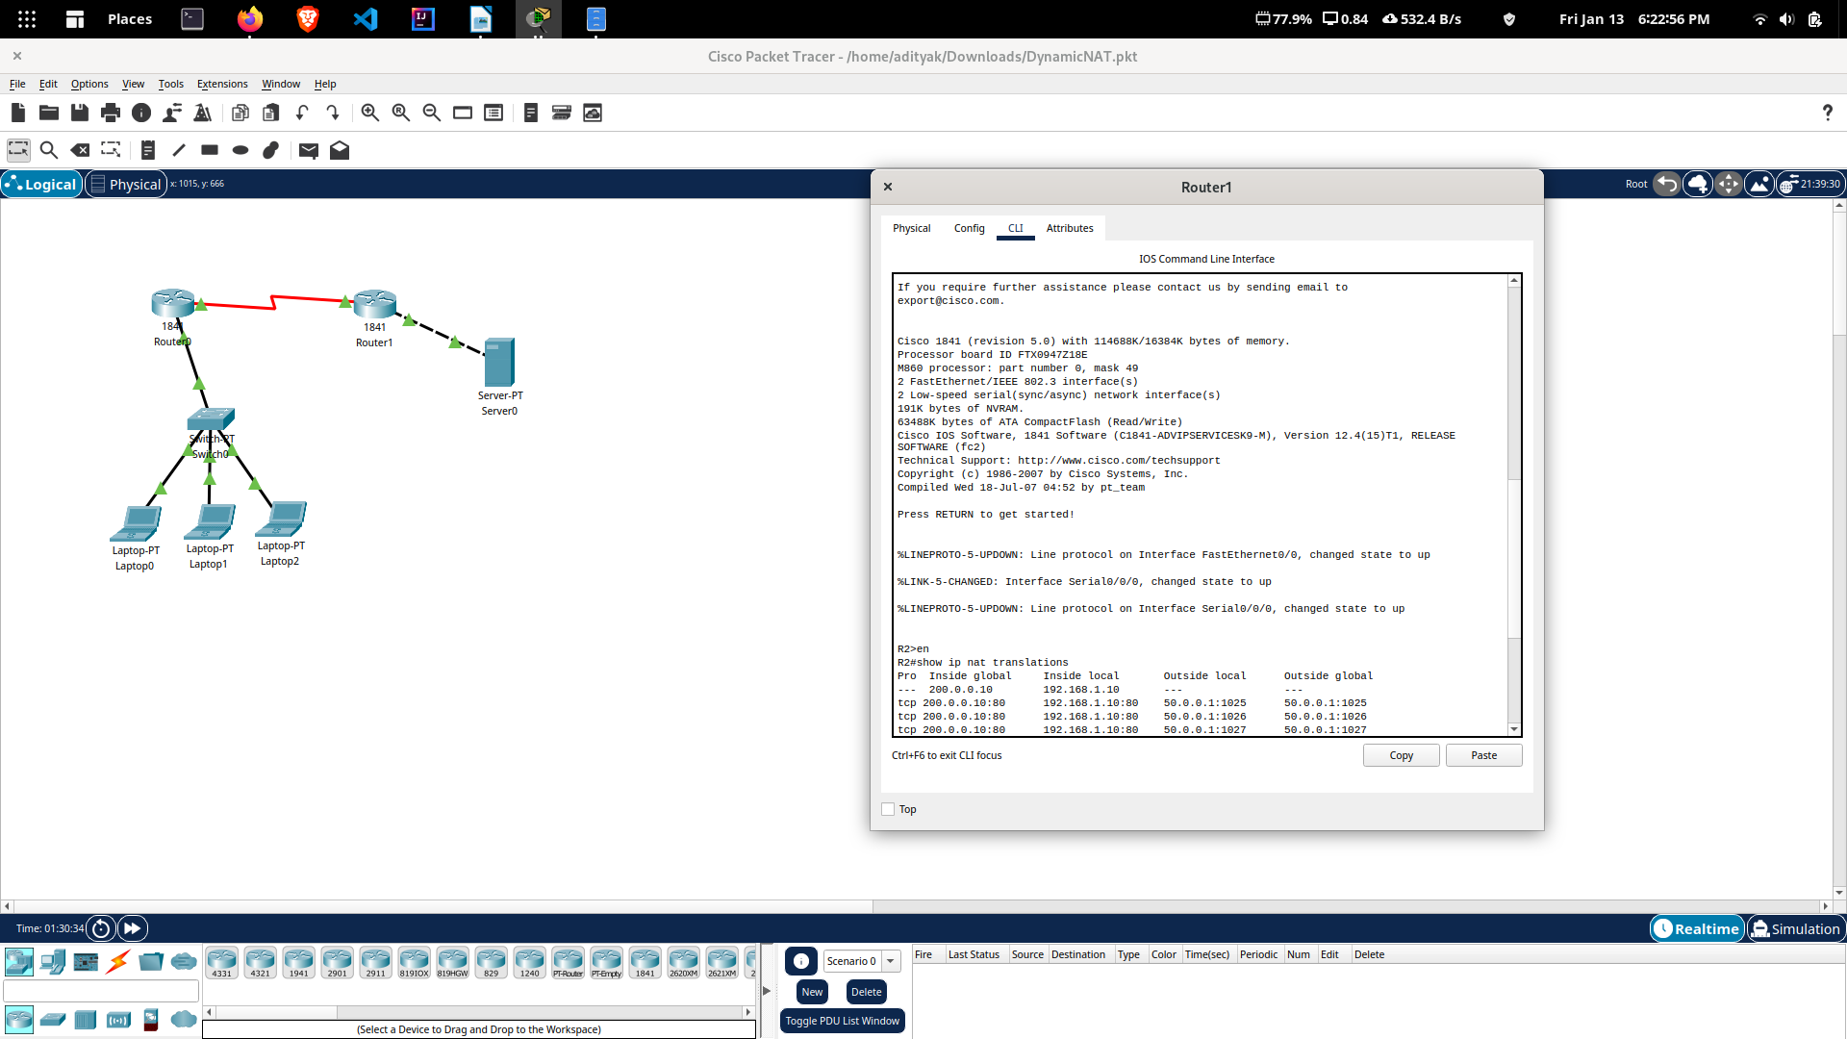
Hence, dynamic nat configuration is finally achieved.

