

CSE 3502
Information Security Management
Winter Semester 2022-23
Lab Report – 5

Port Security

Name:Aditya Krishna
Reg No.:20BCE0456
Guided by: Prof. Lavanya K

20th March, 2023
Introduction :

Switch is a network device, which is configured to connect and maintain communication channel between various devices. Ethernet ports are present on a switch, which are used to connect devices, such as Router, computer system and Laptop in the network. To connect all these networks, Ethernet cables are used. MAC address of these connected devices is used by switch to identify them and provide them with the requested service. It is a crucial task to secure these ports, so that only authorized users are able to connect their systems into the network through a switch. Before configuration of any switch in an organizational network, port security is considered, as it ensures that authentic and authorized user is connected within the network. This security feature of Cisco IOS Switches can only be configured on access ports and by default, this feature is disabled.

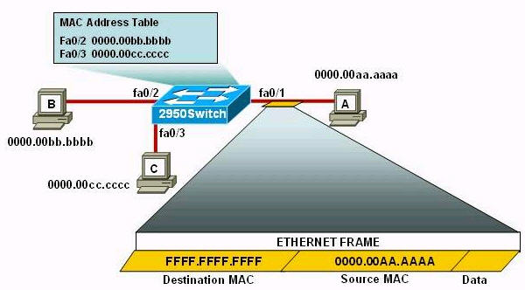

Objectives :
Part 1: Configure Port Security
Part 2: Verify Port Security

Background : In this activity, you will configure and verify port security on a switch. Port security allows you to restrict a port’s ingress traffic by limiting the MAC addresses that are allowed to send traffic into the port.

Configuration of Port Security using CISCO Packet Tracer

Note : For all the demonstrations, timestamp is provided at the top of the screen snapshots.

Step 1 : Outlining the components and their connections

Components used include :
1. Switch 2960-24TT : S1
2. PCs : PC1 and PC2
3. Laptop – Rogue Laptop
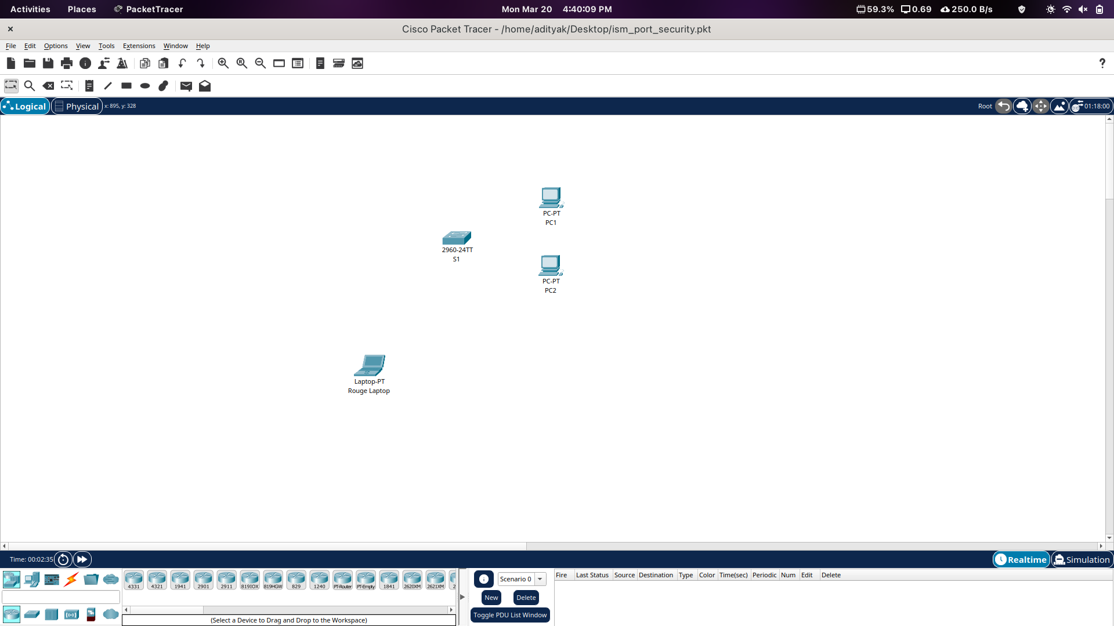

Step 2 : Making Topology and Assigning IP Addresses

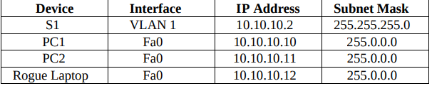
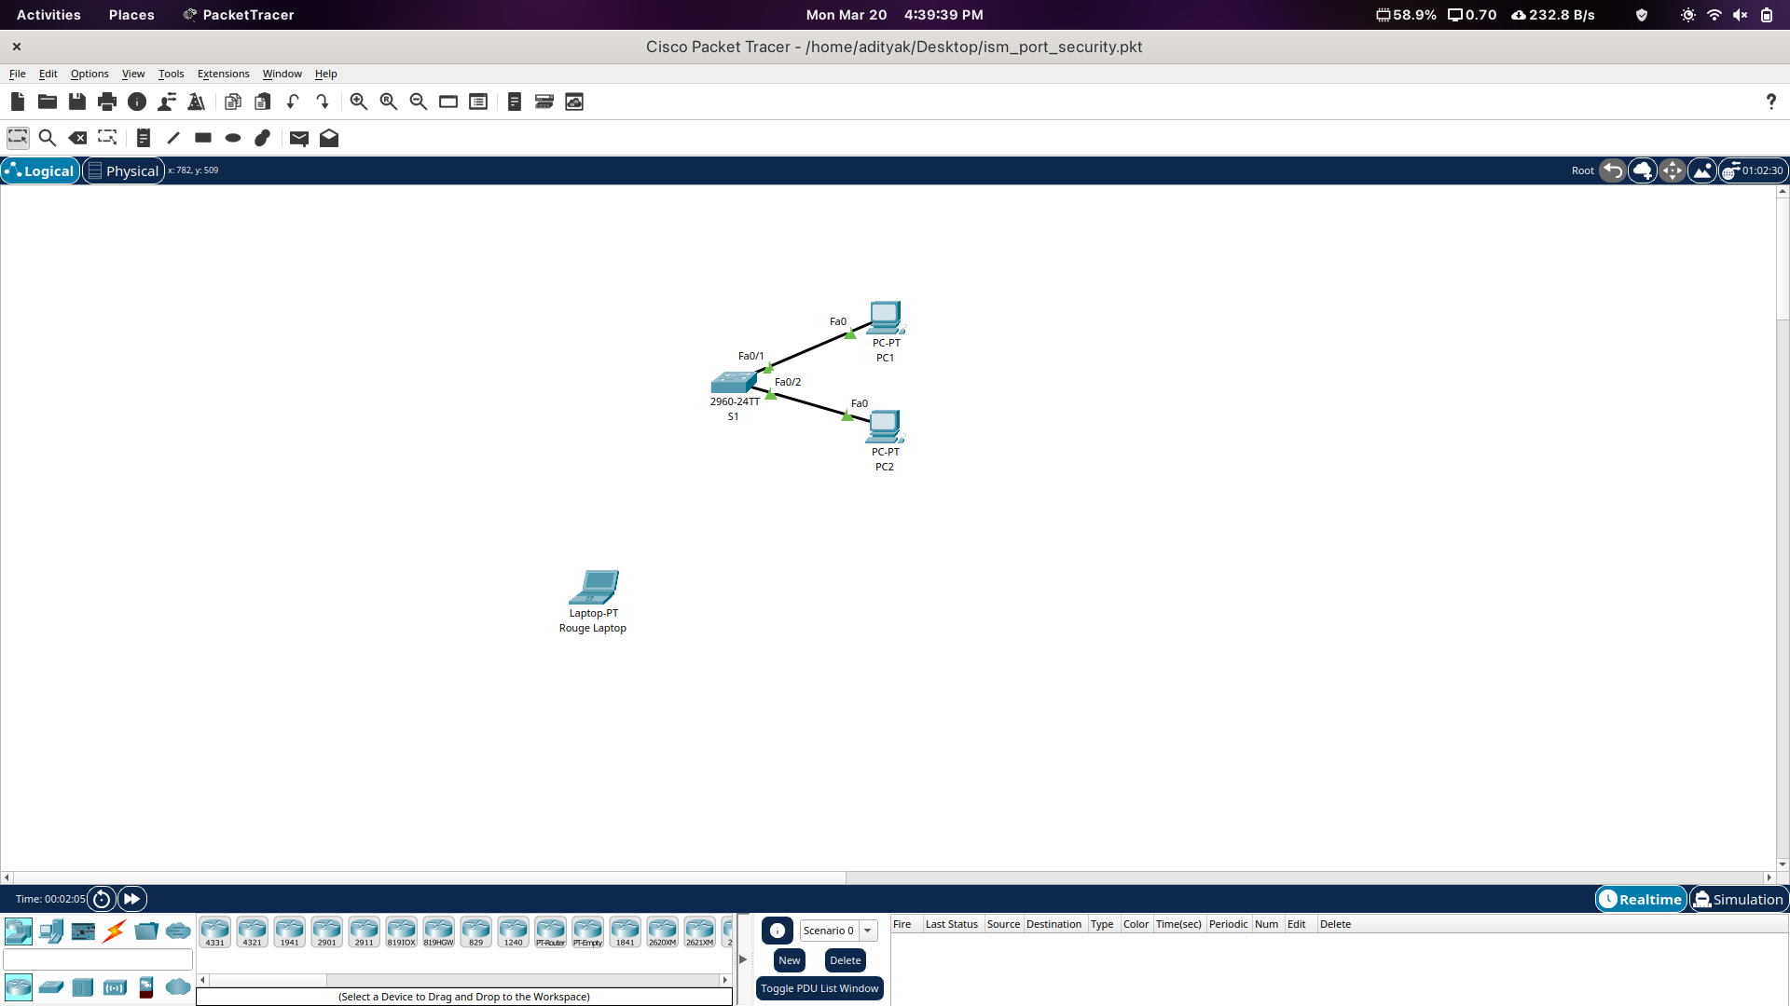
Part 1 : Configure Port Security
Step 1 : Enable Port Security Access the command line for S1 and enable port security on Fast Ethernet ports 0/1 and 0/2.
S1(config)# interface range f0/1 – 2
S1(config-if-range)#switchport mode access
S1(config-if-range)# switchport port-security

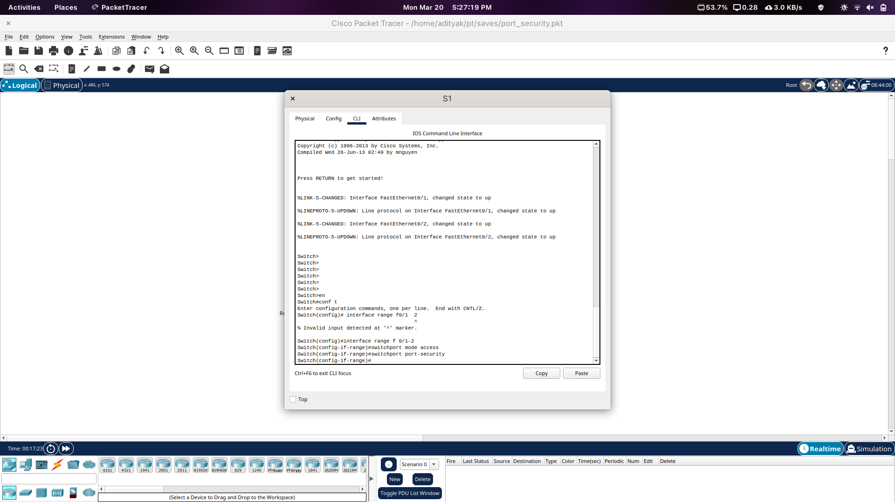
Step 2 : Set maximum Set the maximum so that only one device can access the Fast Ethernet ports 0/1 and 0/2.
S1(config-if-range)# switchport port-security maximum 1
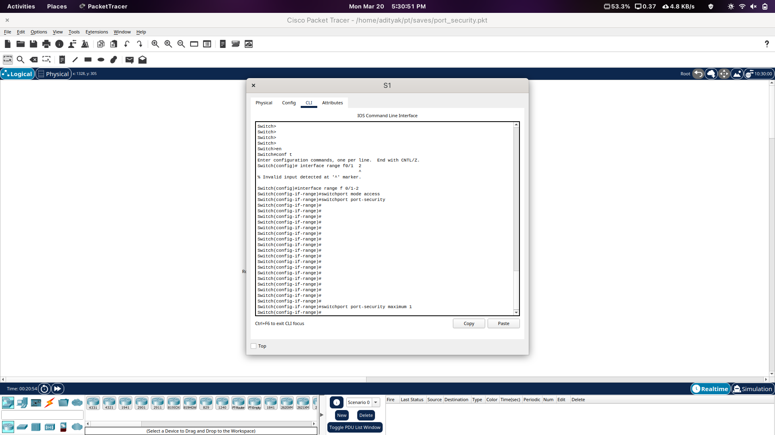
Step 3 : Secure the ports
Secure the ports so that the MAC address of a device is dynamically learned and added to the running configuration.
S1(config-if-range)# switchport port-security mac-address sticky
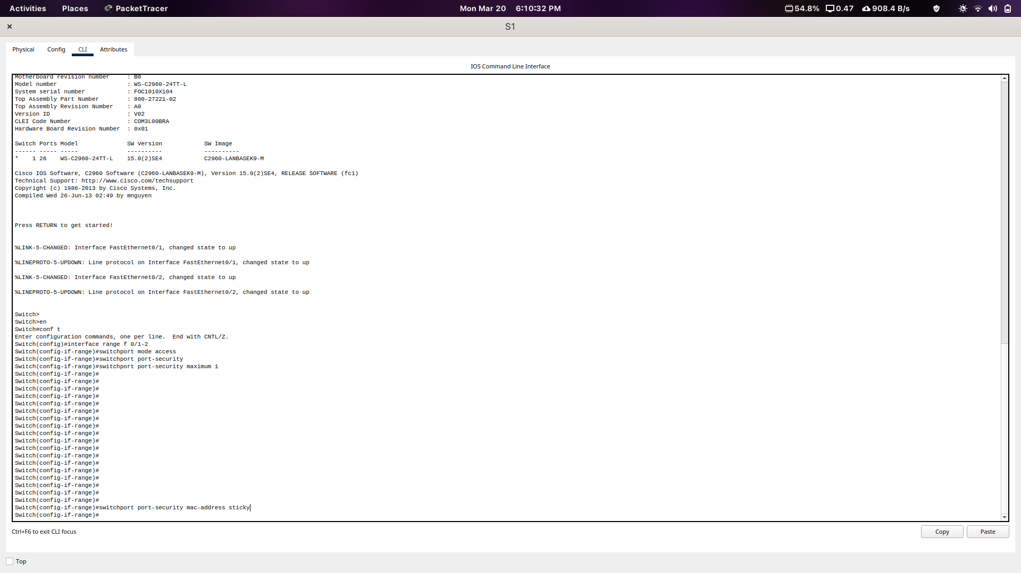
Step 4 : Set violation mode
Set the violation mode so that the Fast Ethernet ports 0/1 and 0/2 are not disabled when a violation occurs, but a notification of the security violation is generated and packets from the unknown source are dropped.
S1(config-if-range)# switchport port-security violation restrict

Step 5 : Disable unused ports
Disable all the remaining unused ports. Use the range keyword to apply this configuration to all the ports simultaneously.
S1(config-if-range)# interface range f0/3 - 24, g0/1 - 2
S1(config-if-range)# shutdown
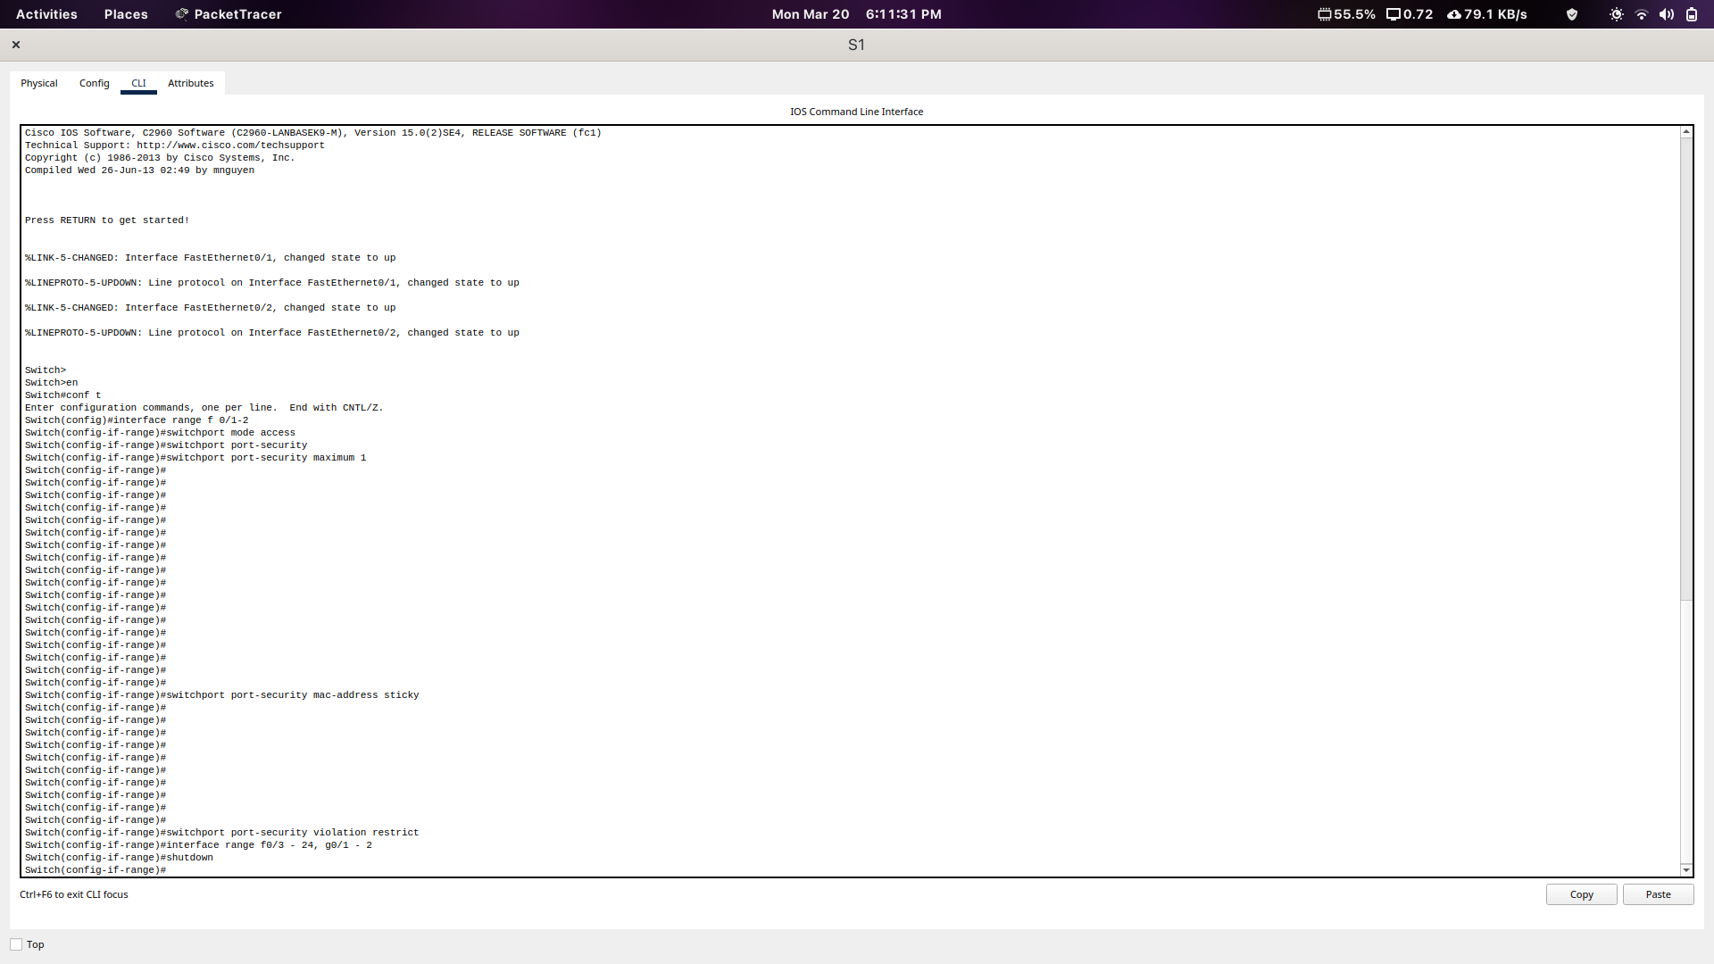
Part 2 : Verify Port Security
Step 1 : Ping
From PC1, ping PC2
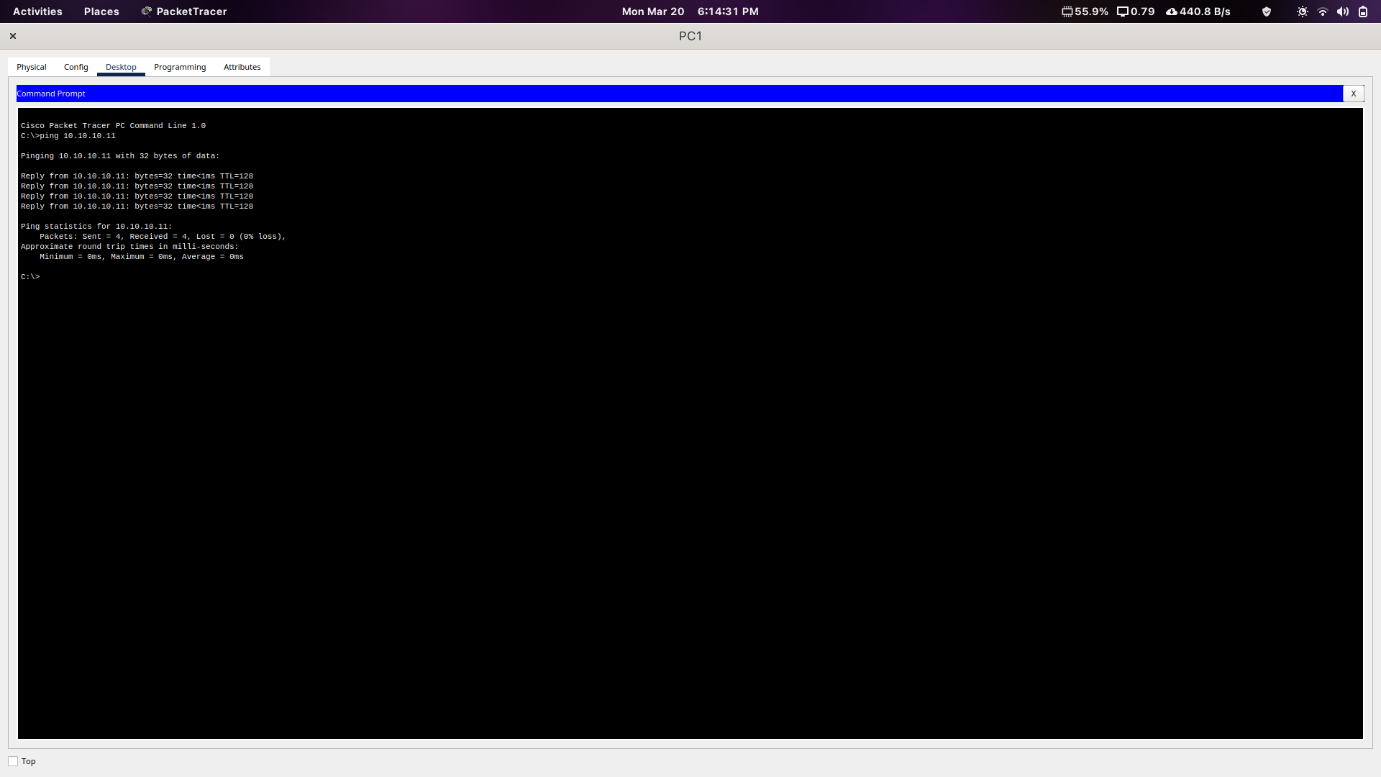
Step 2 : Verify enabled port security Verify that port security is enabled and the MAC addresses of PC1 and PC2 were added to the running configuration.
S1# show run | begin interface

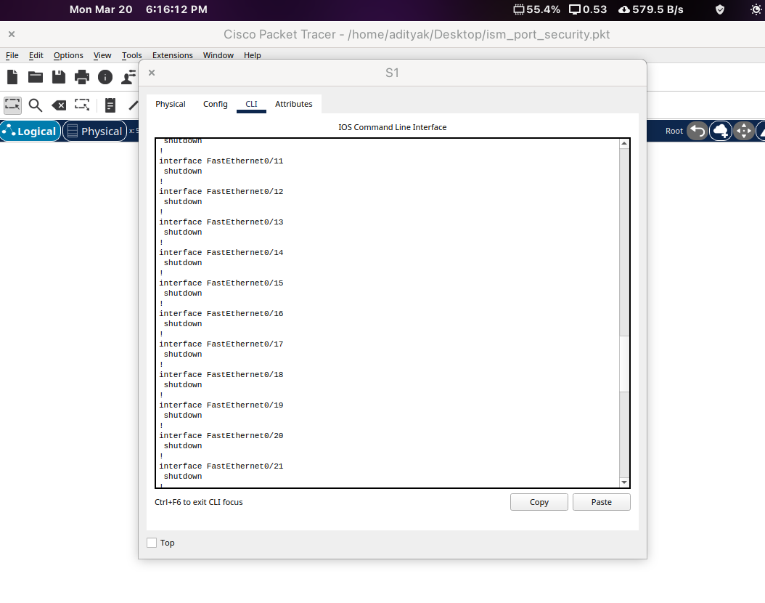
As we can notice, port security has been enabled and MAC addresses of interfaces fa0/1 and fa0/2 (essentially PC1 and PC2) have been added.

Step 3 : Review configuration information

Use port-security show commands to display configuration information.

S1# show port-security
S1# show port-security address

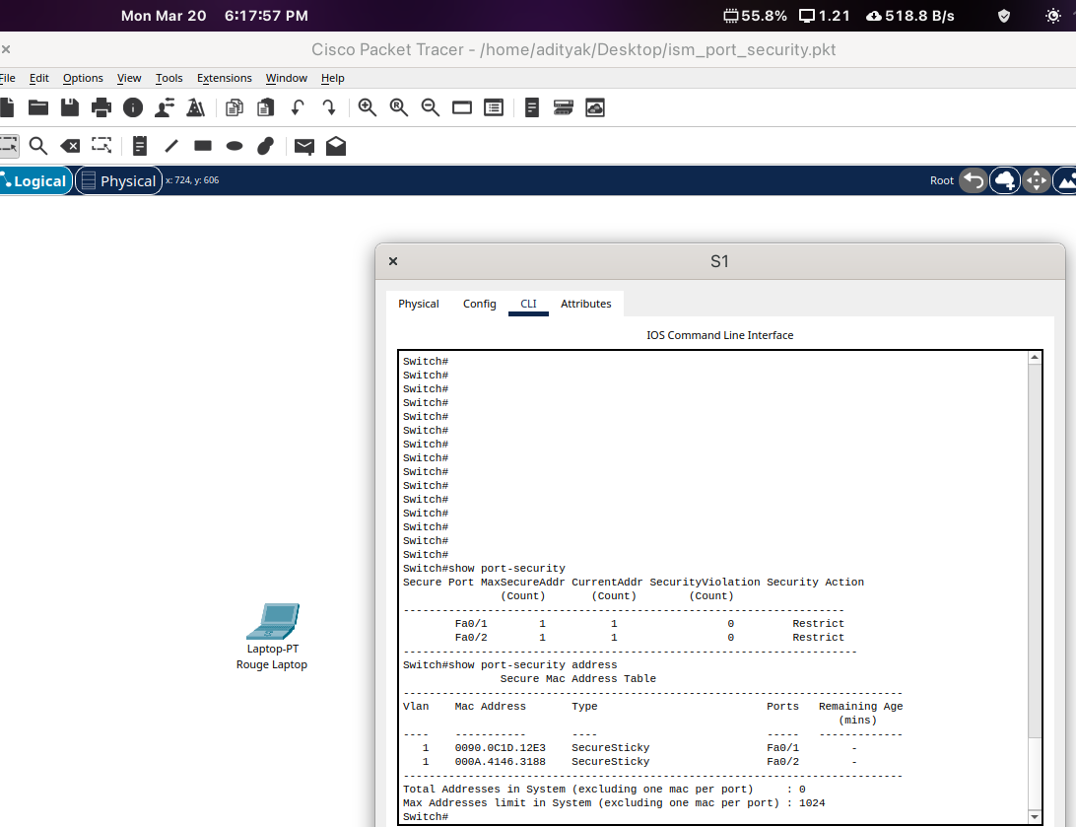

As we can see, Maximum and Current address are 1 and No security violations as of now. Mode is Restrict as set. Further, we can see MAC addresses of both the PCs and the ports connected.

Step 4 : Review using Rogue Laptop

Attach Rogue Laptop to any unused switch port and notice that the link lights are red.
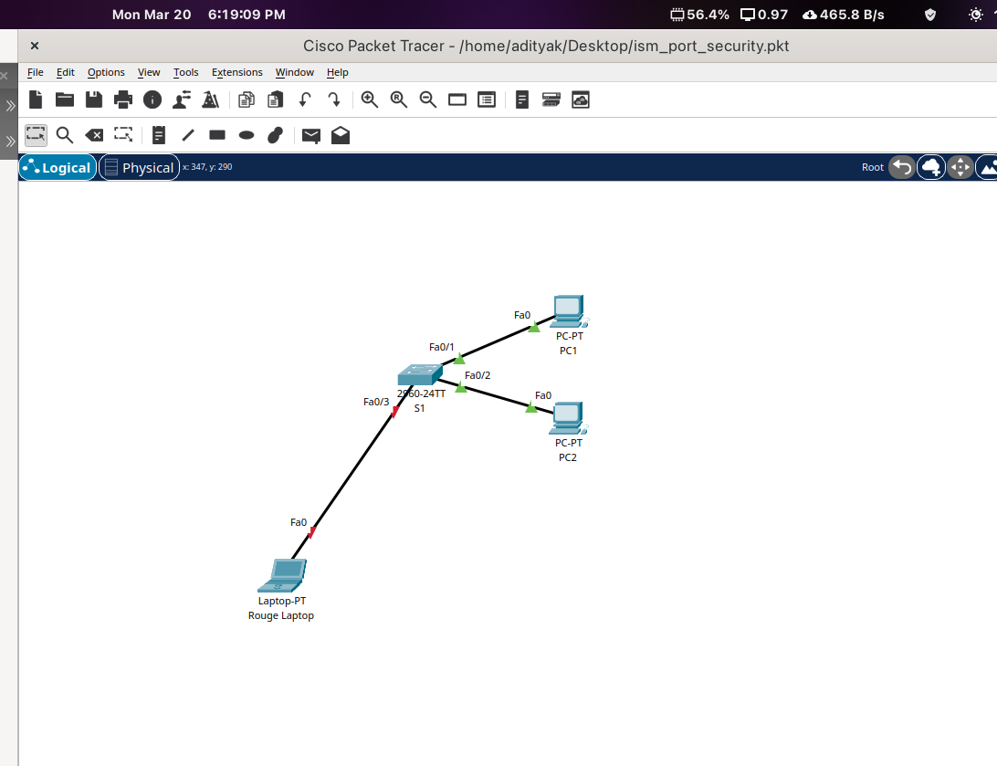

Step 5 : Verify using Rogue Laptop
Enable the port and verify that Rogue Laptop can ping PC1 and PC2. After verification, shut down the port connected to Rogue Laptop
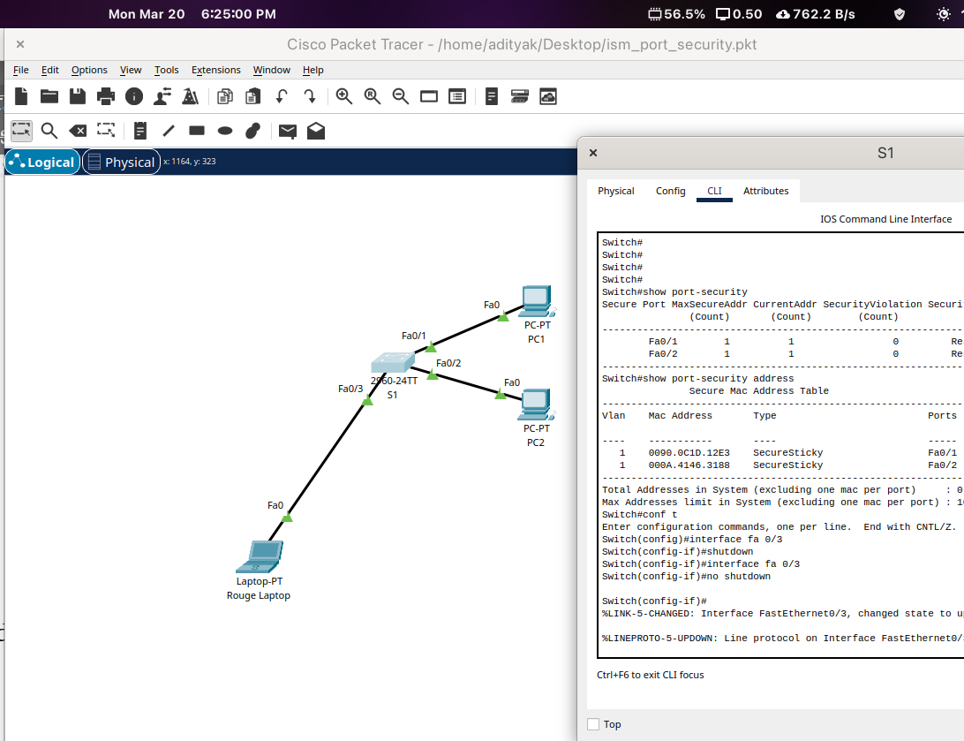

Ping to PC1 and PC2 from Rogue Laptop successful.
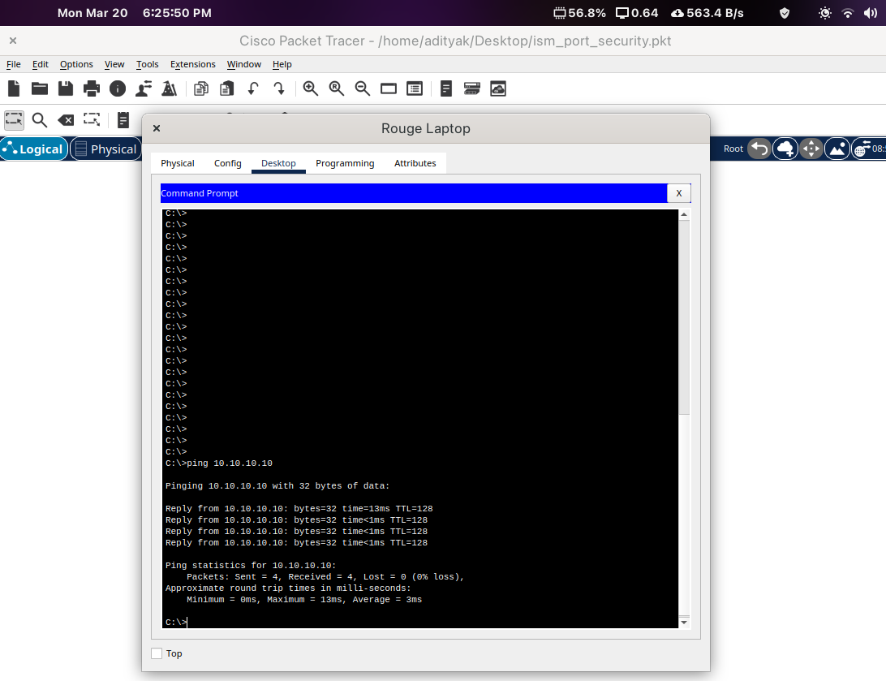

Shutdown the interface now.
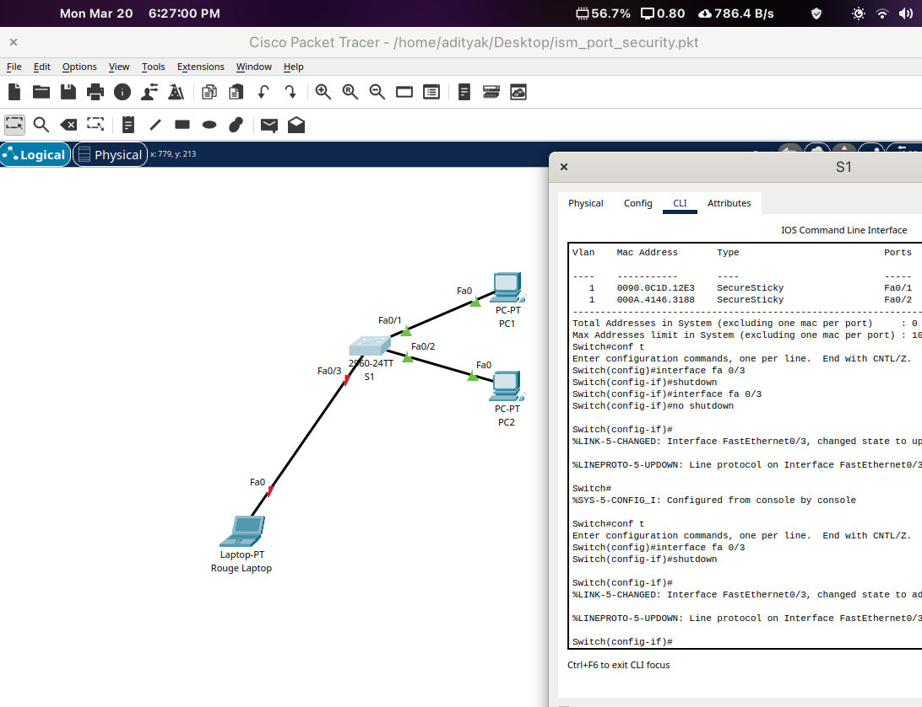
Step 6 : Verify using Rogue Laptop in place of PC2
Disconnect PC2 and connect Rogue Laptop to F0/2, which is the port to which PC2 was originally connected. Verify that Rogue Laptop is unable to ping PC1.
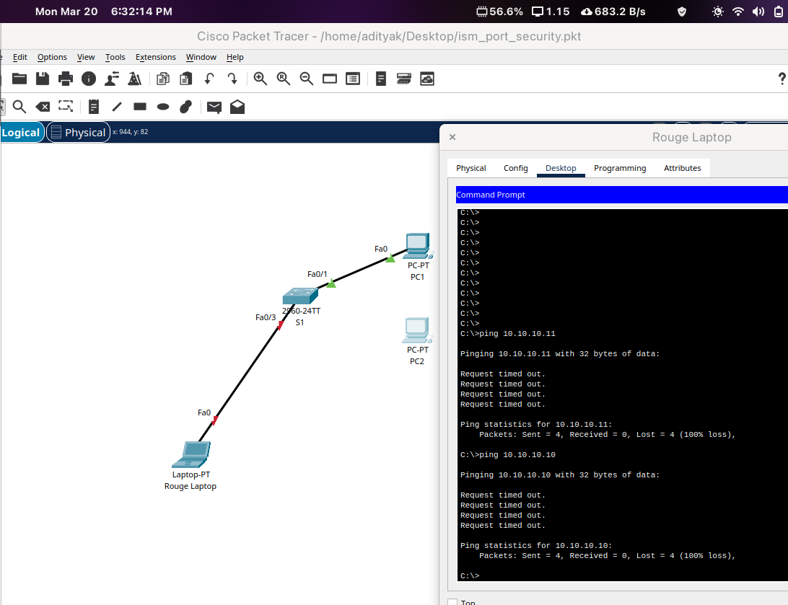
PC2 disconnected and Rogue Laptop connected to port Fa0/2 in which PC2 was originally connected.Rogue Laptop unable to ping PC1 since only PC2 is allowed to connect to port Fa0/2.

Step 7 : Review port security violation
Display the port security violations for the port to which Rogue Laptop is connected.
S1# show port-security interface f0/2
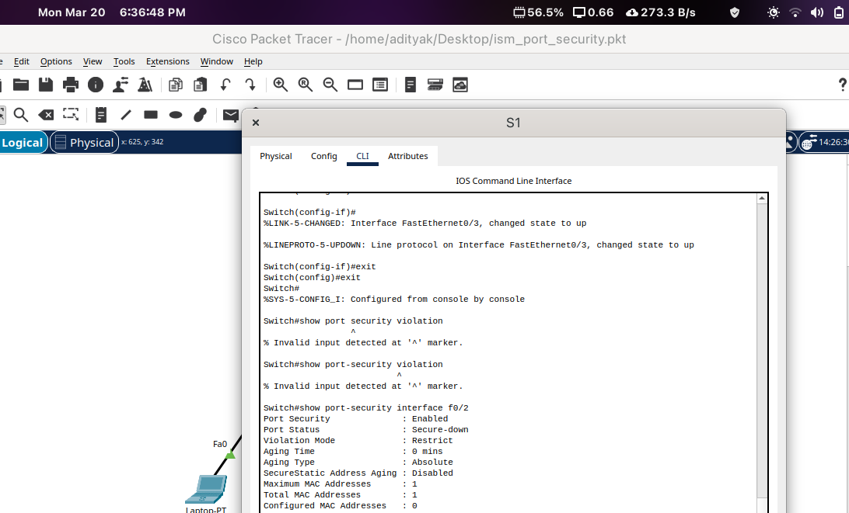
Successfully verified that PC2 can ping PC1.
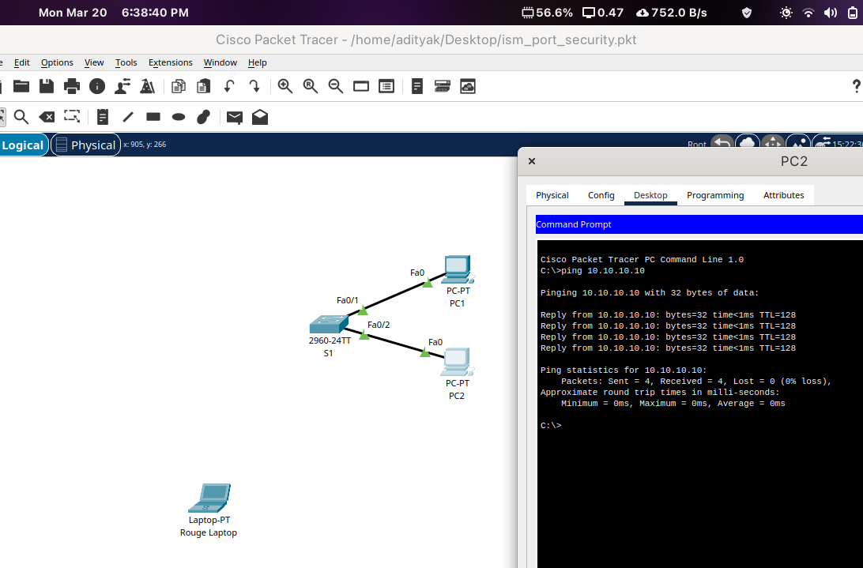

The port security that was enabled on the port only allowed the device, whose MAC was learned first, access to the port while preventing all other devices access.

