**Contents**

1 Overview 2

2 System Requirements 2

3 Setup and Deployment on Local 3

3.1.1 Setup and Deployment Frontend 3

3.2 Production Server Details 3

4 User Manual 4

4.1 Home Page 4

4.2 Left Menu 5

4.3 Login Page 5

# Overview

Agile Project management has been followed using Trello to organize the tasks.

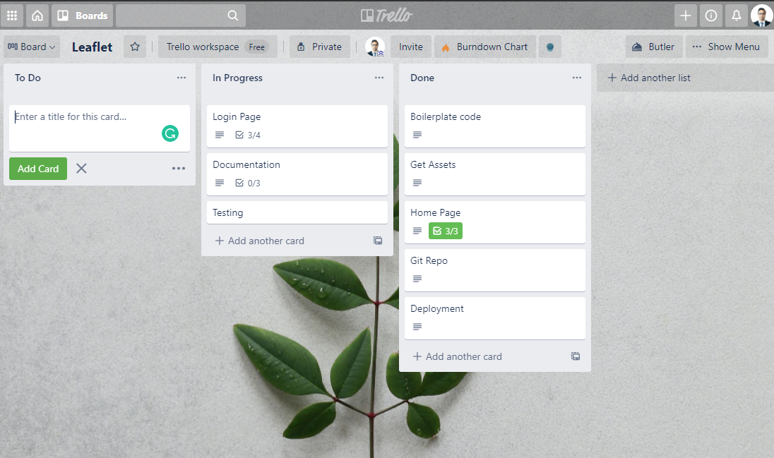

The technologies used are React with semantic UI and Netlify to deploy the app.

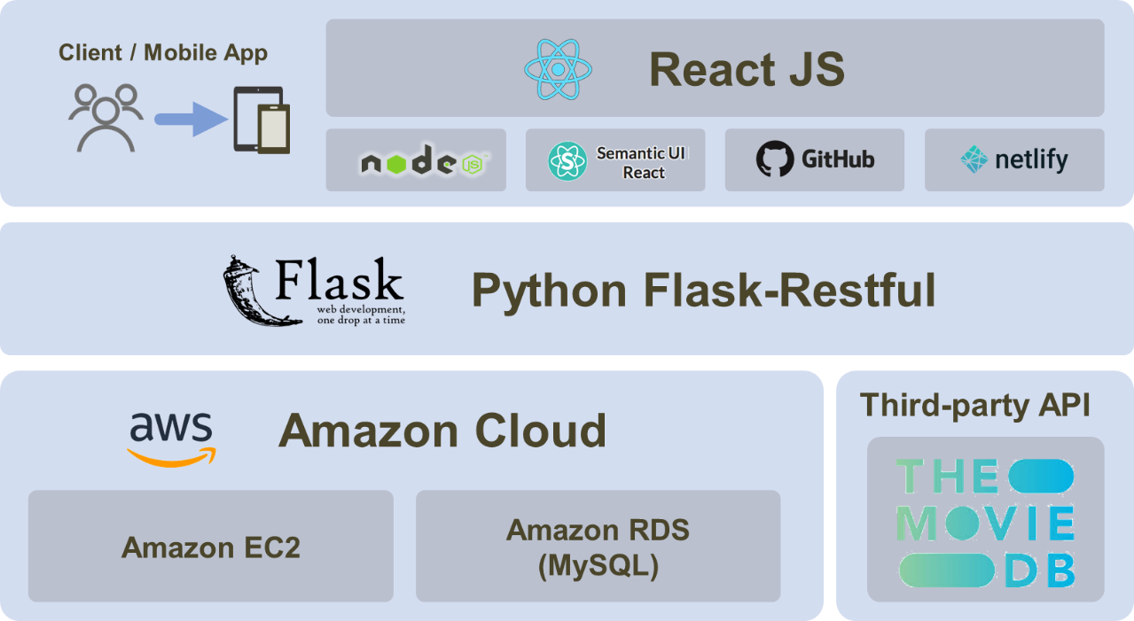

Fig. 1 Tech Architecture

# System Requirements

Operating System: Windows 7+, Linux

Please make sure the following have been installed:

* Node JS
* Git

# Setup and Deployment on Local

Clone the codebase from GitHub repo at

<https://github.com/adi-tej/leaflet.git>

### Setup and Deployment Frontend

* **Step 1: Install frontend packages**

Navigate to the root directory of the frontend code and install the node modules from package.json file.

cd leaflet

npm install

* **Step 2: Run the frontend server** (inside **client** folder)

npm start

You should be able to see the application running at <http://localhost:3000>.

## Production Server Details

Frontend server has been configured for production and deployed on Netlify which is available at

https://leaflet-test.netlify.app/

# User Manual

In this session, we will show you how to use Leaflet application.

## Home Page

Home page contains the left sidebar menu and a start button on screen.

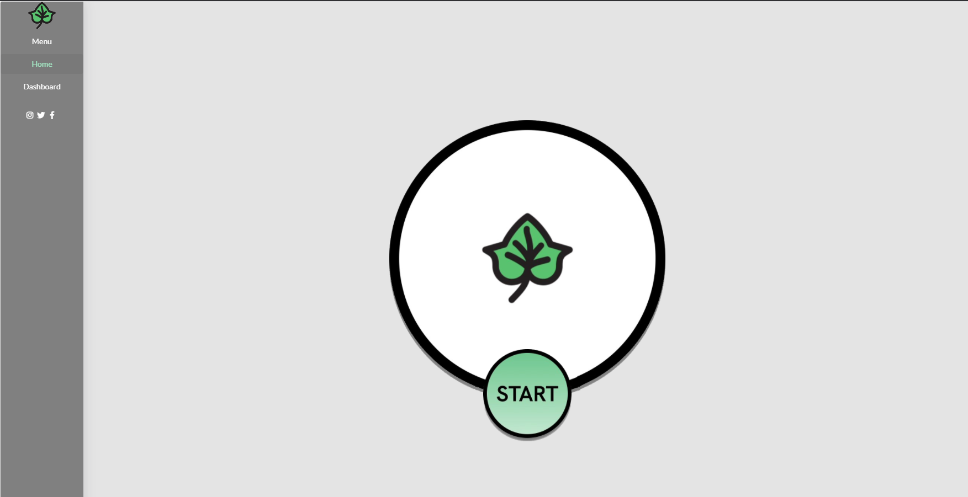

On click of start button takes to login page.

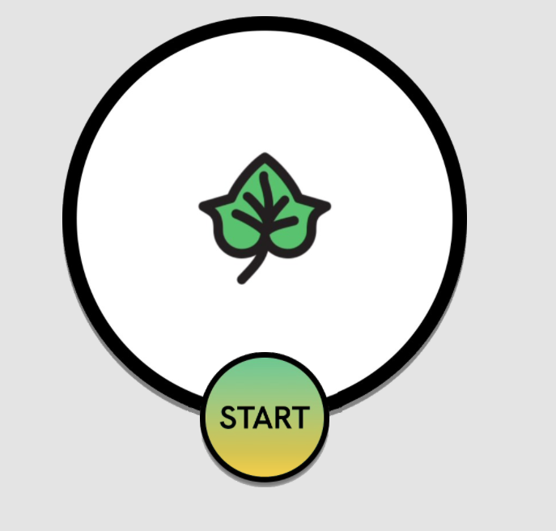

## Left Menu

Provides menu options to navigate to Home page, Dashboard and other pages.

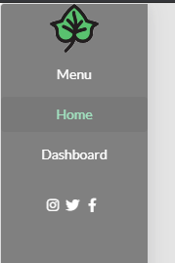

## Login Page

Enter the name, email and password and click on connect now to submit.

