Insights

Insight 1: Top Products Drive Majority of Revenue
Top 3 products contribute a large share of total sales, indicating strong product concentration.
Business Action: Prioritize inventory & promotions for these SKUs.
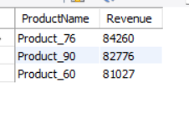

Insight 2: Few Regions Generate Maximum Sales
Sales are heavily concentrated in 2–3 major cities.
Business Action: Focus marketing spend and faster delivery in high-performing regions.
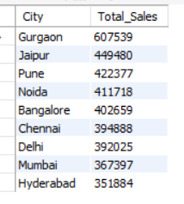

Insight 3: Small Set of Customers Are High-Value Buyers
