THIRANEX DATA ANALYTICS INTERNSHIP
TASK 4
Predictive Analytics Using Historical Data
Sales Forecasting Using Linear Regression
Dataset: Superstore Sales Dataset
Tools: Python, Pandas, NumPy, Matplotlib, Scikit-learn
Target: Sales
Forecast horizon: 6 months

1. Executive Summary
This project demonstrates a basic predictive analytics workflow using historical Superstore sales data. The data was inspected and preprocessed, transaction-level sales were aggregated into monthly sales, the historical trend was visualized, a Linear Regression model was trained, its performance was evaluated, and sales were forecast for the next six months.
The dataset contains 9,800 records and 18 columns. The baseline model achieved an MAE of 18,560.29, RMSE of 23,619.29, and R² of 0.0332 on an 80/20 chronological train-test split.

2. Objectives
- Inspect and understand historical sales data.
- Preprocess the Order Date column and check missing values.
- Convert transaction-level sales into monthly sales totals.
- Visualize the historical sales trend.
- Build a simple Linear Regression prediction model.
- Evaluate model performance using MAE, RMSE, and R².
- Forecast sales for the next six months.

3. Dataset Description
The Superstore dataset contains information about orders, customers, products, locations, categories, and sales. The main fields used in this project are Order Date and Sales.
Property | Value
Records | 9,800
Columns | 18
Date field | Order Date
Target variable | Sales
Missing values | 11 in Postal Code; 0 in Sales/Order Date
Aggregation | Monthly

4. Methodology
Historical Data → Data Inspection → Date Preprocessing → Monthly Aggregation → Trend Visualization → Train/Test Split → Linear Regression → Evaluation → Future Forecast

4.1 Data Loading and Inspection
Pandas was used to load the CSV file. The first rows, dataset shape, information, and missing values were inspected.

4.2 Data Preprocessing
Order Date was converted from day/month/year text into a datetime value using dayfirst=True. The missing-value check found 11 missing Postal Code values, while Order Date and Sales contained no missing values.

4.3 Monthly Sales
Sales from individual transactions were summed month by month. This created a monthly time series for analysis and forecasting.

5. Historical Sales Trend
The historical trend shows substantial month-to-month variation, including several peaks and drops.
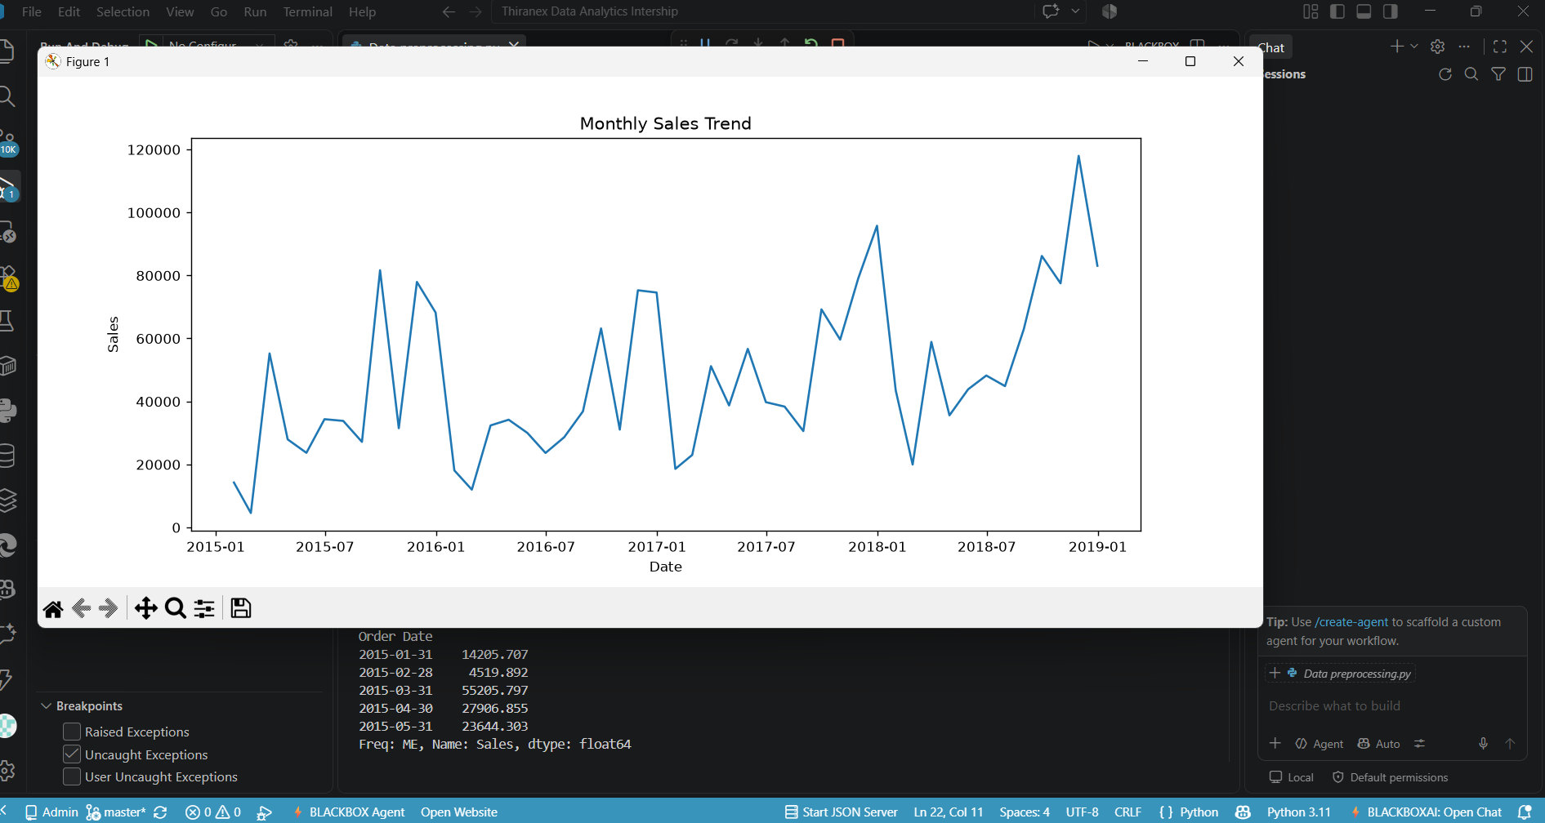
Figure 1: Monthly Sales Trend

6. Predictive Model
Linear Regression was used as a simple baseline model. A sequential month number was used as the input feature and monthly Sales was used as the target. The first 80% of observations were used for training and the remaining 20% were used for testing.

7. Model Evaluation
The model was evaluated using three regression metrics:
- MAE: average absolute difference between actual and predicted sales.
- RMSE: measures prediction error while giving more weight to larger errors.
- R² Score: indicates how much variation in the target is explained by the model.
Metric | Result | Meaning
MAE | 18,560.29 | Average absolute prediction error
RMSE | 23,619.29 | Larger errors have greater influence
R² Score | 0.0332 | Low fit for the simple time-only model
The low R² value indicates that a straight-line relationship with time alone does not capture the strong fluctuations in monthly sales. Therefore, this model should be treated as a baseline rather than a final business forecasting model.

8. Six-Month Forecast
The trained model was used to estimate sales for the next six months.
Date | Predicted Sales
2019-01-31 | 62,426.42
2019-02-28 | 63,112.70
2019-03-31 | 63,798.98
2019-04-30 | 64,485.26
2019-05-31 | 65,171.54
2019-06-30 | 65,857.82
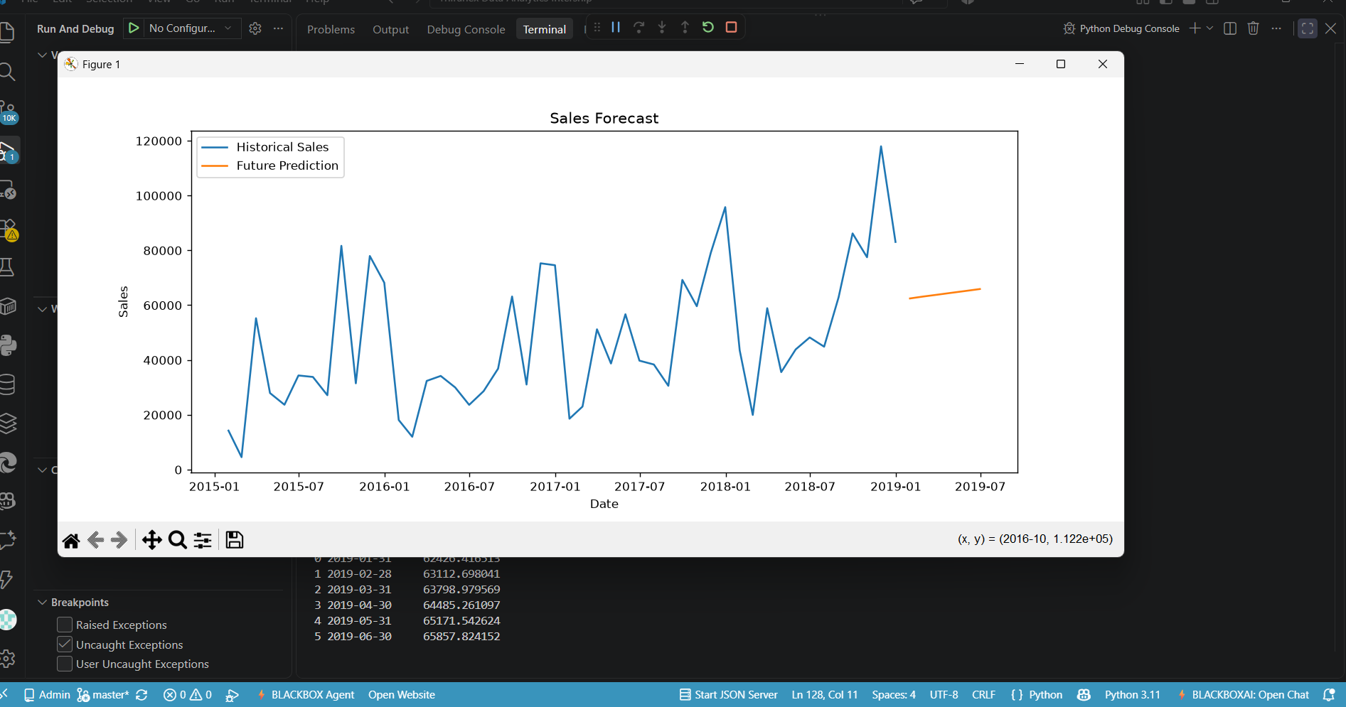
Figure 2: Historical Sales and Future Sales Forecast

9. Key Findings
- The dataset contains 9,800 transactions and 18 columns.
- The Order Date field was successfully converted to datetime format.
- Monthly aggregation made the historical sales trend easier to analyze.
- Sales show considerable fluctuations rather than a smooth straight-line pattern.
- The baseline Linear Regression model has a low R² score of 0.0332.
- The six-month baseline forecast increases gradually from about 62,426 to 65,858.
- The workflow successfully demonstrates data preprocessing, trend analysis, predictive modeling, evaluation, and forecasting.

10. Limitations and Future Improvements
The current model uses only a sequential time index. It does not explicitly learn seasonal patterns, previous-month sales, category effects, regional effects, promotions, or other factors that can influence sales.
- Add previous-month and previous-year sales (lag features).
- Add month or season information.
- Compare Linear Regression with Random Forest or a dedicated time-series model.
- Use relevant business variables such as Category, Region, Quantity, and Profit.
- Compare models on the same chronological test data and select the better-performing model.

11. Conclusion
The project successfully implements the complete basic predictive analytics process on historical sales data. The data was cleaned and transformed, monthly trends were visualized, a Linear Regression model was trained and evaluated, and a six-month forecast was generated. The evaluation also shows that the simple baseline model is not sufficiently accurate for reliable business forecasting, providing a clear direction for future model improvement.

12. Appendix – Main Python Code
import pandas as pd
import numpy as np
import matplotlib.pyplot as plt
from sklearn.linear_model import LinearRegression
from sklearn.metrics import mean_absolute_error, mean_squared_error, r2_score
df = pd.read_csv(r"C:\Users\Admin\OneDrive\Desktop\Thiranex Data Analytics Intership\Task3\train.csv")
print("Dataset Shape:", df.shape)
print(df.head())
print(df.isnull().sum())
df["Order Date"] = pd.to_datetime(df["Order Date"], dayfirst=True)
monthly_sales = df.resample("ME", on="Order Date")["Sales"].sum()
plt.figure(figsize=(12,5))
plt.plot(monthly_sales)
plt.title("Monthly Sales Trend")
plt.xlabel("Date")
plt.ylabel("Sales")
plt.show()
X = np.arange(len(monthly_sales)).reshape(-1,1)
y = monthly_sales.values
train_size = int(len(monthly_sales) * 0.8)
X_train, X_test = X[:train_size], X[train_size:]
y_train, y_test = y[:train_size], y[train_size:]
model = LinearRegression()
model.fit(X_train, y_train)
y_pred = model.predict(X_test)
mae = mean_absolute_error(y_test, y_pred)
rmse = np.sqrt(mean_squared_error(y_test, y_pred))
r2 = r2_score(y_test, y_pred)
print("MAE:", mae)
print("RMSE:", rmse)
print("R2 Score:", r2)
future_X = np.arange(len(monthly_sales), len(monthly_sales)+6).reshape(-1,1)
future_predictions = model.predict(future_X)
future_dates = pd.date_range(
start=monthly_sales.index[-1] + pd.offsets.MonthEnd(1),
periods=6, freq="ME"
)
forecast = pd.DataFrame({
"Date": future_dates,
"Predicted Sales": future_predictions
})
print(forecast)
plt.figure(figsize=(12,5))
plt.plot(monthly_sales.index, monthly_sales.values, label="Historical Sales")
plt.plot(future_dates, future_predictions, label="Future Prediction")
plt.title("Sales Forecast")
plt.xlabel("Date")
plt.ylabel("Sales")
plt.legend()
plt.show()

