**Run Welcome.py after successfully completed all step’s written below**

Hello Friend This is Order book Prototype.

Here I use MySQL as a database server. And python as a frontend

Step to initialize this project:

(Note: I hope you have install python on your system)

Step 1: install xamp on this system.

Step 2: create database called “internshipproject”.

Step 3: create 2 tables in that database .

1. “company” Table



1. “order_by_customer” Table

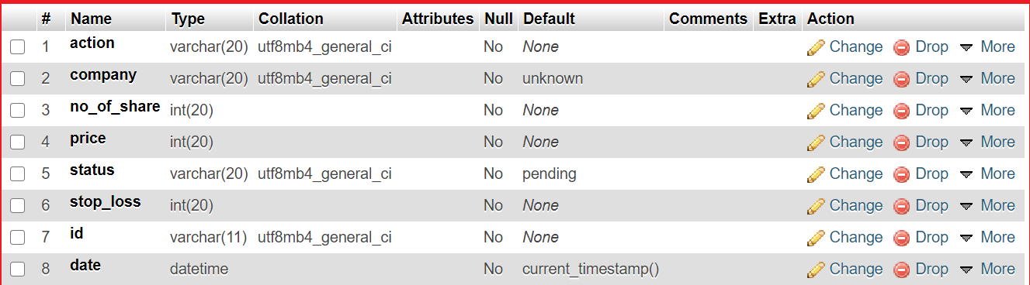

That’s it you are good To go.

I like to show you some images of or project:

Market Order:

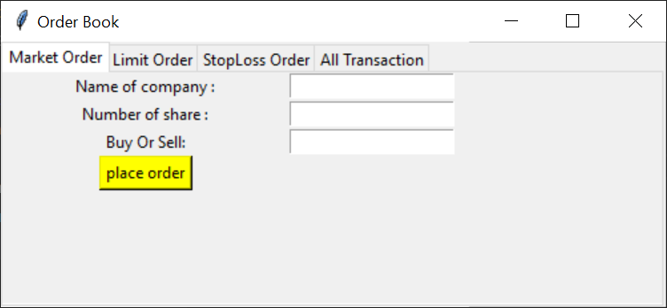

Limit Order :

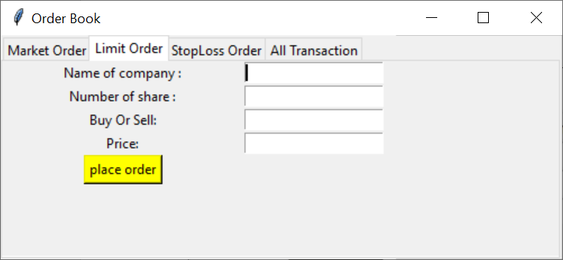

Stop Loss Order :

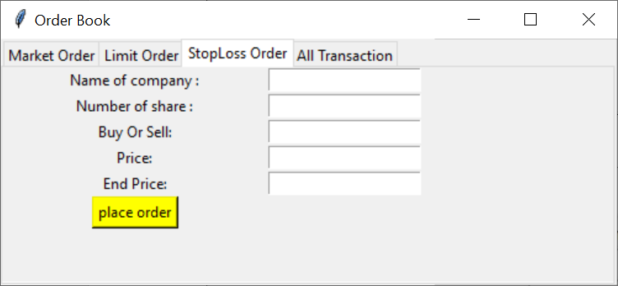

All Transaction :

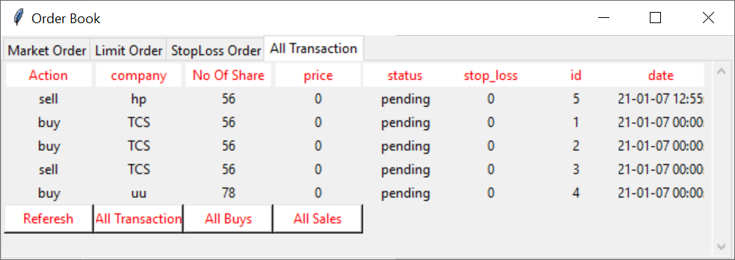

What if I click on “Referesh” Button and “All Transaction” Button :

Ans : it will re fetch data from table and show you

What if I click on “All Buys” :

Ans : it will show all transaction of “buy”

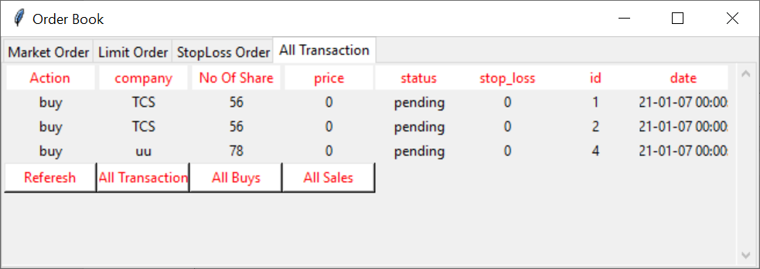

And if you click on “All Sales” then this

