Experiment 1:- Analyze the Computer Network Design using SWITCH and HUB in GNS3.

Switch Configure:
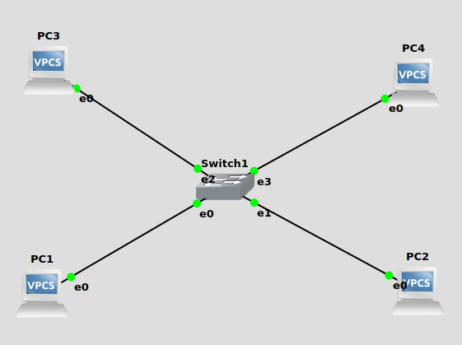
Fig: Switch

- Drag &Drop 4 VPCs and make the required connections and click on start option to run all devices.

- Set ip address for all VPCs as follows:
PC1>192.168.1.1/24 192.168.1.254
PC2>192.168.1.2/24 192.168.1.254
PC3>192.168.1.3/24 192.168.1.254
PC4>192.168.1.4/24 192.168.1.254

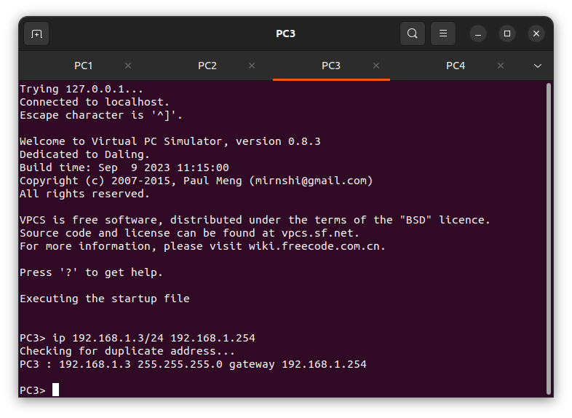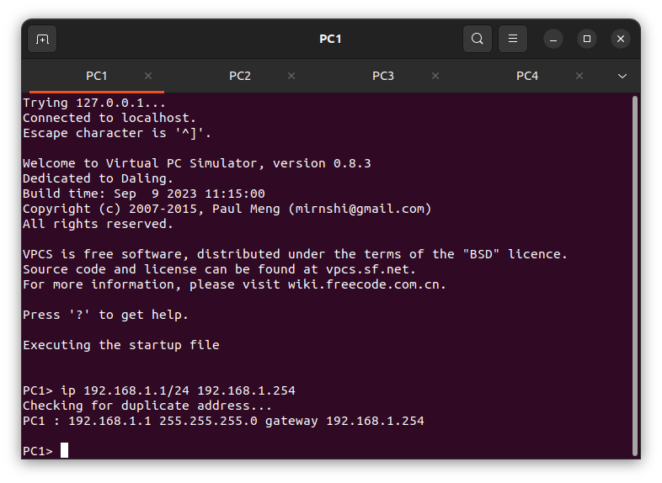

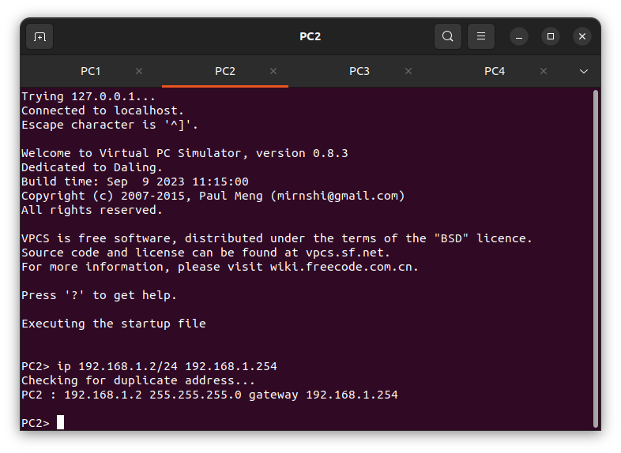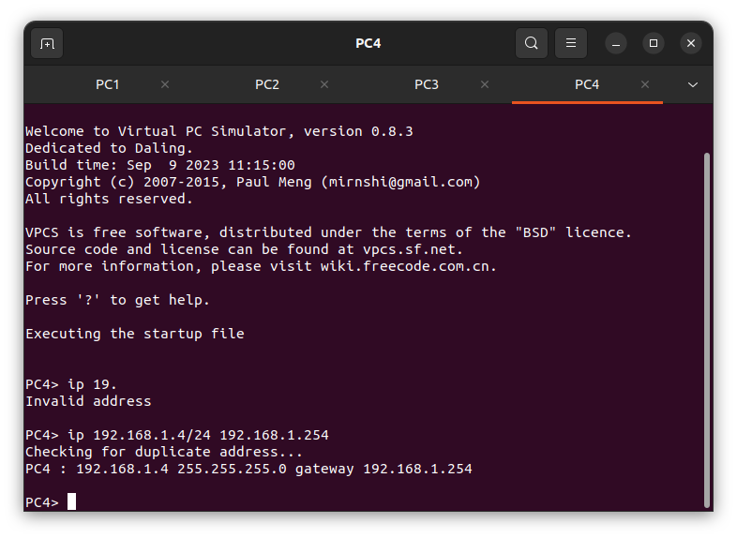
Fig: IP address for all 4 PC’s.

- Right click on PC4 & give start capture.

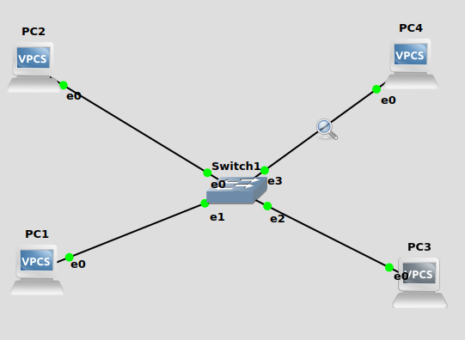
Fig: PC4 Start Capture Picture

4. PC1>ping 192.168.1.2 ->no data transfer
5. PC1>ping 192.168.1.3 ->no data transfer
6. PC1>ping 192.168.1.4 ->data transfer

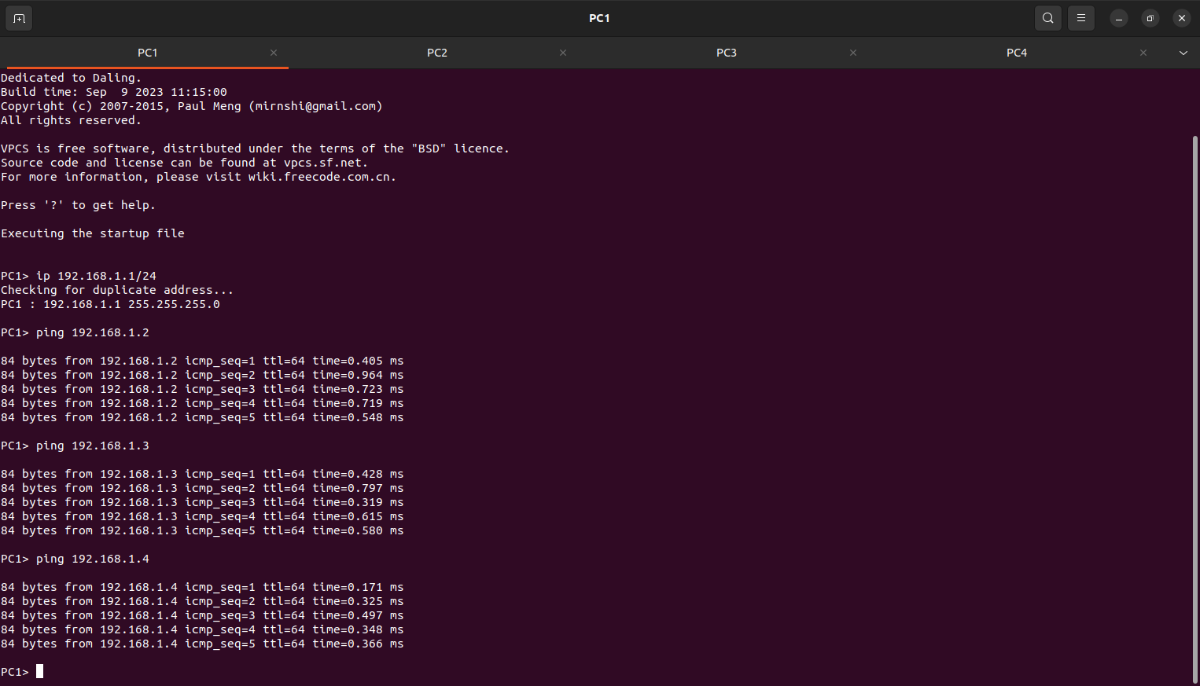

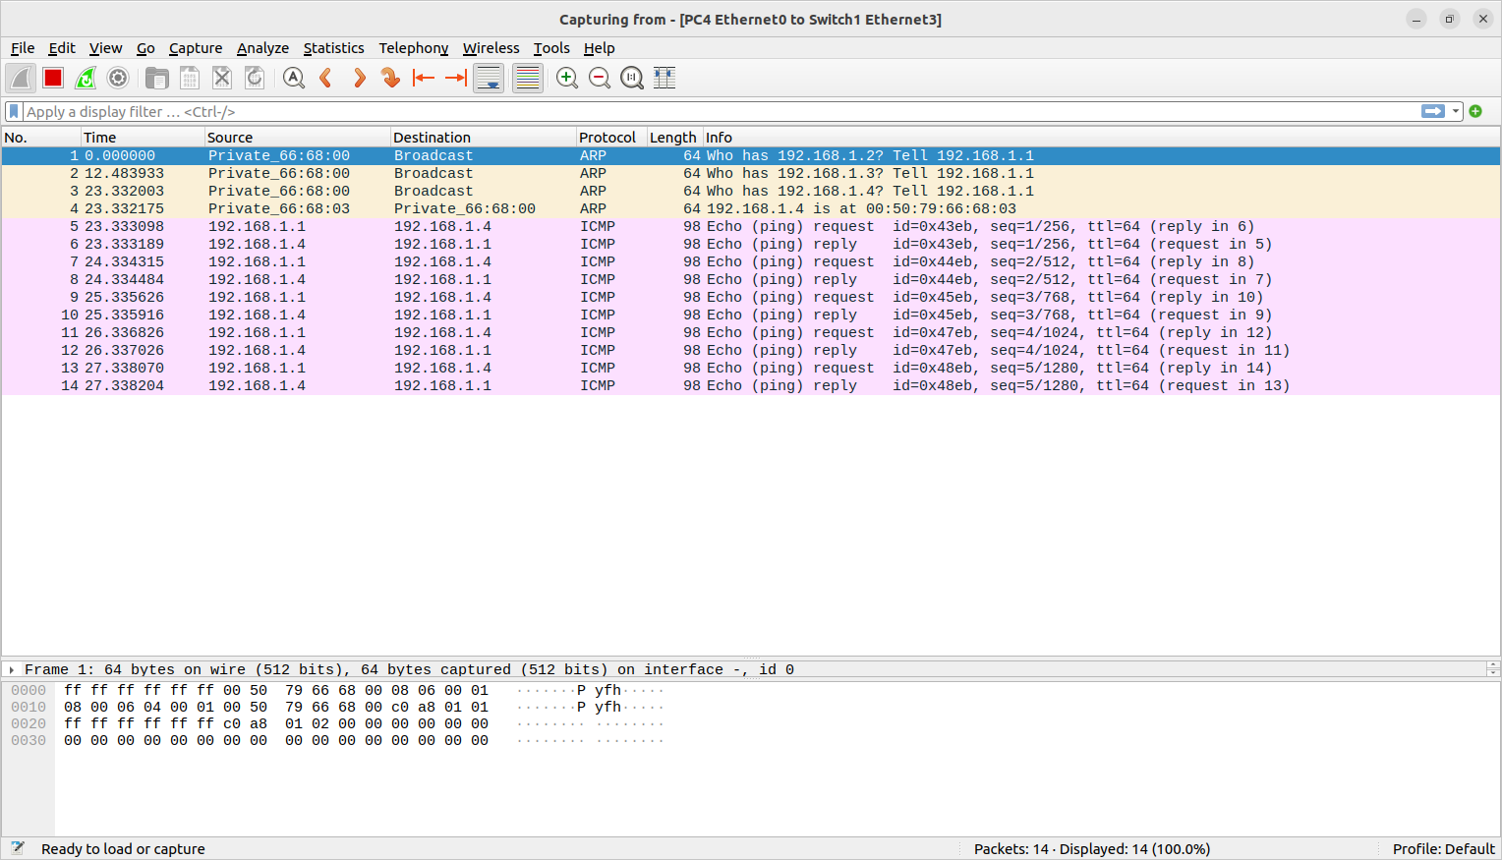
Fig: Wireshark Displaying the request reply through the connected VPCs and Captured PC.

HUB Configuration:-
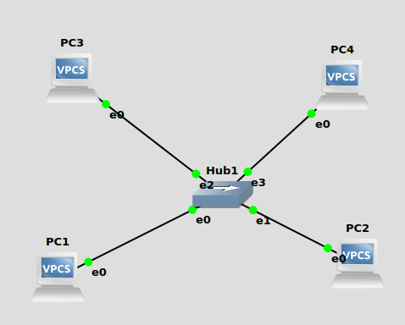
Fig: Hub
- Drag & Drop 4 VPCs
- Add Ethernet Hub and make a connection..
- Set IP Address for all the VPCs.

Fig: setting IP address for all VPCs.

- Right click on PC4 and give Start Capture.

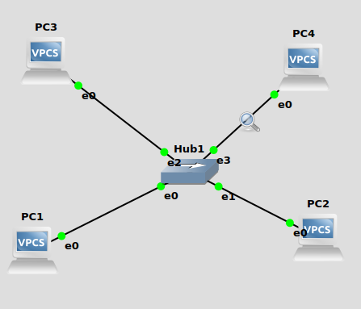
Fig: - PC4 Start Capture Picture

- Ping all the VPCs using ping command
- PC1>ping 192.168.1.2
- PC1>ping 192.168.1.3
- PC1>ping 192.168.1.4

Output:-
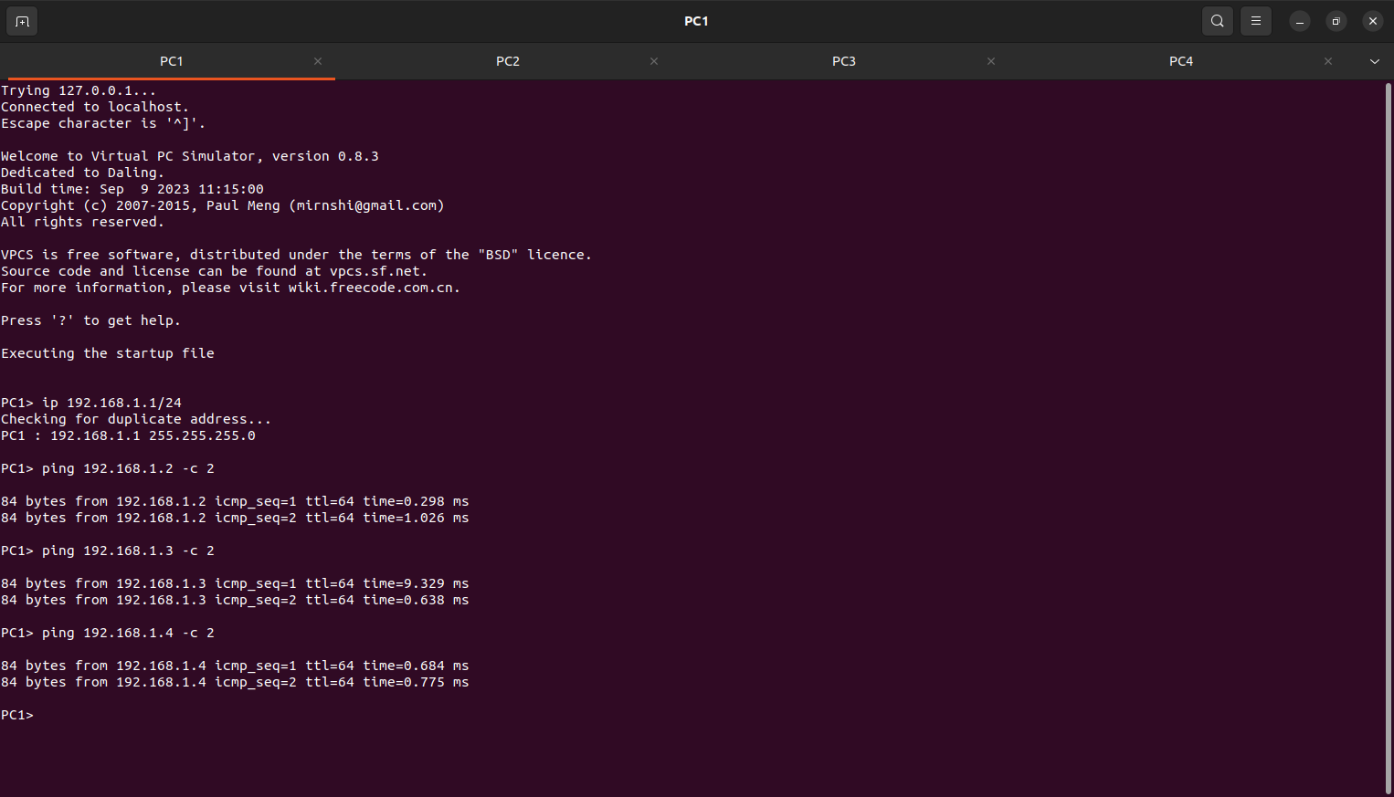

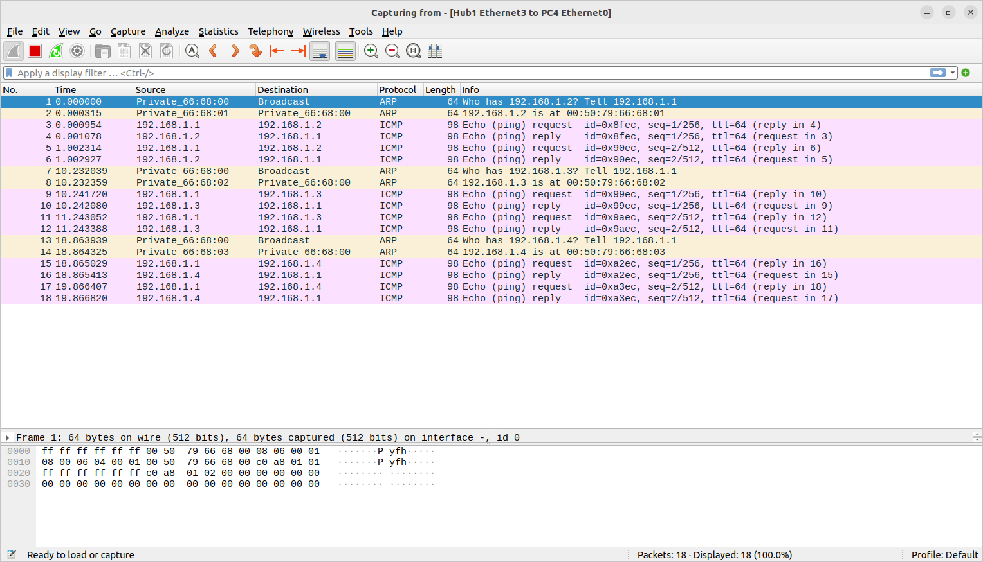

Fig: - Wireshark is displaying the request reply through the connected VPCs and Captured PC.

Experiment 2: - Analyze the Router in Computer Network Design using GNS3.

Objectives:
- To Learn about IP address Assignment for different sub networks
- To study the functions of ROUTER device
- To study the functions of SWITCH device

To start with the Lab exercise, create a topology as shown in Figure below.
Single router:-
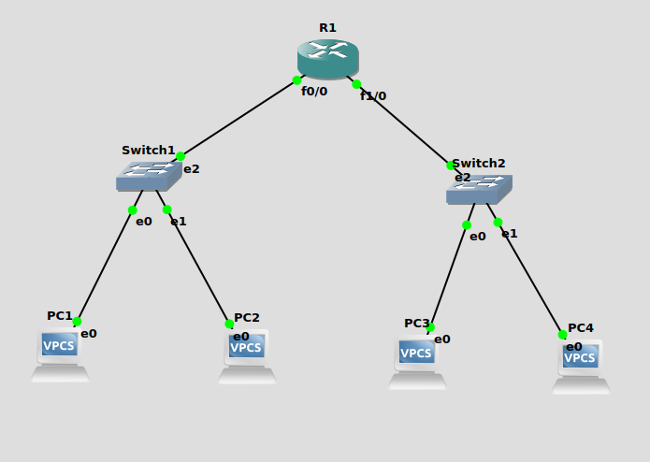
Fig:- Single Router Configuration
- Drag & Drop 4 VPCs, 2 Switches, 1 Router
- Make all the required connections and click on start button to start all the devices.
- Set IP Address for all the VPCs as follows:
PC1>192.168.1.1/24 192.168.1.254
PC2>192.168.1.2/24 192.168.1.254
PC3>192.168.2.1/24 192.168.2.254
PC4>192.168.2.2/24 192.168.2.254

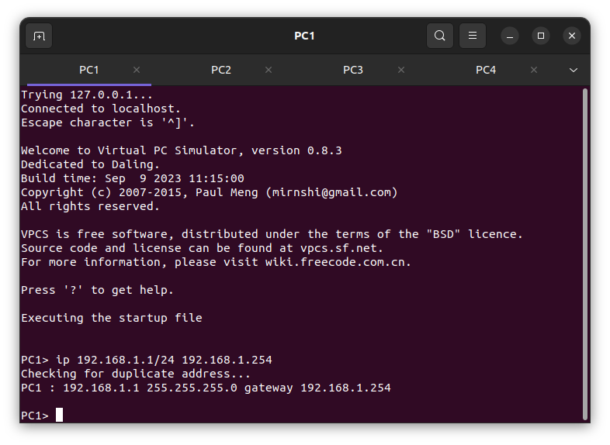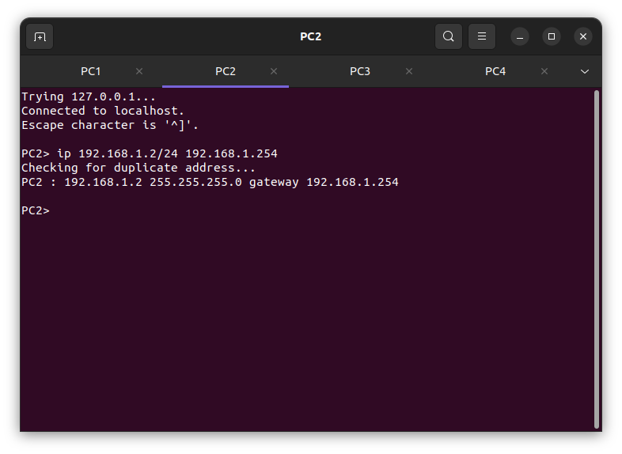
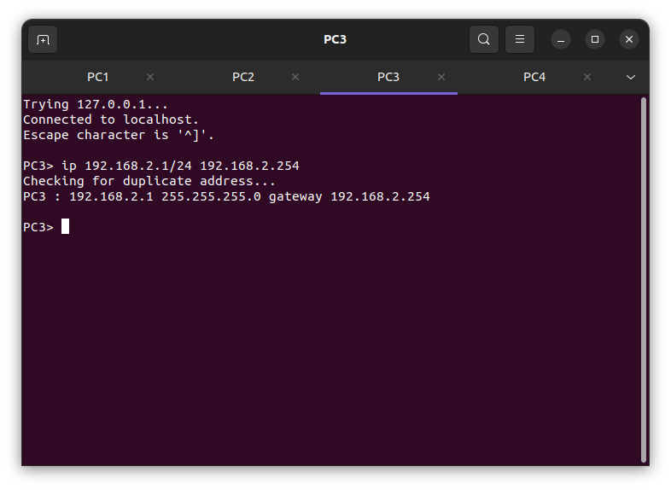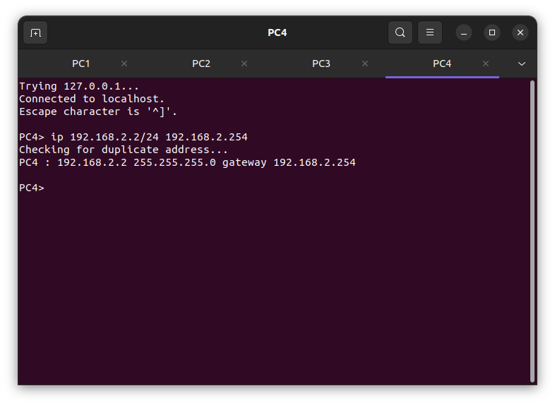
Fig:- Showing PC’s IP address.
- Click on PC1 and start capture
- PC1>ping 192.168.1.1 ->data transfer takes place
- PC1>ping 192.168.2.1 ->Host not reachable
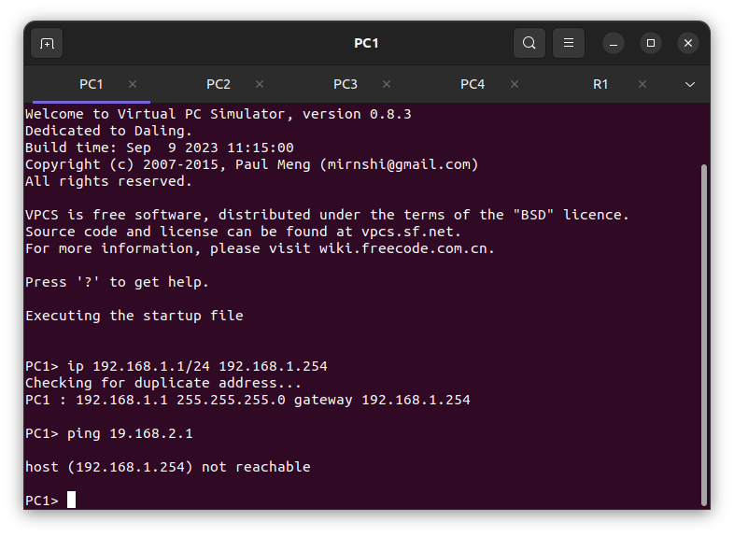
Fig: Ping PC1 to PC3.
Router Configuration:-
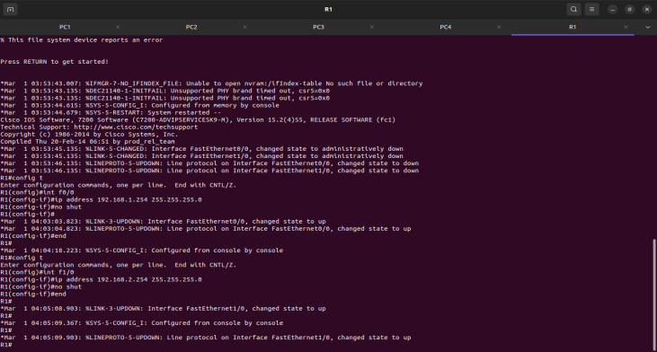
Router Configuration Commands:
R1# config t
R1 (config)#int f0/0
R1 (config)#ip address 192.168.1.254 255.255.255.0
R1 (config)#no shut
R1 (config)#exit
R1 (config)#int f1/0
R1 (config)# ip address 192.168.2.254 255.255.255.0
R1 (config)#no shut
R1 (config)#exit

- Ping PC1 to PC3.

PC1> ping 192.168.2.1
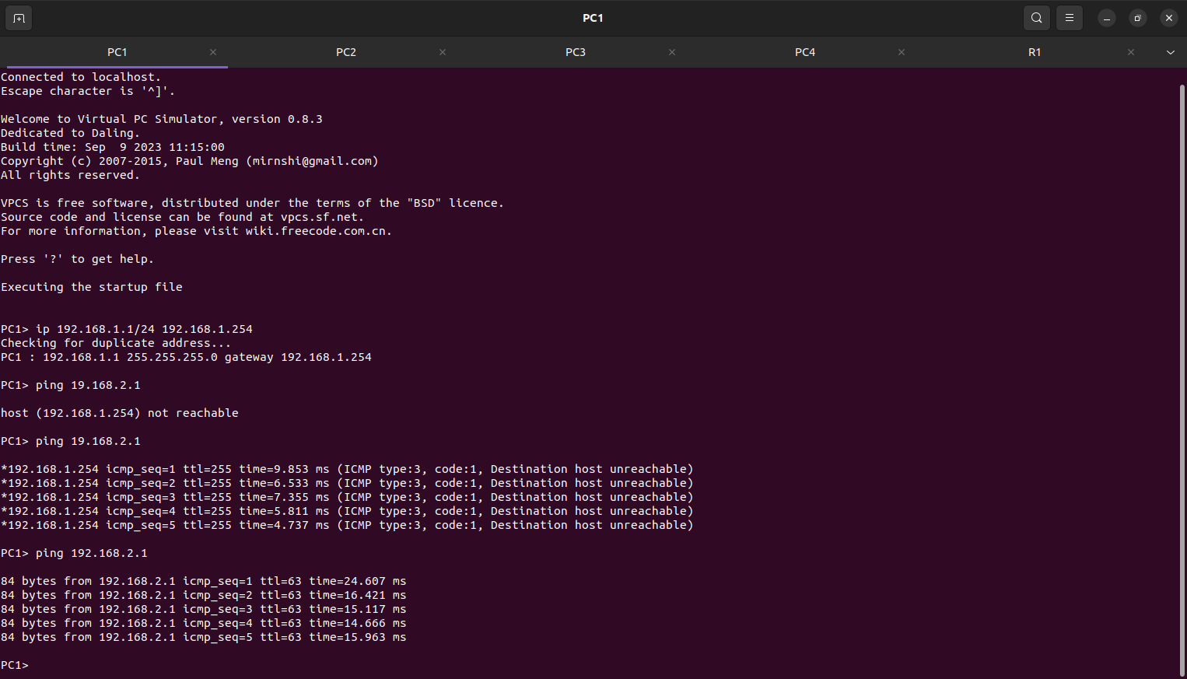
Fig: Data Packets transfer from PC1 to PC3.
Experiment 3:- Analyze the Computer Network Design using Two Routers in GNS3.
Double Router Configuration:
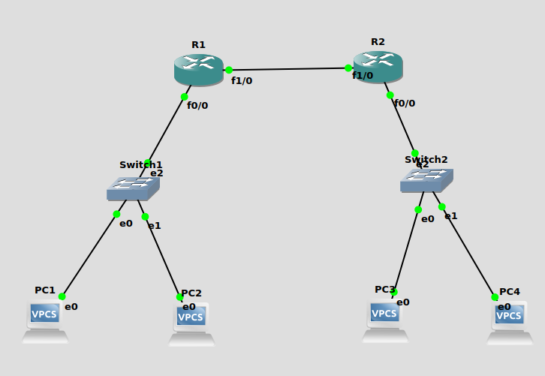
Fig: - Double Router Configuration
- Drag & Drop 4 VPCs and 2 Switch and also add 2 Routers and make connection is shown in above figure.
- Click on start button to start all devices.
- Set Ip Address for all the VPCs as follows:

PC1>192.168.1.1/24 192.168.1.254
PC2>192.168.1.2/24 192.168.1.254
PC3>192.168.2.1/24 192.168.2.254
PC4>192.168.2.2/24 192.168.2.254

Fig:- Showing PC’s IP address.
- Click on PC1 and start capture
- PC1>ping 192.168.1.1 ->data transfer takes place
- PC1>ping 192.168.2.1 ->Host not reachable

- Click on Router R1 and Write the below commands
R1#config t
R1 (config)#int f0/0
R1 (config)#ip address 192.168.1.254 255.255.255.0
R1 (config)#no shut
R1 (config)#exit

R1 (config)#int f1/0
R1 (config)#ip address 192.168.5.1 255.255.255.0
R1 (config)#no shut
R1 (config)#exit

- Click on Router R2 and write below commands.
R2#config t
R2 (config)#int f0/0
R2 (config)#ip address 192.168.2.254 255.255.255.0
R2 (config)#no shut
R2 (config)#exit

R2 (config)#int f1/0
R2 (config)#ip address 192.168.5.2 255.255.255.0
R2 (config)#no shut
R2 (config)#exit

- After the configuration, PC1>ping 192.168.2.1

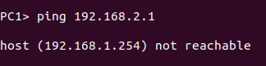

PC1>ping 192.168.1.2

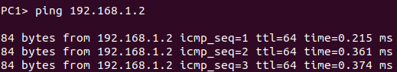

- Now give the Route for transferring the data through the 2 switches using below commands.
For Router R1:

R1#ip route 192.168.2.0 255.255.255.0 192.168.5.2
For Router R2:
R2#ip route 192.168.1.0 255.255.255.0 192.168.5.1

Now ping the VPCs.
PC1>ping 192.168.2.1
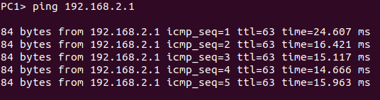
Experiment 4: -Analyze the Dynamic Host Configuration Protocol (DHCP) using GNS3.
Objectives: -
- Understand DHCP Service
- Analyzing DHCP Packets
- Understanding significance of Netmask value

DHCP Overview: -

The Dynamic Host Configuration Protocol (DHCP) is a network protocol that automatically assigns IP addresses to devices on a network.

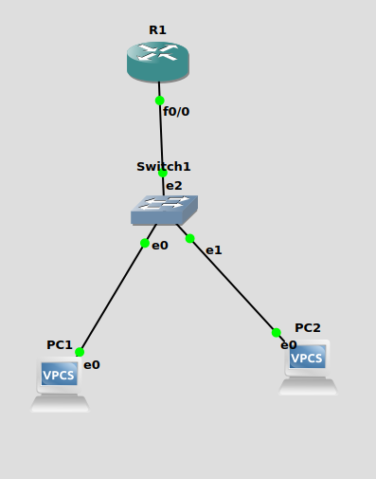
Fig:- Network Topology for DHCP Configuration
- Drag and drop 2 VPCs, 1 Switch, 1 Router and make the connections as shown above.
- Start all the devices.
- In order to configure our router as a DHCP server the following commands are used.

Router Configuration:-

R1#config t
R1(config)#int f0/0
R1(config)#ip address 192.168.1.254 255.255.255.0
R1(config)#no shut
R1(config)#exit
R1(config)#ip dhcp pool formation
R1(dhcp-config) #network 192.168.1.0 255.255.255.0
R1(dhcp-config) #default-router 192.168.1.254
R1(dhcp-config) #dns-server 192.168.1.254
R1(dhcp-config) #class ec2lt
R1(config-dhcp-pool-class) #address range 192.168.1.2 192.168.1.4
R1(config-dhcp-pool-class) #exit
R1(dhcp-config) #exit
R1(dhcp-config) #do wr
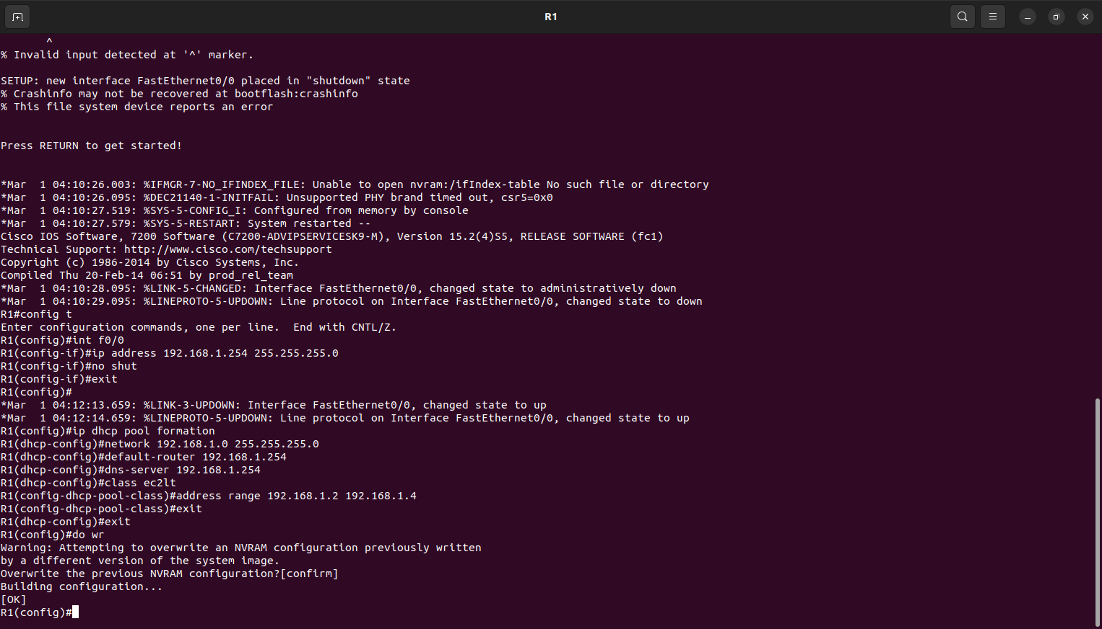
Fig: - Router Configuration
4. The commands above will turn the interface on and assign an IP address.
5. Click the VPCS.
PC1>ip dhcp
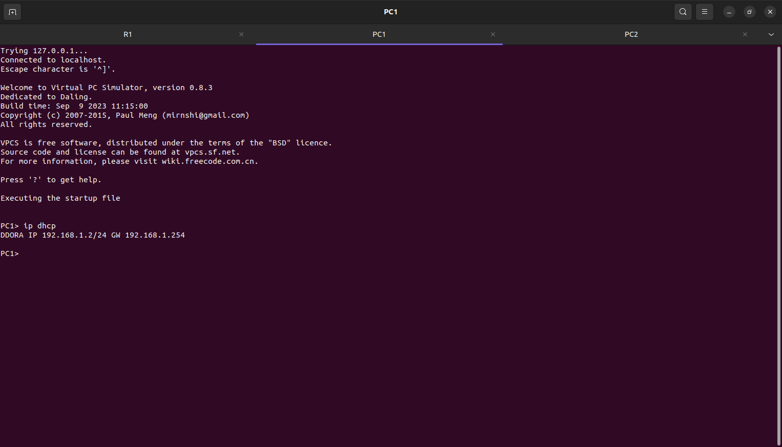
Fig:-Showing PC1 IP address.
DDOORA 192.168.1.2 192.168.1.254 is the output

PC2>ip dhcp
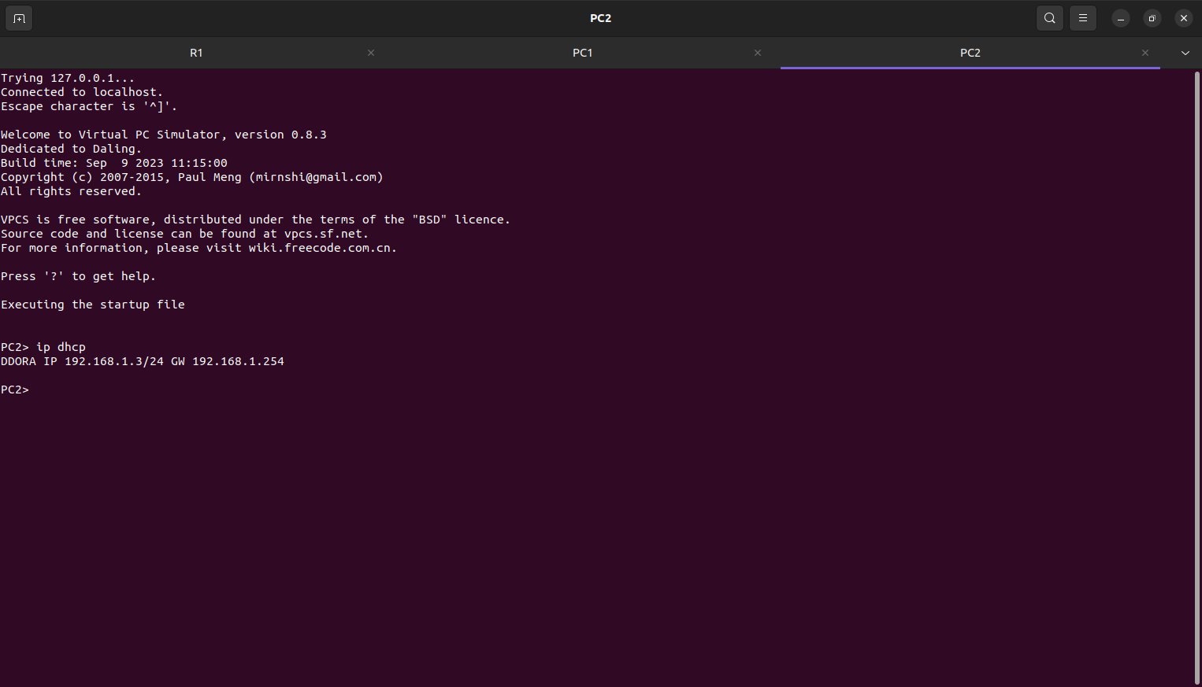
Fig:-Showing PC2 IP address.
DDOORA 192.168.1.4 192.168.1.254 is the output

Experiment 5: - Analyze the design of VLAN’S using GNS3.
Objectives:
- To understand Virtual Lan (VLAN) Concepts

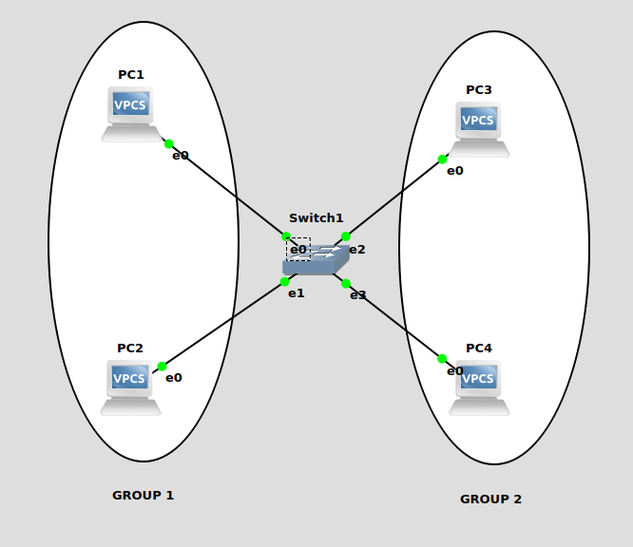
Fig: - VLANs Configuration
1.Set IP address for all VPCS as follows:
PC1>192.168.1.1/24
PC2>192.168.1.2/24
PC3>192.168.1.3/24
PC4>192.168.1.4/24
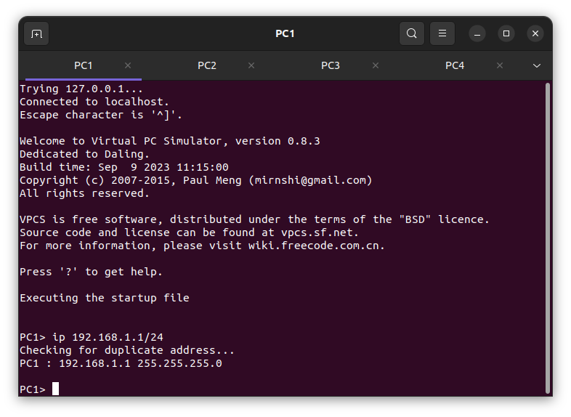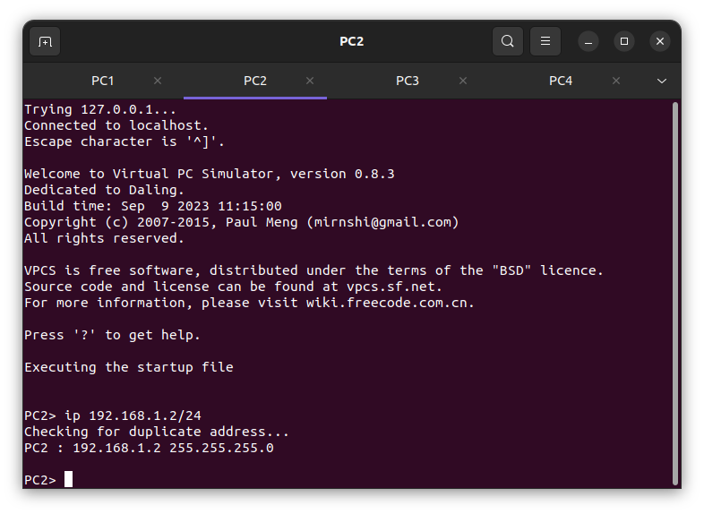
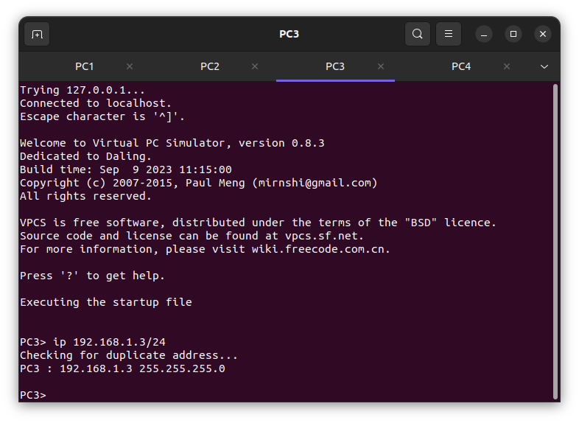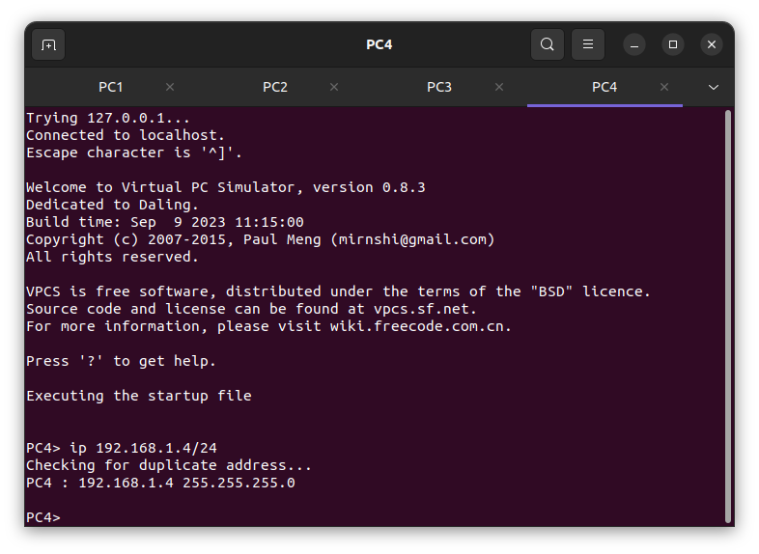

Fig:- IP address for all the PC’S.
2. After the IP address setting, ping the PC’s.
PC1> ping 192.168.1.3
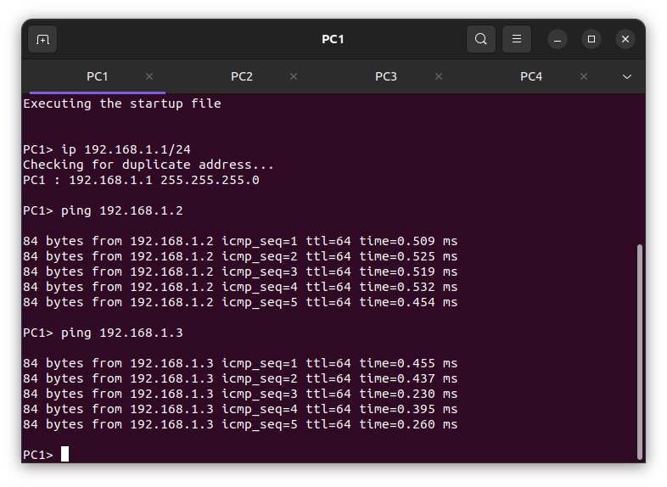
Fig: Ping PC1 to PC3

3. Before setting a LAN connection for VPCs we should remove the wired connection.

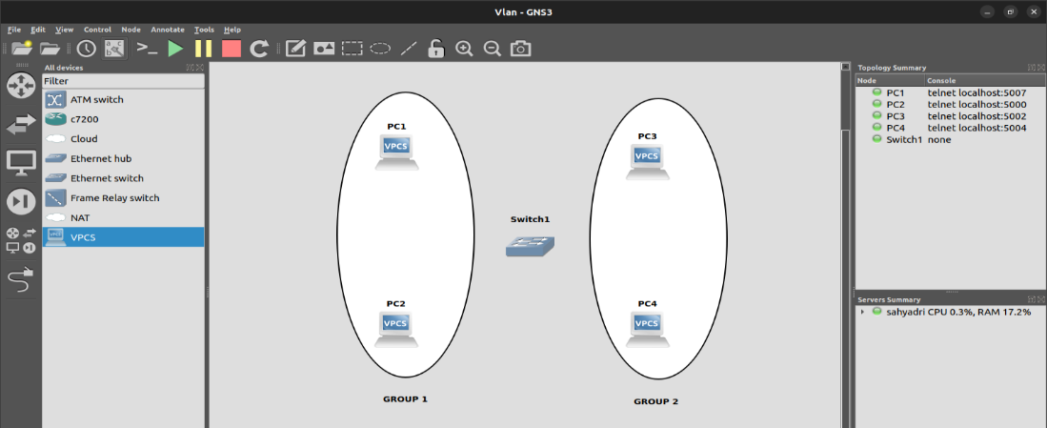
Fig: - deleting all the connections through the VPCS.

- SWITCH Configuration: -

PORT | VLAN
0(PC1) | 1-> ADD
1(PC2) | 1-> ADD
2(PC3) | 2-> ADD
3(PC4) | 2->ADD
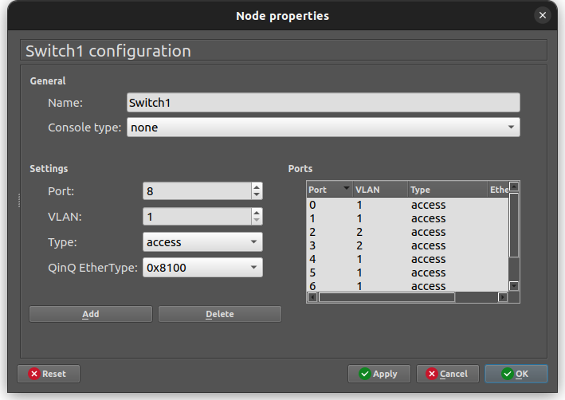
Check-> add-> Apply->&ok.
- PC1>ping 192.168.1.3
