Software Evaluation
&
Feasibility Study

Karaj

Gulf Warranties
Dubai

04-06-2017

Table of Contents

1. Executive Summary 2
2. Evaluation of similar software - karaj 2
3. Organization Scope and Recommendations 3
4. Technology Considerations 4
5. System Flow 4
6. Modules 4
7. Schedule 5
8. Financial Projections 6

Executive Summary

This proposal is prepared in order to design and develop a web based software which can be utilized for:

- Online claim registration
- Receipt online quotes and comparison
- Identify best available Service Center for Auto & electronics
- Identify the Service Center which offers the best rate
- Identify the Service center by which offers the best quality
- Identify the nearby Service Center
- Identify the Service Center within the best possible time
- Compare and review the Service Centers
- Roadside assistance
- Rating the workshop their services

Customer System Flow
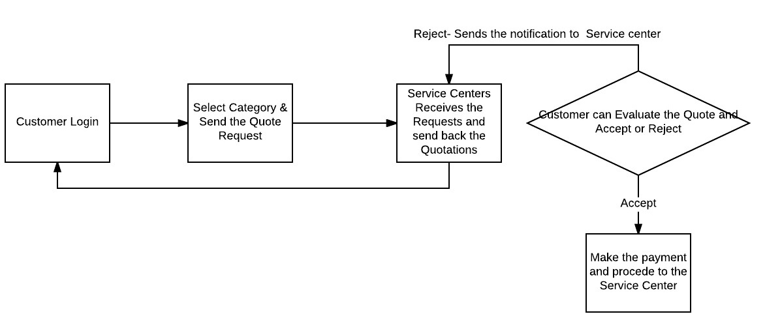

Evaluation of similar software - karaj

Karaj is a web based software where customer can request for a quote for their auto repair and compare and chose the workshop.

Findings

Pros

- Simple application layout and customers can easily understand the system flow
- Online Claim Registration
- Receive various Quotes
- Manually Compare the quotes
- Store and retrieve our car information
- History of service available
- View other customers comments and review
- Review customer rating for Karaj
- Notifications by email
- Pick & Drop Service
- Online payment

Cons

- No recommendations & comparison provided by Karaj
- No options for responding to individual Quotations
- No live GPS tracking & google map interaction
- Workshops rating by public or Karaj is not available, only the reviews by the Karaj customers is available
- Quotes received are not clear and no direct contact details
- No Mobile app availability & no instant notification
- Inspection charges varies from workshop to workshop
- Slow response time
- Prolonged time requirement in cases where inspection is required also may take more time to get repairs
- Minimum charge of AED 100 or 20% of repair cost - looks high and may not be marketable
- No SMS notifications
- No subscription offers or special discounts available
- Few technical bugs need to be checked and corrected.

Organization Scope and Recommendations

As GW is a service providers and has already got its customers and database it is ideal that we design and develop a software for web platform & various mobile app which can support Gulf Warranties in various areas as follows:

- Identifying best workshop for Auto & Electronics
- Identifying service centers by comparing multiple factors such as Cost, Quality, Time, etc.
- Comparison chart of various workshops based on different qualities
- Offer Road side assistance - same as WINCH, including GPS & Google map interactions
- Srevice Contract Offers
- Online Live Chat facility
- Instant notifications through email & SMS
- Online Payment Gateway
- Quick and faster inspection offers
- Provision of GW discount off ers
- Avail special workshop discount for GW

Technology Considerations

Development Machine specifications.
- Windows 7 Operating System
- 16 GB Ram
- 2.5 GHZ processor
- 100 GB spare Hard Disk

Application Servers
Application will be hosted on Apple app store , Google app store , Window app store

Web Servers
Windows server will be used for the deployment of web application.

Database Servers
MSSQL Server and SQLITE will be used for database deployment

Technologies Specifications
Following technologies would be used during the development of the application
- Visual Studio 2017
- Xamarin For Mobile App
- MVVM Architecture for Mobile App
- SQLITE for Mobile App
- Asp.net MVC for Web App
- Angular JS for Web App
- MSSQL Server for Web App

Databases
Brief Description of the databases that would be used for the development of the proposed application are given below:
- SQL Server & SQLITE
- Memory requirements is 4 GB
- CPU requirements is 1.5 GHZ
- Amount of storage needed the first 12 months (300 in GB)
- Projected annual growth (5% or GB)
Resource
For the successful completion of the project following resources are required.
- Test server
- Testing Mobile Devices
- Training If Required

System Flow

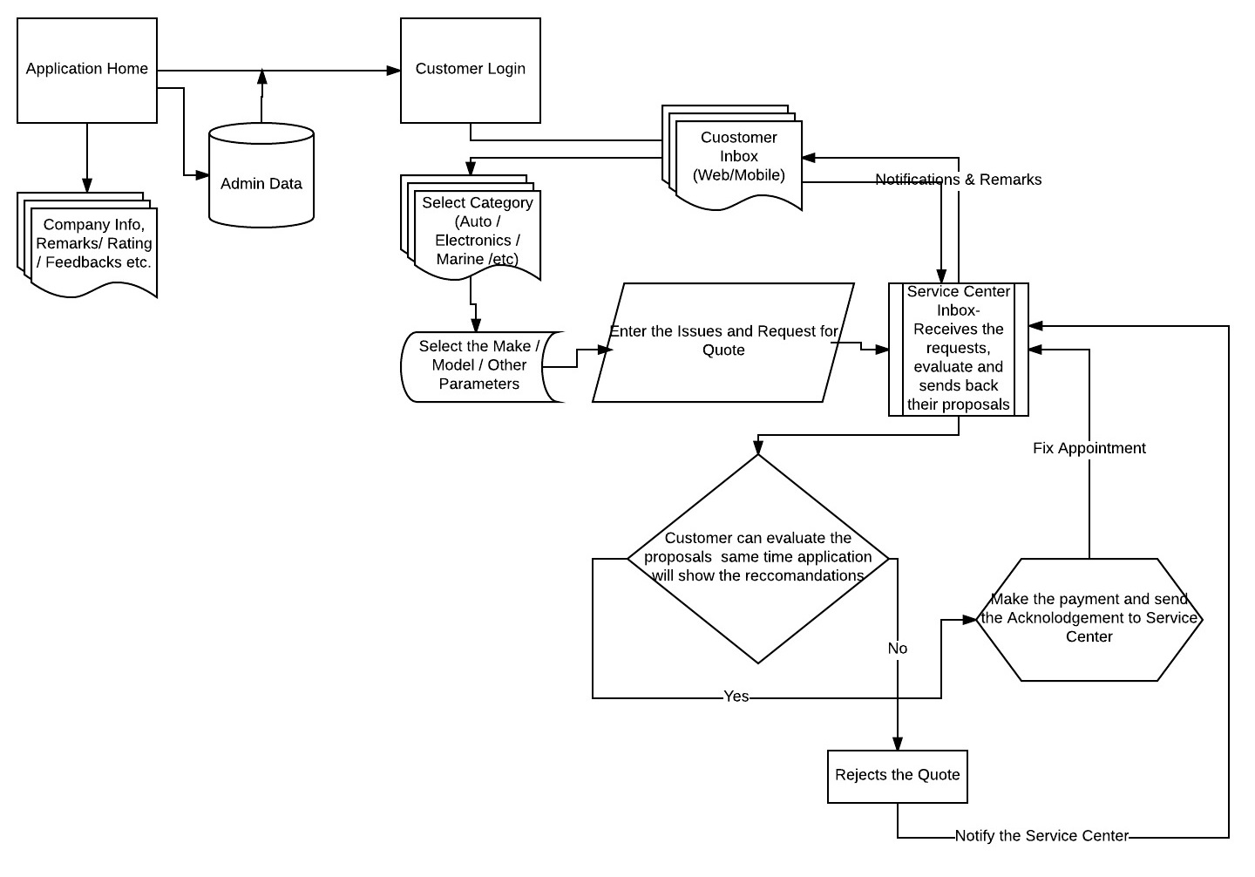

Modules

2.1 Mobile / Web Modules

- System Flow. Man Days - 2 Day
- Garages or Maintenance company profiles. Man Days - 4 Days
- Quote Request. Man Days - 4 Days
- Quote listing. Man Days - 2 Day
- Communication with Garages. Man Days - 4 Days
- Compare quotes. Man Days - 6 Days
- Gulf warranties recommendation. Man Days - 7 Days
- Notifications. Man Days - 4 Days
- Job History. Man Days - 2 Day
- User Reviews. Man Days - 5 Days
- Special Discounts or Packages. Man Days - 5 Days
- Payment Service. Man Days - 5 Days
- Online Chat. Man Days - 2 Day
- About Us. Man Days - 2 Day
- Contact Us. Man Days - 2 Day
2.2 Admin Modules
- System Layout Design. Man Days - 4 Days
- User Account Management. Man Days - 2 Days
- GW Cost Matrix & Calculator. Man Days - 4 Days
- GW Quote Generation & Management. Man Days - 4 Days
- Quote Comparison & Management. Man Days - 4 Days
- Chatting service integration & Management. Man Days - 3 Days
- Google map integration & Management. Man Days - 7 Days
- SMS Service Integration & Management. Man Days - 3 Days
- Email Service Integration & Management. Man Days - 2 Days
- Job Management. Man Days - 2 Days
- Payment Service Integration & Management. Man Days - 7 Days
- Testing. Man Days - 7 Days

2.3 Reporting Module
- User Profile Report. Man Days - 1 Day
- Jobs Report. Man Days - 1 Day
- Quotations. Man Days - 1 Day
- Services. Man Days - 1 Day
- Comparison. Man Days - 2 Day
- Recommendations. Man Days - 1 Day
- Special Discount or Packages. Man Days - 2 Day
- Chat History. Man Days - 1 Day
- Payments History. Man Days - 1 Day
- User Reviews. Man Days - 1 Day
- Service Provider Companies Report. Man Days - 1 Day
- SMS History. Man Days - 1 Day
- Email History. Man Days - 1 Day
- Cost Matrix. Man Days - 2 Day

Schedule

Projected to complete within 6 Months from initiation however, need to have a proper study to finalize the actual timeline.

Financial Projections

Actual financial projections can be obtained only after finalizing scope. However, we will have to consider the following factors:

- Google map Services
- SMS Service
- Training if required.

