1. Write a program to Add, Subtract, Multiply, and Divide 2 numbers

a = 40;  
 b = 10;  
  
 print(**"Addition of two number"**, a+b)  
 print(**"Subtraction of two number"**, a-b)  
 print(**"Multiplication of two number"**, a\*b)  
 print(**"Division of two number"**, a/b)

Ans:-

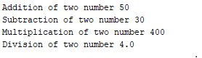

1. Write a program to find the biggest of 3 numbers (Use If Condition)

a = int(input(**"Enter the first number"**))  
 b = int(input(**"Enter the second number"**))  
 c = int(input(**"Enter the third number"**))  
  
 **if** (a>b) & (a>c):  
 print(**"A is biggest number"**)  
  
 **elif** (b>a) & (b>c):  
 print(**"B is the biggest number"**)  
  
 **else**:  
 print(**"C is the biggest number"**)

Ans:-

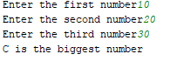

1. Write a program to find given number is odd or Even

a = int(input(**"Enter a number "**))  
  
**if** a%2 == 0:  
 print(**"The given number is Even"**)  
**else**:  
 print(**"The given number is odd"**)

Ans:-

C:\Users\Inspiron\Desktop\Learning\pes_python\Q3 Ans.PNG

1. Write a program to find the number is Prime or not.

a = int(input(**"Enter any number: "**))  
*# prime number is always greater than 1***if** a > 1:  
 **for** i **in** range(2, a):  
 **if** (a % i) == 0:  
 print(a, **"is not a prime number"**)  
 **break  
 else**:  
 print(a, **"is a prime number"**)  
  
*# if the entered number is less than or equal to 1  
# then it is not prime number***else**:  
 print(a, **"is not a prime number"**)

Ans:-

C:\Users\Inspiron\Desktop\Learning\pes_python\Q4 Ans1.PNG

C:\Users\Inspiron\Desktop\Learning\pes_python\Q4 Ans2.PNG

1. Write a program to receive 3 command line arguments and print each argument separately.  
   Example: >> python test.py arg1 arg2 arg3   
   a) From the above statement your program should receive arguments and print them each of them.   
   b) Find the biggest of three numbers, where three numbers are passed as command line arguments.

**import** sys  
print **"First number is"**, sys.argv[1]  
print **"Second number is"**, sys.argv[2]  
print **"Third number is"**, sys.argv[3]  
print **"The biggest of three numbers is"**, max(sys.argv[1], sys.argv[2], sys.argv[3])

**Ans:-**

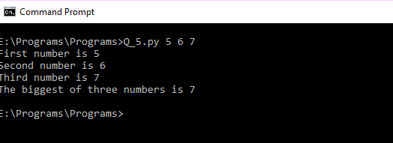

1. Write a program to read string and print each character separately.  
       a) Slice the string using slice operator [:] slice the portion the strings to create a sub strings.  
       b) Repeat the string 100 times using repeat operator \*  
       c) Read string 2 and concatenate with other string using + operator.

str1 = str(input(**"Enter the first string"**))  
 **for** i **in** str1:  
 print(i)  
  
 b = int((len(str1))/2)  
 substring = str1[0:b]  
 print(**"Get the substring of the given str1"**,substring)  
  
 RepeatStr = 100\*str1  
 print(RepeatStr)  
  
 str2 = str(input(**"Enter the second string"**))  
  
 concatenate = str1 + str2  
 print(**"Show the concatenated string"**,concatenate)

Ans:-

( Note : Above answer is big because of repetition of string 1 that is why it’s output is not came properly )

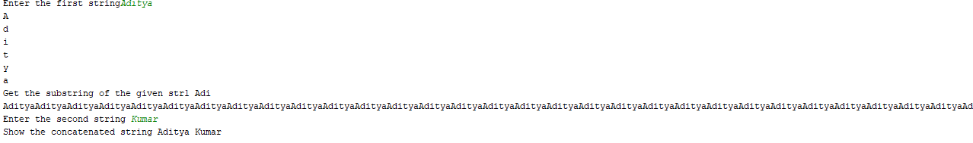

1. Create a list with at least 10 elements having integer values in it;  
          Print all elements  
          Perform slicing operations  
          Perform repetition with \* operator  
          Perform concatenation with other list.

list1 =[]  
**for** i **in** range(0,5,1):  
 a=input(**"enter a no"**)  
 list1.append(a)  
print (**"Elements of the list"**,list1)  
  
*# slicing operation*a =list1[0:int(len(list1)/2)]  
print (**"Sliced list is :-"**,a)  
  
*# Repetition with \* operator*b = list1\*2  
print (**"Repeatation of elements:-"**,b)  
  
print (**"Second list "**)  
list2 = []  
**for** j **in** range(0,5,1):  
 b=input(**"enter a no"**)  
 list2.append(b)  
print (**"Elements of the list"**,list2)  
print (**"Concatenation of the 2 lists"**,list1+list2)

**Ans:-**

**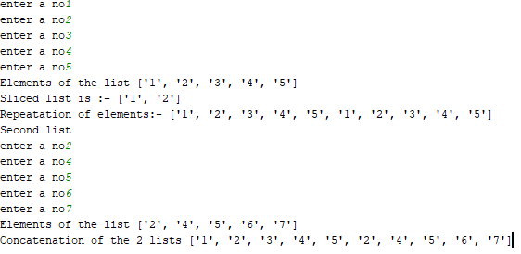**

1. Repeat program 7 with Tuples (Take example from Tutorial)

tuple1= input(**"Enter the values of tuple1: "**)  
i=int(len(tuple1))  
**for** i **in** tuple1:  
 print (**"tuple val"**, i)  
s=tuple1[2:7]  
*# Slicing*print (**"Slicing : "**,s)  
*# Repeatition*rep=tuple1\*5  
print (**"Repeatation : "**,rep)  
  
tuple2=input(**"Enter the values of tuple2: "**)   
  
*# Conacatination*tuple3=tuple1+tuple2  
print (**"Concatanated tup : "**,tuple3)

**Ans:-**

**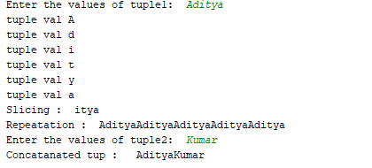**

1. Write program to Add, Subtract, Multiply, Divide 2 Complex numbers.

a=(4+3j)  
b=(3-7j)  
  
print(**"Addition of two complex numbers : "**, a+b)  
print(**"Subtraction of two complex numbers : "**, a-b)  
print(**"Multiplication of two complex numbers : "**, a\*b)  
print(**"Division of two complex numbers : "**, a/b)

**Ans:-**

**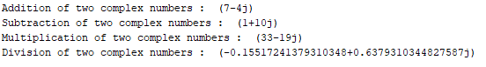**

1. Using assignment operators, perform following operations  
   Addition, Substation, Multiplication, Division, Modulus, Exponent and Floor division operations

a=float(input(**"Enter the a : "**))  
b=float(input(**"Enter the b : "**))  
  
a +=b  
print (**"Value of a after adding b: "**,a)  
  
a -=b  
print (**"Value of a after subtracting b : "**,a)  
  
a /=b  
print (**"Value of a after division by b : "**,a)  
  
a \*=b  
print (**"Value of a after multiplying b : "**,a)  
  
a \*\*=b  
print (**"Value of exponent : "**,a)  
  
a //=b  
print (**"Value of floor div b : "**,a)

Ans:-

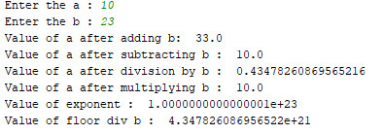

1. Read 2 numbers to variable a and b and perform all bitwise operations on that numbers.

a=450  
b=150  
c=0  
  
c=a&b  
print (**"a AND b: "**,c)  
  
c=a|b  
print (**"a OR b: "**, c)  
  
c=a^b  
print (**"a XOR b : "**,c)  
  
c=~a  
print (**"1's compliment of a: "**,c)  
  
c=a<<2  
print (**"Left shift of a : "**,c)  
  
c=b>>2  
print (**"Right shit of b : "**,c)

**Ans:-**

**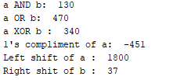**

1. Read 10 numbers from user and find the average of all.  
   a) Use comparison operator to check how many numbers are less than average and print them  
   b) Check how many numbers are more than average.  
   c) How many are equal to average.

count = 0  
s = 0  
numList = []  
  
**for** n **in** range(1,11):  
 a = int(input(**"Enter 10 numbers: "**))  
 numList.append(a)  
 s += n  
print(**"Sum all ten number"**,s)  
print(**"list of ten number for addition"**, numList)  
  
avg = int(s / n)  
print(**"Average is "**, avg)  
  
print(**"Numbers less than average are :"**)  
  
**for** i **in** numList:  
 **if** (avg > i):  
 print(i)  
 count += 1  
  
print(**"No of numbers less than average : "**, count)  
  
count = 0  
print(**"Numbers greater than average are :"**)  
  
**for** i **in** numList:  
 **if** (avg < i):  
 print(i)  
 count += 1  
  
print(**"No of numbers less than average : "**, count)  
  
count = 0  
print(**"Numbers equal to average are :"**)  
  
**for** i **in** numList:  
 **if** (avg == i):  
 print(i)  
 count += 1  
  
print(**"No of numbers equal to average : "**, count)

**Ans:-**

**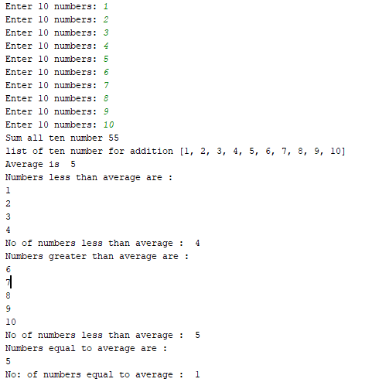**

1. Write a program to find the biggest of 4 numbers.  
      a) Read 4 numbers from user using Input statement.  
      b) extend the above program to find the biggest of 4 numbers.  
   (PS: Use IF and IF & Else, If and ELIf, and Nested IF)

a = int(input(**"Enter the first number"**))  
b = int(input(**"Enter the second number"**))  
c = int(input(**"Enter the third number"**))  
d = int(input(**"Enter the fourth number"**))  
  
**if** (a>b) & (a>c) & (a>d):  
 print(a,**" is the greatest number"**)  
  
**elif** (b>a) & (b>c) & (b>d):  
 print(b,**" is the greatest number"**)  
  
**elif** (c>a) & (c>b) & (c>d):  
 print(c,**" is the greatest number"**)  
  
**else**:  
 print(d, **" is the greatest number"**)

**Ans:-**

**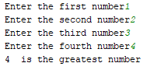**

1. Write a program to create two list A & B such that List A contains Employee Id, List B contain Employee name (minimum 10 entries in each list) & perform following operation  
        a) Print all names on to screen  
        b) Read the index from the  user and print the corresponding name from both list.  
        c) Print the names from 4th position to 9th position  
        d) Print all names from 3rd position till end of the list  
        e) Repeat list elements by specified number of times (N- times, where N is entered by user)  
        f)  Concatenate two lists and print the output.  
        g) Print element of list A and B side by side.(i.e. List-A First element, List-B First element )

**(Note:- I did this program with 5 entries in place of 10 entries because it will give big output if I will try with 10 entries)**

*#a)...*listA=[]  
listB=[]  
**for** i **in** range(0,5,1):  
 a=int(input(**"Enter Employee Id "**))  
 listA.append(a)  
print (**"Employee Id are"**,listA)  
  
**for** j **in** range(0,5,1):  
 b=str(input(**"Enter Employee Name "**))  
 listB.append(b)  
print (**"Employee Name are"**,listB)  
  
*#b)...*k=int(input(**"enter an index and index should be positive "**))  
**if**(k<5):  
 print (listB[k])  
**else**:  
 print(**"invalid index"**)  
*#c)..*k=[]  
k=listB[3:5]  
print (**"After slicing"**,k)  
  
*#e)..*l=[]  
n=int(input(**"Specify the number of times "**))  
l=listB\*n  
print (**"Repeatation of elements of listB "**,l)  
  
*#f)...*k=[]  
k=listA+listB  
print (**"Concatenation of two list is "**,k)

**Ans:-**

**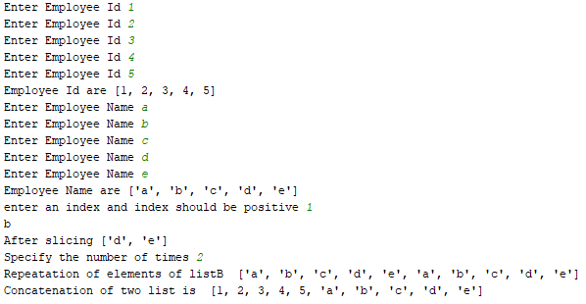**

1. Create a list of 5 names **and** check given name exist **in** the List.  
    a) Use membership operator (IN) to check the presence of an element.  
    b) Perform above task without using membership operator.  
    c) Print the elements of the list **in** reverse direction.  
     
   list1 = []  
   **for** i **in** range(0,5,1):  
    a = str(input(**"Enter the name in list "**))  
    list1.append(a)  
   print(**"Name in list "**,list1)  
     
   j = str(input(**"Enter the name to search "**))  
   **if** j **in** list1:  
    print(**"The given name is present in list"**)  
   **else**:  
    print(**"The given name is not present in list"**)  
     
   l=len(list1)  
     
   **for** i **in** range(l+1):  
    **if** (list1[i]==j):  
    print (**"element found "**)  
    **break  
   else**:  
    print (**"element not found"**)  
     
   list2 = list1[::-1]  
   print(**"list is reverse order "**,list2)

**Ans:-**

**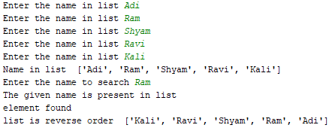**

16. Write program to perform following:  
 i) Check whether given number **is** prime **or not**.  
 ii) Generate all the prime numbers between 1 to N where N **is** given number.  
  
  
i = 1  
x = int(input(**"Enter the number:"**))  
**for** k **in** range (1, (x+1), 1):  
 c = 0;  
 **for** j **in** range(1, (i + 1), 1):  
 a = i % j  
 **if** (a == 0):  
 c = c + 1  
 **if** (c == 2):  
 print(i)  
 **else**:  
 k = k - 1  
 i = i+1

**Ans:-**

**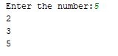**

17 . Write program to find the biggest **and** Smallest of N numbers.  
 PS: Use the functions to find biggest **and** smallest numbers.  
  
  
**import** math  
list1 = []  
**for** i **in** range(1,5,1):  
 a = int(input(**"Enter the number "**))  
 list1.append(a)  
print(**"Get the list"**,list1)  
  
print(**"Get the biggest number from the list "**, max(list1))  
print(**"Get the smallest number from the list "**, min(list1))

**Ans:-**

**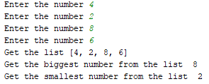**

18. Using loop structures print numbers **from** 1 to 100. **and** using the same loop print numbers **from** 100 to 1 (reverse printing)  
a) By using For loop  
b) By using **while** loop  
c) Let mystring =**"Hello world"**print each character of mystring **in** to separate line using appropriate loop structure.  
  
  
list1 = []  
list2 = []  
list3 = []  
list4 = []  
  
**for** i **in** range(1,101,1):  
 s = 0  
 s = s+i  
 list1.append(s)  
print(**"List of number from 1 to 100 using for loop"**,list1)  
  
**for** i **in** range(1,101,1):  
 s = 101  
 s = s-i  
 list2.append(s)  
print(**"List of number from 100 to 1 using for loop"**,list2)  
  
a = 0  
**while** a <= 99:  
 a+=1  
 list3.append(a)  
print(**"List of number from 1 to 100 using while loop"**,list3)  
  
n=101  
**while**(n>1):  
 n-=1  
 list4.append(n)  
print(**"List of number from 1 to 100 using while loop"**,list4)

**Ans:-**

**List of number from 1 to 100 using for loop [1, 2, 3, 4, 5, 6, 7, 8, 9, 10, 11, 12, 13, 14, 15, 16, 17, 18, 19, 20, 21, 22, 23, 24, 25, 26, 27, 28, 29, 30, 31, 32, 33, 34, 35, 36, 37, 38, 39, 40, 41, 42, 43, 44, 45, 46, 47, 48, 49, 50, 51, 52, 53, 54, 55, 56, 57, 58, 59, 60, 61, 62, 63, 64, 65, 66, 67, 68, 69, 70, 71, 72, 73, 74, 75, 76, 77, 78, 79, 80, 81, 82, 83, 84, 85, 86, 87, 88, 89, 90, 91, 92, 93, 94, 95, 96, 97, 98, 99, 100]**

**List of number from 100 to 1 using for loop [100, 99, 98, 97, 96, 95, 94, 93, 92, 91, 90, 89, 88, 87, 86, 85, 84, 83, 82, 81, 80, 79, 78, 77, 76, 75, 74, 73, 72, 71, 70, 69, 68, 67, 66, 65, 64, 63, 62, 61, 60, 59, 58, 57, 56, 55, 54, 53, 52, 51, 50, 49, 48, 47, 46, 45, 44, 43, 42, 41, 40, 39, 38, 37, 36, 35, 34, 33, 32, 31, 30, 29, 28, 27, 26, 25, 24, 23, 22, 21, 20, 19, 18, 17, 16, 15, 14, 13, 12, 11, 10, 9, 8, 7, 6, 5, 4, 3, 2, 1]**

**List of number from 1 to 100 using while loop [1, 2, 3, 4, 5, 6, 7, 8, 9, 10, 11, 12, 13, 14, 15, 16, 17, 18, 19, 20, 21, 22, 23, 24, 25, 26, 27, 28, 29, 30, 31, 32, 33, 34, 35, 36, 37, 38, 39, 40, 41, 42, 43, 44, 45, 46, 47, 48, 49, 50, 51, 52, 53, 54, 55, 56, 57, 58, 59, 60, 61, 62, 63, 64, 65, 66, 67, 68, 69, 70, 71, 72, 73, 74, 75, 76, 77, 78, 79, 80, 81, 82, 83, 84, 85, 86, 87, 88, 89, 90, 91, 92, 93, 94, 95, 96, 97, 98, 99, 100]**

**List of number from 1 to 100 using while loop [100, 99, 98, 97, 96, 95, 94, 93, 92, 91, 90, 89, 88, 87, 86, 85, 84, 83, 82, 81, 80, 79, 78, 77, 76, 75, 74, 73, 72, 71, 70, 69, 68, 67, 66, 65, 64, 63, 62, 61, 60, 59, 58, 57, 56, 55, 54, 53, 52, 51, 50, 49, 48, 47, 46, 45, 44, 43, 42, 41, 40, 39, 38, 37, 36, 35, 34, 33, 32, 31, 30, 29, 28, 27, 26, 25, 24, 23, 22, 21, 20, 19, 18, 17, 16, 15, 14, 13, 12, 11, 10, 9, 8, 7, 6, 5, 4, 3, 2, 1] **

**19.** Using loop structures print even numbers between 1 to 100.    
a) By using For loop, use continue/ break/ pass statement to skip odd numbers.  
 i) Break the loop if the value is 50  
 ii) Use continue for the values 10,20,30,40,50

b) By using while loop, use continue/ break/ pass statement to skip odd numbers.  
  i) Break the loop if the value is 90  
      ii) Use continue for the values 60,70,80,90

list1=range(1,101)  
**for** i **in** list1:  
 **if**(i%2==0):  
 print(**"The even numbers:"**,i)  
  
**for** i **in** list1:  
 **if**(i%2==0):  
 *#break the loop if the value is 50* **if**(i==50):  
 print(**"The even numbers:"**, i)  
 **break  
for** j **in** list1:  
 **if** (j % 2 == 0):  
 **if** (j==10):  
 print(**"The even numbers 10 :"**,j)  
 **continue  
 if**(j==20):  
 print(**"The even numbers 20 :"**,j)  
 **continue  
 if** (j==30):  
 print(**"The even numbers 30: "**,j)  
 **continue  
 if**(j==40):  
 print(**"The even numbers 40: "**,j)  
 **continue  
 if** (j ==50):  
 print(**"The even numbers 50: "**,j)  
 **continue  
 if** (j ==90):  
 print(**"The even numbers 90: "**,j)  
 **break**number = 1  
**while** number <= 100:  
 **if**(number % 2 != 0):  
 print(**"{0}"**.format(number))  
 number = number + 1  
**for** j **in** list1:  
 **if** (j % 2 == 0):  
 **if** (j==60):  
 print(**"The numbers 60 :"**,j)  
 **continue  
 if**(j==70):  
 print(**"The numbers 70 :"**,j)  
 **continue  
 if** (j==80):  
 print(**"The numbers 80: "**,j)  
 **continue  
 if**(j==90):  
 print(**"The numbers 90: "**,j)  
 **continue  
 else**:  
 **pass**

**Ans:-**

**The even numbers: 2**

**The even numbers: 4**

**The even numbers: 6**

**The even numbers: 8**

**The even numbers: 10**

**The even numbers: 12**

**The even numbers: 14**

**The even numbers: 16**

**The even numbers: 18**

**The even numbers: 20**

**The even numbers: 22**

**The even numbers: 24**

**The even numbers: 26**

**The even numbers: 28**

**The even numbers: 30**

**The even numbers: 32**

**The even numbers: 34**

**The even numbers: 36**

**The even numbers: 38**

**The even numbers: 40**

**The even numbers: 42**

**The even numbers: 44**

**The even numbers: 46**

**The even numbers: 48**

**The even numbers: 50**

**The even numbers: 52**

**The even numbers: 54**

**The even numbers: 56**

**The even numbers: 58**

**The even numbers: 60**

**The even numbers: 62**

**The even numbers: 64**

**The even numbers: 66**

**The even numbers: 68**

**The even numbers: 70**

**The even numbers: 72**

**The even numbers: 74**

**The even numbers: 76**

**The even numbers: 78**

**The even numbers: 80**

**The even numbers: 82**

**The even numbers: 84**

**The even numbers: 86**

**The even numbers: 88**

**The even numbers: 90**

**The even numbers: 92**

**The even numbers: 94**

**The even numbers: 96**

**The even numbers: 98**

**The even numbers: 100**

**The even numbers: 50**

**The even numbers 10 : 10**

**The even numbers 20 : 20**

**The even numbers 30: 30**

**The even numbers 40: 40**

**The even numbers 50: 50**

**The even numbers 90: 90**

**The odd number**

**1**

**The odd number**

**3**

**The odd number**

**5**

**The odd number**

**7**

**The odd number**

**9**

**The odd number**

**11**

**The odd number**

**13**

**The odd number**

**15**

**The odd number**

**17**

**The odd number**

**19**

**The odd number**

**21**

**The odd number**

**23**

**The odd number**

**25**

**The odd number**

**27**

**The odd number**

**29**

**The odd number**

**31**

**The odd number**

**33**

**The odd number**

**35**

**The odd number**

**37**

**The odd number**

**39**

**The odd number**

**41**

**The odd number**

**43**

**The odd number**

**45**

**The odd number**

**47**

**The odd number**

**49**

**The odd number**

**51**

**The odd number**

**53**

**The odd number**

**55**

**The odd number**

**57**

**The odd number**

**59**

**The odd number**

**61**

**The odd number**

**63**

**The odd number**

**65**

**The odd number**

**67**

**The odd number**

**69**

**The odd number**

**71**

**The odd number**

**73**

**The odd number**

**75**

**The odd number**

**77**

**The odd number**

**79**

**The odd number**

**81**

**The odd number**

**83**

**The odd number**

**85**

**The odd number**

**87**

**The odd number**

**89**

**The odd number**

**91**

**The odd number**

**93**

**The odd number**

**95**

**The odd number**

**97**

**The odd number**

**99**

**The numbers 60 : 60**

**The numbers 70 : 70**

**The numbers 80: 80**

**The numbers 90: 90**

**20.** Write a program to generate a Fibonacci series of numbers.  
Starting numbers are 0 and 1,  new number in the series is generated by adding previous two numbers in the series.  
Example : 0, 1, 1, 2, 3, 5, 8,13,21,.....  
   a) Number of elements printed in the series should be N numbers, Where N is any +ve integer.  
   b) Generate the series until the element in the series is less than Max number.

nterms = int(input(**"Enter the number of term "**))  
*#nterms = int(input("How many terms? "))  
# first two terms*n1 = 0  
n2 = 1  
count = 0  
*# check if the number of terms is valid***if** nterms <= 0:  
 print(**"Please enter a positive integer"**)  
**elif** nterms == 1:  
 print(**"Fibonacci sequence upto"**,nterms,**":"**)  
 print(n1)  
**else**:  
 print(**"Fibonacci sequence upto"**,nterms,**":"**)  
 **while** count < nterms:  
 print(n1,end=**' , '**)  
 nth = n1 + n2  
 *# update values* n1 = n2  
 n2 = nth  
 count += 1

**Ans:-**

**C:\Users\Inspiron\Desktop\Learning\pes_python\Q20 Ans.PNG**