Analyse the type of schema available in given Contoso Sales file.

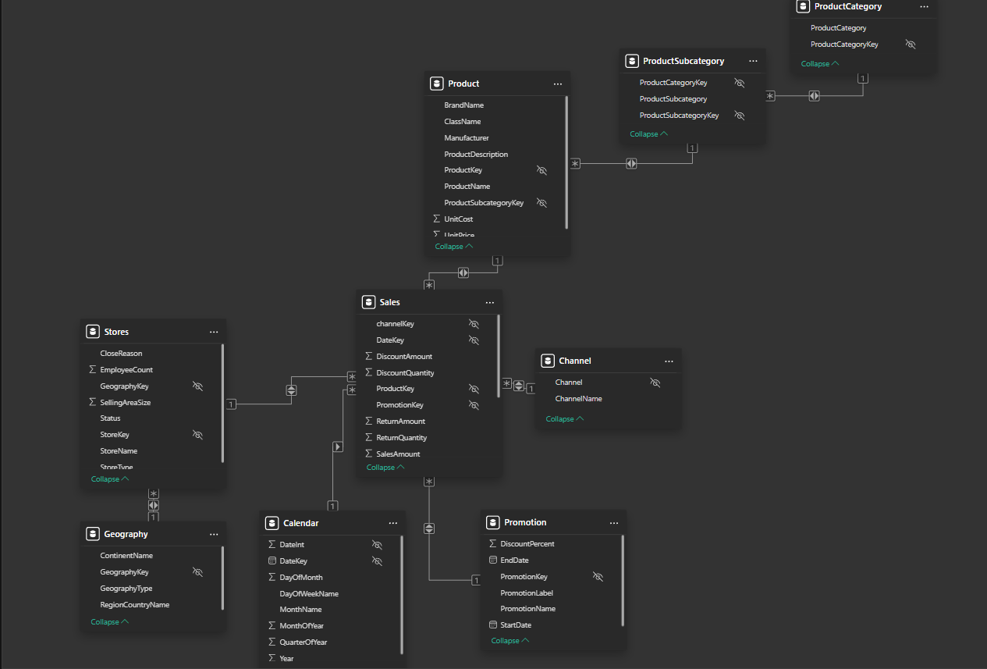

The schema available in the Contoso Sales file is a **Snowflake Schema** because the one of the dimension tables is normalized.

Here, the **Product table** is a dimension table which contains the product information like product name, description, manufacturer etc. It also has a **foreign key** called **ProductSubcategoryKey** which establishes a **One-to-Many** relationship between the ProductSubcategory table and Product table.

It is further normalized into another table containing the category of the product called **ProductCategory** table. It also has a **One-to-Many** relationship with the ProductSubcategory table using **ProductCategoryKey** as the foreign key.

The flow of relationship is like this: **Product -> Subcategory -> Category**

ProductCategory ProductSubcategory Product

Audio 🡪 Headphones, Speakers, Radio Product1 🡪 Headphones 🡪 Audio

Home Appliances 🡪 Refrigerators, Microwaves Product2 🡪 Microwaves 🡪 H.A.

Product3 🡪 Radio 🡪 Audio

Product4 🡪 Refrigerator 🡪 H.A