Using the dataset given below create the One to Many Relationship

a) Students[StudentID] ⟶ Enrollments[StudentID] (1:M)

Step 1: Go into **Model View.**

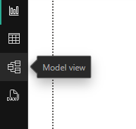

You will see all the tables here.

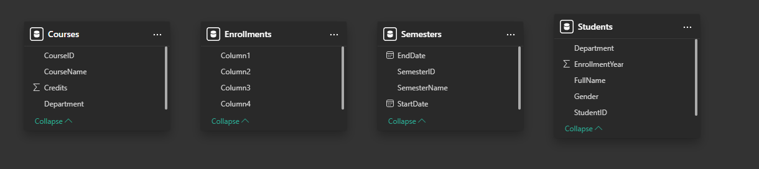

***Note*:** If column headers don’t appear for a table, just like in the Enrollments table in the above picture, then:

**Transform Data 🡪 Home 🡪 Transform 🡪 Use First Row as Headers**

Step 2: Select the StudentID (Primary Key) column in Students table and drag it onto the StudentID (Foreign Key) column in the Enrollments table.

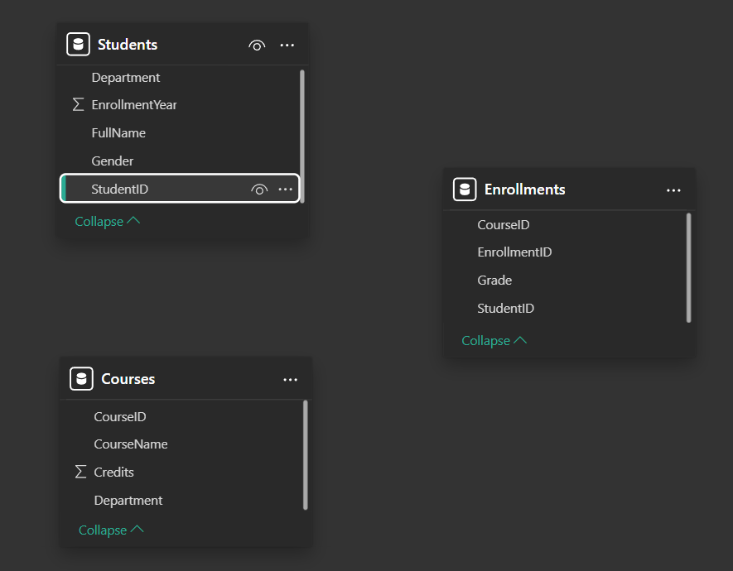

Step 3: Choose **Cardinality: One to Many (1:*)** and **Cross-filter direction: Single.**

Then click on **Save**.

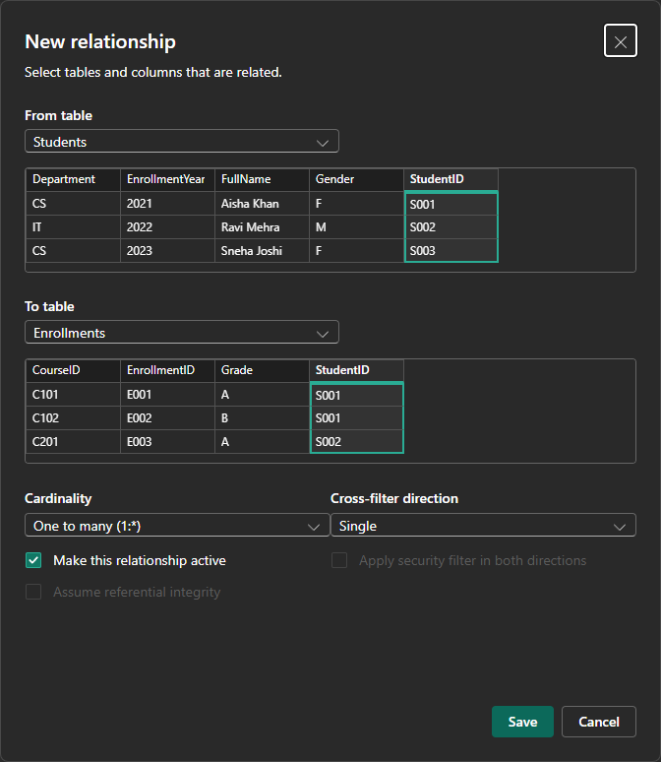

A One to Many relationship between Students and Enrollments tables is established.

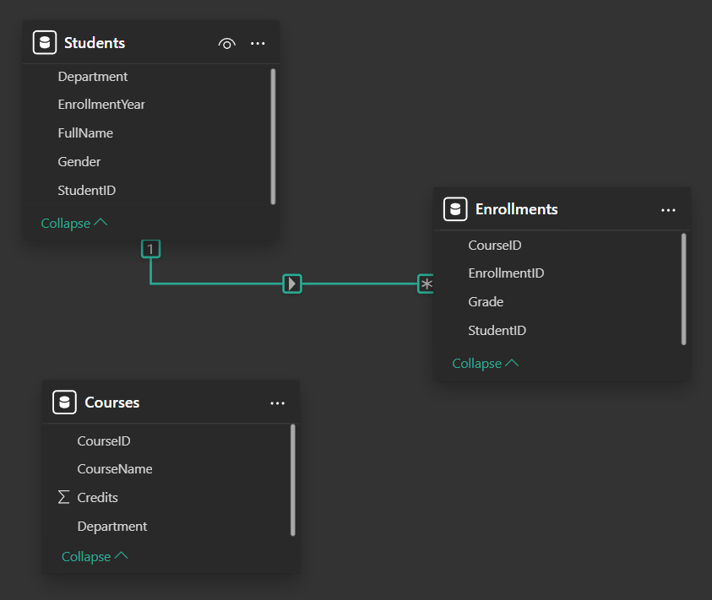

b) Courses[CourseID] ⟶ Enrollments[CourseID] (1:M)

Step 1: Select the CourseID (Primary Key) column in Courses table and drag it onto the CourseID (Foreign Key) column in the Enrollments table.

Step 2: Choose **Cardinality: One to Many (1:*)** and **Cross-filter direction: Single.**

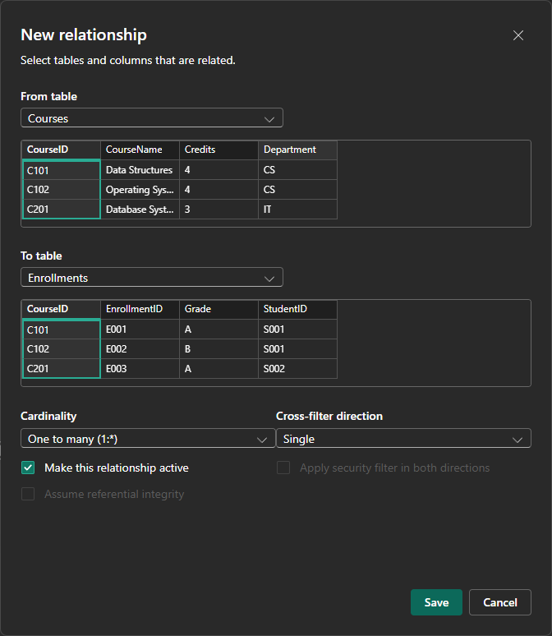

A One to Many relationship between Courses and Enrollments tables is established.

