**Assignment 4 (DBMS)**

**Name:** Devesh Kaushik

**Roll no. :** 39/CSE/16013/170

Q 1: Create the table like (2nd Assignment) using NOSQL with given entries. 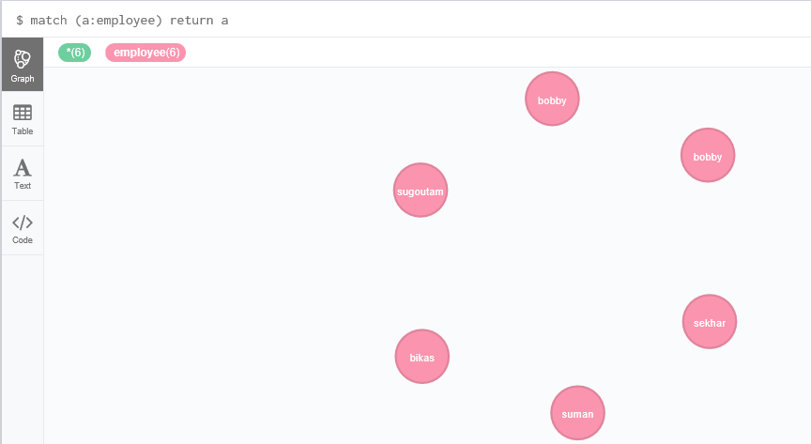

Q 2: Run a Query to find all employees whose salary is > 12000.

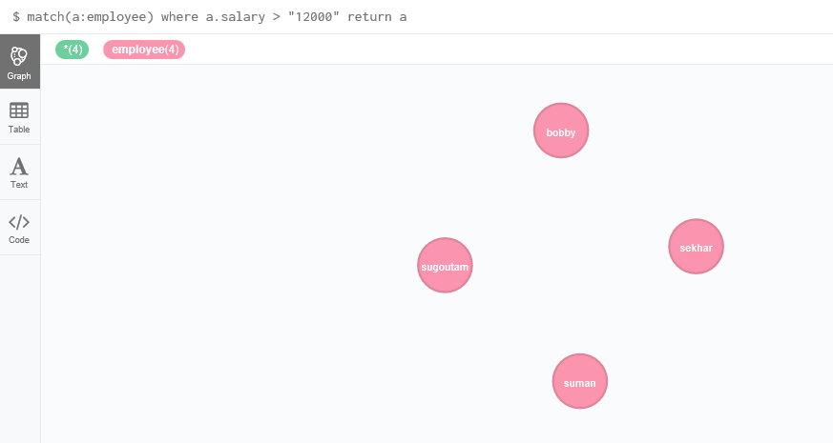

Q 3 : Run a Querry to update salary of bikas to 15000.





Q 4: Run A querry to delete record of employee whise empno = “a-109”.

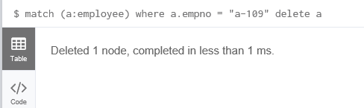



Q 5: Find all employee record with name bobby.

