**INDIAN INSTITUTE OF INFORMATION TECHNOLOGY KALYANI**



**NAME: DEVESH KAUSHIK**

**ROLL NO: 39/CSE/16013**

**REGISTRATION N0: 0000170**

**DBMS ASSIGNMENT- 6**

**SECTION-1**

Database- Company

Table- employee

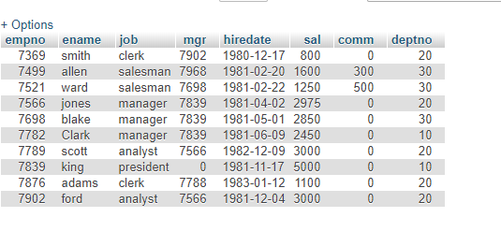

Table- department

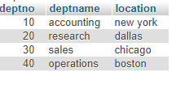

1-List the names of analysts and salesman.

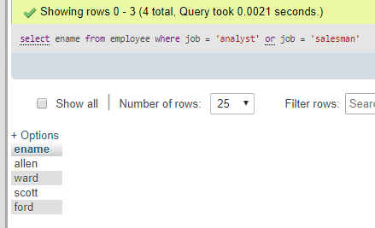

2-List the details of the employee who have joined before 30 sept 81.

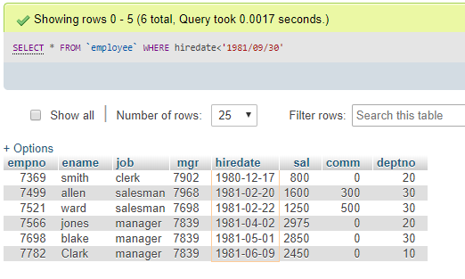

3-List the names of the employees who are nor managers.

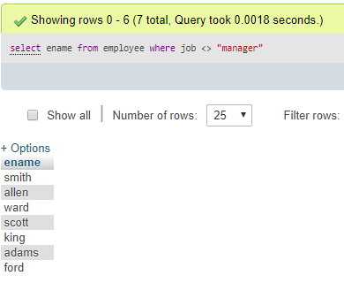

4-List the names of the employees whose employee numbers are 7369, 7521, 7839, 7934, 7788.

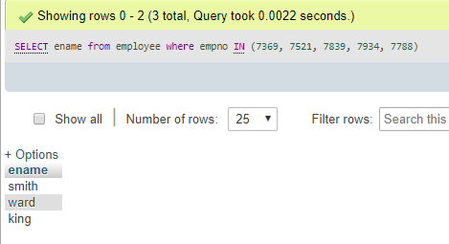

5-List employees not belonging to department- 30, 40 or 10.

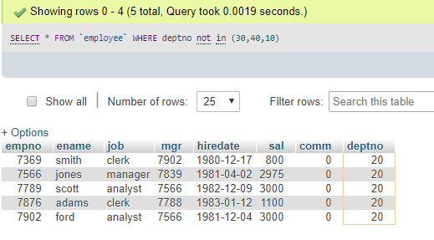

6- List employee names for those who have joined between 30 june and 31 dec 81.

-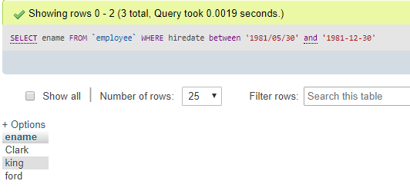

7-List the different designations in the company.

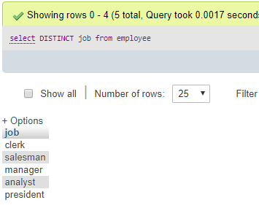

8- List the names of the employee who are not eligible for commissions.

-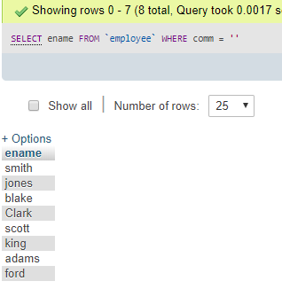

9- List the name and designation of the employee who does not report to anybody.

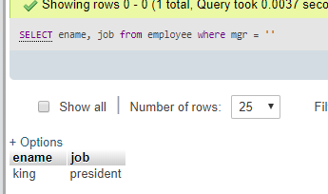

10-List the employees not assigned to any department.

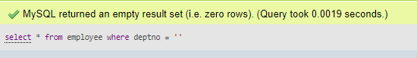

11- List the employees who are eligible for commission.

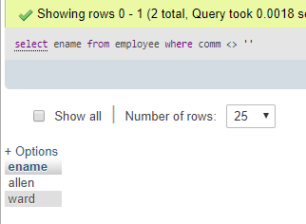

12- List the employee whose name either start oe end with “s”.

-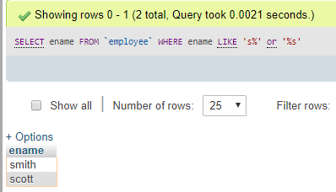

13-List names of employees whose names have “i” as the second character.

-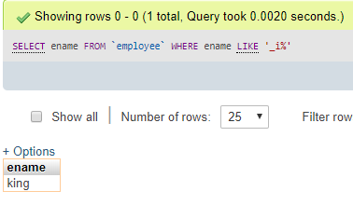

14- List the number of employees working with the company.

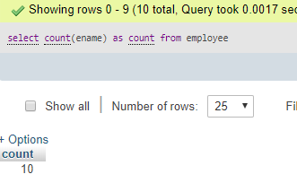

15 - List the number of designations available in the emp table.

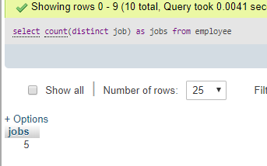

16 - List the total salary paid to the employees.

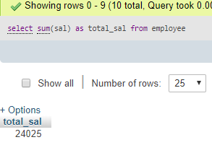

17- List the maximum, minimum, and average salary in the company.

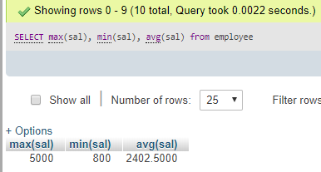

18- List the maximum salary paid to a salesman.

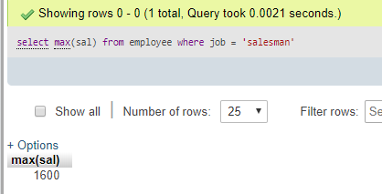

**SECTION-2**

1-List the number of employees and average salary for employees in dept-20.

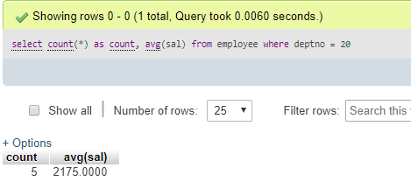

2- List name, salary, and PF amount of all employees .(PF is calculated as 10 % of the salary)

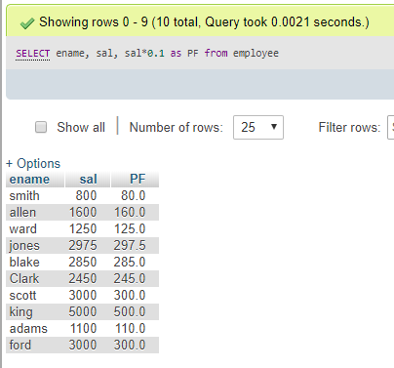

4- List the employee details in the ascending order of their basic salary.

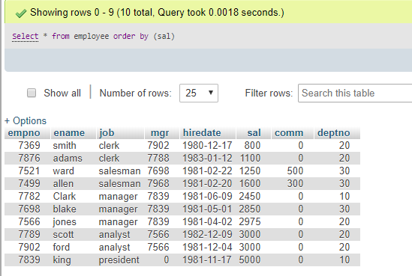

5- List the employee name and hire date in the ascending order of their basic salary.

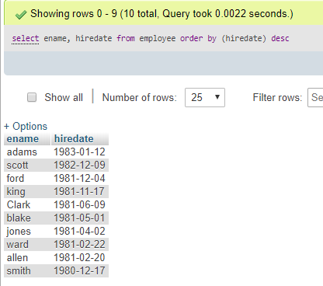

6- List employee name, salary, PF, HRA, DA and gros; order the results in the ascending order of the gross.

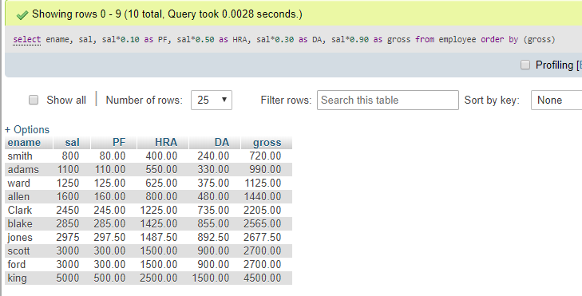

7- List the department number and the number of employees in each department.

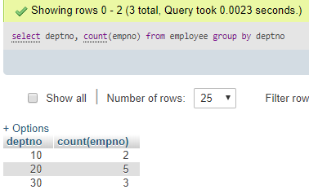

8- List the department number and total salary payable in each department.



9- List the jobs and number of employees in each job. The result should be in the descending order of the number of employees.

-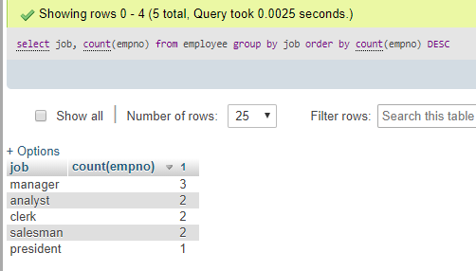

10- List the total salary, maximum and minimum salary and average salary of the employee job wise.

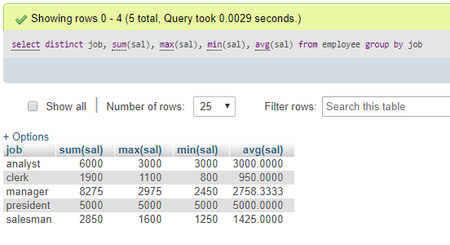

11- List the total salary, maximum and minimum salary and average salary of the employees, for the department 20.

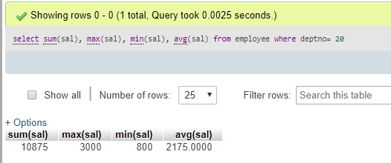

12- List the total salary, maximum and minimum salary and average salary of the employee job wise, for department 20 and display only those rows having an average salary >1000.

