**Create all the below tables and insert data:**

**Table name: Bank (bname Primary key)**

+--------------------+-----------+

| bname | bcity |

| AJNI Bank | NAGPUR |

| ANDHERI Bank | MUMBAI |

| CHANDANI Bank | DELHI |

| DHARAMPETH Bank | NAGPUR |

| M.G. ROAD Bank | BANGALORE |

| NEHERU PALACE Bank | DELHI |

| POWAIBank | MUMBAI |

| VIRAR Bank | MUMBAI |

| VRCE Bank | NAGPUR |

+--------------------+-----------+

**Table name: customer (cname primary key)**

+---------+---------+

| cname | city |

+---------+---------+

| ANIL | KOLKATA |

| KRANTI | MUMBAI |

| MADHURI | NAGPUR |

| MANDAR | PATANA |

| MEHUL | BARODA |

| NAREN | MUMBAI |

| PRAMOD | NAGPUR |

| SANDIP | SURAT |

| SHIVANI | MUMBAI |

| SUNIL | DELHI |

**Table name: deposit**

| actno(pk) | cname(fk) | bname (fk) | amount | adate |

| 100 | ANIL | VRCE BANK | 1000.00 | 1995-03-01 |

| 101 | SUNIL | AJNI BANK | 5000.00 | 1996-01-04 |

| 102 | MEHUL | CHANDANI BANK | 3500.00 | 1995-11-17 |

| 103 | PRAMOD | M.G. ROAD BANK | 1200.00 | 1995-11-17 |

| 104 | SANDIP | ANDHERI BANK | 3000.00 | 1995-03-27 |

| 105 | SHIVANI | VIRAR BANK | 1000.00 | 0000-00-00 |

| 106 | MADHURI | AJNI BANK | 2000.00 | 1995-12-05 |

| 107 | KRANTI | NEHERU PALACE BANK | 5000.00 | 1995-07-02 |

| 108 | NAREN | POWAIBANK | 7000.00 | 1995-08-02 |

**Table name: borrow**

| loanno | cname(fk) | bname (fk) | amount |

| 201 | ANIL | VRCE BANK | 5000 |

| 206 | MEHUL | AJNI BANK | 1000 |

| 311 | SUNIL | DHARAMPETH BANK | 3000 |

| 321 | MADHURI | ANDHERI BANK | 2000 |

| 375 | PRAMOD | VIRAR BANK | 8000 |

| 481 | KRANTI | NEHERU PALACE BANK | 3000 |

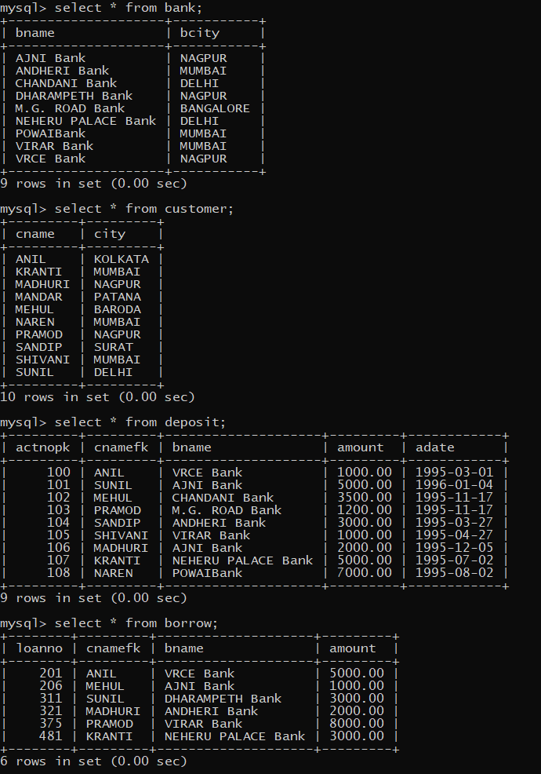

Questions:

1. List Name of Customer Having Living City MUMBAI and Branch City DELHI.

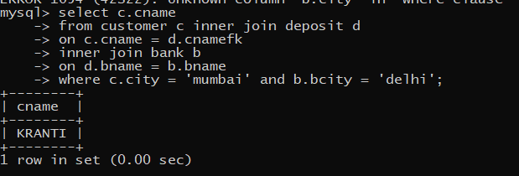

1. List Names of Customers who are Depositors and have Same Branch City as that of SUNIL.

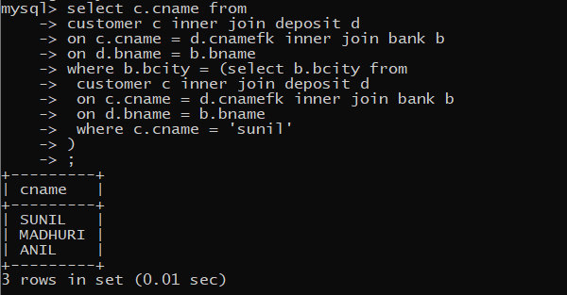

1. List LoanNO and Loan City of Borrowers Having the Same Branch as that of Depositors SUNIL.

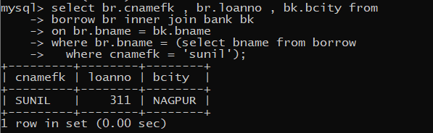

1. List LoanNO,Loan City,Account NO and Deposit City of Customers Living in NAGPUR.

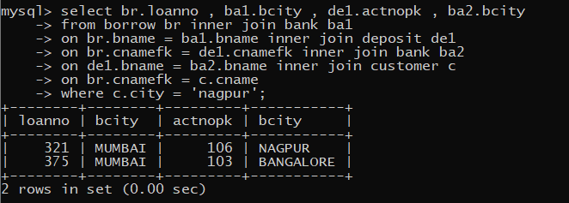

1. List Deposit Details and Loan details of Customers in the City where Pramod is Living.

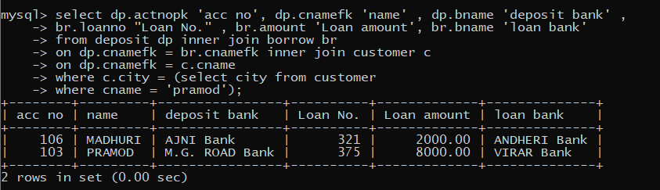

1. List Names of Customers who are Depositors and have Same Branch City as that of SUNIL.

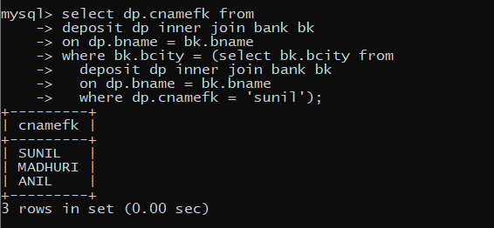

1. List Names of Depositors Having Same Living City as that of SHIVANI and Having Deposit City Greater than 2000.

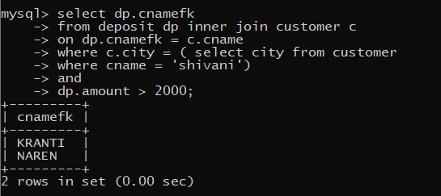

1. List Names of Borrowers Having Deposit Amount Greater than 1000 and Loan Amount Greater than 2000.

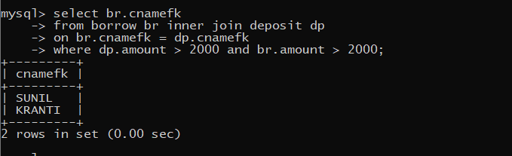

1. List Names of Depositors Having the Same Branch as the Branch of SUNIL.br

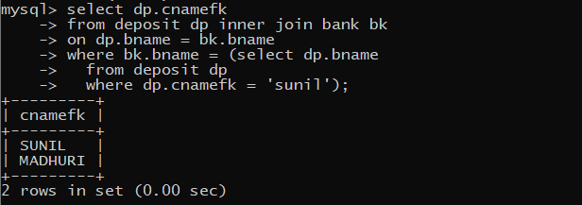

1. List Names of Borrowers Having Loan Amount Greater than the Loan Amount of ANIL.

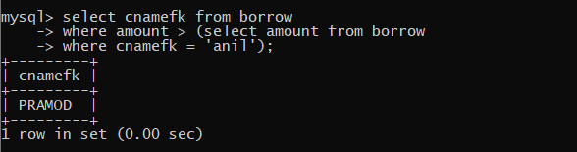

1. List LoanNO,Loan City,Account NO and Deposit City of Customers Having Deposit Branch Located in DELHI.
2. List LoanNO,Loan City,Account NO,Deposit City,Branch Name,Branch City and Living City of Pramod.
3. List Deposit Details and Loan details of Customers in the City where Pramod is Living.
4. List Names of Depositors Having balance Greater than 1000 and group by branch name
5. List LoanNO,Loan City,Account NO,Deposit City,Branch Name,Branch City and Living City of Pramod

**PL*SQL**

**Exercise 1**

1. Write a Procedure that computes the perimeter and the area of a rectangle. Define your own values for the length and width. (Assuming that *L* and *W* are the length and width of the rectangle, Perimeter = *2*(L+W)* and Area = *L*W*. Display the output on the screen

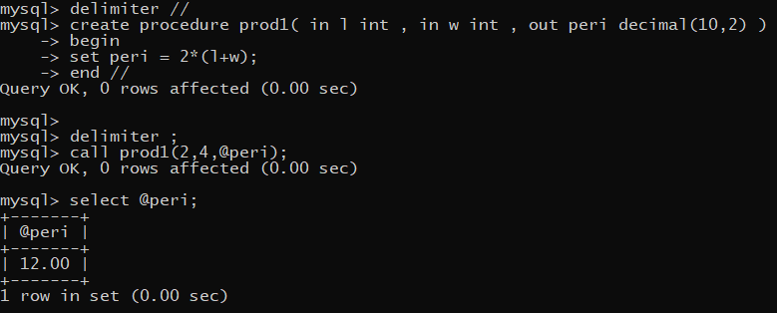

1. Write a Procedure that declares an integer variable called *num*, assigns a value to it, and computes and inserts into the tempp table the value of the variable itself, its square, and its cube.

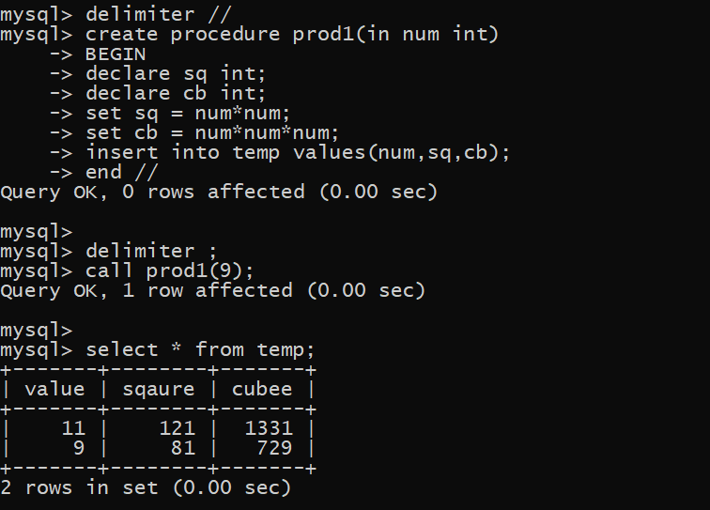

1. 0Convert a temperature in Fahrenheit (F) to its equivalent in Celsius (C) and vice versa. The required formulae are:- *C*= (*F*-32)*5/9

*F*= 9/5\**C* + 32

Display the output on the screen. Data has to be input by the user.

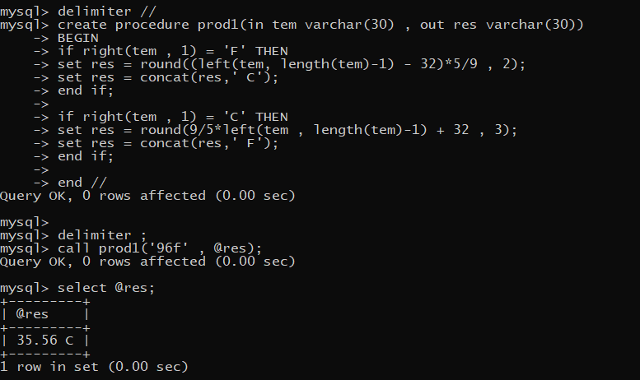

1. Convert a number of inches into yards, feet, and inches. For example, 124 inches equals 3 yards, 1 foot, and 4 inches. Display the output on the screen. Data has to be input by the user.

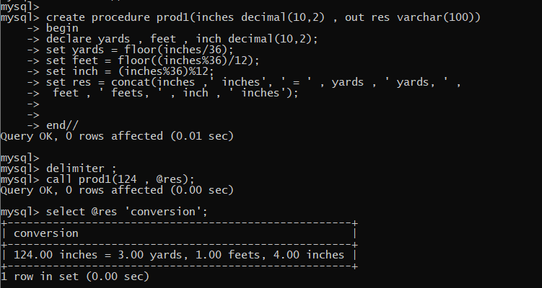

1. Write a program that enables a user to input an integer. The program should then state whether the integer is evenly divisible by 5. Display the output on the screen. Data has to be input by the user.

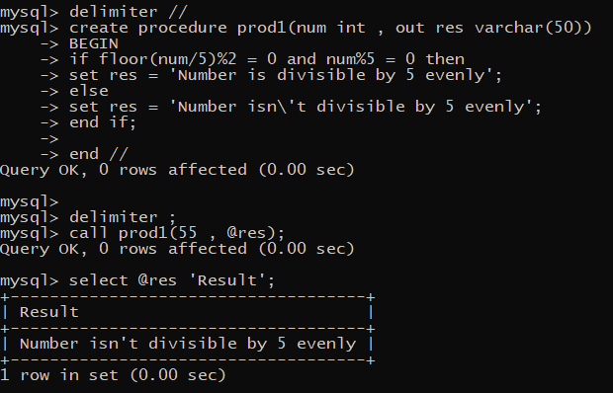

1. Your block should read in two real numbers and tell whether the product of the two numbers is equal to or greater than 100. Display the output on the screen.Data has to be input by the user.

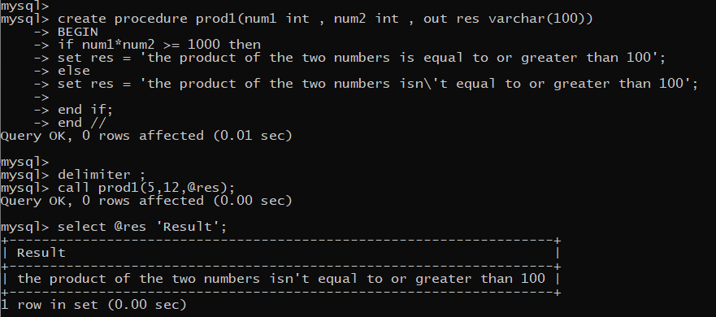

**PL*SQL**

**Exercise 3**

1. Input a number and determine whether it is within a given range (for example, between 1 and 10). The low and high values of the range may be input by the user rather than be fixed by the program. Display the output on the screen

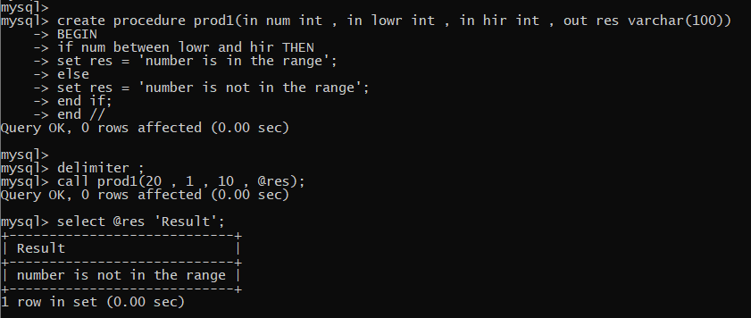

1. Input three positive integers representing the sides of a triangle, and determine whether they form a valid triangle. Hint: In a triangle, the sum of any two sides must always be greater than the third side. Display the output on the screen

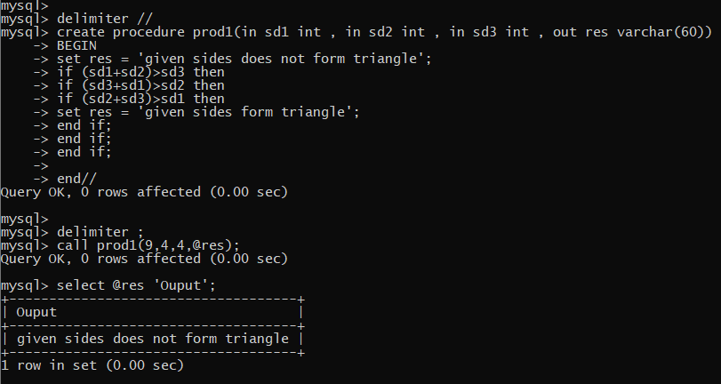

1. Check if a given a year is a leap year. The condition is:-

year should be (divisible by 4 and not divisible by 100) or (divisible by 4 and divisible by 400.) Display the output on the screen. The year should be input by the user.

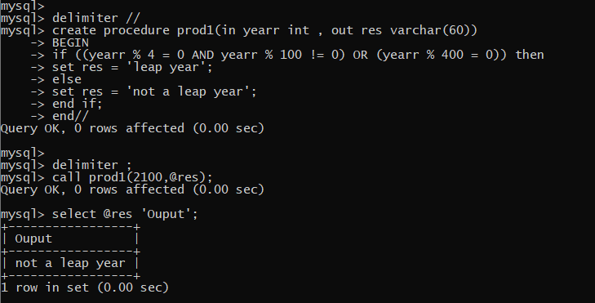

1. Ask the user to enter the weight of an apple box. If the

weight is >= 10 kg, rate =Rs. 5/kg

weight is < 10 kg, rate = Rs. 7/kg

Calculate the cost of the apple box. Display the output on the screen

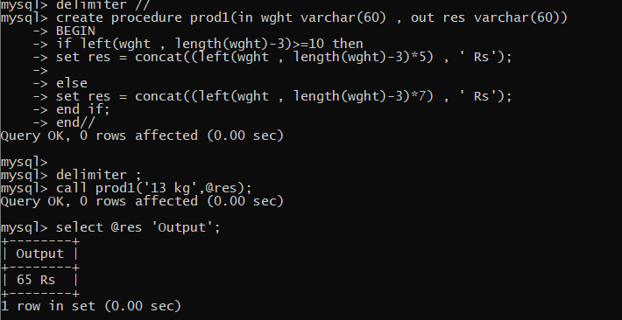

1. Program should accept the age of the user. Depending upon the following conditions it should output:-

age <18 years, “child”

age >= 18 years and <21 years, “major”

age>= 21years “adult”

Display the output on the screen.

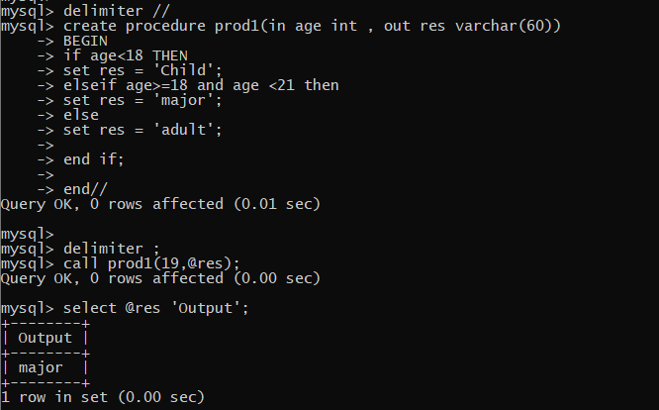

1. Write a program that asks the user to input two character strings. Your program should then determine if one character string exists inside another character string. Display the above on the screen.

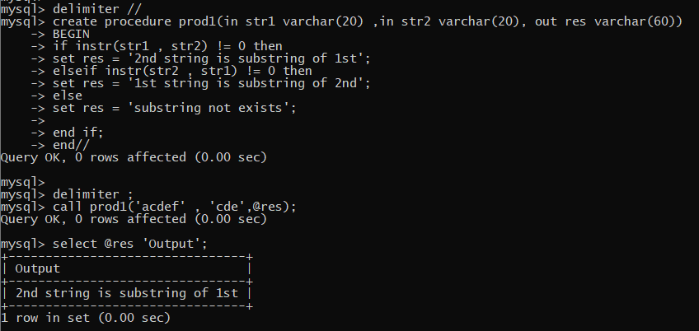

1. Suppose the grade obtained by a student depends upon his scores and the grading rule is as follows. :-

# **Scores** **Grades**

95-100 A

85-94 B

70-84 C

60-69 D

0-59 E

Write a block to accept a student’s marks and accordingly output his grade. Display the output on the screen.

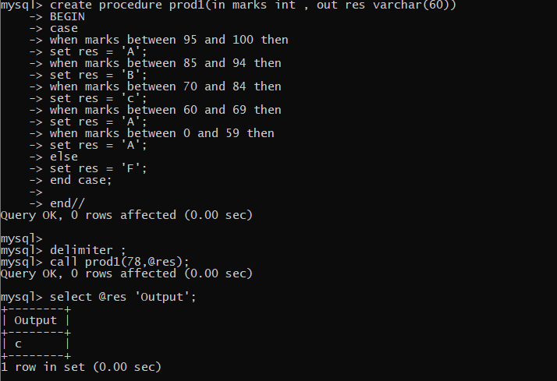

1. A company manufactures three products:- computer stationery, fixed disks and computers. The following codes are used to indicate them:-

|  |  |  |
| --- | --- | --- |
| **Product** | | **Code** |
| Computer Stationery | | 1 |
| Fixed Disks | | 2 |
| Computers | | 3 |
| The company has a discount policy as follows:- | | |
| **Product** | **Order amount** | **Discount rate** |
| Computer stationery | Rs. 5000 or more | 12% |
| Computer stationery | Rs. 3000 or more | 8% |
| Computer stationery | Below Rs. 3000 | 2% |
| Fixed disks | Rs. 20000 or more | 10% |
| Fixed disks | Rs. 15000 or more | 5% |
| Computers | Rs. 50000 or more | 10% |
| Computers | Rs. 25000 or more | 5% |

Write a program to accept the order details i.e. product code and order amounts for the products, calculate the discount amounts as per this policy and output the net order amount. Display the output on the screen.

