Date and Time functions

1. Write a query to display the first day of the month (in datetime format) three

months before the current month.

Sample current date : 2014-09-03

Expected result : 2014-06-01

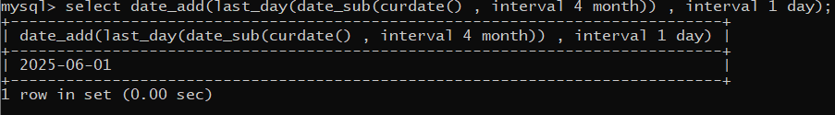

2. Write a query to display the last day of the month (in datetime format) three

months before the current month.

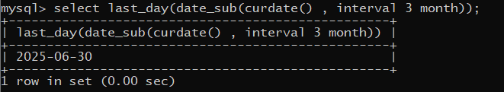

3. Write a query to get the distinct Mondays from hiredate in emp tables.

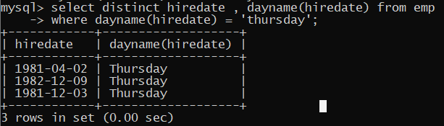

4. Write a query to get the first day of the current year.

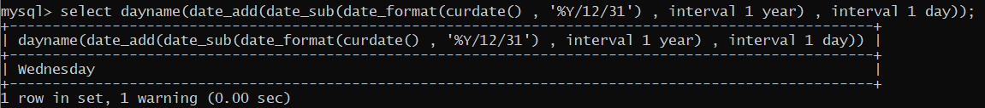

5. Write a query to get the last day of the current year.

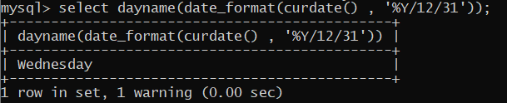

6. Write a query to calculate your age in year.

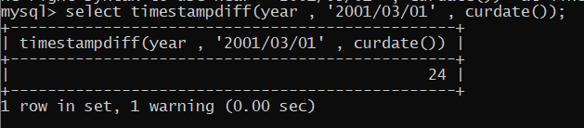

7. Write a query to get the current date in the following format.

Sample date : 04-sep-2014

Output : September 4, 2014

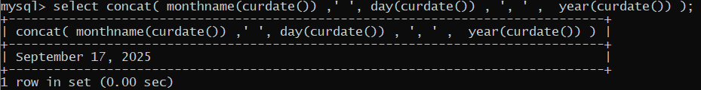

8. Write a query to get the current date in Thursday September 2014 format.

Thursday September 2014

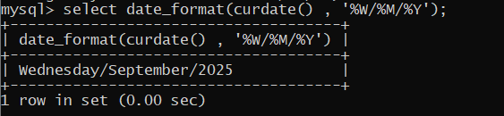

9. Write a query to extract the year from the current date.

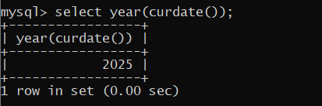

10. Write a query to get the first name and hire date from employees table

where hire date between '1987-06-01' and '1987-07-30'

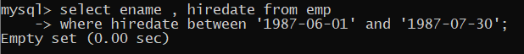

11. Write a query to display the current date in the following format.

Sample output: Thursday 4th September 2014 00:00:00

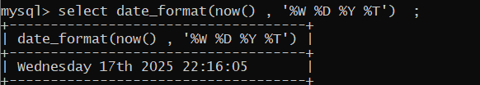

12. Write a query to display the current date in the following format.

Sample output: 05/09/2014

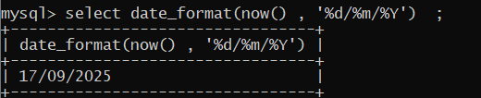

13. Write a query to display the current date in the following format.

Sample output: 12:00 AM Sep 5, 2014

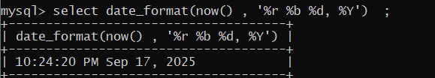

14. Write a query to get the employees who joined in the month of June.

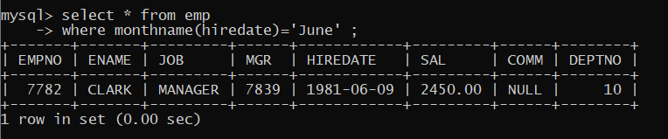

15. Write a query to get the years in which more than 10 employees joined.

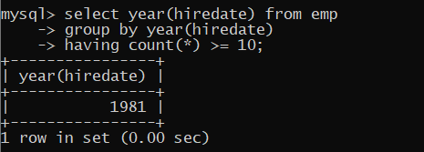

16. Write a query to get first name of employees who joined in 1987.

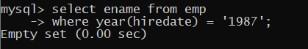

17. Write a query to get employees whose experience is more than 5 years.

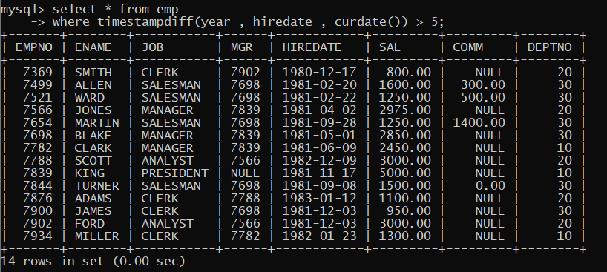

18. Write a query to get employee ID, last name, and date of first salary of the

Employees.

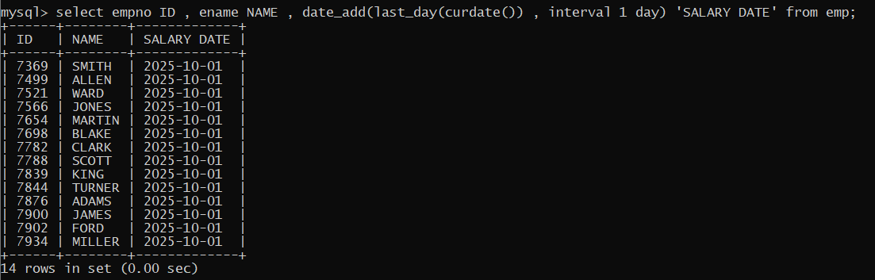

19. Write a query to get first name, hire date and experience of the

employees.

Sample table: employees

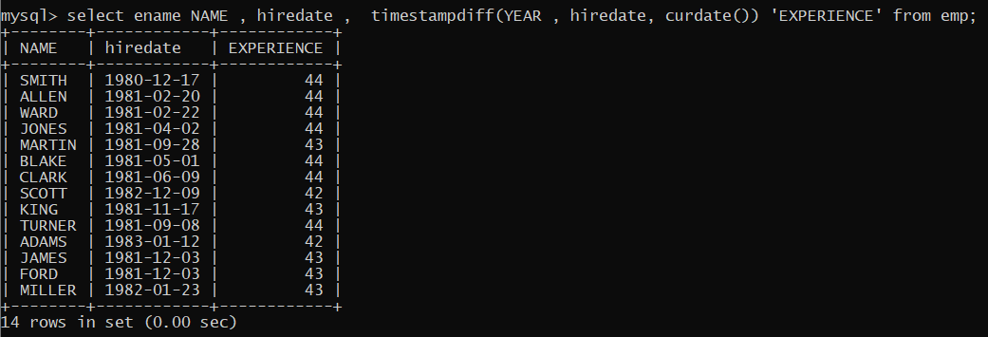

20. Write a query to get the department ID, year, and number of employees

Joined.

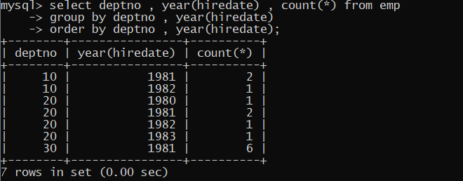

**Practice group-by assignment**

Product table

(pid,pname,qty,price,mfgdate,expdate,type,cid)

Type -→ perishable/non perishable

All perishable products has expdate

1. Find sum of price for all products

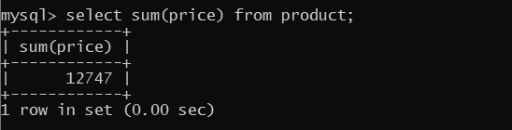

2. Find min and max price for every category

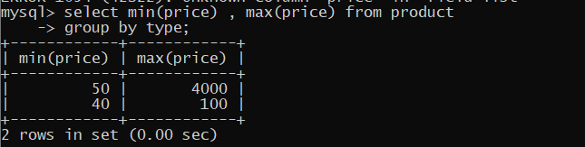

3. Find sum of total amt, for every type of product (amt=qty*price)

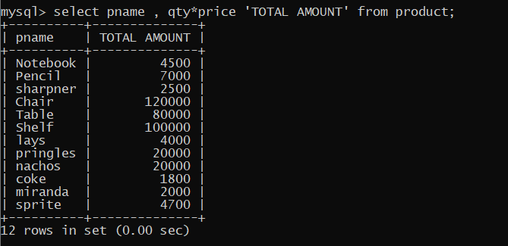

4. Find how many products and what is sum of prices of all products for every category

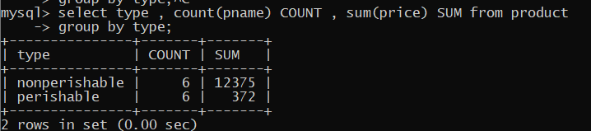

5. Display pid, pname, cid, sum of prices for every category --------- doubt

6. Display sum of prices for every category, if it is perishable product

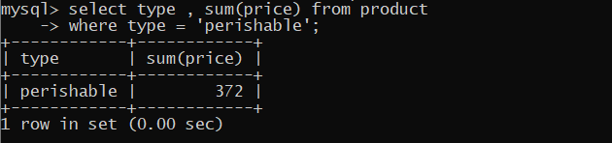

7. Display sum of amt(qty*price) for every category if the qty > 45 and < 100,

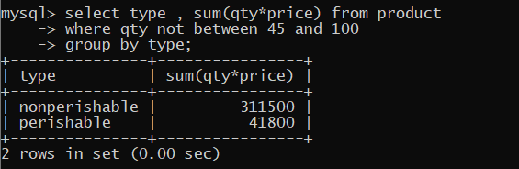

8. Display number of products, sum of amt(price*qty) products, which are manufactured

in year 2024, for every category, only if the number of products in the category are <3

arrange it in sorted order of sum of amt(price*qty)

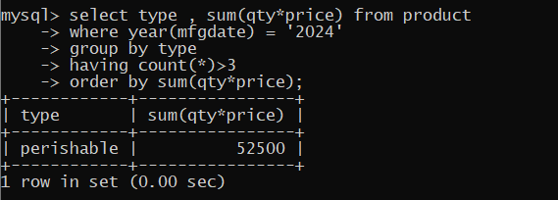

9. Find sum and count of all products manufactured in every year (to find year-→

year(mfgdate)

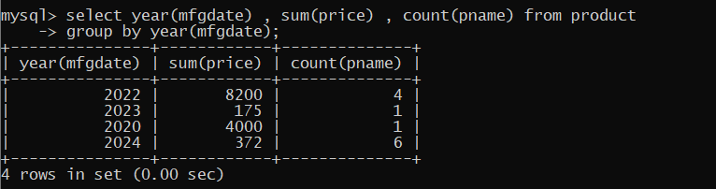

10. Display pid, pname, type, count for every type ------ doubt

