**Create a table**  
**Location(loc_id, lname,address)**  
**Server (sid,sname,configuration,lid, adminid)**  
**Admin(adminid,username,password,mobile,name)**

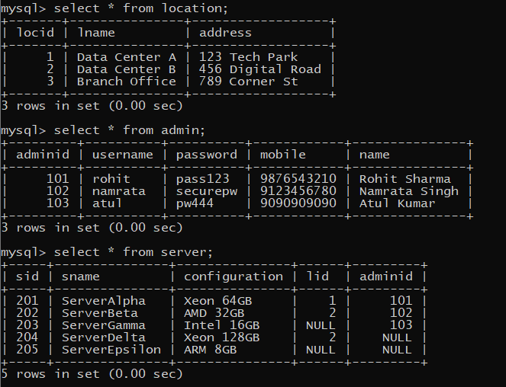

1. display all server-name, location of the server

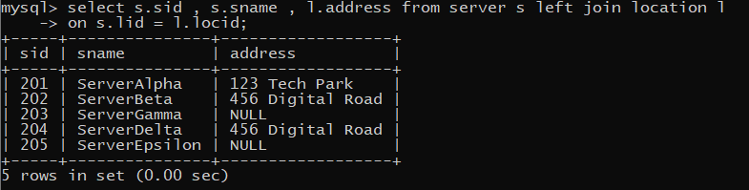

2. display all server-name, admin-name, admin mobile  
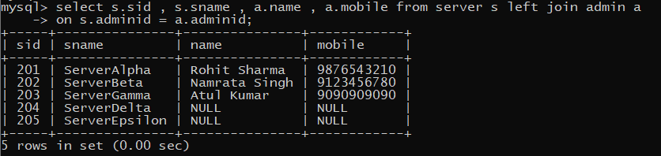

3. display all server which are managed by admin rohit

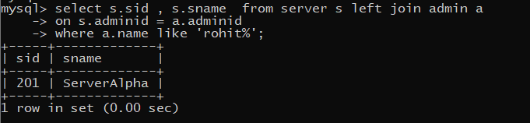

4. display all server and the locations, for which admin is rohit

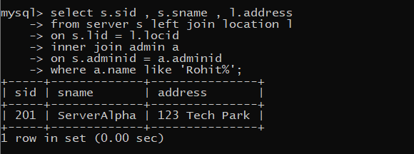

5. display all admins, for whome no server is assigned

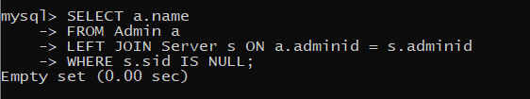

6. display all servers and admin details, and also display admins for whom no server is assigned

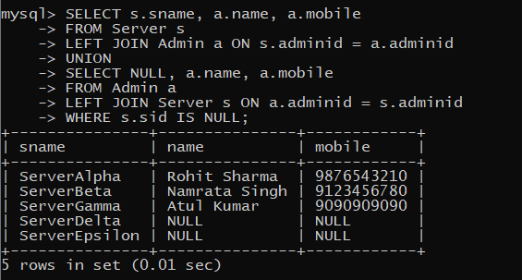

7. display servers, admins and location of the server

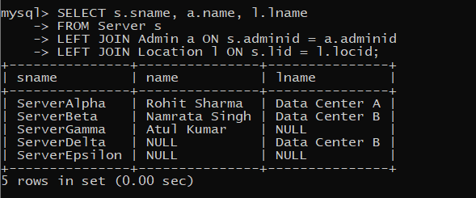

8. to display all admins for whom no server is assigned  
also display locations at which no server is placed

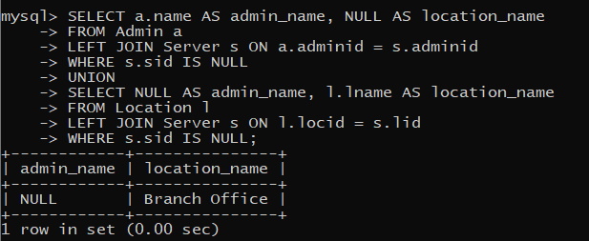

9. display all servers for which no location is assigned

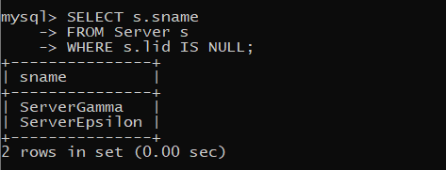

10. display all servers, for which no location is assigned,  
whose admin is namrata

