product(pid,pname,qty,price,mfgdate,expdate,type,cid)  
prod_supp(prodid,suppid)  
category(catid,cname,cdesc)  
supplier(sid,sname,address,mobile)  
  
  
select * from product;  
+-----+----------+------+---------+------------+------------+---------------+------+  
| pid | pname | qty | price | mfgdate | expdate | type | cid |  
+-----+----------+------+---------+------------+------------+---------------+------+  
| 21 | lays | 23 | 40.00 | 2020-12-11 | 2021-02-03 | perishable | 1 |  
| 22 | pringle | 50 | 100.00 | 2021-12-11 | 2022-02-03 | perishable | 1 |  
| 23 | pespsi | 33 | 50.00 | 2021-12-11 | 2022-01-03 | perishable | 2 |  
| 24 | cocacola | 35 | 50.00 | 2021-12-11 | 2022-01-03 | perishable | 2 |  
| 25 | khajoor | 44 | 200.00 | 2022-12-11 | NULL | perishable | 5 |  
| 26 | chair | 37 | 5000.00 | 2021-12-11 | NULL | nonperishable | 6 |  
+-----+----------+------+---------+------------+------------+---------------+------+  
6 rows in set (0.00 sec)  
  
mysql> select * from category;  
+-----+-------------+--------------------+  
| cid | cname | cdesc |  
+-----+-------------+--------------------+  
| 1 | chips | very crunchy |  
| 2 | cold drinks | Thanda cool cool |  
| 3 | biscuits | very crunchy sweet |  
| 4 | chocolates | yummy |  
| 5 | snacks | very tasty |  
| 6 | furniture | very elegant |  
+-----+-------------+--------------------+  
6 rows in set (0.00 sec)  
  
mysql> select * from supplier;  
+-----+---------+----------+--------+  
| sid | sname | address | mobile |  
+-----+---------+----------+--------+  
| 11 | Rohit | Pune | 2222 |  
| 12 | Sonam | mumbai | 2323 |  
| 13 | Reshama | kolhapur | 3333 |  
| 14 | Ashu | mumbai | 4444 |  
| 15 | Saniya | Pune | 55555 |  
+-----+---------+----------+--------+  
5 rows in set (0.00 sec)  
  
mysql> select * from prod_supp;  
+--------+------------+  
| prodid | salesmanid |  
+--------+------------+  
| 21 | 11 |  
| 22 | 11 |  
| 24 | 11 |  
| 21 | 12 |  
| 25 | 12 |  
| 22 | 13 |  
+--------+------------+  
6 rows in set (0.00 sec)

Questions(mix of all concepts)  
1. find all products which expires in year 2022

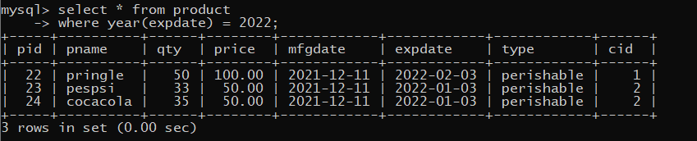

2. list all categories for which no products exists

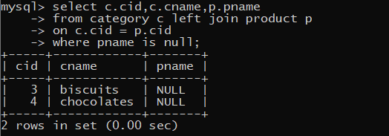

3. list all suppliers who stays in same city where Rohit stays.

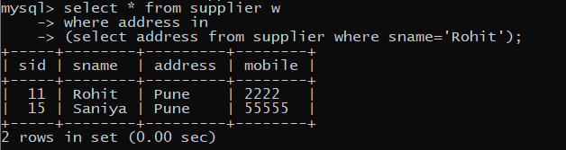

4. list all supplier who have not supplied any product yet.

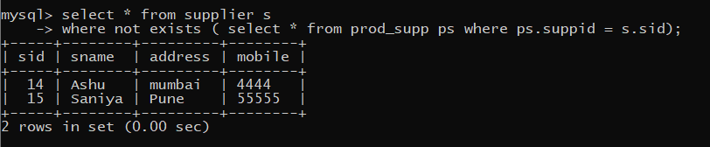

5. find all products of chips category

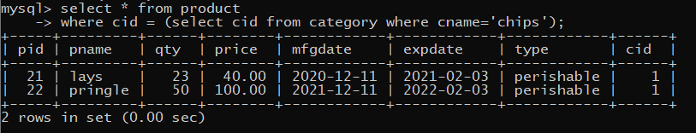

6. list pid,pname,cid,cname,cdesc for all products

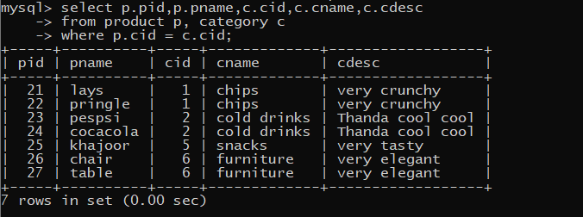

7. list pid, pname,sid,sname for all products



8. list pid,pname,sid,sname,cid,cname for all products

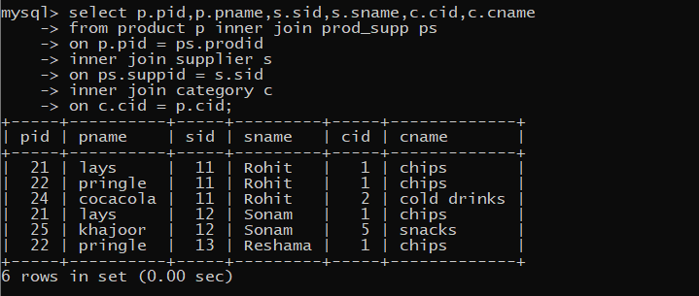

9. display all categories for which no products are there and display suppliers who do not supply any item

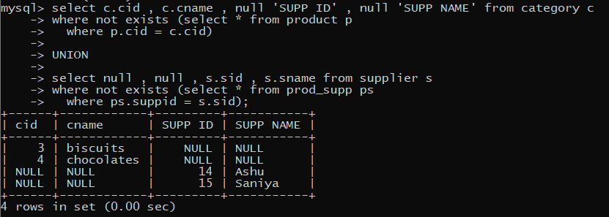

10. list all products which have been manufactured in November



11. list all perishable product with category either chips or cold drink

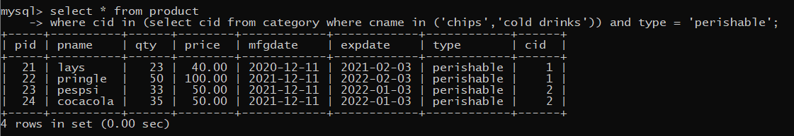

12. list all nonperishable products

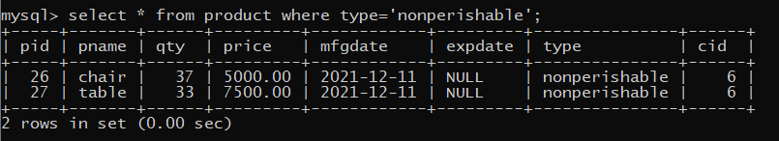

13. list all products supplied by suppliers who stays in pune.

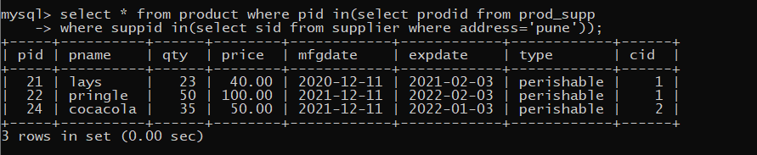

14. list all products supplied by suppliers with name starts with r or s

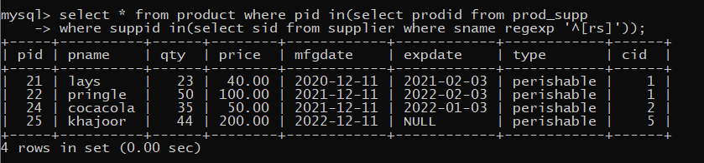

15. list all categories with product price is >=30 and <=100

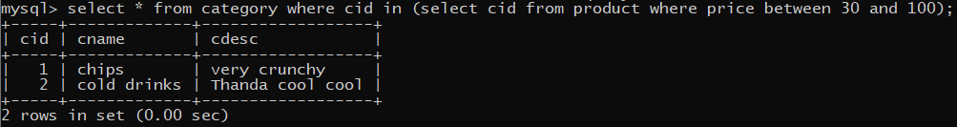

16. list all products of categories chips and cold drinks

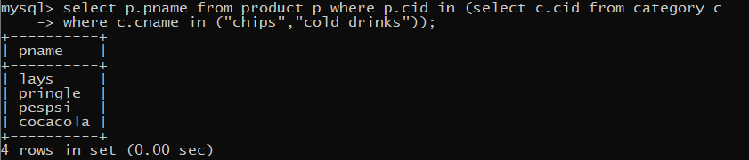

17. list all products with price <= pringles and >= chair

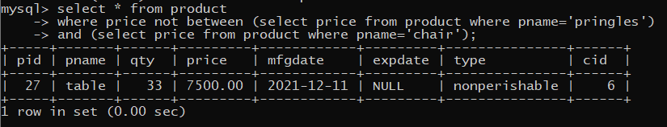

18. list all products which will expire in 12 months from manufacture date

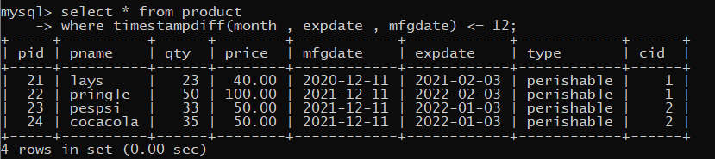

19. display the pairs of product names, qty of first product < qty of 2nd product

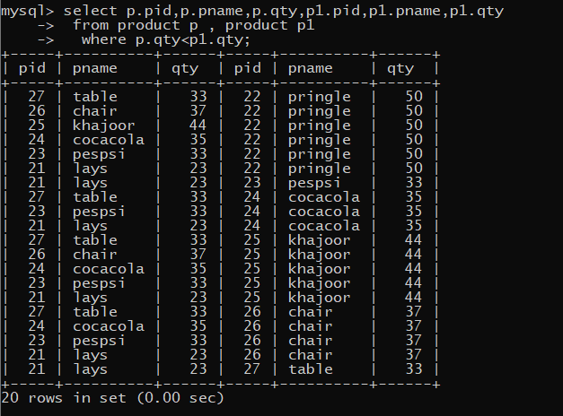

20. display pairs of supplier who stays in same city  
  
