**Assignments - (PLSQL)**

1. Write a procedure for the following.

a. To accept employee number , delete the record of the given employee. ` 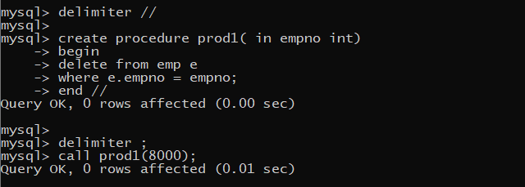

b. To accept grade,losal and hisal and insert a record into salgrad table 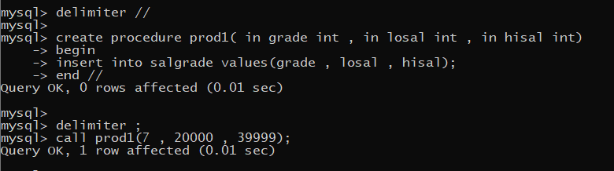

2. Write functions to perform the following.

a. Calculate experience of the employee 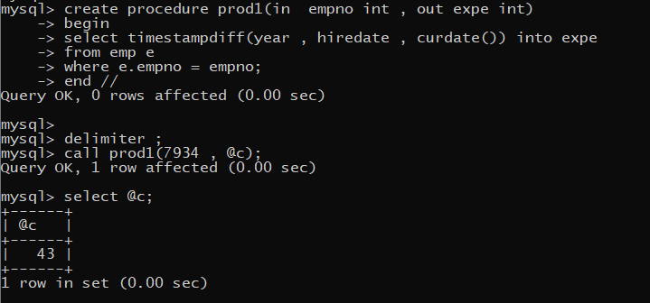

b. To calculate net sal by using formula. Netsal=sal+da+hra-pf+comm Da-→ 10% sal hra→ 15% sal pf --→ 8 % of sal 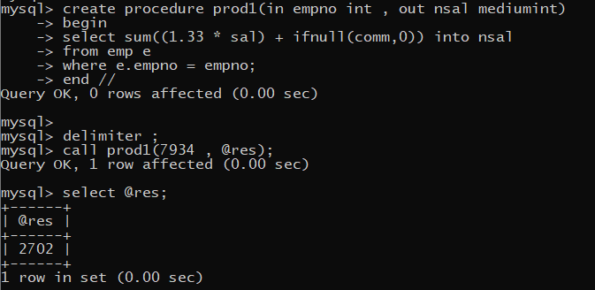

3. Loops example

1. Print the following patterns using loop : DECLARE -- declare variable n, --I AND J of datatype number N NUMBER := 7; I NUMBER; J NUMBER; BEGIN -- loop from 1 to n FOR I IN 1..N LOOP FOR J IN

1..I LOOP DBMS_OUTPUT.PUT('*') ; -- printing * END LOOP; DBMS_OUTPUT.NEW_LINE; -- for new line END LOOP; END;

a. * ** *** **** b. * *** ***** *** * c. 1010101 10101 101 1 d. 1 1 2 1 2 3 1 2 3 4 1 2 3 4 5

4. Write a procedure that displays the following information of all emp Empno,Name,job,Salary,Status,deptno

Note: - Status will be (Greater, Lesser or Equal) respective to average salary of their own department. Display an error message Emp table is empty if there is no matching record.

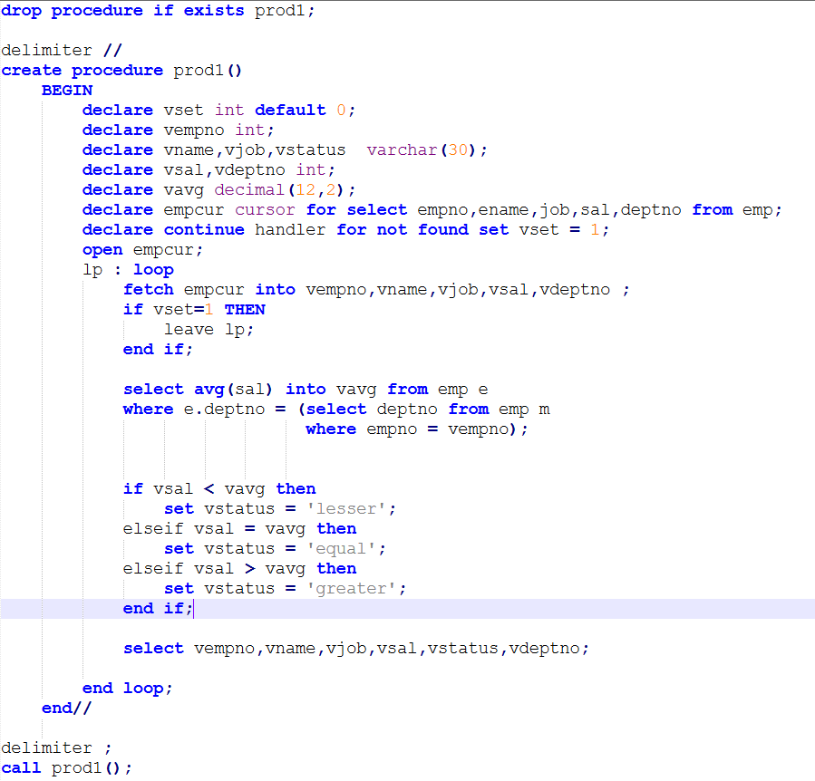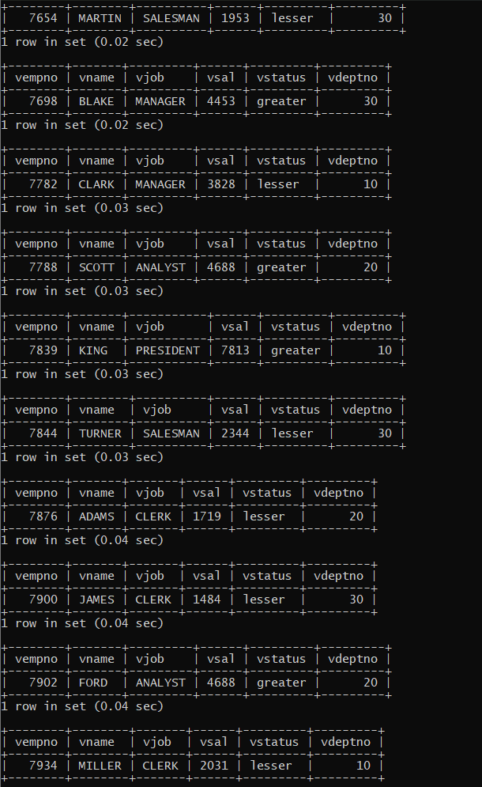

5.Write a procedure to update salary in emp table based on following rules. Exp< =35 then no Update Exp> 35 and <=38 then 20% of salary Exp> 38 then 25% of salary

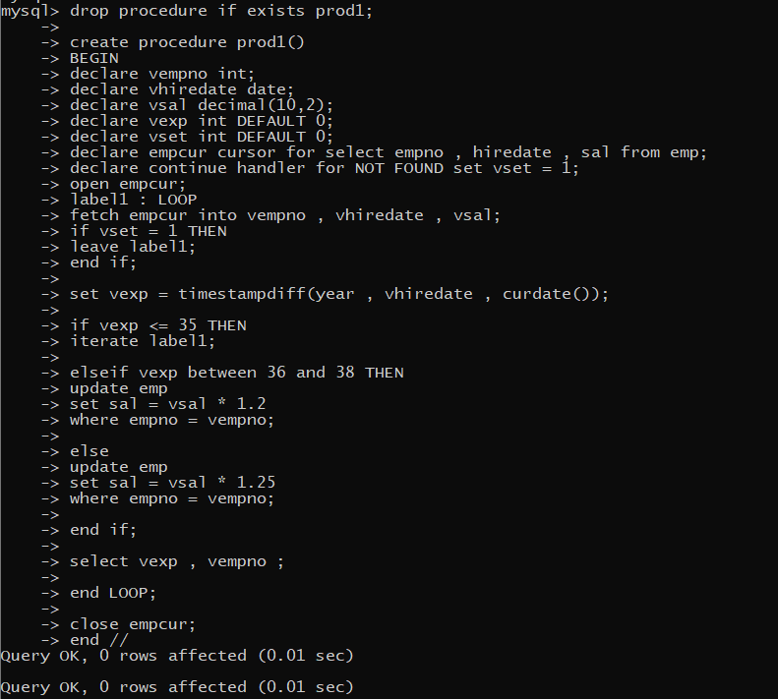

6. Write a procedure and a function. Function: write a function to calculate number of years of experience of employee.(note: pass hiredate as a parameter)

Procedure: Capture the value returned by the above function to calculate the additional allowance for the emp based on the experience. Additional Allowance = Year of experience x 3000 Calculate the additional allowance and store Empno, ename,Date of Joining, and Experience in years and additional allowance in Emp_Allowance table. create table emp_allowance( empno int, ename varchar(20), hiredate date, experience int, allowance decimal(9,2));

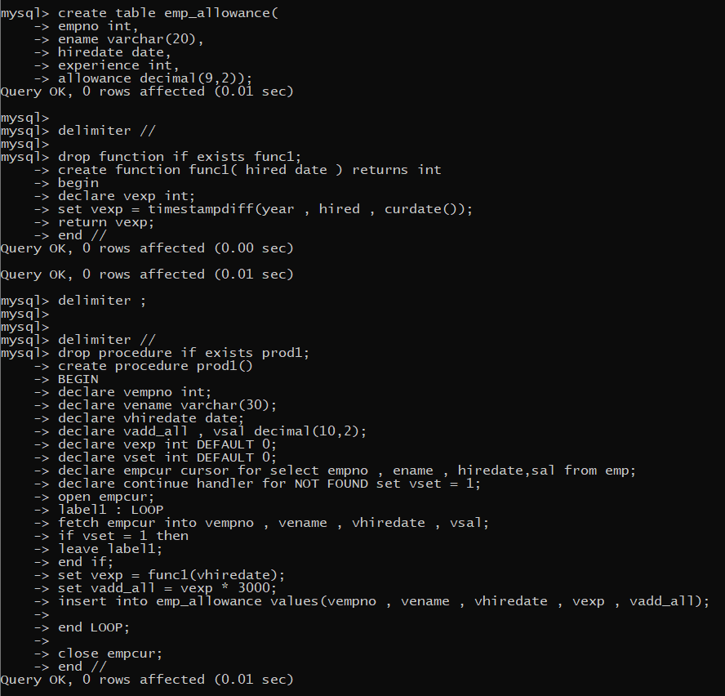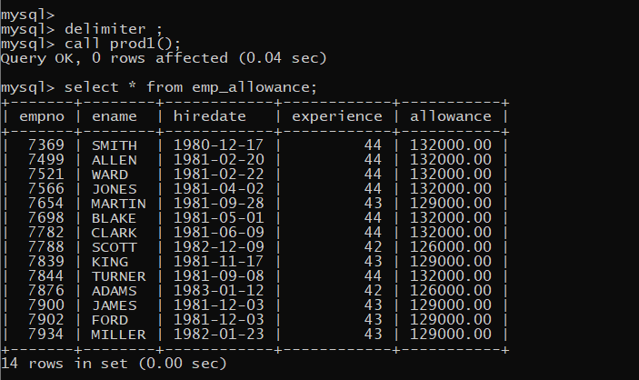

7. Write a function to compute the following. Function should take sal and hiredate as i/p and return the cost to company. DA = 15% Salary, HRA= 20% of Salary, TA= 8% of Salary. Special Allowance will be decided based on the service in the company. < 1 Year Nil >=1 Year< 2 Year 10% of Salary >=2 Year< 4 Year 20% of Salary >4 Year 30% of Salary

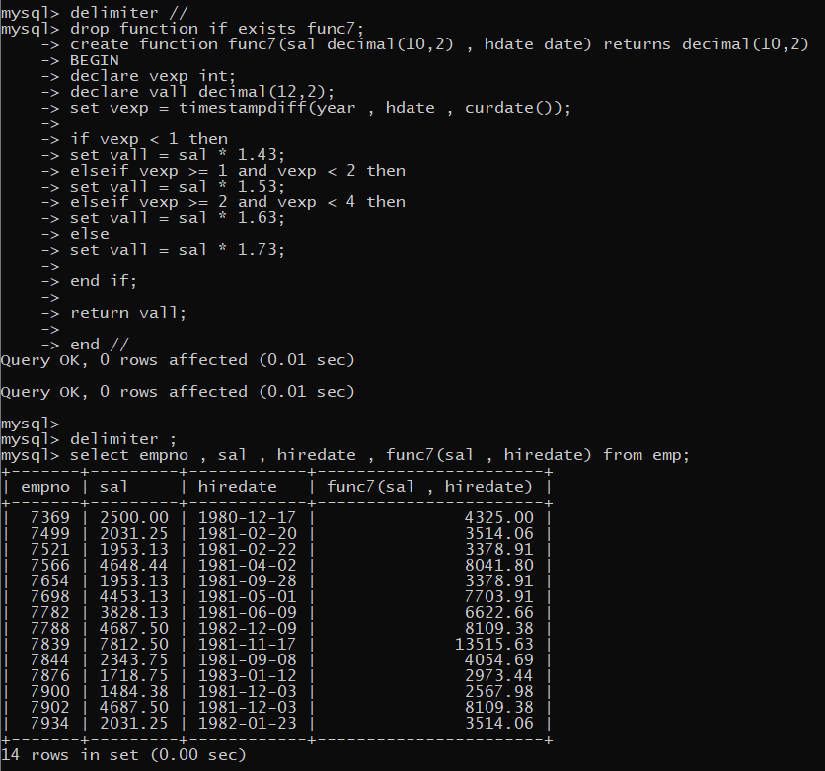

8. Write trigger on employee table for insert, update and delete, make appropriate entries in following table. Create table emp_check( Empid number; Ename varchar2(20), Oldsal number(9,2), Newsal number(9,2), Uname varchar2(20), Chk_date date);

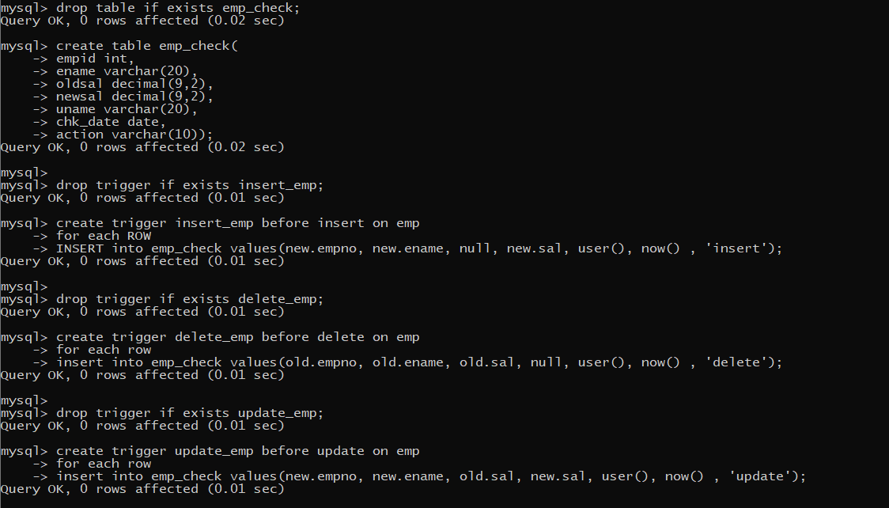

9. Create table product_history. Write inser, update and delete trigger to store old product price and new product price in history table before you perform DML operation in product table (note: use product table). create table product_history( pno int, pname varchar(20), oldprice decimal(9,2), newprice decimal(9,2), chdate datetime, username varchar(20) action varchar(20) );

WORKER ASSIGNMENT

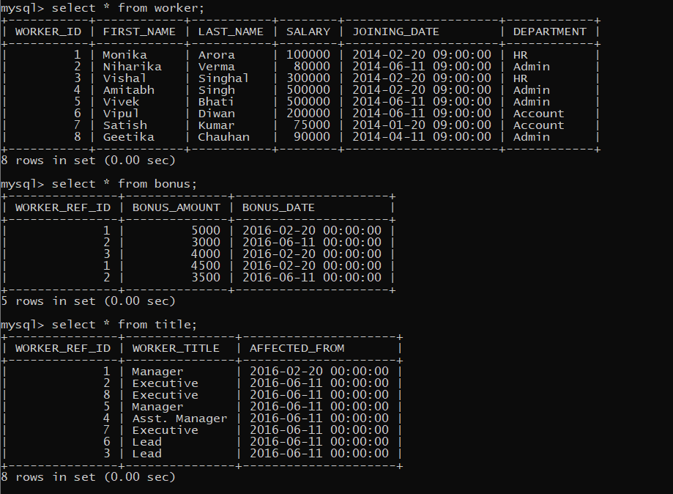

1. Write an SQL query to fetch “FIRST_NAME” from Worker table using the alias name as <WORKER_NAME>.

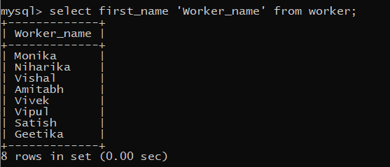

1. Write an SQL query to fetch “FIRST_NAME” from Worker table in upper case.

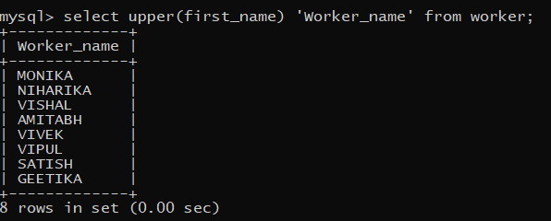

1. Write an SQL query to fetch unique values of DEPARTMENT from Worker table.

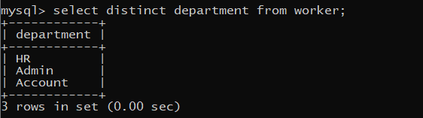

1. Write an SQL query to print the first three characters of FIRST_NAME from Worker table.

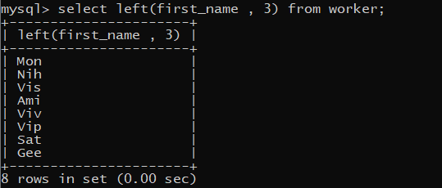

1. Write an SQL query to find the position of the alphabet (‘a’) in the first name column ‘Amitabh’ from Worker table.

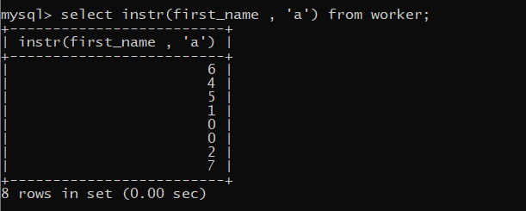

1. Write an SQL query to print the FIRST_NAME , departmentname from Worker table separated by white space.

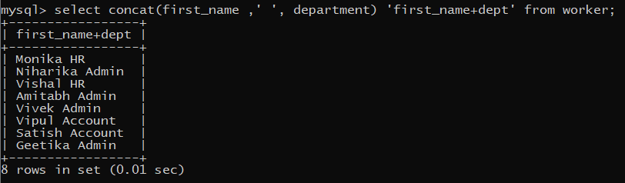

1. Write an SQL query to print the DEPARTMENT from Worker table after removing white spaces from the left side.

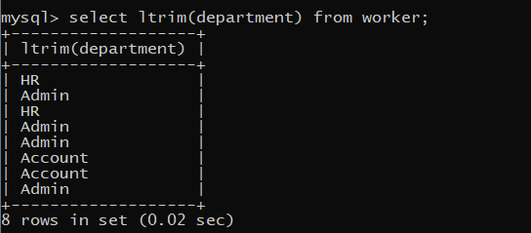

1. Write an SQL query that fetches the unique values of DEPARTMENT from Worker table and prints its length.

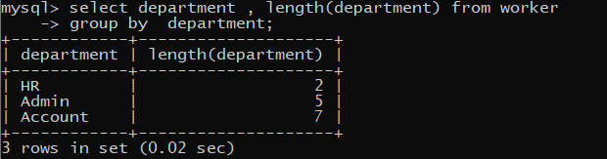

1. Write an SQL query to print the FIRST_NAME from Worker table after replacing ‘a’ with ‘A’.

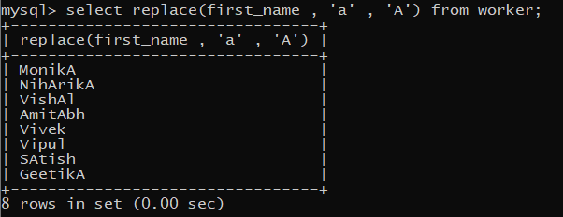

1. Write an SQL query to print the FIRST_NAME and LAST_NAME from Worker table into a single column COMPLETE_NAME. A space char should separate them.
2. Write an SQL query to print all Worker details from the Worker table order by FIRST_NAME Ascending.
3. Write an SQL query to print all Worker details from the Worker table order by FIRST_NAME Ascending and DEPARTMENT Descending.
4. Write an SQL query to print details for Workers with the first name as “Vipul” and “Satish” from Worker table.
5. Write an SQL query to print details of workers excluding first names, “Vipul” and “Satish” from Worker table.
6. Write an SQL query to print details of Workers with DEPARTMENT name as “Admin”.
7. Write an SQL query to print details of the Workers whose FIRST_NAME contains ‘a’.
8. Write an SQL query to print details of the Workers whose FIRST_NAME ends with ‘a’.
9. Write an SQL query to print details of the Workers whose FIRST_NAME ends with ‘h’ and contains six alphabets.
10. Write an SQL query to print details of the Workers whose SALARY lies between 100000 and 500000.
11. Write an SQL query to print details of the Workers who have joined in Feb’2014.
12. Write an SQL query to fetch the count of employees working in the department ‘Admin’.
13. Write an SQL query to fetch worker names with salaries >= 50000 and <= 100000.
14. Write an SQL query to fetch the no. of workers for each department in the descending order.
15. Write an SQL query to print details of the Workers who are also Managers.
16. Write an SQL query to fetch duplicate records having matching data in some fields of a table.
17. Write an SQL query to show only odd rows from a table.
18. Write an SQL query to show only even rows from a table.
19. Write an SQL query to clone a new table from another table.
20. Write an SQL query to fetch intersecting records of two tables.
21. Write an SQL query to show records from one table that another table does not have.

Ans -SELECT table1.* FROM table1 LEFT JOIN table2 ON table1.id = table2.id WHERE table2.id IS NULL;

1. Write an SQL query to show the current date and time.

Ans – now()

1. Write an SQL query to show the top n (say 10) records of a table.

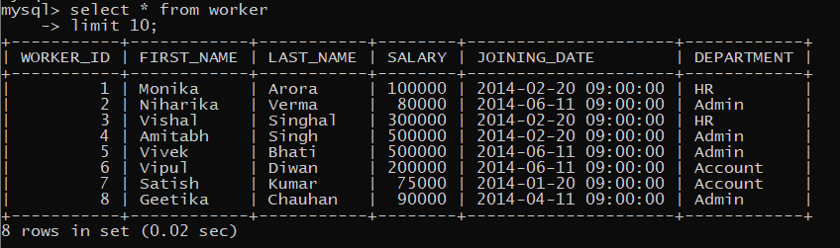

1. Write an SQL query to determine the nth (say n=5) highest salary from a table.

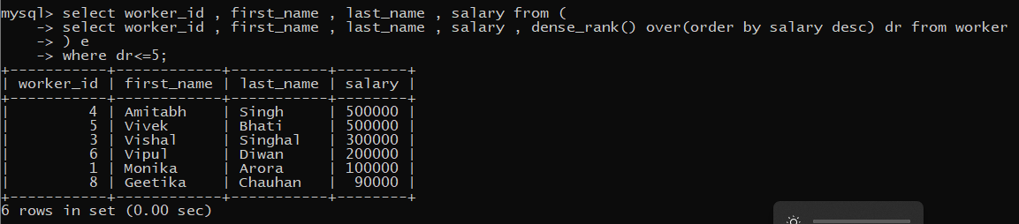

1. Write an SQL query to determine the 5th highest salary without using TOP or limit method.



1. Write an SQL query to fetch the list of employees with the same salary.
2. Write an SQL query to show the second highest salary from a table.
3. Write an SQL query to show one row twice in results from a table.
4. Write an SQL query to fetch intersecting records of two tables.
5. Write an SQL query to fetch the first 50% records from a table.
6. Write an SQL query to fetch the departments that have less than five people in it.
7. Write an SQL query to show all departments along with the number of people in there.
8. Write an SQL query to show the last record from a table.
9. Write an SQL query to fetch the first row of a table.
10. Write an SQL query to fetch the last five records from a table.
11. Write an SQL query to print the name of employees having the highest salary in each department.
12. Write an SQL query to fetch three max salaries from a table.
13. Write an SQL query to fetch three min salaries from a table.
14. Write an SQL query to fetch nth max salaries from a table.
15. Write an SQL query to fetch departments along with the total salaries paid for each of them.
16. Write an SQL query to fetch the names of workers who earn the highest salary.