1. Write a Python program to sum all the items in a list.

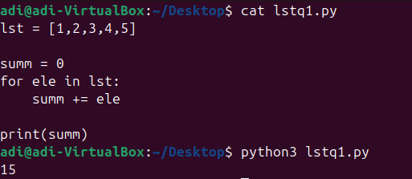

2. Write a Python program to multiply all the items in a list.

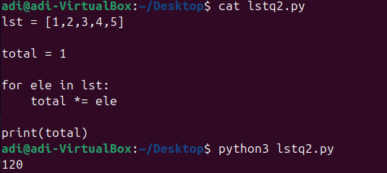  
  
  
3. Write a Python program to get the largest number from a list.

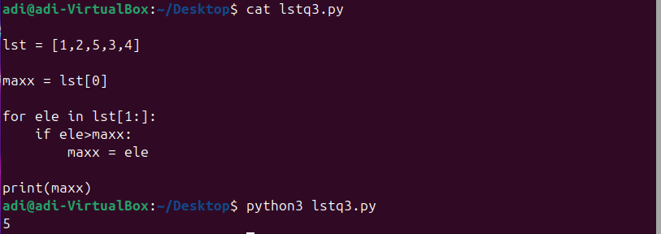  
  
  
4. Write a Python program to get the smallest number from a list.  
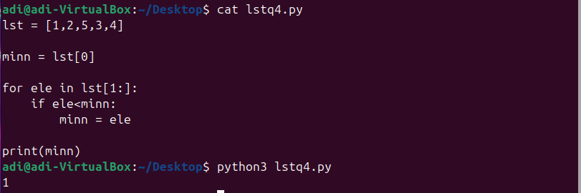

7. Write a Python program to remove duplicates from a list. Use another list to store unique values.  
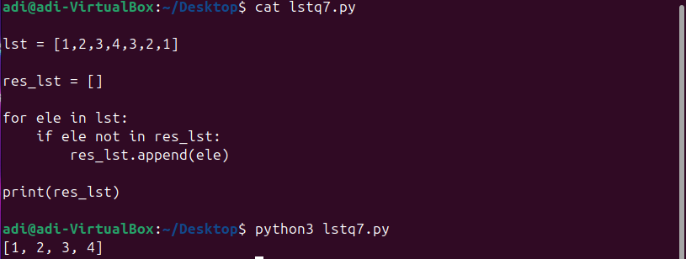

8. Write a Python program to check if a list is empty or not.  
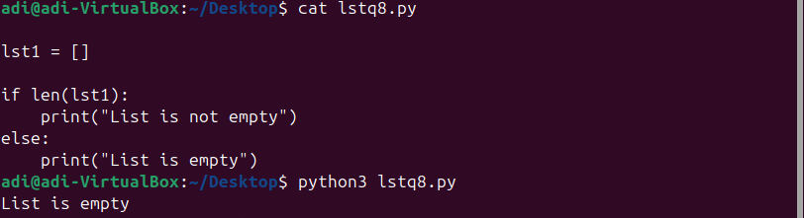

9. Write a Python program to clone or copy a list.

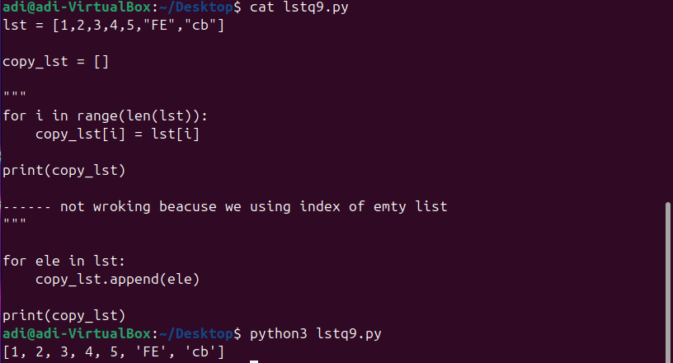

11. Write a Python program which has two lists and returns True if they have at least one common member.  
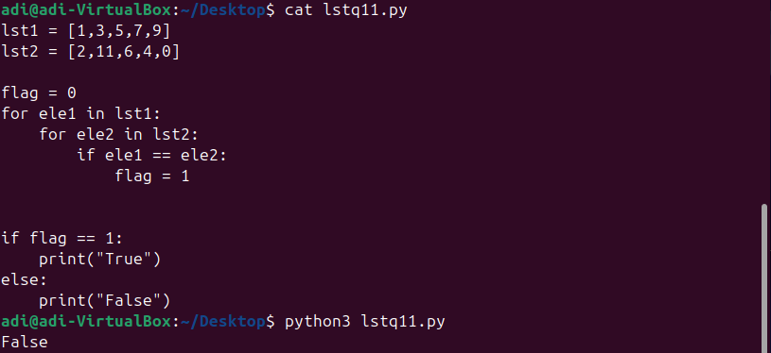

14. Write a Python program to print the numbers of a gven list after removing even numbers from it.  
Ex. l1=[10,25,45,78,90,103,455]  
o/p :: [25,45,103,455]  
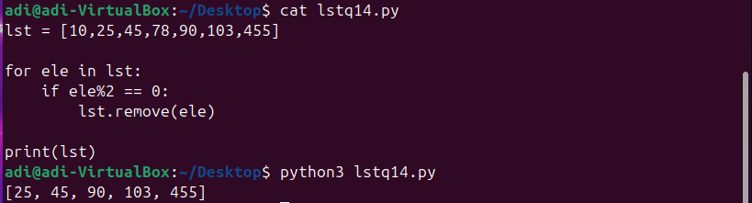

16. Write a Python program to generate and print a list of the first and last 5 elements where the values are square numbers between 1 and 30 (both included).  
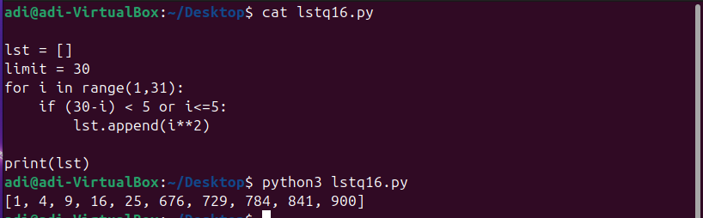

17. Write a Python program to check if each number is prime in a given list of numbers. Return True if all numbers are prime otherwise False.  
Sample Data:  
([0, 3, 4, 7, 9]) -> False  
([3, 5, 7, 13]) -> True  
([1, 5, 3]) -> False

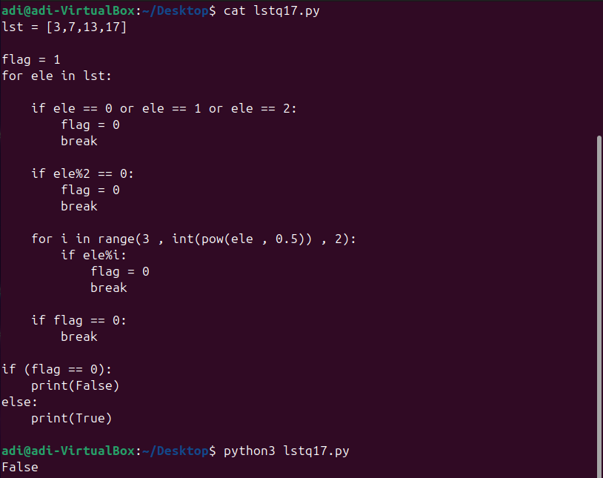

18. Write a Python program to generate all permutations of a list in Python.  
[Hint use library iteratortools]  
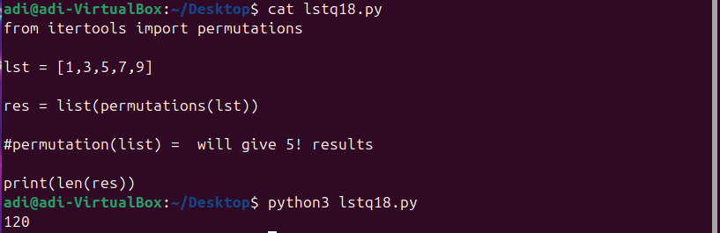

19. Write a Python program to calculate the difference between the two lists.  
ex.   
l1=[1,4,7,8]  
l2=[2,5,7,23]  
ans => total difference is 17  
explaination:   
first element diff 1  
second element diff 1  
third element diff 0  
fourth element diff 15

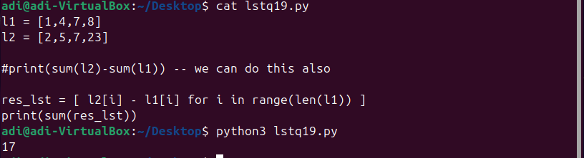

20. Write a Python program to access element at given index of a list.  
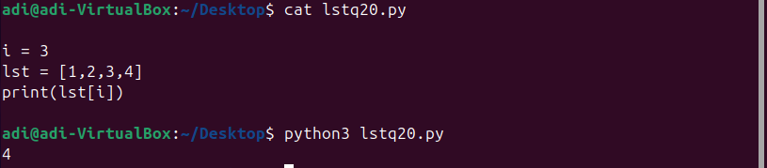  
  
  
22. Write a Python program to find the index of an item in a specified list.

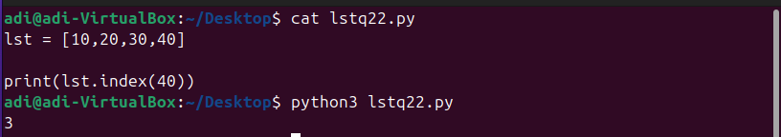

23. Write a Python program to flatten a simple list.

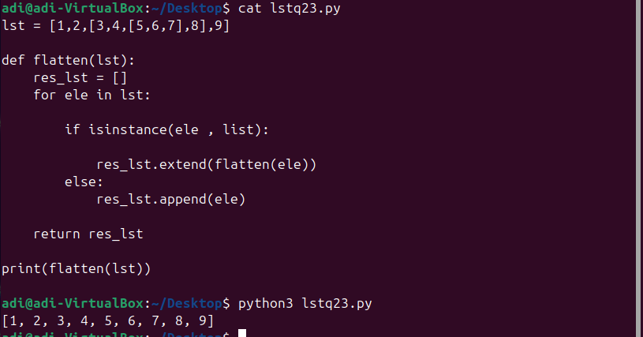

24. Write a Python program to append all elements from a list to the second list.

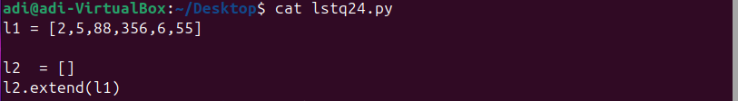

26. Write a Python program to check whether two lists are circularly identical.  
Ex.  
l1=[1,2,3,4]  
l2=[2,3,4,1]  
l3=[4,1,2,3]  
l4=[3,4,1,2]   
all l1, l2, l3 and l4 are circularly same

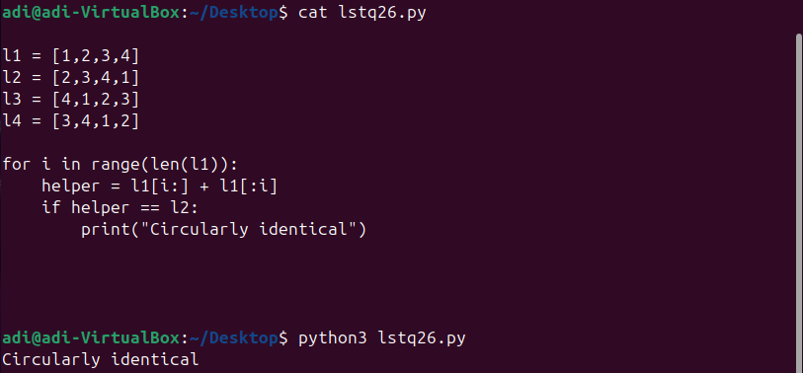

27. Write a Python program to find the second smallest number in a list.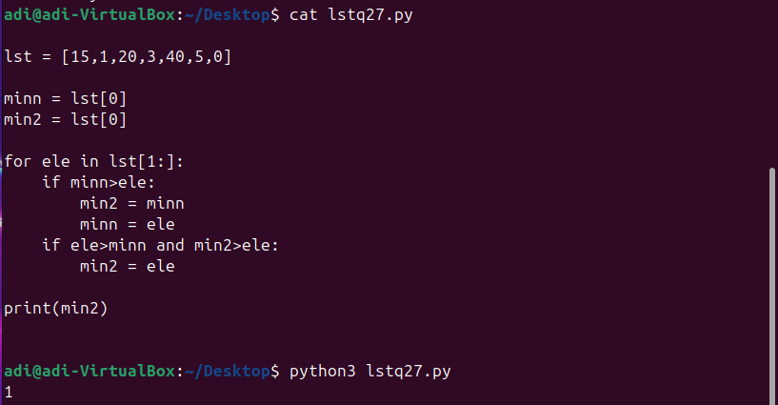  
  
  
28. Write a Python program to find the second largest number in a list.

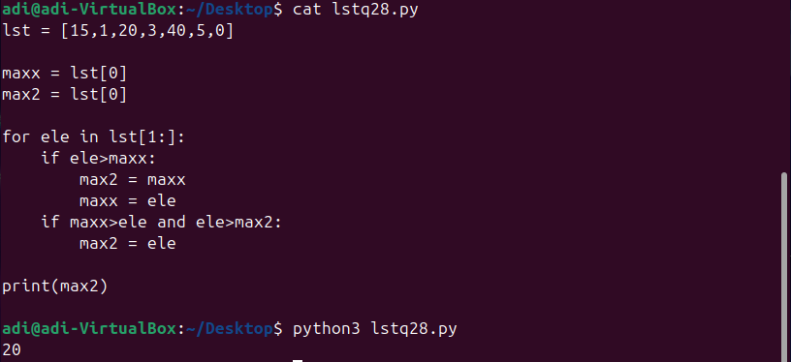

29. Write a Python program to get unique values from a list.  
  
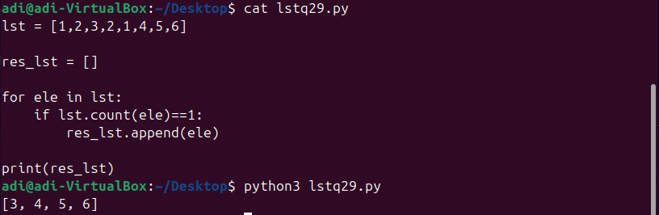

30. Write a Python program to get the frequency of every element in a list.

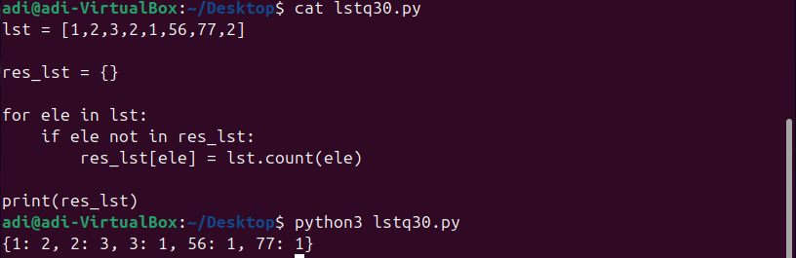  
  
32. Write a Python program to check whether a list contains a sublist. ( all elements from one list are present in other list)  
Ex.   
l1=[5,7,9,12]  
l2=[7,9]   
l2 is sublist of l1 --> print True  
l3=[12,7]  
l3 is sublist of l1

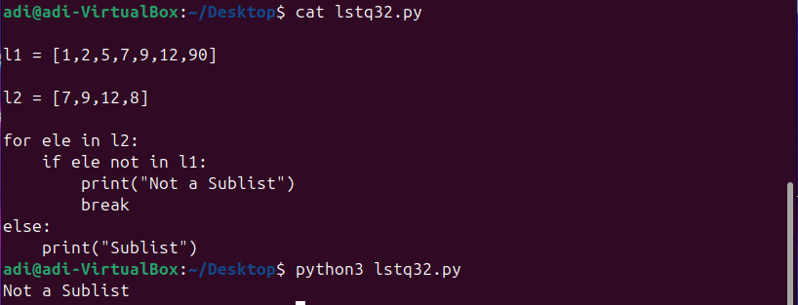  
  
  
36. Write a Python program to make list of all digits from given number

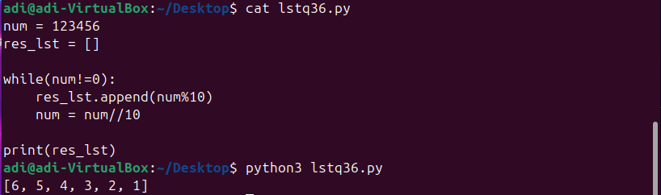  
  
  
38. Write a Python program to change the position of every two consecutive elements n-th value to the (n+1)th in a list. ( swap nth and n+1 th value)  
Sample list: [0,1,2,3,4,5]  
Expected Output: [1, 0, 3, 2, 5, 4]  
Explaination: here we have swapped  
0 -1 , 2-3 , 4-5

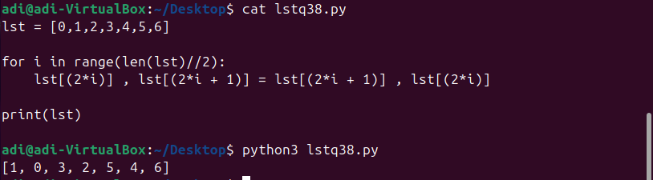

39. Write a Python program to convert a list of multiple integers into a single integer.  
Sample list: [11, 33, 50]  
Expected Output: 113350  
ex2: l1=[8,9,0]  
output : 890  
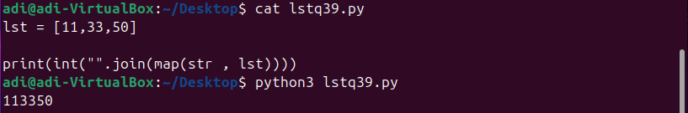

41. Write a Python program to check if given list contains another list object or not.  
Ex. l1=[10,20,30]  
output: no list object inside l1  
  
l2=[10,20,[45,67]]  
output: there is list object inside l2  
Here [45,67] is list object inside l2

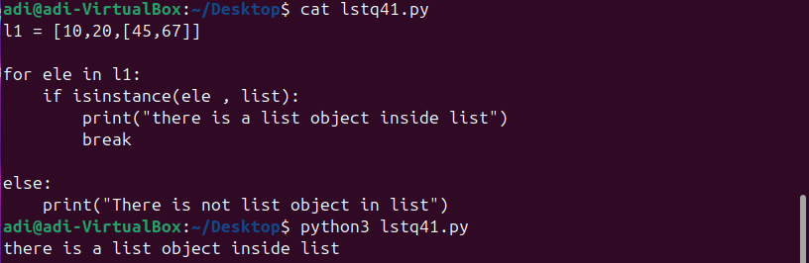

43. Write a Python program to split a list into different variables from center.  
Ex.  
l1=[12,23,34,45,56,67]  
first=[12,23,34]  
second=[45,56,67]  
  
l2=[12,23,34,45,56,67,99]  
first=[12,23,34]  
second=[45,56,67,99]

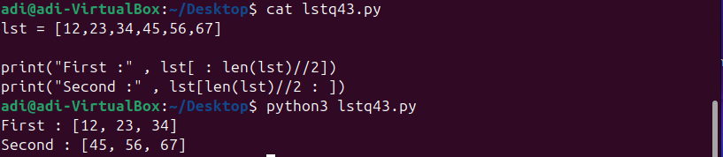  
  
  
44. Write a Python program to generate groups of three consecutive numbers in a list.  
l1=[1,2,3,4,5,6,7,8,9,10]  
Ans  
[1,2,3], [2,3,4], [3,4,5], [6,7,8], [7,8,9], [8,9,10]

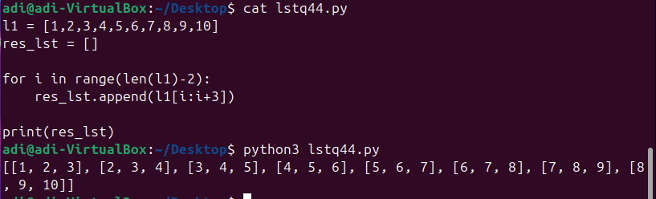

45. Write a Python program to take a list. Find all unique values. Then print all unique values in sorted order.

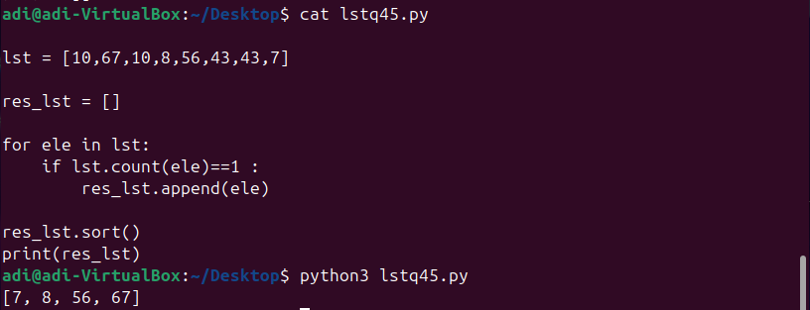  
  
  
  
47. Write a Python program to insert an element before each element of a list.  
Ex. l1=[1,2,3]  
insert 10 before every element  
o/p [10,1,10,2,10,3]  
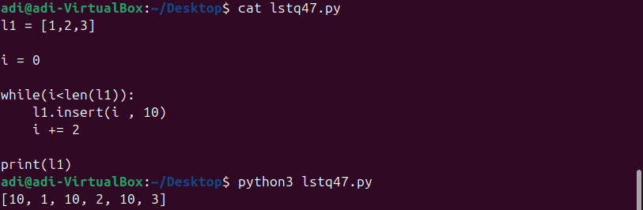

54. Write a Python program to concatenate elements of a given list to another list.

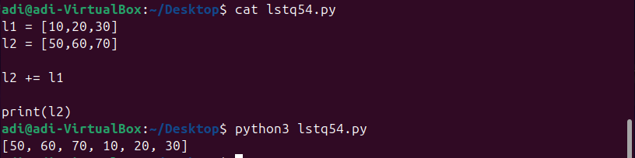

56. Write a Python program to convert a string to a list.

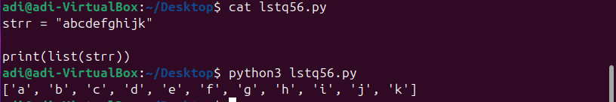

58. Write a Python program to replace the last element in a list with another list.  
Sample data : [1, 3, 5, 7, 9, 10], [2, 4, 6, 8]  
Expected Output: [1, 3, 5, 7, 9, 2, 4, 6, 8]  
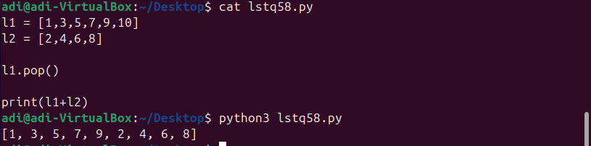

59. Write a Python program to check whether the n-th element exists in a given list. Dont give error if n is out of bounds, print out of bounds message.  
Ex.  
l1=[90,98,87,76,65]  
n=1 o/p: exists ( explaination l1[1] exists)  
n=10 o/p: out of bound index

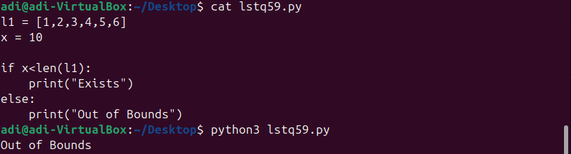  
  
  
64. Write a Python program to iterate over two lists simultaneously.  
ex.  
l1=[2,4,7]  
l2=[12,45,67]  
output:  
2 12  
4 45  
7 67

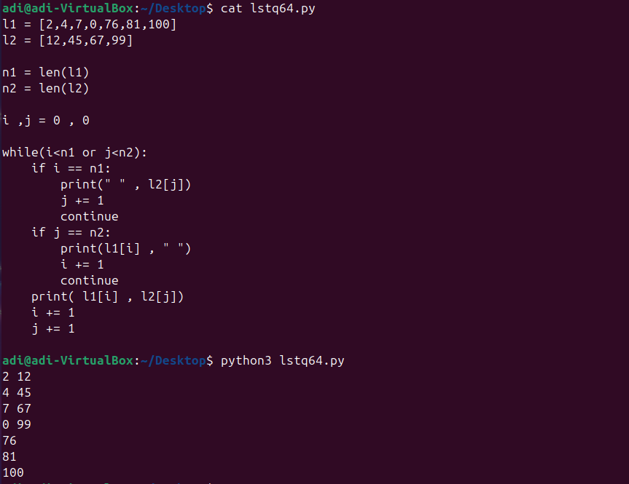

65. Write a Python program to move all zero digits to the end of a given list of numbers.  
  
Original list:  
[3, 4, 0, 0, 0, 6, 2, 0, 6, 7, 6, 0, 0, 0, 9, 10, 7, 4, 4, 5, 3, 0, 0, 2, 9, 7, 1]  
Expected output:  
Move all zero digits to end of the said list of numbers:  
[3, 4, 6, 2, 6, 7, 6, 9, 10, 7, 4, 4, 5, 3, 2, 9, 7, 1, 0, 0, 0, 0, 0, 0, 0, 0, 0]

