Create a file “calculation.sh” . Write a shell script to print

1. you are logged in as which user
2. in which directory you are
3. total number of files and directories in current directory

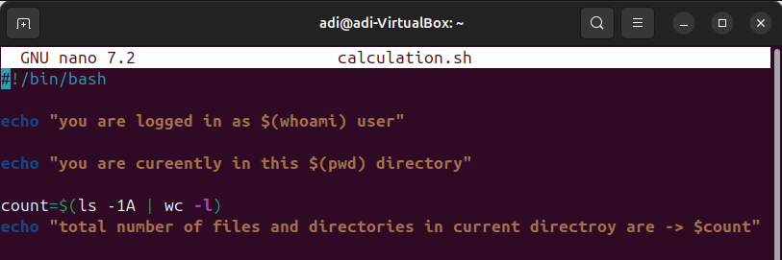

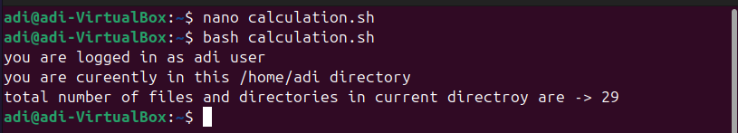

Init

1. get access control list of file.
2. Give permission to read and write to user “user1” for file .
3. Give permission to read to group “dac” for file .

